Changemakers: Creativity and Value Creations

Assignment-1 Online Portfolio of Set Exercises (e-portfolio)
Student Name: Zainab Jalloh
Student ID: 2008337
Lecturer: Eleni Koutsogeorgou

Table of Contents
Introduction 1
The gap in the Health and Social Care Sector 2
Artefact Task 4 4
Introduction 4
key Issues 4
Conclusion 5
Artefact Task 5 6
Introduction 6
Focused issue 7
Recommendations 7
Conclusion 8
Conclusion 9
References 10

Table of Figures
Figure 1: Inequality in public health 4
Figure 2: Discrimination in health and social care 6

Introduction
In the health and social care sector people have to engage so that they can overcome their health issues and get the chance to lead a fit and disease-free life (Ray et al., 2020). In the UK it is seen that the government as well as different non-government organisations are working nonstop process to ensure the necessary services to people of all ages, religions, gender, and other types from different segments. But it is very critical for them to the reason for discrimination which is a major gap in this sector. This paper will cover how the findings gap will be overcome as a part of a new project which will be presented to the audience by creating an elevator-style written pitch to engage them by assuring them that the issue is no more here. A poster will also create to showcase innovative ideas that will be very effective to overcome difficulties and it will encourage the people to come for getting the necessary services without facing the issues.

The gap in the Health and Social Care Sector
Heath and social care are the basic rights of every people and everyone should take necessary services wherever they feel to need the services (Kirst-Ashman, 2016). Everyone is taken with seriousness to ensure necessary services for the people to make them able for performing their regular activities. In the UK the government is implementing different strategies so that people are getting interested to go to the service providers whenever they need any services for resolving any issue. But in this sector, the main gap is failing to take necessary unitive for avoiding discrimination or the implemented rules or regulations are not enough to overcome the issue. Discrimination can be referred to as the situation of prejudicial or unfair treatment of individuals or groups of people based on their gender, class, categories, or other things.
The people in a society feel the necessity of health and social care services for their different health issues and go to the service providers to ask for necessary care services so that it can be possible to overcome. People with different health issues are not able to lead their life and face difficulty to focus on their daily tasks. It is not satisfactory for any country to get poor productivity from the people of their different health issues. 75% of people face discriminating situations in health and social care that demotivate them to avoid health care services (Andrews, 2019). It impacts negatively which long-term result that is very serious and can not possible to overcome easily. It is very challenging and needs to be overcome by preparing a plan by including the following issues.
Ensure creative public leadership: In public health, there is a huge shortage of qualified and creative leadership. Leadership in an organization is mandatory because all of the activities are performed by the leader's decision and in the healthcare sector skilled and creative leaders will be able to avoid discrimination (Ellis et al., 2016). The team leaders in public health should convince another team member to serve any people with great concern to solve their issues. They can describe the impact of discrimination on the people and the law of the country against the issue.
Public awareness: The health care services need to arrange a different campaign to provide information about the rights of the people to get health and social care services, their roles to avoid discrimination issues, and increase their engagement to solve their health issues (Joy and Lobelo, 2017). By taking the necessary initiative it can be possible to overcome discrimination in the public health sector.
Promotion: By using different innovative tools it can be possible to promote the services to increase the engagement of the people (Pinnock et al., 2017). To avoid discrimination should be taken diverse initiatives so that people can learn about their rights and go to the services providers to get the services by overcoming hesitation. At the time of promotion, it should be mentioned what will be the roles of the people at the time of facing discrimination and the rules of the government which can attract the people mostly. It also brings the confidence of the people and the service providers who practice discrimination will be conscious to avoid it.
Strict implementation of rules and regulations: To avoid discrimination must be needed to implement the rules and regulations of the government (Evans, 2016). When the service providers get punishment for discriminating against the people at the time of taking health and social care services everyone will be aware of the issue and try to serve the people equally. To implement the rules and regulations public awareness is very important. Government, as well as non-government organisations, should work together to avoid discrimination will be more effective to overcome the issue at the earliest time.

Artefact Task 4
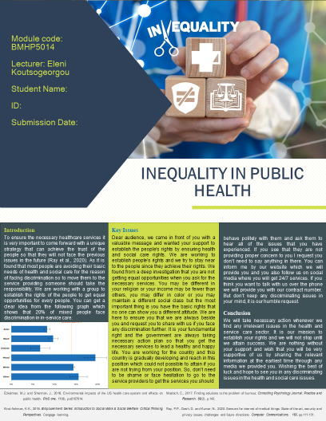

Introduction
To ensure the necessary healthcare services it is very important to come forward with a unique strategy that can achieve the trust of the people so that they will not face the previous issues in the future (Ray et al., 2020). As it is found that most people are avoiding their basic needs of health and social care for the reason of facing discrimination so to move those to the service providing someone should take the responsibility. We are working with a group to establish the rights of the people to get equal opportunities for every people. You can get a clear idea from the following graph which shows that 20% of mixed people face discrimination in in-service care.
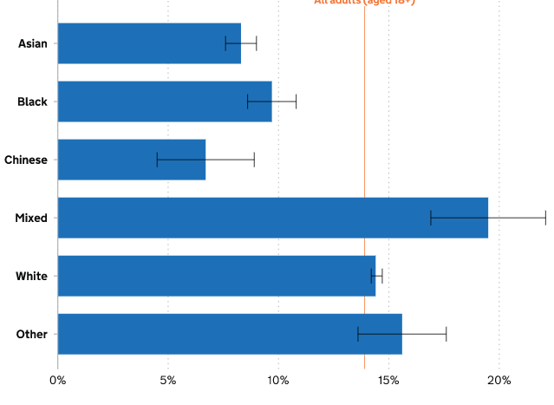
Figure 1: Inequality in public health
Sources: (Ray et al., 2020)

Key Issues
Dear audience, we came in front of you with a valuable message and wanted your support to establish the people’s rights by ensuring health and social care rights. We are working to establish people's rights and we try to stay near to the people since they achieve their rights. We found from a deep investigation that you are not getting equal opportunities when you ask for the necessary services. You may be different in your religion or your income may be fewer than others, you may differ in colour or you may maintain a different social class but the most important thing is you have the basic rights that no one can show you a different attitude. We are here to ensure you that we are always beside you and request you to share with us if you face any discrimination further. It is your fundamental right and the government are always taking necessary action plan so that you get the necessary services to lead a healthy and happy life. You are working for the country and this country is gradually developing and reaches in this position which could not be possible to attain if you are not trying from your position. So, don’t need to be shame or face hesitation to go to the service providers to get the services you should behave politely with them and ask them to hear all of the issues that you have experienced. If you see that they are not providing proper concern to you I request you don’t need to say anything in there. You can inform me by our website which we will provide you and you also follow us on social media where you will get 24/7 services. If you think you want to talk with us over the phone we will provide you with our contract number. But don’t keep any discriminating issues in your mind, it is our humble request.

Conclusion
We will take necessary action whenever we find any irrelevant issues in the health and service care sector. It is our mission to establish your rights and we will not stop until we attain success. We are nothing without your support and wish that you will be very supportive of us by sharing the relevant information at the earliest time through any media we provided you. Wishing the best of luck and hope to see you in any discriminating issues in the health and social care issues.

Artefact Task 5
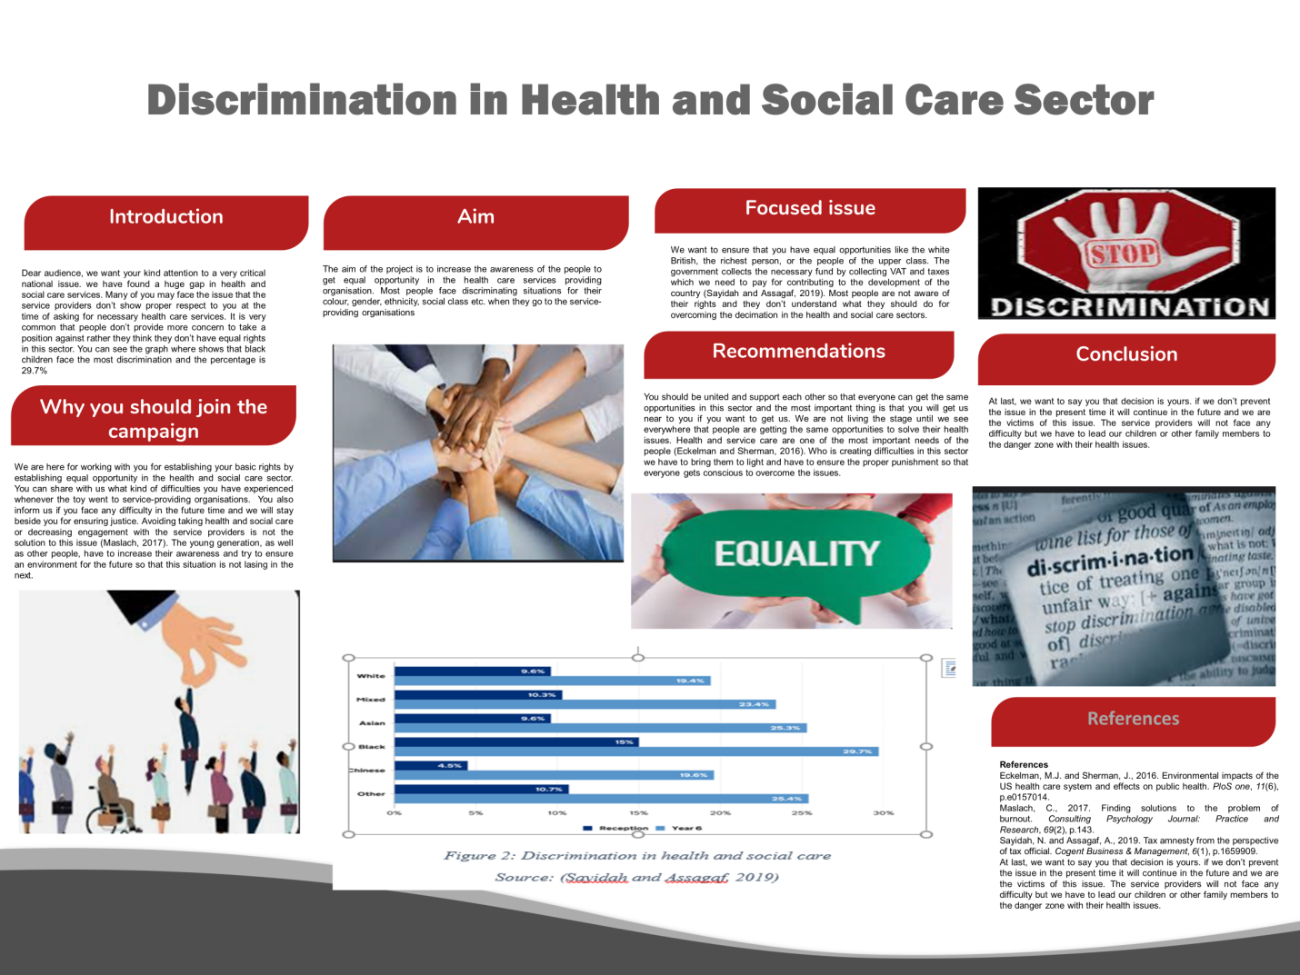

Introduction
Dear audience, we want your kind attention to a very critical national issue. We have found a huge gap in health and social care services. Many of you may face the issue that the service providers don’t show proper respect to you at the time of asking for necessary health care services. You can see the graph that shows that black children face the most discrimination and the percentage is 29.7%

Aim
The aim of the project is to increase the awareness of the people to get equal opportunity in the health care services providing organisation. Most people face discriminating situations for their colour, gender, ethnicity, social class etc. when they go to the service-providing organisations
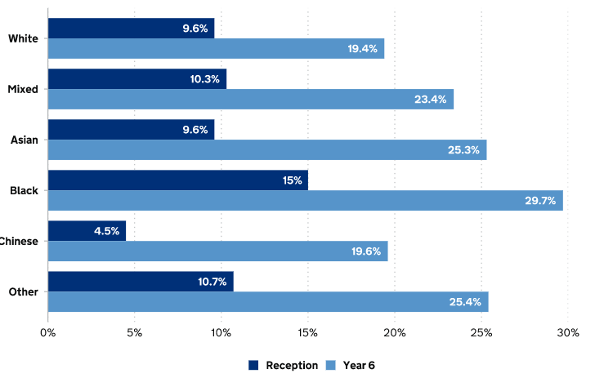
Figure 2: Discrimination in Health and social care
Source: (Sayidah and Assagaf, 2019)

Focused issue
We want to ensure that you have equal opportunities like the white British, the richest person, or the people of the upper class. The government collects the necessary fund by collecting VAT and taxes which we need to pay for contributing to the development of the country (Sayidah and Assagaf, 2019). Most people are not aware of their rights and they don’t understand what they should do for overcoming the decimation in the health and social care sectors.

Why you should join the campaign
We are here for working with you for establishing your basic rights by establishing equal opportunity in the health and social care sector. You can share with us what kind of difficulties you have experienced whenever the toy went to service-providing organisations. You also inform us if you face any difficulty in the future time and we will stay beside you for ensuring justice. Avoiding taking health and social care or decreasing engagement with the service providers is not the solution to this issue (Maslach, 2017). The young generation, as well as other people, have to increase their awareness and try to ensure an environment for the future so that this situation is not lasing in the next.

Recommendations
You should be united and support each other so that everyone can get the same opportunities in this sector and the most important thing is that you will get us near to you whenever you face any difficulty. We are not leaving you until we see everywhere that people are getting the same opportunities to solve their health issues. Health and service care is one of the most important needs of the people (Eckelman and Sherman, 2016). Who is creating difficulties in this sector we have to bring them to light and have to ensure the proper punishment so that everyone gets conscious to overcome the issues?

Conclusion
At last, we want to say you that decision is yours. if we don’t prevent the issue in the present time it will continue in the future and we are the victims of this issue. The service providers will not face any difficulty but we have to lead our children or other family members to the danger zone with their health issues.

Conclusion
Preparing a new project can be possible with creative ideas and the need to attain the aims of the project. It is very critical to create value for any topic if there don’t have any importance to the topic and the people are not interested in it. Discrimination in health and social care creates a big gap that every people are not able to reach with their necessary health care services. So this issue needs to be overcome by planning in the proper way.

References
Andrews, L., 2019. Public administration, public leadership and the construction of public value in the age of the algorithm and ‘big data’. Public Administration, 97(2), pp.296-310.
Eckelman, M.J. and Sherman, J., 2016. Environmental impacts of the US health care system and effects on public health. PloS one, 11(6), p.e0157014.
Ellis, A., Chebsey, C., Storey, C., Bradley, S., Jackson, S., Flenady, V., Heazell, A. and Siassakos, D., 2016. Systematic review to understand and improve care after stillbirth: a review of parents’ and healthcare professionals’ experiences. BMC pregnancy and childbirth, 16(1), pp.1-19.
Evans, T., 2016. Professional discretion in welfare services: Beyond street-level bureaucracy. Routledge.
Joy, E.A. and Lobelo, F., 2017. Promoting the athlete in every child: physical activity assessment and promotion in healthcare. British Journal of Sports Medicine, 51(3), pp.143-145.
Kirst-Ashman, K.K., 2016. Empowerment Series: Introduction to Social Work & Social Welfare: Critical Thinking Perspectives. Cengage learning.
Maslach, C., 2017. Finding solutions to the problem of burnout. Consulting Psychology Journal: Practice and Research, 69(2), p.143.
Pinnock, H., Barwick, M., Carpenter, C.R., Eldridge, S., Grandes, G., Griffiths, C.J., Rycroft-Malone, J., Meissner, P., Murray, E., Patel, A. and Sheikh, A., 2017. Standards for reporting implementation studies (StaRI) statement. bmj, 356.
Ray, P.P., Dash, D. and Kumar, N., 2020. Sensors for internet of medical things: State-of-the-art, security and privacy issues, challenges and future directions. Computer Communications, 160, pp.111-131.
Sayidah, N. and Assagaf, A., 2019. Tax amnesty from the perspective of tax official. Cogent Business & Management, 6(1), p.1659909.

