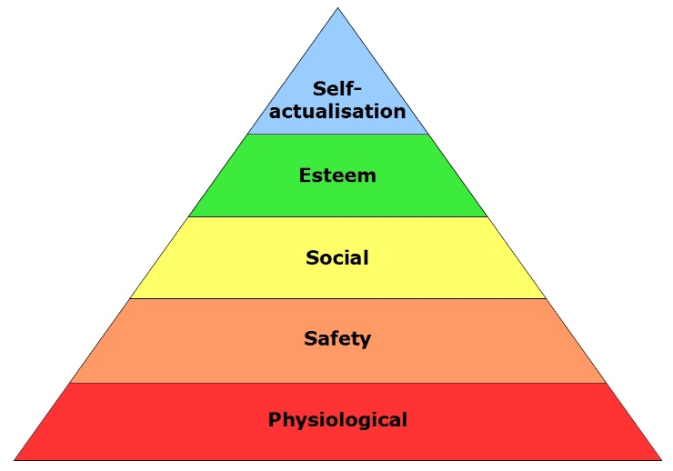
Maslow’s Hierarchy of needs.
Read through the scenarios below and use Maslow’s Hierarchy of needs to help you decide what impact each challenge will have on the individuals involved, identify which level of need they are needing to satisfy.
Profile |     A 32 year old woman with she has two children.
Challenge faced – | Evicted by her landlord, and very little money.
Impact to self esteem –

Impact to motivation to learn –

Interest in making new friends-

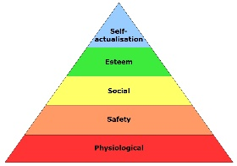
Main immediate needs

Profile |   18 year old – Finished A-Levels  Has a girlfriend and lots of friends,
Challenge faced – | Awaiting a-level results – fears that he has not done enough to pass.
Impact to self esteem –

Impact to motivation to learn –

Interest in making new friends-

Main immediate need

Profile | A 45 year old man, married with children.
Challenge faced – | During a solo fishing trip a large shark is spotted close to the boat.
Impact to self esteem –

Impact to motivation to learn –

Interest in making new friends-

Main immediate need.

Profile |   A 67year man, married, father, respected professionally, high level of financial success in life.
Challenge faced – | He has recently retired and now questions the meaning of life.
Impact to self esteem –

Impact to motivation to learn –

Interest in making new friends-

Main immediate need.

Profile |   A two year old girl.
Challenge faced – | It is a hot day and she has a thick jumper on, she is crying.
Impact to self esteem –

Impact to motivation to learn –

Interest in making new friends-

Main immediate need.

Profile |   A 27 year old woman, graduate who owns her house.
Challenge faced – | Her husband has left her after 3 years of marriage, he is now living with another woman.
Impact to self esteem –

Impact to motivation to learn –

Interest in making new friends-

Main immediate need.

