Nature and direction of archaeology and its relationship within the wider range of humanities.

Archaeology as a field of study is one that can be hard to define in a few words. According to Bahns and Renfrew (2016, p. 12), the discipline is concerned with the discovery of treasures of the past, the meticulous work of scientific analysis, and is partly an exercise of the creative imagination. It is both a physical activity out in the field, focusing on excavation of human artefacts, and an intellectual study in the laboratory. Archaeology is deeply concerned with materiality, and through following quasi-scientific methods is interdisciplinary in nature, with it being anthropological, historical and scientific in nature. This essay aims to outline the nature and direction of the discipline, and also how important its relationship within the wider range of humanities is.
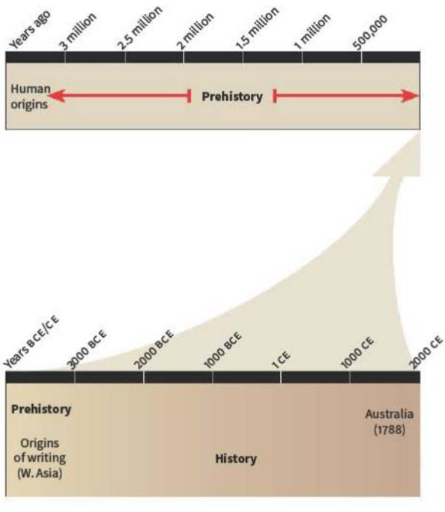
One defining feature of archaeology is its wide scope. Archaeology is concerned with a vast timespan, that of the entire history of humankind (Bahns and Renfrew, 2016, p. 13). This includes “prehistory”, the period before human written records, and “history”, the period of written evidence. (The term “prehistory” is seen as outdated and derogatory by some in the modern day due to issues of identity, race and class that accompany it, and that certain cultures prioritised written records more than others (Gosden, 2003), however for the sake of this essay it is a useful distinction to make).
(The vast timespan of “prehistory” compared with the relatively short timespan of “history” (Bahns and Renfrew, 2016, p.13))

Humans have existed for a long period of time, and throughout this time all humans have lived in a particular social, physical and environmental context. These contexts are not static and are dynamic, and in this dynamic process humans leave imprints in the form of material remains (Rajan, 2017). Archaeologists aim to study these imprints not in isolation but as a whole, as looking at archaeological sites in isolation will not give the archaeologist all the information they aim to study (Rajan, 2017).
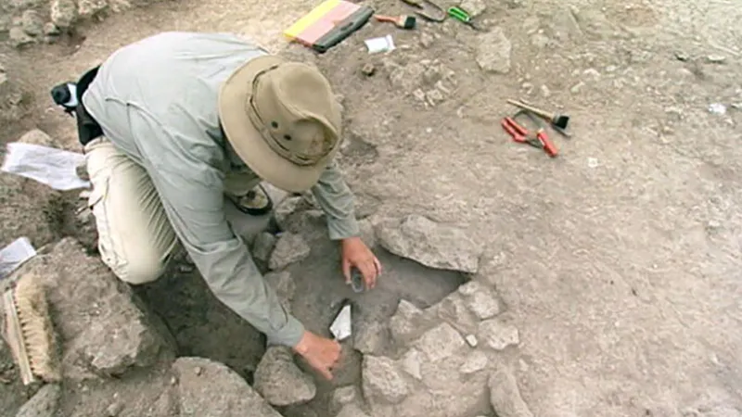
Another defining feature of the nature of the discipline of archaeology is the specific methodology that is conducted by archaeologists. Archaeology is interested in conducting field research and excavation. This often begins with a survey of an area that has the potential to reveal human artefacts or cultural debris. This could be through simply walking across a field, or in more modern times using technology such as drones or satellite imagery to discover unusual topography (Hasty, Lewis and Snipes, 2023). Already existing cultural sites are also used as a basis for excavation, including heritage sites. Once a site survey is completed, then the next step in archaeological methodology is excavation. Excavation to this day remains the key role in archaeological fieldwork due to it yielding the two main kinds of evidence that archaeologists are interested in: human activity and changes in those activities. Very broadly, it can be stated that contemporary activities take place horizontally in space, whereas changes in activity are recorded vertically in space (Brahn and Renfrew, 2016, p. 110). Whilst surveying a site beforehand is vital, the role of chance in the discovery of artefacts or of materials that are interesting to archaeologists can not be understated. Luck can also be on the side of the archaeologist, for example when farmers accidentally unearth sites whilst ploughing their fields, or when the Upper Paleolithic cave of Lascaux in southern France was discovered by chance when four schoolboys decided to investigate a hole left by an uprooted tree (Daniel, 2023). Once a site has been chosen for excavation, then excavation can begin. There are a host of different excavation methods that can be used by an archaeologist, depending on the objective of the excavation and the characteristics of the site itself. One such method of excavation on earth is Wheeler box-grid.
(Britannica, 2023a)
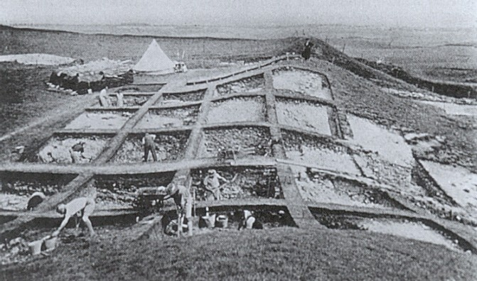

(Wheeler box-grid (Dig It With Raven, 2020))

This method creates a grid pattern on the floor, with baulks in between the squares of the grid. Each square within the grid is a different layer, allowing archaeologists to see different layers of the earth at the same time (Bahns and Renew, 2016, p. 112). A second excavation method is open-area excavation.

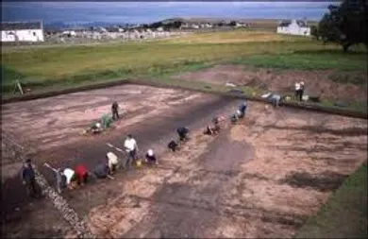
(Open-area excavation (Dig It With Raven, 2020))

Advocates of the open-area method argue that the Wheeler is weak, due to the fact that the baulks in between the grids may invariably be in the wrong place (Bahns and Renew, 2016, p. 112). In the open-area method, large horizontal layers are opened up, and vertical sections are only cut at various angles where they are required to clarify certain stratigraphic relationships of the site. This is a meticulous process due to everything having to be recorded and is more demanding than the Wheeler method, but modern recording techniques with the help of technology make this easier (Dig It With Raven, 2020).
A third above ground excavation method would be step trenching. If the excavation requires quite deep digging, then the Wheeler method might get dangerous due to how high the baulks would be, and the open area would be too large to get so many layers in one period (Dig It With Raven, 2020). Step trenching is when the sides of the site are stepped at intervals to maintain stability and to be able to view multiple levels at once. This has its own major downside of that without making it exceptionally large, due to each layer’s area gradually becoming smaller than the last, then the deepest most layers will have quite a small area (Darvill, 2009).
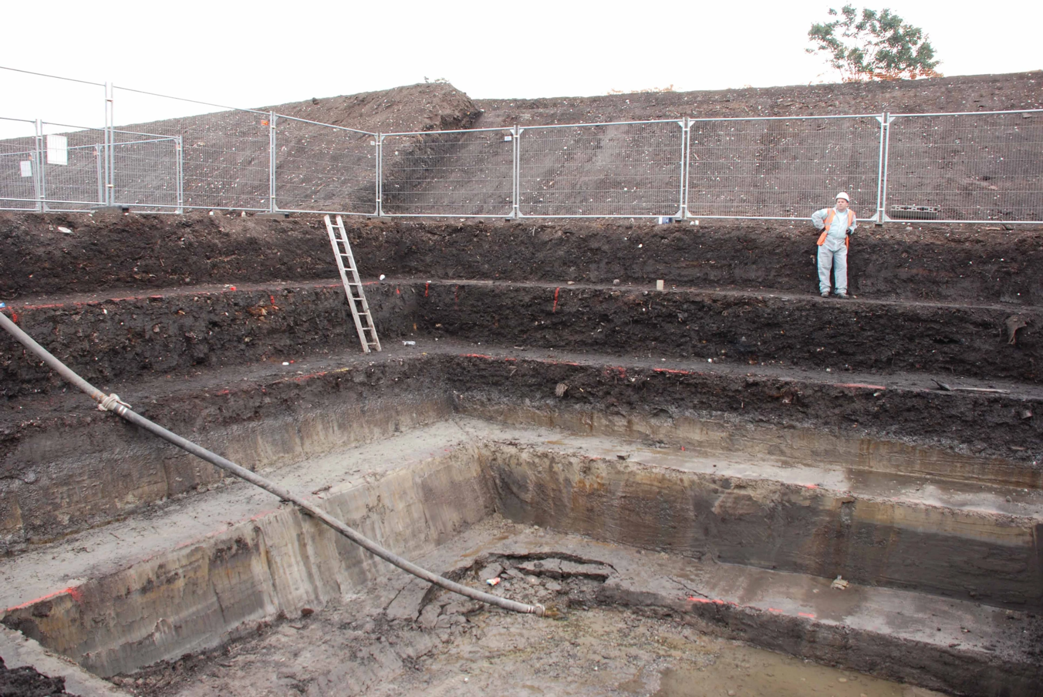
(Dig It With Raven, 2020)
Other excavation methods exist, including methods for underwater excavation and urban excavation (Bahns and Renew, 2016, pp. 113-127), however this essay is not focusing on the intricacies of archaeological expeditions.
When thinking of the direction that the field of archaeology is headed, then an understanding of the history of archaeology must be understood. Bahns and Renew (2016, p. 48) state that whilst humans have always been interested in their past, it was not until 1784 that Thomas Jefferson undertook the first scientific excavation, the first truly “archaeological” excavation. This entailed an excavation of a Monacan Indian burial mound being excavated near the Rivanna River, whereby the human remains of an estimated one thousand peoples were found. This disproved the “lost race” theory that Americans held at the time, believing that these mounds were built by a previous “lost race” of “Moundbuilders” and not by Native Americans (Hantman, 2020). This was the first time that a person had taken a scientific approach to the past of humankind, by testing ideas that people had about the mounds (namely the “lost race” of “Moundbuilders”) against hard evidence. Unfortunately, whilst an advancement was made, Jefferson still had not advanced knowledge of the past much due to one limitation - the lack of knowledge of the antiquity of humankind (Bahns and Renew, 2016, p.23). At the beginning of the 19th century, 4004 BCE was then thought to be the year of the Creation described in the Bible (Britannica, 2023b). French customs inspector Jacques Boucher de Perthes challenged this after discovering human artefacts in the gravel quarries of the Somme river which he argued must have predated the Biblical flood. Whilst initially disregarded by academics, the notion of humankind only being as young as 4004 BCE has been disproven numerous times (Bahns and Renew, 2016, p.26).
Following on from this, in 1859 Charles Darwin’s On The Origin of Species was published, which also disagreed with how young humankind was (Britannica 2023b). The key idea that Darwin put forward was natural selection. Darwin stated that in the struggle for existence, environmentally better adapted individuals of a particular species would survive whilst less well adapted individuals would die out (Bahns and Renew, 2016, p. 26). This idea went against the idea of Biblical creationism and the idea that humankind had only existed since 4004 BCE.
Danish antiquarian C.J. Thomsen in the early 19th century also came up with a key concept for the development of archaeology as a field of study: the Three-age system. Thomsen recognised that artefacts of stone, bronze and iron were characteristic of three periods or phases of prehistory: namely the stone age, the bronze age, and the iron age. This new system was the first to subdivide the prehistoric past on the basis of archaeological finds, and it was a first attempt at a chronology of relationship for the prehistoric past. This idea was adopted throughout Europe in the 1860s and by the 1920s was widely used as a basis for classifying prehistoric artefacts (Fagan, 2004).
The acceptance of these three new ideas: the antiquity of humankind, the theory of natural selection and the development of the three-age systems offered a framework for studying the past through materiality (Bahns and Renew, 2016, p.48).
In the 1960s however, anthropologists such as Franz Boas began to realise that the three-age system was not suitable, and did not fit with North American archaeology (Cisneros and Paskey, 2023) as these three ages were purely arbitrary and did not actually coincide with any levels of social evolution (Fagan, 2004). This led to a shift in archaeological thinking, whereby instead of focusing on creating a chronology of human past, sought to explain the past through the use of materiality (Bahns and Renew, 2016, p.48). Known as processual archaeology, the primary idea underlying this was that artefacts can be used to explain the past and not just describe it. Decades later, this also led to post-processual archaeology, which advocates for multiple interpretations of the archaeological record as post-processual archaeologists believe that there is no single objective way to view archaeology and that objectivity within the field is impossible (Cisneros and Paskey, 2023).
In the modern day, there has been a movement for archaeology to work towards and with heritage (Bahns and Renew, 2016, p.48). UNESCO defines cultural heritage as:

...[including] artefacts, monuments, a group of buildings and sites, museums that have a diversity of values including symbolic, historic, artistic, aesthetic, ethnological or anthropological, scientific and social significance.

(UNESCO, 2009)

Archaeology is vital to this interdisciplinary approach to preservation through its excavation practice, and archaeology plays a vital role in the establishment of national and ethnic identity through heritage (Bahns and Renew, 2016, p.48).
In conclusion, archaeology is a large field of study with a broad scope, encompassing the entirety of human existence. As a field it is committed to understand the dynamic social, physical and environmental contexts of society. The discipline is committed to this through unique methodologies, namely a number of different excavation methods, focusing on material evidence.
The direction of the discipline has shifted considerably throughout its life. Early challenges of beliefs of the past gave way to a scientific and more nuanced approach to the past of humankind. The discipline within has changed drastically throughout the last two hundred years, and will continue to change. Archaeology has also taken on a vital role in heritage preservation, contributing to the strengthening of national and ethnic identity.

Bibliography

Bahns and Renfrew (2016) Archaeology: Theories, Methods and Practice. 7th edn. London: Thames and Hudson

Britannica (2023a) Archaeology. Available at: https://cdn.britannica.com/93/179793-138-FF2B6B44/archaeologists-traces-Georgia-metallurgical-workshop.jpg?w=800&h=450&c=crop (Accessed: 17th of October 2023)

Britannica (2023b) Jacques Boucher de Perthes. Available at: https://www.britannica.com/biography/Jacques-Boucher-de-Perthes (Accessed: 18th of October 2023)

Cisneros, A.B. and Paskey, A.W. (2023) 3.1: Evolution of Archaeology. Available at: https://socialsci.libretexts.org/Courses/HACC_Central_Pennsylvania's_Community_College/Archaeology%3A_It's_More_Than_Digging_In_The_Dirt_(Scheib)/03%3A_Contemporary_Archaeology_(1960s_and_Beyond)/3.01%3A_Evolution_of_Archaeology (Accessed: 18th of October 2023)

Daniel, G.E. (2023) archaeology. Available at: https://www.britannica.com/science/archaeology/Fieldwork (Accessed: 17th of October 2023)

Darvell, T. (2009) step trenching. Available at: https://www.oxfordreference.com/display/10.1093/acref/9780199534043.001.0001/acref-9780199534043-e-4011?rskey=vmwZt5&result=4123 (Accessed: 18th of October 2023)

Dig It With Raven (2020) Archaeological Excavation Methods. Available at: https://www.digitwithraven.com/single-post/archaeological-excavation-methods (Accessed: 17th of October 2023)

Fagan, B.M. (2004) Three-age System. Available at: https://www.oxfordreference.com/display/10.1093/acref/9780195076189.001.0001/acref-9780195076189-e-0445 (Accessed: 18th of October 2023)

Gosden, C. (2003) Prehistory. 1st edn. Oxford: Oxford University Press

Hantman, J. (2020) Jefferson’s Mound Archaeological Site. Available at: https://encyclopediavirginia.org/entries/jeffersons-mound-archaeological-site/ (Accessed: 18th of October 2023)

Hasty, J., Lewis, D.G. and Snipes, M.M. (2023) 2.2: Archaeological Research Methods. Available at: https://socialsci.libretexts.org/Bookshelves/Anthropology/Introductory_Anthropology/Introduction_to_Anthropology_(OpenStax)/02%3A_Methods-_Cultural_and_Archaeological/2.02%3A_Archaeological_Research_Methods (Accessed: 17th of October 2023)

Rajan, K. (2017) Archaeology; Principles and Methods. Available at: https://epgp.inflibnet.ac.in/epgpdata/uploads/epgp_content/S000829IC/P001688/M020079/ET/1493287641P07-M01-DefinitionandScopeofArchaeology-ET.pdf (Accessed: 17th of October 2023)

UNESCO (2009) Cultural heritage. Available at: https://uis.unesco.org/en/glossary-term/cultural-heritage (Accessed: 18th of October 2023)

