Declaration/Statements page

DECLARATION

This work has not previously been accepted in substance for any degree and is not being concurrently submitted in candidature for any degree.

Signed ...................................................................... (candidate)

Date ........................................................................

STATEMENT 1

This work is the result of my own investigations, except where otherwise stated.

Other sources are acknowledged by footnotes giving explicit references. A bibliography is appended.

Signed ..................................................................... (candidate)

Date ........................................................................

STATEMENT 2

I hereby give consent for my work, if accepted, to be available for photocopying and for inter-library loan, and for the title and summary to be made available to outside organisations.

Signed ..................................................................... (candidate)

Date ........................................................................

Change management in the retail industry: compare New Look and Primark in response to the current financial challenges

Dissertation Written by:
Chang Liu

1704196
Abstract:
The retail market is changing and developing. Every year a number of enterprises go bankrupt, and new companies seize the opportunity to emerge and win. In March 2018, New Look closed up to 60 of the 600 British stores. But at that time Primark sales rose by 3% . In this highly competitive business environment, companies need to know more about challenges and change management than ever before.
Retailers face a series of problems in the current environment. These problems refer to reduced turnover because the number of customers has also decreased. This study aims to show what tools retailers use to reduce the negative impact of crisis. The significance of this research is to analyse the challenges in the retail market and to recognize the need for change and development of enterprises, and to consolidate the improvements needed in the research, and to provide suggestions for future retail research.
From the perspective of financial challenges and change management, this dissertation critically evaluates the internal and external factors of retailing industry and reviews the relevant academic literatures which directly inform the main data. The five forces theory and value chain theory help to understand the internal and external environment competition of the organization, which can be used as a method to find the trigger and resistance of change. Besides, from the viewpoint of changes management, Lewin and stakeholder theory, further reference was provided to better understand the organization change management and future development.
50 questionnaires and an interview were analysed by using SPSS software with the Chi Square and Independent simple test to obtain objective quantitative data. and there are following three groups of results: 1 gender has a significant impact on customers who value up to date as important when they shop for clothes. 2 brand has a significant impact on the frequency of consumer's shopping in Primark. 3 Price may have a great significant impact on expenditure in New Look. 4 convenience and service may influence people prefer New Look or Primark.
The Interview data collected provides an interesting insight and obtain valid information. Firstly, the most reason why New Look close the stores is because it is a private-equity firm (internal factor). Secondly, companies should develop distinctive capabilities for sustainable market differentiation and advantage, as competitors cannot easily replicate these capabilities. Thirdly, the biggest challenge for fashion retailers is to compete with not only other fashion retailers, but the alternative ways of outspent of spending money. Fourthly, government and fashion retailers change will be needed to welcome the challenge. In the end, mature retailers and consumer goods companies must actively pursue innovation and are willing to change themselves.
In the end, the dissertation provides three recommendations to the future retail industry. First is moving the target and adding additional customer profiles to the costume design. Then use a variety of digital platforms to create customer experience and journeys. Third step is to reassess the location and size of stores, optimize store density, design stores to reduce investment and operating costs, and possibly renegotiate leases.

Content
Content 1
1 Introduction 4
1.1 Introduction 4
1.2 Rationale 4
1.3 Aims and Objectives 6
1.4 Dissertation Structure 6
2 Literature Review 7
2.1 Challenges faced with retail market 7
2.2 Triggers and resistance to change 8
2.2.1 Porter five forces theory 8
2.2.2 Value chain theory 10
2.3 Typology of change 12
2.3.1 Nadler’s typology of organizational change 12
2.3.2 The “trap of success” 13
2.4 Process of change 15
2.4.1 Lewin’s force field 15
2.4.2 Three step process 17
2.5 Strategy of change 19
2.6 Stakeholder map 21
2.7 Conclusion 22
3 Methodology 23
3.1 research philosophy 23
3.2 research approach 24
3.3 research strategy 25
3.4 research choices 26
3.5 Time horizons 27
3.7 sampling 28
3.8 questionnaire and interview design 29
3.9 piloting the question 30
3.10 reliability and validity 30
3.11 research ethics 31
4 Data Analysis 32
4.1 Survey 32
4.1.1 Theme one: Gender and Up to date 33
4.1.2 Theme two: Brand and How often go shopping in Primark 34
4.1.3 Theme three: Price and Up to date and may influence expenditure in New Look 35
4.1.4 Theme four: Factors influence customers to choose New Look or Primark 37
4.2 Interview analysis 39
4.2.1 Theme one: the reason why New Look close the stores. 39
4.2.2 Theme two: distinctive capabilities companies should own. 40
4.2.3 Theme three: current challenges facing the fashion retail industry. 40
4.2.4 Theme four: change management of the fashion retail industry 41
4.2.5 Theme five: future retail industry 41
5 Conclusion 42
5.1 Achievement of aims 43
5.2 Limitations 44
5.3 Recommendations 45
Bibliography 46
APPENDIX 62
Appendix 1- Survey Questions 62
Appendix 2- Survey Results 64
Appendix 3- Interview questions 76
Appendix 4- Interview transcript 77
Table of figures 81

Introduction

1.1 Introduction
This dissertation will attempt to determine the challenges in the retail market, with considering both the driving and restrictive forces of the change status and to recognize the need for change and development of enterprises including planned and emergent approaches, with Lewin force field and three-step process being considered, and to consolidate the improvements needed in the research. consideration was also being given to provide suggestions for future retail market research along with the stakeholder relationship and strategic change management.
The retail market is changing and developing. Every year a number of enterprises go bankrupt, and new companies seize the opportunity to emerge and win. In this highly competitive business environment, companies need to know more about challenges and change management than ever before (MarketLine, 2018A). It is said (Wallace and Armstrong, 2017) that since the financial crisis, retail sales have fallen at the fastest rate, KPMG (Martin, 2018) estimates that the health status of the retail sector is likely to decline for the first time since 2012 and will gradually separate the winners from the losers in 2018. While Christmas and black Friday purchases usually support the quarter's performance, increased costs and profit margins, combined with a full impact of currency hedging and wage tightening will hurt retail market businesses.

1.2 Rationale
New look is a clothing retailer, the company's goods include male, female, children clothes and so on. New look offers its products through its retail chains and online websites. The company operates through stores in different parts of the UK and also has business in Europe and Asia (MarketLine, 2018B). Many companies have overextended themselves in good year, exposing them dangerously and making many retailers burdened with debt. Because of tight trading conditions, retailers are unable to withstand underperforming outlets and have to close stores. According to the report (Hooker, 2018), New look will close 60 of the 600 UK stores to fight massive debt.
Primark (MarketLine, 2017) is also a fashion retailer based in the UK. The company already owns more than 290 stores and offers its products to the Primark brand. In addition to selling goods in the store, the company also manages the UK and Ireland sourcing and sales teams, which are sourcing the latest fashions and latest designs at competitive prices. As Todd (2017) stated that due to the Brexit and wallet tightens, low-cost alternatives are more attractive. Consumers may continue to demand products with low demand. So, Primark may benefit from this business model which provide cheap and appear the same as high cost branded items.
Expert stated that Britain's retail market is in crisis. The pound has fallen nearly 15% per cent since the UK's vote to leave the European Union, pushing inflation more than 3% (Thomas, 2018). This makes imported goods more expensive, and these costs are turned to consumers. Coupled with the fact that wages are growing less than inflation, the discretionary income shoppers spend on shops and restaurants has fallen. In addition, the sector has experienced structural troubles, increased shopping online and high commercial interest rates, leading to far lower sales growth than retailers expect (Butler, 2018). Evidence of a disconnect between the consumer and the corporate apparel sector can be seen in the company's annual financial statements. Clothing accounted for 2015 of the total income of 45%, The figure is now only 40% and may fall further (Weinswig, 2017). An independent retail analyst Hyman estimates that at least 20% of the retail space needs to be closed in the next few years, as sales of business rates and wages have risen, and sales of real stores continue to decline (Ruddick, 2016). Store closure announcements are commonplace in high street, and analysts are looking for the next company forced to enter the store to close or completely disappear. The most serious trouble is found in the retail of clothing, NewLook and other well-known brands almost into the perilously administration. Given (Marketline, 2018C) that the clothing sector is more difficult to survive than most business, even competitive retailers such as Primark, cutting the number of stores is now one of the most highly valued plans for high street brands in consumers ' society.
In the current economic crisis, it is necessary and new to study the retail market. Retailers face a series of problems in the current environment. These problems refer to reduced turnover because the number of customers has also decreased. This study aims to show what tools retailers use to reduce the negative impact of crisis. The significance of this research is to analyse the challenges in the retail market and to recognize the need for change and development of enterprises, and to consolidate the improvements needed in the research, and to provide suggestions for future retail research.

1.3 Aims and Objectives
The main objectives of the dissertation and the philosophy of the study are as follows:
-To critically analyse internal and external factors of retail sector in the context of financial crisis.
-To evaluate the main element that constitute change management: nature of change, anatomy of change, process of change, strategies and development, leading change, and change management.
-To contrast the change management strategies and stakeholders’ relationship of New Look and Primark operating in the UK.
-To develop a change management method that embraces and reflects all the major relevant concepts to the topic of change management and apply in retail market.

1.4 Dissertation Structure
The first chapter will introduce the research project and present the research purpose to determine the challenges in the retail market, understand background of fashion retail industry, recognize the significance for change and master the framework of the full dissertation.
The second chapter will include a review of the second studies and a critical analysis of the current literature around the internal and external environment of changing retail market, nature and typology of change, driving and restraining forces around the change, Lewin force field model, three-step process, stakeholder map, and strategic of change.
The third chapter will present the primary study with research onion and will assess the research philosophy, approach and strategy in order to examine change management in retail market in the research in relation to the behaviours and attitudes of customers, employees and experts.
The fourth chapter will analyse around 50 questionnaires and an interview using SPSS software to analyse the Chi Square and Independent simple test to obtain objective quantitative data. The results are linked to the qualitative data obtained from the interviews and the literature previously analysed in chapter two.
In the end, the fifth chapter will draw conclusions from the first- and second-hand data and information from studies of the previous chapters and will provide advices for the development of retail market and strategic change management.

Literature Review
The purpose of this chapter is to critically discuss relevant research papers, academic journals, theories, models and case studies with research data and define and evaluate the concepts related to this paper. This literature part will review the relevant research on change management in retail business. Considerations has also been given to analyse the challenges, triggers, resistance, typology and process of change management which applied with the Nadler and Lewin models. This study critically evaluated the existing evidence and theory and laid the literature foundation for the methodology and data analyse part in this paper.

Challenges faced with retail market
As the Guardian reported (Butler, 2018), nearly one-fifth of UK retailers are planning to cut employment in the next three months because the high street is not only affected by online shopping. After pound's depreciation, retailers also face rising costs of buying goods from abroad, as well as increased commercial interest rates and legal minimum wages. At the same time, as the UK's uncertainties persist, household spending remains weak and consumer confidence does not work. So far, traditional high streets brands (Fildes,2018), including House Fraser, New Look, M&S, Moss Brothers and Carpetrights, have closed dozens of stores and invested money into home delivery infrastructure and IT departments. These close of stores, as well as the collapse of weaker chains, include Maplin, Pound world and Toys R Us. What’s more, a former retail owner warns (Westbrook, 2018) that if action is not taken immediately, the UK's urban centre will be in danger of being a ghost town in the future.
There is no denying that retailing is going through an era of unprecedented change, and it is vital to see the challenges and chance and glimpse the future of the high street. To better understand the overall target of this dissertation, first footstep is to look into the theory of triggers to change.

Triggers and resistance to change

Porter five forces theory
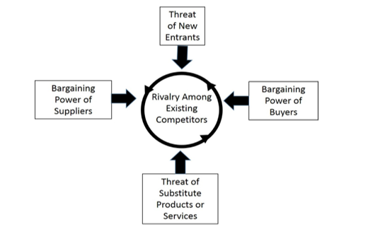
Figure 2.2.1 Porter five forces theory
To understand triggers for change, it is significant to identify that changes in line with the fiercely competitive industry and environment. As Burnes (2009) stated that the retail industry strongly influences the competitive rules as well as structure and strategies open to the organization. The industry analysis is closely associated with the work of Porter (1985) five forces framework (Figure 2.1). The five-force analysis (Grant, 2016) will help to understand the pressures of the organization's external environment and the competition that is facing, and it is possible that this is what triggers the change.
Academics have come to view organizations through the five forces theory, most of the studies are focused on food (Rachapila & Jansirisak, 2013), vehicle (Uzwyshyn, 2012), medicine (Pines, 2006) and education (Aydin, 2017). One report (Wood,2010) applied the analysis of Porter's five forces to Canadian food retailing, which helped international marketing and retail chains better concentrate and realise the Canadian food industry and better understand this dynamic and evolving overall direction. In terms of risk management, Rice (2010) has developed a model of environmental threats analysis which aimed at assessing aid managers in assessing these threats, so that they can use the five-force analysis to create strategies to make them more successful in finding internal organizational hazards and industrial hazards. According to Adewole (2005), the five-force model was applied to assess the influence of major communication and technical factors on the attractiveness of British apparel industry. Determining the profitability potential of the industry is the basis for analysing the strategic gap between the company's external environment and its data resources.
In reference to context of five forces analysis (Recklies, 2015), the models of Porters competitive force allow systematic and structured analysis of market structure and competition. All these methods that affect competitiveness must be adjusted according to the specific circumstances of each organization. The choice of organization depends not only on the external market environment, but also on its internal resources, capabilities and goals. These five forces (Johnson, 2014) are the bargaining power of suppliers, the bargaining power of buyers, the threat of new entrants, the threat of substitutes and the level of competition among competitors.
However, the practical application of the five-force framework is more challenging. The five-forces framework (Dobbs, 2012) is mainly a tool to assess the level of the industry's attractiveness, rather than to gain a strategic insight into how a company can manage change more effectively in its industry. The intrinsic limitation (Lee, Kim and Park, 2012) of the five-force model is that it is difficult to implement; that is to say, its analytical ability is limited, because the overall competitive conditions and the degree of each force cannot be quantified. The important condition for the implementation of the five-force model is to treat it as a complex system composed of interrelated forces and their secondary forces, considering their interdependence and giving priority to them. To this end, Kumar and Dass (2015) proposed a new five force analysis. From the transformation of the competitive advantage of the enterprise to the node advantage based on the ecosystem, the enterprise must make a strategic choice to strengthen the node entity, prevent the replacement of the node, ensure the node to reduce the potential of the bypass, and contribute to the defence of the whole ecosystem. The goal of this decision is not only to manage current profitability, but also to manage node vulnerability and ecosystem permanence.
It could therefore be argued that five forces theory is necessarily to understand the organization's external environment and the outside competition, and it can be served as an approach to find triggers and resistance of change. Then next section will look at the theory considering internal environment of organization to provide further reference for change management.

Value chain theory
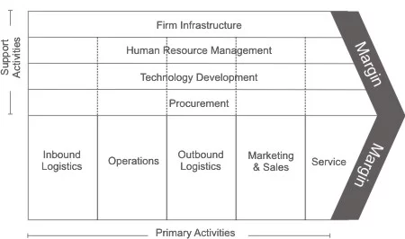
Figure 2.2.2 Value chain theory
When considering internal environment of the company, value chain theory (Figure 2.2) helps to identify areas that can maximize efficiency and profitability in the field of retail. The value chain (Johnson, 2014) explains the sorts of events within an organisation which, together, create a product or service. The retailer creates the value by obtaining the raw material and using them to produce useful things, and the value chain is a series of activities that create value for the customer. By analysing and evaluating the effectiveness and cost of product quality and service, the value chain (Harrison, 2017) helps to find and implement improvement strategies for enterprises.
The basic focal point that underlies many discussion of value chain in the retail market are strategic capabilities, relationship between retailers and manufactures and customer’s needs. There is a study that focus on the difficulties of internal R&D ability to reform retailers. Bruce and Daley (2004) use the supply chain model to learn the co- partnership between the retailers and the manufacturers in the British clothing industry, providing more important scope for the reform. Another study (Abecassis, 2006) has been made to explore the relationship between clothing manufacturers and retailers with new product design procedures that are based on the clothing value chain, based on 50 companies in France, the United States and the UK. The results show that in the apparel industry, integrated design and retail strategies can lead to more flexible design processes that improve product performance and lead to boundary changes in the apparel value chain. There is also a study focused on customers who are in the needs of the design program, Berger et al (2005) noted that the idea of integrating users into design and production procedures is a promising strategy for companies that are having to respond to the increased personalization of the requirements. It bypasses retailers and makes final customers become designers.
There are rich studies about the methodology of value chain analysis about retail markets. Maxham et al (2008) used stratified random sampling to test the value chain model of 1615 retail employees, dividing the model into five aspects: the perception of the retail staff, the performance of the retail staff, the customer evaluation, the customer expenditure and the growth of the comparable store sales. It is found that retail workers' work cognition has a major interaction effect on employees' job performance and has an impact on customer assessment of retailers. Bhattacharya (2012) analyse the driving factors, potential benefits and implementation problems of RFID in the value chain of large retailers by using a mixture methodology, namely, quantitative analysis and Delphi.
As in any other theoretical framework or model, the concept of value chain is not without restriction. The framework (Frederick et al, 1980) assumes that company operations can be clearly divided into different main and supporting activities. Considering the increasingly complex level of business operation, it may not be true in real life. Besides, the application of the tool (Grigorescu, 2015) in practice may be too time-consuming because it requires a comprehensive analysis of all business operations. What’s more, in order to conduct an analysis of value chain in an appropriate way, it is difficult to find all the necessary information (Harrison, 2017). However, As Wang and Li noted, (2009), with the growth of IT technology, the rapid development of globalization and the rapid growth of the network economy, using value chain analysis can be helpful to assess whether the company needs to make changes in the fields.
Therefore, value chain theory can be helpful to recognize the value, source and internal triggers and resistance for a change. And after exploring the complex, fast-moving internal and external environment theory, the next step of this chapter intends to identify the typology of organizational changes.

Typology of change

Nadler’s typology of organizational change
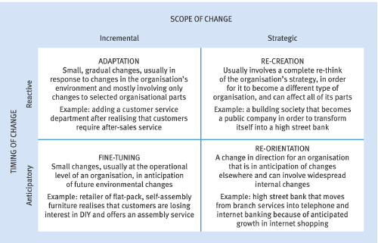
Figure 2.3.1 Typology of organisational change
Given the rapid changes in the organization's operating environment, there is no doubt about the typology of organizational changes. (Figure 2.3) is the focusing point that this research intends to explore. Hayes (2007) applied the model of organizational change, combining the changes of the two dimensions discussed so far, involving changes in incremental adjustment or transformational change and the degree to which an organization's responsiveness to change is active or unresponsive. While Burnes (2009) draw on the work of Nadler and identifies three categories of change: incremental change, the punctuated equilibrium changes and the continuous transformational change, which brings these together to create a change matrix that appears to cover most situations.
Typology of organisational change has received much concerned over the last decade. However, there are slightly differences in diverse research direction. For reducing resistance to change, Self (2009) has provided solutions for resistance and specific preparation strategies and formulated specific proposals through the model proposed by Nadler and others. This has led to a change in preparation and future research exploring areas and sources in a more in-depth field. Talking about new thinking and ways of change, Marshak (2002) believes that changing the organizational environment may be relevant in a changing world. On the basis of Nadler, he proposed a changing scenario matrix and introduced the term "deformation" to describe the continuous overall system changes in the multi dynamic business environment. From the viewpoint of Tudor (2014), Nadler model provide a strict framework for the analysis of some complex organizational problems, because it does not use some method or strict method to observe the situation of the investigation. In addition, it allows organizations to assess the impact of changes on internal interactions, respectively, on performance. What’s more, the Nadler’s model (Basu, 2013) also attaches importance to the social part (personnel and informal structure) and the technical part (responsibilities and formal structure) of the organization.
Typology change theory are emerged with the application of organisational change. Amiri (2011) established a model and assessed the reasons for variability of public organizations with methodology of depth interview and questionnaire. The research includes three basic stages, each of which tries to study the theoretical literature of change management and the resistance to change in order to determine the dimension of the reason for variability. Thomas (2007) reviews the literature on change and provides a typology that classifies the different methods of facilitator education based on the level of consciousness. He used typology of change to provide an explanatory framework to reflect, discuss and further study the theory and practice of facilitator.
The disadvantage of Nadler model (Basu, 2013) is that its application may be a long and expensive process, mainly for larger organizations. In this case, if there is no method, allowing flexible methods may prevent managers from encountering a quick solution. The application of the model may exclude the fact that the lack of "perfect agreement" (complete agreement) does not necessarily indicate a problem, mainly in small, dynamic companies, which are rapidly and permanently adjusting the market demand. Gough (2009) further notes that while the model is good at diagnostics, it does not help the organizers determine what to do next. And the model is too focused on the internal workings of the Organization to make no representations about the external environment. One of the most common reasons for organizational change failures is that they focus on only one area and ignore other areas. For example, a reorganization (formal organization) may make things worse, not better, unless it takes into consideration the effects on politics, power and culture (informal organizations).

2.3.2 The “trap of success”
Organizations may not identify the need to change and threaten the company's long-term viability. Nadler (1995) illustrates the proposition that success often leads to complexity and greater differences in growth and growth. If not stopped, the end result of this "success trap" may be what they call the "death spiral". It was pointed out (Hayes, 2007) that some firms were adept at predicting the need to change, which gave them time to consider emerging issues or opportunities and select how best to respond.
The “trap of success” has a profound impact on view of how organisations are structured and changed in terms of price, brand and efficiency. Moehlman and Osgood (2015) stated that most organizations fall into the trap of thinking about their immediate needs and based solely on these needs of price and brand. This usually leads to a set of disconnected point solutions for the independent problem. Instead, the organization should take the time to evaluate and create a roadmap to understand the potential value of the entire organization. To properly assess the investment, they have proposed a well-planned approach, including a long-term strategy that involves immediate operations and finance. Linkner (2012) argued that Circuit City, Pan Am, Borders books, Blockbuster used to be very special, but then they lost. Success has changed the mind of the enterprise. They faced overpricing, alternative retailers, unknowledgeable staff, inaccurate inventory and don’t change or innovate, ultimately, they fail to survive. The “trap of success” is that enterprises try to continue their work in the past instead of developing them (Arussy, 2018). This is the loss of hunger and the submission of progressive correction rather than bolder exception. After a period of time, when the enterprise focusing on the success, others are busy with some breakthrough experience to redefine, In the process, they out-innovate those companies which choose to stagnate, dethroning long-lasting empires in a variety of fields.
From diversity of methodology, the “trap of success” theory follow Nadler’s lead and use the term complexity theories. Killen (2013) uses the perspective of dynamic capabilities and uses organizational learning theory to study the path dependence of implementation and development of portfolio management. Identify potential "vulnerabilities", such as the emergence of a "successful trap" that prohibits exploratory innovation and prevent poverty projects from reallocating resources. Wang (2015) assesses the impact of successful traps on developing countries and corporate strategy and market dynamism. According to the survey information from 113 Britain high-tech SMEs, it is found that the success trap has a important and strong negative influence on the organizational dynamic capabilities, which in turn has a weak positive impact on the performance of the enterprise. It is because the company overemphasizes exploitative learning, and passive practical studying process, concentrating on working procedures and repeating zero level capabilities. This may stop advanced levels of deliberate studying and influence the company's current situation and development (Zahra et al., 2006).
Some commentators have seen the improvement of success trap theory. Spacey (2016) suggests that the “trap of success” lies in the organization's development structure, processes, infrastructure, technology and culture. Changing fatigue is one of the situations where low energy is used to change because of historical failures or problems. In the long run, explore to change is a more rational investment. Reeves and Harnoss (2018) stated that businesses in a successful trap are over-exploiting their present business model and cannot update or grow their future growing options. They believed that although there is no clear answer that keeps the company evergreen, as long as the requirements of cultivating adaptive, shaping capability and ambidexterity are engraved on the mind, the company is likely to remain a leader and avoid a success trap.
Therefore, understanding the nature and typology of the changes which organization want to implement and the working environment are important. It can be helpful to retail organizations to think about the future development and the evolution associated with its long-term goals. The following part will provide many changing behaviours and principles to adapt and test further movements by providing organizational flexibility.

Process of change

2.4.1 Lewin’s force field
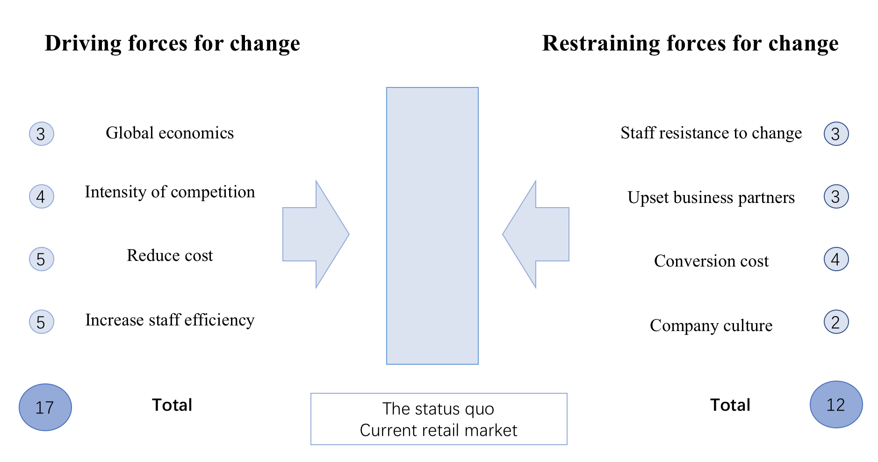
Figure 2.4.1 Lewin’s force field shows the driving and restricting forces of New Look’s closure

Managers developing strategies is to respond to changes in the business environment and benefit from changing opportunities. One of the famous models for changing the business environment to establish a structured approach to address changes in the workplace is the Lewin's force field analysis (Figure 2.4). Lewin's work (1952) has been traditionally applied to changes in social science and organization, and he developed a theoretical vision called the field of forces analysis, with driving and resistance factors of the army. Force field analysis (Johnson, 2014) could be applied to recognise aspects of the organisation that possible help to changes, the barriers to change, and what needs to be developed to help change. As shown above, the sum of each driving forces scores is greater than the sum of the resistance forces of New Look’s closure, so the status changed.
In practice, force field analysis has become useful tool in analysing the implication of employees, managers and resources on company. On the basic application, Nien-tai Tsai (2013) attempt to use force field theory to explain the psychological mechanism of employee dissent. The theoretical model suggests that employee dissent is driven by four internal driving forces: organizational risk perception, organizational recession perception, psychological contract violation and relative deprivation. Situational factors and psychological security atmosphere enhance the positive four internal driving force and the impact of employee dissent. In view of management, Capatina (2017) proposed the new theoretical structure of strategic management of intellectual investment properties of software growth firms. The structure is grounded on Lewin Field analysis to assess the perceptions of software company managers as to how motivating and restrictive forces affect the backbone of intellectual capital. By examining samples from 74 Romanian companies. The aim is to help the enterprise management to drive and restrain the power of intellectual capital prop. The framework provides a tool to help managers drive organizational change through effective intellectual capital management and inspire the operation of changes that produce value for the company. For the present exploratory case study, Toves(2016) collect data through interviews, field observations and questionnaires from thirteen participants, and stated that the force field analysis is used as the driving method to better comprehend the procedure of technology enabling change by identifying factors that affect change and to identify possible action stages to develop the process through driving and blocking forces.
The method of force field combines a wide range of tools including interviews, questionnaire and case study. Rabak (2006) investigate driving and suppressing force affecting employee accept and boycott e-learning in a large retail chain. He used survey design to collect interviews and survey data to explore factors affecting learners' interests and resistance, training and e-learning. The results provide an in-depth understanding of the attitudes and views in a large retail chain of training and identification areas to further focus on ways to promote best practices in order to increase participation. Cronshaw (2008) critically review the Kurt Lewin work that three groups of tissue field conditions to determine, rather than in the widely used field analysis tissue diagnosis technology assessment of driving force and restraining force. Assessing the ability of 31 professional professionals to diagnose the conditions proposed in the case study of commercial mergers and acquisitions. They are accurate in this diagnostic task, but they have discounted the severity of the blocking condition that hinders the success of the merger. The results suggest that decision bias may have a very harmful effect on the effectiveness of tissue diagnosis.
The disadvantage of force field analysis (Brent, 2017) is the need for all relevant personnel to participate fully in order to provide accurate information needed for effective analysis. If the organisation cannot participate fully, this may be a drawback, which leads to the fact that analysis cannot provide the reality of support and opposition. In view of this, Tistai(2014) stated that the Lewin’s model has good rationality, goals and planning guidance. But this change lack consideration of human feelings and experience and will have negative consequences. The analysis will not reach consensus within the group. In fact, force field analysis may actually lead to differences between policy makers and opponents.

2.4.2 Three step process
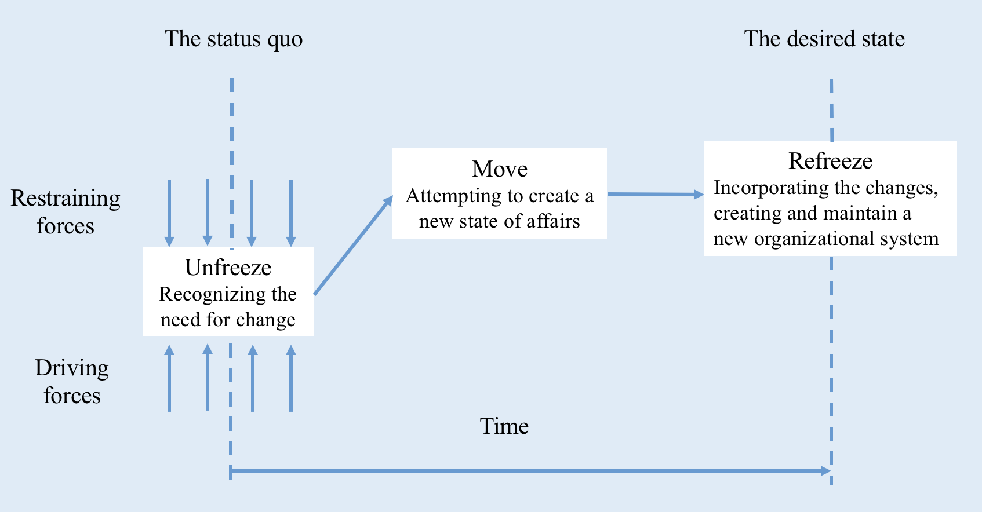
Figure 2.4.2 Lewin’s three step process
It is the important value of Lewin model to identify the common model and structure in the process of change, and to relate the ability of change and action to structural performance. Lewin's three-step model (1952) uses the organism metaphor of an organization, including any organization that has a natural trend to change itself back to its initial stable state. Lewin stated that the new balance must be intentional and then firmly established so that the changes will persist. Cameron (2015) believes that Lewin's opinions offer a helpful instrument for those who consider organizational alteration. Most importantly, the invention of the term "freeze" will cease completely at the end.Frozen is the natural state of the organization until the agent intervenes and keeps on grinding.
There emerged various research to construct the model of three step in organizational research background. Scherpereel (2006) uses the three-step change model of Lewin to introduce new dialogues and start the organizational change process by using business simulation. A detailed introduction of the Internet business simulation developed some design considerations, design guide for development professional business management strategy and future development of the management. Ford (2006) intend to prove the practicability of the method in the study of transformation process, profile analysis is used in cross-sectional study. The theories linked to the three-step change model of Lewin were tried applying dates gained from directors involved in change operation. The results confirm the progress in the implementation of the thawing motion through the Lewin - the re freezing sequence. An overview of factors that reflect the use of change processes in higher systems is also found to be relevant to the success of implementation. Manchester et al (2014) discover the relationship between practice and system through Kurt Lewin's Three-Step Change Model unfreezing, movement and refreezing. By reassembling this model of action research into the organizational processes, the Lewin model should be used to develop and mature ebp demonstrations or other labour development work that may be valuable, and the behaviour of new staff can lead to changes in workflow and systems.
There are many research methods to apply three-step process to organisational change including quantitative and qualitative. Riddell (2017) chose to use comprehensive methods to collect 26 narrative studies and articles, and systematic evaluate in various forms. He believes that external and internal factors have been forcing organizations to change. In order for organizations to survive and change successfully, rapid response, willingness to change and taking actions in the implementation of change is the essential key to success. Kritsonis (2005) summarizes several changes in theory and assumptions about the nature of change. He shows how successful change can encourage and promote long-term success. And he compares the characteristics among the Lewin three-step change, Lippitt change theory (1958), Prochaska and DiClemente change theory (1985) and reasoning about action and planned behaviour theory. Thus, leading industry experts will need to constantly review and provide new information relative to the changing process and our evolving culture and society.
However, Lewin has been criticized by scholars for over-simplifying the change process and unable to represent the reality of change (Cummings, 2016). Besides, Child (2005) points out that the Lewin rigid "re-freezing" ideas are not appropriate in today's complex world of flexibility and adaptation. Although the basic significance of this model is still beyond doubt, Clegg et al (2005) stated that Kurt Lewin's "three step changes” is still considered by many to be a typical or basic method of management change. Considerations have also been drawn to strategies of change which attempts to model the same phenomena in the further below.

Strategy of change
Whether an organization will change is usually decided by its strategic vertex. Kotter's eight step model is very helpful for the current strategy of organizational change. According to the definition of Kotter (1996), change needs to be created. The new system then institutionalized the new method. Changes indicate a significant interruption that already exists like established rules, norms, culture, manufacturing processes and regulations and of the organization. In other normal systems, it can cause familiar social behaviour, destruction and substitution of structures. and relationships (Carr et al, 2006). All these destructive or even gradual changes, most of the time, put employees in a new unknown situation facing new problems, challenges and ambiguities (Harvey and Brown, 2001). It changes the employee's working procedures and job skills, due to an unknown, but perceived threat.
The eight-step model further illustrates the change process pattern by emphasizing the inherent problems of organizational change (Gammelgaard, 2015). The first step of the eight-step model is building a sense of necessity. The second step is forming a powerful alliance, step three to create a vision, step four is vision, step five is authorizing others to act on vision, step six is plan and create short-term wins, step seven is integration improvement and generate more. The last step eight is to institutionalize the new method. Meredith (2013) uses Kurt's eight step model to carry out the thought research of transformational strategy. Kurt's change management model provides a pragmatic structure for organizational change by behaviour. Practical significance includes the best practices to promote the assessment of company, including the necessary resources and possible solutions. Smith (2011) stated that Kurt's change management model is somewhat different because it includes steps to plan and ensure small winners. It can be thought as an iterative method, although its intent seems to be to think of the change itself as a large task with a clear endpoint, but it is decomposed into a smaller task. This is not entirely accurate, but the idea of small victory is clearly stated.
Seijts & Gandz (2018) presents an overall eight-step process for building a comprehensive index and develops a meta-level evaluation framework to systematically assess the existing resilience assessment framework in the context of integrated indicator building applications. This meta-hierarchical framework is based on the proposed eight-step integrated indicator builder and is qualified by introducing 19 dimensions and 36 quality assessment indicators. Based on four standard collection measures: community-based, multidimensional, quantified and operable for further integrated indicator analysis. On the basis of the recognition of Kurt's model, Sidorko (2008) emphasize a cyclical process of change, which they call "the control loop of strategic change". They believe that any strategy cannot be maintained for a long time. Therefore, the strategy of changing the process must never be completed when its implementation is completed. They attach great importance to reconsidering and redefining the vision of what is their stage five and what is equivalent to step seven. However, their focus is much more obvious than that of the court, because they require that the process be completely repeated from the very beginning.
The drawbacks of the Kotter model are shown as follows: it is essentially a top-down model. Kotter (Gough, 2009) has extensive experience in collaborating with large change projects, most of which are working with very large companies. and it's a little mechanical. Organizations are not just machines; they are also people's communities. While the Kotter model is very powerful at initiating change, step seventh consolidating results and generating more change does not give a lot of specific guidance on how to sustain change.
Hence considerations have been taken into stakeholder’s map theory below which could be complements for the general drawbacks of Kotter’s model and prioritise stakeholders needs.

Stakeholder map
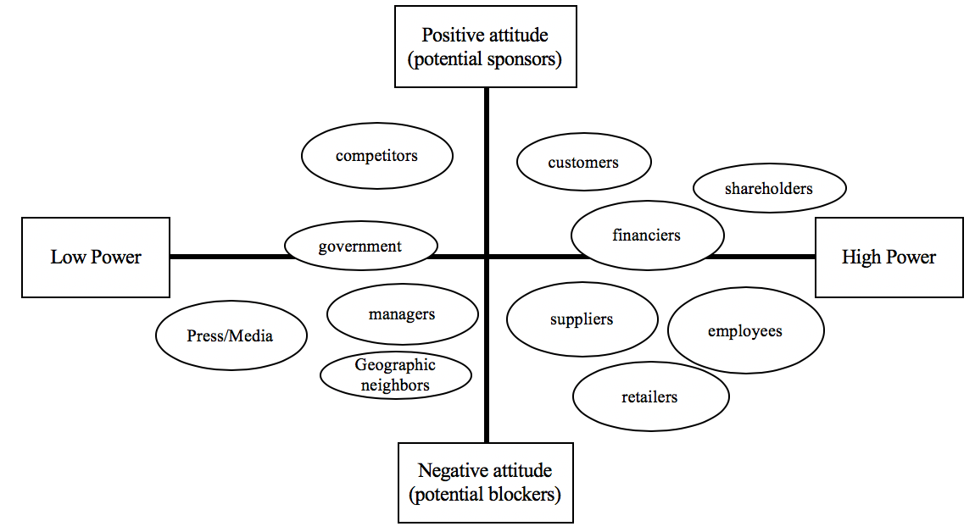
Figure 2.6.1 Stakeholder map of New Look closure
Stakeholder map theory (Figure 2.6) is helpful to identify perspectives and interests of relevant groups, organizations, and people and rank stakeholder relevance and identify issues. As shown on Figure 2.6, there are four different types of powers and attitude towards New Look’s closure. The most important forces are shareholders, customers and financiers in the upper right corner.Retail companies connects global commodity markets and local communities (Hayes, 2007). Although their stores are only in the local community, their business can be extended to the world (RILA, 2013). retailers and a wide range of stakeholders have built bridges from shareholders, employees and customers, and extended to government, non-profit organizations, academic institutions and local community organizations.
Previous studies have addressed retail industry and stakeholder relationships or the meeting of social issues in different countries. In terms of stakeholder attitudes, Janssen et al (2014) has invited three sets of stakeholders (real estate inventers, retail associations and local administrations) to participate in the network founded joint selection experiment to study the preference of Holland stakeholders and their adaptation to the surrounding retail plans, revealing the impact structure of individual stakeholder decisions. She assumes that each stakeholder's opinion to the surrounding retail is impacted by the inclination structure of other stakeholders, which may reproduce their specialized background. It also focuses on the adaptive behavior of decision-makers in adjusting their preferences for other stakeholders' preferences. When it comes to influence factor, Mlenga et al (2015) has studied the obstacles and contributing factors to the startup, survival and growth of SMME in the retail industry of South Africa. The qualitative study of semi-structured interviews is applied to store statistics from stakeholders and business owners. The findings show that stakeholders and entrepreneurs believe that lack of support, competition, shortage of skills and poor internal control are the main obstacles to SMME startup, survival and development. Stakeholders believe that the business environment is the key driving factor, while business owners regard demand growth as a key driving factor. When mentioned to stakeholder priorities, De Mascena (2018) analyses industry factors of the Brazil company and compares the interests of the internal stakeholders with those of the external stakeholders. It confirms that internal stakeholders have higher level assumptions. In addition, external stakeholders can have a great impact on the organization. He believes that for business administration, the priority criteria for studying stakeholder treatment are related and potential future research.

2.7 Conclusion
This chapter review the relevant literature with a specific focus on change management, including triggers and resistance to change, nature, typology, process and strategy of change and stakeholder map, from the perspective of Nadler and Lewin. Findings related to this show that five forces theory and value chain theory is necessarily to understand the organization's external and internal environment to find triggers and resistance of change. In addition, he typology of change can be helpful to retail organizations to think about the future development and the evolution associated with its long-term goals. Therefore, it is clear that additional study is vital surrounding the change management of retail market in order to face in the current challenging retail conditions. The next chapter will consider the methodology adopted by the study and how and why to use these methods.

Methodology
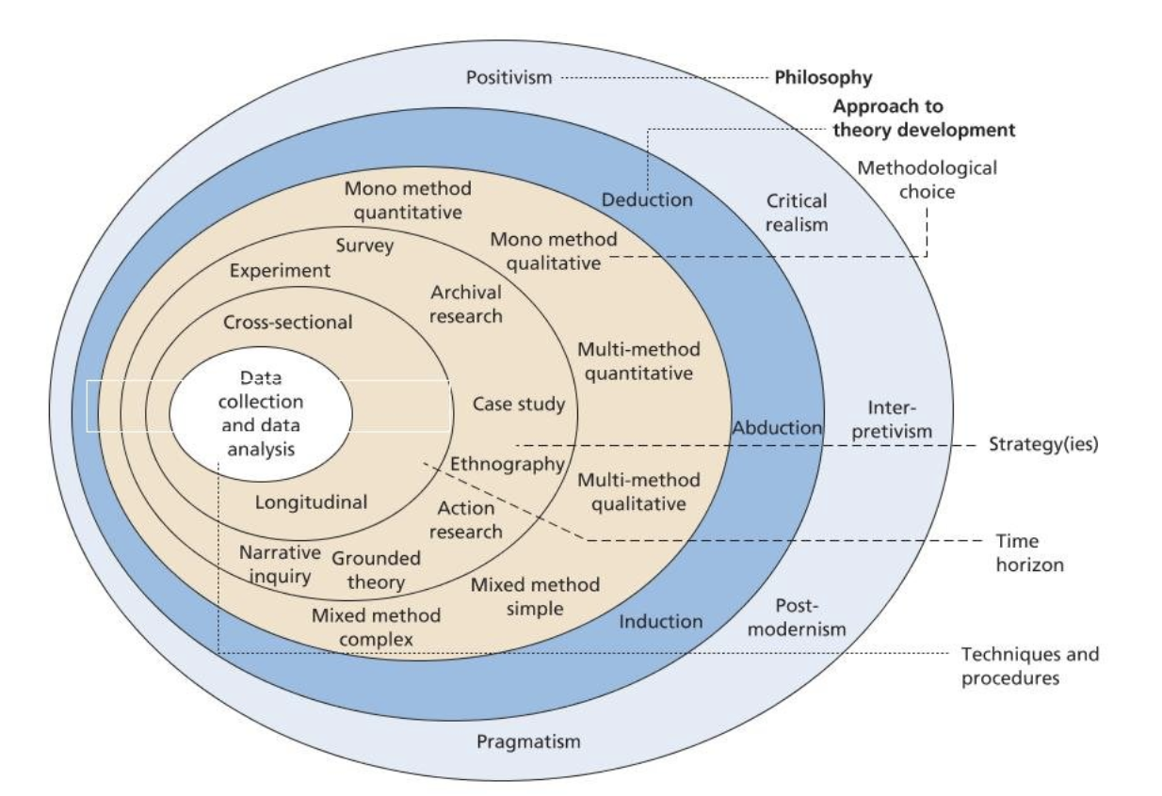
Figure 3.0.1Research onion
This chapter summarizes the research philosophy, approach, strategy and so on that are most suitable for this dissertation and discusses why and how to select and use them. When mentioned to research method, Saunders et al (2009) adapted research onion model (see Figure 3.1) for analysis of the research approaches and procedure, which allowing the most appropriate methods to be considered and how they should be applied. It can be described in six aspects: philosophies, approaches, strategies, choices, time horizons, techniques and procedures.

3.1 research philosophy
The research philosophy of this study adopted positivism. Research philosophy is a certainty in the method in which information would be collected, examined and applied in a phenomenon (Saunders et al, 2009). There are many research philosophies in western scientific, such as positivism and critical realism, pragmatism and so on. Positivist researchers tend to trust in that the reality is steady and can be viewed and described from an objective perspective. They will search for random relationships in the statistics to produce laws -like those formed by scientists. (Gill and Johnson, 2010). The paper uses the existing theory and collected objective measurable data to confirm the investigation, and in order to better observe and understand the phenomenon of the retail market. This dissertation is grounded on a series of experiential things or knowledge materials to discover its elementary regulation or common law and predict similar things in the retail market.
There are many empirical studies focused on retail market. Evans et al (2008) believes that a large number of studies have made substantial contributions to the study of retail internationalization in a quantitative sense, but many empirical methods of research have failed to produce consistent findings. In addition, previous research (Theodosiou and Leonidou, 2003) did not differentiate between the company's present strategies and the preferred approaches. Predictably, as companies gain more retail experience, their strategic preferences can change. But because of infrastructure, production and other resources constraints, the actual strategic changes may have a lag effect. Akehurst and Alexander (2013) further stated that the shortage of understanding of the effectiveness of the retail change model does not lead to testing of these models, such as abandoning studies that favor micro-research rather than macro-development. This subject has been sheltered from the microscopic level in the empirical study.
Therefore, this study uses the positivism method. The philosophy and the paradigm which will help the retail and the change management research find the uniqueness and the value, which represents a different and unique organization view.

3.2 research approach
The research approach of this dissertation follows the inductive methodology. Inductive method (Saunders et al, 2009) runs on the basis of observation, thus drawing a general pattern of patterns generated by the empirical evidence provided, including the theory of the development of data collection and analysis as a result of the analysis. Inductive methodology (Pla-Barber,2017) can be applied through the study of a unique case that, because of its importance and significance, which is considered critical and valid to illustrate good practices and draw conclusions from it.
To date, inductive research has been well investigated in the theoretical literature in retail market. In order to determine the speed of translation and dissemination of fashion in the retail market, Barnes (2010) uses explanatory and inductive methods to make use of participatory observation and main insider interview, and the classification methods obtained from the academic outline defined in the literature and the analysis of the statistic itself. It is found that the efficiency of supply chain promotes the success of fast fashion, but these competences and flexibility have not yet been transformed into retail market. A study by Watson et al (2015) applied inductive methodology involving interviews with price managers in the UK about 85 percent of food retailers and 64 percent of the US food retailers. He aims to induce the development of conventional price decision models in grocery retailing. In view of the lack of research on regular pricing by food retailers, this method is proved to be appropriate. The findings reveal the certainties of price decision in 2 well developed retail companies and provide management insights.
Woo et al (2017) further points out that a healthy science requires a good balance between the three forms of reasoning: exploratory induction to find new knowledge, explanatory abduction to put forward feasible interpretations and theories, and confirmatory deduction to check the validity of these theories. Too many inferences can lead to a close relative and stagnant science, which limits itself to what is known. Too much induction leads to a useless science, which is related to a series of irrelevant facts.
As a result of comparatively new research and the nature of retail fashion, the study attempt to apply inductive methods, in which shop questionnaires and basic informant interviews provide the foundation for statistic gathering in two companies the New Look and Primark and then sums up the challenges facing the current retail market.

3.3 research strategy
The research strategy in this thesis will be based on case study analysis. This is because (Yin, 2009) when people conduct case studies, people have a deeper understanding of why they see certain results and can also reveal new ideas. Hartley (2004) points out that case studies include data surveys collected over a period of time, usually in the context of their background, with the aim of providing an analysis of the background and clarifying the process of studying the theoretical problems that are being studied. In this regard, it is important to note (Kohlbacher, 2006) that case studies play an important role in generating hypotheses and establishing theories.
There are many research studies for organizational change management and retail market in a case study. Emriksson & Poposka's (2015) research is a case study of a large Swedish retail bank and its journey of change management. A qualitative interview was conducted with five middle-level managers and two employees, and a model was established. By exploring a case study of an organization of Halfords in the British retail industry, Cullen (2013) explores the application of accounting management in organizational change and the role of accounting in the pursuit of strategic and commercial advantages. The data were collected through Halfords's participation in structured seminars and industry forums. In terms of analysing failure of organization, Campbell (2014) takes the failure of the Circuit City in 2008 as a case, from a historical perspective to analyse the circuit city management model and tries to understand the relationship between staff and management, especially in relation to Gilbert's behavioural engineering model. It is found that staff morale and performance are shaken as management changes, which in turn affect customer perceptions and attitudes. Together, these actions lead to a negative feedback loop, which greatly contributes to the demise of the company.
The advantage of the case study approach (Knezevic, 2016) is to understand complex problems or objects through a comprehensive context study of a restricted figure of events or circumstances and their relationships. Critics of the method argue that when creating a general result, a few cases are a problem, and some people think it is just an exploration tool. On the other hand, one of the fundamental advantages of the case study approach is the use of multiple sources and technologies in the data collection process.
Because the case study method applies to the real life. So this case study will be taken from two companies Primark and New Look. The case study paper can also be designed as a comparative survey to show the difference and maintain their competitive advantage.

3.4 research choices
The research choices tend to carry out mix methods. The methodology of mixed studies has been greatly developed recently. It focuses on understanding multiple aspects of a phenomenon. Researchers pragmatically combined quantitative and qualitative studies for a complex research problem (Bryman, 2006). The choice of qualitative methods involves subjective evaluation of attitudes, viewpoints and behaviours (Scotland, 2012). Quantitative analysis can be conducted in an impartial and in-depth way based on evidences rather than opinions or attitudes. Using these instruments, as well as using existing theory, can lead to collect objective measurable data to confirm the investigation.
Many literatures have sought to explain the activity involved in the retail market and business management, and for some authors, mix method proved to be suitable models to understand retail market. In order to identify mixed methods of qualitative and quantitative research issued in main marketing periodicals. Hanson carried out content analysis on 1195 articles published in 1993 and 2002 in three noticeable marketing periodicals. It was said that 24.80% of the articles used qualitative approaches and 46.28% quantitative studies. Qualitative methods can offer more insight or more in-depth thought of the fact in the survey. However, the number of qualitative studies published during this period has not increased year by year. He used the historical, social and practical argumentation to illustrate the sustainable advantages of quantitative research. BĂLĂŞESCU (2014) discusses the theoretical problems of marketing research methods and tools suitable for retail fashion industry. The theory of qualitative and quantitative study approaches is held by related examples to better understand the market investigation process and its efficiency to retail events. Ibrahim & Chua (2010) takes Singapore as a research field and uses qualitative and quantitative method to carry out sequence design. It aims to investigate shoppers' views on online stores and to conduct qualitative research by means of in-depth interviews. In the design and implementation of quantitative research, qualitative research and literature review are combined. This is a form of triangulation in an attempt to improve the internal validity of research results.
As there are weaknesses in both quantitative and qualitative research. (Gummesson, 2007). Quantitative research is weak in understanding the context or setting of data collection. Qualitative research may include bias, not suitable for statistical analysis and generalization. The mix strategy can counteract these shortcomings and give full play to their advantages through exploration and analysis in the same research.
Therefore, this dissertation combines not only qualitative but also quantitative data sources with different analyses to strengthen sampling procedures, collect data, and analyse data in analysing retail companies of New Look and Primark.

3.5 Time horizons
As for time horizons, the research uses cross sectional analysis. Cross sectional studies usually apply with investigative strategies. They may try to define the occurrence of a situation or explain how aspects in different companies are related. However, they can also use qualitative or mixed methods to study strategies (Saunders, 2009). For example, many case studies are grounded on interviews managed throughout a short period of time. The cross-sectional statistics analysis (Lavrakas, 2008) ordinarily involves comparison with the difference between the different issues and the time series data, and the observation of the similar slight scale or the aggregated entity at different time points.
In fact, there are few literatures focused on retail market with cross sectional method. In order to investigate the impact of retail brand loyalty, Murray (2017) took the cross-sectional analysis of two stores in a leading European fast fashion retailer in 10 countries with more than 300 stores. Retailers now use new prototype designs in some seven shops. This cross-sectional group comparison method is effective in identifying perceptual differences in a cross related environment. Iwu (2017) assessed the influence of retail store brand on the shopping mall under the use of non-probabilistic sampling and cross-sectional investigation. But he further pointed out that consumer behaviour is dynamic, and it is subdivided from one customer to another. Future studies should consider longitudinal studies, not cross-sectional surveys. Miller (1999) discusses the cross-sectional connection between the rivalry and retail organisation of changed categories of retailers. Surveys demonstrate that there is a positive link between the number of large stores and small stores. This implies a jointly beneficial relationship between different categories of retailers, rather than the crushing competitive advantage of large stores. Although there is reason to believe that retailers analysis needs to reach a long-term survey, short-term results may occur in any cross-sectional research.
Although cross-sectional does not allow the analysis of change over time and in some cases can lead to misleading inferences (Rafferty et al, 2015), Cross section studies are usually fast, simple and cheap (Philip, 2014). They are usually based on questionnaires. As participants only interviewed once, there would be no loss of follow-up action.
So, a cross-sectional study will be used to assess the risks and challenges faced by Primark and New Look, with all measurements of sample members to be carried out at a single time in August 2018.

3.7 sampling
The sampling way selected in this study is non-probabilistic. Non-probabilistic sampling provides a series of substitute tool for adopting samples, majority of which include elements of judgement call. During the exploratory phase of some research projects, for example pilot surveys and non-probabilistic samples may be the most practical one. (Saunders, 2009).
There are many researches focused on non-probability sampling of retail market. To investigate whether cross-sectional demographics of retailers affect their business transactions with telecom service providers. Sahoo (2014) uses non-probabilistic sampling method through 400 retailers' sample size. Data were analysed by SPSS 20 multivariate regression analysis and variance analysis. In South Africa, Soobramoney (2016) explores the relationship between company societal obligation and organizational pledge in the retail organization. The company societal obligation scale and the organizational commitment scale were designed to investigate the non-probability samples of 171 employees from 268 employees from the retail companies.
As a result, the researchers collected data from customers of Primark and New Look, who were over 18 years old. The research object is selected on the basis of non-probabilistic convenient sampling. 50 responses were collected in Swansea for this study. The researcher will investigate the individual's preference for commodities, their ideas, and their impact on the two companies when they choose to buy the product.
The target sample for the interview is Primark, Newlook manager and retail market consultant. This sample was selected to investigate their views on the company's status, changes and future development to determine the change strategy management of the retail industry, who were informed about key ideas, concepts, policies, and practical goals of key topics included in the study

3.8 questionnaire and interview design
There are two methods of collecting statistics in this study: Interview and questionnaire survey. Questionnaires are often used for quantitative studies that provide a larger sample model and provide richer data. The sample is made up of more than 18-year-old male and female adults who live near Swansea City and have recently shopped in Primark or new features. On the other hand, Interviews can provide an in-depth subjective view of personal views and attitudes.
When designing questionnaires, the researchers will include a mix of open and closed questions, hoping to collect qualitative and quantitative data. The questionnaires assess the shopping frequency, buying preference, the online retail and other questions (including an open question), with SPSS 20 statistical analysis after the data collects. The number of questionnaires was 50, and the quantitative information of the subjects could be collected as an effective way for the short time organization information analysis. In addition, the questionnaire needs to provide reliable and effective data to prove that it is challenging, so it will proceed with Cronbach ' Alpha and KMO Bartlett ' s test. Because the subject is both perceptual and subjective and is influenced by many external factors. At the end of the survey, the researchers will apply the subjective information to make an objective and rational analysis of the retail market challenges between Primark and the New Look.
Respondents were selected to managers and experts who work in the retail industry with a wealth of expertise and background. Two managers from the New Look and Primark and an expert from retail research centres, for their knowledge and expertise related to this research in retail market field thus to achieve a strong and informative paper. The interview takes a semi-structured format because it is flexible to obtain qualitative data from the interviewees ' thoughts, feelings and experiences, and to discuss their views and ideas based on their expertise in the retail field. Using qualitative methods to study topics can also reduce the likelihood of respondents skipping a problem and provide a complete and rich answer of this paper.

3.9 piloting the question
Piloting questionnaires plays an essential role before it is used to collect data. Pre-test and pilot can help researchers identify problems that are meaningless to participants, or questions that may lead to biased answers in a questionnaire. After completing the questionnaire design，the researcher test all questionnaires and interviews with 5 individuals. After all the testers have completed the investigation, taking notes of where they hesitate or make a mistake, such as the problem and the layout is not clear enough, need to be improved, etc., and then change the problem or structure.

3.10 reliability and validity
When constructing and evaluating measurement, social scientists pay close attention to two technical indicators: reliability and validity (Babble, 2009).
Reliability is the consistency of the similar outcomes when using the similar indicator or measurement tool to repeatedly assess the same object in the study (Yin, 2009). At present, the most usually used analytical method is the Cronbach’s alpha test. Generally speaking, the consistency coefficient should be controlled between 0 and 1. When the consistency coefficient of the scale is greater than 0.9, the stability of the scale is better. When the reliability coefficient of the scale is between 0.8 and 0.9, the data is acceptable. When the reliability coefficient of the scale is between 0.7 and 0.8, some scale items need to be modified.

Reliability Statistics
Cronbach's Alpha | Cronbach's Alpha Based on Standardized Items | N of Items
.750 | .731 | 8
Figure 3.2 Cronbach’s Alpha Test

The score of 0.75 in Cronbach's Alpha test showing that the section of customers’ buying preference (Price, Convenience, Brand, Quality, up to date, Special offer, Products range and Services) is reliable and indicates a great level of internal consistency for scale with this specific sample.
Validity is a tool of whether the widespread assessment procedure could precisely reflect the assessment of objectives and requirements (Saunders, 2009). It implies that the measuring instrument could evaluate the validity of the characteristic that it wants to evaluate. General measurement select KMO and Bartlett ' s test. When the KMO analyzing data is more than 0.7, the structure result of the questionnaire is well.

3.11 research ethics
Research need to follow moral norms, such as voluntary participation, no harm to participants, anonymous principles and confidentiality principles (Babble, 2009). And researchers must learn how to express, evaluate and assess various research guidelines, and how to take decisions and moral behaviors in variety of circumstances (Resnik, 2015).
In the process of designing questionnaire and interview process, the researcher and the tutor will make paper proofreading, spelling check and the rewrite repeatedly to avoid the language confusion and the misunderstanding, this can make the questionnaire and the interview to be more practical and suitable. In terms of the content of questionnaire, the risk is low because the questionnaire is anonymous, no personally identifiable information, and the design content does not include the privacy of the respondents. And this paper closely follows Ethics forms of the University of Wales Trinity Saint David. In the conduct of the investigation research will solicit consent to collect views and points of participants. In the process of data storage, all documents will be safely stored on a computer with password protected to ensure that privacy is maintained. In the course of this research project, both researchers and participants have no personal risk.

Data Analysis
This chapter discusses data analysis and research results. The questionnaires applied in this primary research were carefully examined to guarantee that the statistics collected were clearly offered with tables and percentages (see Appendix1-4) to obtain the necessary data and to complete the research objectives. The purpose of the questionnaire was to determine the consumer's preference for Primark and New look in order to gain operational status and performance of two companies in the face of the economic challenges. The aim of interview analysis is to evaluate the performance of two companies according to expert opinions in change management and their future strategies in a more professional way for continuous improvement.

Survey
The survey was divided into eight questions: gender, age, frequency, expenditure, shopping ways, buying preferences, choice of two companies and one open questions. In order to determine the factors when consumers shopping in the Primark and New Look, there are 50 respondents were surveyed and analysed with Chi Square test and Independent Simple test. During the observation, the author found that female was naturally more interested in shopping than male which result in uneven sample sizes, so that the sample selection was random and did not deliberately balance the male and female samples.
Theme one to three is the analyzing results applied with the Chi square test, mainly to compare the correlation analysis of two categorical variables. When the Pearson Chi Square value in the upper-right corner is less than 0.05, this indicates that variable A has an effect on variable B, that is, they are dependent. When P value is greater than 0.05, it can be understood that the variable is independent (not associated).
Multiple of variables were analyzed in this paper, and the author only select data with less than 0.05 results for analysis, and there are following four groups of results: 1 Gender and up to date, 2 Brand and How often go shopping in Primark, 3 Price and Up to date may influence expenditure in New Look, 4 Factors influence customers to choose New Look or Primark.

4.1.1 Theme one: Gender and Up to date
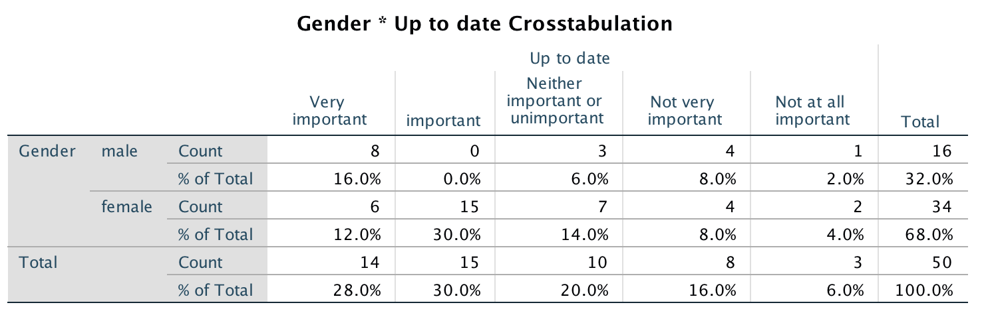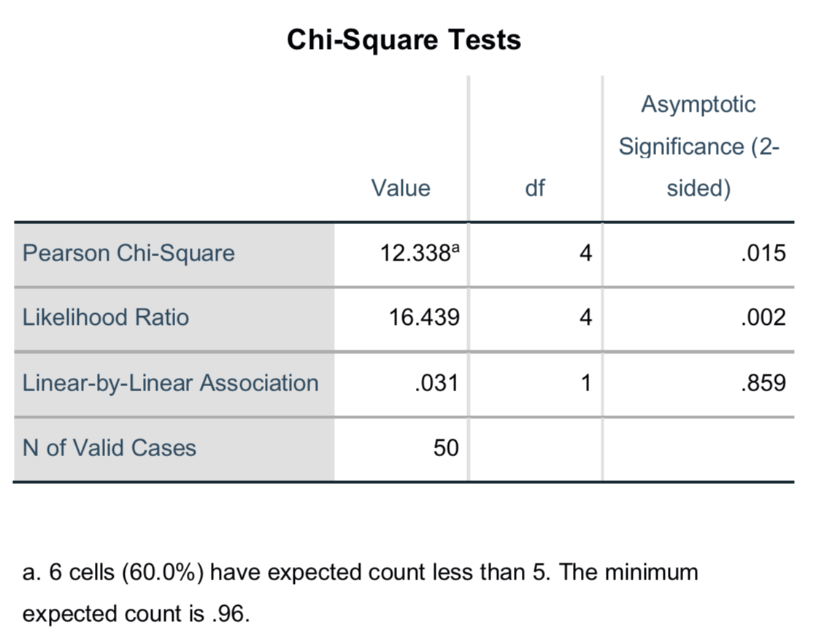
Figure 4.1: Chi square test shows a significant effect of gender on valuing up to date as important when buying clothes.
From the customer questionnaires, gender and up to date are considered relevant (questions 1 and 6 in appendix 1). When comparing age to other variables, only the up to date variable is less than 0.05. So, the Chi Square test results (Figure 4.1) show that gender has a significant impact on customers who value up to date as important when they shop for clothes. 30% female think up to date as important whereas there is no male think as important. This demonstrates that female is significantly more likely to place emphasis on up to date than male. There is a finding (Aswegen, 2015) supports the existing literature on the impact of gender on up to date that women are mainly pleasure oriented shoppers. They are more likely to find up to date, online sales and discounts than men. However, men’s shopping process is effective, faster, and more likely to accept mobile device shopping. Koca & Koc (2016) also studied the buying behaviour of men and women in fashion and brand awareness with 382 random consumers, identifying differences between consumers from a gender perspective. The finding suggested that women are more influenced by fashion and men are more influenced by brands. Thus, male shopping and female shopping are different, and affect their shopping preferences, women will be more inclined to diversified and latest products, while men prefer quickly to complete the purchase.

4.1.2 Theme two: Brand and How often go shopping in Primark
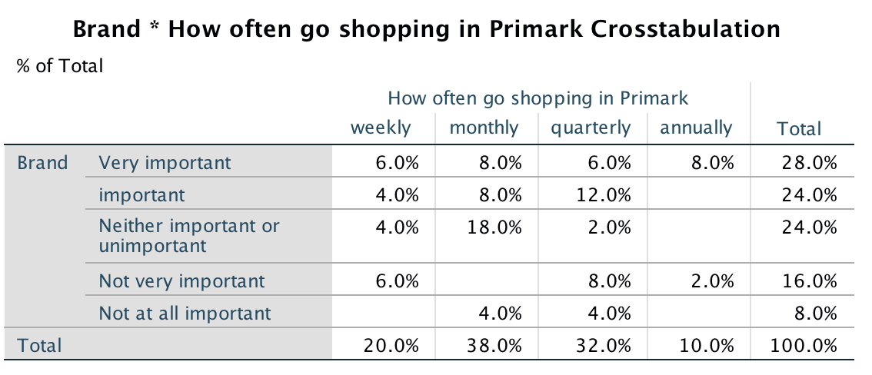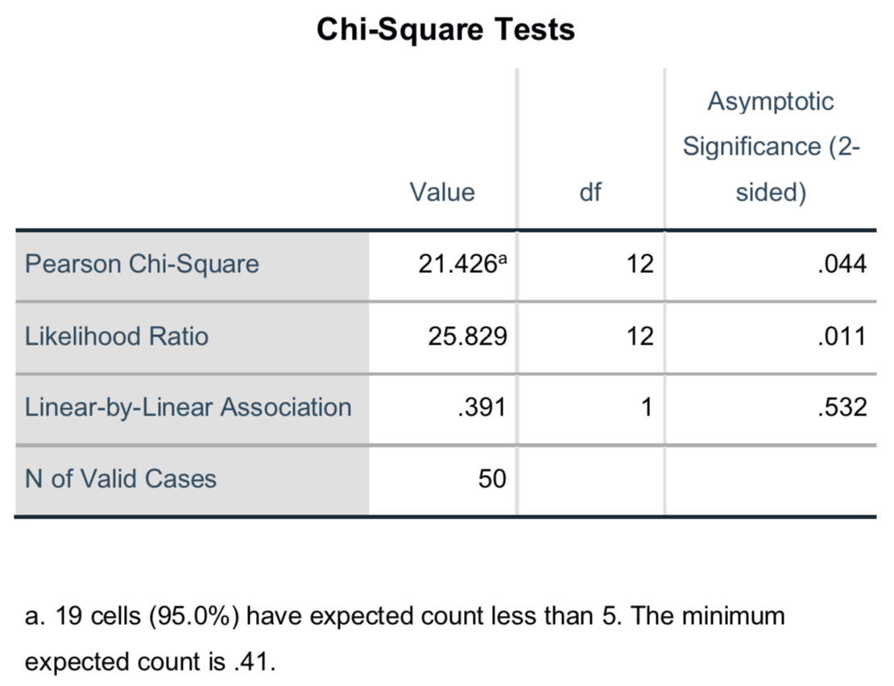
Figure 4.1: Chi square test shows a significant effect of brand on frequencies of shopping in Primark when buying clothes.

As shown in Figure 4.2, (see question 3 and 6）the P value is less than 0.05 which highlights the extent to which the brand has a significant impact on the frequency of consumer's shopping in Primark. 18% of customers who treat brand as neither important or unimportant will go shopping in New Look monthly. This indicates that the brand is less likely to affect the consumer's shopping times in Primark. Marchant (2015) point out that brand awareness of Primark is lower in Europe, so expanding the US market and raising American brand awareness will be a challenge. In addition, Charlton (2013) stated that Primark's offline-specific strategy is a great decision for a low-margin retailer. Primark produces cheap, "throw away" fashion, shopping in the store will provide customers impulse to buy many goods. While Gilliland (2017) mentioned that New Look intend to differentiate brands from others such as Boohoo and Misguided but has not succeeded because it is not as cold or avant-garde as Zara, or as mass-market as H&M, so New Look's brand strategy is not prominent. Thus, consumers who do not value brand too much may prefer to shop in Primark frequently, while brand awareness has no effect on New Look.

4.1.3 Theme three: Price and Up to date and may influence expenditure in New Look
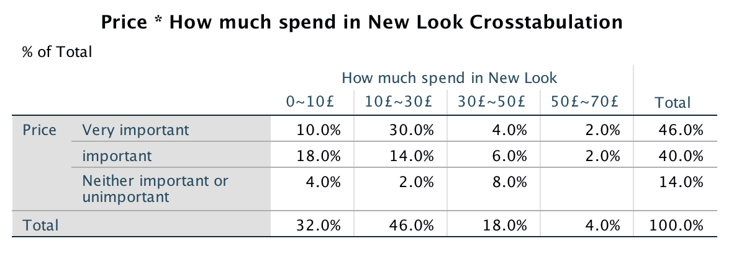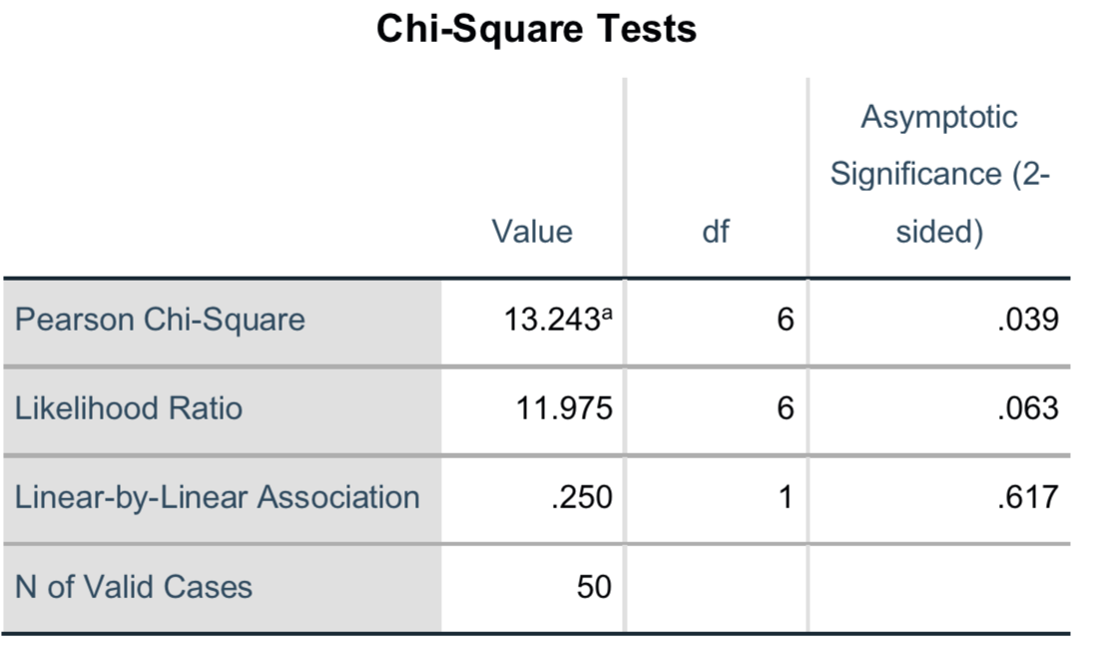
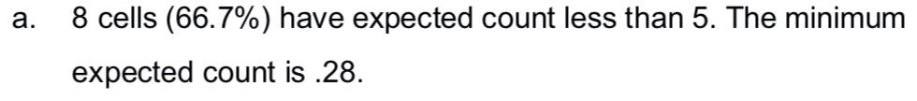
Figure 4.1: Chi square test shows a significant effect of price on expenditure of shopping in New Look when buying clothes.
The findings presented in Figure 4.3 (question 4 and 6) demonstrate price may have a great significant impact on expenditure in New Look. 30% of customers who think price as important will expend 10£~ 30£ in New Look. Whereas it is not as expected that customers would spend more in Primark which has more cheaper goods than New Look. So, it's easy to understand (Morrison, 2018) that when New Look finds sales down, retailers sell "value-driven fast fashion" at a price of £ 20 or less to stay afloat amid the worsening high street crises. But for Primark, the marketing strategy is already very low-priced, so more low-cost strategies (such as promotions and discounts) do not lead to a rise in sales. In addition, New Look (Hoggan, 2018) adapt new strategies charging more for clothes that use more fabrics, which means larger sizes will be more expensive than smaller sizes. According to Geoghegan (2017), New look will be "more aggressive" in all categories of prices. There will be more products at a higher entry price, and the pricing structure will also be stretched upward. That is to say, the two companies are in different positioning, so in order to face the financial crisis, they should choose the appropriate strategy to increase turnover.
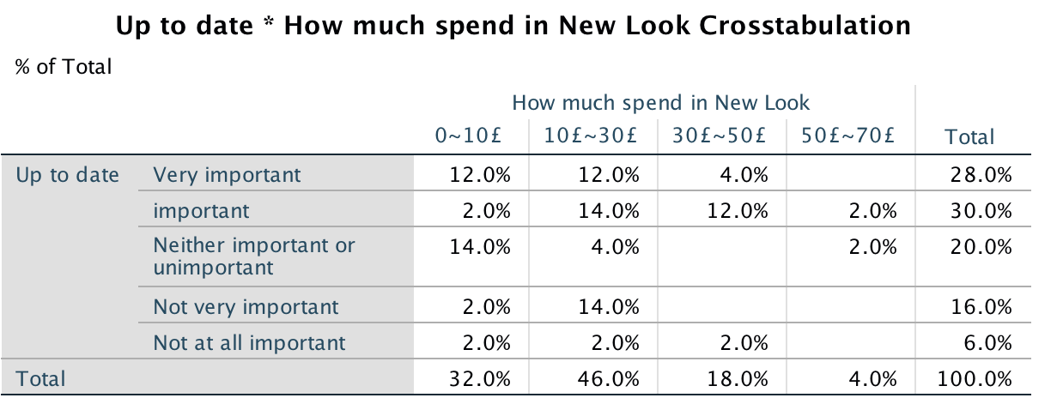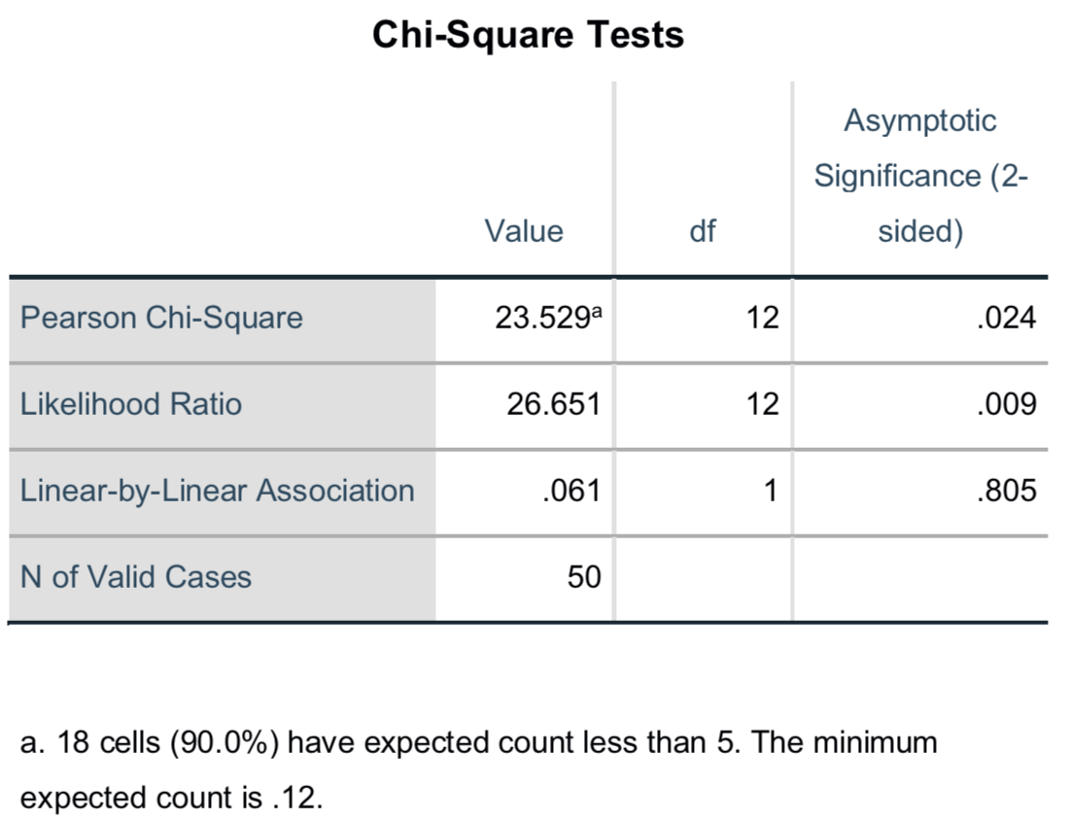
Figure 4.1: Chi square test shows a significant effect of up to date on expenditure of shopping in New Look when buying clothes.
Results from the research (question 4 and 6) demonstrated that there is a highly significant effect of up to date on expenditure in New Look. As shown above, 14% of customers who treat up to date as important would expend 10£~30£ when shopping in New Look. When New Look tries to launch a fast-updating fashion product that meets consumer demand for a new product for a week, it may make the company profitable and in a favorable position. However, Siegle (2018) stated that this is not the fast fashion, but a pathological concept of consumption. Behind this business model is a huge risk, such as dangerous working conditions, long work hours and low wages for clothing worker and moral scandals. Just as the news (Muller, 2014), two Primark shoppers in Swansea found their brand-new clothes tagged; one read "forced to work for hours" and the other "degrading sweat shop conditions." And the most fatal garment industry accident in history, the collapse of Rana Plaza has killed 1129 workers (Josephson, 2018) and so on. So, fashion retailers should pay attention not only to profit, but also to geographically more diversified supply chain, social responsibility and morality which will make companies go further in the future.

4.1.4 Theme four: Factors influence customers to choose New Look or Primark
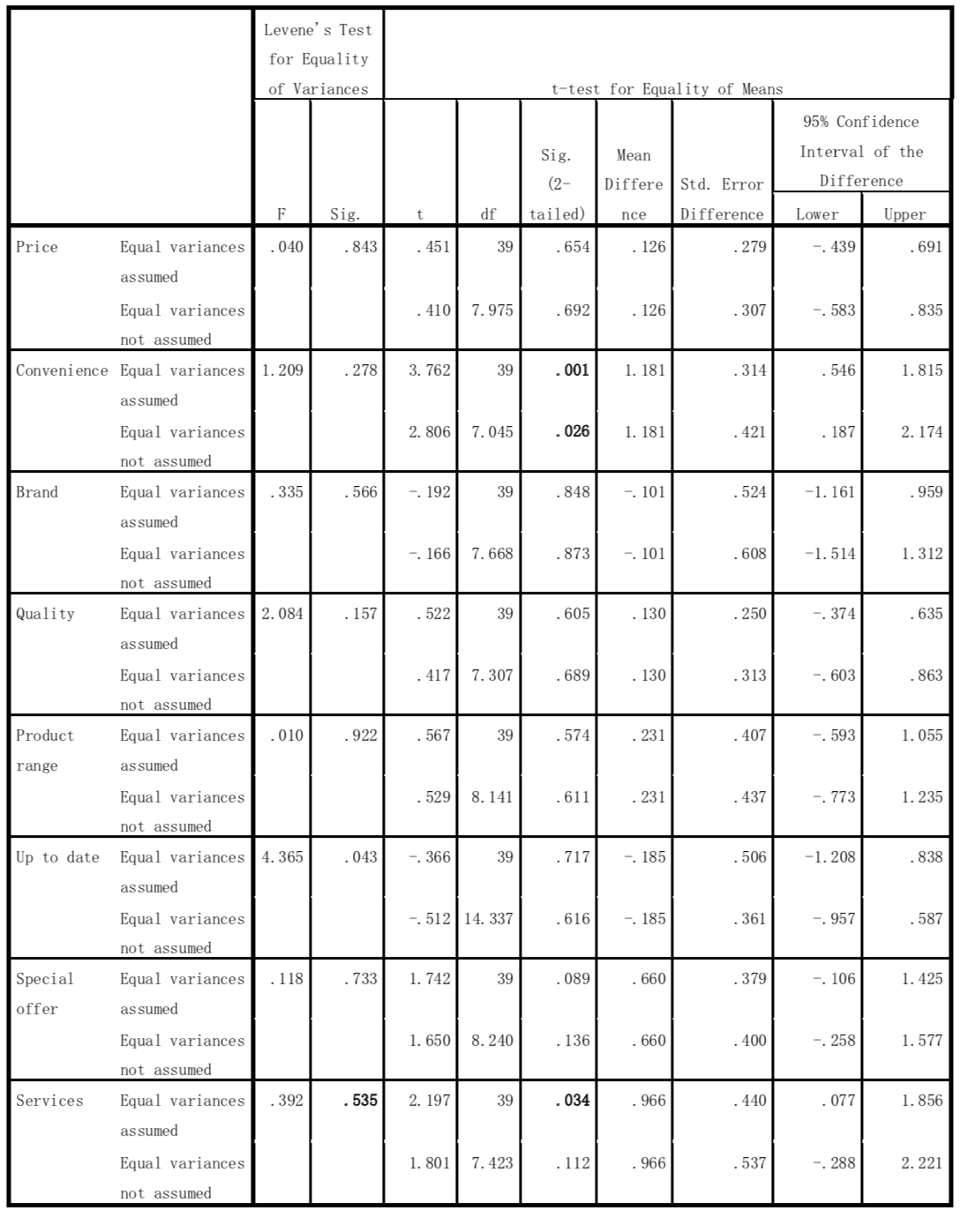
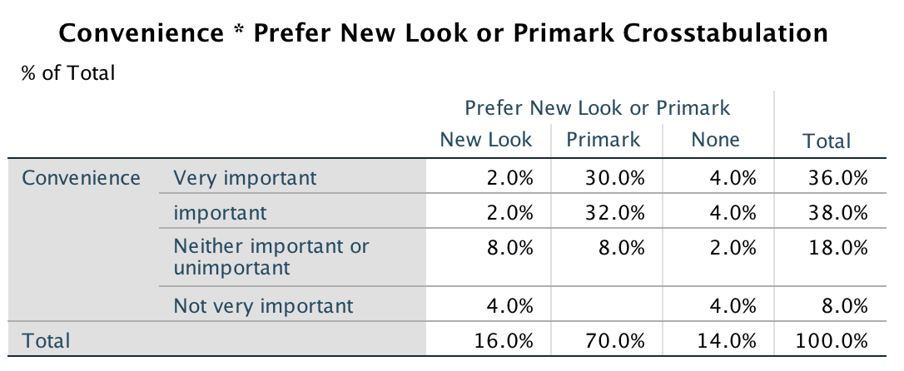
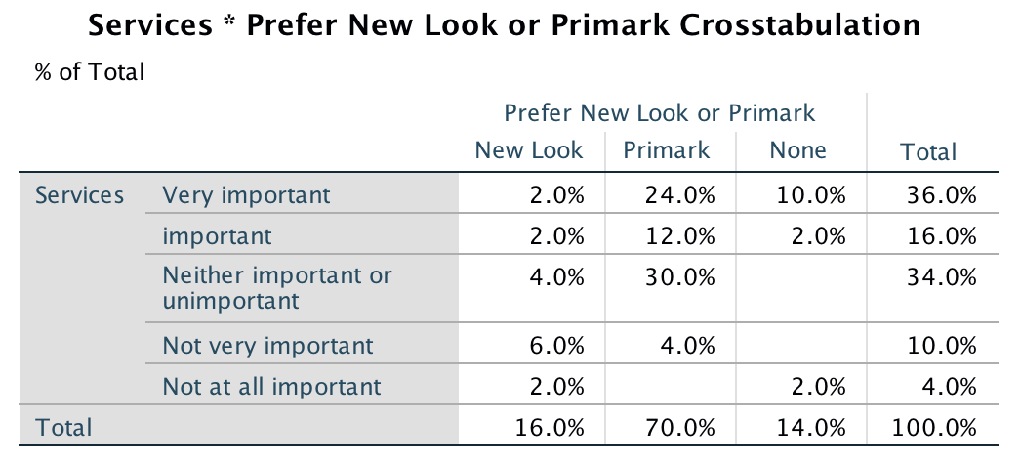
Figure 4.1: Independent sample test shows a significant effect of convenience and services on customers preference of New Look or Primark.
Independent sample test was used to analysis the relationship with customer prefer Primark or New look with customer preference: price, convenience, brand, quality, product range, up to date, special offer, services, as shown in Figure 4.5. when the equal variance of Independent sample test P-value is greater than 0.05, that is, there is no significant difference between the two population variances, which can be seen from the first line test results. When the equal variance test p-value is less than 0.05, that is, through the significance test, the two general variance has a significant difference between the two groups of data.
As shown in Figure 4.5, convenience, services P-value results are less than 0.05, indicating that there is significant difference between these factors with customers choice of the New look or Primark, that is, convenience and service may influence people prefer New Look or Primark; on the other hand, price, brand, quality, Product range, up to date, special offers P-value results are greater than 0.05, indicating there are no significant difference between these factors with New Look and Primark and there are no correlation.
In terms of convenience, the data evidences show that 34% of customers who treat convenience as important may more prefer Primark and who not value convenience as important would more prefer New Look. Primark has a total of 176 UK stores and distributes evenly across densely populated areas throughout the county. In contrast to New Look, Matalan and Peacocks, the target consumers in these regions reach most potential customers, and the operating costs of these stores are low (Phillips, 2018). New look website data shows (Armstrong, 2017) that shoppers still visit their stores and websites, but these trips failed to convert to purchases because they did not inspire them to share their hard-won cash. Asos and Boohoo are stepping up their paces, New Look must quickly catch up with a comprehensive and competitively priced performance quote.
As for services, 34% of customers, who are more interested in the service when shopping, may prefer Primark, and who does not value the service more would like New Look. Although Primark products are not known for their high quality and durability, they do seem to know what consumers want (Pemberton, 2017). For example, Disney, Harry Potter, Unicorn and Internet-inhabitants collection have collected and many consumers are eager to get their hands on and then show off projects. When mentioned to New Look (Sharma, 2018), despite the unsatisfactory business performance, New look is implementing a transformation plan to accelerate product turnaround, enhance its multichannel experience, and respond more to consumer demand as consumer spending shifts to experience online shopping. Whether to choose to copy Primark, although this is not online sales, to attract customers to visit its stores, that is the problem that managers need to consider.

Interview analysis
This sector intended to conduct an interview with retail experts to collect the required receipts and browse two companies online official news to obtain valid information. Questionnaires are mainly aimed at researching customers ' preference for Primark and New Look, and not intuitive to reflect the state and strategy of how two companies manage the change. While qualitative research will help to make up this, so the dissertation applies the telephone interview to collect more information about the object answer and improve the statistic accuracy. This sector summarizes the interview data that has been managed and a file of the interview script could be found in Appendix 4

4.2.1 Theme one: the reason why New Look close the stores.
According to retail consultant(Appendix 4), He stated that New Look,“as a private-equity firm”, has been in trouble for years and has lost money. Closing the store is a way to protected from loss. As Brown alleged that (2017), chief executive of New Look Kristiansen, resigned five years later after a series of poor performance of this private equity-backed British fashion retailers. The new management team plans to salvage the business through partial bankruptcy. Chief executive of retail economics, a consultancy also states (Hendriksz, 2018) that in the context of reduced disposable incomes, retailers are facing a clamp-down in operating and purchasing costs. Because of the lack of flexible leases, high rents and excess housing, they are struggling to cope with the relentless shift in online shopping and the emergence of an experience economy that is driving their business model to collapse. In addition, a retail research director (Frank, 2018) affirm that the private equity-owned company such as Toys R Us, Maplin, New Look as well as dining Prezzo, burger chain Byrons and Jamie's Italian, all of these failures are due to the fact that retailers and private equity ownership often cause toxic mixes. So, the internal and external forces drive the New Look to close the store.

4.2.2 Theme two: distinctive capabilities companies should own.
When mentioned to distinctive capabilities companies should own, the retail consultant stated that first is to“ keep selling products that meet consumers want”, “consistent approaches” are the next thing as needed. then, customers are very price oriented. Companies should “make goods as cheaply as possible in the far east”. Fourthly, the usual world is changing so quickly everywhere. And the other thing is good luck and “pay enough attention to the changes”. Leinwand and Mainardi (2010) in PWC insists that any market success is attributed to companies with a coherent edge, whose strategic direction is closely related to the ability to make it unique. The company has numerous tactical options, particularly in fast-growing marketplaces and businesses. The basic advantage is an influential notice that capabilities should show a vital role in organizing them. Mainardi (2016) proposed that the identity of a successful company has three basic elements: a value proposition (the company is unique in providing value to its customers); A unique competency system that enables the company to achieve this value proposition; And all combinations of products and services that take advantage of these features. What’s more, McKinsey (Hensley, 2017) also believes that the pace of change is difficult to predict, so the strategy of the future company is to determine what kind of capabilities and capabilities the company needs. Capabilities can be "difficult", such as predictive analytics and software development, or "soft", such as decision-making and talent management. So, capabilities can be used as a basis for sustainable market differentiation and advantage, as competitors cannot easily replicate these capabilities.

4.2.3 Theme three: current challenges facing the fashion retail industry.
According to the Truth Report 2018 (Thompson, 2018), most consumers (51%) are unable to identify their favourite brands, while most of them (74%) are constantly confused about brand advertising and news. No doubt the exciting days of consumer loyalty are long gone. The retail research consultant states that the first and the most important problem is probably that “people are spending less on fashion than they used to”. Fashion retailers have to compete with not only other fashion retailers, but the alternative ways of outspent of spending money. The second is that “the cost of running a brick and mortar shop are extremely high”. The retail fashion industry changes so quickly. So, it's very difficult to lay down a recipe or a menu that retail can use, the challenge is to increase loyalty in long-term purchase categories rather than always in our minds. Challenges are also opportunities. McKinsey (MacKenzie et al, 2013) puts forward a different view that the brick and mortar store will not disappear. And it is estimated that in 2025, in-store sales will still account for 75% to 85% of the retail price. In other words, physical stores are no longer just places to buy products. Stores can play several possible roles: it serves as a showroom for product experience, a fulfilment centre for online orders, or a destination for ideas and inspiration. Brick and mortar stores are likely to sell and profit weakly but are a strong contributor to retailers ' overall performance.

4.2.4 Theme four: change management of the fashion retail industry
The retail research expert advised that the first thing is “government change”, It is great if government sees this as a problem and changes the tax system to ensure that everyone has tax insurance. And the best for fashion retailers is to“dress in fashionable clothes”. If everyone has a new trend that everybody got to have, that would be very successful fashion gallons. As Chancellor Hammond (Conway, 2018) said, he was considering introducing a so-called "Amazon tax" to try to save retailers in trouble. The imposition of a special retail tax on online business, if necessary, does not require comprehensive international cooperation. In addition, he warns that high street must change for good. According to retail minister Griffiths (Gov, 2018), a retail committee of senior executives from Boots, Amazon and other well-known retailers, together with the government, provides expert advice to the industry on how best to ensure that the industry adapts to meet the changing needs of consumers. Consumers (Iliff, 2018), especially millennials, are integrating their online and offline behaviour in an unprecedented way. In the end, they want to be part of the fashion process, rather than being relegated to the background. They want to connect with brands and retailers throughout the experience. So consumers have changed, fashion retailers should changed too.

4.2.5 Theme five: future retail industry
As for future retail industry, the retail consultant infers that it may become “the sort of stability”, with the industry controlled by “some four or five companies and dominating industry”. There are thousands of much smaller companies“doing specialized jobs”. Amazon, Asos, Primark (bricks and mortar industry), the Edinburgh woolen mill (Philip Day) will probably success and remain. Many department stores will “go and department stores have been important way of selling middle range and expensive fashion to people”. Danziger (2017) added that retailers will have a lot of statistics to support AI, and provide identified personalized, and localized capabilities that pleasure customers. More statistics hits better algorithms each time, and sellers continue to produce large quantities of data online and offline. McLellan (2018) predicts that emerging technologies will flourish in the coming years, and of course, will also affect the retail industry. Top topics highlight the challenges facing the retail industry, mastering new techniques such as augmented reality, voice, Internet of Things and 3D printing. As Accenture report mentioned (Donnelly and Wright, 2018), today's retail and consumer goods companies should explore four transformational business models, so they can reinvent themselves in the new consumer era. The first is the sharing model (Rent products), where companies offer consumers the convenience and experience of ownership at low prices and costs. Another model is the personalization model (Surprise me). This is where the expert plans the product and delivers the product according to the individual. Auto replenishment is the third mode that the smart sensor detects when a product is running low, and then automatically reorder and deliver it. Finally, there is the Service model (Do for me) where the day-to-day activities are outsourced. So，to flourish in the next decade, mature retailers and consumer goods companies must actively pursue innovation and are willing to change even destroy themselves.

5 Conclusion
The last chapter is intended to summarize the main findings collected and assess the change management in fashion retail industry. First of all, the findings and achievements of the dissertation has been summarized, based on the questionnaire and interview survey on the basis of the two companies Primark and New look in the change management with deeper understanding of retail industry. Secondly, the research method and research investigation process limitations has been elaborated. The last part will provide recommendations to the further development of fashion retail industry

5.1 Achievement of aims
The aim of the research was to critically analyse the driving force and restrictive factors of market change, this paper recognizes the needs of enterprise transformation and development, including planning methods, and considers the three-step process, and consolidates the necessary improvements in the study. It also considers advising on future retail market research, as well as stakeholder relations and strategic change management. Three objectives were set out in this research in order to obtain reliable and substantial results:
- To understand literature of change management, recognize the significance for change and master the background of fashion retail industry.
The theory of five forces is a necessary theory to understand the external environment and external competition of the organization, which can be used as a method to find the trigger and resistance of change. The paper combs the theory of change management from the perspective of the internal environment of the organization and provides further reference for the change management. Value chain theory helps to understand the value, source and intrinsic inducement and resistance of change. The dissertation combs the theory of change management from the perspective of the internal environment of the organization and provides further reference for the change management. It is important to understand the nature and type of changes the organization wants to implement and the work environment. For retail organizations, it is helpful to think about the future development and evolution associated with long-term goals.
- To compare New Look and Primark in response to changing retail market include a review of the primary studies and a critical analysis of the current literature.
50 questionnaires have been tested by Chi Square and independent simple test. and there are following three groups of results: 1 gender has a significant impact on customers who value up to date as important when they shop for clothes. 30% female think up to date as important whereas there is no male think as important. 2 brand has a significant impact on the frequency of consumer's shopping in Primark. 18% of customers who treat brand as neither important or unimportant will go shopping in New Look monthly. 3 Price may have a great significant impact on expenditure in New Look. 30% of customers who think price as important will expend 10£~ 30£ in New Look. 4 convenience and service may influence people prefer New Look or Primark. 34% of customers who treat convenience as important may more prefer Primark and who not value convenience as important would more prefer New Look
- To draw conclusions from the interview data and information from studies of the previous chapters and provide advices for the future development of retail market and strategic change management.
Interview data that has been processed with retail experts and obtain valid information. Firstly, the most reason why New Look close the stores is because it is a private-equity firm (internal factor). Secondly, companies should develop distinctive capabilities for sustainable market differentiation and advantage, as competitors cannot easily replicate these capabilities. Thirdly, the biggest challenge for fashion retailers is to compete with not only other fashion retailers, but the alternative ways of outspent of spending money. Fourthly, government and fashion retailers change will be needed to welcome the challenge. In the end, mature retailers and consumer goods companies must actively pursue innovation and are willing to change even destroy themselves.

5.2 Limitations
The following part will be elaborated on the shortcomings of the study. The main limitations of the paper in this study are related to preliminary studies. First, the limited sample size involved in the questionnaire survey was taken randomly in Swansea city centre, and the data obtained from the analysis of 50 sample volumes did not extend to the entire target population. And there are too many female samples in the random gender ratio. However, this still provides reference and important instructions for the study of change management in Primark and New look, and it also discovers and observes consumer preferences and choices through SPSS analysis, providing materials for further retail change management.
Interview surveys also have some limitations. Primark and New Look managers and retail consultants were originally planned to be questioned by telephone interview. However, due to the stores busy business during the holidays, the two managers refused to be interviewed, resulting in too few interviews samples to get managers' views on the change management of New look and Primark. In addition, due to the limitations of the investigators knowledge, many of the professional vocabulary of the retail industry is not mastered when talking to retail consultant. If further research is needed on change management in the retail industry, it would be wise to investigate more people from different retail backgrounds in order to truly grasp the dynamics of the industry.

5.3 Recommendations
As retail consultant (Appendix 4) states, it is difficult to imagine the future retail imagine. So, based on Accenture's four business models for the future there are some suggestions for New Look, Primark and other retail companies.
1. Instant availability of the product. One way to stay competitive and take market share is to offer new and exciting products. As shown in the survey analysis, up to date have an impact on the customer's spending on New look. There is an example New Look and Primark could learn from, unlike other businesses that launch products every quarter, Asos can launch different new products every week and continue to occupy market share.So it's important to launch a new product portfolio in the store.
2.Digital. Young fashion consumers prefer to use a variety of digital platforms at any time to obtain information about up to date, customer experiences or compare prices, particularly through smart phones. For example, Primark and New Look could apply with automated application technology to allow customers to check out and charge for free after leaving. In addition, installing smart mirror, just as Rebecca Minkoff do, to allows customers to browse and order different styles and sizes as well as contact staff. This is especially important for Primark, which focuses on the physical store experience to distinguish it from other retailers .
3.Personalisation. Retailers need to focus on narrow personalisation efforts and Primark could be great learning model in designing Disney and Harry Potter goods. So it is important for New Look to add additional customer profiles to the costume design, for example male respondents said they had never been to New Look because the company was targeting women and not sale men's clothing. Try to figure out what buyer really want and buy.
4. Store service. Retailers need to be helping their buyers with automated retail assistance and interact online services. Through conversational commerce, graph database fit into daily life. For the future of New Look and Primark, there may be a system that shoppers search for something, and it knows the detail such as style, color, type, size and budget and then provides specific recommendations.

Bibliography

Abecassis, C. (2006). Integrating design and retail in the clothing value chain: An empirical study of the organisation of design. International Journal of Operations & Production Management, 26(3/4), pp.412–428.
Adewole, A. (2005). Developing a strategic framework for efficient and effective optimisation of information in the supply chains of the UK clothing manufacture industry. Supply Chain Management, 10(5), pp.357–366.
Akehurst, G. and Alexander, N. (2013). The Emergence of Modern Retailing 1750-1950. Hoboken: Taylor and Francis.
Amiri, A., Rasaeefard, R. & Dastan, B. (2011). An Analysis of Changeability Grounds in Iranian Public Organizations: A Case Study in the Cities of Lamerd and Mohr. Iranian Journal of Management Studies, 4(2), pp.121–142.
Armstrong, A. (2017). Can New Look's fall out of fashion be fixed?. [online] The Telegraph. Available at: https://www.telegraph.co.uk/business/2017/08/12/can-new-looks-fall-fashion-fixed/ [Accessed 9 Sep. 2018].
Arussy, L. (2018). How to Avoid Falling Into the 'Success Trap'. [online] Inc.com. Available at: https://www.inc.com/lior-arussy/success-may-be-your-biggest-obstacle-to-future-success.html [Accessed 19 Jun. 2018].
Aswegen, A. (2015). Women vs. Men – Gender Differences in Purchase Decision Making. [online] Guided Selling. Available at: https://www.guided-selling.org/women-vs-men-gender-differences-in-purchase-decision-making/ [Accessed 7 Sep. 2018].
Aydin, O (2017). Assessing the Environmental Conditions of Higher Education: In a Theoretical Approach Using Porter’s Five Forces Model. Yükseköğretim ve Bilim Dergisi, 7(2), pp.378–391.
Babbie, E. (2009). The practice of social research. 11th ed. Hua Xia Publication, pp.63-68.
BĂLĂŞESCU, M. (2014). METHODOLOGICAL AND PRACTICAL ISSUES OF SCIENTIFIC RESEARCH ON THE RETAIL MARKET. Bulletin of the Transilvania University of Brasov. Series V: Economic Sciences, 7(1), 9-17.
Barnes, L. (2010). Fast fashion in the retail store environment. International Journal of Retail & Distribution Management, 38(10), 760-773.
Basu, C. (2013). Pros and Cons of the Congruence Model. [Online] Smallbusiness.chron.com. Available at: http://smallbusiness.chron.com/pros-cons-congruence-model-36161.html [Accessed 19 Jun. 2018].
Berger, C., Moslein, K., Piller, F. and Reichwald, R. (2005), "Co-designing modes of cooperation at the customer interface: learning from exploratory research", European Management Review, Vol. 2 No. 1, pp. 70-87
Bhattacharya, M. (2012). Impact of RFID on the Retail Value Chain: An Exploratory Study Using a Mixed Method Approach. Journal of Technology Management & Innovation, 7(4), pp.36–49.
Brent, M. (2017). Advantages & Disadvantages of the Force Field Analysis. [online] Career Trend. Available at: https://careertrend.com/info-8613855-advantages-disadvantages-force-field-analysis.html [Accessed 20 Jun. 2018].
Brown, J. (2017). New Look chief executive departs after run of poor results | Financial Times. [online] Ft.com. Available at: https://www.ft.com/content/5fd1b8fa-8f1b-11e7-9084-d0c17942ba93 [Accessed 10 Sep. 2018].
Bruce, M. and Daly, L. (2004), Lean or agile, a solution for supply chain management in the textiles and clothing industry? International Journal of Operations & Production Management, Vol. 24 No. 2, pp. 151-71.
Bryman, A. (2006), “Paradigm peace and its implications for quality ", International Journal of Social Research Methodology, Vol. 9 No. 2, pp. 111 - 126.
Burnes, B. (2009). Managing change. 5ed. Edinburgh: Pearson Education.
Butler, S. (2018). Apocalypse now for Britain’s retailers as low wages and the web cause ruin. [online] the Guardian. Available at: https://www.theguardian.com/business/2018/feb/17/uk-retail-industry--gloom-high-street-shift-consumers [Accessed 17 Jul. 2018].

Cameron, E. & Green, M. (2015) Making Sense of Change Management: A Complete Guide to the Models, Tools and Techniques of Organisational Change, 4th edition, London, Kogan Page.
Campbell, A. (2014). What Could Have Been Done? Circuit City: A Case Study of Management and Employee Performance Failure. Performance Improvement, 53(4), 16-24.
Capatina, A. et al., (2017). Leveraging intellectual capital through Lewin's Force Field Analysis: The case of software development companies. Journal of Innovation & Knowledge, 2(3), pp.125–133.
Carr, D. K., Hard, H. J., & Tranhant, W. J. (1996). Managing the change process: A field book for change agents, consultants, team leaders and reengineering managers. New York: McGraw Hill.
Charlton, G. (2013). Primark uses ASOS to test the ecommerce waters - Econsultancy. [online] Econsultancy. Available at: https://econsultancy.com/primark-uses-asos-to-test-the-ecommerce-waters/ [Accessed 8 Sep. 2018].
Child J (2005) Organization: Contemporary Principles and Practice. Oxford: Blackwell.
Clegg SR, Kornberger M and Pitsis T (2005) Managing & Organizations: An Introduction to
Theory and Practice. London: SAGE.
Conway, E. (2018). Chancellor Philip Hammond considering 'Amazon tax' for online retailers. [online] Sky News. Available at: https://news.sky.com/story/chancellor-philip-hammond-considering-amazon-tax-for-online-retailers-11468623 [Accessed 12 Sep. 2018].
Cronshaw, S. & McCulloch, A. (2008). Reinstating the Lewinian vision: From force field analysis to organization field assessment. Organization Development Journal, 26(4), pp.89–103.
Cullen, J. (2013). Reverse logistics in the UK retail sector: A case study of the role of management accounting in driving organizational change. Management Accounting Research, 24(3), 212-228.
Cummings, S., Bridgman, T. & Brown, K.G. (2016). Unfreezing change as three steps: Rethinking Kurt Lewin’s legacy for change management. Human Relations, 69(1), pp.33–60.
Danziger, P. (2017). Top Shopping Trends Of 2018: Retail Experts Share What To Watch For Next Year. [online] Forbes.com. Available at: https://www.forbes.com/sites/pamdanziger/2017/12/27/retail-shopping-predictions-2018/#2362f981fb33 [Accessed 12 Sep. 2018].
De Mascena, Keysa Manuela Cunha. (2018). Stakeholder Prioritization in Brazilian Companies Disclosing GRI Reports. Brazilian Business Review (English Edition), 15(1), 17-33.
Dobbs, Michael. (2012). Porter's Five Forces in Practice: Templates for Firm and Case Analysis. Competition Forum, 10(1), pp. 22-33.
Donnelly, C. and Wright, O. (2018). PAINTING THE DIGITAL FUTURE OF RETAIL AND CONSUMER GOODS COMPANIES. [online] Accenture strategy, p.7. Available at: https://www.accenture.com/gb-en/insight-painting-digital-future-retail-cpg?c=ad_giukFY17_10002185&n=bac_0617 [Accessed 23 Aug. 2018].
Emriksson, E., & Poposka, V. (2015). Leading Change from the Middle: A Case Study on Office Managers within Retail Banking.
Evans, J., Bridson, K., Byrom, J. and Medway, D. (2008). Revisiting retail internationalization: Drivers, impediments and business strategy. International Journal of Retail & Distribution Management, 36(4), pp.260-280.
Fildes, N. (2018). UK high street braced for more store closures | Financial Times. [online] Ft.com. Available at: https://www.ft.com/content/bdf03d40-5c24-11e8-9334-2218e7146b04 [Accessed 25 Aug. 2018].
Ford, M.W. & Greer, B.M. (2006). Profiling Change. The Journal of Applied Behavioural Science, 42(4), pp.420–446.
Frank, K. (2018). CVAs / administrations of Toys ‘R Us, Maplin, New Look. [online] Knightfrank.co.uk. Available at: https://www.knightfrank.co.uk/blog/2018/03/08/cvas-administrations-of-toys-r-us-maplin-new-look [Accessed 10 Sep. 2018].
Frederick, W., Steven, P. and Walleck, S. (1980). Strategic Management for Competitive Advantage. [Online] Harvard Business Review. Available at: https://hbr.org/1980/07/strategic-management-for-competitive-advantage [Accessed 18 Jun. 2018].
Gammelgaard, B. (2015). The emergence of city logistics: the case of Copenhagen's Citylogistik-kbh. International Journal of Physical Distribution & Logistics Management, 45(4), pp.333–351.
Geoghegan, J. (2018). A new era as New Look sharpens its strategy. [online] Drapers. Available at: https://www.drapersonline.com/people/the-drapers-interview/a-new-era-as-new-look-sharpens-its-strategy/7024919.article [Accessed 9 Sep. 2018].
Gill, J., Johnson, P. and Clark, M. (2010). Research methods for managers. 4th ed. London: Sage.
Gilliland, N. (2017). New Look sees profits fall: What can turn it around? - Econsultancy. [online] Econsultancy. Available at: https://econsultancy.com/new-look-sees-profits-fall-what-can-turn-it-around/ [Accessed 9 Sep. 2018].
Gough, V. (2009). Organisational change: Which model should I use?. [online] TrainingZone. Available at: https://www.trainingzone.co.uk/lead/culture/organisational-change-which-model-should-i-use [Accessed 2 Jul. 2018].
GOV. UK (2018). Industry-led Retail Sector Council launched to act as champion for future growth. [online] Available at: https://www.gov.uk/government/news/industry-led-retail-sector-council-launched-to-act-as-champion-for-future-growth [Accessed 12 Sep. 2018].
Grant, R. (2016). Contemporary strategy analysis. 9th ed. Chichester, West Sussex, United Kingdom: John Wiley & Sons Inc.
Grigorescu, I. (2015). Value Chain Analysis – Basic Element of an Organization’s Competitive Advantage. International conference KNOWLEDGE-BASED ORGANIZATION, 21(2).
Gummesson, E. ( 2007 ), " Case study research ", in Gustavsson, B. (Ed.), The Principles of Knowledge Creation: Research Methods in the Social Sciences, Edward Elgar, Cheltenham, pp. 87 - 110 .
Hanson, D., & Grimmer, M. (2007). The mix of qualitative and quantitative research in major marketing journals, 1993-2002. European Journal of Marketing, 41(1/2), 58-70.
Harrison, K. (2017). What is a Value Chain Analysis? [Online] Business News Daily. Available at: https://www.businessnewsdaily.com/5678-value-chain-analysis.html [Accessed 18 Jun. 2018].
Hartley, J (2004). Case study research. In Catherine Cassell & Gillian Symon, Essential guide to qualitative methods in organizational research (pp.323-333). London: Sage.
Harvey, D., & Brown, D.R. (2001). An experiential approach to organizational development (6thed.). New Jersey: Pearson Prentice Hall
Hayes, J (2007). The Theory and Practice of Change Management, 2th edition, Basingstoke, Palgrave Macmillan
Hendriksz, V. (2018). Buyers move in as New Look edges closer to breaking-point. [online] Fashionunited.uk. Available at: https://fashionunited.uk/news/business/buyers-move-in-as-new-look-edges-closer-to-breaking-point/2018011527650 [Accessed 10 Sep. 2018].
Hensley, R. (2017). A capabilities strategy for successful product development. [online] McKinsey & Company. Available at: https://www.mckinsey.com/Business-Functions/Operations/Our-Insights/A-capabilities-strategy-for-successful-product-development [Accessed 12 Sep. 2018].
Hoggan, K. (2018). New Look slashes prices as sales fall. [online] BBC News. Available at: https://www.bbc.co.uk/news/business-44451139 [Accessed 8 Sep. 2018].
Hooker, L. (2018). New Look to axe 1,000 jobs and 60 stores. [online] BBC News. Available at: https://www.bbc.co.uk/news/business-43486521 [Accessed 17 Jul. 2018].
Ibrahim, M., & Chua, C. (2010). Permanent and temporary retail space: Shoppers' perceptions of in-line stores and retail carts in Singapore. Journal of Property Investment & Finance, 28(2), 123-140.
Iliff, R. (2018). Three 2018 Fashion Trends That Will Have You Rethinking Business As Usual. [online] Inc.com. Available at: https://www.inc.com/rebekah-iliff/emerging-fashion-trends-shed-light-on-what-matters-for-business-in-2018.html [Accessed 12 Sep. 2018].
Iwu, Chux Gervase. (2017). Impact of Retail branding on Consumer Buyer Behaviour: A case of Retail Outlets in Botswana. African Journal of Business & Economic Research, 12(1), 141-162.
Janssen, I., Borgers, A., & Timmermans, H. (2014). Stakeholders' Preferences and Adaptive Behaviour in Retail-Location Choice Decisions. Environment and Planning B: Planning and Design, 41(2), 307-322.
Johnson, G., Whittington, R. and Scholes, K. (2014). Exploring Strategy：Text and cases. 10th ed. Pearson, pp.76-77.
Josephson, A. (2018). The Economics of Fast Fashion - SmartAsset. [online] SmartAsset. Available at: https://smartasset.com/credit-cards/the-economics-of-fast-fashion [Accessed 9 Sep. 2018].
Killen, C. & Hunt, R. (2013). Robust project portfolio management: capability evolution and maturity. International Journal of Managing Projects in Business, 6(1), pp.131–151.
Knezevic, B. (2016). the Changing Structure of Retail Industry: Case Studies on Competitive Advantage of Small Companies in Croatia. Entrepreneurial Business & Economics Review, 4(4), 171-188.
Koca, E., & Koc, F. (2016). A Study of Clothing Purchasing Behavior By Gender with Respect to Fashion and Brand Awareness. European Scientific Journal, 12(7), European Scientific Journal, Mar 2016, Vol.12(7).
Kohlbacher, F (2006). The Use of Qualitative Content Analysis in Case Study Research. Forum: Qualitative Social Research, 7(1), 1-30.
Kotter, J. P. (1996). Leading change. Boston: Harvard Business Review Press
Lavrakas, P. (2008). Encyclopedia of survey research methods. Thousand Oaks, Calif.: SAGE Publications.
Lee, H., Kim, M. and Park, Y. (2012). An analytic network process approach to operationalization of five forces model. Applied Mathematical Modelling, 36(4), pp.1783-1795.
Leinwand, P. and Mainardi, C. (2010). The Essential Advantage: How to Win with a Capabilities-Driven Strategy. [online] Strategyand.pwc.com. Available at: https://www.strategyand.pwc.com/books/display/the-essential-advantage [Accessed 12 Sep. 2018].
Lewin, K. (1952). In D. Cartwright (Ed.), Field theory in social science; selected theoretical papers. London: Tavistock.
Linkner, J. (2012). Palm, Kodak, Blockbuster, Sears, RIM, Borders, Circuit City, Compaq and The Only Thing You Can Do To Avoid Being Next. [online] Forbes.com. Available at: https://www.forbes.com/sites/joshlinkner/2012/11/16/palm-kodak-blockbuster-sears-rim-borders-circuit-city-compaq-and-the-only-thing-you-can-do-to-avoid-being-next/#188e8ec85364 [Accessed 4 Jul. 2018].
Lippitt, R., Watson, J. and Westley, B. (1958). The Dynamics of Planned Change. New York:
Harcourt, Brace and World,
MacKenzie, I., Meyer, C. and Noble, S. (2013). How retailers can keep up with consumers. [online] McKinsey & Company. Available at: https://www.mckinsey.com/industries/retail/our-insights/how-retailers-can-keep-up-with-consumers [Accessed 14 Sep. 2018].
Mainardi, P. (2016). Creating a Strategy That Works. [online] strategy+business. Available at: https://www.strategy-business.com/feature/Creating-a-Strategy-That-Works?gko=5d483 [Accessed 12 Sep. 2018].
Manchester et al. (2014). Facilitating Lewin's change model with collaborative evaluation in promoting evidence based practices of health professionals. Evaluation and Program Planning, 47(C), pp.82–90.
Marchant (2015). Primark prepares for power growth. [online] WGSN Insider. Available at: https://www.wgsn.com/blogs/primark-prepares-for-power-growth-surge-and-its-not-just-about-the-us-says-analyst/ [Accessed 8 Sep. 2018].
MarketLine (2017). COMPANY PROFILE Primark Stores Ltd. [online] Advantage.marketline.com.ezproxy.uwtsd.ac.uk. Available at: http://advantage.marketline.com.ezproxy.uwtsd.ac.uk/Product?ptype=Companies&pid=38AFA4BB-20F2-4346-ABEC-0F3C792B8F6C [Accessed 17 Jul. 2018].
MarketLine (2018A). The Future of Retail. Five ways e-commerce and high street stores are evolving to suit changing consumer behaviors. [online] London: MarketLine, p.2. Available at: http://advantage.marketline.com.ezproxy.uwtsd.ac.uk/Product?ptype=Theme+Reports&pid=ML00026-011 [Accessed 23 Aug. 2018].
MarketLine (2018B). COMPANY PROFILE New Look Retailers Ltd. [online] Advantage.marketline.com.ezproxy.uwtsd.ac.uk. Available at: http://advantage.marketline.com.ezproxy.uwtsd.ac.uk/Product?ptype=Companies&pid=DAB24485-CBA4-455E-9B82-9592B1F180A8 [Accessed 17 Jul. 2018].
Marketline (2018C). Marks & Spencer in decline Extensive remedial action required for turnaround plan to work. [online] Advantage.marketline.com.ezproxy.uwtsd.ac.uk. Available at: http://advantage.marketline.com.ezproxy.uwtsd.ac.uk/Product?ptype=Case+Studies&pid=ML00028-025 [Accessed 17 Jul. 2018].
Marshak, R. (2002). Changing the language of change: how new contexts and concepts are challenging the ways we think and talk about organizational change. Strategic Change, 11(5), p.279.
Martin, P. (2018). BRC - KPMG Retail Sales Monitor January 2018. [online] KPMG. Available at: https://home.kpmg.com/uk/en/home/media/press-releases/2018/02/brc-kpmg-retail-sales-monitor-january-2018-.html [Accessed 24 Aug. 2018].
Maxham, J., Netemeyer, R. and Lichtenstein, D. (2008). The Retail Value Chain: Linking Employee Perceptions to Employee Performance, Customer Evaluations, and Store Performance. Marketing Science, 27(2), pp.147-167.
McLellan, C. (2018). The Future of Retail: 2018 and beyond | ZDNet. [online] ZDNet. Available at: https://www.zdnet.com/article/the-future-of-retail-2018-and-beyond/ [Accessed 12 Sep. 2018].
Meredith Gorran Farkas, (2013). Building and sustaining a culture of assessment: best practices for change leadership. Reference Services Review, 41(1), pp.13–31.
Mlenga G Jere, Albertina K Jere, & Jonathan Aspeling. (2015). A study of small, medium, and micro-sized enterprise (SMME) business owner and stakeholder perceptions of barriers and enablers in the South African retail sector. Journal of Governance and Regulation, 4(4), 620-630.
Moehlman, C. & Osgood, R. (2015). HOW TO GET THE MOST OUT OF YOUR COSTING SYSTEM: MAXIMIZING SUCCESS THROUGHOUT YOUR ENTIRE COMPANY? Cost Management, 29(5), pp.34–40.
Morrison, C. (2018). New Look slashes prices as it battles sliding sales. [online] The Independent. Available at: https://www.independent.co.uk/news/business/news/new-look-sales-price-cuts-under-20-pounds-high-street-crisis-house-of-fraser-poundworld-a8394576.html [Accessed 8 Sep. 2018].
Muller, R. (2014). The Problem with Primark. [online] CUB Magazine. Available at: http://cubmagazine.co.uk/2014/08/the-problem-with-primark/ [Accessed 8 Sep. 2018].
Murray, J. (2017). Examining the role of store design on consumers’ cross-sectional perceptions of retail brand loyalty. Journal of Retailing & Consumer Services, 38, 147-157.
Nien-Tai Tsai. (2013). A FORCE-FIELD PERSPECTIVE ON DISSENT BEHAVIOR: THE INTERACTION BETWEEN EMPLOYEE NEGATIVE PERCEPTION AND GROUP POSITIVE CLIMATE. Proceedings for the Northeast Region Decision Sciences Institute (NEDSI), 202-220.
Pemberton, B. (2017). Primark fan? Here’s how you can buy the store’s must-have collections online. [online] The Sun. Available at: https://www.thesun.co.uk/fabulous/4571825/primark-buy-stores-collections-online/ [Accessed 9 Sep. 2018].
Percy, S. (2018). The future of shopping is changing. [online] The Telegraph. Available at: https://www.telegraph.co.uk/connect/better-business/leadership/accenture/shopping-needs-are-changing/ [Accessed 23 Aug. 2018].
Philip, S (2014). Cross sectional studies: advantages and disadvantages. BMJ. 348: g2276\
Phillips, S. (2018). Primark – what’s the secret to its success? [online] Blog.localdatacompany.com. Available at: http://blog.localdatacompany.com/primark-whats-the-secret-to-its-success [Accessed 9 Sep. 2018].
Pines, J.M., (2006). The economic role of the emergency department in the health care continuum: Applying Michael Porter’s five forces model to emergency medicine. Journal of Emergency Medicine, 30(4), pp.447–453.
Pla-Barber, J. (2017). Why has Caixa Ontinyent survived? An analysis of its business model and strategy. Universia Business Review, (54), 18-70.
Porter, M (1985). Competitive advantage. Free Press: New York, USA
Prochaska and DiClemente, (1985). DiClemente C.C., Prochaska J.O. Processes and stages of self-change: Coping and competence in smoking behavior change
Rachapila, T & Jansirisak, S (2013). Using Porter’s Five Forces Model for Analysing the Competitive Environment of Thailand’s Sweet Corn Industry. International Journal of Business and Social Research, 3(3), pp.174–184.
Rafferty, A. Walthery, P. and King, S. (2015) Analysing change over time: repeated cross-sectional and longitudinal survey data. UK Data Service, University of Essex and University of Manchester.
Recklies, D. (2015). Porters Five Forces: content, application, critique. [online] Themanager.org. Available at: https://www.themanager.org/2015/11/porters-five-forces/ [Accessed 18 Jun. 2018].
Reeves, M. and Harnoss, J. (2018). Don’t Let Your Company Get Trapped by Success. [online] Harvard Business Review. Available at: https://hbr.org/2015/11/dont-let-your-company-get-trapped-by-success [Accessed 19 Jun. 2018].
Resnik, D. (2015). What is Ethics in Research & Why is it important? [online] National Institute of Environmental Health Sciences. Available at: https://www.niehs.nih.gov/research/resources/bioethics/whatis/index.cfm [Accessed 21 Jul. 2018].
Rice, J. (2010). ADAPTATION OF PORTER'S FIVE FORCES MODEL TO RISK MANAGEMENT. Defense AR Journal, 17(3), pp.375–388.
Riddell, Rebecca Victoria, R. & Røisland, Maren Tofte, R. (2017). Change Readiness Factors influencing employees’ readiness for change within an organisation: A systematic review. Change Readiness Factors influencing employees’ readiness for change within an organisation: A systematic review.
RILA (2013). Retail sustainability Report. Stakeholder Engagement. [online] Available at: http://www.rila.org/sustainability/sustreport2013/implementingsustainability/Pages/StakeholderEngagement.aspx [Accessed 18 Jul. 2018].
Ruddick, G. (2016). Britain's high streets under strain as 15 shops close every day. [online] the Guardian. Available at: https://www.theguardian.com/business/2016/oct/25/britains-high-streets-under-strain-as-15-shops-close-every-day [Accessed 17 Jul. 2018].
Sahoo, D. and Reddy, A., (2014). Retail Outlet Engagement & Expansion Program in Indian Telecom Sector. i-Manager's Journal on Management, 9(1), pp. 12-23.
Saunders, M., Lewis, P., & Thornhill, A. (2009). Research methods for business students (5th ed.). Harlow: Financial Times Prentice Hall.
Scherpereel, C. & Lefebvre, J. (2006). Shocking the legacy mind set (TM): management development and the internet. The Journal of Management Development, 25(3/4), pp.232–248.
Scotland, J. (2012). Exploring the Philosophical Underpinnings of Research: Relating Ontology and Epistemology to the Methodology and Methods of the Scientific, Interpretive, and Critical Research Paradigms. English Language Teaching, 5(9).
Seijts & Gandz, (2018). Transformational change and leader character. Business Horizons, 61(2), pp.239–249.
Self, D. & Schraeder, M., 2009. Enhancing the success of organizational change. Leadership & Organization Development Journal, 30(2), pp.167–182.

Sharma, N. (2018). New Look: Refocusing on customer ‘sweet spot’ right way to revival. [online] WGSN Insider. Available at: https://www.wgsn.com/blogs/new-look-refocusing-customer-sweet-spot-revival/ [Accessed 9 Sep. 2018].
Sidorko, P., 2008. Transforming library and higher education support services: can change models help? Library Management, 29(4/5), pp.307–318.
Siegle, L. (2018). The high price of New Look’s low-cost strategy | Lucy Siegle. [online] the Guardian. Available at: https://www.theguardian.com/commentisfree/2018/jun/13/new-look-fast-fashion-high-price-low-cost [Accessed 8 Sep. 2018].
Smith, I. (2011). Organisational quality and organisational change. Library Management, 32(1/2), pp.111–128.
Soobramoney, J. & Ledimo, O. (2016). Exploring corporate social responsibility and organisational commitment within a retail organisation. Risk Governance & Control: Financial Markets & Institutions, 6(4), 132-140.
Spacey, J. (2016). 5 Types of Success Trap. [Online] Simplicable. Available at: https://simplicable.com/new/success-trap [Accessed 19 Jun. 2018].
Theodosiou, M. and Leonidou, L.C. (2003), “Standardization versus adaptation of international marketing strategy: an integrative assessment of the empirical research”, International Business Review, Vol. 12 No. 2, pp. 141-71.
Thomas, D. (2018). Six reasons behind the High Street crisis. [online] BBC News. Available at: https://www.bbc.co.uk/news/business-43240996 [Accessed 17 Jul. 2018].
Thomas, G. (2007). A study of the theories and practices of facilitator educators. La Trobe University.
Tiistai (2014). A comparison between Lewin´s and Kotter´s models of change. [Online] Vuodatus.net. Available at: https://tumpelontekeleet.vuodatus.net/lue/2014/08/a-comparison-between-lewin-s-and-kotter-s-models-of-change [Accessed 20 Jun. 2018].
Todd, P. (2017). Primark expansion: the impact of Brexit on its profit margins. [online] Advantage.marketline.com.ezproxy.uwtsd.ac.uk. Available at: http://advantage.marketline.com.ezproxy.uwtsd.ac.uk/Product?ptype=Analyst+Insights&pid=MLAI0002-020 [Accessed 17 Jul. 2018].
Toves, P., Graf, L. & Gould, D. (2016). Innovative Use of Force Field Analysis: Factors Influencing Technology-Enabled Change. Journal of Behavioral and Applied Management, 17(2), pp.85–102.
Tudor, L. (2014). MANAGEMENT OF ORGANISATIONAL CHANGE IN THE CONTEXT OF SUSTAINABLE DEVELOPMENT. Calitatea, 15(S1), pp.484–488.
Uzwyshyn, R., (2012). The US Auto Industry in 2013: Five Forces to Consider. Automotive Industries, 191(3), pp. 14-14, 16.
Wallace, T. and Armstrong, A. (2017). Retailers on edge as sales dive at fastest pace since the financial crisis. [online] The Telegraph. Available at: https://www.telegraph.co.uk/business/2017/10/26/retailers-edge-sales-dive-fastest-pace-since-financial-crisis/ [Accessed 24 Aug. 2018].
Watson, I., Wood, S., & Fernie, J. (2015). "Passivity": A model of grocery retail price decision-making practice. European Journal of Marketing, 49(7/8), 1040-1066.
Wang, C., Senaratne, C. & Rafiq, M. (2015). Success Traps, Dynamic Capabilities and Firm Performance. British Journal of Management, 26(1), pp.26–44.
Wang, Y. & Li, Y. (2009). Formation of Value Chain Theory Jungle and Its Developing Status in China. Asia Pacific Management Review, 14(3), p.2009.
Weinswig, D. (2017). UK Value Clothing Market— Pure Plays Drive Market Growth. [ebook] Fung Global Retail & Technology. Available at: https://www.fungglobalretailtech.com/wp-content/uploads/2017/03/UK-Value-Clothing-Retailers-April-3_2017-DF.pdf [Accessed 17 Jul. 2018].
Westbrook, I. (2018). Town centres 'could become ghost towns'. [online] BBC News. Available at: https://www.bbc.co.uk/news/business-44695269 [Accessed 25 Aug. 2018].
Woo, O & Amp, A; Boyle, H., & Spector, E. (2017). Best practices in developing, conducting, and evaluating inductive research. Human Resource Management Review, 27(2), 255-264.
Wood, L (2010). Research and Markets: Analyzing Food Retail in Canada 2010 Report applies the PEST Framework Analysis & Porters Five Forces Strategy Analysis to the Canadian Food Retail Industry. Business Wire.
Yin, R.K. (2009). Case study research, design and method (Fourth Edition). London:
Sage Publications.
Zahra, S.A., H. J. Sapienza and P. Davidson (2006). ‘Entrepreneurship and dynamic
capabilities: a review, model and research agenda’, Journal of Management Studies, 43,
pp.917-955.

APPENDIX

Appendix 1- Survey Questions
Change Management in The Retail Industry: How New Look and Primark Response to The Current Financial Challenges
Dear Participant:
My name is Chang Liu, an MBA student in University of Wales Trinity Saint David. I would like to invite you to participate in my research project. This will only take two minutes. All answers and results are anonymous and will not be shared with any third party. Your input is very much appreciated! Thank you for your time!

Q1. Your gender:
□Male □Female □prefer not to say
Q2. Which age range are you:
□18 – 25 □26 – 35 □35 – 45 □46 – 55 □over 56. □prefer not to say
Q3. How often do you usually go shopping for clothes in physical stores?
 | Weekly | monthly | quarterly | annually
New Look
Primark

Q4. How much did you approximately spend when you go shopping in stores? (Last time)
 | 0~10£ | 10£~30£ | 30£~50£ | 50£~70£ | 70£+
New Look
Primark

Q5. Which shopping way do you prefer when you shop for clothes?
 | Physical store | Online | Both
New Look
Primark

Q6. Please rate the following statements on what is important to you when you shop for clothes?
 | Very important | important | Neither important or unimportant | Not very important | Not at all important
Price
Convenience
Brand
Quality
Products range
Up to date
Special offer
Services
Others

Q7. Do you prefer shopping in New Look or Primark? Why?

Q8. Do you have any other comments, questions or concerns about the two companies?

Appendix 2- Survey Results
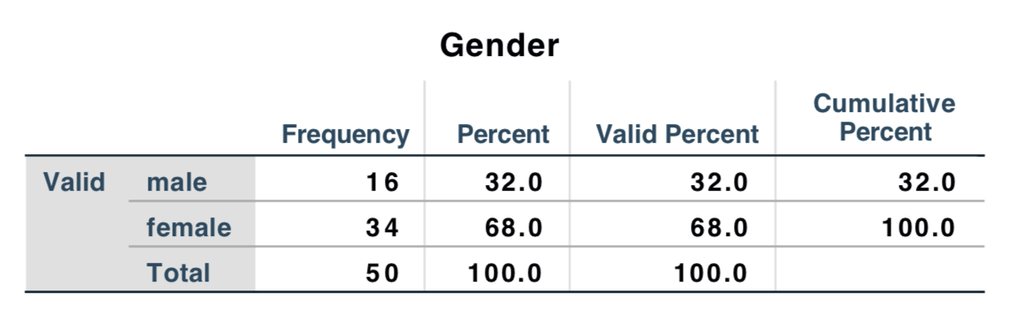
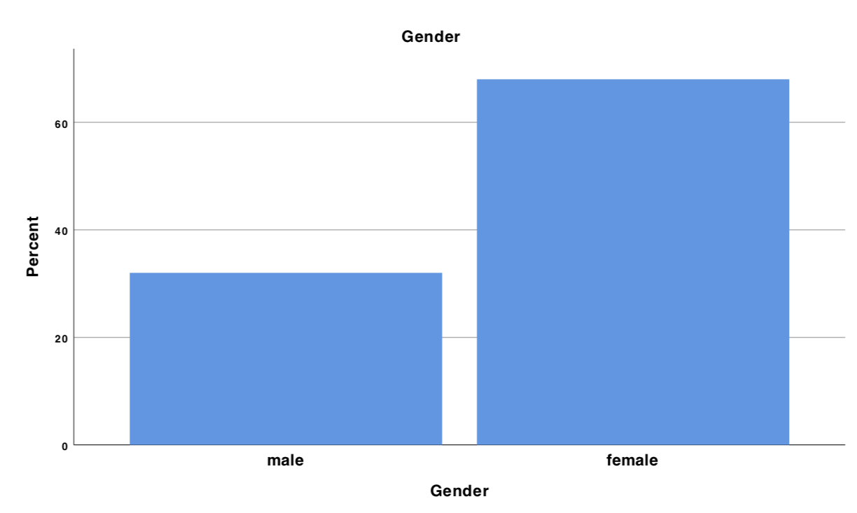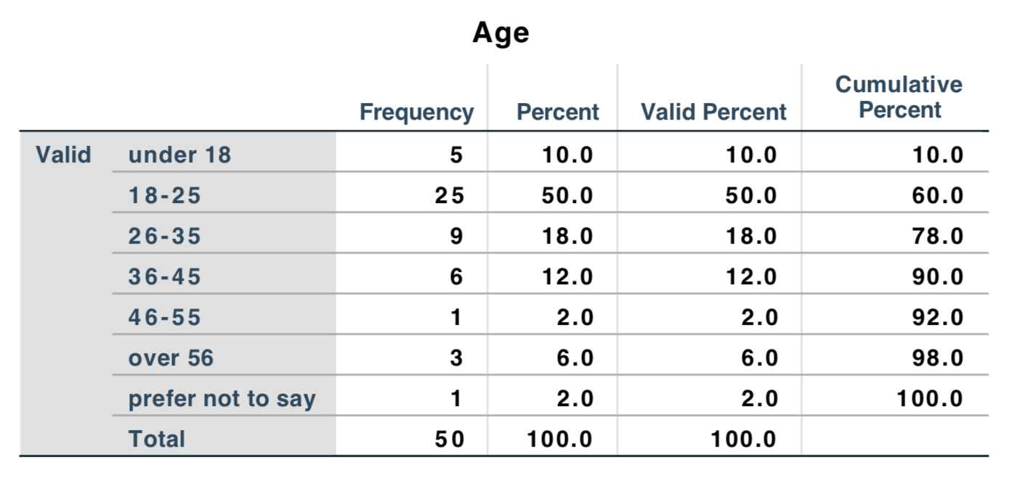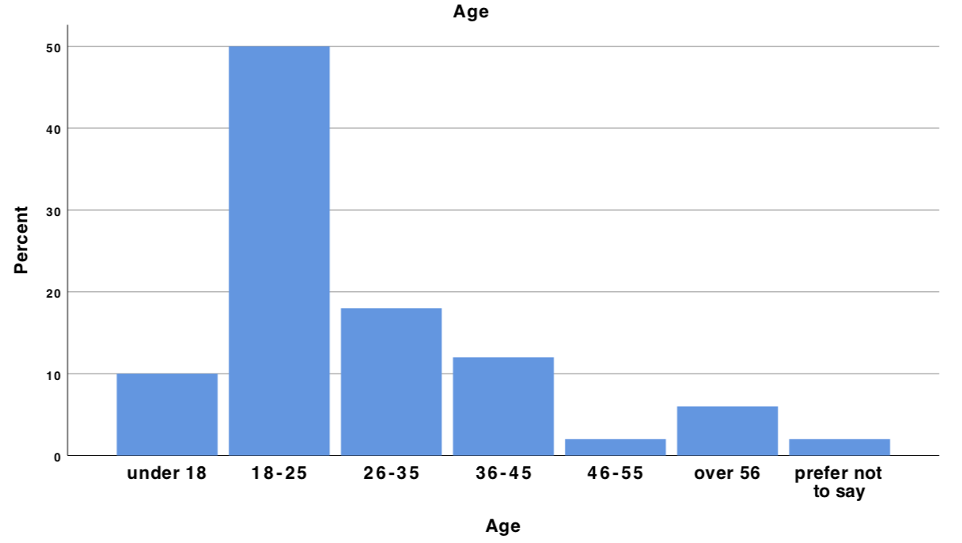
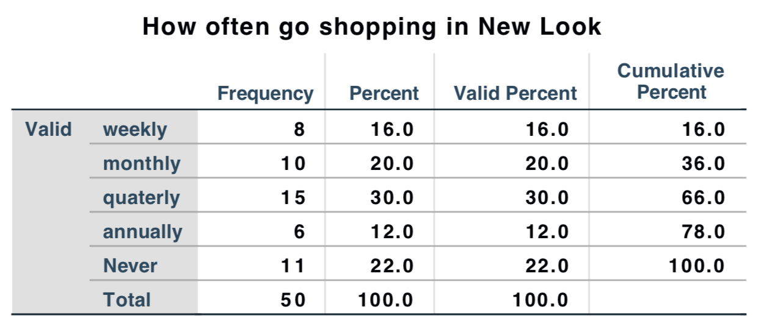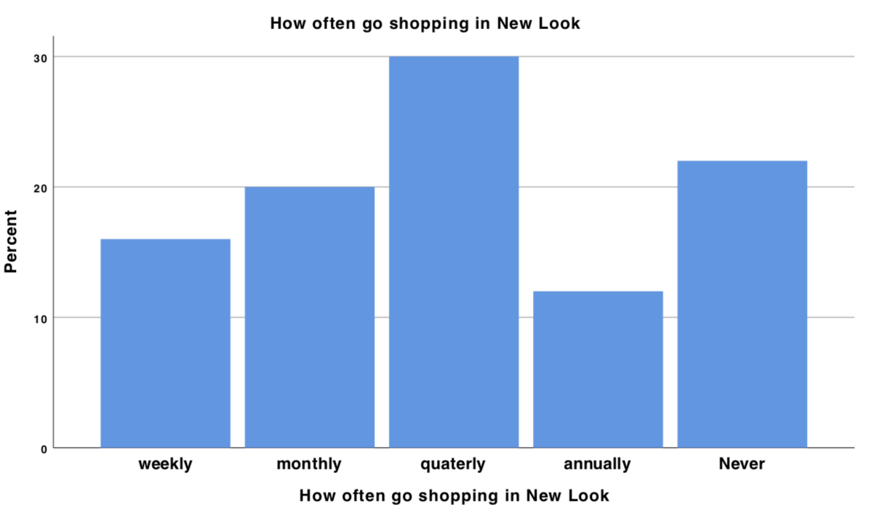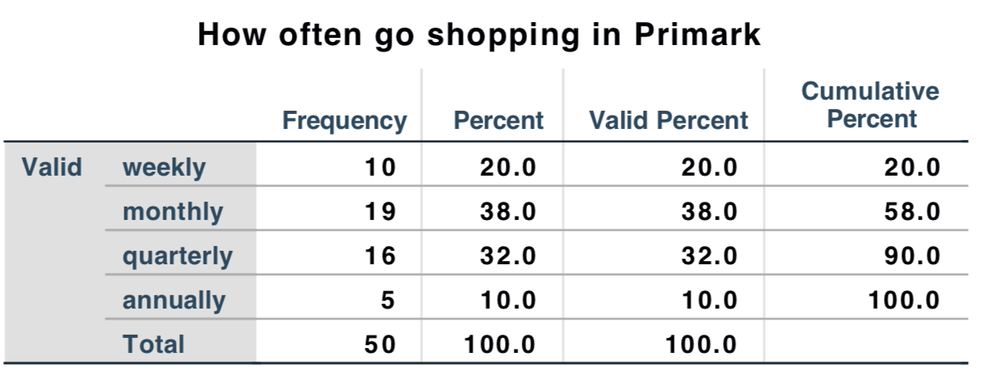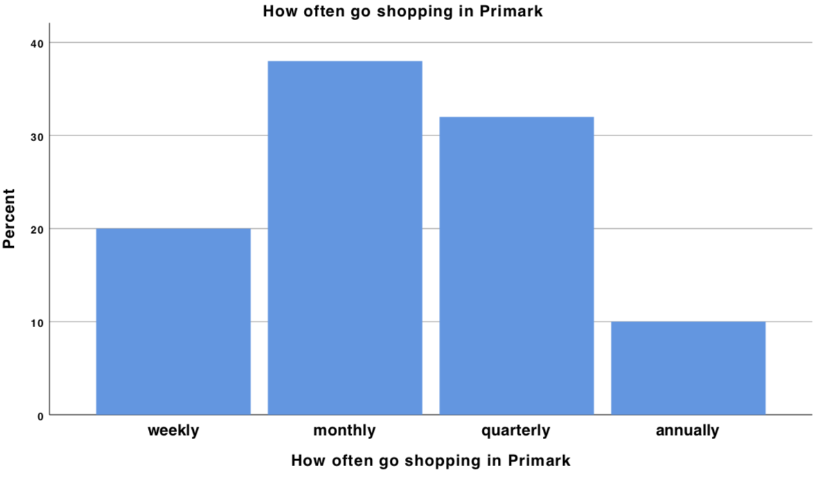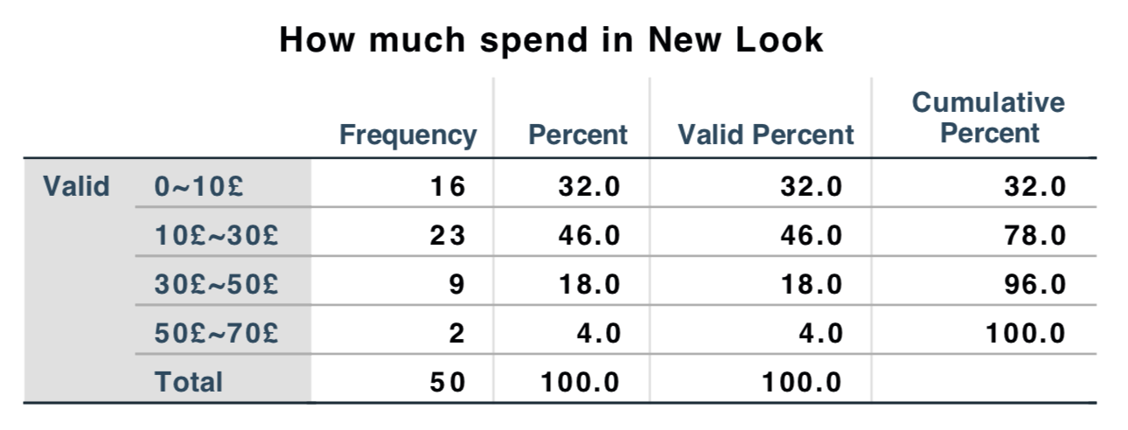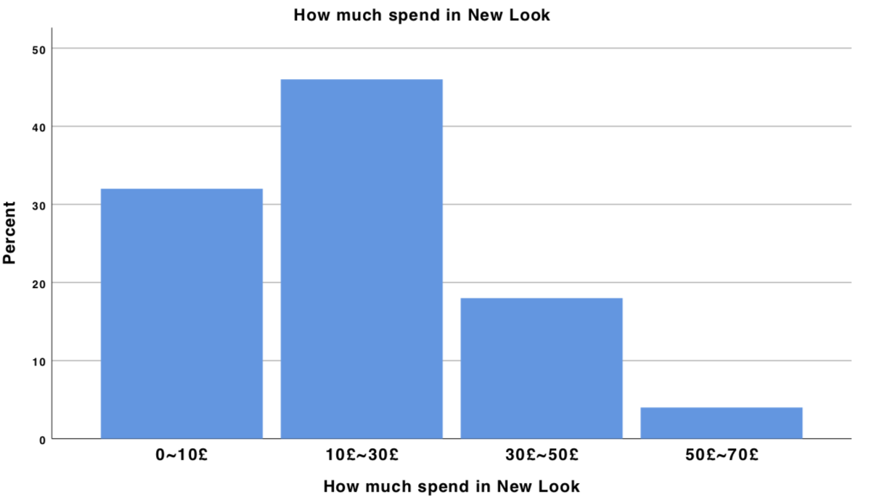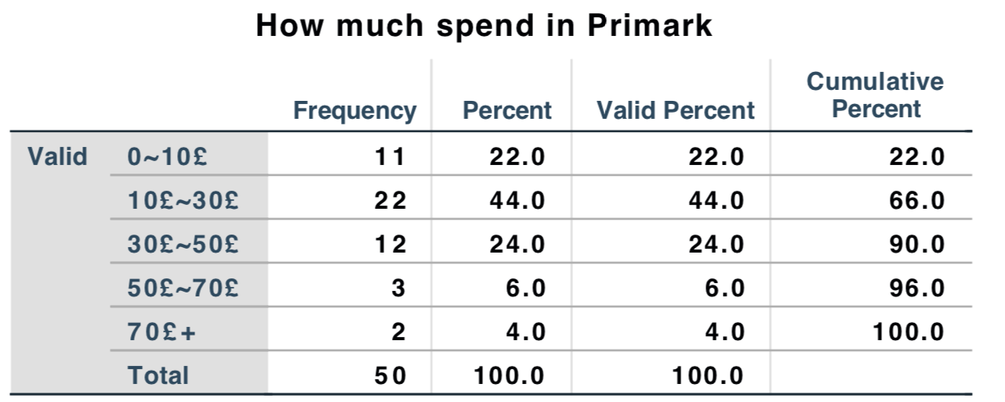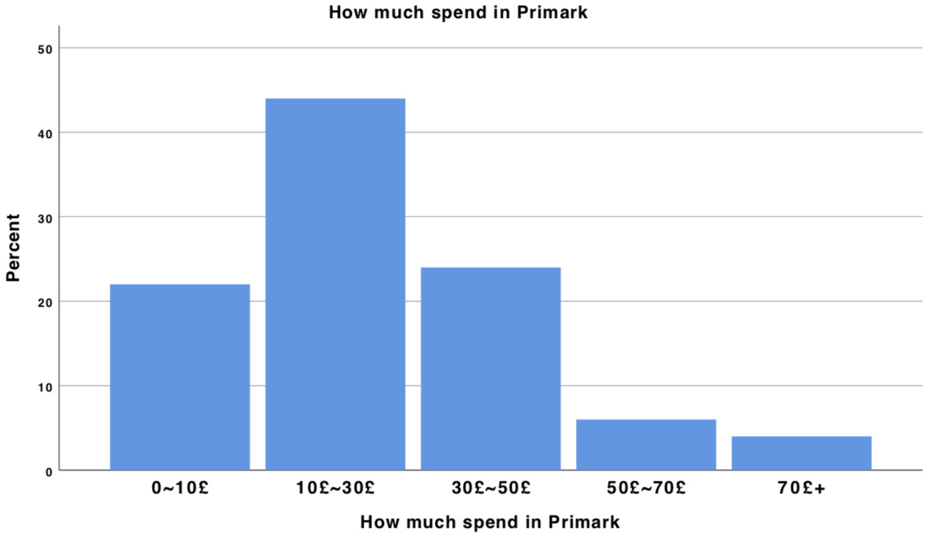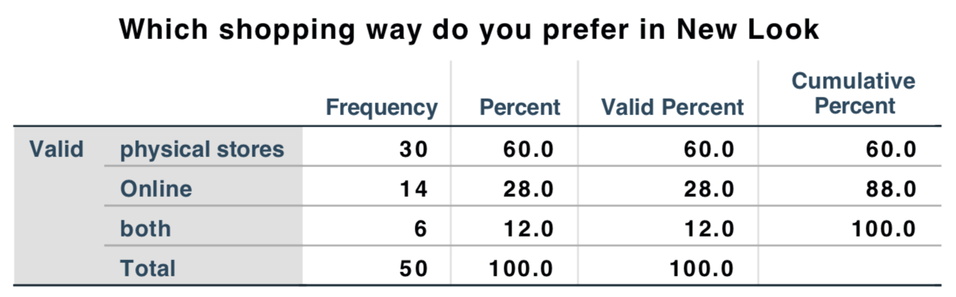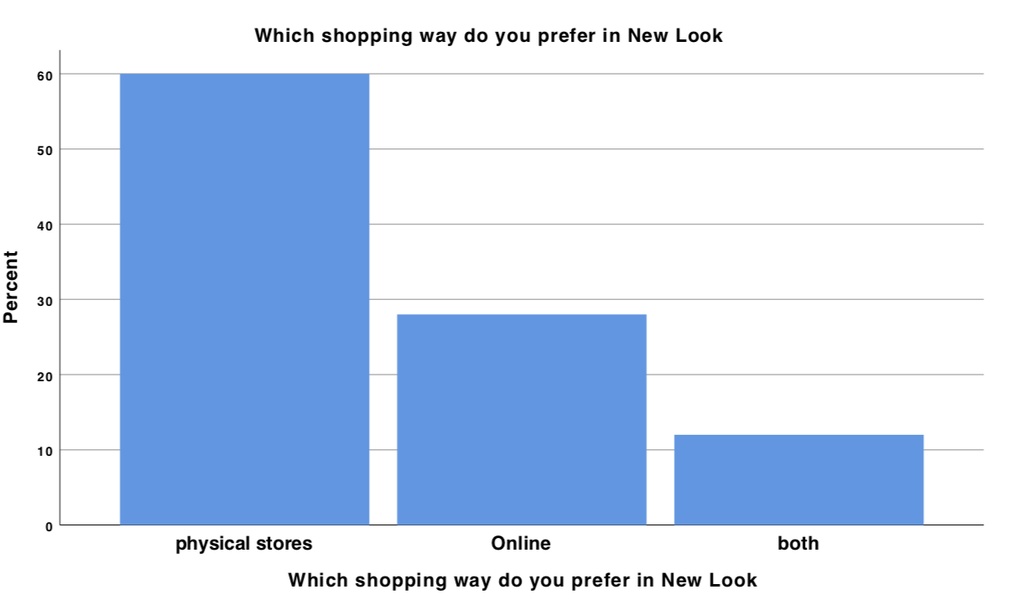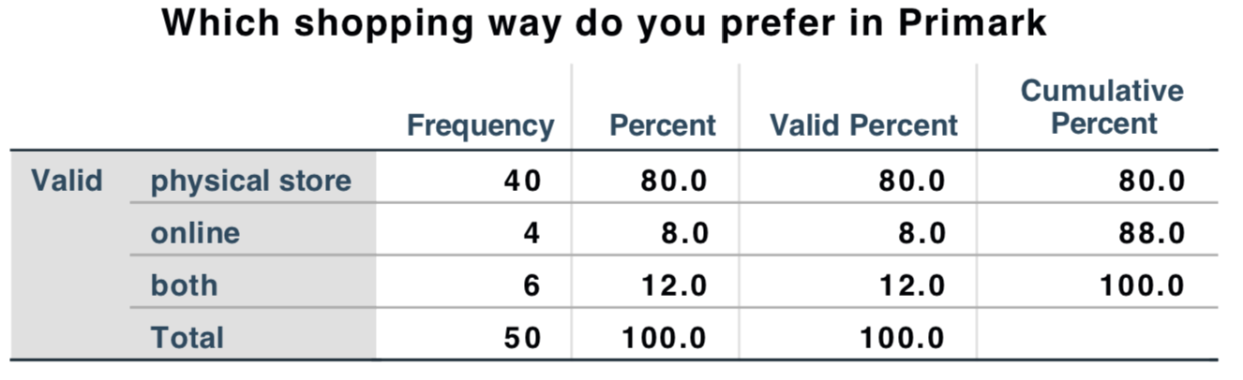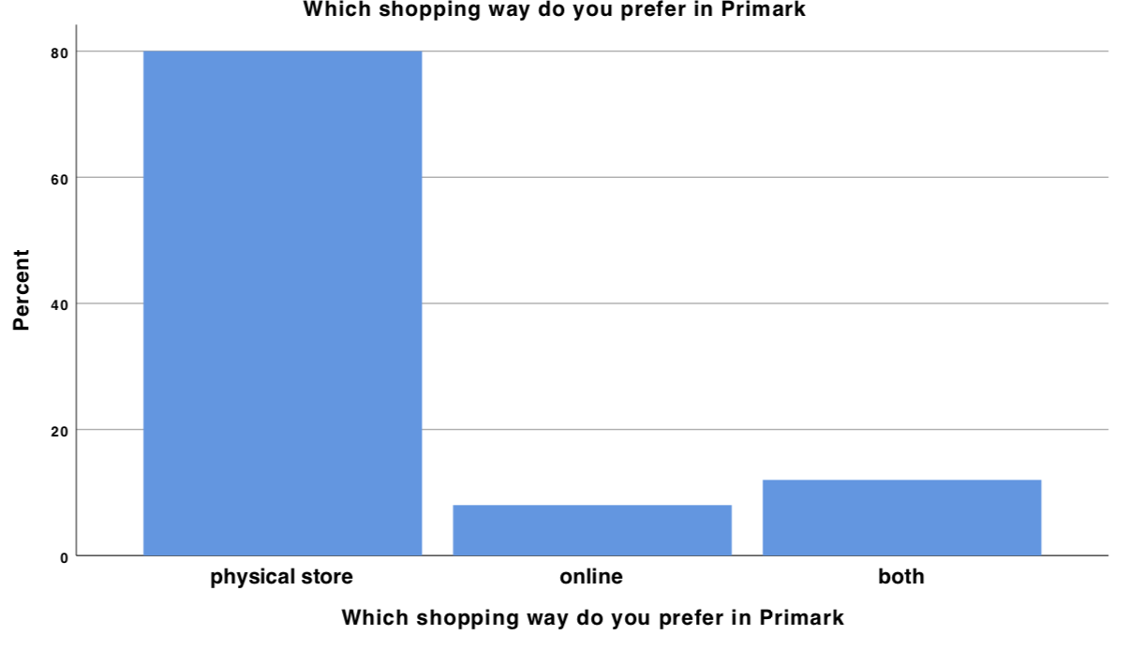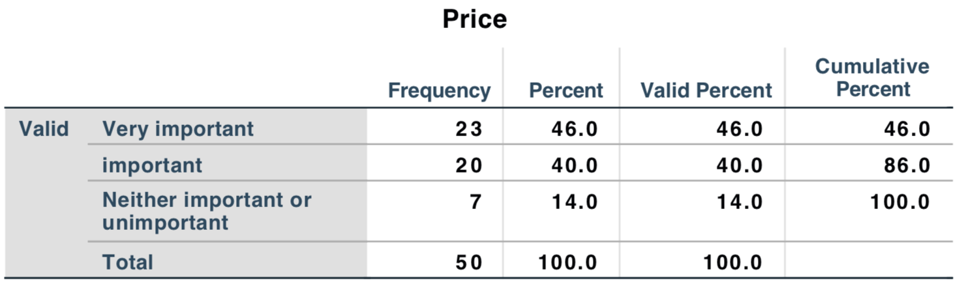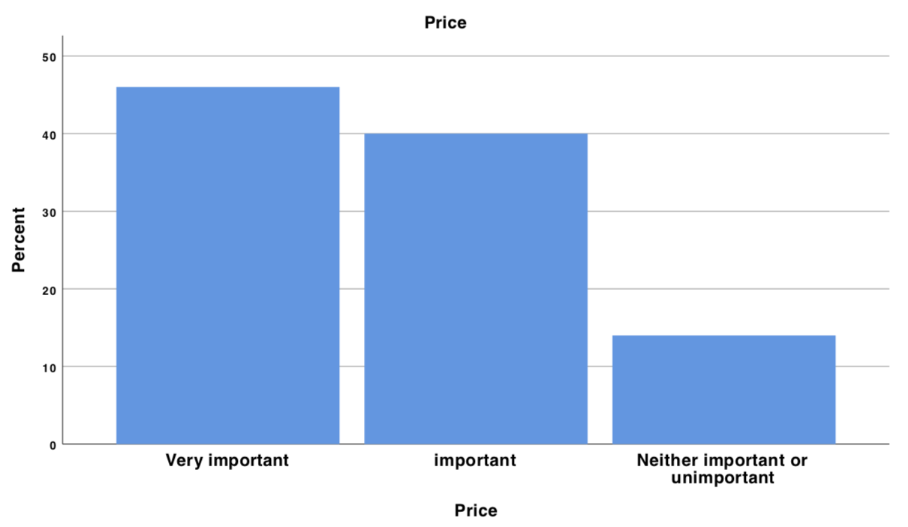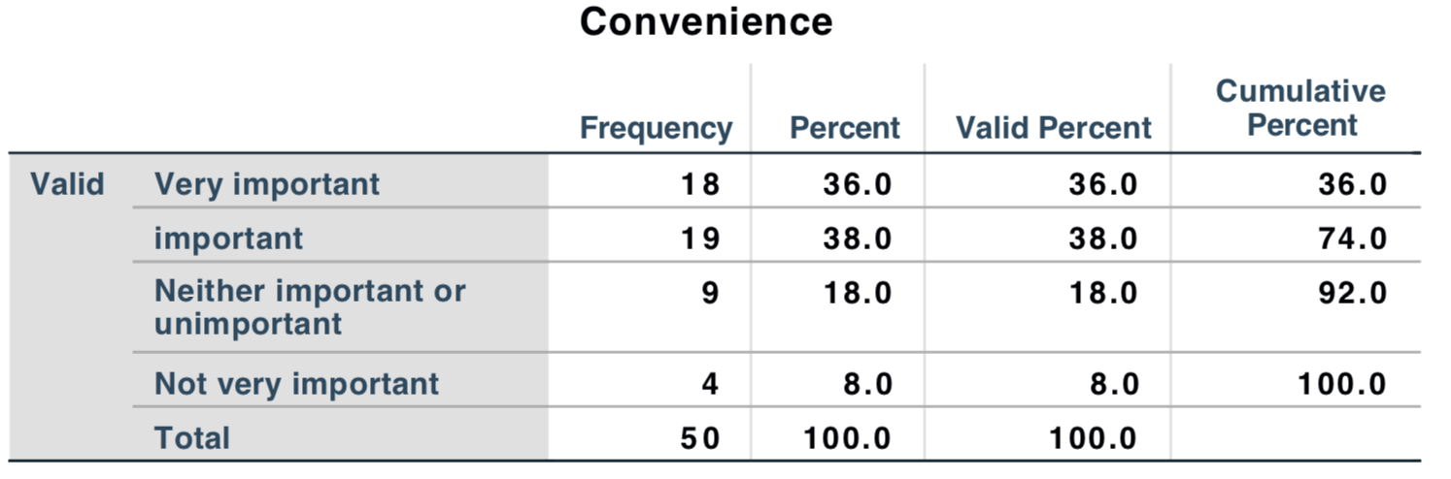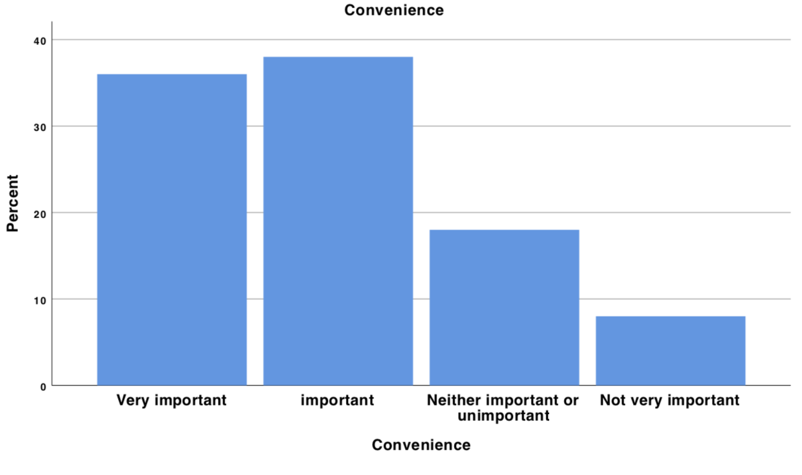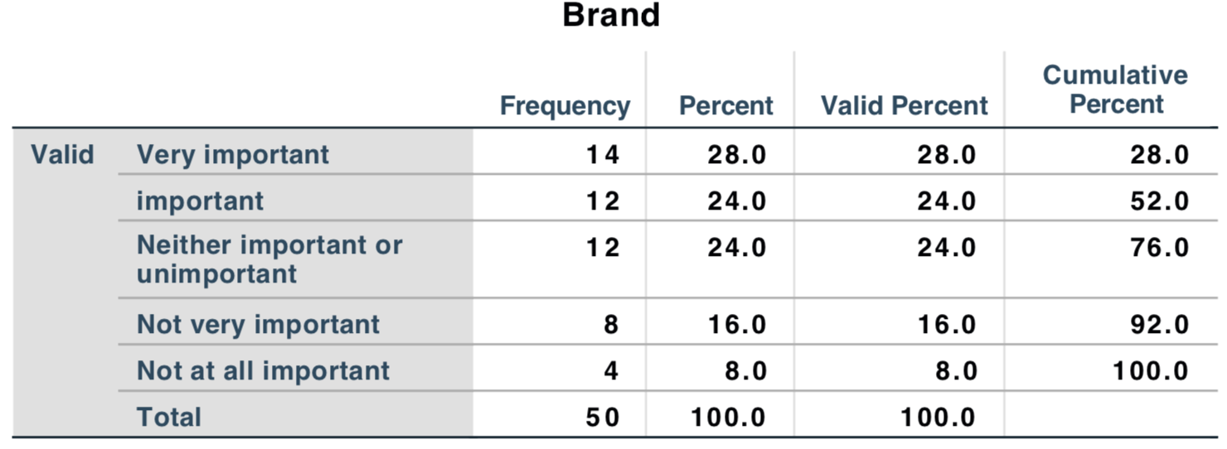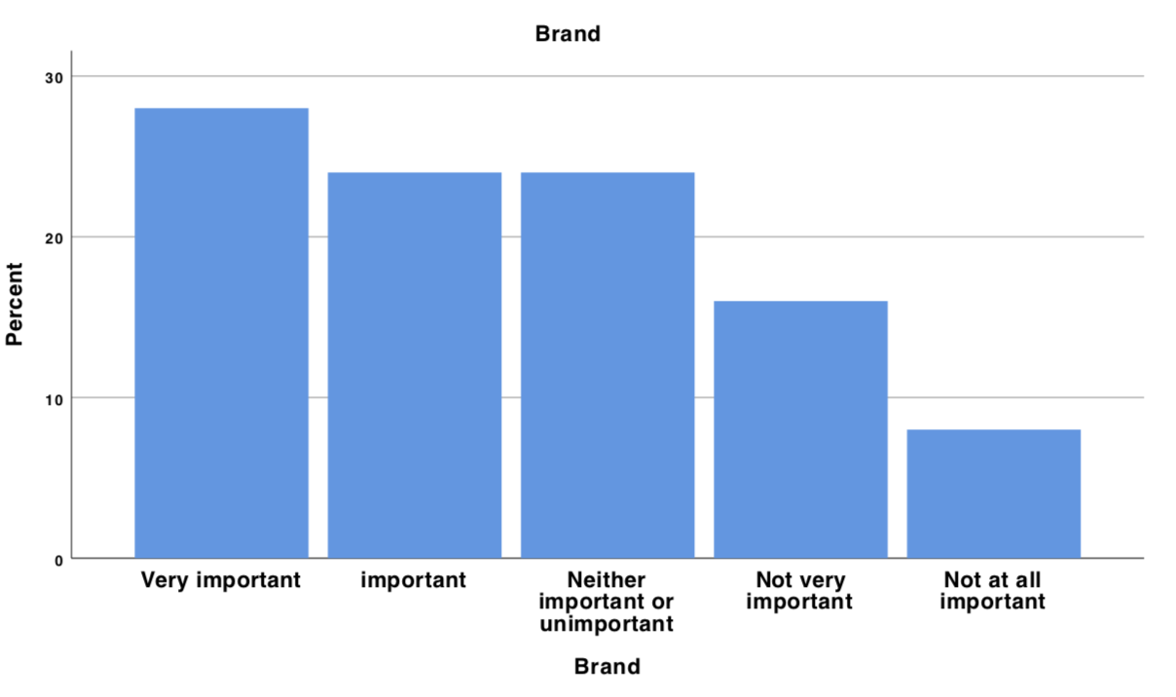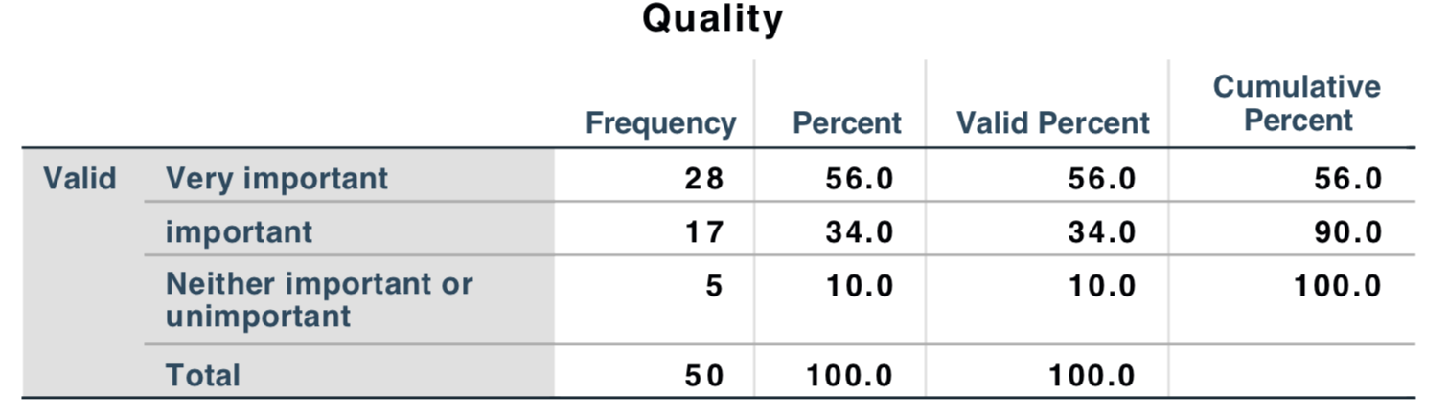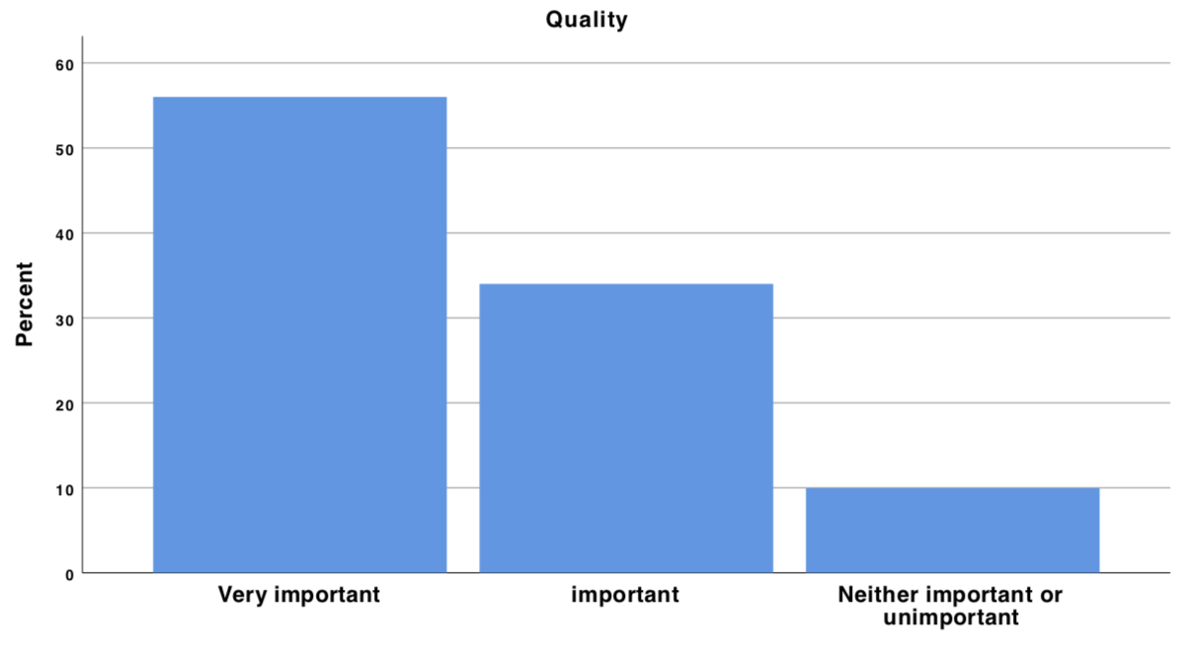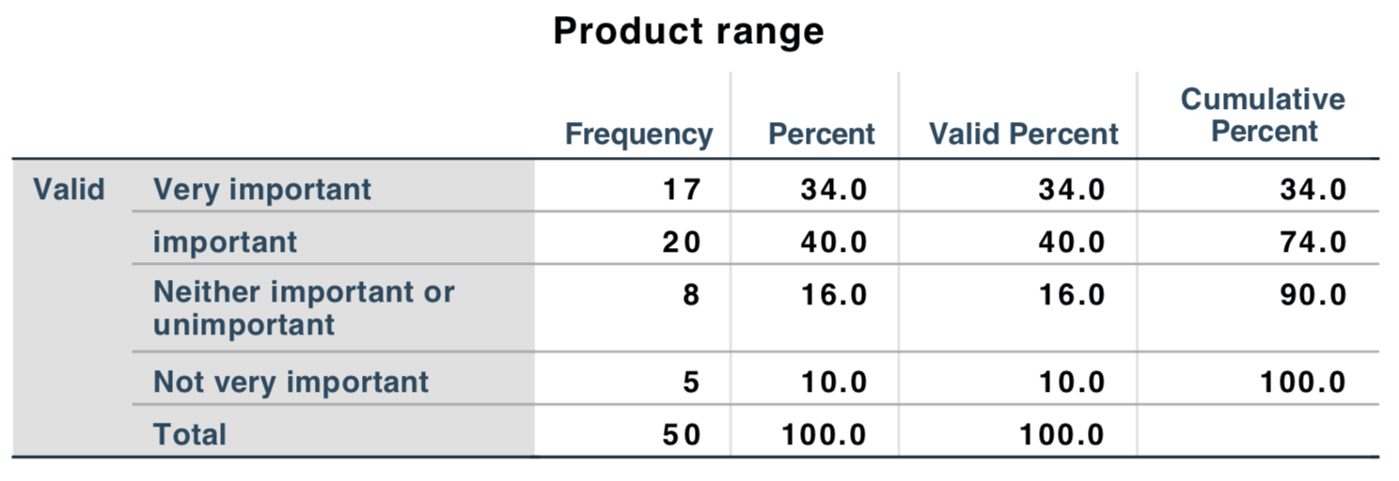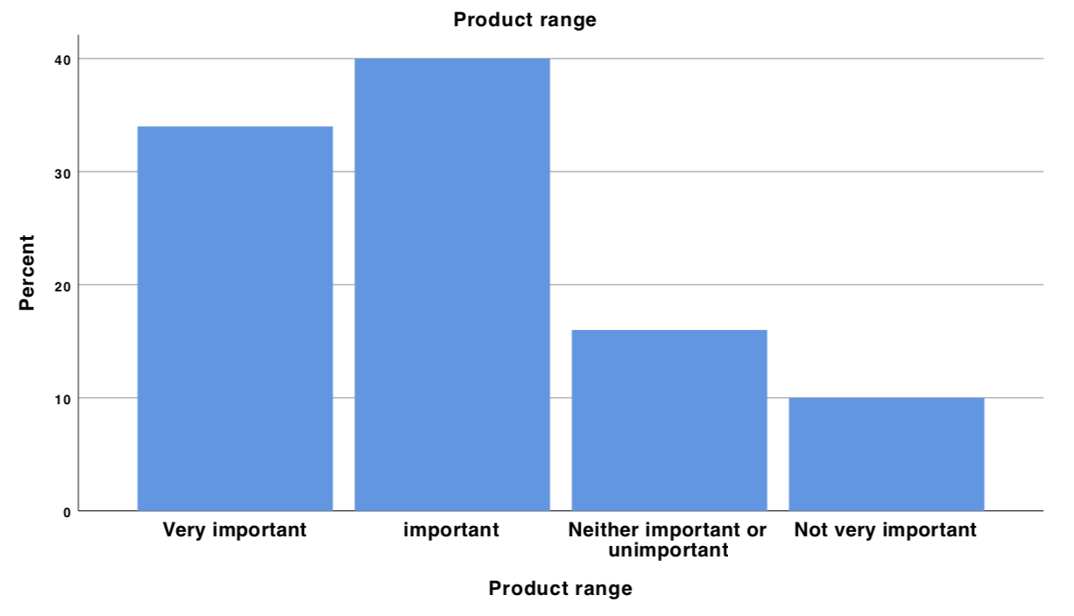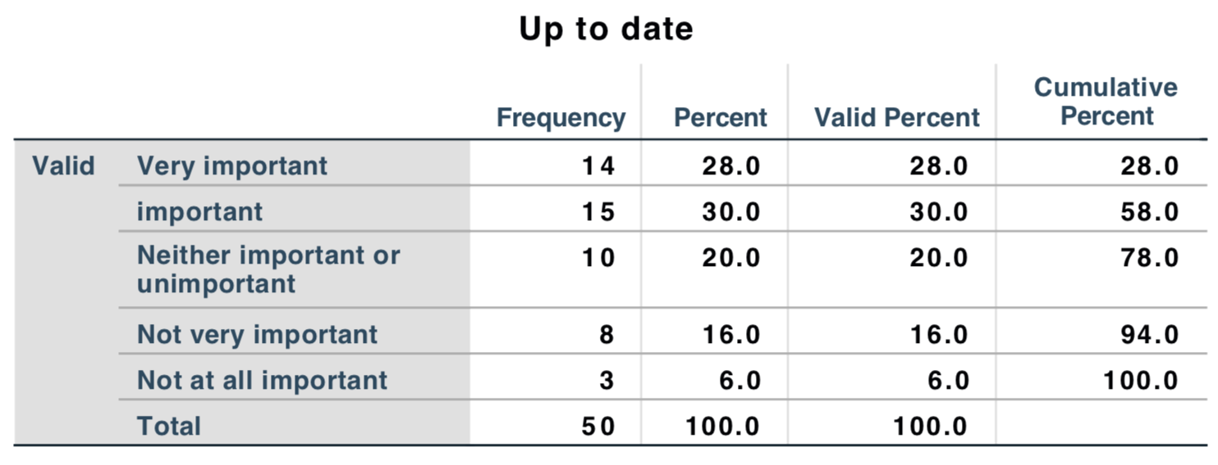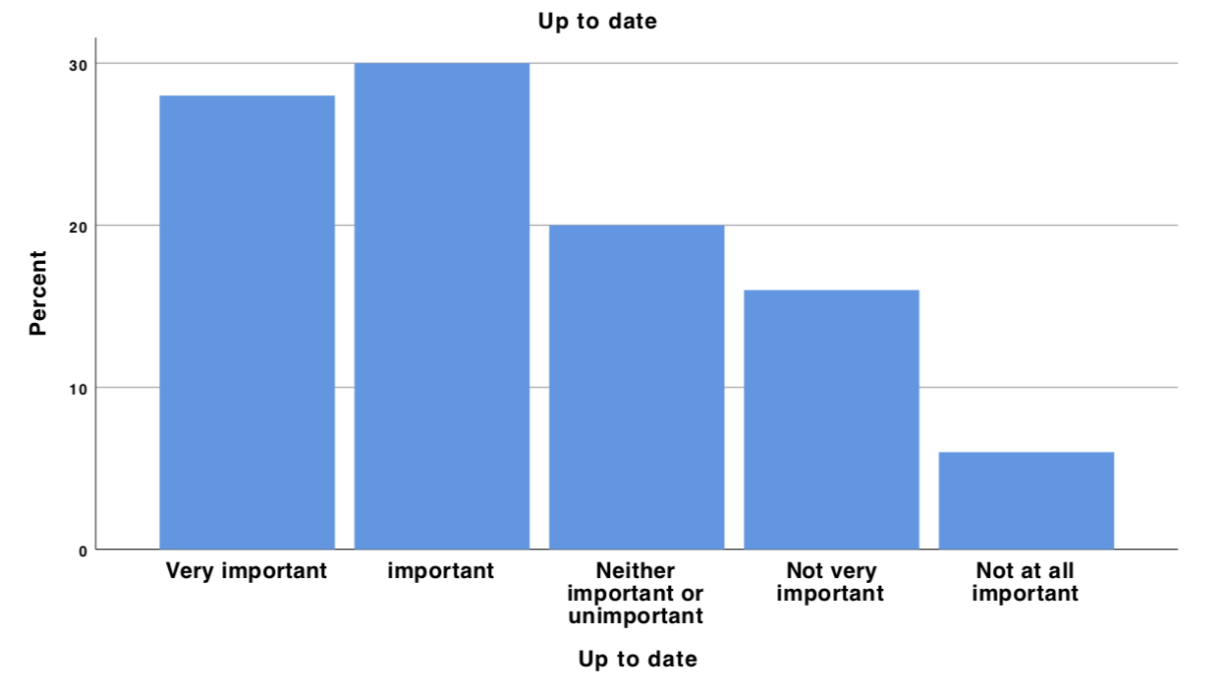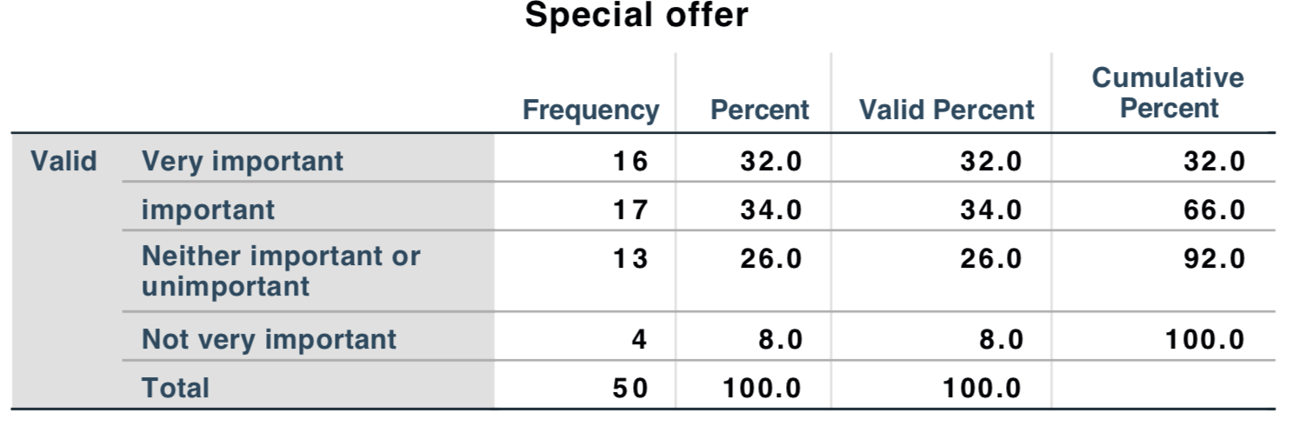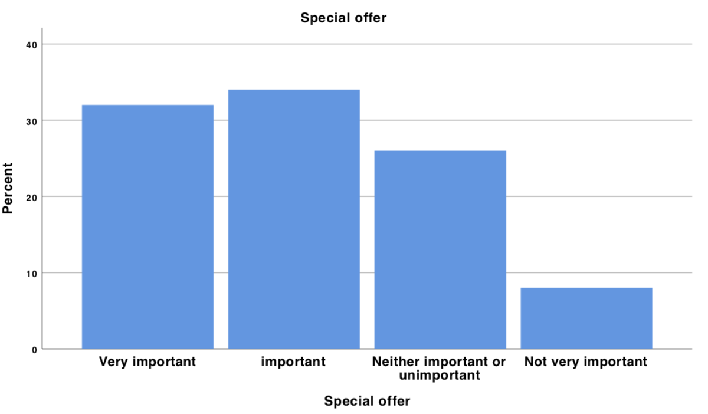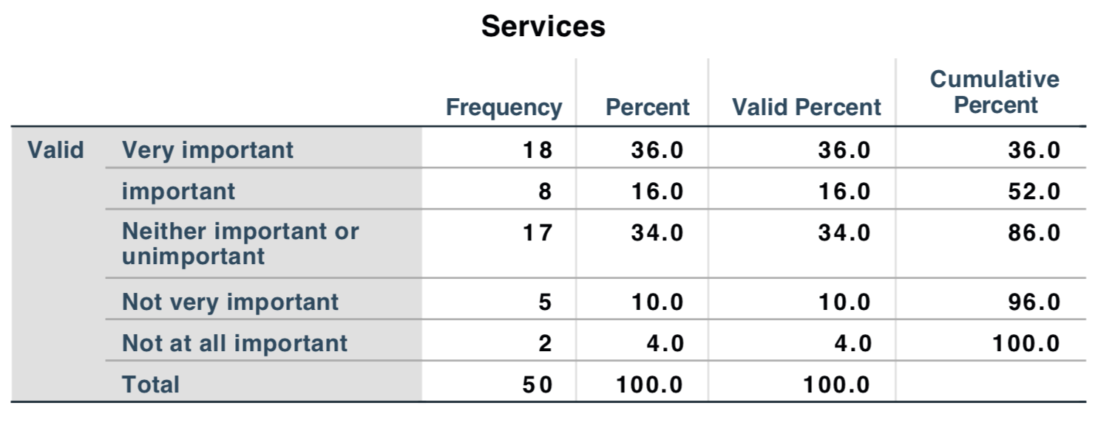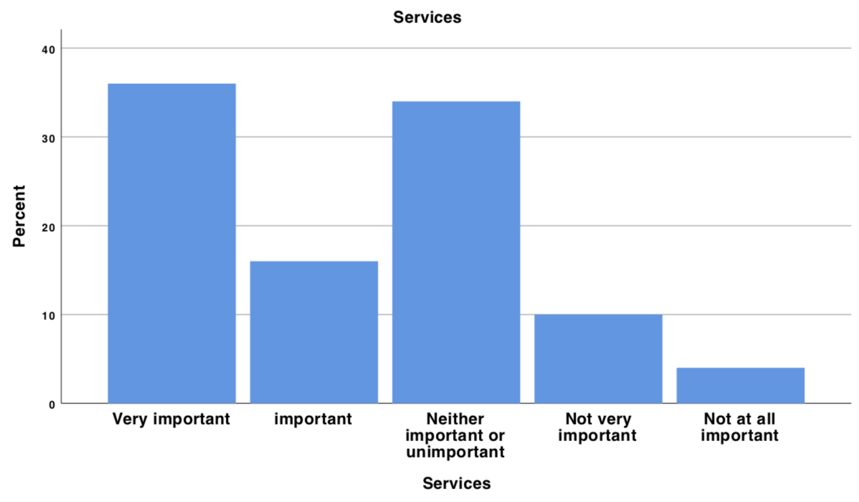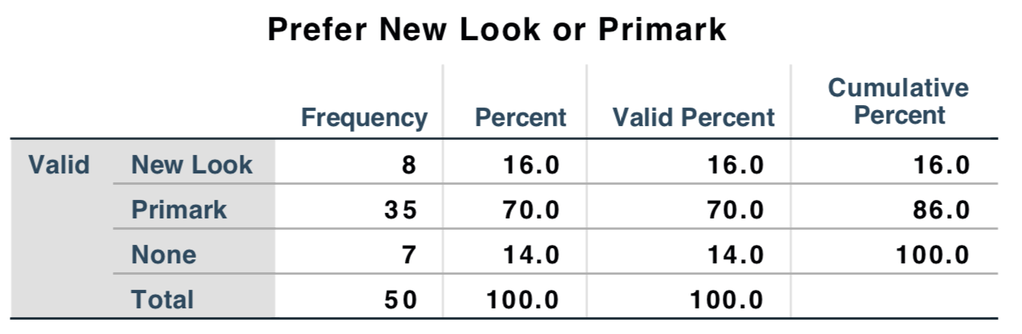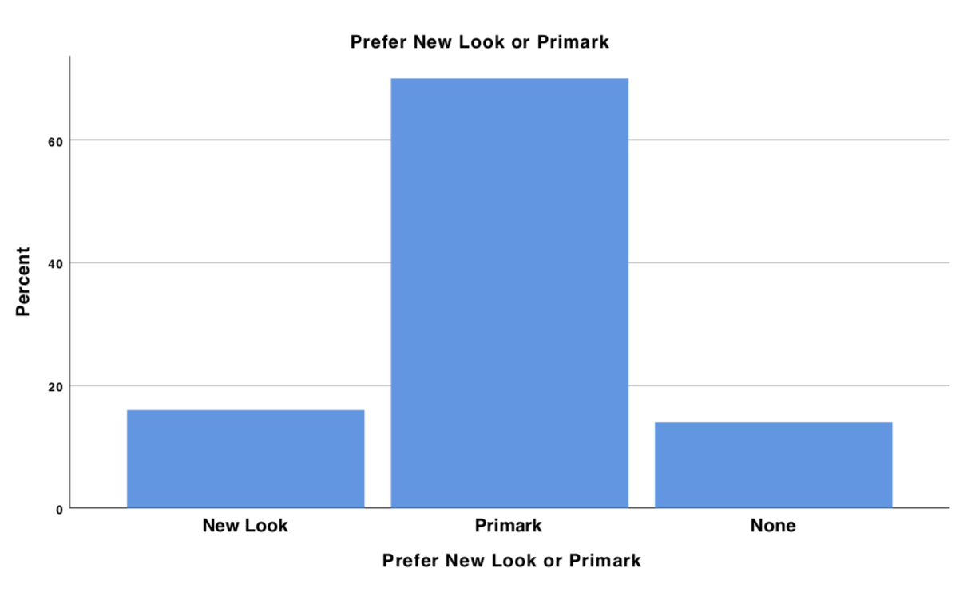

Appendix 3- Interview questions

Hello. My name is Chang Liu, an MBA student in University of Wales Trinity Saint David. I would like to invite you to participate in my research project. The aim of the research is to compare New Look and Primark to see how they have responded to current challenges in the retail industry. This will only take a few minutes. All answers and results are anonymous and will not be shared with any third party. Your input is very much appreciated! Thank you for taking part!

1. I found that in March 2018, New Look closed up to 60 of the 600 British stores. But Primark sales rose by 3% in the end of March. Could you please tell me why you think that is the case?

2. What distinctive capabilities do you think fashion retailers should develop to be successful in the future?

3. Could you please tell me your opinions about current challenges facing the fashion retail industry?

4. In your opinion, what did the fashion retailers do to manage the change to the current situation?

5. What change if any would you welcome?

6. What vision do you think the fashion retail market will be in the future?

Thank you so much for your time.

Appendix 4- Interview transcript

Q ：The question one. I found that in March 2018, New Look closed up to 60 of the 600 British stores. But at that time Primark sales rose by 3%. Could you please tell me why you think that is the case?

J：Well, it’s simply that New Look has been in difficulty for several years and is lost making and It is owned by a private equity company, and regards it’s way forward as involving the closure of its loss making stores. So on that basis, perhaps twenty percent of the stores make a loss conservation and just cut them.
Primark is owned by the western family. it's a profitable and very successful, highly appreciated company and it's making profit. So, there's no need for them to close any stores. Of course, we can find that they build new stories in the city and it may close another smaller stories that's not trading so well, whatever. So, it becomes always opening and closing stores. But with New Look, it's in difficulties. And that's the reason why it's adopted this approach. we renegotiate many of its leases since it pays less went, but also to close sixty stores right.
Q : And then, what distinctive capabilities do you think fashion retailers should develop to be successful in the future?
J: Yeah. Well, New Look at one time was one of the most successful new retailers. I think New Look was set up in about 1968, 1969 and was very successful. It was the products were cheap. It was the things well made, and especially in that sort of young women and their mothers and was very successful.
What the comparison between Primark and New Look show is that, first of all, you've got to keep selling products that meet what your consumers want. And with me, New Look, they keep changing it. Primark, though, is very much sort of mid-range. it's not trying to be too exciting but keeps its price low and always like that.
The same thing is that the Primark has been run by not same group of people, but certainly by the same company since it was set up in whenever it was 1968, 1969.Whereas New Look has changed several times. And each new company that comes in and says, well, we can do it better. So consistent approaches are the thing as needed.
Thirdly, of course, fashion is very much about making goods as cheaply as possible in the far east. And both New Look and Primark has been criticized for lack of integrity in ensuring that people get paid. But it doesn't hear the differences between the fact that New Look is moral, or Primark is moral. but customers are very price oriented. And unless you can sell good at cheap price or convince customers why they should pay more, then you know your sort of ability to consistence or in denial.
And fourthly, I think Primark has always been seen as a very successful company and the people who write about fashion and who read vogue and so on. Regard Primark is a company that it has gonna compassion and fashions change. Whereas there are changes in New Look, the changes in membership, the changes in management. I meant that sometimes New Look is being too expensive. At the moment, New Look is trying to be very cheap to cut its costs and so on.
But in the last three or four years, the private equity company that's burning it. it introduced a lot of very exciting new designs, but in fact world popular with the customers who generally went to New Look. So, the customers who go to New Look usually are in the lower social groups of C to D and E.
So, what you need to do is have some consistency in strategy. You need to understand your customers a lot more. You need to have good designers who were will be able to produce articles that are attractive and also have links with overseas suppliers. So that means the goods can be made cheaply.
But we have the problem that, of course, the usual world is changing so quickly everywhere. And the other thing that you need is just good luck. Because you see many wonderful retailers that got into difficulties simply because they didn't pay enough attention to the changes that were happening in the marketplace. So that capability, you know, you need to be able to walk and have a future.
Q : And professor, I just heard you mention a lot of changes. So, could you please tell me your opinion about current challenges facing the fashion retail industry?
J: Well, the most important one is probably the fact that people are spending less on fashion than they used to. So, people who shop at New Look they couldn't decide what to buy. The items were cheaper, they might buy both things so that they might bring the other thing go back for then and might wear. people are much less likely to do that. it's spending a lot more on entertainment, on experiences, going to shows, going to concerts, eating out and so on and much less on the retain of goods. So, fashion retailers have got to compete with not only other fashion retailers, but the alternative ways of outspent of spending money. so that's the first problem.
The second problem is what's happening to brick and mortar retailing easy. The cost of running a brick and mortar shop are extremely high. And it is very difficult to make money from it. Many large companies in the fashion industry have gone bankrupt, gone into administration in the last three years. And the coincidence because the operating costs of shops are very high. So probably what to do about online retailing. And if you're a new company, it's probably best to better off starting up online, and then perhaps opening a few shops if you can in the major trading centers.
so, there's going to be the big changes, I think. And it's very difficult to lay down a recipe or a menu that retail can use, you know, and say well do that and everything's going to be alright. The retail fashion industry changes so quickly. it's very very hard to bring that about. But probably with New Look, the question is after that close the sixty stores, they cut their costs and so on. So what are they going to do next? what are the next options? Probably they got to introduce products at lower price, but also that made the target customer base a lot more successfully than has been the case in the last three years.
Q: And then, professor, what do you think what kind of change, if any would you will come to the retail industry?
J: Well, at the moment I think that, the brick and mortar retailing is in difficulties. And one reason why it's in difficult is because it's being too late to respond to online retailing.
Another is because you have to pay taxes and business rates and wages which much higher than that paid by online retailers. So, the first thing is to say, it would be nice if the government saw this as an issue and change the tax system to ensure that everybody is in tax ensure. I got the moment that the online retailers are able to pay much lower rate of tax than was a case for, as you know, the consumer is always right. Consumers have changed. they spent much less on clothes. They want clothes that are much less expensive than before. But in addition, probably the best thing for fashion retailers would be when if there was a new trend that everybody got to have, if that everybody started wearing skirts that were half way again the car and customers are again dive and find things.
So, one reason why the fashion industry is in such difficult settings is because the fashion is no longer like a single thing that everybody has to buy and conform to. That people can be fashionable in their own ways and cheaper. It is the same with male fashion as well as female fashion. Whether we like to get back to the idea that fashion means everybody dressing the same way, I don't know, but just think that would be very successful fashion gallons if they would do that. Probably this is just an old man talking.
So, I think one change is government change. There's another change I think it must would see wearing fashionable clothes as important again. And you know, I think there are some ways away from that some years away from that.
Q: So, is that the view of the fashion retail market for the future? Well, what vision do you think the fashion will be in the future?
J: It's a difficult question. I think that in the last few years, fashion has been a very turbulent market. many stores players and businesses have gone out of operation. In the next two or three years, what we're going to see is the sort of stability, with the industry controlled by some four or five companies and dominating industry. And then thousands of much smaller companies doing specialized jobs. Probably one of those companies is going to be Amazon. In the UK another going to be ASDA. In the bricks and mortar industry, it's going to be Primark. whether New Look will continue to exist I don't know. Next wonderful would continue to exist.
And the third one is going to be Philip Day with the Edinburgh woollen mill. Philip Day has been buying up for the last ten years, every fashion brand that can. And it will be very interesting to see what he does with these. Well, we're already see the department stores are much less important to fashion than was the case that ten years ago. And some people are also questioning whether the department stores will continue to exist. Obviously, a lot of department stores are going to close, but the thought that a smaller department stores where you are selling mainly fashion, but also perhaps food and leather goods and health and beauty perfume and so on would be successful. But the industry has yet in a position to move to live there.
So that's the fashion retail market would be like, I think it will be smaller and fewer big plans. Online would be very important. The goods will continue to be cheap. Once again, the consumer will be always changing and always forcing other changes. There's other point I mentioned that many department stores will go and department stores have been important way of selling middle range and expensive fashion to people. So new ways have to be developed in order to continue selling luxury and big market pressure goods to consumers want to buy those or can be induced by them.
That's all. Thank you so much for your time.

Table of figures
Figure 2.2.1 Porter five forces theory 8
Figure 2.2.2 Value chain theory 10
Figure 2.3.1 Typology of organisational change 12
Figure 2.4.1 Lewin’s force field shows the driving and restricting forces of New Look’s closure 15
Figure 2.4.2 Lewin’s three step process 17
Figure 2.6.1 Stakeholder map of New Look closure 21
Figure 3.0.1Research onion 23

