
International Business Communication
LCBB6001
BA (Hons) Business Management
University of Wales Trinity Saint David (London Campus)
Student Name: Oana Gabriela Marin
Student ID: 1909897

Table of Contents
Introduction 3
Overview/ background of ASDA 4
Location 4
Mission 4
Introduction to the developing country by using PESTLE Analysis 4
Cultural differences 6
Communication barriers and challenges between the UK and Bangladesh 8
Cultural sensitivity 9
Communication strategies and recommendation 10
Conclusion 11
Reference 12

Introduction
International business occurs when goods, services, technology, capital, and knowledge are traded across the national border as well as beyond the national border (Cavusgil et.al, 2014). When the transactions of goods and services are traded between two or more countries it is called a cross-border transaction. The transaction involved various economic resources and the international production of physical goods and services like finance, banking, and insurance. Moreover, globalization is another name for international business. On the other hand, communication is a medium to transmit information from one place, and people to another (Guffey & Loewy, 2012). Communication is the most important part of international business. However, there are so many production challenges a country faces like a lack of skilled workers, poverty, lack of support, and so on. In this report, the chosen company is ASDA, and the developing company in Bangladesh. In this report, first of all, the introduction of the developing company is discussed. Additionally, the cultural differences between two countries, challenges and barriers between them, and cultural sensitivity are discussed.

Overview/ background of ASDA
In 1949, ASDA stores were founded as a firm that is Associated Dairies & Farm Stores Limited (ASDA, 2004). After being associated with the merger of the Asquith chain of three supermarkets, it adopted the name ASDA in 1965 (Weave,2019). The abbreviation of ASDA is Asquith and Dairies. IN November 1964, ASDA took the benefits of the termination of the price maintenance retail instead of offering large-scale, minimal cost supermarkets, the GEM retail that took over by aid and included the first out-of-town store in West Bridgford. In the North of England, the store mainly focused on the food retailer which expanded in 1989 in the South later. The large-format store is getting rival Gateway superstores by buying it for 705 million pounds (Student, 2016).

Location
ASDA made its headquarters called "ASDA House." In the Holbeck district, West Yorkshire, the building was located as one of the large office blocks to open as the part of the redevelopment of the large area south which is situated at the River Aire in the city center (ASDA, 2004).

Mission
The mission statement for ASDA is to set out the long-term strategies for the business. The main mission of this company is to become the best-value retailer to exceed the need of the customer in Britain always. However, ASDA is the statement of the purpose. It helps the stakeholders of the business to get to know the reason the business exists. Its purpose is to make products and deliver the service to the customer more affordably.

Introduction to the developing country by using PESTLE Analysis

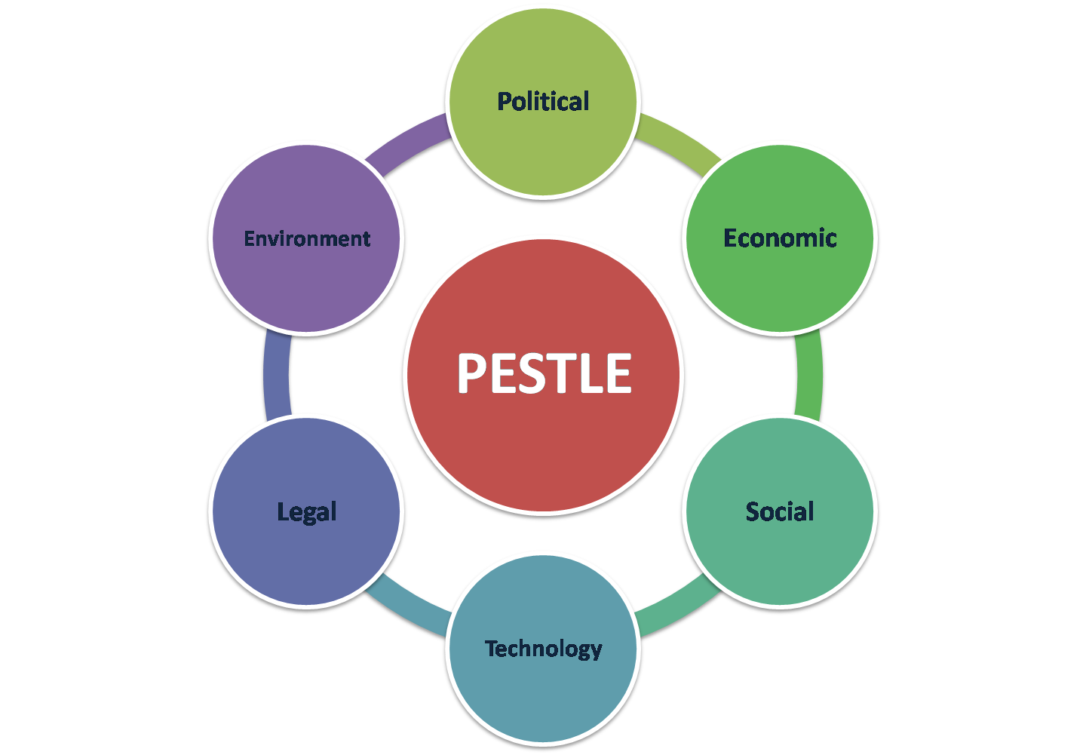
Figure 1: PESTLE analysis
[Source- pngimage.net]
Political Factors: Bangladesh is a unitary parliamentary democratic republic country. Its presidential and legislative system is fully functional. The president of Bangladesh is Sheik Hasina Wajed and she is the prime minister of the state. Other political parties are functional and they have their independent objectives. Anything against the regulation is strictly prohibited in Bangladesh. The political environment is stable in Bangladesh. Bangladesh is an ally of the United States which is a great advantage for the business. Despite having a non-chaotic political system, corruption is a little bit noticeable in Bangladesh. Bigger corporations tend to take bribery and they try to dominate using their power. In some cases, corporations have to bribe politicians to sustain the market.
Economic Factors: Bangladesh has a GDP of 348.891 billion dollars (2020) (Khan et.al, 2018). In the last decade, Bangladesh has seen immense developments, and currently, it's the 35th strongest economic power in Asia. The second major industry of Bangladesh is the cotton industry which contributes 28.5% to the economy of the country (Banu et.al, 2018). The third main industry is agriculture which added the value of 13.1% of the agricultural products like fruits, spices, tobacco, sugarcane, wheat, jute, tea, rice, and many more (Hossain, 2019). Moreover, this country provides labor with a very cheap amount in the Middle East in different categories by whom it earns money when they come back to their home country. However, compromising remittance is about 5% of the total GDP (Sayed, 2022).
Social Factors: Bangladesh is one of the most developing countries in the world. The culture of Bangladesh is sort of Indian culture and it follows patriarchal and hierarchical values strongly. The head of the family is the elder man the family and the young one must abide by their rules. Both home and workplace maintained these rules. The mother language of Bangladesh is Bangla. Moreover, 90% of the citizen are Muslim, but Hindu, Christian, and Buddist are also seen in this country (Arif & Hossin, 2016). As Bangladesh is mostly a Muslim country, that is why Muslim religious festivals are the main occasion in this country. However, it also respects the other religious festivals.
Technological Factors: Bangladesh has limited industries and research institutes. They are working on developing their labor force and advanced infrastructural facilities. They are working based on prioritizing innovation in the latest technologies which can create a difference for mankind. Bangladesh focuses on its research and development sectors. They are trying to involve foreign participants in the tech industry to develop connectivity around the globe.
Legal Factors: Bangladesh's Legal and Judiciary system is structured based on the British Judicial System of the colonial era. Bangladesh has a fair and functional legal environment. The incentive and tax systems are favorable as well. However, Bangladesh does not allow investment that can hamper its environment like forest plantation, mining, etc. On the other hand, the government warmly welcomes the other types of investment and business except these.
Environmental Factors: Bangladesh is full of natural resources which is the main attraction for tourism. However, it becomes the worlds’ second most polluted country according to the report 2019 (Hossain & Ahmed, 2019). If the country promotes its tourism and attracts foreign investors it is not an admirable characteristic. The major issues in the country are water and air pollution.

Cultural differences
Geert Hofstede is a Dutch social psychologist. His model is a framework of cultural models. It is more essential because it helps to know about cultural differences between countries & how to handle those differences.
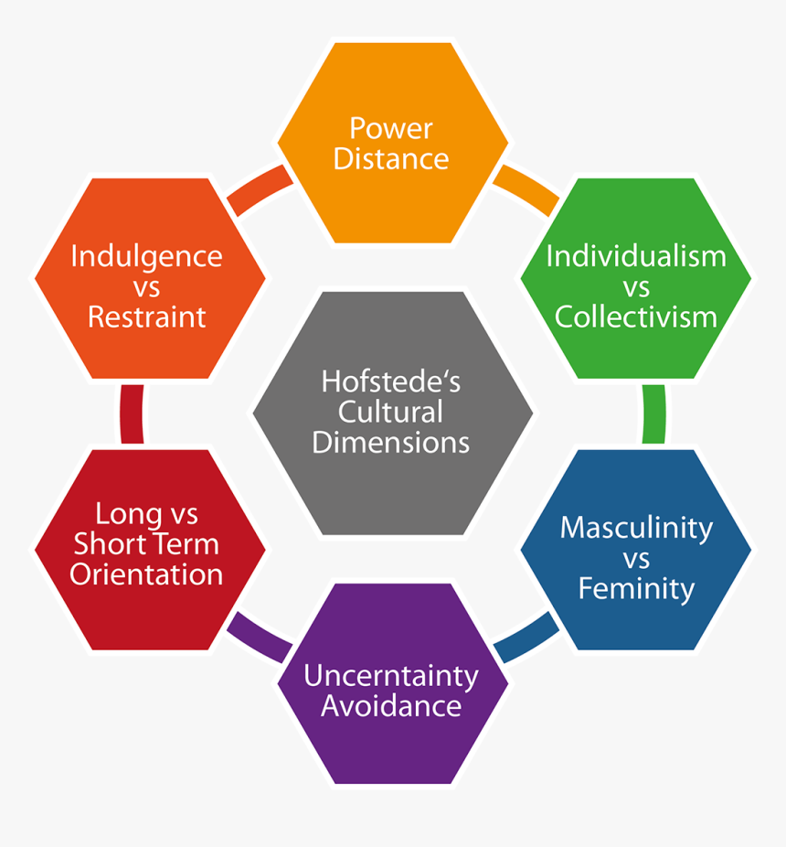
Figure 2: Hofstede cultural dimension
[Source- Robbins, 2010]
Power Distance: This dimension shows the inequality between powerful people & without power. A high PDI rate means in the hierarchy distribution number & low PDI means people are moderate. In Bangladesh, power distance is high compared to the UK. Here, people are maintaining their hierarchical position & they think their decision is right. They believe that the way they do their work is good for the organization (Naghavi & Mubarak, 2019). At the time of global expansion, Bangladesh & UK employers face this distance dimension. So, during the time of promotional activity, they need to focus on this distance to grab a huge market.
Individualism vs Collectivism: The individualism dimension means people have an individual interest. These people are concentrating on their own goals. In a collectivist culture, people think about a group's goal. They always think about other people's motives. In UK culture this rate is so high on the other hand in Bangladeshi culture collectivism rate is high (Haque & Mohammad, 2013.). These are opposite cultures. In a time of marketing activities, ASDA needs to focus on these dimensions. They can give family offers like buy 2 get 1.
Uncertainty Avoidance: People in different cultures have different looks about uncertainty. With high uncertainty avoidance, cultural society is more organized and they think about their laws. These feel uncomfortable in an unorganized society. These people are focused on safety & fewer risk-takers. On the other hand, low uncertainty avoidance culture people behave relaxed in terms of unorganized situations. They are happy with ambiguity & unsolved problems. In these cultures, rules don't get any priority. People believe their versions. In Bangladeshi culture, the uncertainty avoidance score is at a high point. These cultures believe in their emotions. For that reason, ASDA needs to focus on what people think & what type of activity they like.
Long Term Orientation: This dimension focuses on how people are connected with their past & they are dealing with that. Here Bangladeshi score is higher than the UK. These people are more connected with their past wars. To catch Bangladeshi markets they need to focus on their events like International Mother Language Day.
Indulgence: This dimension focuses on how people are managing their own needs & impulse. On the other hand, those who have weak control are called "Restraint". In this dimension, the UK holds a 69 score while Bangladesh holds 20 (Littlemore, 2003). Bangladeshi people are thinking about their norms & society's culture. During the time of advertising ASDA can focus on Ramadan. They can offer the product for Iftar.
Masculinity: Compared to the UK & Bangladeshi culture in this dimension the UK scored 66 & Bangladesh 55 (Abdullah et.al, 2011). High scores mean the culture focuses more on their achievement & success.

Communication barriers and challenges between the UK and Bangladesh
In the UK ASDA offers the products to their customers at a lower price and delivers them the respect which they desire. The company offers part-time as well as full-time employees for the company. For this reason, most young minds in the UK do part-time jobs for their tuition. The communication strategy of ASDA is to provide the own service of the company. For this purpose, they are using modern technology and developing social networking to get to know others (Rhodes et.al, 2003). The internal communication of ASDA is very well organized so that everyone knows who is reporting whom. They are using the same marketing channels for marketing purposes. People who are working at the central-local on service get to know about the research data of marketing.
Now the difference between two countries' communication is about people's minds. In the UK most people at ASDA are all the people in the community and also they offer students to do work in their stores. They do this work to support their tuition fees. Because they know if they want to be successful in the country they have to be in people's eyes and doing moral work for the welfare of the society is the biggest thing a brand can do. In the UK, affiliation with stars will not be productive as working for people. ASDA always raises its voice against racism, sexism, inequality, and allowing people who are deprived of it (de Brito‐Ashurst et.al, 2011). Moreover, they apply high-end technology in their marketing process. In Bangladesh, people are very much fond of their culture and language. Additionally, students cannot work at the retail store. The story in the UK does not match with Bangladesh, so they will have to do something that will match Bengali culture. They will have to focus on the cultural values and language more in Bangladesh. So, the main difference is culture, language, and people's perception of it. ASDA will have to research and make their campaign around what the cultures demand.

Cultural sensitivity
Fast-growing businesses take a new initiative to introduce their business in another country. The business takes a new footprint around the globe. They will be introduced to a new audience which is more interesting & challenging for them. There are some pros & cons to global expansion. Introducing a business in a new country with a new audience it’s not easy (Roodsaz, 2018). Some cultural problems arise. Before global expansion people need to know about the host country's rituals, culture, business ethics & employment rights & conditions. Before the expansion, companies need to change their promotional activities based on the host country's culture. ASDA is a well-renowned brand in the UK market.
The culture of the UK is different compared to the host country Bangladesh. ASDA, UK knows their customer very well. So, they do the advertisement according to their own country's culture. The demand for the product and the product listed on the menu is completely different in Bangladesh. Also, the packaging process and design are different from Bangladesh. Their communication with consumers inside the store is also different from Bangladesh. The UK is so into the Christmas and New Year festivities. On the other hand, Bangladesh is completely a Muslim country and they prefer the EID festival two times a year also they prefer cultural programs like pohela boishakh, falgun. Moreover, ASDA always tries to come up with new advertisement strategies in this period. In Bangladesh, their advertisement strategy will support the right activities and stand against all wrongs. Their advertisement strategy in Bangladesh should be a friendly conversation area and comfortable. They will have to make sure people who are a part of ASDA should feel like a family.

Communication strategies and recommendation
Culture is one of the most pivotal aspects that influence consumer behavior in decision-making. ASDA is originally from the UK which is the home country and if ASDA will operate in Bangladesh it will be the host country. Both countries hold different cultures. So it will shape their behavior towards the brand. Some of the cultural factors are beliefs, norms, ethics and values, religion, and language (Van Ruler, 2004). Both countries share different cultural values. Thus it impacts consumer behavior. Bangladesh always prefers its language first over any language. So ASDA will always put their name in Bangla language in outlets first. ASDA knows that it would make an impact on Bengali Consumers. Consumers love a brand when they see its culture is practiced by the band. ASDA will be successful in Bangladesh for maintaining everything around their culture. Since the UK is the home country, ASDA doesn't have to work on anything with language. Bengali people love their values, norms, and cultural heritage. So, ASDA will have to follow the norms of Bangladesh. In Bangladesh, Most people use their hands while they receive or give money. They strictly follow these rules. ASDA will also support this norm and widely follow it in their store. This is another cultural factor that shapes consumer behaviors. To make them believe that this brand is best suited for their culture and the country, they've got used to their culture. Bengali people have a widely followed tradition in their country. For this reason, ASDA will have to bring some changes to its ambiance. To make their company more popular among local Bengali people they will have to do this and people in Bangladesh love that their tradition is being respected by the foreign companies. That will increase ASDAs' sales growth in Bangladesh and will be overwhelming compared to their rivals' retail stores.

Conclusion
ASDA is the name of a famous British retail store. It's a well-renowned brand. It expanded its business in Japan and Chile. With these expansions, we can easily believe how popular it is. They are more popular because of their authentic products and services. ASDA has huge popularity in Japan. But it still faces some barriers from its competitors like Walmart, and Tesco. Every single day they try to build up their marketing strategy. If ASDA opens its new outlet in Bangladesh at Dhaka it will be more popular. They have a strong loyal customer base. As ASDA's people's first choice & their loyalty is so high they can easily grab new consumer minds. In the time of buying products from ASDA people don't think about their test & quality they can buy them. Because they have a mindset about it and for this reason, ASDA remains popular in the UK.

Reference
Abdullah, A.B.M., Boyle, S. and Joham, C., 2011. Cultural factors in workforce management: the case of multinational companies operating in Bangladesh. International Review of Business Research Papers, 7(2), pp.196-211.
Arif, T.M.H. and Hossin, M.Z., 2016. A comparative analysis of internal and external environments between Hotel Hyatt, UK and Hotel The Cox Today, Cox’s Bazar, Bangladesh. IOSR Journal of Humanities and Social Science, 21(6), pp.13-22.
Banu, N.T., Rahman, S. and Khan, R., 2018. Freddy’s Coffee Shop: Expanding the Coffee Business in Bangladesh. SAGE Publications: SAGE Business Cases Originals.
Cavusgil, S.T., Knight, G., Riesenberger, J.R., Rammal, H.G. and Rose, E.L., 2014. International business. Pearson Australia.
CompaniesHistory.com - The largest companies and brands in the world. 2004. Asda. [online] Available at: <https://www.companieshistory.com/asda/> [Accessed 19 April 2022].
Guffey, M.E. and Loewy, D., 2012. Essentials of business communication. Cengage Learning.
Haque, S.T.M. and Mohammad, S.N., 2013. Administrative culture and incidence of corruption in Bangladesh: A search for the potential linkage. International Journal of Public Administration, 36(13), pp.996-1006.
Hossain, M.S. and Ahmed, S., 2019. Quality cereal seed in achieving sustainable development goals in Bangladesh: A review of perspectives on policy analysis. Journal of Agricultural Research Advances, 1(03).
Hossain, N.T., 2019. Analyzing the business prospects of ABC Globals Limited in Bangladesh.
Khan, M.R., Hossain, S.K. and Rabbi, M.M.I., 2018. The Strategic Environment Analysis of Islami Bank Bangladesh Limited (IBBL). IIUM Journal of Case Studies in Management, 9(1), pp.28-41.
Littlemore, J., 2003. The effect of cultural background on metaphor interpretation. Metaphor and symbol, 18(4), pp.273-288.
Naghavi, N. and Mubarak, M.S., 2019. Negotiating with managers from south asia: India, Sri Lanka, and Bangladesh. In The Palgrave Handbook of Cross-Cultural Business Negotiation (pp. 487-514). Palgrave Macmillan, Cham.
Rhodes, P., Nocon, A. and Wright, J., 2003. Access to diabetes services: the experiences of Bangladeshi people in Bradford, UK. Ethnicity & health, 8(3), pp.171-188.
Robbins, S.P., 2010. Organizational behavior.
Roodsaz, R., 2018. Probing the politics of comprehensive sexuality education:‘Universality’versus ‘cultural sensitivity’: A Dutch–Bangladeshi collaboration on adolescent sexuality education. Sex education, 18(1), pp.107-121.
Sayed, M., 2022. A Comparative Analysis of Selected Retail Chain Brands in Bangladesh.
Van Ruler, B., 2004. The communication grid: an introduction of a model of four communication strategies. Public relations review, 30(2), pp.123-143.
Weaver, J.M., 2019. The history of the specialty of dental anesthesiology. Anesthesia Progress, 66(2), pp.61-68.

