Image Commentary: Royal 14 B V: Membrane 4 & 5 Rollo and his descendants
HPHI5009
Ania d’Abdank Kunicki
2306132

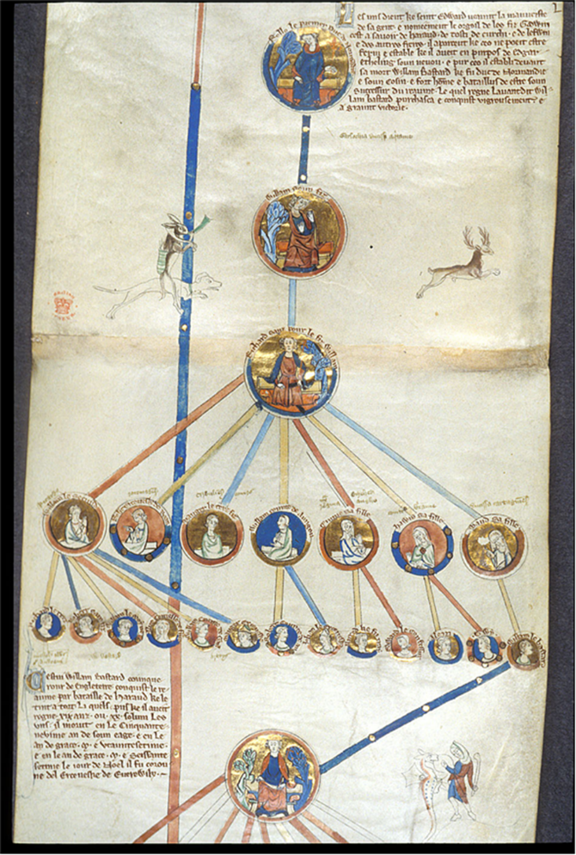
Royal MS. 14 B. V: Membrane 4 & 5

The image used for this commentary is from Royal 14 B V, Membrane 4 & 5 from the British Library. It is an example taken from “Les Grandes Chroniques de France” which contain information on the ruler of France and was commissioned during the reign of Saint Louis, who ruled as King Louis IX. It wouldn’t be completed until 1375. The document was produced during a turbulent time in history with France experiencing conflict such as the Hundred Years War and could serve as political propaganda in terms of legitimizing a persons claim to the French nobility. The preservation of the rolls that these were kept on has been instrumental in providing the historical context of how the family tree was laid out.
This image contains a family tree of the Normans. The fragment being used goes from Rollo, the first Duke of Normandy, to William the Conqueror. The first thing to notice about the writing is that it is in French and not Latin meaning that this was most likely a French manuscript that this image came from. The first person we see in this genealogy is Rollo, above his medallion it says, “Rollo le premer Duc de Normandie” which translates to “Rollo the first Duke of Normandy.” That gives us one clue that this would have been made after the time of Rollo and likely much later. One because the language that was used to write it was French and not Latin and also that if this had been made earlier, Rollo would have been known as Count of Rouen which made him the first ruler of Normandy. Rollo himself appears to be wearing a crown while wearing quite vibrant blue robes and is sitting on a bench. Behind the image of Rollo, gold leaf was used for the background of the image. After Rollo you have his son William who would later become known as William Longsword. His medallion is flanked by a hare riding a hound while hunting a deer. The scene he is depicted is quite similar to Rollo with the only major difference being the clothes and pose. He appears to be wearing a read robe or blanket over his blue clothes. William’s portrait would be followed by Richard I. he is also depicted quite similar however compared to Rollo and William, he is facing forward and appears quite angry compared to the other two portraits. Gold leaf has so far been used for the backgrounds of all the portraits and all of the portraits appear to have crowns on their heads.
After Richard I there is a change in the styles of the portraits. Before they were quite large and would have the whole body of the person as they were the only legitimate issue from the ruler that came before them that we know of. Richard I had multiple children who are included in this manuscript. From left to right it includes Richard II of Normandy, Robert II, Mauger, what I believe is meant to be William I Count of Eu, but it is difficult to read, Emma of Normandy, Hawise of Normandy, and maud of Normandy. The portraits for the children of Richard I are much smaller, presumably so that the scribe and artist for this manuscript was able to fit them all on the same page. Some of these portraits seem to have small notes written on top of them such as above Emma’s portrait you can see the word “Regina” which is likely someone making the note that she was Queen of England in the past. These notes look as if they were written in at a later time when looking at both the colour of the ink as well as the handwriting. Perhaps it was someone making notes after realizing some information had been missed when the manuscript was originally made. The portraits still include almost their whole body but are still significantly smaller than the portraits made above them. Another major change is that the gold leaf is not use on the background of ever single portrait and only certain ones. In the row of Richard I’s children the ones who have gold leaf used for the backgrounds of their portraits are William II, Mauger, Emma of Normandy, and Maud of Normandy.
In the third line of portraits it is noticed that these portraits are even smaller and only include the face of the individual rather than the body. The first ones included are the children of Richard II. It is hard to read exactly what the names are on the page, but it appears to include Richard III, his son Robert, the fourth is his daughter Alice, then you have who is likely one of his sons named William, and finally his son Mauger. This is the second time not all of the children have been included and also they were not necessarily put in birth order. The final person on that row is William the Bastard, there is a direct line drawn from him to a portrait of William the conqueror in the same style as the first few portraits, likely showcasing his importance as the conqueror of England while being Duke of Normandy. After him that is all we have of this image that is but a small piece if the whole manuscript. Next to this lat portrait of William there seems to be a drawing of a person perhaps training their pet dragon with a stick in their hand.
One thing to note about this genealogy is that the spouses are not included in it, only the direct line is included. Another thing that is left out is the children of some of the people included. Only two of Emma’s children are included and that is Alfred Ætheling and Edward the Confessor. It only includes two of her children buy Æthelred the Unready and none of her children by Cnut. It is not shown why it only shows two of her children, but it seems to be due to the fact that this particular family tree does not show much of those that are not connected to the direct line after a certain point. It could also be due to the space available on the roll that they had available. Perhaps those writing out the family tree did not believe her other children to be of high enough importance to include.
The art style is very typical of, most illuminated manuscripts of the time and of western Europe. The manuscript itself was finished long after the Normans had first been established in Normandy and over a hundred years after the Norman Dynasty had ended within England. The colours themselves are quite vibrant, especially the blue which shows that a high quality pigment was used and that quite a bit of money was put into the manuscript. The amount of money spent on this manuscript can also be shown by the amount of gold leaf used in the images, not only would the gold itself have been expensive, but it would have been and incredibly laborious process of carefully laying the gold leaf on the paper. It has a gothic style to the portraits with elongated faces and bodies, a style typical of the high medieval period in which the manuscript comes from. The one thing about this particular one is that it does not contain the same amount of detail as another similar manuscript Royal MS. 14 B. VI.

Bibliography:
Royal MS. 14 B. V: Membrane 4 & 5

Du Trévou, Henri Scribe, et al. The Major Chronicles of France. [Place of
Publication Not Identified: Publisher Not Identified, to 1377, 1375] Pdf. Retrieved from the Library of Congress, <www.loc.gov/item/2021668229/>.
de Laborderie, Olivier , ‘The First Manuals of English History: Two Late Thirteenth-Century Genealogical Rolls of the Kings of England in the Royal Collection’, Electronic British Library Journal, 2014
Mark, Joshua, ‘Rollo of Normandy’, World History Encyclopedia, 2018 <https://www.worldhistory.org/Rollo_of_Normandy/>
Masson, Victoria , ‘Emma of Normandy’, Historic UK <https://www.historic-uk.com/HistoryUK/HistoryofEngland/Emma-Of-Normandy/>
Public, ‘Rollo and His Descendants from BL Royal 14 B v, Membrane 4 and 5 - PICRYL - Public Domain Media Search Engine Public Domain Search’, PICRYL - Public Domain Media Search Engine, 2016 <https://picryl.com/media/rollo-and-his-descendants-from-bl-royal-14-b-v-membrane-4-and-5-d14953> [accessed 2 March 2025]

Du Trévou, Henri Scribe, et al. The Major Chronicles of France. [Place of Publication Not Identified: Publisher Not Identified, to 1377, 1375] Pdf. Retrieved from the Library of Congress, <www.loc.gov/item/2021668229/>.
Royal MS. 14 B. V: Membrane 4 & 5
Royal MS. 14 B. V: Membrane 4 & 5
Victoria Masson, ‘Emma of Normandy’, Historic UK <https://www.historic-uk.com/HistoryUK/HistoryofEngland/Emma-Of-Normandy/>.
Olivier de Laborderie, ‘The First Manuals of English History: Two Late Thirteenth-Century Genealogical Rolls of the Kings of England in the Royal Collection’, Electronic British Library Journal, 2014.

