

Student name: Blessing Ogieriakhi
Student ID: 2416087
Module name: Introduction to Physiology
Module code: BMHP5023_LON
Lecturer name: Shaila Hussai
Assessment: 1
Word Count: 2193

Table of Contents

Table of Contents 2
1. Introduction 3
What is diabetes 3
Types of Diabetes 3
Physiological Roles of Insulin and Glucagon 4
Risk factors associated with diabetes. 5
2. Blood Sugar Regulation 5
3. Cellular Metabolism 7
4. Tracking and Recording blood sugar levels for type 2 diabetes 8
5. Recommendations 9
6. Conclusion 10
Reference 11

1. Introduction
As a practice nurse working in a GP surgery, it has become increasingly evident from experience that a growing number of patients are being diagnosed with type 2 diabetes. According to Whicher, O’Neill and Holt (2020), diabetes is one of the most common chronic diseases in the United Kingdom (UK), with serious health and economic challenges.
There are approximately around 4.6 million people that have been diagnosed with diabetes in the UK, of which 90% are diagnosed with Type 2 diabetes (NICE, 2024). This report will explore diabetes holistically, focusing on Type 2 diabetes, which is considered the most prevalent endocrine condition (NICE, 2022). It will critically examine diabetes mellitus, comparing its various forms, investigating epidemiology, analysing the anatomy and physiology of glucose regulation, and assessing the influence of lifestyle factors on the course of the disease.
In addition, this report will highlight the complications in Type 2 diabetes, including its diagnosis, treatment, and long-term control, and provide relevant information to support patient education. Finally, the report will make appropriate recommendations on the impact of smoking, diet, and physical activity to improve patient outcomes and guide health policy and will integrate observations from clinical practice to show practical relevance.

What is diabetes
According to the World Health Organisation (2024), diabetes mellitus is a group of metabolic diseases described as high blood glucose levels caused by impaired insulin secretion. Pancreatic β-cells release insulin, which in turn promotes the uptake of glucose into skeletal muscles, adipose tissue, and hepatocytes, where it is either stored as glycogen or metabolised for energy. Chronic hyperglycaemia damages blood vessels and organs, resulting in both macrovascular problems like retinopathy, nephropathy, and neuropathy (Czech, 2017).

Types of Diabetes
There are two main types of diabetes: Type 1 and Type 2. The autoimmune disease known as Type 1 diabetes is characterised by the death of Pancreatic β-cells, leading to insulin deficiency. It usually starts in childhood and requires lifelong insulin therapy. Patients usually show signs acutely with polyuria, polydipsia, and weight loss, according to clinical observations. Type 1 diabetes needs insulin from outside the body (Atkinson et al. 2014).
Type 2 diabetes is the most widespread endocrine condition, and it is primarily brought on by a malfunction in the hormone-based communication system that controls blood sugar: insulin resistance and relative β-cells dysfunction. Some of the attributes include Obesity, inactivity, and high sugar diets. Delays in detection lead to complications, and many patients are asymptomatic at diagnosis. Type 2 diabetes can first be managed with healthy lifestyle changes and tablets. About 90% of diabetes cases in the UK, representing 4.6 million people, are Type 2, according to the country’s diabetes prevalence estimate for 2023-2025, as shown below in table 1 (Diabetes, UK, 2025).
Category | Estimated Number | Source
Diagnosed diabetes | 4.6 million | Diabetes UK
Undiagnosed Type 2 Diabetes | 1.3 million | Diabetes UK
Prediabetes (non-diabetic hyperglycaemia) | 6.3 million | Diabetes UK
Percentage with Type 2 Diabetes | 90% | Diabetes UK

Table 1: Source: (Diabetes UK, 2025)

Physiological Roles of Insulin and Glucagon
The pancreas is an essential endocrine gland that generates two hormones to preserve homeostasis, or glucose balance. These consist of glucagon and insulin. When blood sugar rises, insulin is released to tell cells to take up glucose for energy, and when blood sugar is low, glucagon is released to tell the liver to release glucose that has been stored. These systems malfunction in type 2 diabetes because cells become insulin-resistant (Hall, 2021; Tortora and Derrickson, 2018). Table 2 below illustrates the roles of insulin and glucagon in the body.
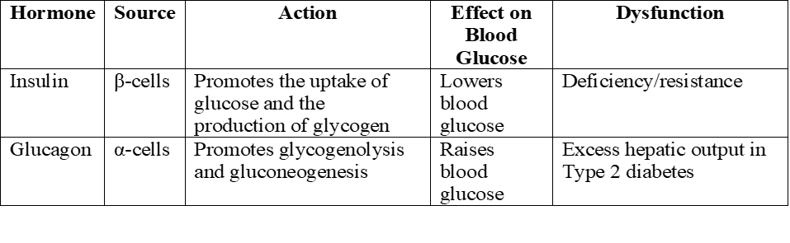
Table 2: Adopted from (Hall,2021; Tortora and Derrickson, 2018)

Risk factors associated with diabetes.
People of African descent, Caribbean, and South Asian are commonly associated with Type 2 diabetes. The risk factors associated with diabetes are modifiable and non-modifiable. Obesity, central adiposity, inactivity, poor eating habits, and smoking are all modifiable risk factors. Age, ethnicity, and genetic leaning are examples of non-modifiable factors (Singer et al., 2022). Central adiposity alters adipokine secretion and causes chronic inflammation, it raises insulin resistance (Ahmed, Sultana and Greene, 2021). Observational evidence suggests that more intensive interventions are frequently needed to achieve control in patients with multiple modifiable risk factors. The clinical presentation often reveals the importance of early detection and intervention, as individuals without a diagnosis often present with setbacks at the time of screening (Herman et al., 2015).

2. Blood Sugar Regulation
Insulin and glucagon work together to balance the system, ensuring blood sugar is at a healthy level (about 80-100mg/dL fasting). The pancreas is the organ that controls this process (Cleveland Clinic, 2022). Figures 1 and 2 show, respectively, the negative feedback loop and the regulation of blood sugar levels, while Table 3 lists the anatomy of blood sugar regulation.
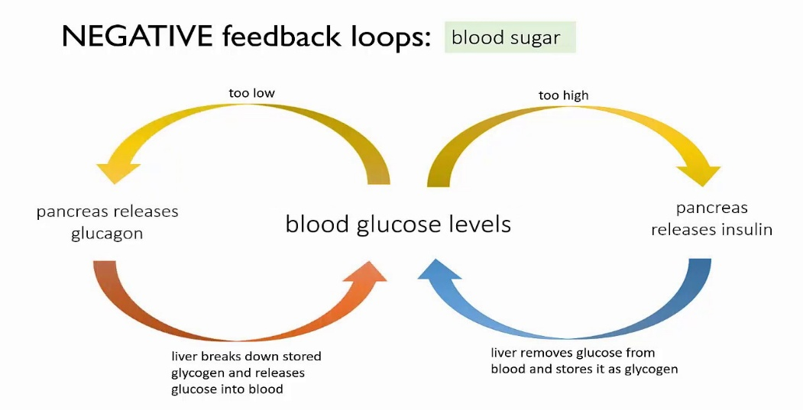
Blood glucose level Regulation

Figure 1: (White, 2020)

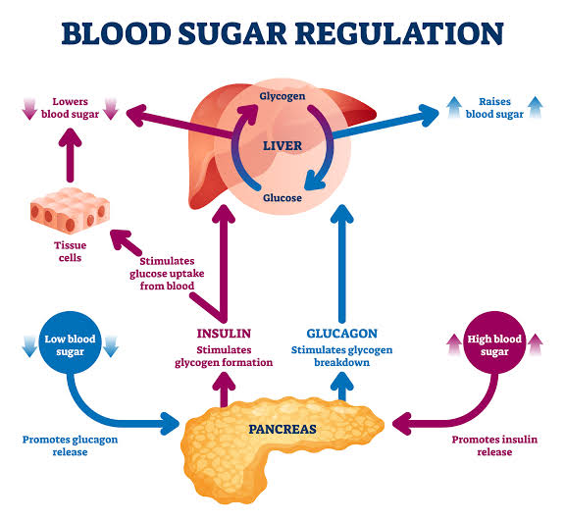

Figure 2: (VectorMine, 2026)

Insulin is released or secreted by the pancreas β-cells when blood glucose levels rise. Insulin stimulates or increases glycogenesis in the liver, increases fat storage in adipose tissue, and increases the uptake of glucose into skeletal muscle through Glucose Transporter Type 4 (GLUT4). GLUT4 is a regulated protein. It acts as a transporter, moving sugar into Adipose Tissue and Skeletal Muscle cells. Its movement to the cell surface is crucial for maintaining normal blood glucose levels. When blood glucose levels drop, pancreatic α-cells release glucagon, which enables the liver to produce more gluconeogenesis and glycogenolysis. The network of organ system of the body is made up of the skeletal muscles, adipose tissues, liver and the pancreas. These maintain blood glucose homeostasis (Czech, 2017). These important anatomical structures are listed in the table below.

Anatomy of blood sugar regulation
Structure | System | Function | Relevance to Diabetes
Islets of Langerhans, or the Pancreas | Endocrine/Hormonal | Release glucagon and Insulin | Failure of β-cells resulting in hyperglycaemia
Liver | Metabolic and Digestive | Processes Glycogenesis, glycogenolysis, and gluconeogenesis | Excess production of glucose in insulin resistance
The Skeletal muscle | Musculoskeletal | Primary site of insulin-mediated glucose uptake | Reduced uptake in insulin resistance
Adipose tissue | Endocrine and Metabolic | Storage of energy and secretion of adipokines | Excess adiposity (body fat) worsens insulin resistance

Table 3: Adopted from (Czech, 2017).

3. Cellular Metabolism
Cells use Oxygen and glucose for aerobic respiration, which generates adenosine triphosphate (ATP), the energy source. Glucose is converted by Glycolysis into pyruvate, which is further oxidised inside mitochondria during the Krebs cycle to produce Nicotinamide Adenine Dinucleotide (NADH) and Flavin Adenine Dinucleotide (FADH2). NADH and FADH2 are molecules that enable movement of high-energy from Electrons to the Electron transport chain during Cellular Respiration to help produce ATP (Campbell et al., 2020).
To generate energy (ATP), electron carriers pass electrons through the electron transport chain, where oxygen receives the electrons. In Type 2 diabetes, this process is impaired because the fats and muscle cells are unable to sufficiently absorb glucose due to insulin resistance. As a result, tissue function and physical performance is reduced in Type 2 patients (Tortora and Derrickson, 2018; Hall, 2021). See figure 3 below.
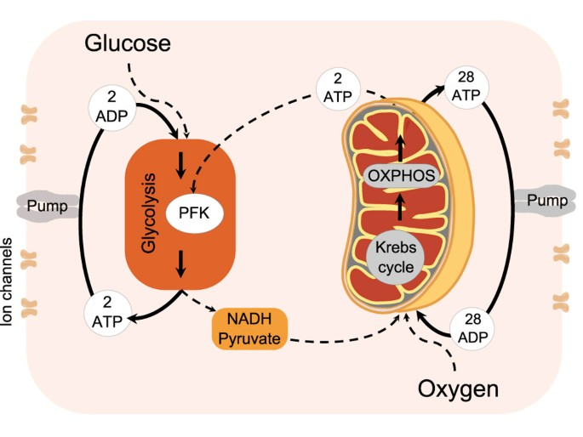

Figure 3: (Lancaster et al., 2016)

4. Tracking and Recording blood sugar levels for type 2 diabetes
Regularly checking and recording blood glucose levels is crucial for managing diabetes. The meaning of blood glucose readings, the importance of fasting and post-meal levels, and long-term indicators like HbA1c should all be explained to patients. Additionally, information about how often patients should check their blood glucose levels and how to accurately record results should be provided. Patients and medical nurses can spot patterns and trends by monitoring blood glucose over time, which enables prompt changes to medication or lifestyle choices like nutrition, exercise, stress, and illness that affect their blood glucose levels. This process encourages safer self-regulation and better glycaemia control. (ElSayed et al., 2023; DeFronzo et al., 2015).
Diabetes monitoring apps such as mySugr and Accu - Chek Instant have also helped people with diabetes to better manage their blood sugar (Roche, 2025). Moreover, diabetes patients who regularly check their blood sugar have fewer health problems such as kidney and cardiovascular diseases, retinopathy and neuropathy. In addition, their glucose levels are much more stable. (Davies et al., 2018). In people with Type 2 diabetes, with the help of these apps they can lower their HbA1c by about 0.49%, (Hou et al., 2016).
By saving data, providing learning materials, reminders, feedback, and help with taking medication and checking their health, patients can better keep track of their blood sugar, especially when they also get advice from healthcare experts (Bonoto et al.,2017). According to real-world data, Type 2 diabetes patients with high baseline levels experienced improvement in Haemoglobin A2 (HbA2) over 6-15 months. When blood sugar levels are not monitored and recorded, it may lead to remission. The Consequences of a remission could result in a prolonged high blood sugar level that affects different organs of the body negatively (Elsayed et al., 2023).

5. Recommendations
In treating Diabetes, NICE guidelines must be followed. The NICE guidelines (NG28) for type 2 diabetes, which were updated in February 2026, represent a significant departure from a one-size-fits-all approach in favour of individualised, risk -based management. Important modifications prioritised long-term organ protection (heart and kidneys) over only glycemic control (HbA1c) and advocate for combined initial therapy, which emphasises early cardiovascular protection (Brown and Diggle, 2026). Effective diabetes care combines medical treatment, health promotion, and lifestyle modification, as recommended by bodies like the World Health Organisation and NICE (NICE, 2022; WHO, 2024).
Managing Type 2 diabetes well is very important because it is a long-term chronic condition that does not go away. It needs lifelong and consistent management. Type 2 diabetes affects the way the body regulates blood sugar levels, and without proper care, it can lead to serious health problems. Therefore, good care helps prevent health problems and maintain a good quality of life. According to research, patients are more likely to safely and successfully manage their Type 2 diabetes when they are well-informed about basic pathophysiology of Type 2 diabetes and the lifestyle changes that affect blood glucose levels (Powers et al., 2020).
Giving Type 2 diabetes patients this basic information enables them to comprehend the need for medication, lifestyle modifications, and monitoring. Information about dietary management as part of healthcare workers’ roles is essential. Patients require precise instructions on how their dietary choices affect their blood glucose levels. Portion control, balanced meals, and the value of consistent eating habits should all be covered in education (Hall and Tolhurst, 2020). Patients can make educated dietary choices that help stabilise blood glucose levels by being aware of the effects of highly processed and high sugar foods. In addition to supporting glycaemic control, better dietary choices also help manage weight, lower cardiovascular risk, and lessen the need for more intensive pharmacological treatment (Evert et al., 2019).
It is commonly acknowledged that physical activity plays a crucial role in diabetes management and should be thoroughly addressed. Patients with Type 2 should receive advice on safe practices, including the risk of hypoglycaemia, and the amounts of physical activity required. Exercises support weight management, lower blood glucose, strengthen the heart, and improve overall well-being (Colberg et al., 2016).
Quitting smoking is another essential component of diabetes care. The risk of cardiovascular disease is already higher in people with diabetes, which is generally increased by smoking, which also increases insulin resistance. People with Type 2 diabetes should be informed about the negative consequences of smoking, the advantages of quitting, and the support services that are available to assist them in quitting. Improved circulation, better glycaemic control, and lower risk of long-term complications like neuropathy and heart disease can result from quitting smoking (Evert et al., 2019).
People with Type 2 diabetes should pay special attention to managing their weight. Research indicates that even a small amount of weight loss can greatly enhance blood glucose regulation and insulin sensitivity. Reasonable weight management control can improve physical mobility, lower the need for medication, and, in certain situations, cause Type 2 diabetes to go into remission. Patients with Type 2 diabetes can use their treatments more safely and effectively if they are informed about possible side effects, the importance of adherence, how medications work and lifestyle modifications (NHS, 2022).
According to research by Davies et al. (2023), People with Type 2 diabetes who check their blood sugar more often experience fewer issues like retinopathy, neuropathy, kidney and cardiovascular disease. They also have more stable glycaemic levels. This is evident in lowering long-term complications, sustained improvements in HbA2 over 6-15 months, according to real-world data, particularly in patients with higher baseline levels. Lifestyle factors significantly impact physiological functions and anatomical structures (Hou et al., 2016).

6. Conclusion
In summary, practice nurses can provide effective patient education by obtaining thorough information on diabetes pathophysiology, blood glucose monitoring, diet, exercise, quitting smoking, managing weight, using medications and preventing complications. These strategies empower patients, reduce complications, maximise resource use, and enhance quality of life by enhancing patients’ comprehension of their diabetes condition, especially Type 2, and the effects of lifestyle decisions, introducing digital self-monitoring tools, and offering ongoing support in primary care. Patients with Type 2 diabetes benefit from a standard healthcare service that is shaped and maintained by adherence to NICE and regulatory body guidelines.

Reference
Ahmed, B., Sultana, R. and Greene, M. (2021). Adipose tissue and insulin resistance in obesity. Biomedicine & Pharmacotherapy, [online] 137(111315), p.111315. doi: https://doi.org/10.1016/j.biopha.2021.111315 : [Accessed 3rd March 2026].
Atkinson, M.A., Eisenbarth, G.S. and Michels, A.W. (2014). Type 1 diabetes. The lancet, 383(9911), pp.69-82. Available at: https://doi.org/10.1016/s0140-6736(13)60591-7 : [Accessed 22nd March 2026].
Brown, P. and Diggle, J. (2026). The NICE NG28 type 2 diabetes guideline: Management update-what’s new? Diabetes & Primary Care, [online] 28(1), p.5. Available at: https://diabetesonthenet.com/diabetes-primary-care.
Bonoto, B.C., Araújo, V.E., Godói, I.P., Lemos, L.L.P., Godman, B., Bennie, M., Diniz, L.M. & Guerra Júnior, A.A. (2017). Efficacy of mobile apps to support the care of patients with diabetes mellitus: A systematic review and meta-analysis of randomised controlled trials. JMIR mHealth and uHealth, 5(3), e4. https://doi.org/10.2196/mhealth.6309 : [Accessed 17th March 2026].
Campbell, N.A., Urry, L.A., Cain, M.L., Wasserman, S.A., Minorsky, P.V. and Reece, J.B., 2020. Biology. 12th ed. Harlow: Pearson.
Cleveland Clinic (2022). Glucagon: What It Is, Function & Symptoms. [online] Cleveland Clinic. Available at: https://my.clevelandclinic.org/health/articles/22283-glucagon : [Accessed 11th March 2026].
Colberg, S.R., Sigal, R.J., Yardley, J.E., Riddell, M.C., Dunstan, D.W., Dempsey, P.C., Horton, E.S., Castorino, K. & Tate, D.F. (2016). Physical activity/exercise and diabetes: A position statement of the American Diabetes Association. Diabetes Care, 39(11), pp.2065–2079 : [Accessed 10th March 2026].
Czech, M.P. (2017). Insulin action and resistance in obesity and type 2 diabetes. Nature Medicine, 23(7), pp.804–814: [Accessed 23rd Feb 2026].
Davies, M.J., D’Alessio, D.A., Fradkin, J., Kernan, W.N., Mathieu, C., Mingrone, G., Rossing, P., Tsapas, A., Wexler, D.J. and Buse, J.B. (2018). Management of hyperglycaemia in type 2 diabetes, 2018. A consensus report by the American Diabetes Association (ADA) and the European Association for the Study of Diabetes (EASD). Diabetologia, [online] 61(12), pp.2461–2498. doi:https://doi.org/10.1007/s00125-018-4729-5 : [Accessed 2nd March 2026].
DeFronzo, R.A., Ferrannini, E., Zimmet, P. and Alberti, G. (2015). International Textbook of Diabetes Mellitus. 4th ed. Wiley Blackwell
Diabetes UK (2025). How Many People in the UK have diabetes? [online] Diabetes UK. Available at: https://www.diabetes.org.uk/about-us/about-the-charity/our-strategy/statistics. : [Accessed 23rd Feb 2026].
ElSayed, N.A., Grazia Aleppo, Bannuru, R.R., Bruemmer, D., Collins, B., Laya Ekhlaspour, Hilliard, M.E., Johnson, E.L., Kamlesh Khunti, Ildiko Lingvay, Matfin, G., McCoy, R.G., Mary Lou Perry, Pilla, S.J., Polsky, S., Priya Prahalad, Pratley, R.E., Segal, A.R., Jane Jeffrie Seley and Stanton, R.C. (2023). 13. Older Adults: Standards of Care in Diabetes—2024. Diabetes Care, 47(Supplement_1), pp. S244–S257. doi:https://doi.org/10.2337/dc24-s013: [Accessed 24th Feb 2026].
Evert, A.B., Dennison, M., Gardner, C.D., Garvey, W.T., Lau, K.H.K., MacLeod, J., Mitri, J., Pereira, R.F., Rawlings, K., Robinson, S. & Saslow, L., (2019). Nutrition therapy for adults with diabetes or prediabetes: A consensus report. Diabetes Care, 42(5), pp.731–754: [Accessed 23rd March 2026].
Hall, J.E. (2021). Guyton and Hall Textbook of Medical Physiology. 14th ed. Philadelphia: Elsevier.
Hall, M. and Tolhurst, E., 2020. Nurse Perspectives on Supporting Self-Management of Type 2 Diabetes within a Primary Care Setting. Journal of Diabetes Nursing, 24(5).
Herman, W.H., Ye, W., Griffin, S.J., Simmons, R.K., Davies, M.J., Khunti, K., Rutten, G.E.H.M., Sandbaek, A., Lauritzen, T., Borch-Johnsen, K., Brown, M.B. and Wareham, N.J. (2015). Early Detection and Treatment of Type 2 Diabetes Reduce Cardiovascular Morbidity and Mortality: Diabetes Care, [online] 38(8), pp.1449–1455. doi:https://doi.org/10.2337/dc14-2459 : [Accessed 20th March 2026].
Hou, C., Carter, B., Hewitt, J., Francisa, T. and Mayor, S. (2016). Do mobile phone applications improve glycemic control in diabetes self-management? A systematic review and meta-analysis. Diabetes Care, 39(11), pp.2089-2095 : [Accessed 9th March 2026].
Lancaster, G., Suprunenko, Y.F., Jenkins, K. and Stefanovska, A. (2016). Modelling chronotaxicity of cellular energy metabolism. Scientific Reports, 6(1). doi: https://doi.org/10.1038/srep29584 : [Accessed 16th March 2026].
National Health Service (NHS) (2022). Type 2 diabetes – Treatment and management. Available at: NHShttps://www.nhs.uk/conditions/type-2-diabetes/ : [Accessed 23rd Feb 2026].
NICE. (2022). Type 2 diabetes in adults: Management (update). United Kingdom: National Institute for Health and Care Excellence. Available at: https://www.nice.org.uk/guidance/ng28 : (Accessed 28 Feb. 2026).
NICE (2024). Diabetes - type 2: How common is it? [online] NICE. Available at: https://cks.nice.org.uk/topics/diabetes-type-2/background-information/prevalence/: (Accessed 28 Feb. 2026).
Powers, M.A., Bardsley, J., Cypress, M., Duker, P., Funnell, M.M., Fischl, A.H., Maryniuk, M.D., Siminerio, L. and Vivian, E. (2020). Diabetes self-management education and support. Diabetes Care, 43(7), pp.1636–1649 : [Accessed 19th March 2026].
Roche (2025). Rouche Diabetes Care Management. [online] Accu-Chek. Available at: https://www.accu-chek.co.uk [Assessed 13th April 2026].
Singer, M.E., Dorrance, K.A., Oxenreiter, M.M., Yan, K.R. and Close, K.L. (2022). The type 2 diabetes ‘modern preventable pandemic’and replicable lessons from the COVID-19 crisis. Preventive Medicine Reports, 25, p.101636 : [Accessed 22nd March 2026].
Tortora, G.J. and Derrickson, B.H. (2018). Principles of anatomy and physiology. John Wiley & Sons.
VectorMine (2026). Blood Sugar Regulation. [online] iStockphoto.com. Available at: https://vectormine.com/item/blood-sugar-regulation-vector-illustration-labeled-process-cycle-scheme/ : [Accessed 2 March 2026].
Whicher, C.A., O’Neill, S. and Holt, R.I.G. (2020). Diabetes in the UK: 2019. Diabetic Medicine, [online] 37(2), pp.242–247. doi:https://doi.org/10.1111/dme.14225 : [Accessed 12th March 2026].
White, K. (2020). NEGATIVE feedback loops.(regulating blood sugar diagram-negative loop diagram - Search) Available at: https://i.ytimg.com/vi/uqOLAEmS0Mg/maxresdefault.jpg : [Accessed 17th March 2026].
World Health Organisation (2024). Diabetes. [online] World Health Organisation. Available at: https://www.who.int/news-room/fact-sheets/detail/diabetes : [Accessed 2nd March 2026].

