Marketing Essentials

Meneghetti Wine Hotel & Winery
Marketing Plan

Name: Corina Stefan
Student ID:2108562
Module cod:BMIH4005
Lecturer: Neil Dyer

Table of Contents
Introduction 3
Marketing Mix 3
Marketing Environment (Micro) 5
SWOT Analysis 5
Marketing Environment (Macro) 6
PESTLE analysis 6
Customer Value 7
Effective use of Digital Marketing 7
Conclusion 8
References 8

Introduction
Meneghetti Wine Hotel & Winery, Croatia is located in a place that is infused with peace and wholesomeness. Geographically, the hotel is in the rural area of Bale. The property of Meneghetti is built with an Istrian white stone mansion followed by the tranquil beauty of the vines and olive trees along with an entrancing Mediterranean atmosphere. The nearby attractions of the hotel are Valle Istria/Bale (3.0 miles), Stancija Collis (3.8 miles), and Makedonija Hill Fort (4.9 miles).
The purpose of the Marketing Plan is to illustrate the strategy that the company uses to market its product/service to the target customers (Mahoney, 2018). In the marketing plan, the identification of the target market, development of the marketing programs, metrics to assess the responses, and ways to enhance long-term profitable relationships are focused. The marketing plan will be prepared for the front office and back-office team to get a clear direction about the strategy that needs to be followed to achieve the desired marketing objectives.

Marketing Mix
Marketing Mix elements are the range of marketing tools that the firm uses to pursue attaining the marketing objectives related to the identified target market (Baker, 2020).
- Product: The hotel used to source the food within a 50km radius for emphasising organic and local food. The close relationship with the local communities and local suppliers has been prioritised by the hotel. Meneghetti has formed a partnership with the suppliers that provide fresh, homemade, and organic vegetables (Meneghetti, 2021). The highly trained chefs used to turn the organic vegetables into Istrian haute cuisine as a part of the traditional recipes (Brassington, 2019). Meneghetti Wine Hotel & Winery used thirty-nine forms of air-conditioned accommodation with minibars and a safe premise for the guests. The convenient on-site amenities like fitness centre, spa centre and others will provide a relaxing service to the guests. In the context of cleanliness, disinfectant is used in the entire property and the equipment is washed at 60 degrees under the disinfectant practices mentioned by the Croatian Tourism Association (HUT-Croatia).
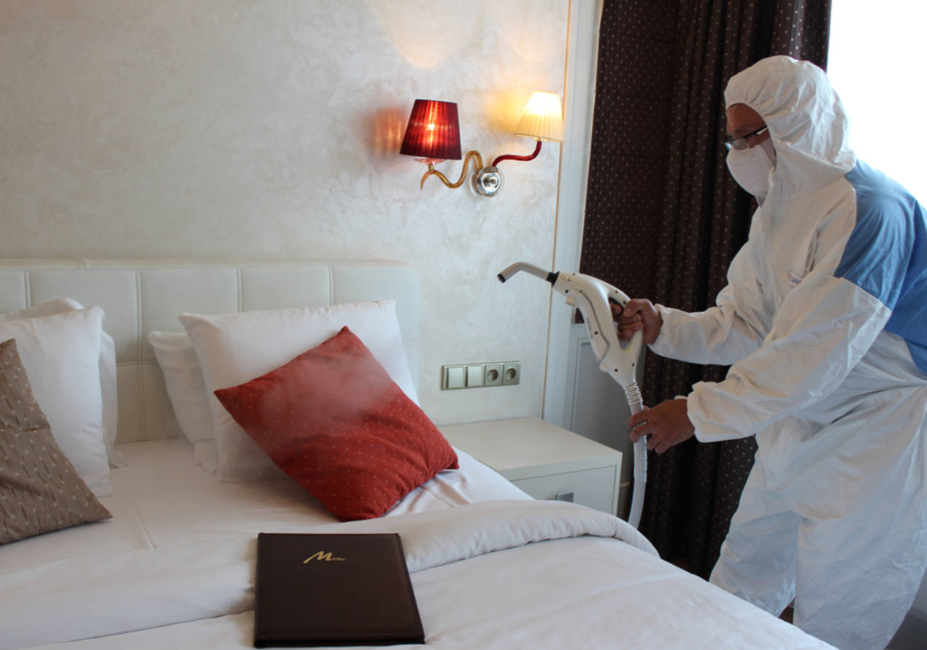
Sanitisation Activities, Source: https://meneghetti.hr/
- Price: Price is the critical marketing mix element that determines the revenue generation of the organisation (Chaffey, 2018). The superior room of Meneghetti Wine hotel & Winery starts from $250, the price is high but reflect the quality for all the services offered.
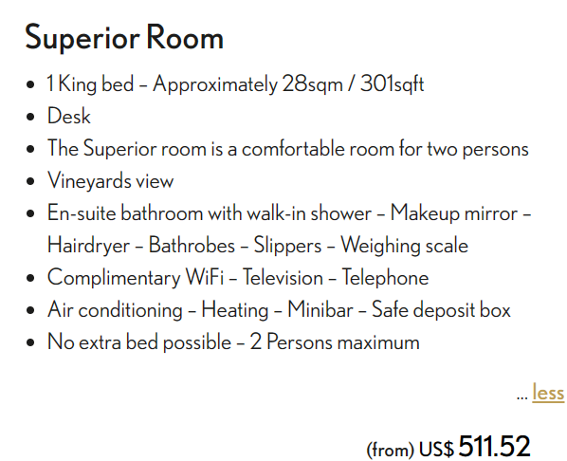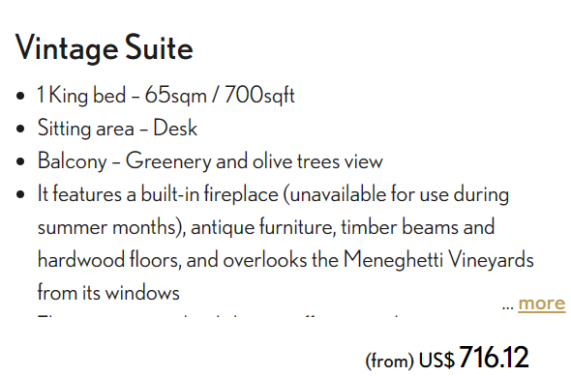
Price Chart, Source: https://meneghetti.hr/
- Place: Place in the marketing mix element determines the distribution strategy of the organisation (Cheung, 2020). The objective of the place is to ensure high reach and availability. The hotel has enabled web based platforms like mobile applications and websites for creating convenience in the reservation system. Third-party booking agencies like Booking.com are also assisting the people to reserve the property at Bale (Booking.com, 2021). Therefore, the strategic partnership with the third-party booking agencies will increase the reach and availability of the services of Meneghetti Wine hotel & Winery, Bale.
- Promotion: Meneghetti Wine hotel & Winery, Bale is trying to create a fusion between traditional values and modern thinking. The hotel has clarified that the tradition inherited from the ancestors is focused while designing their accommodation service (Cheung, 2020). The clear brand message has been transmitted to the guest through their website. It has been observed that Meneghetti Wine hotel & Winery, Bale has also emphasised the ‘sales promotion’ to attract the guests at their property. Therefore, sign-up offers are provided to the guests to increase the number of bookings.

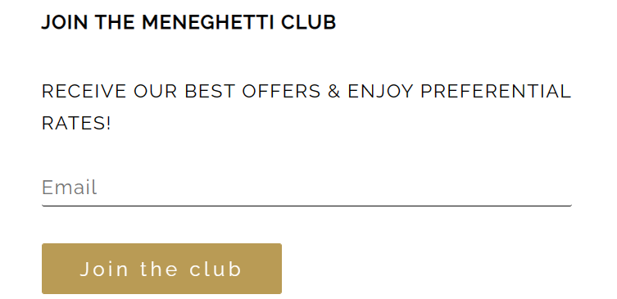
Guest Offer, Source: https://meneghetti.hr/

Marketing Environment (Micro)

SWOT Analysis
Strengths  - Incredible hospitality at an outskirt location of Bale with outstanding food and wine range.  - The spa, restaurant, and beach club provide superior vale position to the guests.  - Meneghetti Wine Hotel & Winery, Bale is owned and managed by Relais & Châteaux that have 500 members in 60 countries on five continents. | Weaknesses  - The promotional strategy of the property is not effective due to low reach.  - The enhanced distribution network is missing.  - The add-on services need to be intensified for increasing the bookings (Freytag, 2020).
Threats  - Economic uncertainty has increased after the major hit by the COVID-19 pandemic in the tourism and hospitality sector.  - The competitive rivalry has increased due to the growth of independent boutique hotels and global chains. | Opportunities  - Strategic partnership in the business can increase the service portfolio of the brand.  - Technological development has increased business efficiency in the form of digital marketing and smart technology.

The hotel is offering highly personalised service by embedding technology in the service portfolio as a strategy to capitalise on the opportunities related to technological development.

Marketing Environment (Macro)

PESTLE analysis
- Political factor: The tourism infrastructure has been developed since World War II. It has been observed that cultural heritage and preservation of history have been emphasised by the Government for boosting tourism.
- Economic factor: As per UNWTO, international tourism has been dropped by 74% due to the COVID-19 travel restrictions. The estimated loss in tourism has been reported around USD 1.3 trillion (Hutton, 2020). Moreover, 120 million tourism jobs are at the risk due to the collapse of the hospitality and tourism industry. Currently, the Croatian Government has emphasised the harmonisation, coordination, and digitalisation of the COVID-19 travel related risk elimination measures for boosting tourism. As a consequence, Meneghetti Bale is using the disinfectant in the entire property and washing the equipment at 60 degrees under the disinfectant practices framed by the Croatian Tourism Association (HUT-Croatia).
- Socio-cultural factor: The taste and preferences of the customers are changing due to globalisation in the business (Patterson, 2018). In the case of the hospitality sector, the frequent change in consumer behaviour can be observed in the terms of personalised services, add-on facilities, destination management, etc. The shorter product life cycle has also increased the operation cost of the hotel.
- Technological factor: The rapid development in the technology and proliferation of the internet has influenced the business operations of the hotel. Meneghetti, Bale has acknowledged the utilisation of the SMART technology in delivering personalised services to the guests and to ensure a contactless service delivery process.
- Legal factor: The regulatory norms increased the administrative activities of the organisation. For example, hotels operating in Croatia must adhere to the compliances under the Hospitality and Catering Industry Act 2015 in the terms of working hours, service delivery process, safe working practices, etc (Rutin, 2019).
- Environmental factor: The climate change issues, and rising pollution level has influenced hotels to adopt sustainable practices. Meneghetti Wine Hotel & Winery used to source the food within a 50km radius for emphasising organic and local food (Ateljevic, 2020). The close relationship with the local communities and local suppliers has been prioritised by the hotel to support the ethical sourcing activities. Meneghetti has formed a partnership with the suppliers that provide fresh, homemade, and organic vegetables.

Customer Value
Customer Value signifies the total benefits that the organisation promises to the customers in return for their payment (Kingsnorth, 2019). Meneghetti has formed a partnership with the suppliers that provide fresh, homemade, and organic vegetables. The hotel is also offering an exclusive range of wine. Considering the COVID-19 pandemic, sanitisation to the entire property and washing the equipment at 60 degrees under the disinfectant practices framed by the Croatian Tourism Association (HUT-Croatia).

Effective use of Digital Marketing
Social Media marketing is one of the effective digital marketing strategies that use social media platforms (Facebook, YouTube, Instagram) to connect the audience with the brand and also to drive the website traffic (Kotler, 2019). Currently, 4.48 billion people across the world are actively using social media platforms for the sake of connectivity. The reach of the social media advertisement is high and thereby supports the Brand to promote its services (Leeflang, 2019). Interaction with the guests or leads can be done efficiently with social media platforms.

Conclusion
To conclude, the report has provided a marketing plan by developing the marketing programs, and metrics to assess the responses for enhancing the long-term profitable relationship. The marketing plan is prepared for the front office and back-office team to get a clear direction about the strategy that needs to be followed to achieve the desired marketing objectives.

References
Ateljevic, I. a. D. S., 2020. Unpacking the local: A cultural analysis of tourism entrepreneurship in Murter, Croatia. Tourism Geographies, 5(2), pp. 123-150.
Baker, R., 2020. Marketing Week. [Online]
Available at: https://www.marketingweek.com/tesco-boosts-digital-strategy-with-mobile-site/
[Accessed 13 04 2021].
Booking.com, 2021. [Online]
Available at: https://www.booking.com/hotel/hr/villa-meneghetti.ru.html?aid=318615;label=Catch_All-RU-125213373003-asLloGiIgc7XBoiQ_gJ0zwS548736517880%3Apl%3Ata%3Ap1%3Ap2%3Aac%3Aap%3Aneg%3Afi159082117569%3Atiaud-297601666995%3Adsa-1232732499011%3Alp9298984%3Ali%3Adec%3
[Accessed 17 11 2021].
Brassington, F. a. P. S., 2019. Principles of marketing. In: London: Prentice Hall.
Chaffey, D. a. S. P., 2018. eMarketing eXcellence: Planning and optimizing your digital marketing. London : Routledge.
Cheung, J. a. V. D., 2020. An exploratory study to understand online consumers' experiential responses towards fashion visual content. Academy of Marketing 2015: The Magic in Marketing., 34(6), pp. 222-228.
Freytag, P. a. C. A., 2020. Business to business market segmentation. Industrial marketing management, 30(7), pp. 473-486.
Hutton, G., 2020. Hospitality industry and Covid-19. [Online]
Available at: https://commonslibrary.parliament.uk/research-briefings/cbp-9111/
[Accessed 05 06 202].
Kannan, P., 2019. Digital marketing: A framework, review and research agenda. International Journal of Research in Marketing, 34(5), pp. 22-45.
Kingsnorth, S., 2019. Digital marketing strategy: an integrated approach to online marketing. London : Kogan Page Publishers.
Kotler, P., 2019. Marketing Management. London: Pearson.
Leeflang, P. V. P. D. P. a. F. T., 2019. Challenges and solutions for marketing in a digital era. European management journal, 32(4), pp. 1-12.
Mahoney, L. a. T. T., 2018. Strategic social media: From marketing to social change. London: John Wiley & Sons..
Meneghetti, 2021. About us. [Online]
Available at: https://meneghetti.hr/
[Accessed 17 11 2021].
Patterson, L., 2018. Marketing and sales alignment for improved effectiveness. Journal of digital asset management, 3(2), pp. 185-189.
Rutin, J., 2019. Coastal tourism: A comparative study between Croatia and Tunisia. Tourism Geographies, 12(2), pp. 264-277.



