An Assignment
on
Individual Academic Poster Presentation

Module Name: Introduction to Physiology
Module Code: BMHP5003

Submitted by, Submitted to,
Sumi Teresa Ascension Gillian Weaver
Student ID: 2130237

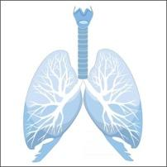
The wonders
of
Respiratory System
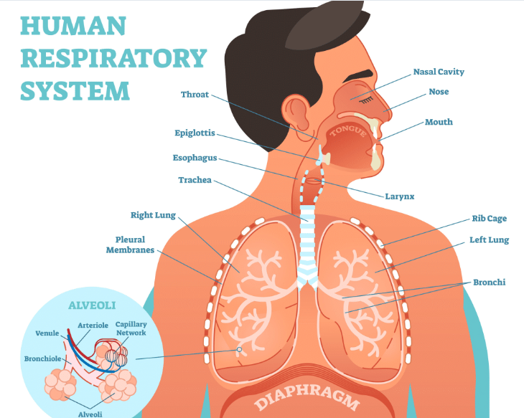
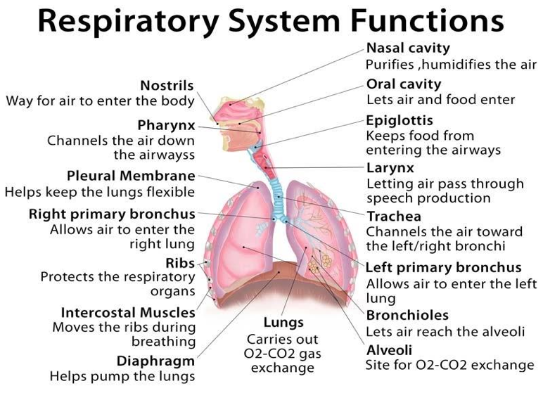

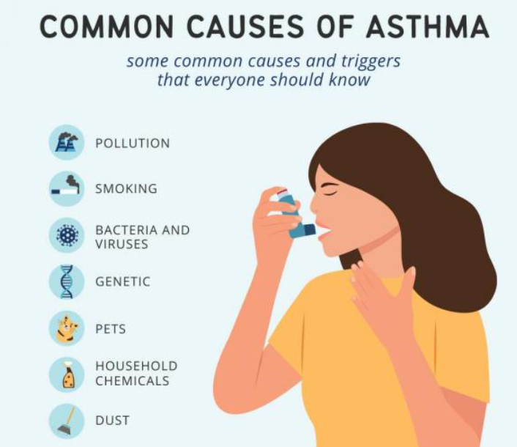
Complications of Asthma
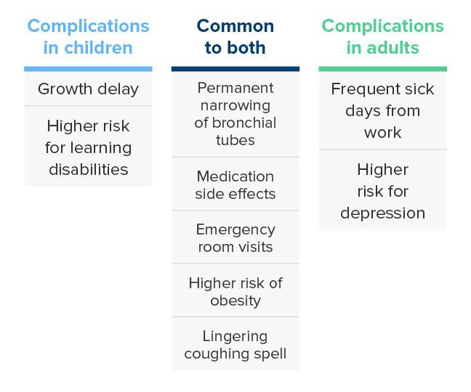

Tips to prevent
/manage Asthma

Using the inhaler correctly

Using preventer inhaler or tablets every day

Checking before taking other medicines

Not smoking

Exercising regularly

Eating healthly

Getting vaccinated

References

Asthma and Allergy Foundation of America. "Asthma Support Groups." Available at: https://aafa.org/about-aafa/aafa-affiliated-asthma-allergy-support-groups/ (Accessed: 18 October 2023)

Global Initiative for Asthma (2022) Global Strategy for Asthma Management and Prevention. Available at: https://ginasthma.org/gina-reports/ (Accessed: 18 October 2023)

How to Keep Your Lungs Healthy. Available at: https://www.nhlbi.nih.gov/health/lungs/lung-health (Accessed: 17 October 2023)

Hall, J.E., (2015) Pocket Companion to Guyton & Hall Textbook of Medical Physiology E-Book. Elsevier Health Sciences.

Marieb, E.N. and Hoehn, K., (2007) Human anatomy & physiology. Pearson education.

Muhammad F. H., Maryam T., Mary E. C., (2023) Asthma. StatPearls publishing. Available at: https://www.ncbi.nlm.nih.gov/books/NBK430901/ (Accessed: 18 October 2023)

National Heart, Lung, and Blood Institute (2020) Asthma. Available at: https://www.nhlbi.nih.gov/health-topics/asthma\ (Accessed: 18 October 2023)

Overview-Asthma. Available at: https://www.nhs.uk/conditions/asthma/ (Accessed: 18 October 2023)

Rhoades, R.A. and Bell, D.R. eds., (2012) Medical physiology: Principles for clinical medicine. Lippincott Williams & Wilkins.

Respiratory disease. Available at: https://www.england.nhs.uk/ourwork/clinical-policy/respiratory-disease/ (Accessed: 17 October 2023)

Saladin, K.S. and Porth, C., (2010) Anatomy & physiology: the unity of form and function. Vol. 5. New York: McGraw-Hill.

Silverthorn, D., Cafferty, P., Casagrand, J., Co, E., Flemming, M., McFarland, J., O'Loughlin, V., Scott, D.A. and Tomicek, N., (2023) ‘Introducing the HAPS Physiology Learning Outcomes’, HAPS Educator.

Tortora, G.J. and Derrickson, B.H., (2018) Principles of anatomy and physiology. John Wiley & Sons.

Widmaier, E. P., Raff, H., & Strang, K. T. (2022) Vander's Human Physiology: The Mechanisms of Body Function. McGraw-Hill Education.

