ST FAGANS CASE STUDY

Wun Leung Chen

ACBA 4022 Fundamentals of Construction Technology
University of Wales Trinity Saint David
January 8, 2026

Table of Contents
Introduction 1
Part 1 2
Windows and Doors 3
Wall Coverings 4
Roof Coverings 6
Eaves Details and Rainwater Goods 7
Floor Coverings 8
Internal Joinery 9
Part 2 10
Windows and Doors 10
Wall Coverings 11
Windows and Doors 12
Bibliography 13

Introduction

This case study examines evolution of construction materials and methods at Rhyd-y-car Terrace from St Fagans National Museum of History. The terrace was to provide housing for workers in the iron-ore mine at Merthyr Tydfil(Rhyd-y-Car cottages - Collections Online). The six houses have been carefully restored to represent the working-class domestic life in 1805, 1855, 1895, 1925, 1955, and 1985. Moreover, this case study analyses changes across windows and doors, wall coverings, roof coverings, eaves details and rainwater goods, floor coverings, and internal joinery. By analyzing these materials, it illustrates how buildings change across time. Furthermore, it will include labelled sketches illustrating typical construction methods for pre-1900, 1950s, and post-2000 dwellings, linking the visual analysis to the discussed thematic areas.

\

Part 1: Analysis of Changes in Rhyd-y-car Terrace
The sequential restoration of the six houses demonstrates a clear trajectory of improvement and adaptation in British vernacular architecture. The changes observed are responses to factors such as industrialization, public health reforms, post-war building programmes, and rising expectations of comfort and convenience.

Windows and Doors
The earliest houses (1805 and 1855) feature simple, small-paned timber casement windows, designed for basic light and ventilation. The house uses small casement windows with few panes. The design minimized heat loss and reduced glazing costs, as glass remained expensive in early 19th century. However, it cannot be open because of the design. Moreover, the house uses ledge & brace door. It does not have any features to prevent poor weather conditions; hence the design prioritize economy over comfort.
By 1895, the influence of mass production is evident with the introduction of larger, sliding sash windows, improving light penetration and outlook.
The 1925 period saw timber sashes or early casements with improved ironmongery, plus small top-hung vents for background ventilation, reflecting interwar emphasis on hygiene and ventilation (Teaching resources - Understanding traditional (pre-1919) and Historic buildings).

The 1955 house showcases steel-framed Crittall-style windows, representing modernist influences and industrial aesthetics. However, steel is an excellent thermal conductor, leading to significant condensation and heat loss—a major defect that later prompted replacement (Building pathology; principles and practice, 2d ed2007). The door evolved from plank-and batten timber types to panelled designs.
The 1985 house uses uPVC double-glazed window. This change was driven by the need to improve thermal performance and reduce maintenance. uPVC frames are poor conductors, and the sealed double-glazed unit significantly reduces heat transfer. Similarly, the door is a modern composite door with a foam core, prioritising airtightness, security, insulation over economy.

Wall Coverings
The treatment of interior walls reveals much about changing technologies, aesthetics, and understandings of hygiene.

The 1805 and 1855 interior would have presented masonry walls, which is bare stone or brick walls. The 1805 house uses lime-based mortars and renders that were compatible with the soft bricks and stones, which is a breathable coating, allowed moisture from the solid wall to evaporate. However, it offers a rough, uneven finish that collected dust. It also can streak or patch if water runs unevenly down the surface.

The 1855 and 1895 external uses a stone wall. It has long been recognised as a material of great durability and superior artistic quality. It is thick, with random rubble, and shallow foundations. However, the stone is without limewash, leading to less surface protection. The stone is directly exposed to rain, frost, and pollution. It can cause surface erosion, scaling and micro-cracking over time.
The 1925 house remained uses original solid walls, with improvements focused instead on internal linings and renders. While the cavity wall had become an ubiquitous feature in new housing construction across the UK, the Rhyd-y-car Terrace preserved historical structure in Wales. Therefore, it maintained its original stone façade. The interior wall uses an affordable, mass-produced wallpapers. It often with small, repeating patterns, revolutionised the working-class interior. Paper provided a cleaner, brighter, and more decorative surface that could be easily replaced.

In the 1955 house, the external walls retained their thick stone construction, coated with lime-based render to allow breathability. Internally, the walls were likely finished with wet plaster directly applied to the masonry. Decorative wallpapers or emulsion paint were commonly used as final finishes, with emulsion valued for its durability and ease of cleaning. Lime-based render on the external walls ensured moisture regulation, aligning with traditional building practices.

By 1985, wall construction had evolved into a fully modernised system. Externally, a new cavity wall with a cement-based render or brick outer leaf would be typical, offering a superior weather resistance and insulation. Inside, timber stud framing became the standard for both external wall linings and new internal partition walls. It allows for flexible room layouts, easy routing of services, and deep insulation batts. These studs were clad with plasterboard, which was then given a thin skim coat of finish plaster to achieve a perfectly smooth, seamless surface (Hughes Bsc). The 1985 wall thus represents the peak of this evolution. It has a high-performance and factory-made assembly where structure, insulation, services, and finish were fully integrated. Hence, it significantly minimizes the time of building walls.

Roof Coverings

The roof is the primary shield against weather, and its covering materials have evolved due to availability, cost, and performance demands.

In the early period (1805-1895), the roof covers by stone tiles These thick, irregular tiles offer good weathering but require a robust supporting structure of heavy timber rafters and purlins. When slate roof is properly maintained, it could last over a century. Moreover, the roof was steeply pitched to aid water run-off, and the eaves were typically simple and open. However, building it is time consuming and expensive.

The roof covering of the 1955 house uses the slate tiles. It increases the durability time, reduces its weight and thickness. In addition, the water absorption also very low, provide an excellent waterproof for the house.

A decisive material change is evident in the 1985 house. The original slate was likely replaced with concrete interlocking tiles, making a hallmark of late-20th century refurbishment. These factory-made tiles were cheaper and easier to install than slate and offered low-maintenance finish. The addition of a bituminous felt underlay beneath the slates for improved secondary weatherproofing. Also, the introduction of mineral wool insulation laid between the ceiling joists in the loft—an early response to growing awareness of fuel efficiency. Furthermore, the eaves were fitted with a complete uPVC system of soffits, fascias, and gutters.

Eaves Details and Rainwater Goods
In order to steer water away from the building, the details of where the roof and wall meet is essential.
In the earliest 1805 house, a basic but functional rainwater system would have been present. While eaves were simple with exposed rafter ends, the critical upgrade from mere drip edges was the use of lined troughs at the eaves, often lined with lead or painted sheet metal. These channels would direct water to early cast iron downpipes to carry it away from the foundation. This demonstrates an early understanding of the need to manage roof runoff systematically to protect the building's fabric from rising damp.
By the late Victorian era (1895, 1925), rainwater management had become standardized and robust. Cast-iron gutters and downpipes became omnipresent, reflecting industrial production and public health reforms that emphasized proper drainage. The eaves became more enclosed with the addition of soffit and fascia boards, creating a neater finish and protecting the rafter ends. This era established the principle of the roof as a fully engineered watershed, directing water efficiently into the public drainage system.
The mid-to-late 20th century (1955, 1985) was characterized by the development of durable and easily maintained materials. Painted mild steel eventually took the place of heavy cast iron, followed by uPVC systems. Because uPVC was lightweight, resistant to corrosion, and did not have to be painted, it was perfect for the post-war goals of cost-effective housing. Additionally, the eaves detail developed into a complete assembly. Continuous ventilation strips in the soffit became crucial with the addition of significant loft insulation to prevent moisture and rot in the roof timbers, demonstrating how advancements in ventilation strategy were required in tandem with improvements in thermal performance.

Floor Coverings
The evolution of floor coverings at Rhyd-y-car Terrace charts a clear path from purely functional, structural surfaces to layers dedicated to hygiene, thermal comfort, and domestic aesthetics.
In the earliest phases (1805, 1855, and 1895), the ground floor was a direct structural element, comprising large, unadorned stone slabs. These were hard, cold, and porous, resulting in difficult to clean and offering no thermal break from the ground beneath. By 1895, while the floor structure remained stone, the surface may have been improved using more regularly quarried flags, creating a tighter, more level jointed surface, though still uncovered.
The mid-century 1955 house marks the decisive shift towards installed floor coverings. The structural floor was now timber floorboards over joists, providing resilience and a level base. These boards were then covered with functional materials: oilcloth or linoleum in service areas, offering a waterproof, wipeable surface. Moreover, a layer of carpet in the main living room, introducing warmth and acoustic softening. The floor was no longer merely a surface to walk on but a contributor to domestic comfort.
By 1985, the floor had developed into a crucial area for both aesthetic expression and comfort. Living and bedroom areas were surrounded by entire walls of deep-pile carpet, which offered outstanding thermal insulation and a feeling of comfort. The dense, tall fibers traps still air, creating a barrier that reduces heat loss through the floor. It represented the late 20th-century ideal of the home as a warm private space and formed a contrast to the bare practical floors of earlier times.

Internal Joinery
Internal joinery includes the stairs, skirting, doors, and built-in cupboards.

Early joinery (1805, 1855) was integral to the structure and space-saving. For instance, the circular staircase next to the fireplace, occupying minimal space to maximize the efficient use of a cramped footprint.

By the 1895 house, internal joinery reflected the powerful influence of industrial manufacturing, which made standardized decorative elements affordable and accessible to the working and middle classes. For instance, plinth blocks at the base of door architraves, a simple but definite picture rail running around the main living room to allow for the artwork display and photographs without damaging walls, and four-panel doors with modest mouldings on the panels. This shift signified the joinery was no longer purely utilitarian but incorporated designed elements that signified comfort and propriety rather than bespoke craftsmanship.

In 1955, the idea of the "fitted" interior has already widespread. The standing dresser and table in the kitchen are replaced by early fitted pieces. By 1985, equipped bedrooms with wardrobes and completely integrated fitted kitchens had become the norm. This change produced a simplified, designed look while optimizing storage in cramped areas. This profoundly changed the nature of home woodwork by emphasizing surface appearance and function over material durability in an effort to make construction more affordable.

Part 2: Sketches of Typical Construction Methods

Sketch 1: Pre-1900
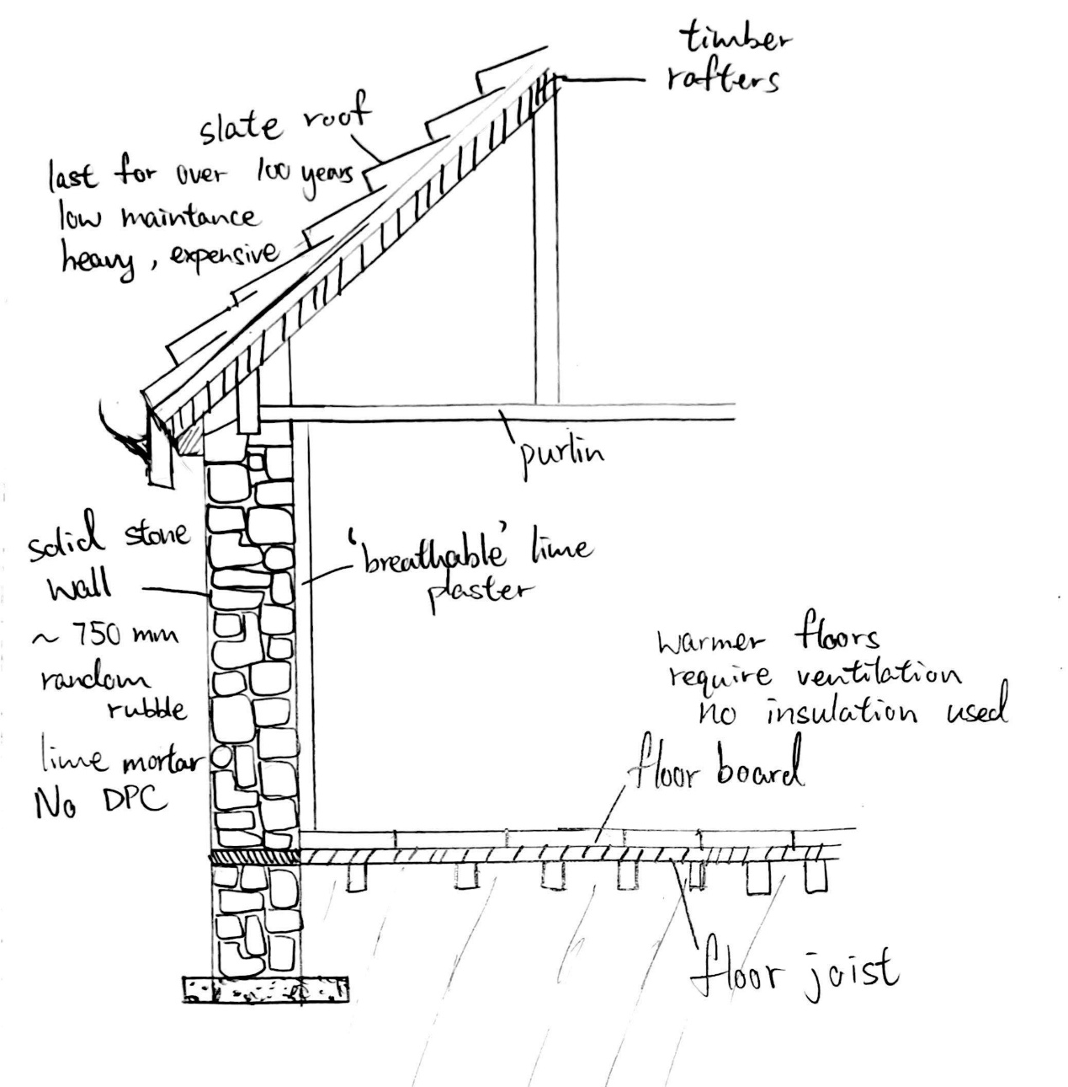

Sketch 2: 1950s
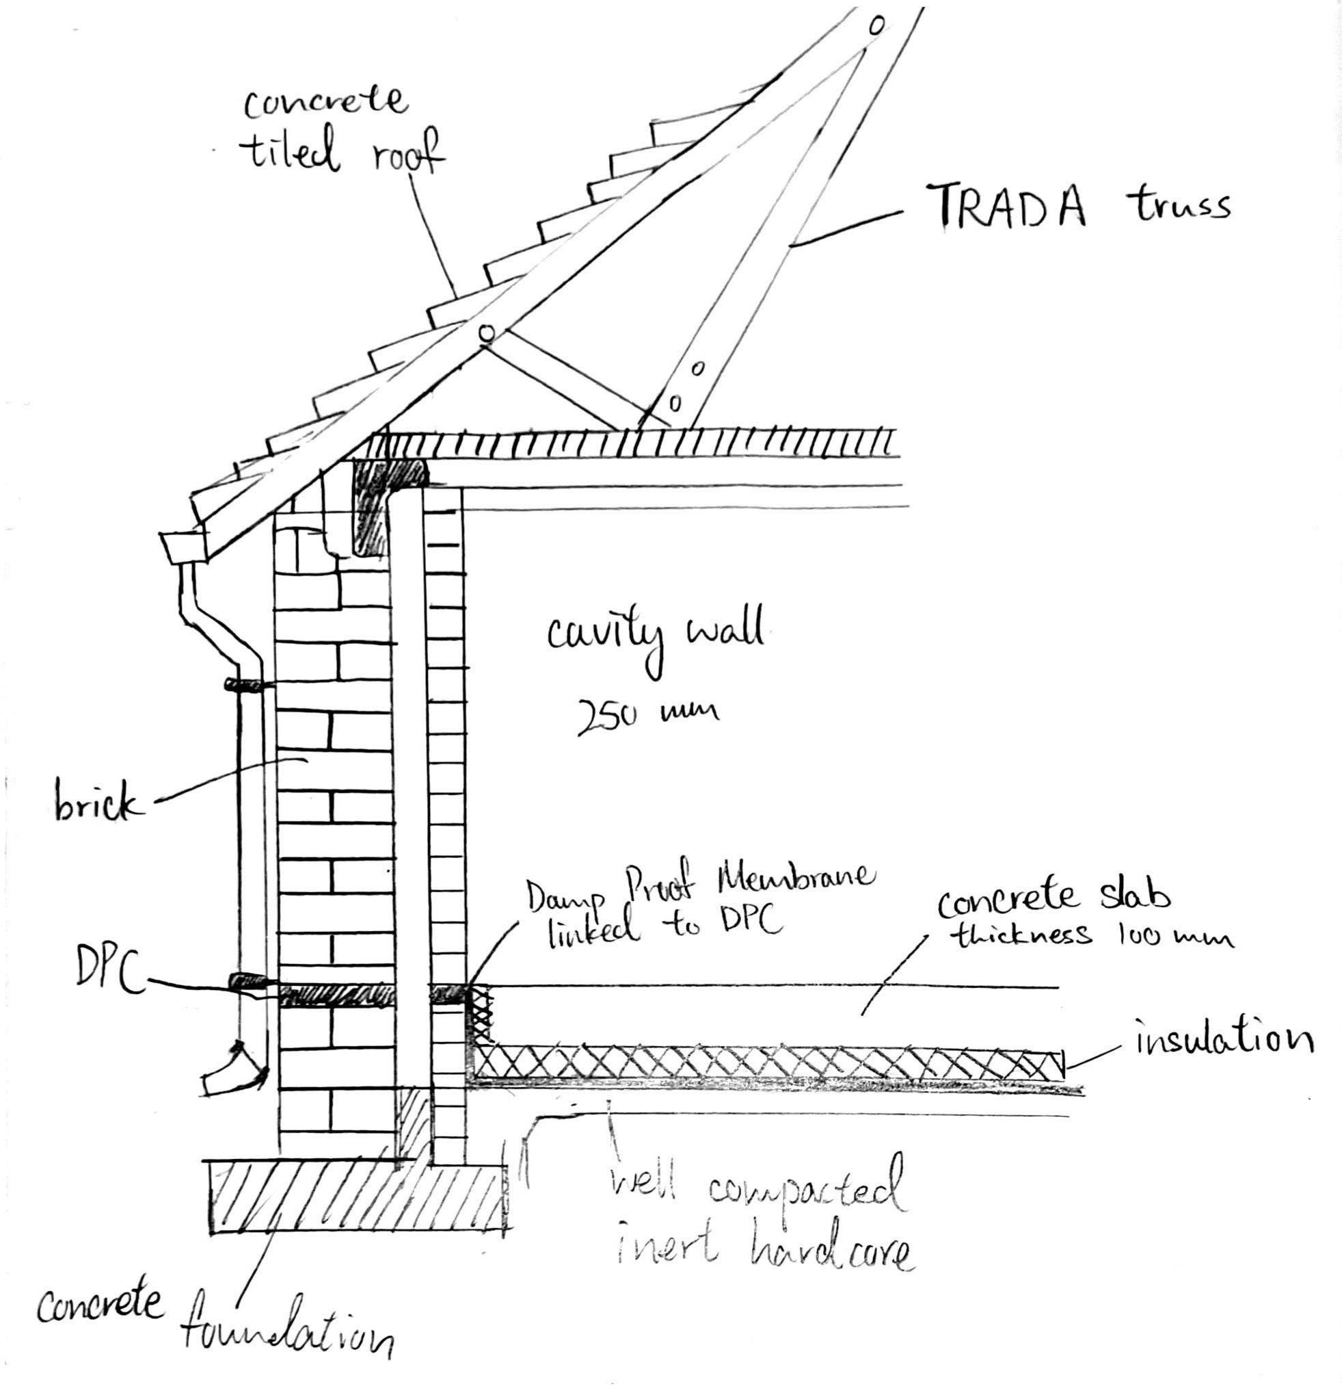

Sketch 3: Post-2000
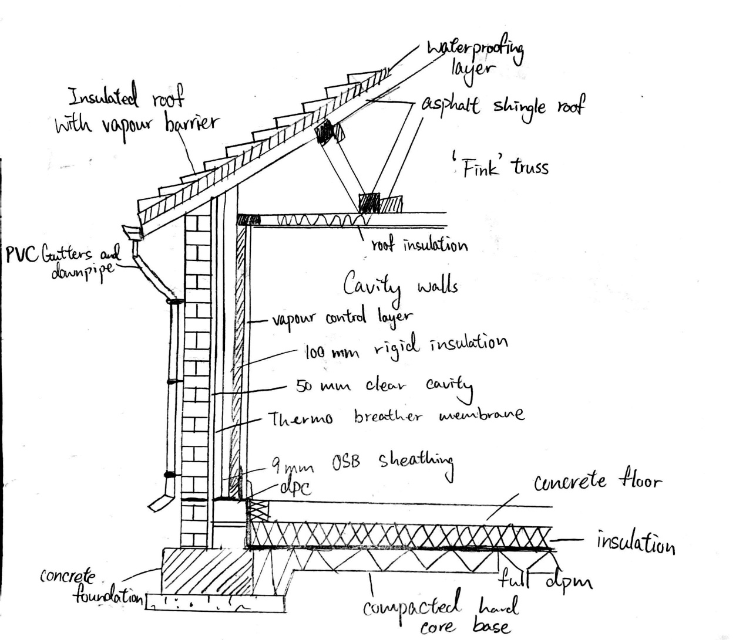

Bibliography

Properties of Traditional Building Construction (2025) .
Building pathology; principles and practice, 2d ed (2007) Copyright Clearance Center, Inc.
Rhyd-y-Car cottages - Collections Online Available at: https://museum.wales/collections/historic-buildings/29/Rhyd-y-car-Terrace/ (Accessed: Jan 8, 2026).
Teaching resources - Understanding traditional (pre-1919) and Historic buildings.
Hughes Bsc, P. The Society for the Protection of Ancient Buildings.

