  Component One: Student Journal (learning log) | Student No: | 2221478
 | Module Title: | Hotel Administration and Front Office
 | Module Code: | BMIH4004
 | Lecturer: | Muhammad Cassamo
Learning Log (Reflection on the development of major skills required to work within the hotel front office in Premier Inn Whitstable hotel)

Introduction
Different types of tasks and activities are required to be performed by front desk office in hotels (Bardi, 2011). These job responsibilities require specific skills and aptitudes (Corgel et al., 2011). My learning log of 6 weeks during my experience of working in Premier Inn Whitstable hotel is presented below by applying the Gibbs Reflective Cycle.

Week 1
Skill to be developed: Communication skills.

Gibbs Reflective Cycle
Description: I have got the opportunity to communicate and interact with people and individuals with different personalities, needs and communication styles from the hotel staff team and with the clients and guests of the hotel.
Feelings: I was feeling highly confident and enthusiastic from the beginning of the experience as I am an extrovert person with great communication skills.
Evaluation: The positive aspect of the learning experience was the scope of improving my verbal communication skills and the negative aspect was the lack of proper instructions and support from the other staff.
Conclusion: There could be better opportunities to improve my formal written communication skills.
Action plan: I will enroll myself in online courses to improve verbal and formal communication skills.

Week 2
Skill to be developed: Multitasking skills.

Gibbs Reflective Cycle
Description: I was assigned with several different tasks altogether which required the ability of multitasking.
Feelings: I was feeling nervous and less confident as my multitasking skills are not very good.
Evaluation: The positive aspects was the scope of improving my multitasking skill and the negative aspect was the lack of cooperation from other coworkers.
Conclusion: I could have applied some techniques and strategies of multitasking to perform better.
Action plan: I am planning to join some group activities and learn online about multitasking.

Week 3
Skill to be developed: Time management skills.

Gibbs Reflective Cycle
Description: I was assigned with multiple tasks with specific deadlines.
Feelings: I was feeling worried about meeting deadlines and completing tasks properly.
Evaluation: The positive aspects was the learning scope of time management, and the negative aspect was lack of clarity in the provided instructions for tasks.
Conclusion: I could have developed a proper task and working schedule and plan chart to keep proper tracks of my advancements in completing the assigned tasks and time remaining in hand before deadlines to plan further.
Action plan: I have plans to join both online and offline courses to learn new techniques and practice strategies of time management.

Week 4
Skill to be developed: IT skills.

Gibbs Reflective Cycle
Description: I was responsible for giving entry to the personal and booking information about the guests booking, check in, check out, service requirements and other aspects which required IT skills.
Feelings: I was highly confident because of my excellent IT skills.
Evaluation: The positive side was that I enjoyed the IT related tasks and responsibilities. The negative aspect was the several incidents of malfunction of the computers used in the front desk.
Conclusion: I could use my own resources to complete the tasks rather than waiting for the service team to repair the computers in the front desk.
Action plan: I have plans to enroll myself in a computer course to improve my IT skills further to learn to use computers better.

Week 5
Skill to be developed: Customer service skills.

Gibbs Reflective Cycle
Description: I was responsible for receiving the phone calls to response to the queries and requests from new and existing guests of the hotel, providing correct information and updates.
Feelings: I was feeling very confident in this task because of my effective ability of interacting with others.
Evaluation: positive aspects of the task was the support and proper instructions offered to me and the negative aspect was a very high frequency of customer queries which created challenges for me.
Conclusion: I could learn better customer service techniques to perform better.
Action plan: I have a plan to learn effective customer service skills by enrolling myself in an online course in Udemy.

Week 6
Skill to be developed: Organizing and managerial skills.

Gibbs Reflective Cycle
Description: I was supposed to organize and manage the information, data and paperwork related to all the bookings, personal details of guests.
Feelings: I was feeling quite tensed because of my poor organizing skills.
Evaluation: The overall experience was very challenging for me.
Conclusion: I could have learnt some managerial and organizing skills beforehand.
Action plan: My plan is to learn effective managerial and organizing skills to perform better in future.

The effective planning helped a lot to identify and develop the skills required to work in the front office (Hammer, 2016). The Reflective model was effective and helpful in identifying my skill level and effective plans to improve the skills further (Solomon, 2018). Effective skill development is highly important in hotel management (Tesone, 2010).

Component Two
Trip Advisor Review Response
Dear Jodie,
A heartfelt thanks for your kind words and positive response about your recent stay at our hotel. We are highly delighted and pleased to know that your experience of staying at Premier Inn Whitstable Hotel was an enjoyable one. We are also grateful that you liked the services of our friendly staff and enjoyed the food. It is a great pleasure to also know that you liked breakfasts, lunch and evening menu along with the food from Beefeater next door. Lastly, we are delighted that you liked our special Valentine cocktails as well and had a great time with your special person.
We are always sincere to perform our best to provide enjoyable, positive and memorable experiences to our guests. Your positive feedback is a testament to our sincerity, dedication and hard work for providing excellent and extraordinary services to guests.
We hope to welcome you back here very soon. Best wishes to you.

Sincerely,
Raducu Ciolpan

Screen shot of referenced Trip Advisor review used:
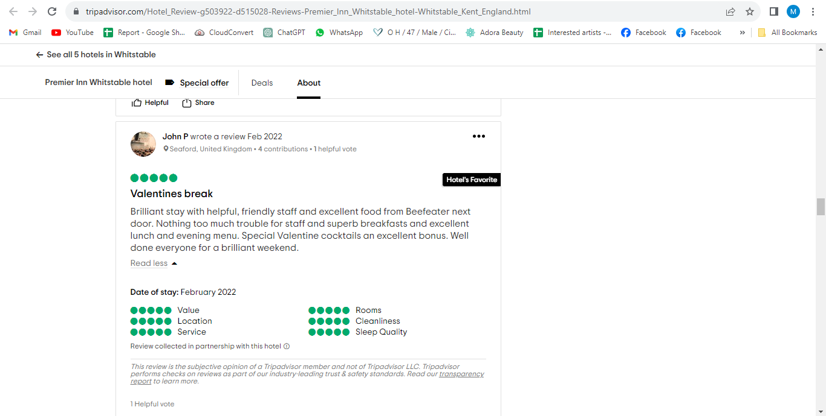
Source: (Tripadvisor, n.d.)
Weblink of the review: https://www.tripadvisor.com/Hotel_Review-g503922-d515028-Reviews-Premier_Inn_Whitstable_hotel-Whitstable_Kent_England.html

Letter of complaint response
Dear Mrs. Atkinson,
I am writing this letter to sincerely apologize to you for your recent disappointing experience at Team Premier Inn Whitstable Hotel. I am taking your feedback with high level of sincerity and importance. The management of the hotel understands your dissatisfaction and disappointment and are highly interested to take this opportunity to apologize to you for the disappointing experience and service quality which was not up to the mark to meet your expectation levels.
I will address each of your concerns and issues individually in this letter for explaining things better for your consideration and understanding.

Breakfast
We are extremely sorry to hear that you were dissatisfied with the quality of the breakfast as we always try our best to offer an appetizing and warm breakfast to our guests to start the day with positivity and freshness. We are highly disappointed that we could not meet your expectations with the quality of the breakfast. To address this issue, we have conducted investigations and inquiry with the kitchen staff to identify the issues and have taken further effective steps to improve breakfast quality and variation.

Noise
We are sincerely apologizing for the noise you experienced during your stay at the hotel because we understand that guests are expecting a comfortable and peaceful experience. Although we try our best to minimize the noise levels in the hotel premises as much as possible, it is not always possible to control noises from neighbouring rooms. We are determined to improve our soundproofing measures and systems further to solve these issues. We will also instruct and train the staff to keep the noises at minimum during the day and especially at the night time.

Cleanliness
We are sincerely apologizing for the fact that your room was not properly clean at the time of your arrival at the hotel. We have a strict policy of maintaining proper standard of cleanliness in the hotel premises and rooms to provide a pleasant experience to our guests. However, we are sorry that our staff could not meet your expectations and maintain the usual high standard of cleanliness at the time of your visit at the hotel. We have already investigated the matter with the staff responsible for cleaning and housekeeping to identify and resolve the matter. We have taken further steps to train them better to improve their efficiency and performance quality in future.

We understand that your experience of staying at our hotel was not up to the expectation level and was dissatisfactory to you. We are apologizing again for not being able to meet the standards and expectations at high levels. We are assuring that, your feedback and opinions are being considered with high level of sincerity by the management of the hotel and effective as well as required actions will be taken immediately to resolve the issues and concerns pointed out and mentioned by you.

We would like to offer you a 2 day complimentary stay at our hotel to compensate for the dissatisfaction you experienced the last time. Thanks again for your valuable feedback.

Sincerely
Raducu Ciolpan

Component Three:
Element 1 – Pre-Arrival

The stage of pre-arrival in a hotel starts from the time guests show interest in booking services at the hotel. The visits of customers in the official website of the hotel, making a phone call for booking information, making a reservation on the hotel are some specific examples of pre-arrival aspects and activities (Foskett & Bergsteiner, 2021). It is crucial for the staff of hotels such as Premier Inn Whitstable Hotel to ensure high level of responsiveness, sincerity and efficiency to provide all types of information, customer support and service to the guests. It ensures the final decision making of the customers to stay in the favour of the hotel. It is also effective for creating a positive and great first impression of the hotel among the guests.
Major elements of service quality maintaining at a high level at this stage include an official website of the hotel which is very user friendly and easy to navigate in different devices. All the required information related to services, prices, availability, booking procedures and policies, offers and discounts must be arranged in the website to support the customers. A highly responsive customer service department is crucial as well along with personalized communication with clients to cater specific needs, requirements and queries.
According to a study by Google, smartphones are used by 76% of traveller’s and tourists for finding good hotels which increases the importance of developing a mobile friendly website and mobile app for hotels like Premier Inn Whitstable Hotel. Different personalized features and scope of customizing the services are offered by Premier Inn Whitstable Hotel in their hotels to satisfy customers further (Hyken, 2020).

Element 2 – Arrival

The second stage in the hotel guest cycle is the arrival stage. It starts with the arrival of the guests and clients at the hotel premises and with the check in of the customers (Kasavana, 2022). The maintaining of a friendly as well as welcoming environment and behaviour from the staff of the hotels are crucial at this point to develop a positive impression and image among the guests. The staff and management of Premier Inn Whitstable Hotel strives to make the check in process highly efficient and smooth for the guests to ensure service quality and high satisfaction level among customers.
Major elements of activities of Premier Inn Whitstable Hotel at the arrival stage to satisfy the guests are the assurance of a warm welcome, smooth and easy check in process, brief tour of the hotel, providing accurate and most updated information about the amenities available for the guests.
According to a research and study conducted by Cornell University, one of the most important and deciding factors in the development of customer satisfaction in the hotel industry is a warm welcome and friendly environment maintenance for the guests. This makes it highly crucial at the arrival stage for Premier Inn Whitstable Hotel (Leary, 2020). According to another study by J.D. Power, an efficient, easy and smooth check in process highly motivates the guests to stay in the hotel for a longer period of time and to pay for other additional services of the hotel as well. Premier Inn Whitstable Hotel. Sincerely ensures a proper and smooth check in, warm welcome and effective tour of the hotel to the guests to make them feel welcomed, nice and positive.

Element 3 – Duration of stay

The 3rd stage in the hotel guest cycle is the duration of stay which starts after the check in of the guests at the hotel. The stage ends when the guests check out from the hotel. This stage is of great significance for the hotel managements for hotel business organizations like Premier Inn Whitstable Hotel due to the fact that, this is the time when the guests actually experience the firsthand services and amenities provided by the hotel.
Some of the most effective and important tasks, activities and responsibilities for the hotel in this stage of the guest cycle include the providing of excellent and high quality customer services to the guests to accomplish higher levels of customer satisfaction, ensuring the availability of all resources and supplies required and important for the guests, offering a wide range of services and amenities to the guests to make them feel special and satisfied and lastly, ensuring effective and prompt customization and personalization of the services and guest experiences according to the specific needs, requests and requirements of the guests (Sullivan & Volpe, 2021).
Premier Inn Whitstable Hotel performs effective strategic approaches to ensure high quality services and efficiency in this stage of the hotel guest cycle to achieve higher performance and success level, higher popularity and preference among the customers through assuring high level of customer experience and customer satisfaction (Tewan, 2022). The staffs of the hotel are highly trained, well behaved and instructed to response sincerely and promptly to any requests and complains from the guests. Variety of amenities such as bar, restaurants, gym, family friendly activities are available as well.

Element 4 – Departure

The 4th and last stage in the hotel guest cycle is the departure stage which starts at the check-out of the guests and ends when the guests leave the hotel premises (Wiley & Sons, 2019). This stage is the last impression making opportunity and time for the hotel business organizations such as Premier Inn Whitstable Hotel on the clients and guests (Kasavana & Weaver, 2023).
There exist some important and effective elements to be maintained by the hotels to manage the departure stage efficiently and create a lasting positive impression and image on the minds of the guests to motivate them to revisit and book the services of the hotels again in the future (Volpe, 2020). Thanking guests properly for their stay at the hotel, making and ensuring smoothness and efficiency in the check-out process, asking guests politely to provide feedback and opinions of the quality of the services, asking if the guests have any complains and negative experiences during their stay, apologizing sincerely and offering compensations to guests for any unwanted or negative incidents are some of the most effective strategies for the hotel at this last stage of the guest cycle.

References
Bardi, J. (2011) Hotel Front Office Management, Wiley, London
Corgel, JB, Sturman, MC & Verma, R. (2011) The Cornell School of Hotel Administration on Hospitality: Cutting Edge Thinking and Practice, John Wiley & Sons, Incorporated, Hoboken.
Foskett, D., & Bergsteiner, D. (2021). Hotel management: Theory and practice. London: Routledge.
Hammer, J. (2016) Revenue superstar! The simple rules of hotel revenue management. Great Britain: Amazon.
Hyken, S. (2020). The new rules of customer service: How to create a customer experience that customers love and employees enjoy delivering. New York: AMACOM.
Kasavana, M. L. (2022). Hotel food and beverage management: A practical guide. Hoboken, NJ: Wiley.
Kasavana, M. L., & Weaver, D. B. (2023). Hospitality management: An introduction. Hoboken, NJ: Wiley.
Leary, B. (2020). Customer obsessed: How great leaders create and sustain winning service cultures. New York: Penguin Random House.
Solomon, M. (2018) The Heart of Hospitality. New York: SelectBooks, Inc.
Sullivan, B. F., & Volpe, R. J. (2021). Hotel sales: A practical guide. Hoboken, NJ: Wiley.
Tesone, D. (2010) Principles of management for the hospitality industry. London: Routledge.
Tewan, J. (2009) Hotel Front Office: Operations and Management, Oxford Higher Education Press
Tewan, J. J. (2022). The hotel front office: Operations and management. Oxford: Oxford Higher Education Press.
Tripadvisor. (n.d.). PREMIER INN WHITSTABLE HOTEL $71 ($̶1̶0̶0̶) - Updated 2023 Prices & Reviews - Kent. [online] Available at: https://www.tripadvisor.com/Hotel_Review-g503922-d515028-Reviews-Premier_Inn_Whitstable_hotel-Whitstable_Kent_England.html [Accessed 5 Oct. 2023].
Volpe, R. J. (2020). Hotel revenue management: A practical guide. Hoboken, NJ: Wiley.
Wiley & Sons. (2019). Guest cycle management: A strategic approach to customer service. Hoboken, NJ: Wiley.

