 | APPENDIX GA28

MODERATION OF MARKED ASSESSMENT
This form is used to ensure that marked assessments have been through an internal and external review process. This form should be completed for each assessment for a particular module.

PARTNER (and taught location if relevant):
EXTERNAL EXAMINER NAME:
ASSESSMENT AUTHOR : | Heddwen Davies
MODULE TITLE: | Foundations for High Quality and Outdoor Learning
MODULE CODE: | BMPE5005 |  | MODULE LEVEL: |  | 5
COMPONENT NO. (e.g. 1 of 2): | 2 |  | COMPONENT WEIGHTING  (e.g. 50% of the module): |  | 50%
ASSESSMENT PERIOD | Semester 2
TYPE OF ASSESSMENT: | ☒ Coursework | ☐ Examination |  | ☐ Practical
LANGUAGE OF ASSESSMENT: | English |  | TRANSLATION PROVIDED: |  | ☒ Yes | ☐ No
TURNITIN CHECK FOR UNFAIR PRACTICE: | ☐ Yes | ☒ No

Agreed Marking Process (According to GA15)
☒ Internal Moderation | ☐ Second marking | ☐ Blind double marking

Please see AQH 7.8(4) for Moderation Regulations and Process

Students listed below must be registered on a UWTSD award.
FOR COMPLETION BY INTERNAL MODERATOR OR SECOND MARKER

Universal Student Number (ID) | 1st Marker (Mark) | Moderator  (Agree or  Disagree) | 2nd Marker  (Mark) | 3rd Marker  (Mark) | Agreed Mark
2217472  R | 74% | Agree |  |  | 74%  This is an excellent presentation linking to a range of theory and research throughout to support the narrative. There was a clear understanding of the role of motor skills in supporting development and physical activity and critical analysis of the observed movement experiences of the children in the settings
2318074  L | 60% | Disagree | 56% |  | Agreed 56%  Evidence of engagement with the literature to support the observations and application of the theory to the presentation. A well structured presentation, which was delivered in a clear and confident way. However, there was some errors in the references eg Clarke and Metcalfe _ not Metcalfe for the mountain of motor development. Able to answer questions and explain ideas but not a clear understanding of the role of foundational movement and when it applies to a sport specific context.
2315622  F | 58% | Disagree | 62% |  | Agreed 62%  There is clear engagement with literature throughout to support the observations. A very good understanding of the need for children to develop a varied movement vocabulary and the role of affordances in this. An understanding of the value of the outdoors to support development and a recognition of good practice in movement sessions. Very good understanding of good practice in physical education and child development demonstrated in the conclusions and the response to questions. The delivery of the presentation was clear and overall a very good presentation.
2306610  B | 42% | Agree | 42% |  | Some engagement with literature. Limited engagement with the audience. Some understanding of the role of motor skills in development however a lack of reference to the literature and theory that supports this. The presentation is descriptive and lacks critical analysis.

If agreement has not been reached, this needs to be raised with the Programme Manager, as a third marker is required.

If agreement has been reached, please explain how agreement has been reached and if there are changes to any marks. If changes have been made, all students on the module must be listed in the table above.
INTERNAL MODERATOR (or second marker) |  | Please ü |  | Comments
 |  | YES | NO | Comments
1 | Has agreement on the marks been reached? | ü |  | After very good discussion between both markers agreement was made on these marks
2 | Does feedback identify opportunities for improved performance? | ü
3 | Is feedback constructive? | ü
4 | Is the feedback linked to the appropriate category/ classification of the assessment criteria? | ü
5 | Is the feedback consistent across the sample? | ü
6 | Is there mention of improvement to referencing and consideration of unfair practice, where relevant? | ü
7 | Actions to complete  As a result of this moderation – the first marker had a clearer focus in terms of expectations for marking purposes for the whole cohort. The first marker marked the Welsh and English medium assessments which also aided in ensuring consistency in expectations across languages.  This box will expand as you type
8 | How was agreement between markers reached?  Through discussion after independently watching the videos of the presentations and marking them.  This box will expand as you type

THIRD MARKER
Only required when the first two markers have been unable to reach a resolution.
The table above must include all students enrolled on the module and new marks entered in 3rd Marker Column and on the Registry system.
1 | Comments
2 | Actions to complete

FOR COLLABORATIVE PROVISION ONLY

PARTNERSHIP TEAM LEADER |  | Please ü |  | Comments
 |  | YES | NO | Comments
1 | Has appropriate internal moderation taken place?
2 | Does feedback identify opportunities for improved performance?
3 | Is feedback constructive?
4 | Is the feedback linked to the appropriate category/ classification of the assessment criteria?
5 | Is the feedback consistent across the sample?
6 | Is there mention of improvement to referencing and consideration of unfair practice, where relevant?
7 | Actions to complete  This box will expand as you type

EXTERNAL EXAMINER REVIEW ONLY FOR THOSE MODULES / ASSESSMENT COMPONENTS detailed in the annual GA15 External Examiner Agreement

EXTERNAL EXAMINER |  | Please ü |  | Comments
 |  | YES | NO | Comments
1 | Has appropriate internal moderation taken place?
2 | Does feedback identify opportunities for improved performance?
3 | Is feedback constructive?
4 | Is the feedback linked to the assessment criteria?
5 | Is the feedback consistent across the sample?
6 | Is there mention of improvement to referencing and consideration of unfair practice, where relevant?
7 | Actions to complete  This box will expand as you type

Signed (internal moderator/2nd Marker):  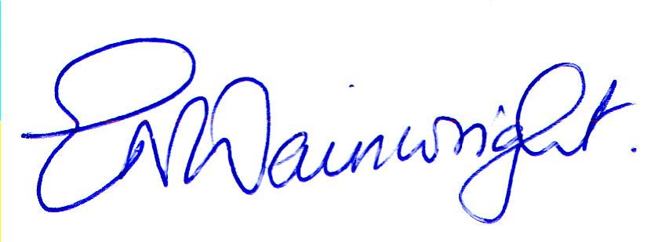 | Date: 11/2/25
Signed:  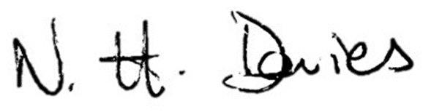 | Date: 10/2/2025
Signed (Partnership Team Leader): | Date:
Signed (External Examiner): | Date:

UWTSD PROVISION: please submit the completed document to the appropriate Programme Manager.
COLLABORATIVE PROVISION: please submit the completed document in accord with the specific arrangements for the programme (e.g. upload to Teams site).

NOTES ON MODERATION

All assessments which contribute to a final award/degree classification must be subject to moderation. At their discretion, Institutes may use double-marking in place of moderation.
Where moderation is used, a Moderation of Marked Assessment report (Appendix GA28) should be completed.
A list of marks for all assessment components for all students in the module should accompany the Moderation Form.
A representative sample of at least six pieces of work should be identified for moderation and should include:
- examples of work in the first class category (or equivalent for other awards);
- examples of work in the fail category;
- examples of work from each classification;
- examples of work within 2% of a classification boundary (or equivalent for other awards);
- any work on which the marker wishes for a second opinion.

If the moderation process identifies concerns relating to the marking in one or more categories, all work in the identified category must be double-marked and any residual differences in marks awarded by two markers must be resolved by means of discussion and negotiation. If such resolution is not possible, the work must be marked by a third marker identified by the Chair of the relevant Progression/Award Board. The marks awarded by the third marker are final. The process by which a final mark is agreed must be carefully documented so that the external examiner is able to follow that process.
Where a module is delivered by a collaborative partnership institution, moderation is normally a two stage process, with internal moderation at the collaborative partnership institution followed by University moderation.

THIS DOCUMENT IS ALSO AVAILABLE IN WELSH

