Martin Darzins Student ID 1909722 Assignment 1 – ePortfolio

Unit 1 - Essential Skills for Study and Employment

Table of Contents
Abstract
Introduction
Aims
Objectives
Unit 1 – Essential Skills for Study and Employment
Written (initial) Summary
Learning Techniques
Time Management
Skills and Qualities
Information and Research
Critical Thinking and Writing
Assessment Terms and Methods
Conclusion
Word Count:
References
Images
Similarity Score (Turnitin)
Reflection
Improvement Methods
Own Mark Assessment
Explanation

Abstract
To appreciate the essential skills required for study and employment; learning behaviours, independent learning and the multi-sensory learning approach, must first be appreciated. Learning behaviours help determine where emphasis is required to become an independent learner and the Multi-Sensory Learning approach method, shows that by ‘saying and doing’ you retain more.
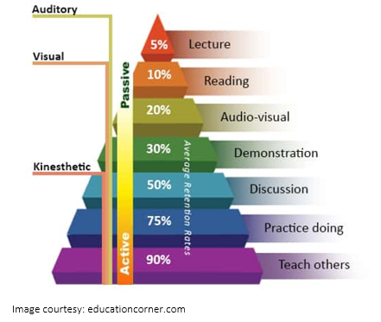

Introduction
Aims
The aim is to demonstrate the foundational skills required to be a resilient, healthy and independent learner.
To show use of suitable technology, in order to support and enhance the learning experience.

Objectives
The purpose is to produce and submit an ePortfolio that addresses the 4(four) set Tasks of Assignment 1, covering;
- Unit 1 – Essential Skills for Study and Employment
- Unit 2 – Mind Map
- Unit 3 – Video Presentation
- Unit 4 – Academic Poster
Further participation and contribution work will be carried out through completing various on-line module learning activities/tasks, including padlet and discussion forums.

Unit 1 – Essential Skills for Study and Employment
Written (initial) Summary
Learning Techniques
How we learn determines efficiency, ‘if it’s not hard work, it’s not learning’ [1], various techniques including ANSWER help successful learning, incorporating Areas of Improvement and Action Plan behaviours.
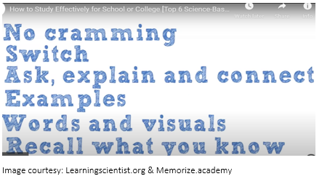
Time Management
Time Management recognition; procrastination, perfectionism and planning, define performance. Employing control strategies with managing clutter and interruptions, will improve efficiency. Swiss Cheese/SMART techniques; breaking the task into manageable parts, target setting, effective planning, prioritising and maintaining plan, continue the essential skills development [2].
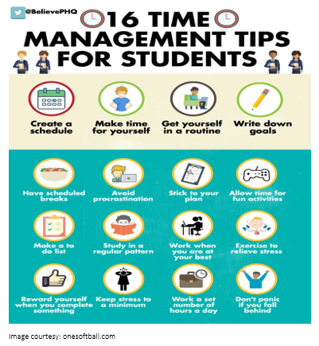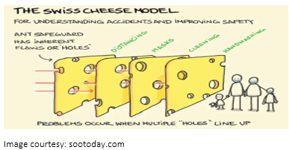
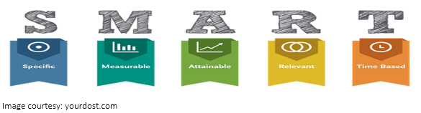
Skills & Qualities
Skills are an ability, typically acquired through special training and knowledge [3], whereas Qualities are a personality trait/characteristic, they are not identical, but both are required. Developing key personal qualities translate into employment skills. Improvements are obtained from identifying your strengths/weaknesses and determining your goals/inhibitors.
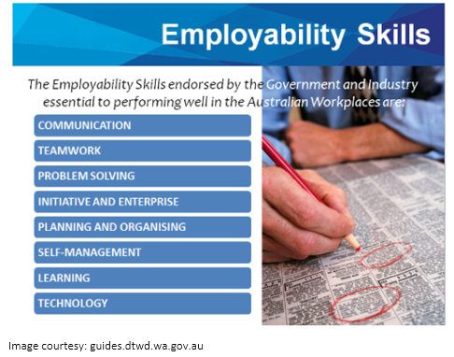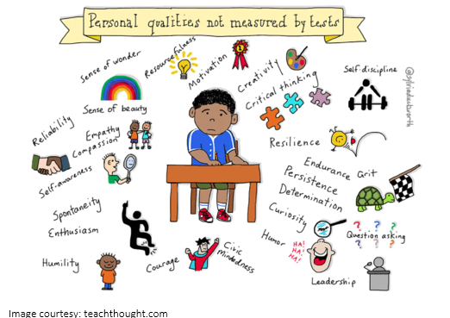

Information and Research
Using CRAAP type techniques and understanding acquisition and evaluation methods for credible sources of information, help form arguments and identify ‘Fake News’ [4].
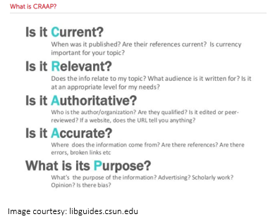
Critical Thinking and Writing
Ability to paraphrase and synthesising gathered information into your own words, will avoid plagiarism by displaying all required citations/references [5], [6].
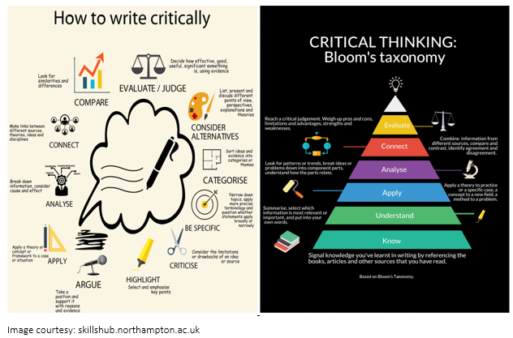

Assessment Terms & Methods
In both education and employment, assessment terms and structured method appreciation will assist work completion and enable a uniform approach to problem solving [7].
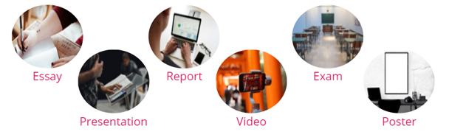
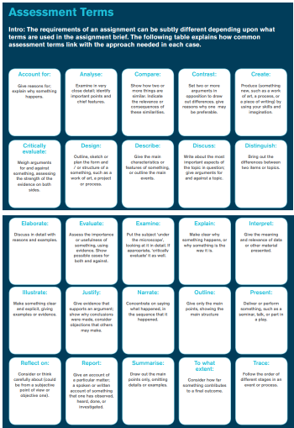
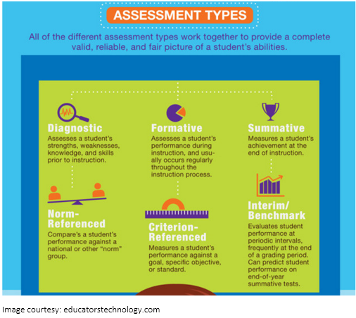
Conclusion
Furthermore: the readiness to learn, an open mind, being curious, learning from mistakes, willingness to change, keeping motivated with a target/reward structure, will enhance your academic and career prospects.
All essential skills for study and employment.

Word Count: 250

References
[1] L. Deslauriers, L. McCarty, K. Miller, K. Callaghan, G. Kestin, Measuring actual learning versus feeling of learning in response to being actively engaged in the classroom, Vol 116 (39). pp.19251-19257.
Washington: National Academy of Sciences, 2019. ISSN 0027 8424.

[2] D. McCarthy, “10 Timeless Time Management Techniques,” Aug. 29, 2019. [Online].
Available: https://www.thebalancecareers.com/time-management-techniques-2276138.
[Accessed Oct. 18, 2020].

[3] Collins Dictionary, “Definition of Skill,” 2020. [Online].
Available: https://www.collinsdictionary.com/dictionary/english/skill.
[Accessed Oct. 18, 2020].

[4] Benedictine University, “Evaluating Sources: The CRAAP Test,” Aug. 24, 2020. [Online].
Available: https://researchguides.ben.edu/c.php?g=261612&p=2441794.
[Accessed Oct. 18, 2020].

[5] University of Northampton, “Critical Thinking,” 2018. [Online].
Available: https://skillshub.northampton.ac.uk/critical-thinking/.
[Accessed Oct. 18, 2020].

[6] N. Warburton, The Basics of Essay Writing.
Abingdon: Routledge, 2007. ISBN 9780 4154 34041.

[7] Educational Technology and Mobile Learning, “A Good Visual Featuring 6 Assessment Types,” Jul. 30, 2013. [Online]. Available: https://www.educatorstechnology.com/2013/07/a-good-visual-featuring-6-assessment.html. [Accessed Oct. 18, 2020].

Images courtesy of:
- Educationcorner.com
- Learningscientists.org & Memorize.academy
- Onesoftball.com
- Sootoday.com
- Yourdost.com
- Guides.dtwd.wa.gov.au
- Teachthought.com
- Libguides.csun.edu
- Skillshub.northampton.ac.uk
- Educatorstechnology.com

