Marketing Fundamentals
LCBB4004

Student name: Cristina Elena Negoita

Student Id number: 2133077

Lecturer name: Tushara Balendran

Contents
Introduction 4
Company’s Overview: 4
PESTEL Analysis: 5
Political Factors: 6
Economic Factors: 6
Social Factors: 6
Technological Factors: 7
Environmental Factors: 7
Legal Factors: 7
Google: Porter’s Five Forces Industry and Competition Analysis 8
Threat of New Entrants 8
Bargaining Power of Suppliers 8
Bargaining Power of Buyers 9
Threat of Substitutes 10
Industry Rivalry 11
SWOT analysis 11
Strengths 12
Weaknesses 12
Threat 12
Opportunity 12
Recommendations 13
Conclusion 15
References 17
Appendix 18

Introduction
Successful organisations must comprehend and adjust to the external influences that affect their operations in the fast-paced business climate of today. Companies must strategically analyse these external elements in order to find opportunities and reduce potential risks (Banka et al., 2023). This paper, written by a Google marketing professional, intends to undertake an external review of the company and look at the major factors that have an impact on its operations. This examination will offer insights into the difficulties and possibilities facing Google by applying appropriate academic theory and practical industrial examples (Liu, An, & Zhou, 2021). Additionally, solid advice for the future will be offered to assist the business in keeping its position as a pioneer in the technology sector.

Company’s Overview:
Google Inc. is a popular US multinational organization focused on technology and offering products and services related to the Internet (Company website, 2023). Google is one of the USA’s ‘Big Five’ I.T. organizations along with Apple, Microsoft, Amazon, and Meta. Two Ph.D. students of Stanford University, namely Sergey Brin and Larry Page founded Google in 1998. The mission statement of the organization is to “organize the world's information and make it universally accessible and useful." Google’s search engine is its key product, which is also the globe’s most famous search engine. Moreover, Google offers some other services and products that involve:
- Android: A world-famous operating system designed for tablets and phones
- Gmail: A free service for email
- Google Drive: A service for cloud storage
- YouTube: A website for sharing videos
- Google Maps: Service of internet mapping
- Google Slides: An application for presentations
- Google Sheets: A platform for spreadsheet
- Google Chrome: An Internet Browser
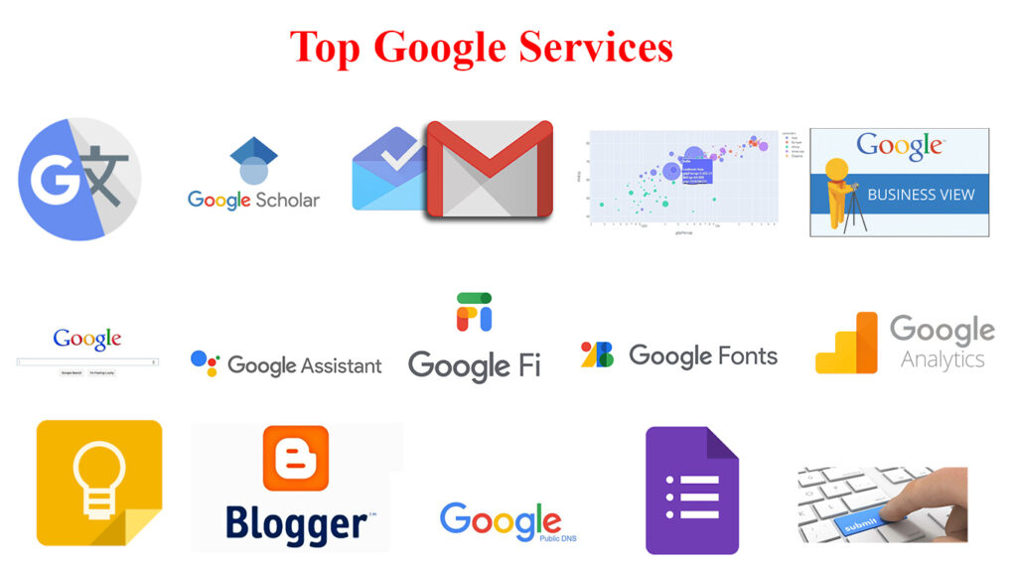
Figure 1: Google Products
Including its key goods and services, Google offers many other goods and services that involve:
- Google AI: A branch of Google that centers around AI
- Google Self-Driving Car Project: A division of Google to create cars with self-driving features.
- Google Cloud Platform: A division of cloud computing services
- Google Loon: A Google project to offer internet services to remote and rural areas
- Google Fiber: A very high-speed internet service with fiber-optic
Google Inc. is an international organization having its offices in more than 60 nations. Moreover, the market capitalization of Google is more than $1 Trillion which makes it one of the most valuable organizations globally. Google has a huge influence on how people utilized the internet. Google’s search engine has made it easier than ever for people to search for data, and its other services and products have made communication more convenient for people and made it easy to coordinate and develop content. In addition, it's been a huge innovation driver within the technological sector.
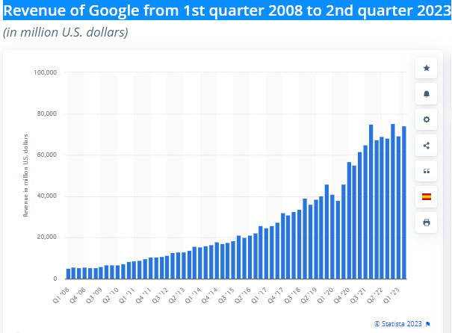
Figure 2: Google Revenue (Statista, 2023)
Despite this, Google has been slammed for its privacy practices and its supremacy within the online marketing sector. Recently, Google has been facing more inspections from regulators globally.
However, regardless of such challenges, Google is still known as one of the most powerful organizations globally and is expected to be a major contributor to the Internet in the future as well.

PESTEL Analysis:
An organization’s PESTEL analysis offers an outline of the external factors that might influence the growth of a firm. Although Google is one of the leading organizations, still it gets influenced by external factors (Clohessy & Acton, 2019). This analysis highlights the effects of political, economic, social, technological, environmental, and legal conditions on the growth of the organization. However, with good strategies, Google can deal with such challenges.

Political Factors:
Google's growth is impacted by political conditions. As the “free trade agreement” provides increased import and export opportunities, Google should regard the demand for their products and sell them. This agreement might be utilized for enhancing Google’s hardware and online products sale. If the political and market conditions are stable in a country, Google might penetrate the market with good strategies. Meanwhile, Peterson (2023) showed that government-sponsored or government organizations might serve as a threat to Google because such organizations enjoy government benefits, and could give tough competition. Although, if Google studies the market before expanding its business and set effective strategies, it can develop its business.

Economic Factors:
economic factors play a major role in the development of all organizations. The situation of the market affects the organization’s sales and might impact the overall growth of the firm. The majority of developing nations are providing a developing marketplace to organizations that want to invest. The demand for technological goods is increasing as well which is good for Google. Various nations' economies have shrunk after the COVID-19 in which Google operates. The temporary import and export bans might barricade their development (Nandi, & Chauhan, 2022). The majority of nations have increased demands for various technological items or gadgets, hence, favorable for Google. If the market of the USA remains stable, then Google might introduce a few luxury goods gradually (Monti & Wacks, 2020). Google might consider both the positive and negative sides while searching for a market to expand its business.

Social Factors:
Social factors affect the operations of a firm directly or indirectly. Following are some social factors that affect Google’s revenue generation:
- Privacy of data is a huge concern for various users. The majority of users might regard the idea of “ad-blocking” to secure their information (Moslehpour et al., 2021). The majority of browsers are incorporated with an “ad-free” version. Because Google produces a significant part of its profit from ads, this condition might impact its profit.
- Other platforms are getting popularity as well, hence, increasing competition.
- Social media platforms are a threat to Google too. Most people publish ads on social media platforms instead of Google because of the Ad-blocking mechanism.

Technological Factors:
Advancement in technology is good for Google’s development. The number of internet users is amplifying day by day, which is favorable for Google. Following are some technological challenges that might be a problem for Google:
- Cloud-based and AI technologies are getting popular among people, and various organizations are applying AI-based technologies as well. Google could incorporate such technologies with advanced features.
- Google might continuously update its products. Moreover, they should protect their platforms from viruses and hackers because it's preferable for users.

Environmental Factors:
Environmental factors impact the revenue of an organization either directly or indirectly as the environment is becoming an increasing concern for users. Hence, when selecting a good, users prefer organizations who develop eco-friendly products. Following are some of the initiatives that Google can take:
- Google can support eco-friendly projects and gain the interest of users.
- The company has already developed a sustainable bond with its vendors, leaving a positive impression.
- Being a corporate organization, Google should participate in various social events to draw the attention of users.

Legal Factors:
Legal factors might harshly impact the profitability of any organization. A nation’s law might increase or restrict an organization’s business. There might be few laws for trade that might open new opportunities. Following are some legal problems that might affect Google:
- Various nations are imposing online privacy laws which might affect Google’s business. Although, Google might enhance its services to make them protected for its users.
- A huge amount of Google revenue is generated from ads but laws against using user data might affect its growth.
- As nations are taking steps to stop breaching intellectual property rights, Google can have a chance to safeguard such rights of a person for online published content.

Google: Porter’s Five Forces Industry and Competition Analysis

Threat of New Entrants
There is an increased threat to Google for new entrants. Within increasingly competitive and innovative sectors like search engines and technology, this threat is more. New entrants might possess innovative strategies for business or new technology, which might be a threat to Google.
Although, Google possesses numerous benefits that make it challenging for new entrants to take its position. For instance, Google’s brand image is very strong, which enables it to invest more in R&D, buy advanced technology and best talent, and deal with the evolving needs of the sector.
Google could improve the market entry barriers by applying various strategies:
Patents and Intellectual Property: The products and technology of Google could be protected via trademarks, patents, or other kinds of intellectual property. This makes it hard for new entrants to copy products from Google and offers a legal base for Google to uphold its position in the market.
Network Effects: Google might utilize its product’s network influence like Google’s search engine to develop a good development cycle. As increasing users use the products of Google, the firms become more important to their users, hence making it hard for new entrants to gain market position.
Brand Reputation: Google might develop and maintain a powerful brand image, hence, making it more competitive for new entrants. Because a powerful brand image might improve the loyalty of customers.
Strategic Alliances and Partnerships: Google might develop strategic partnerships with its competitors. Such alliances might offer access to advanced technologies, resources, as well as talent, hence making it hard for new entrants to enter the market.
Cost Advantages:
Google could utilize its resources to develop cost benefits that make it hard for new entrants to maintain. For instance, Google might invest in organization and technology that enhances productivity and lowers costs.

Bargaining Power of Suppliers
Google’s supplier's bargaining power is temperate. As Google is a huge and powerful organization having noteworthy purchasing power, this offers it some power over bargaining during its negotiation with vendors. Google possesses a huge number of vendors that offers numerous services and products.
A few of its main vendors involve a firm that offers hardware elements for their gadgets like mobiles, laptops, and smart home gadgets, and firms that offer services and software like marketing, cloud computing, and promotional services.
More vendors involve firms that offer infrastructure for data centers, different kinds of online content like books, movies, and music, and data storage services. Moreover, Google depends upon vendors for different professional services like legal, auditing, and consulting.
There exist numerous strategies that Google might adopt to reduce its vendor’s bargaining power.
Diversify Suppliers: By purchasing services and products from different vendors, a firm could lower its reliance upon one vendor and improve competition between vendors, hence, reducing its bargaining power.

Improve Relationships with Suppliers: Developing a strong alliance with vendors might enhance the bargaining power of an organization and lowers the vendor’s bargaining position. This might involve operating closely with vendors to know about their needs and searching for methods to fulfill them efficiently.

Develop Alternative Sources of Supply: Investing in the creation of substitute supply sources might improve the bargaining position of a firm and lowers its reliance upon one vendor. This might involve creating in-house talents or developing alliances with other firms.
Increase Investments in Technology: Technological investment might enhance the bargaining power of a firm and lowers the vendor's bargaining power. For instance, creating exclusive technology or financing in computerization might lower the firm’s reliance on vendors and improves its bargaining position.
Form Strategic Alliances: Developing strategic partnerships with other firms might improve the bargaining power of Google and lower it for vendors. This might involve establishing alliances with firms to negotiate good contacts with vendors or sharing resources to lower costs.

Bargaining Power of Buyers
Throughout, the buyer’s bargaining power level of Google is temperate. It relies upon the particular segment of the market and the dynamics of the sector.
Within the marketing segment, buyers might possess comparatively more bargaining power because of more available options for marketing and the convenience of switching.
Although, within other segments of the marketplace, like hardware, the buyer’s bargaining power might be low because of the powerful brand image and awareness of Google and the restricted number of substitutes available for purchasers.
There exist numerous strategies that might be utilized by Google to reduce the buyer’s bargaining power:
Maintaining strong customer relationships: By establishing strong bonds wither its users, Google has the opportunity to improve its organizational loyalty and lower users’ readiness to switch to substitutes.
Providing high-quality products and services: By constantly innovating and offering increased quality services and products that are hard to substitute, Google might lower buyers’ bargaining power by making it hard to search for similar services like Google.
Building brand loyalty: By developing brand loyalty through its branding and advertising campaigns, Google might improve its product's apparent value and lower the buyer’s bargaining power.
Diversifying its product portfolio: By increasing its portfolio of goods in new segments of the market, Google might lower its reliance upon any specific market or consumer segment, which eventually will lower the buyer’s bargaining power within any provided marketplace.
Improving supply chain management: By enhancing its SCM (Supply Chain Management) and lowering its reliance upon a specific vendor, Google might lower the vendor’s bargaining power and improve its power of bargaining in buyer’s negotiations.

Threat of Substitutes
The substitution threat for Google is High. ‘Text-centered search’ or ‘Natural language processing’ technologies that are utilized in ChatGPT might be viewed as an alternative to conventional search engines. ChatGPT can respond to questions of users in an interactive way, which is not like conventional search engine findings that give a series of websites as per the relevance of a keyword. This might make ChatGPT a popular substitute for customers who are looking for more informal and conversational experiences.
Although, conventional search engines such as Google possess the benefit of a huge database of indexed websites, making it a more thorough information source for users. Moreover, Google has increasingly invested in enhancing its normal language processing skills, making it ideal for interpreting and responding to queries of users.
To deal with substitutional threats such as ChatGPT, Google should keep updating its normal language processing skills and provide its users with more interactive search encounters. Furthermore, Google might utilize its huge database to offer more relevant findings of search, hence, making it more reliable in contrast to ChatGPT.

Industry Rivalry
The industry rivalry level of Google is High. Google experiences major industrial competition, specifically within the search engine sector, in which Google is a leading player. A few of its key rivals involve organizations such as Yahoo!, Bing by Microsoft, and Baidu in China. Such organizations contest with Google in terms of relevance, correctness, and speed of search, and also in creating advanced options and features to enhance the consumer experience. Few organizations are financing technologies of AI and machine learning to enhance the results of searches and improve their competitiveness with Google. The leadership of Google within the industry of search engines and powerful awareness of the brand offers it an incentive over its rivals. Although the organization should constantly innovate and enhance its algorithms of search and user experiences to keep up its place within the industry. To deal with the risk of the sector’s competition, Google should keep financing in R&D to keep ahead of its rivals and increase its product portfolio to become an increasingly reliable online search engine for users. Moreover, by procuring small firms and incorporating their technologies, Google could improve its position within the industry and enhance competitiveness.

SWOT analysis
An effective method for assessing a company's internal strengths and potential external threats to its performance is a SWOT analysis. As a global leader in technology, Google exhibits a number of qualities that support its success. The company's search engine, which is the most frequently used search platform globally, is acknowledged in the literature as being its main strength (Smith, 2019). Google has cemented its position as a dominant player in the digital sphere by making its search engine associated with online searches. In addition, Google offers a wide range of products, including services like Google Maps, YouTube, and Android, all of which contribute to the company's broad user base and popularity (Alkhater & Gomes, 2020).

Strengths
Google's reputation as one of the most valuable and reliable brands in the world is a valuable asset (Fahy & Jobber, 2015). The favourable brand image of Google increases customer retention and draws new customers to its platforms. Furthermore, Google has a strong presence in many nations, giving them access to a range of marketplaces and user demographics, which is a key strength (Smith, 2019).

Weaknesses
However, Google has some flaws that have received notice in the literature. The company's management of user data privacy issues is one obvious flaw. For its data gathering practises and the exploitation of personal data for targeted advertising, Google has come under fire and regulatory scrutiny (Smith, 2019). To retain user confidence and prevent any legal and reputational implications, it is essential to address these privacy challenges (Alkhater & Gomes, 2020).

Threat
Despite the enormous success of Google's core products, some of its endeavours have failed to find a meaningful market foothold. Google+ and Google Glass, for instance, did not meet expectations for success and were later abandoned (Fahy & Jobber, 2015). This emphasises how critical ongoing innovation and market analysis are to the success of new launches and the maintenance of a competitive edge.

Opportunity
Google can investigate the expanding demand for cloud services and AI applications by turning to the opportunities. The market for cloud computing is expanding quickly, and Google's entry into this industry could increase its revenue streams (Smith, 2019). Likewise, Google can take advantage of opportunities in a variety of sectors, including healthcare, banking, and autonomous cars, thanks to its proficiency in AI (Fahy & Jobber, 2015).
Another potential possibility for Google is to enter new markets. In order to tap into the sizable user populations in these places, the corporation has made an attempt to penetrate emerging markets with inexpensive devices and customised services (Alkhater & Gomes, 2020). Google may improve its position in these markets by tailoring its goods and services to local preferences. Google, however, also faces serious risks that could have an effect on its business operations in addition to opportunities. Companies like Apple, Amazon, and Microsoft are fighting for market supremacy in the fiercely competitive tech sector (Smith, 2019). Due to the fierce rivalry, it may be difficult to maintain market share and draw in new customers.
Furthermore, continued dangers to Google's operations include governmental pressure and data privacy issues. Google must maintain vigilance to comply with rules and safeguard user data as governments throughout the world tighten data protection legislation (Fahy & Jobber, 2015). Inadequate resolution of these problems could subject the company to heavy fines and harm its reputation (Alkhater & Gomes, 2020).

Recommendations
A grand strategy includes the extensive frameworks that aid in outlining an organization's strategic actions. They concentrate on a company's long-term strategy. The development of markets and products, innovation, concentric and conglomerate diversification, and strategic alliances are a few of Google's big goals. Google's growing momentum will maintain itself in the wake of its outstanding success. One of the main drivers of this expansion is its ambitious scanning of international high-tech advances. The business is the most esteemed employer in the planet. Since it places less emphasis on research and product development than market expansion, market growth is a low-risk strategy (Gamble, 2013). One of the major strategies employed by Google Inc. is product development. The company's fans continue to grin as it introduces new goods one after another because to its unrivalled inventive capabilities. For the company's long-term growth and sustainability, for instance, the introduction of the Chromecast gadget, the Android operating system, and the Nexus 7 tablet are crucial tactics.
The fundamental plan of action for Google's rapid international expansion is market penetration. Google faces competition from other large search engines and internet advertising outside of the US. In order to compete with these businesses, the organisation uses market penetration. It keeps working to increase its market share in the global Internet advertising industry. Market expansion is a crucial component of Google Inc.'s overall strategy. The business uses an aggressive strategy in the US for its Google Fibre offering and cable television. The company has found success with this strategy in a number of states, including Kansas, Missouri, Texas, and Utah. The market expansion strategy will take advantage of the introduction of cable television and fibre products in more states and other countries.
The Google Inc.'s effective marketing strategy has been a key factor in its success. The enormous search engine has created many products, like Google Fibre and Glass. The company's marketing mix includes a variety of strategies to complement its wide range of products. From being a purely online company, Google Inc. has grown to offer a variety of services, including mobile smartphone devices like the Nexus and Chromecast video players, Android operating systems, desktop software, and mobile apps. The company's growth and market expansion are clearly demonstrated by this product diversity. The corporation uses the generic technique to increase its market share for already-released goods like Nexus and Google AdWords, among others. Place, Product, Promotion, and Place are together known as the 4Ps.
Online locations often make up Google's place component of its marketing mix. The platform is used to distribute goods in a way that allows customers to access them online. Customers can download the Google Maps app, for instance, from any physical location in the world as long as they have access to the internet. The corporation can promote its digital products to customers around the world without having to interact face-to-face because to the internet's cross-border utility. It uses retail establishments as the primary distributors of physical items like Nexus smartphones. For these products, Google selects well-known retailers to boost sales volumes and broad access by big populations of potential customers.
Since its reputation and market dominance play that function, Google's promotion element of the marketing mix is not extremely proactive. However, only a little amount of product promotion is done through internet ads, like the Gmail for work ads that are present on numerous websites.
Given its various product lines, Google has a variety of prices and pricing strategies. Freemium, marketing-focused, penetration, and value-based pricing are a few examples of such tactics. First, Google offers free products while charging for their premium or supplemental services using the freemium pricing model. Gmail is the product that is marketed using this tactic. The market-oriented pricing strategy, in addition, bases product prices on the traits of the target market.

A market-focused strategy is used to set the pricing of the Chromecast. Third, penetration pricing means offering fresh goods at discount rates in a market dominated by potent rivals. By keeping the price of its products cheap, this strategy aids Google in expanding its market share. The Google Fibre Internet and cable television services have found success with this approach.
Product Creation
Google's proactive innovation is how it carries out its product development approach. The corporation stands out from its rivals in the technological sector thanks to the creation of innovative goods like Google Glass, driverless cars, and Nexus mobile devices. The Google Inc. has been able to develop new streams of revenue thanks to this intensive strategy. These overarching strategies line up with the strategic goals of the business.
Key Success Factors for Google
The company's unified leadership team, dedication to innovation, prudent expansion, and unobtrusive marketing are among its important success reasons. The founders of Google, Brin and Page, as well as CEO Schmidt, form a tightly coordinated classic leadership molecule at the company. It incorporates high-tech into its operations to guarantee that customers receive top-notch services like Google Instant, Real-time search, and Universal search. These modern technological advancements enhance client comfort and happiness. Through its purchase methods, the corporation has created a stepping stone for its expansion outside of the search engine industry. Additionally, it uses distinctive proactive marketing techniques for its brand name. Examples of covert marketing strategies include the Google letters that display on the home page and the Google doodle, which is most frequently seen during holidays.

Conclusion
The company's business approach ensures that it is rarely impacted by sociocultural, political, legal, and economic variables. Through investing in app development, Google Inc. can become more competitive. Google may use its creative ability to close this market gap given the rising need for mobile apps in other industries such as banking, healthcare, and insurance. A thorough SWOT analysis of Google identifies its internal strengths and weaknesses as well as the external opportunities and dangers it must contend with. Google can continue to hold the top spot in the technology sector by utilising its potent search engine, broad product portfolio, solid brand recognition, and global presence. But for long-term success in the face of competition and shifting regulatory environments, addressing data privacy issues, ensuring effective product launches, and using opportunities in cloud services and AI applications are essential.

References
Statista. (2023). Revenue of Google from 1st quarter 2008 to 2nd quarter 2023 [Online] https://www.statista.com/statistics/267606/quarterly-revenue-of-google/#:~:text=Google%3A%20quarterly%20revenue%202008%2D2023&text=The%20company%20amounted%20an%20annual,Google%20sites%20and%20its%20network.
Liu, R., An, E., & Zhou, W. (2021). The effect of online search volume on financial performance: Marketing insight from Google trends data of the top five US technology firms. Journal of Marketing Theory and Practice, 29(4), 423-434.
Moslehpour, M., Ismail, T., Purba, B., & Wong, W. K. (2021). What makes GO-JEK go in Indonesia? The influences of social media marketing activities on purchase intention. Journal of Theoretical and Applied Electronic Commerce Research, 17(1), 89-103.
Monti, A., & Wacks, R. (2020). COVID-19 and Public Policy in the Digital Age. Taylor & Francis.
Nandi, S., & Chauhan, C. (2022). Impact of COVID-19 on decent work, economic growth, and world trade. In COVID-19 and the Sustainable Development Goals (pp. 105-121). Elsevier.
Peterson, K. R. (2023). WE CAN DO THIS/JUNTOS SÍ PODEMOS: A CRITICAL DISCOURSE ANALYSIS OF GOVERNMENT-SPONSORED COVID-19 PUBLIC SERVICE ANNOUNCEMENTS (PSAS) IN ENGLISH AND SPANISH.
Clohessy, T., & Acton, T. (2019). Investigating the influence of organizational factors on blockchain adoption: An innovation theory perspective. Industrial Management & Data Systems, 119(7), 1457-1491.
Banka, M., Tien, N. H., Dao, M. T. H., & Minh, D. T. (2022). Analysis of business strategy of real estate developers in Vietnam: the application of QSPM matrix. International journal of multidisciplinary research and growth evaluation, 3(1), 188-196.

Appendix


