Downloading your Data into SPSS for Qualtrics:

- First, you need to ensure you have labelled each question correctly - the name of each question will download directly into SPSS and appear as the variable name for that specific question: 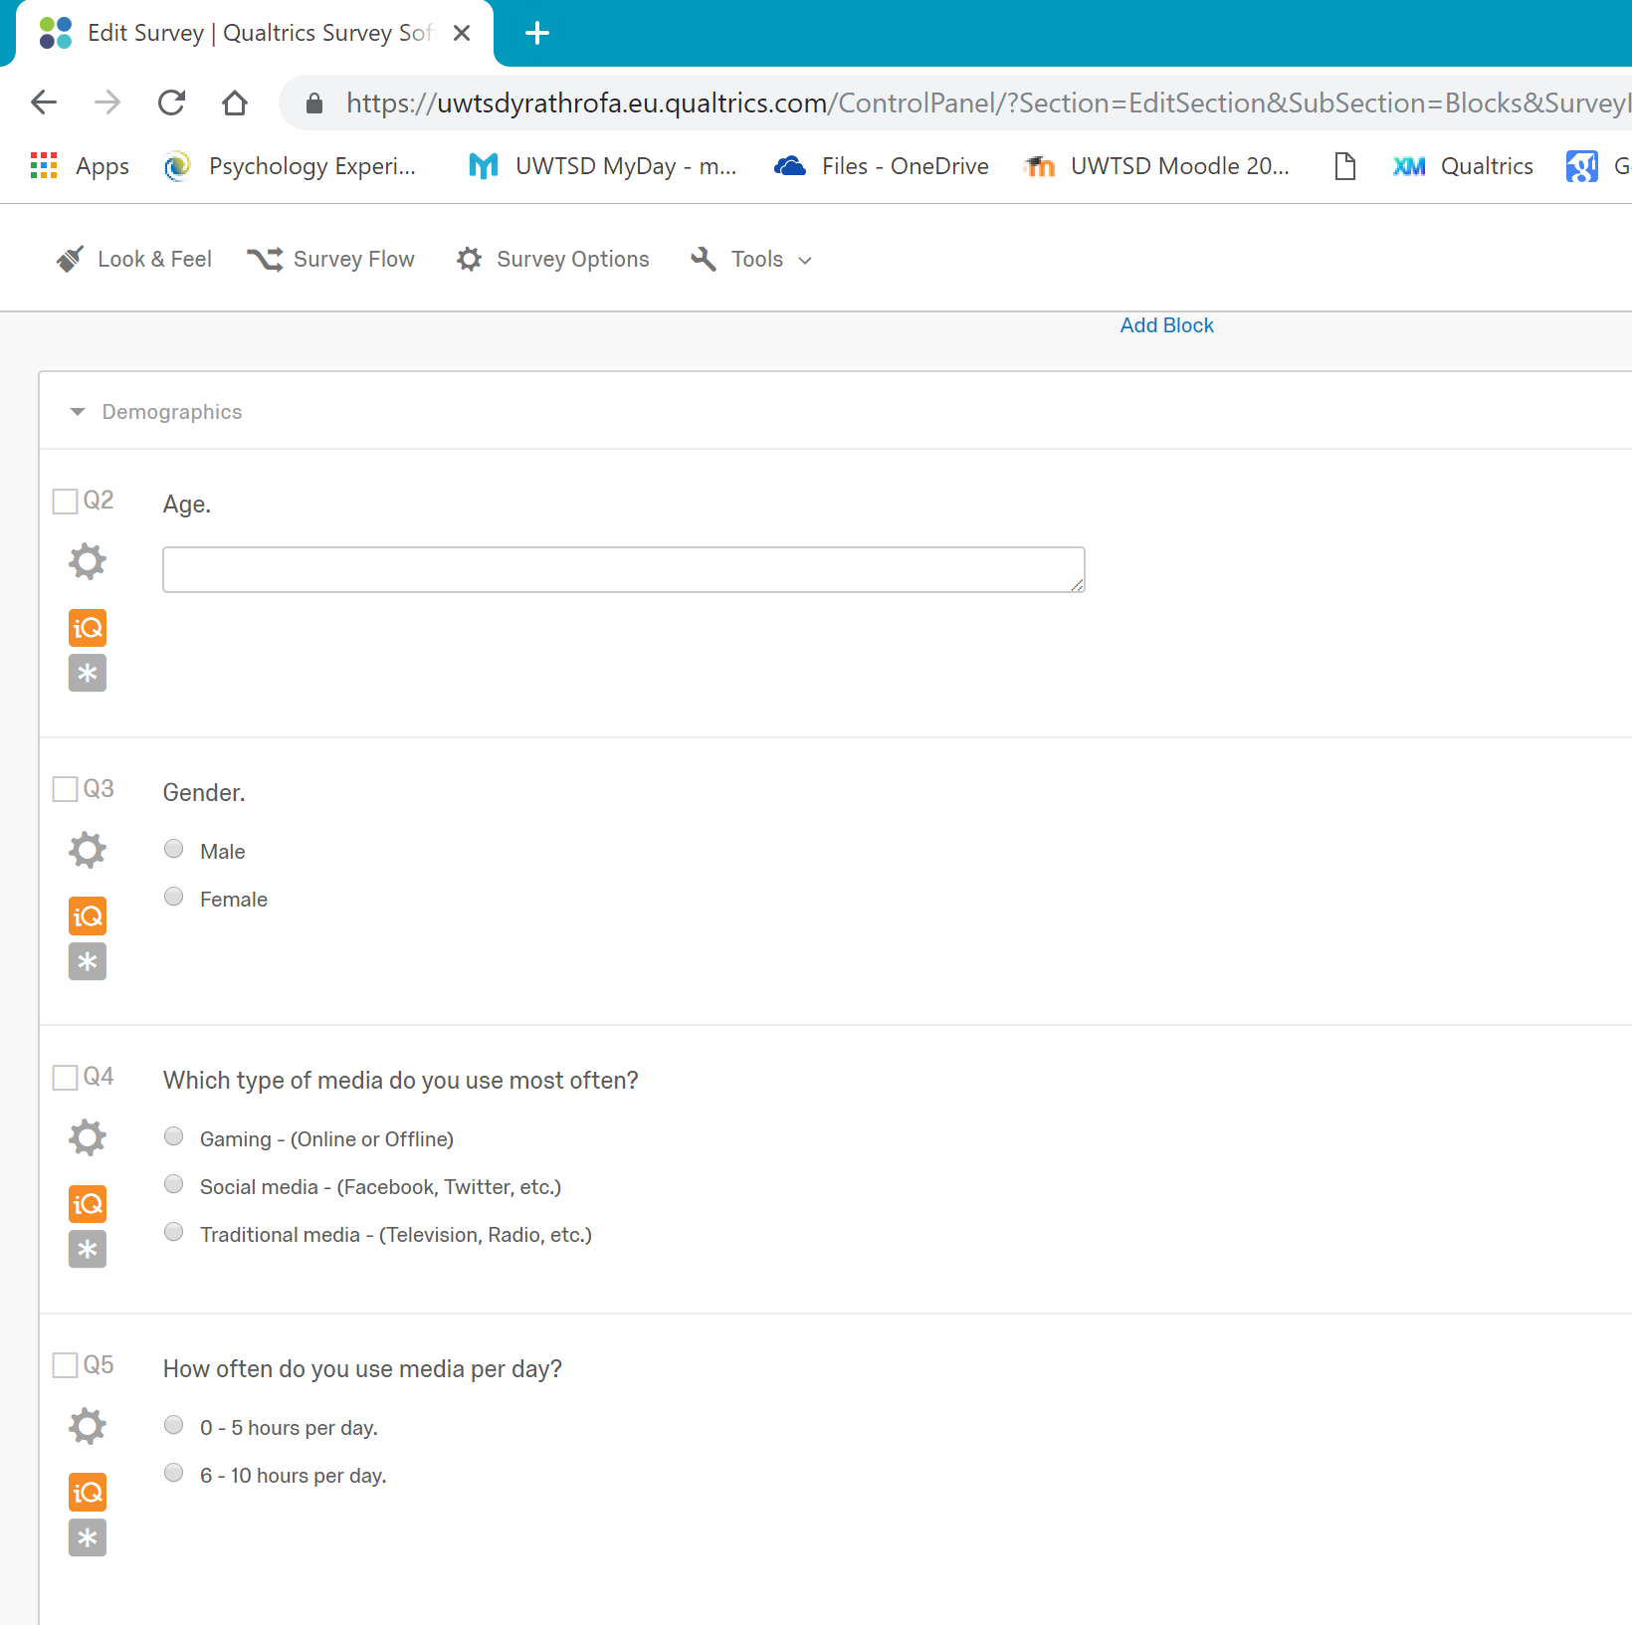
E.g., Gender
E.g., Media_Usage
E.g., Age

- If you are using multiple questionnaires you will want to label each question in accordance with which questionnaire it came from:
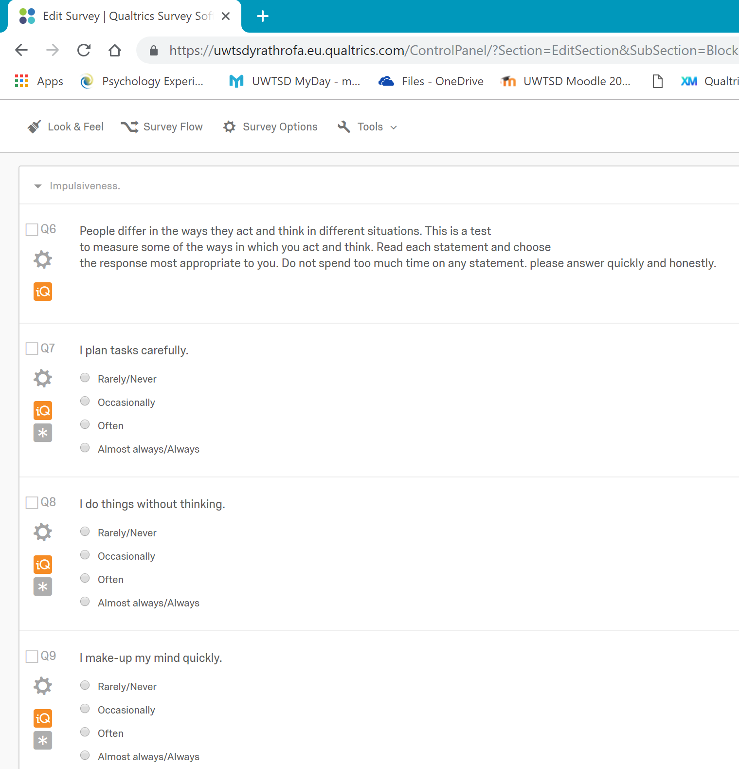
E.g., Impulsiveness_Q1
Please Note: The labels must be compatible with the SPSS variable name format.

- Next, you need to make sure you have scored your data into the numerical values:
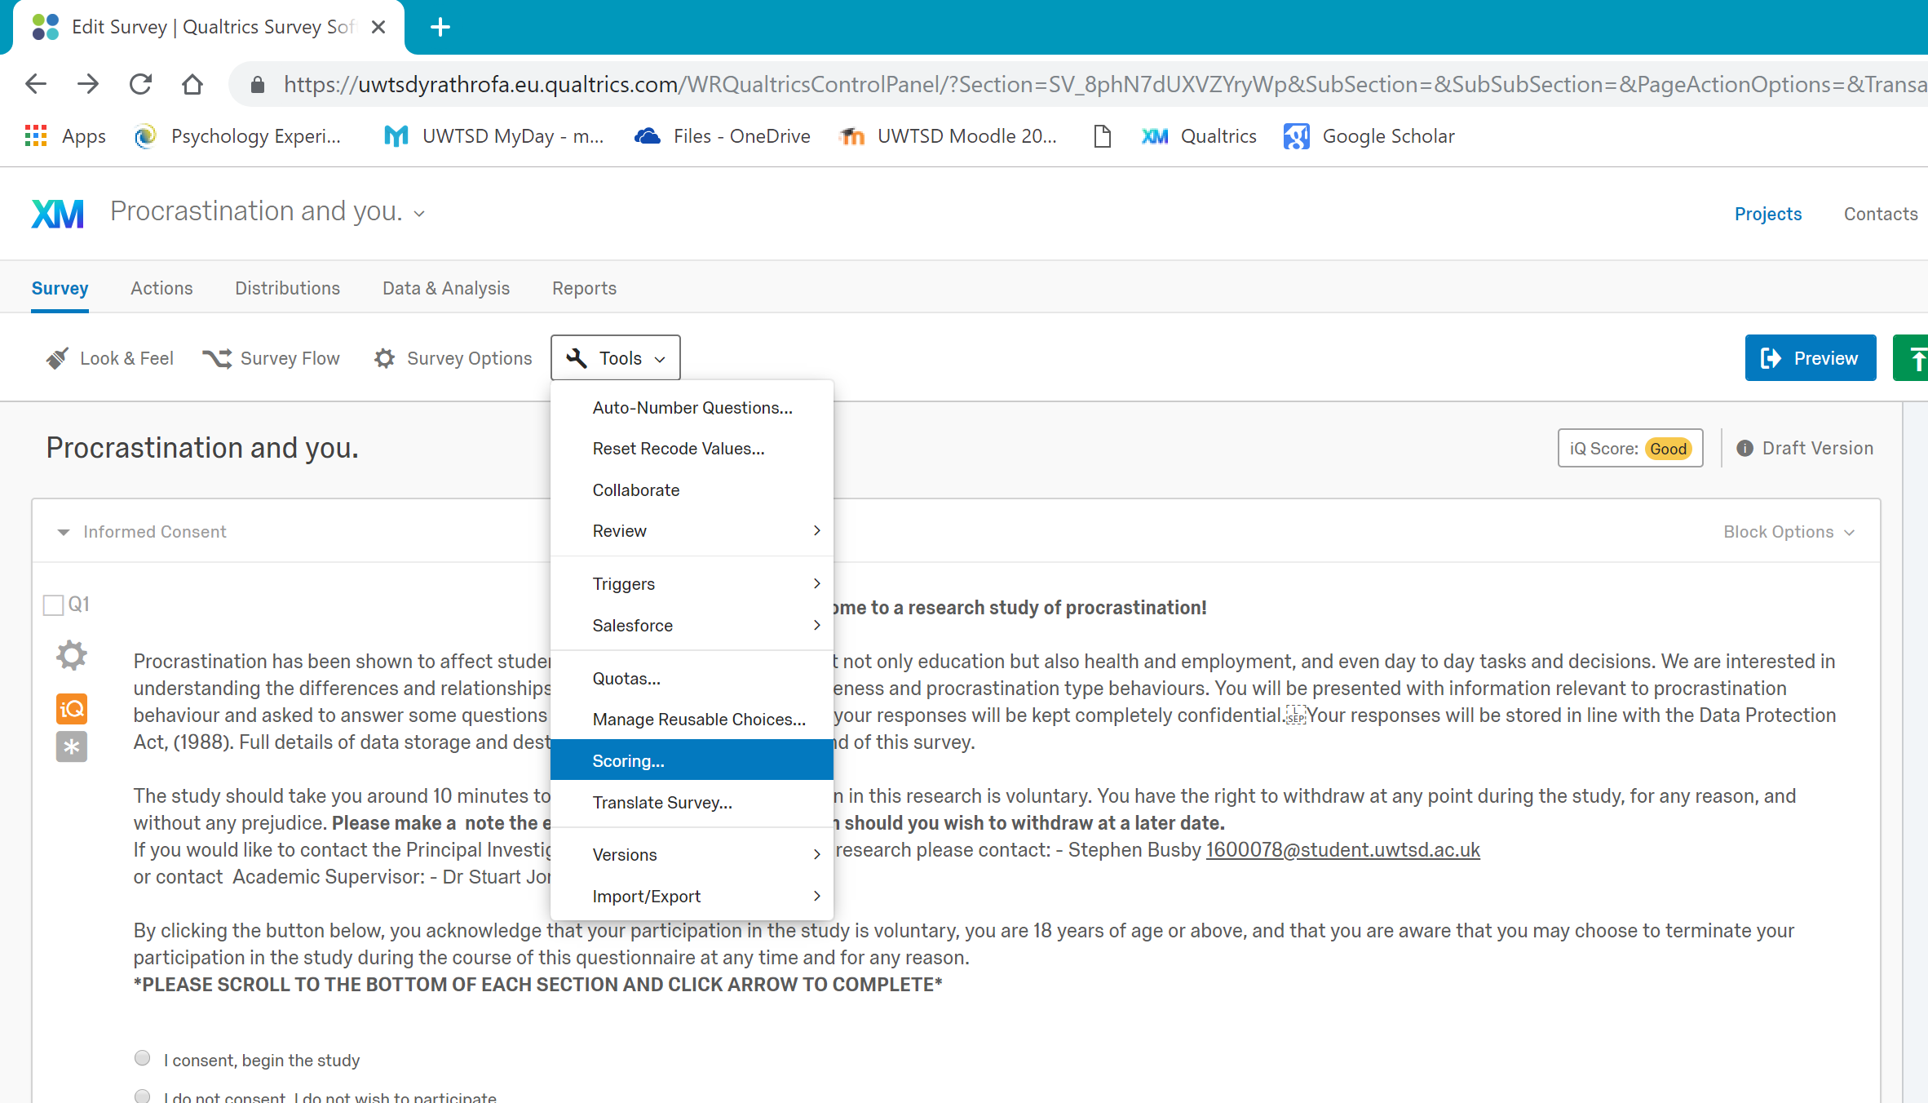
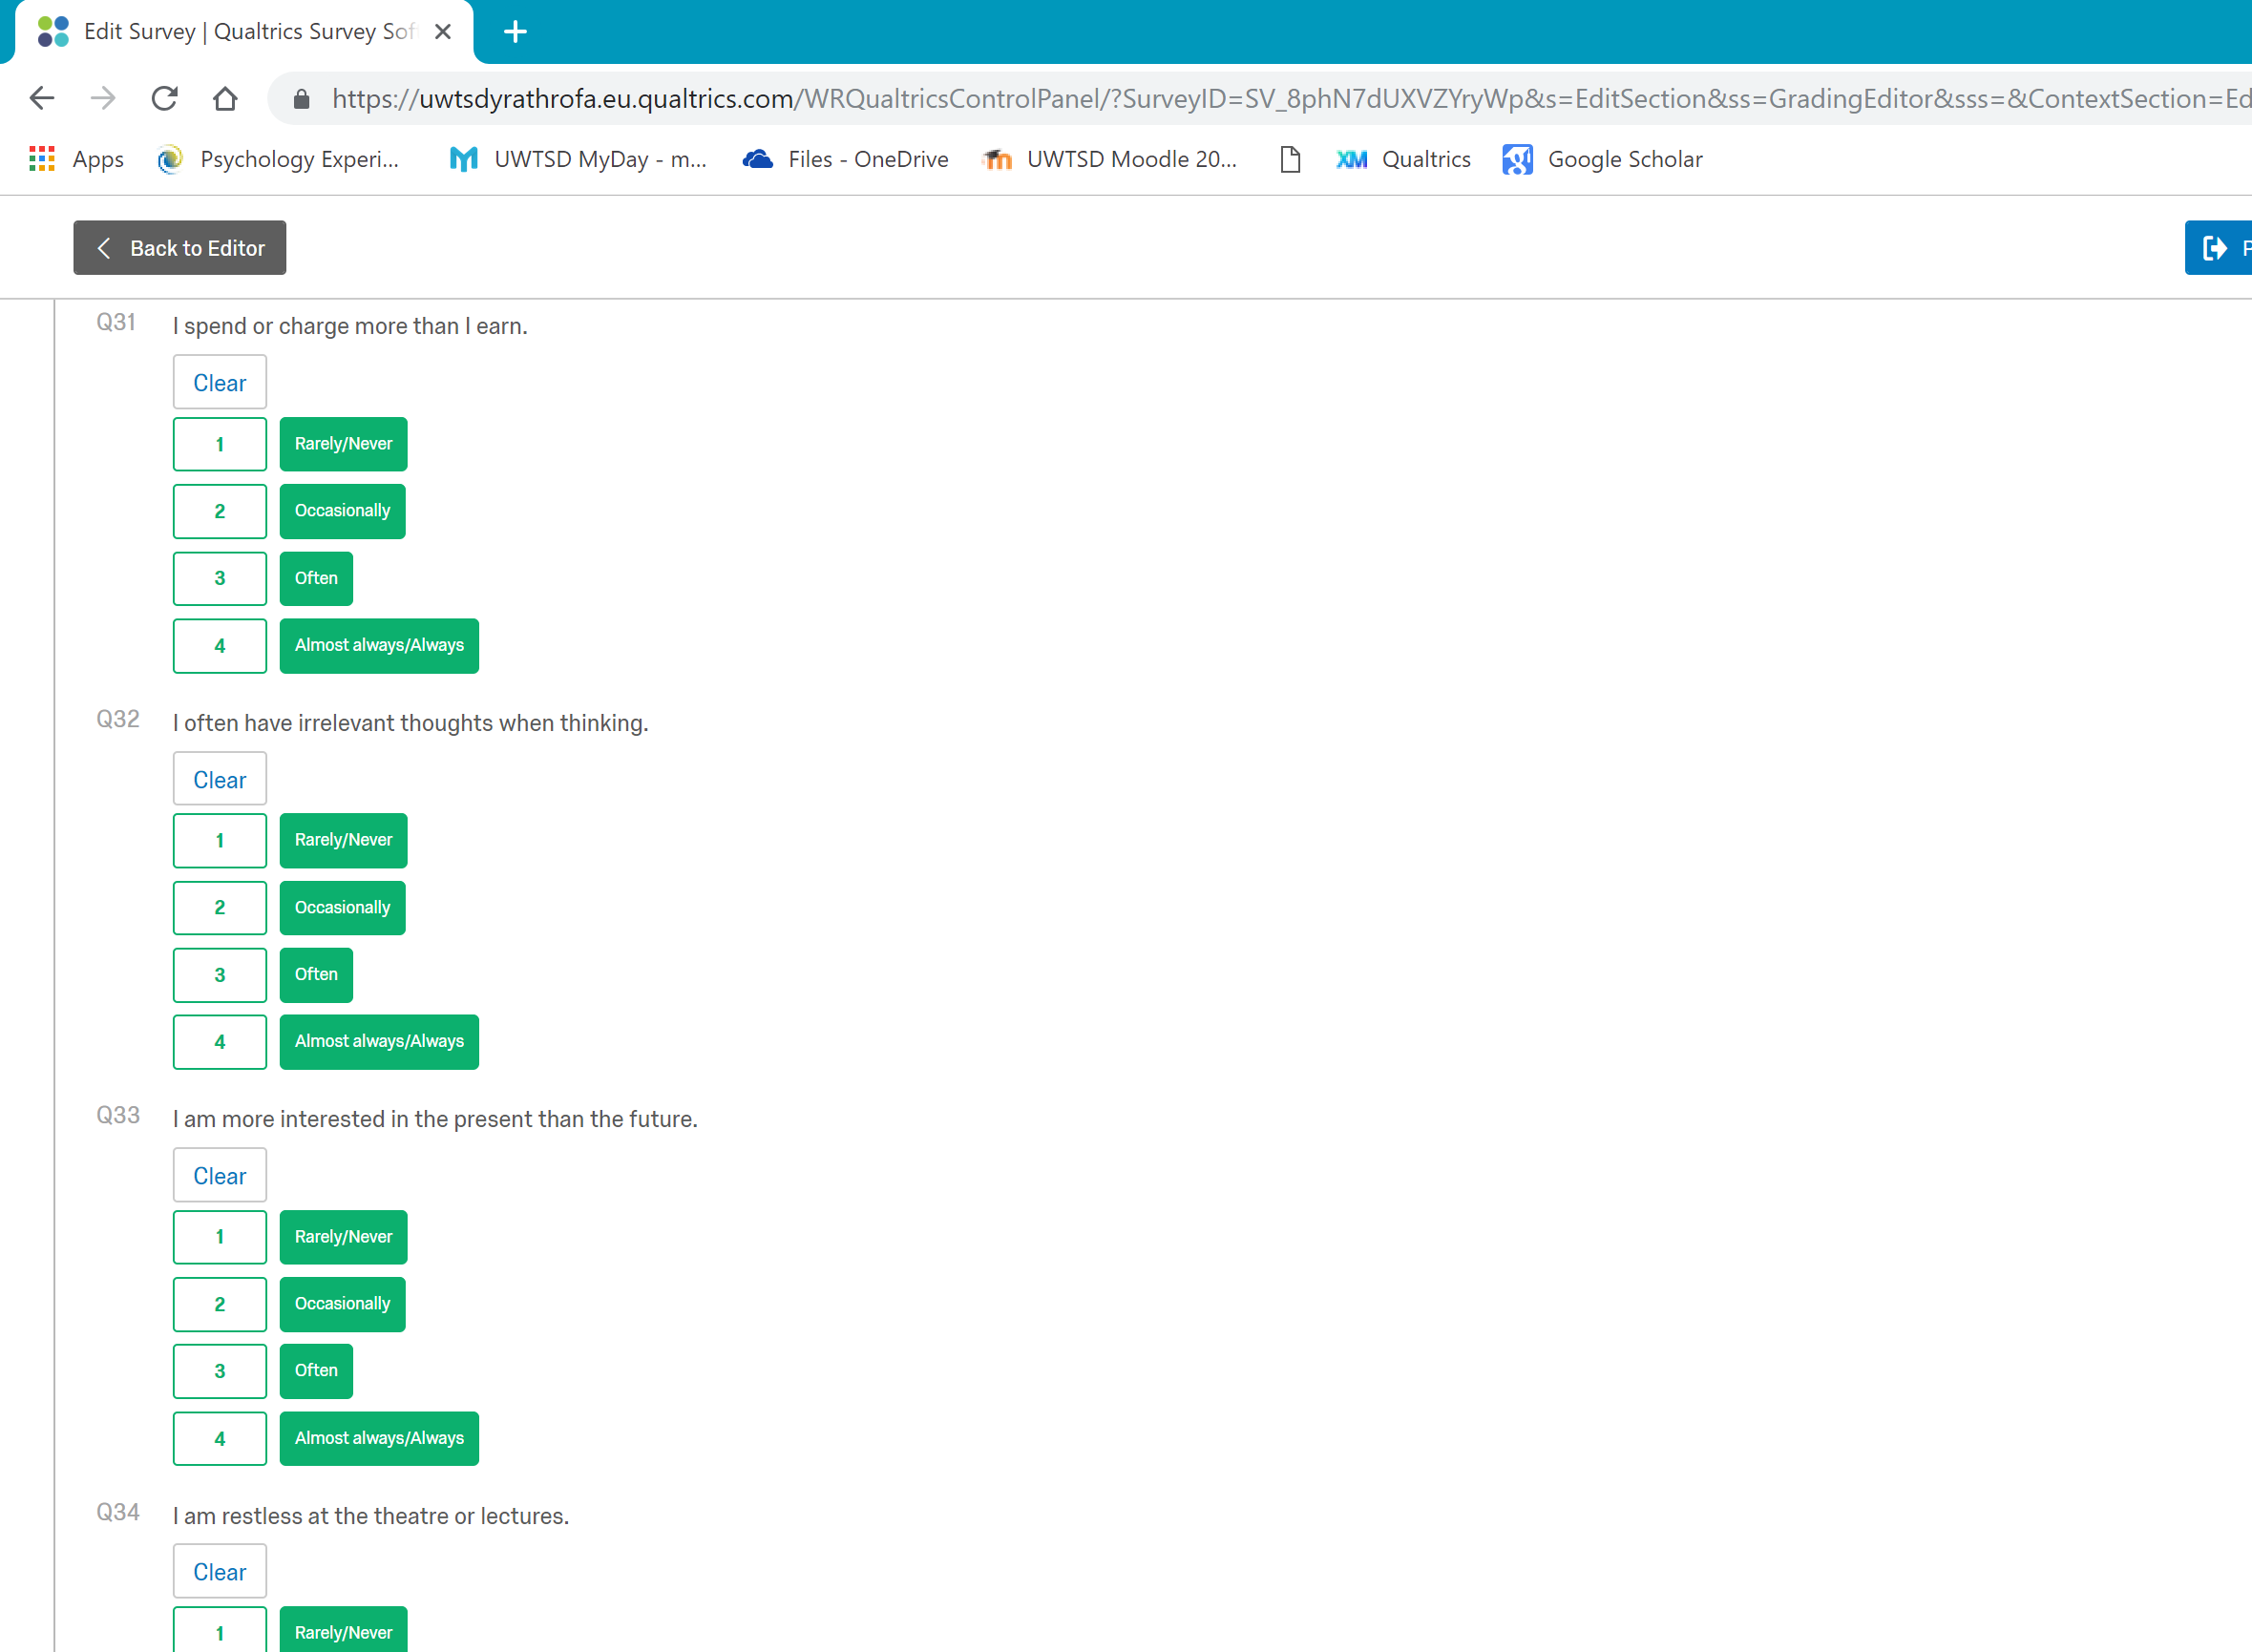

- The scoring will depend upon the values of each question in your Likert scale.
- Make sure you put your raw data here – you can reverse code any questions in SPSS once your data has been downloaded.

- Now, download your data into SPSS:
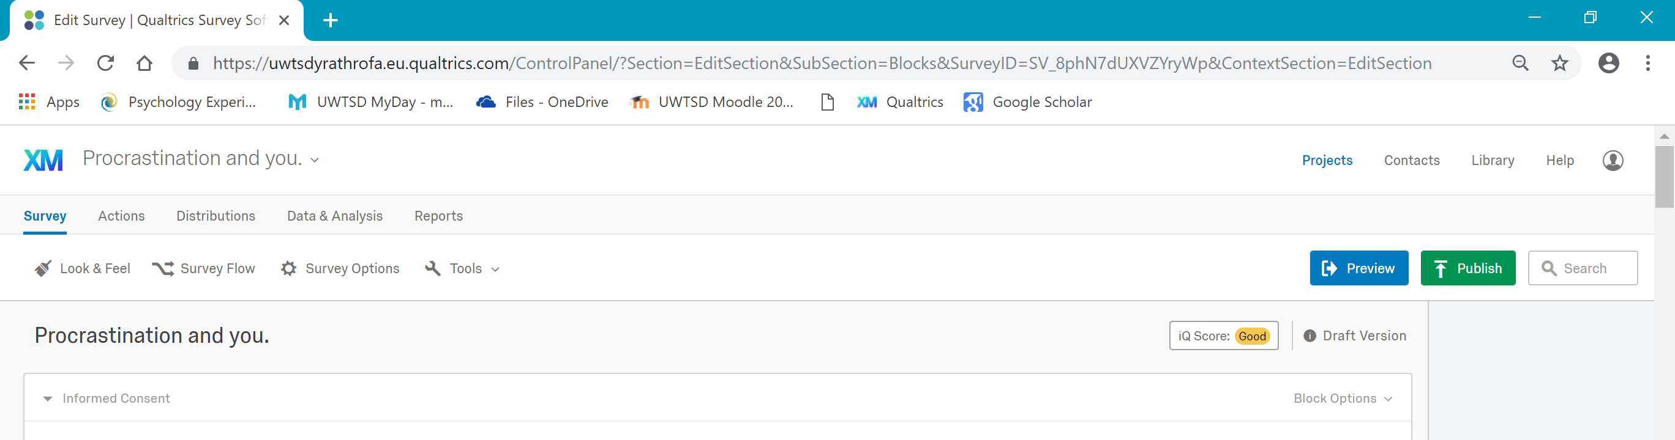

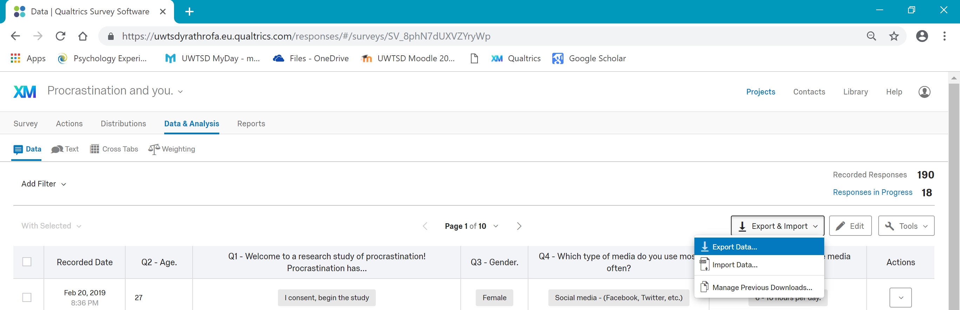

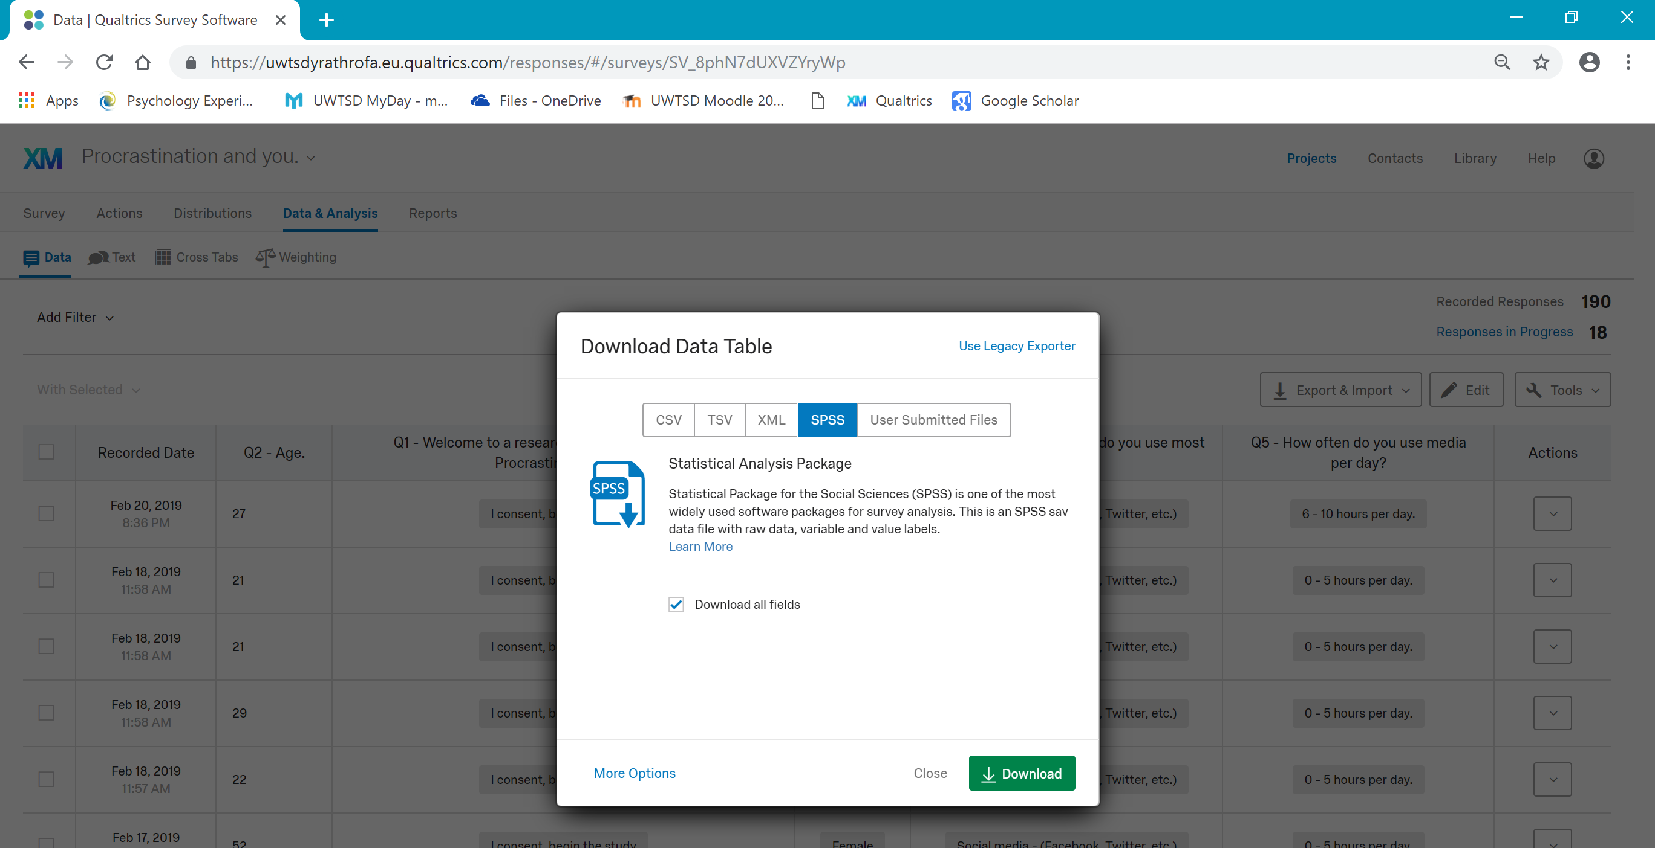

- Once your data has been downloaded, there is a lot you can delete before you start your analysis:
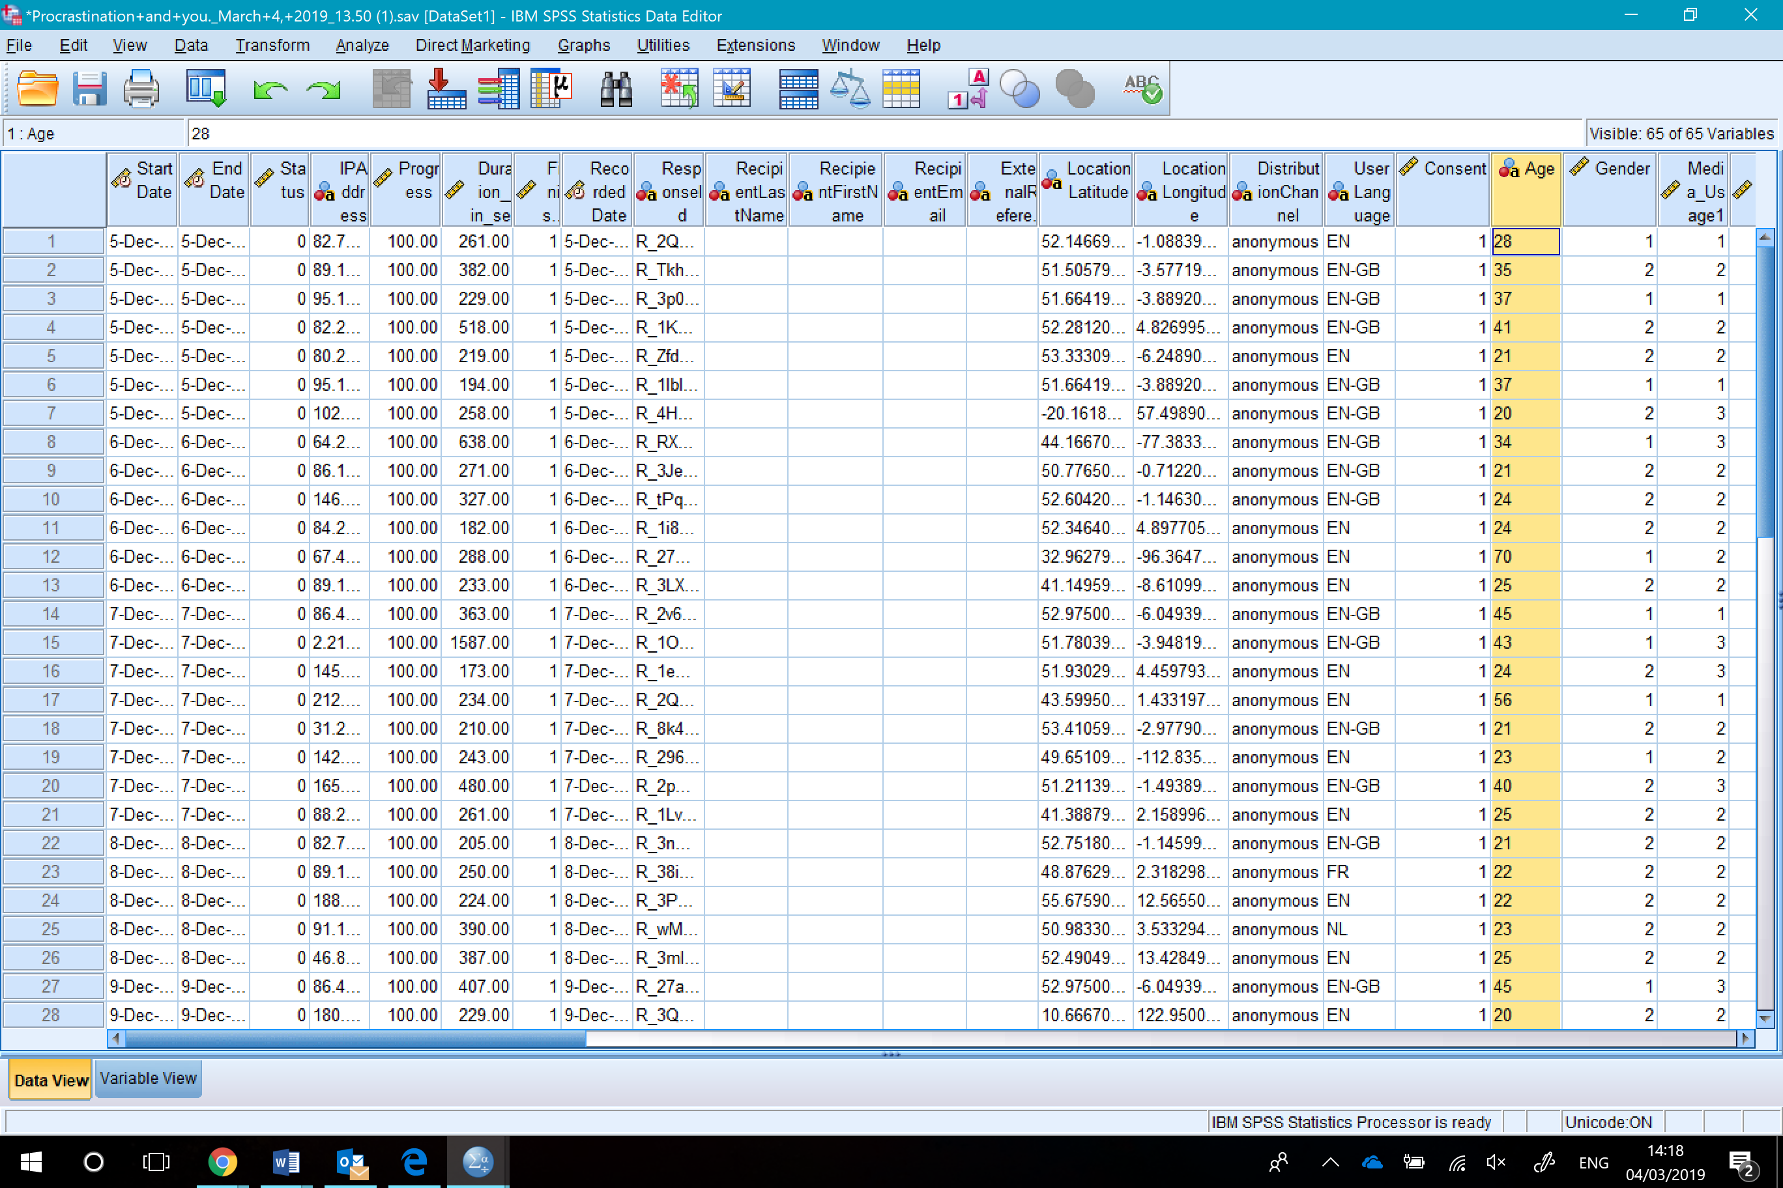
You can delete any irrelevant data which has downloaded from Qualtrics (either up to demographics or the Q1 of your first questionnaire).

- Finally, check the values have downlaoded correctly in accordance to your Likert scale:
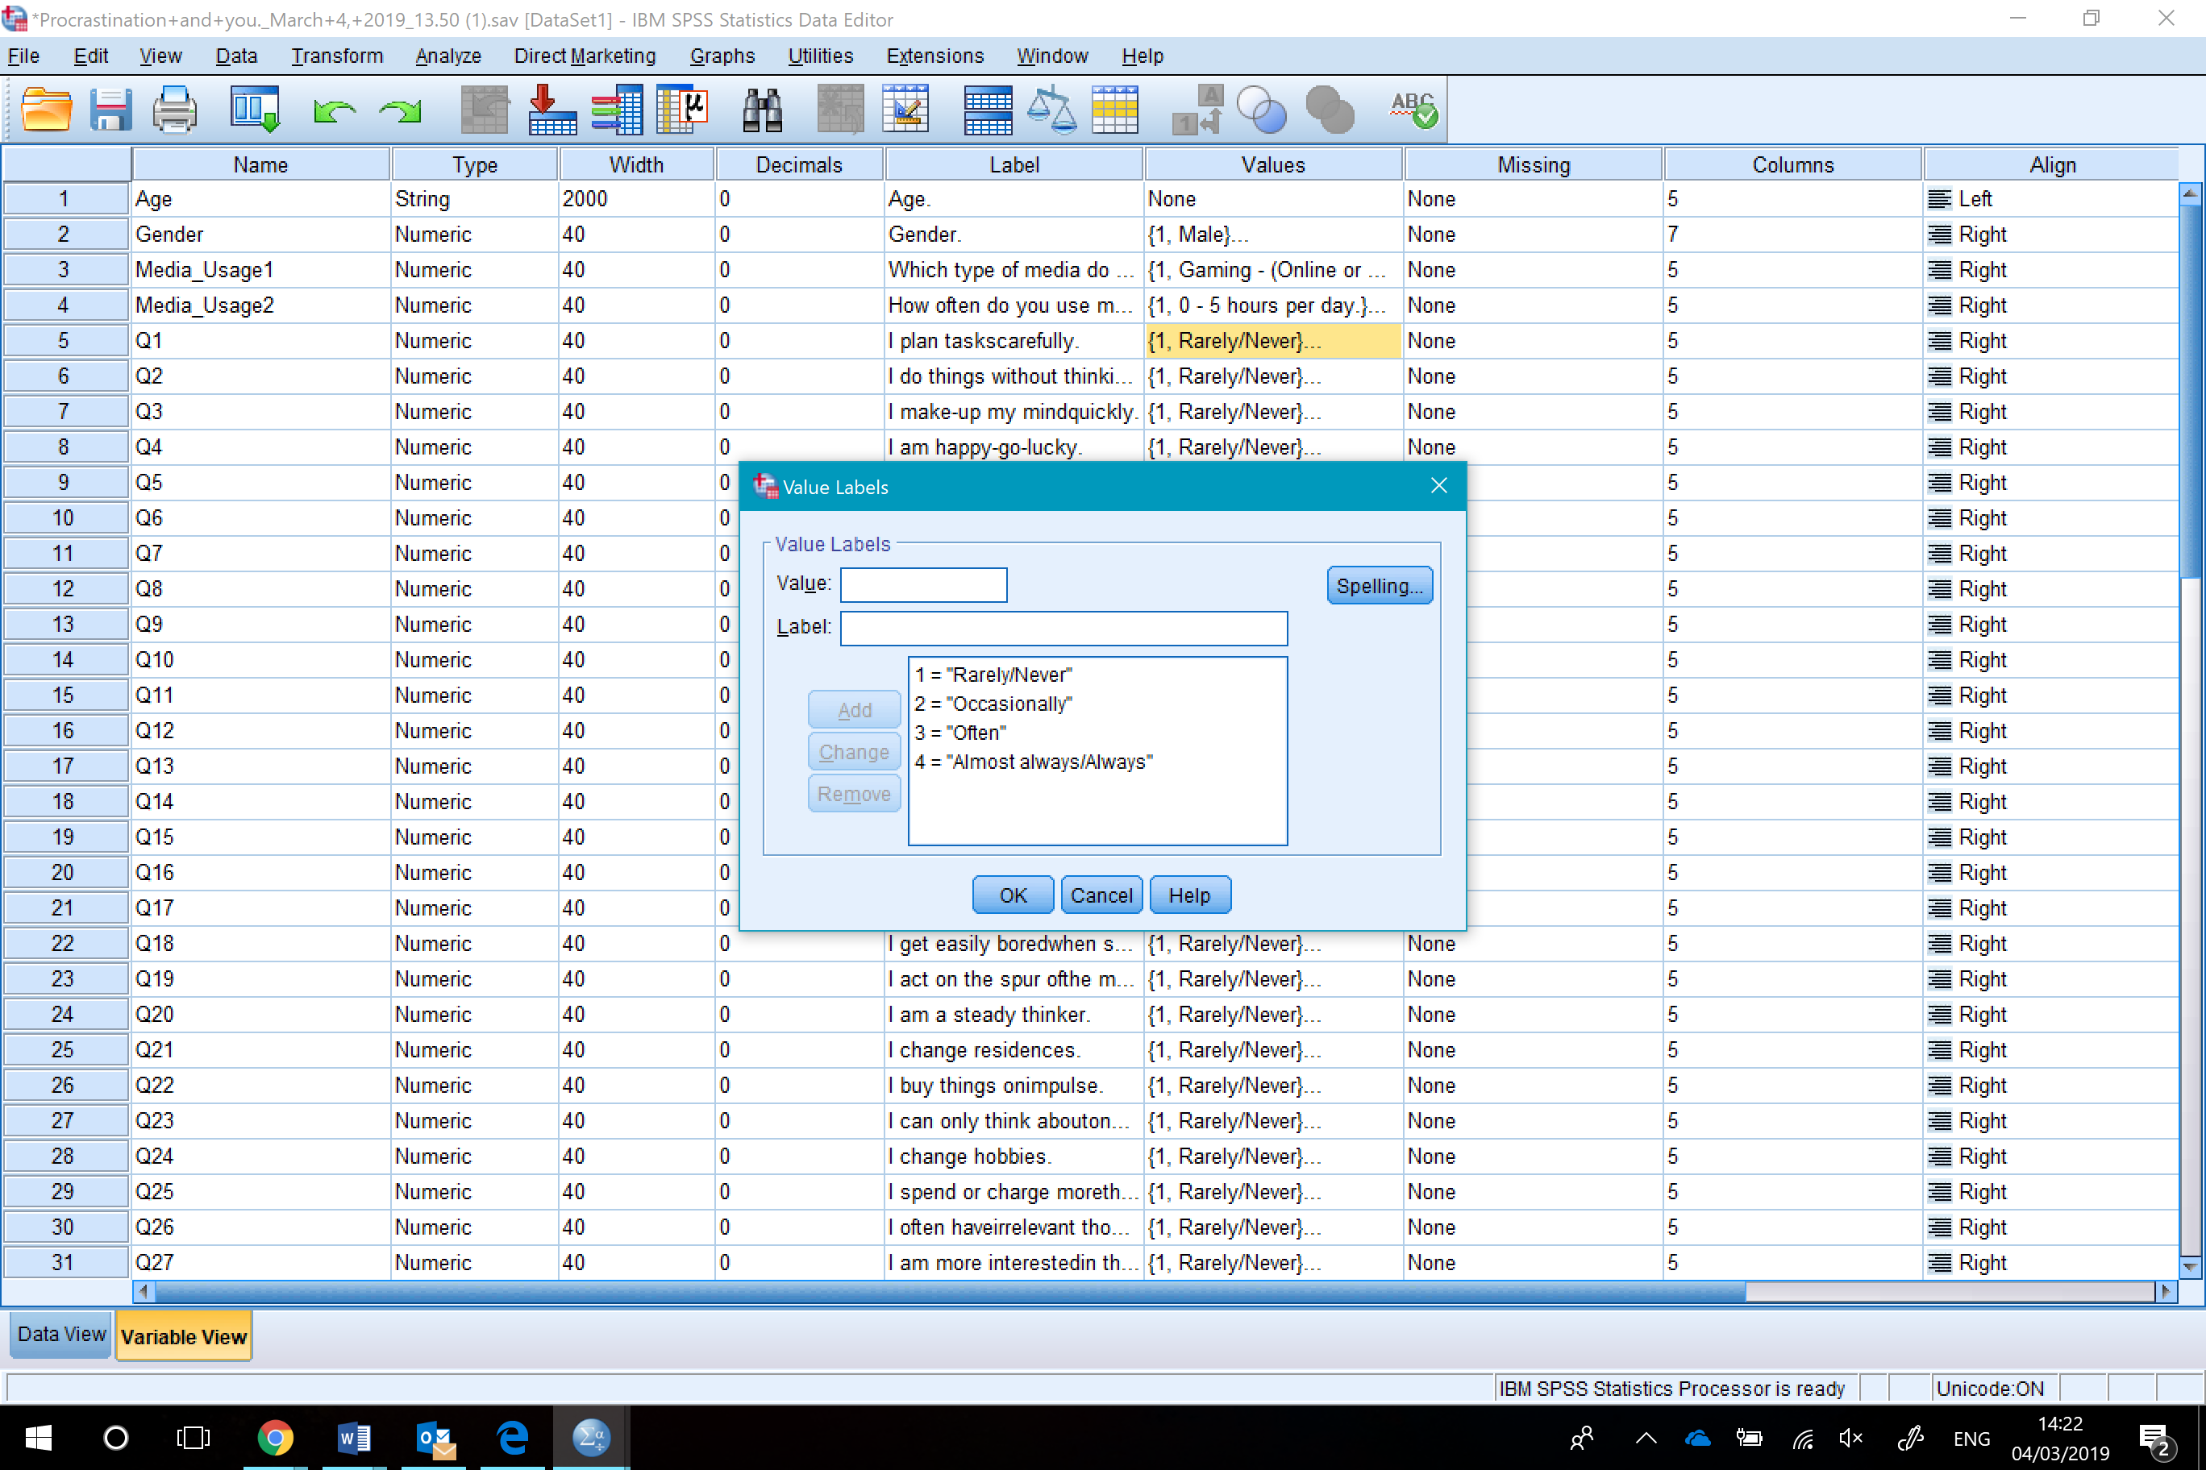

Your data is now ready for analysis – good luck

