
(Robinson & Garton, 2007)

Problem Solving and Decision Making
(BMSW4004_LON)

MODULE LECTURER´S NAME: Dr Nandish Patel
STUDENT NAME: Analius Jose Mendoza Silva
STUDENT IDENTITY NUMBER: 1916664

Table of Contents
1. Introduction 2
2. Define the Problem 2
3. Effects of the problem 3
4. Generate Solutions 3
5. Implementation 5
6. Conclusion 5
References 6

Introduction

I have work in Harrods as a Brand Specialist for three years, working in one of the biggest departments store in London have taught me how to identify and solve problems in an effective way. When I started working for Rag&Bone, we have to weekly targets and monthly, but we were not able to reach the targets and this was a challenging moment for the brand, to analyze and solve the problem I generated a list of the possible problems and solutions we were facing to have a successful brand. Rag&bone is and international brand that keeps growing every year, they have high standard and great quality in their products, customers at Harrods come to shop this brand, in other to identify the problems the brand was facing I will discuss the problems the brand had and how I manage to solve the problem.

2. Define the Problem

The Encyclopedia of the Sciences of Learning defines problem in the workplace as a task that is giving for someone that can be challenging (Seel, 2012). Rag&Bone is a denim brand created twenty years ago in New York, nowadays is one of the most popular denim brands and it’s been sale at Harrods. When I started working for the brand the sales were low and the expectations for the brand were high, the weekly targets were £19k and we will only reach £12k a week. Rag&Bone had a lot of potential between the young and older generation since the brand was in constant improvement, they are always creating new lines of clothing and change the styles with the fashion, to find the problem for the sales I made a list of the possible problems that were affecting to the sales. I notice that the brand was having miss opportunities due to the disorganization in the stockroom, the sales associate at the store could not found the jeans or the sizes for the customers and this was stopping the brand to reach the weekly and monthly targets, another possible cause of the problem was that at that moment the brand had a big demand in bigger sizes for the jeans such as 32 waist and XL for the t shirts, the brand is very popular for their stretchy jeans and the confines of this one, customer are looking for jeans that will adjust to their need at all time, and the brand was having miss opportunities because they were not aware of the changes and needs of the customers at Harrods.
The first possible problem was the stockroom, this was allocated in the corner of the room with other brands that were not meeting their targets, the location of the best brand were next to the fitting room for customer which made it easy for the sales associate and faster service, the stockroom was dark and they did not have any size cube in the jeans or t shirts so the sales associated could not see if they had sizes or if the same item was allocated in other place. The second problem was the sizes, Rag&Bone will send in the delivery a bigger quantity in the smaller size such as 23,24 and 25 waists but we were not receiving more than 2 sizes in the larger sizes, this was making difficult that the brand meets the targets and was preventing the customers to come and shop the brand at Harrods.

3. Effects of the problem

When facing a problem and making a decision to solve the problem we must understand that these to elements work together and to success while facing a problem we need to understand the aim to have a long-term improvement in both (team, 2019). The brand was facing two essential problems that was challenging to reach target, the organization in the stockroom is fundamental to maximize the sell and the service for the customers, there was not size cubes in any of the items to facilitate the search for the sales associate, also the styles of the jeans and t shirts were mix and it was not easy to found the items while looking for them, the styles of the jeans were not categorize so sales associate were not able to distinguish between styles, the lighting in the stockroom was poor and when the sales associate were having a busy day it was not easy to walk look for the items in that stockroom, it was allocated far from the customers fitting room this will bring the sales down and the customers that were coming to shop for Rag&Bone will leave the store unsatisfied. The brand experienced a period without a brand specialist that will look after the brand and help with the needs they might have, there was a time were there was a poor communication between the Harrods buyers and the Rag&Bone team, they were not aware that the brand also experiencing a high volume of customers shopping larges sizes and that this market will open new opportunities for them, these factors were slowing the sell and the monthly productivity. To identify the problems and analyze the brand and the opportunities of succeeding I made a swot analysis.

Swot Analysis
Strength: Rag&bone have twenty years of experience in the jeans market they are well known for their high quality and values.
Opportunities: The brand is expanding to a new market with a new size range and there are in constant improvement and innovation with the jeans and their fabrics.
Weaknesses: Jeans larges sizes are delivered in small quantity, and the deliveries might take a month to arrive to the store.
Threats: Customers are loyal to the fabrics they use to make before, and they might change
their might with the new jean’s fabric.

4. Generate Solutions

The difficulty of the brand organization at the stockroom, with no size cubes in the items, the poor lightning and the styles mixed it was bringing the sales down, which made it challenging to reach the monthly target and the sales were not consisted, also the lack of communication between the buying team at Harrods and the brand generated miss opportunities when selling the brand since the brand was not receiving enough large sizes for the ready to wear or the jeans and at that moment it was highly demand by the customers. The sales associate found it difficult to sell the brand for the organization and the locations of this one. To generate solutions to this problem I use the fishbone analyses also known as, the diagram by Kaoru Ishikawa was develop during the 1960s, is a systematic way to understand a problem and found out the origin of those problems, the diagram it is like a skeleton of a fish, and it will help to find the roots of the problems and as consequence find the solution of these one. (Hayes, 2020)

System
Suppliers
Surroundings
Lights
Jean Style
Size cube

TARGETS
Delivery
Larger Size
Stygu
Location
Buying Team
More sizes
Same fabrics
accessibility
Organization
Sales Asociate
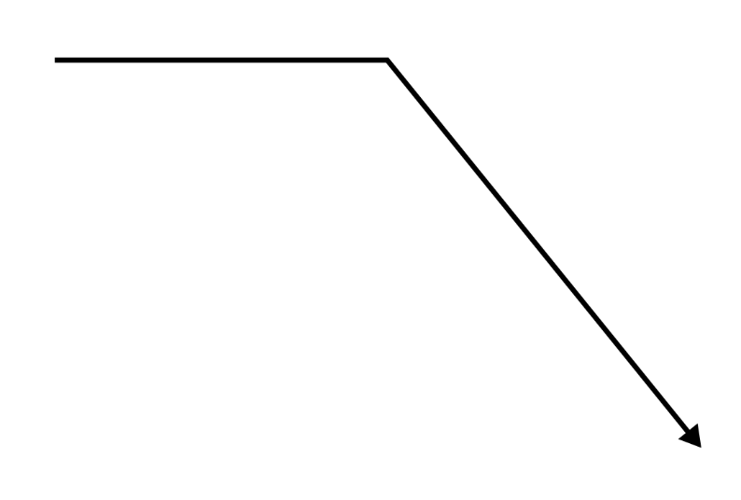
Procedure
People
Place

Fishbone Analyses: by Dr. Kaoru Ishikaya

After analyzing the problems and possible causes that the brand had whilst trying to meet monthly and weekly targets, the possible solutions I generated are the next one:
- Organization at the stockroom this will include, size cubing all the items and separate by styles the jeans and ready to wear.
- Advised the manager about the lightning and call the operations team to fix the problem.
- Advised managers about the customers demand of the brand and change the stockroom location.
- Email the buying team and the brand about the highly demand in larger sizes and ask to deliver a bigger size range for the customer.
- Make sure that the sales associate knows about the changes in the stockroom and the new size rage.

5. Implementation

The implementation plan will help to bring the strategics to life and it will help to go through the steps and have a successful plan, this is done by organizational plan to allocate the resources of the company and bring the implantation plan to life (Malsam, 2019). The brand will implement four steps that will help to maintain the organization in the stockrooms and will help the sales associate to acknowledge the brand changes also managers and members of the burying team and Rag&Bone will be notified with this change to ensure the brand is successful whilst performance at Harrods and with these changes being implanting it will reflect in the productivity of the brand. To succeed with the organizational plan, I have created the following steps that it will help to the areas that make the brand a poor performance at Harrods.
First Step: Emailing the managers and let them know about the changes that needs to be done in the stockroom before opening the store organize the stockroom with the help of one of the team, the stockrooms will be size cubeb and the styles of jeans and ready to wear will be separated and organize by categories with the respective labels, this will help the sakes associates to identify the item quickly and they will be able to deliver a great and fast customer service.
Second Step: Advised the manager about the lightning in the stockrooms also speak about the productivity of the brand and how it will be beneficiary to change the stockroom location to another one that is closer to the fitting rooms that it will increase the speed of the service and the productivity of the brand.
Third Step: Advised the buying team at Harrods about the increase demand of larger sizes in the jeans and the benefits of buying a full range of larger size will help to sell brand to new customers that are looking for this type of product, emailing and contacting the Rag&bone team to speak about the delivery service and how the demand in these larges’ sizes is increasing every week.
Fourth Step: Daily briefing to the sale associate and managers about the new changes in the stockroom and to let them know about the changes in the size range.
To ensure the efficiency of this steps I will follow a daily sell improvement, and the productivity of this one, for the stockroom I will make sure the team knows about the changes and I will print labels to ensure the team respects and follow the new organization in the stockroom, also to promote the sell of the brand the shop floor will be tidy and ready for the customers, review the sales we are producing after these changes to follow the effectiveness of the process, emailing the team about this changes will be imperative to maintaining the new standards and motivate the team to keep selling Rag&bone and to support the news changes within the brand.

6. Conclusion
Rag&bone is a brand with potential to succeed selling with the new and old generation, the brand is one if the leading brand within the jean industry, joining Harrods was great opportunity for them to expand their market and the popularity with customers, they are also in constant improvements and they are willing to change within the fashion industry and make the brand suitable for every generation. In order to increase the productivity of the brand the team and I will make sure we will follow the steps to succeed when selling the brand. The organization in the stockroom will be imperative for the success of the brand, the size cubes and the styles of the jeans and ready to wear will maintain high standers the sales associate will have more knowledge about the brand the new changes as well as managers and member of the buying team, also Rag&Bone will be notified will the changes that needed to be done at Harrods. Following the implantation plan will ensure that the brand will grow within Harrods and will expand new clientele, it will be reflected in the monthly productivity and this will help the brand to succeed.

References
Hayes, A., 2020. Investopedia. [En línea]
Available at: https://www.investopedia.com/terms/i/ishikawa-diagram.asp
[Último acceso: 17 12 2020].
Malsam, W., 2019. ProjectManager. [En línea]
Available at: https://www.projectmanager.com/blog/implementation-plan
[Último acceso: 18 12 2020].
Seel, N. M., 2012. Encyclopedia of the Sciences of Learning. [En línea]
Available at: https://link.springer.com/referenceworkentry/10.1007%2F978-1-4419-1428-6_914
[Último acceso: 15 12 2020].
team, C., 2019. Changeboard. [En línea]
Available at: https://www.changeboard.com/article-details/16960/problem-solving-vs-decision-making-what-is-the-difference-/
[Último acceso: 16 December 2020].

