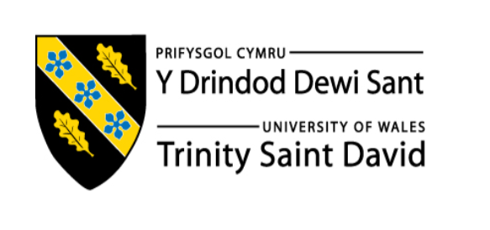

Topic:
Nike, Inc.: A Critical Evaluation of Marketing Strategy and Future Recommendations

Name: Siva Narendra Morla
Student’s ID: Name: 2513831
Module Name: Managing Marketing Change
Module Code: BMMB7026

Table of Contents
Executive Summary 3
1. Introduction 4
2. Macro and Micro Marketing Environment 5
2.1 Macro Environment 5
2.2 Micro Environment 7
3. Segmentation, Targeting, Positioning and Marketing Mix 8
3.1 Segmentation and Targeting 8
3.2 Positioning and Differentiation 9
3.3 Marketing Mix (7Ps) 11
4. Media Strategy 13
5. Measuring Marketing Effectiveness 14
6. Conclusion 15
7. Recommendations 16
7.1 Product-Level Sustainability Communication 16
7.2 Integration of Sustainability into Core Marketing Communication 17
7.3 Application of the SHIFT Behavioural Framework 17
7.4 ESG Marketing Governance System 18
Reference List 19
Appendix 28

Executive Summary
Nike, Inc. is known in the world as a leader in selling sportswear and having their operation in more than 190 countries. This reports evaluates the marketing activities of Nike focusing on its external environment, target market strategies, marketing mix, communication channels, and methods used to measure marketing performance.
The analysis shows that Nike has advanced marketing capabilities especially when it comes to digital engagement, storytelling that is focused on athletes, and direct-to-consumer (DTC) strategy. All these strengths have helped Nike to have a strong brand image, creating emotional connections with customers, and maintaining a competitive advantage in the global sportswear market.
This report also identifies the challenges that are connected to sustainability and Environmental, Social and Governance (ESG) pressures. Some of these challenges include a gap between the claims on sustainability of Nike and the evidence that is provided to support those claims, communication of sustainability initiatives that are inconsistent, a difference between the environmental concerns of consumers and actual purchasing behaviour of consumers and limited integration of ESG factors into decision making that involves marketing and measurement of performance.
Even though the marketing strategy of Nike continues to perform well when it comes to the growth of the brand and commercial success, it needs to adapt to the many regulations and the expectations of consumers that keep changing. The report finishes by looking into four recommendations that are practical to make sure that claims on sustainability are accurate and managed well.

1. Introduction
Nike, Inc. is a leader in the global market especially known for their products in the sportswear, footwear, and equipment industry, having operations in more than 190 countries (Zheng, 2022). The company has been able to be successful through their innovations that are continuous, having a brand image that is strong and having marketing strategies that are effective that connect sport, culture, and lifestyle (Hou, 2023).
Nike sees marketing as an important investment not just another expense because it is very important to their business strategy because it has helped the company to attract customers and build a brand that is strong over time (Kim, 2020). Nike always invest heavily in the activities of marketing such as digital advertising, endorsements of athletes, experiences of different brands, and direct engagement with customers through their online platforms (Saini et al, 2023).
The Marketing strategies of Nike is always influenced by external factors such as the growing expectations for sustainability, Environmental, Social and Governance (ESG) requirements, and regulations that are strict on environmental claims. On the other hand, the company still face competitions from different companies such as Adidas, Puma, On Running, and Lululemon who have placed a greater emphasis on sustainability in their strategies of marketing (Nike, 2025).
This reports also evaluates carefully the strategies of marketing and looks at their effectiveness. It also identifies the key weaknesses and recommendations that are realistic and is supported by evidence to help in improving the future marketing performance.

2. Macro and Micro Marketing Environment

2.1 Macro Environment
Nike has operations in business environment that keeps changing influenced by legal, economic, social, technological, and environmental factors. All these factors have great impacts on the marketing strategy of the company mostly when it comes to its communication about sustainability (Narayana et al., 2021).
From a legal point of view, sustainability marketing involves the act of being more regulated. The FTC Green Guides (2012) and the UK CMA Green Claims Code (2021) require companies to make sure that their claims about environment are clear, accurate, and supported by evidence (Rotman et al., 2024). This clearly mean that Nike cannot just rely on sustainability messages that are broad such as “Move to Zero” without being able to provide clear proof at the product level. This is because regulations keep being strict, and Nike faces greater pressure and they have to comply with standards of advertising and protect their reputation, especially when operating in different countries which have different legal requirements (Diandra, and Apriliant, 2024).
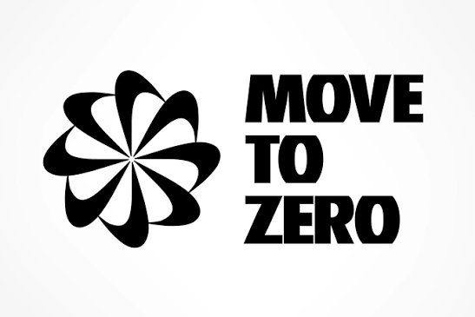
Figure 1: “Move to Zero” campaign (Nike 2019).
Looking at economic point of view, Nike is affected by the high costs coming from sustainable materials, responsible sourcing, and monitoring ethical supply chains. This extra cost has the ability of increasing the production expenses which in turn make it more difficult to maintain profit margins while trying to keep premium prices (Dupree, 2020). Given the situation, the marketing of Nike needs to show customers why their products are worth the higher price by highlighting innovation, durability, performance, and long-term value, instead of relying only on their brand reputation (Asghar, 2023).
Looking at the social point of view, it is evident that there is a growing interest in sustainability especially from the consumers who are Generation Z who always want brands that reflects their values and what they believe in (Albers, 2023). However, the SHIFT model shows that there is always a gap between what consumer say and what they actually do. Even though many of the consumers care about the issues that relates to the environment, their decisions on buying are always influenced by factors such as product performance, design, and price (White et al., 2019). This clearly shows that messages on sustainability alone is not enough to influence purchases. That being said, Nike needs to show their initiatives on sustainability add value to their products and improves the experiences of customers.
From a technological point of view, Nike benefits more from the innovative materials such as Flyknit and Nike Grind, which always help in improving sustainability and reducing impacts on the environment (Nike, 2022). However, the main challenge is not the technology itself but how the technology is being communicated to the consumers. These new innovations are not always explained well in a clear and simple way, which makes it more difficult for consumers to understand the benefits of those technologies. As a result, Nike is not fully benefiting from these innovations they have on their marketing efforts (Nike Grind, 2019).
Environmentally, there is a growing concern about climate change and there is also an increased pressure from investors, activists, and other stakeholders who want Nike to be more transparent about their efforts on sustainability (Nike,2025). Given this many expectations, it creates a great risk of greenwashing accusations when the environmental claims of the company are not supported by evidence that is clear and reliable (Bingaman et al., 2022).

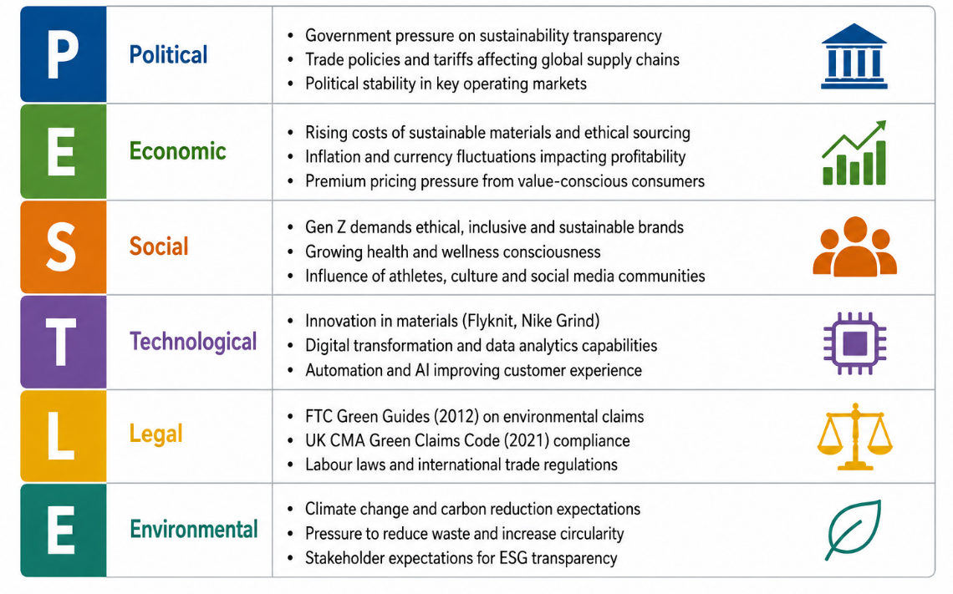
Figure 2: PESTLE of Nike

2.2 Micro Environment
When looking at the micro level environment, the marketing strategy of Nike is always influenced by the behaviour of consumers, the strong brand community and the great competition in the global sportswear market (Asghar, 2023).
The main target market of Nike is the younger consumers who are between the age of 16 and 24 who are highly active online (Jayashree et al., 2025). Their decision on purchasing is always influenced by social media athletes, influencers, and the sneaker culture (Jayashree et al., 2025). Nike also targets consumers who see sports as a way of improving themselves, those who want to gain social status, and those who want to feel the part of a wider community (Anton, 2026).
There is also competition in the market because sustainability is no longer something that makes a brand stand out (Niskanen, 2019). Customers now expect all major brands to have sustainability initiatives which has made companies like Adidas, Puma, and On Running to have sustainability to be part of their brand (MEHRIN, 2023).This means that Nike cannot rely only on sustainability alone to differentiate itself and must put their focus on communicating its sustainability efforts more clearly in an authentic manner and across all their marketing channels (Niskanen, 2019).

3. Segmentation, Targeting, Positioning and Marketing Mix

3.1 Segmentation and Targeting
Nike uses different types of segmentation so that they can target different groups of customers. It known for putting most of its focus on age, gender, lifestyle, interests, attitudes, and buying habits of people so that they can be able to attract consumers who are more interested in sports and those who just want to wear the products from Nike just as fashion and for their everyday use (Wu, 2022).
Nike is also known for targeting different types of customers especially those who are between the age of 15 and 45. The company pays more attention to them because they are more active in the digital spaces and are always engaging with brands online (Nadifah et al., 2025). The company uses tools such as Nike App and the SNKRS platform to understand the preferences of those customers better so that they can provide experiences that are personalised (Nike, 2024). The company also targets people who see sports as part of their personal identity and style. This is because most of these customers put more value on motivation, personal development, and express themselves by wearing the products from Nike not just for sport but also to show who they are (Fadillah et al., 2021).
The company also have a Nike Membership programme, which had over 160 million members in 2023 which clearly shows that the company uses the data they collect to target people, build relationships that are stronger and encourage loyalty that is strong (Nike Annual Report, 2023).
Even though this segmentation has had many benefits, it has also shown that it has some weaknesses this is because it mainly depends on consumers who are young and are greatly influenced by the trends and the preferences that keep changing (Mngadi, 2020). This situation presents Nike with a very great risk because any changes in popular culture or the changes in the interest of consumers can greatly reduce the way people engage with the brand (Li, 2023). For example in a situation where the young people decide not to be connected with Nike in future, it will affect the company negatively because the loyalty to the brand will be reduced and their sales might drop greatly. (Gausselin, 2019).

3.2 Positioning and Differentiation
Nike has always positioned itself as a brand that is able to combine high performance, innovation, and different need of different cultures. The famous slogan of the company called “Just Do It” is always used in encouraging people to be confident, have more ambitions, and be determined so that they can achieve their goals. This message that is motivating has always helped Nike to create a brand identity that is strong and known and also very respected all over the world by many people (Chanpaneri, and Jain, 2021).
Nike also has another campaign called "You Can’t Stop Us" which is always used to show that Nike has the ability to connect with their customers through the message emotionally because it is a messages about unity, inclusion, and perseverance (Nike, 2024). This approach at an emotional level helps Nike to strengthen the image of the brand and increase the loyalty of customers towards the brand (Nike, 2024).

Figure 3: “You Can’t Stop Us” (Nike, 2024).
Sometimes the company finds it hard to balance the image of the brand which is focused on growth with the growing expectations for sustainability (Diandra and Aprilianty, 2024). This situation occurs because the company is always encouraging consumers to buy products and pursue their aspirations, but at the same time the efforts on sustainability promotes reducing consumption and protecting the environment (Chanpaneri, and Jain, 2021). This situation always create a conflict in the way message is communicated at Nike especially in markets where consumers and investors place a strong emphasis on environmental, social, and governance (ESG) issues (Alqudsi, 2024).
There is also great competition from brands like Adidas who have already included sustainability as part of their brand identity. Nike presents sustainability as an additional benefit and not a core value of the brand (Niskanen, 2019). This situation sometimes makes it hard for Nike to be seen as a leader when it comes to environmental, social, and governance (ESG) practices, even though the company has invested greatly on initiatives and operations of sustainability (Alqudsi, 2024).

3.3 Marketing Mix (7Ps)
Even though the marketing mix of Nike is very effective, there is always room for improvement across the 7Ps so that there is consistency.
Product: Nike is greatly known for creating products that are innovative in nature using technologies such as Air, Zoom, and Flyknit, which always helps them in improving performance and the experience of customers (Nike, 2019). However, their sustainable products which are under the "Move to Zero" initiative are not always promoted well the way the main products of the company are promoted. This type of behaviour always make the sustainable products not to be seen by many consumers which always reduce their impact on the market (Park et al., 2022).
Price: Nike is also known for using their premium pricing strategy, where the higher prices are supported by its strong brand reputation, products that are innovative, and high standards of performance (Nike, 2023). However, the company is not able to connect its sustainability efforts to the value customers receive. This situation makes Nike to miss an opportunity of strengthening the perceptions of customers when it comes to quality and the ability to justify premium prices through environmental responsibility (Mansour et al., 2024).
Place: The direct-to-consumer approach of Nike on its website, mobile apps, and flagship stores always give the company a great control over the experience of their customers (Standaert, 2022). This also helps Nike in collecting more data of customers and providing more personalised experiences to them. Because these channels are controlled by Nike, the company always have a strong opportunity of communicating the efforts on sustainability more effectively to customers (Mansour et al., 2024).
Promotion: Nike is also known for their very powerful campaigns where they use athletes and emotional storytelling so that they can connect with consumers well (Nike, 2019). All these campaigns always help in building a strong awareness on the brand and loyalty among the customers. However, the messages on sustainability are sometimes less visible in the main activities on promotion of Nike which in the long run can reduce their impact on the consumers (Park et al., 2022).
People: Nike also has a network of athletes, influencers, and brand ambassadors who help the company to be known by many people and have a great advantage over other companies which always help the company to reach and inspire many people to use the products of the company (Nike, 2024). However, the company sometimes does not use experts who know more about sustainability and advocates of the environment in their ambassador program which reduces the credibility of the brand when it comes to matter of sustainability.
Process: Nike always use advanced digital systems, such as membership rewards, personalised recommendations, and mobile apps, to help the company in improving the engagement of customers and loyalty to the brand (Nike, 2019).The system that the company has provide limited rewards or incentives for customers who make more sustainable choices and in doing that it reduces their potential in supporting the sustainability goals of Nike (Park et al., 2022).
Physical Evidence: Nike has been able to include information on sustainability on some packaging and product labels, which shows their commitment to environmental responsibility (Nike Sustainability Report, 2025). However, this information is not always very clear when displayed across all customer touchpoints, which always make it hard to notice which reduces its overall impact on consumers (Mansour et al., 2024).
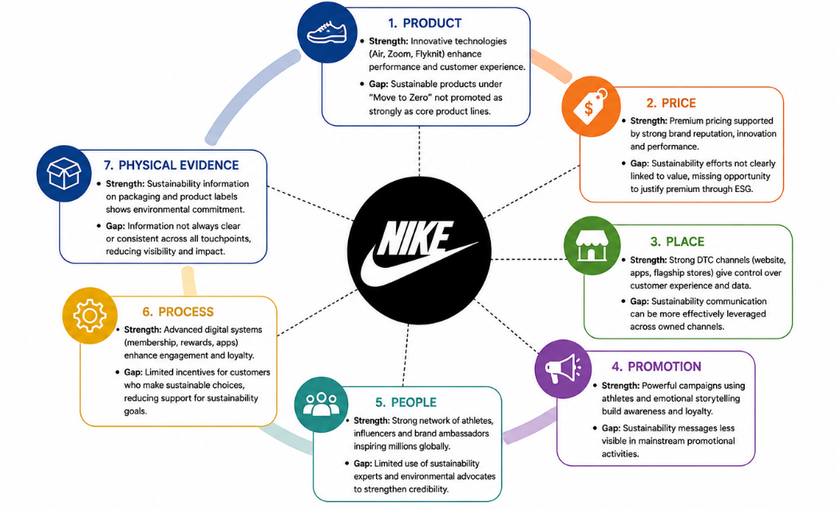
Figure 4: Market Mix

4. Media Strategy
The company uses omnichannel marketing approach which is always made up of digital and social platforms such as Instagram, TikTok, YouTube, and X. These platforms are very helpful in supporting global storytelling, athlete engagement, and cultural marketing (Narayana et al., 2021).
The company also has Nike App, SNKRS, and Nike Training Club which always helps it in direct consumer engagement and behavioural data collection (Nike 2019). This is useful because it helps in supporting personalised marketing and strengthening customer loyalty. The success of this strategy can be seen in the growth of the company's direct-to-consumer (DTC) sales, which was able to account for 44% of total revenue in 2023 (Nike Annual Report, 2023).
However, the company only talks about sustainability through its Move to Zero programme. This clearly mean that information on sustainability is not always visible where customers make their buying decisions (Nike 2022).

5. Measuring Marketing Effectiveness
Nike always measure the success of its activities of marketing using a combination of financial, brand, and digital performance indicators. This shows that the company always use data and technology when they make decisions on marketing (Nica et al., 2021).
The financial performance is always measured using indicators such as demand creation spending, revenue growth, and the contribution of Direct-to-Consumer (DTC) sales. The performance of the brand is always evaluated using the measures such as Net Promoter Score (NPS), brand equity tracking, and share of voice analysis (Sharma et al., 2025). On the other hand, digital marketing effectiveness is measured using the rates of engagement, conversion tracking, and attribution models across the owned and paid media platforms of Nike (NIKE (2024).
This combination of measure clearly shows that Nike has strong ability of connecting activities of marketing with business results. However, one limitation is that these system puts its main focus on engagement and outcomes from sales not trust and impacts of sustainability (Donga et al., 2025).
Nike always measure sustainability separately using ESG indicators, which includes carbon emission reduction and the use of recycled materials (Soltanisehat, and Jestratijevic, 2026). Even though these measures are developed well, they are not fully connected to the systems of marketing performance (Soltanisehat, and Jestratijevic, 2026). Because of this situation, Nike cannot clearly measure whether the communication on sustainability has the power of improving trust on the brand, influencing buying decisions, or increasing customer loyalty over time (NIKE, Inc. Impact Report, 2025).
This situation creates a great gap between performance on sustainability and effectiveness in marketing. In practice, Nike always put most of its focus on indicators that are easier to measure such as reach, engagement, and sales conversion, instead of looking into indicators that are becoming more important in a market that is focused on ESG , such as trust, credibility, and authenticity of the brand (Hou, 2023).
From a strategic point of view, this situation limits the ability of Nike in understanding if the messaging on sustainability is improving or weakening the overall value of the brand. As the expectations of customers and the regulations from the government continue to increase, this gap may become an important strategic risk for the company (Hou, 2023).

6. Conclusion
Nike shows a strong marketing capability through its storytelling of the brand, development of digital platform, partnerships with athletes, and positioning of the brand on a global scale. All these strengths have always helped the company in maintaining a strong value of the brand, remaining culturally relevant, and keeping a competitive advantage in the global sportswear industry.
However, this analysis identified four major challenges that are becoming more important in a business environment that is focused on ESG. Firstly, there is a gap in the credibility between the messages on sustainability of Nike and the level of evidence provided to consumers. This situation can increase the risk of criticism from regulators and later damage the reputation of the brand.
Secondly, communication on sustainability is still separated from the main product of Nike and the activities in marketing. This has made sustainability to have less influence during important consumer buying decisions.
Thirdly, there is a gap between attitude and behaviour. Even though many consumers have a great interest on sustainability, their decisions on purchases are still influenced more by factors such as performance of the product, style, and price.
Finally, ESG governance is not yet fully included in decision making that involves marketing. As a result, it has reduced consistency, accuracy, and the integration of messages on sustainability across marketing campaigns of Nike.

7. Recommendations
The following recommendation are based on the weaknesses that was identified in the current marketing strategy of Nike. Each recommendation is designed to be very practical, cost-effective and very suitable for the existing global marketing operations of Nike.

7.1 Product-Level Sustainability Communication
The company need to have a clear verified sustainability information directly on all customer touchpoints such as on product pages, packaging, digital platforms, and retail displays. They should not use general information but should provide specific and measurable details such as the percentage of recycled materials used, carbon emission reductions, or improvements in manufacturing efficiency (Dorsey & Whitney, 2025). Doing this will help the company to meet all requirements needed by the law such as the FTC Green Guides (2012) and the CMA Green Claims Code (2021), and at the same time it will help in increasing the trust of customers because there is transparency when making decisions on purchases (HM Government, 2021). it will also help to make sustainability as part of the quality of the products and its performance not just as an ethical message that is separate (Dorsey & Whitney, 2025).

7.2 Integration of Sustainability into Core Marketing Communication
The company should also have sustainability message as part of their main products and performance marketing and not just keeping it separate on campaigns such as Move to Zero (Nike, 2022). This clearly means that the benefits of sustainability should be presented together with the performance of the products in the same marketing campaigns (McKinsey & Company, 2024). For example, communication about cushioning, durability, or material innovation should also explain the environmental improvements that is being achieved. Doing that will help the company to have a stronger brand, increased visibility of messages and brand that is focused on performance (McKinsey & Company, 2024).

7.3 Application of the SHIFT Behavioural Framework
The company should also apply SHIFT behavioural framework which is made up of (Social influence, Habit formation, Individual self-identity, Feelings, and Tangibility) to help them in reducing the gap between awareness of sustainability to consumers and actual buying behaviour (Khan et al., 2026). Some of the things the company can do is use the influence of athletes to help in encouraging sustainable product choices, rewarding sustainable actions through Nike membership programmes, and presenting sustainable purchasing as part of a lifestyle that is focused on performance and not just as an environmental responsibility (Steven D'Alessandro and Varsha Jain, 2024). The company should also ensure that customers understand sustainability by using simple evidence on products for example “made using 20 recycled bottles.” Doing that will help in making the benefits to the environment to be more visible and relevant to the decisions on making purchases (Steven D'Alessandro and Varsha Jain, 2024).
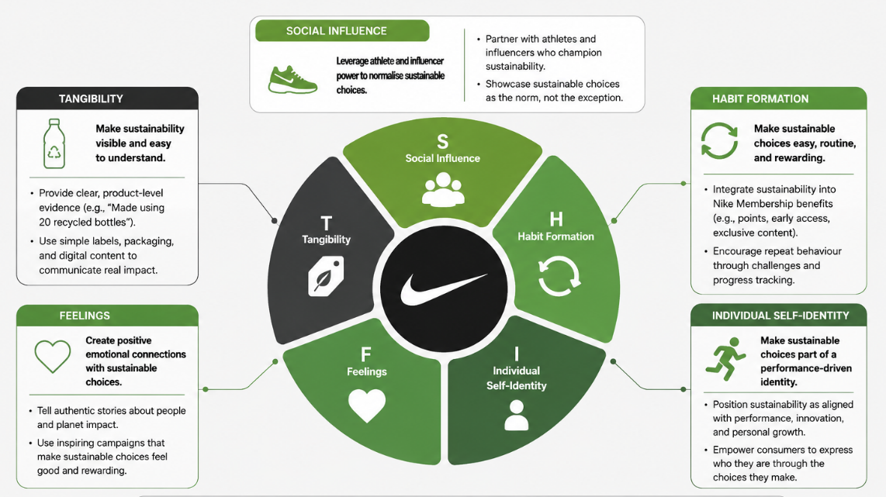
Figure 5: SHIF OF Nike

7.4 ESG Marketing Governance System
The company should also create a formal ESG marketing governance system that involves making collaborations between the teams that are involved in marketing, law, sustainability, and development of products (Soltanisehat, and Jestratijevic,I., 2026). Doing that will the company to have environmental claims are checked, verified, and approved before being released to the public. Doing that will help in reducing messaging that is inconsistent and in lowering the risk of greenwashing (Soltanisehat, and Jestratijevic,I., 2026). Another thing is that having an ESG governance in processes of marketing will help in improving accountability, increasing the accuracy of messages and in strengthening the trust of customers when it comes to commitment that Nike has when it comes to sustainability of Nike (Dorsey & Whitney, 2025).

Reference List
Albers, J., 2023. The Gen-Z Sneakerhead Paradox: Balancing Sustainability and Streetwear in the World of Nike: Nike Case Study (Master's thesis, Universidade NOVA de Lisboa (Portugal)). https://www.proquest.com/openview/015006b04e34547c41915299769168a2/1?pq-origsite=gscholar&cbl=2026366&diss=y
Alqudsi, M.M., 2024. Beyond ESG Compliance: A Horizon of Economic Peace for Nike. SAGE Publications: SAGE Business Cases Originals. https://sk.sagepub.com/cases/skpromo/RAjN8B/beyond-esg-compliance-a-horizon-of-economic-peace-for-nike#_
Anton, A., 2026. “Other Customer” perception as strategic insight into Gen Z consumer–brand identification and purchase behavior: A mixed-methods approach. American Behavioral Scientist, 70(5), pp.590-619. https://journals.sagepub.com/doi/abs/10.1177/00027642241235838
Asghar, M., 2023. Consumer perception of Nike green business strategy and implementation of profitable and sustainable products. https://www.theseus.fi/handle/10024/811583
Bingaman, J., Kipkoech, G. and Crowley, J.P., 2022. Inoculation & greenwashing: Defending against misleading sustainability messaging. Communication Reports, 35(3), pp.135-147. https://www.tandfonline.com/doi/abs/10.1080/08934215.2022.2048877
Chanpaneri, A. and Jain, P., 2021. A content marketing as the leading technique in digital marketing: A case of Nike. International Journal of Research and Analytical Reviews, 8(4), pp.226-236. https://www.researchgate.net/profile/Apeksha-Chanpaneri-4/publication/357366168_A_CONTENT_MARKETING_AS_THE_LEADING_TECHNIQUE_IN_DIGITAL_MARKETING_A_CASE_OF_NIKE/links/61ca9482b8305f7c4b073b37/A-CONTENT-MARKETING-AS-THE-LEADING-TECHNIQUE-IN-DIGITAL-MARKETING-A-CASE-OF-NIKE.pdf?__cf_chl_tk=s3QUrNrcKcnXS_fQZFTmQPGXtQVEQhD9L_3j02kz0Ko-1782216164-1.0.1.1-HSIS2EopHxrrVpMur_fjEmJgEu5mg2n9D2U.hc9zcV0
Chanpaneri, A. and Jain, P., 2021. A content marketing as the leading technique in digital marketing: A case of Nike. International Journal of Research and Analytical Reviews, 8(4), pp.226-236. https://www.researchgate.net/profile/Apeksha-Chanpaneri-4/publication/357366168_A_CONTENT_MARKETING_AS_THE_LEADING_TECHNIQUE_IN_DIGITAL_MARKETING_A_CASE_OF_NIKE/links/61ca9482b8305f7c4b073b37/A-CONTENT-MARKETING-AS-THE-LEADING-TECHNIQUE-IN-DIGITAL-MARKETING-A-CASE-OF-NIKE.pdf?__cf_chl_tk=s3QUrNrcKcnXS_fQZFTmQPGXtQVEQhD9L_3j02kz0Ko-1782216164-1.0.1.1-HSIS2EopHxrrVpMur_fjEmJgEu5mg2n9D2U.hc9zcV0
Chen, Y., 2024, May. A Relevant Analysis of Nike and its Marketing Strategies. In 9th International Conference on Financial Innovation and Economic Development (ICFIED 2024) (pp. 426-434). Atlantis Press.
Diandra, P. and Aprilianty, F., 2024. The impact of greenwashing towards brand trust and brand loyalty: A study of Nike Move to Zero initiatives. Mandalika Journal of Business and Management Studies, 2(2), pp.85-114. https://digilib.itb.ac.id/assets/files/2024/MjAyNCBTSyBQUCBQYXRyaWNpYSBEaWFuZHJhICAgWzE5MDIxMjY2XSAtIEZ1bGwgVGV4dC5wZGY.pdf
Donga, G., Chimucheka, T. and Shambare, R., 2025. Brands, branding and young consumer behaviour. In Brands, Branding, and Consumerism: Personal and Social Influences on Consumption (pp. 275-309). Cham: Springer Nature Switzerland. https://link.springer.com/chapter/10.1007/978-3-031-80859-3_7
Dorsey & Whitney LLP (2025). ‘The Federal Trade Commission Updates the Green Guides for Environmental Marketing Claims’ | News & Resources | Dorsey. [online] Dorsey.com. Available at: https://www.dorsey.com/newsresources/publications/2012/10/the-federal-trade-commission-updates-the-green-g__
Dupree, A.R., 2020. The Impact of Nike Inc.’s Utilization of Sustainable Business Practices in Their Marketing Strategy on Brand Equity, Brand Image and Brand Loyalty (Doctoral dissertation). https://cache.kzoo.edu/items/07778e50-902e-4cd8-8ffa-236b90e544e8
Fadillah, D., Hao, D. and Long, B., 2021. The New Strategy of Nike Corporate Communication in Efforts to Build a New Corporate Image. Jurnal Komunikasi Ikatan Sarjana Komunikasi Indonesia, 6(2), pp.344-352. https://www.jurnal-iski.or.id/index.php/jkiski/article/view/549
Gausselin, B., 2019. Impact of Nike Inc.'s Utilization of Social Issues in Their Marketing Strategy on Brand Equity, Brand Image, and Brand Loyalty (Doctoral dissertation). https://cache.kzoo.edu/items/56cb2a5d-959a-4707-bc47-67ccbe6ac67b
HM Government (2021). Green Claims Code. [online] greenclaims.campaign.gov.uk. Available at: https://greenclaims.campaign.gov.uk/.
Hou, Q. (2023). Analysis Of Nike Brand Operation and Marketing Strategy in Different Business Periods Based On 4P... [online] ResearchGate. Available at: https://www.researchgate.net/publication/377707072_Analysis_Of_Nike_Brand_Operation_and_Marketing_Strategy_in_Different_Business_Periods_Based_On_4P_Marketing_Theory.
Hou, Q., 2023. Analysis of Nike brand operation and marketing strategy in different business periods based on 4P Marketing Theory. Highlights in Business, Economics and Management, pp.636-641. https://pdfs.semanticscholar.org/ba79/66f9297a15b950c40ef70bf0d7763bd9b422.pdf
Jayashree, R., Vishal, C.S.S. and Krishna, S.V., 2025. The Impact Of Social Media Marketing On Consumer Purchasing Decisions On Nike Shoes. International Journal of Management Research and Reviews, 15(2), pp.66-72. https://www.proquest.com/openview/aad78bebd5cbf18285313ac14d3b2b5e/1?pq-origsite=gscholar&cbl=2028922
Khan, N., Jabeen, S., Qureshi, M.I. and Falahat, M. (2026). Greenwashing Communication Deficiencies and Consumer Response: Implications for Sustainable Technology Entrepreneurship. Sustainable Technology and Entrepreneurship, 3(34), p.100132. doi:https://doi.org/10.1016/j.stae.2026.100132
Kim, M., 2020. How Phil Knight made Nike a leader in the sport industry: Examining the success factors. Sport in Society, 23(9), pp.1512-1523. https://www.tandfonline.com/doi/abs/10.1080/17430437.2020.1734329
Li, D., 2023. Investigation and Analysis of Nike Product Marketing Strategy. https://www.theseus.fi/bitstream/handle/10024/811920/Li%20Dequan.pdf?sequence=2&__cf_chl_rt_tk=vgVu5RBZewTN8l5jb2ZSqewmGlSPQZ6w_j7_m5m1_PA-1782216033-1.0.1.1-JhdEzOA0nkqA7YOIFLNhLMfqm4pKd_O_oPxEj6_MhqY
Mansour, A., Al-Ahmed, H., Deek, A., Alshaketheep, K., Al-Ma'aitah, M., Asfour, B. and Alshurideh, M., 2024. Developing green marketing strategies: a comprehensive analysis of consumer behaviour and business practices. International Review of Management and Marketing, 14(6), p.206. https://www.aaup.edu/sites/default/files/2024-11/21_IRMM_17345__20241014_V11.pdf
McKinsey & Company (2024). Consumer Packaged Goods Insights | McKinsey & Company. [online] www.mckinsey.com. Available at: https://www.mckinsey.com/industries/consumer-packaged-goods/our-insights.
MEHRIN, N., 2023. CONSUMER PERCEPTION TOWARDS COMPETING BRANDS: A STUDY ON NIKE & ADIDAS (Doctoral dissertation, St Teresa's College (Autonomous), Ernakulam). http://117.239.78.102:8080/jspui/bitstream/123456789/2571/1/Naura%20Mehrin.pdf
Mngadi, L., 2020. Brand Humanisation: The Impact of Brand Personality on Customer Loyalty-A Nike Case Study (Master's thesis, University of the Witwatersrand, Johannesburg (South Africa)). https://www.proquest.com/openview/8b254cbf01346b138faeaab1e21cedc4/1?pq-origsite=gscholar&cbl=2026366&diss=y
Nadifah, S., Pasha, J.A., Annisa, N.M. and Widhyastusti, C., 2025. CORRELATION AND RELIABILITY ANALYSIS OF BRAND LOVE AND REPURCHASE INTENTION: A CASE STUDY OF NIKE CONSUMERS. Malaysian Journal of Computing and Applied Mathematics, 8(2), pp.32-37. https://journal.unisza.edu.my/myjcam/index.php/myjcam/article/view/170
Narayana, A., Oyama, N., Gough, R. and Calhoun, B., 2021. Nike Inc.: Strategic Communication Plan. Strategies, 8(9). https://static1.squarespace.com/static/62faccb0290b7c741be06a2d/t/63c2953530bbc576b7731285/1673696565697/Final+Team+Written+Plan-docx.pdf
Nica, I., Chiriță, N. and Ionescu, Ș., 2021. Using of KPIs and Dashboard in the analysis of Nike company's performance management. Theoretical & Applied Economics, 28(1). https://www.ebsco.ectap.ro/Theoretical_&_Applied_Economics_2021_Spring.pdf#page=61
Nike (2019). The Nike App. [online] Nike.com. Available at: https://www.nike.com/nike-app.
Nike (2019). What to Know About Nike’s Stance on Tackling Climate Change. [online] Nike. Available at: https://about.nike.com/en/newsroom/releases/nike-move-to-zero-climate-change-initiative.
Nike (2019a). Nike Flyknit. [online] Nike.com. Available at: https://www.nike.com/flyknit.
Nike (2022). Sustainable Materials. [online] Nike. Available at: https://www.nike.com/sustainability/materials.
Nike (2023). Zoom Series Nike Flyknit. Nike ID. [online] Nike.com. Available at: https://www.nike.com/id/w/zoom-series-flyknit-170vvz47w4rz8d752za6d74
Nike (2023a). Nike Zoom Running Shoes. Featuring the Nike Zoom Fly. Nike.com. [online] Nike.com. Available at: https://www.nike.com/w/zoom-air-running-shoes-37v7jz8y8c6zy7ok
Nike (2024). Nike SNKRS App. [online] Nike.com. Available at: https://www.nike.com/snkrs-app.
NIKE (2024). NIKE, Inc. - Investor Relations - Home. [online] Nike.com. Available at: https://investors.nike.com/Home/default.aspx.
Nike (2024a). Nike Athletes — NIKE, Inc. [online] Nike.com. Available at: https://about.nike.com/en/newsroom/releases/nike-athletes.
Nike (2024b). You Can’t Stop Us. nike.com. Available at: https://www.nike.com/you-cant-stop-us.
Nike (2025). Nike - Protecting the Planet — NIKE, Inc. [online] Nike.com. Available at: https://about.nike.com/en/mission/focus-areas/sustainability.
Nike (2025). Nike - Reducing Our Carbon Footprint — NIKE, Inc. [online] Nike.com. Available at: https://about.nike.com/en/mission/initiatives/reducing-carbon-footprint.
Nike Grind (2019). Nike Grind | More Performance. Less Waste. [online] Nikegrind.com. Available at: https://www.nikegrind.com/.
Nike Sustainability report (2025). Resources — Nike - FY24 Sustainability Data — NIKE, Inc. [online] Nike.com. Available at: https://about.nike.com/en/resources/sustainability-data.
NIKE, Inc. Impact Report (2025). FY23 NIKE, Inc. Impact Report. [online] Nike.com. Available at: https://about.nike.com/en/mission/.
Niskanen, H., 2019. Sustainability in the sporting goods industry: How Nike, Adidas and Puma have developed company sustainability. https://www.theseus.fi/handle/10024/221993
Park, J.Y., Perumal, S.V., Sanyal, S., Ah Nguyen, B., Ray, S., Krishnan, R., Narasimhaiah, R. and Thangam, D., 2022. Sustainable marketing strategies as an essential tool of business. American Journal of Economics and Sociology, 81(2), pp.359-379. https://onlinelibrary.wiley.com/doi/abs/10.1111/ajes.12459
Rotman, R.M. and David-Pennington, A., 2024. Truth in advertising for environmental sustainability. UC Law Environmental Journal, 31(1), p.93. https://repository.uclawsf.edu/hastings_environmental_law_journal/vol31/iss1/5/
Saini, M., Kutty, N.M. and Agrawal, R., 2022. Brand influencing customers buying behaviors: a case study on Nike. Electrochemical Society Transactions, 107(1), pp.5597-5604. https://iopscience.iop.org/article/10.1149/10701.5597ecst/meta
Sharma, P. and Ganguly, D.G., 2025. Brand Equity Management and Marketing in the Digital Era: Strategies for Phygital Success. In Brand Creation and Management in the Phygital Era (pp. 161-200). IGI Global Scientific Publishing. https://www.igi-global.com/chapter/brand-equity-management-and-marketing-in-the-digital-era/381582
Soltanisehat, M. and Jestratijevic, I., 2026. Sustainability Reporting in the Spotlight: Exploring Evidence from Nike’s Corporate Reports. Accounting and Auditing, 2(1), p.3. https://www.mdpi.com/3042-6618/2/1/3
Standaert, W., 2022. Product digitalization at Nike: The future is now. Journal of Information Technology Teaching Cases, 12(1), pp.28-34. https://journals.sagepub.com/doi/abs/10.1177/2043886920963286
Steven D'Alessandro and Varsha Jain (2024). Journal of Consumer Behaviour. [online] Wiley Online Library. Available at: https://onlinelibrary.wiley.com/journal/14791838.
Wu, G., 2022. The brand analysis of Nike based on its emotional branding and marketing strategies. BCP Business & Management, 19, pp.278-284. https://pdfs.semanticscholar.org/c71f/c987829d59f4856c72d931b46b7ee3b4037a.pdf
Zheng, K., 2022. The analysis of Nike’s marketing strategy from social media and consumer psychology & behavior. BCP Business & Management, 34, pp.436-442. https://pdfs.semanticscholar.org/dac3/04d473cd08ba3b9bdc36ef40bb47233e1ecb.pdf

Appendix
Appendix 1: “Move to Zero” campaign
Appendix 2: PESTLE of Nike
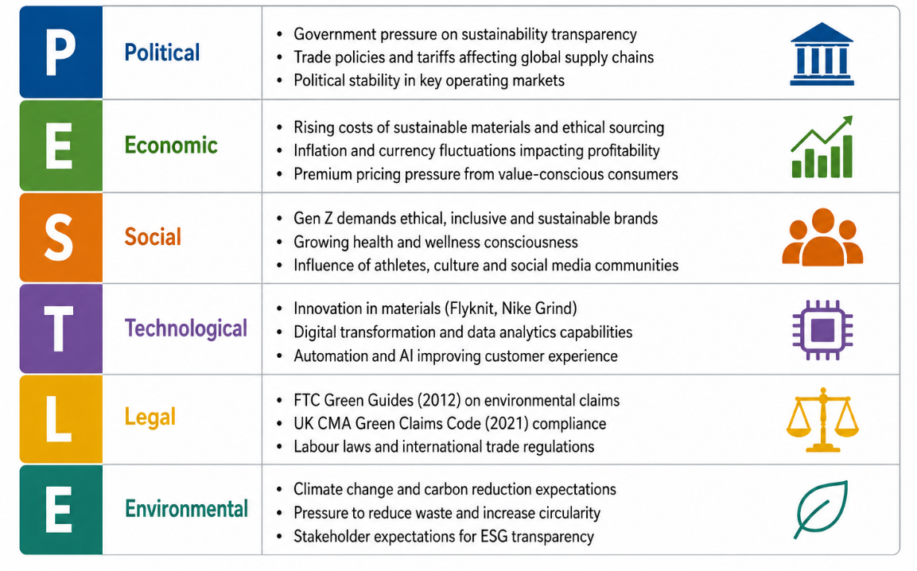
Appendix 3: “You Can’t Stop Us”
Appendix 4: Market Mix
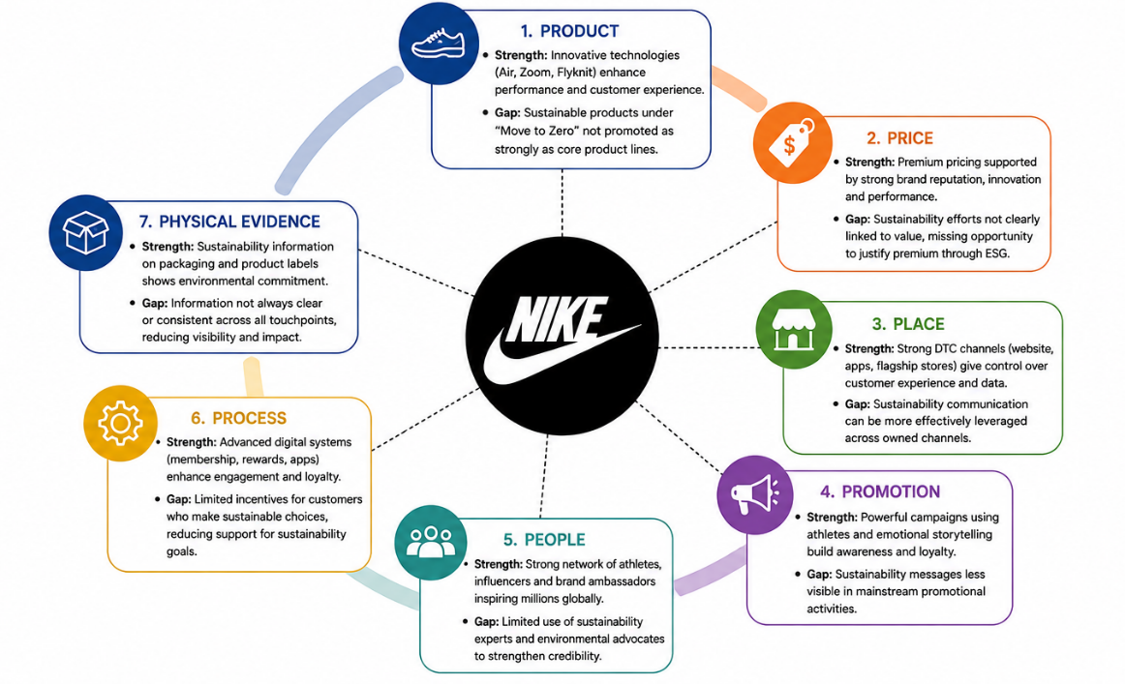
Appendix 5: SHIF OF Nike


