Component A (50%) Marketing Plan
Table of Contents

Introduction 3
Situational Analysis 3
5 Cs 3
Company: SWOT Analysis (Micro analysis) 3
-Customers: Segmentation and Targeting 3
-Competitors: Perceptual positioning map, Bowmans strategy clock 4
-Collaborators 5
-Climate: PESTLE (Macro analysis) 5
-Marketing Mix (4Ps) 5
Objectives 6
Strategy 6
Tactics 6
Communication Mix 7
Conclusions 8
References 9
Appendix 10

Introduction
The goal of this study is to create a marketing strategy for the American hotel brand Holiday Inn. The primary goal will assist the organisation in making the required adjustments to the business. Objectives, plans, and tactics will all be carried out in addition to situation analysis. In this research, Gantt charts will also be provided.

Situational Analysis

5 Cs

Company: SWOT Analysis (Micro analysis)
Strengths | Weaknesses
- Development of the brand image and value  - Financial position and unique services (GOWREA, 2021). | - Lack of effective communication through operations  - Lack of hygiene standards (GOWREA, 2021)
Opportunities | Threats
- Marketing opportunities with the growth of expansion.  - Seasonal offers with the country specific. | - Competition from different companies like Travelodge, Premier Inn.  - Growth of the operational costs.

-Customers: Segmentation and Targeting
Segmentation - There will be the following of demographic and psychographic segmentation that will be helpful to attract the attention of the consumers in the market.
Targeting - There will be the target of the company from younger consumers to older consumers. Mainly they will target the family members and independent people who want to explore the new places. The targeted age group will be 18 to 60.

-Competitors: Perceptual positioning map, Bowmans strategy clock
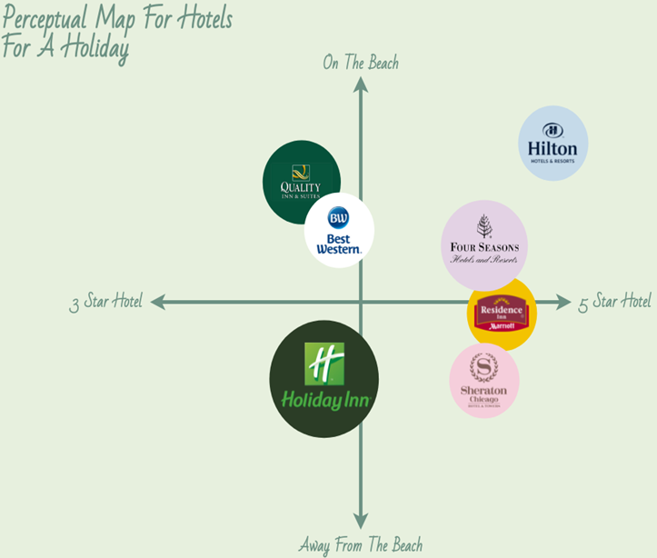
Perceptual map of Holiday Inn
(Source: Visual-paradigm, 2022)
The following perceptual map demonstrates the geographical position of the company and the rating that are provided by the consumers. Through this it has been seen that there is a huge competition and the company got a rating less than 5.
This particular approach called Bowmans strategy clock is designed with the purpose of comprehending an organization's competitive situation. This concept has eight distinct stages, including low value, low price, hybrid, differentiation, focused differentiation, increased price/poor value, increased price, and low value. The Holiday Inn goes through a few of the phases as shown below -
There is a focus of the company on the differentiation strategy that is helpful for the company to compete against the competitors in the market. Through this there is the consideration of the hybrid structure of the organisation. Through this there is the consideration of offering proper products as well as the services to the consumers that creates great value to the consumers in the market.

-Collaborators
Holiday Inn collaborates with travel agencies, internet booking platforms, airlines, and corporate clients through its B2B agreements. Additionally, the business has alliances with a number of well-known companies, including Coca-Cola, Microsoft, Disney, Mastercard, and others. Holiday Inn Express, Holiday Inn Club Vacation, and Holiday Inn Hotels & Resorts are a few of its franchisees (Ihgplc, 2023).

-Climate: PESTLE (Macro analysis)

Factors | Analysis
Political | Brexit has an impact on the employment rate. Government regulation and the taxation policies impact on the organisational operations.
Economic | Growth of the inflation rate effects on the operations and fluctuations of exchange rate create a huge concern through the operational development.
Social | Changing lifestyle of the consumers affects the changes of the organisational strategy in the market.
Technological | Development of innovative services with the technology and the facility of online booking.
Legal | Consumer data protection act and the safety of the consumers and employees need to be maintained.
Environmental | Concern of CO2 emissions, water energy consumptions as well as the concern of the waste materials (Quintás et al. 2023).

-Marketing Mix (4Ps)

Components | Explain
Product | Different resorts, event spaces, hotel services and the other types of the services also.
Place | Operates in different countries and there are also the options of online booking.
Price | Competitive strategy of the pricing areas.
Promotion | Digital marketing with social media (Brandcredential, 2023).

Objectives

Specific | Measurable | Achievable | Relevant | Time plan
To develop an effective system of the communication | Comparison of the employee as well as consumer feedback | Development of the technological transformation helps to reach the goal | Improvement of the communication system help in the development of the operational efficiencies. | 8 months
To develop the information system of the organisation. | Comparison of the success rate of the organisation. | Development of the decision making process within the workplace of the organisation. | Quick access off the information helps to attract the consumer attention | 5-6 months

Strategy
Upon thorough analysis of all the problems, it was discovered that Holiday Inn is mostly dealing with communication-related problems. It is evident from reading visitor reviews that patrons gave the motels one or two stars out of a possible five. According to Trustpilot (2022), the majority of visitors are dissatisfied.
The business can put certain methods into practice to address this problem. The business might, for instance, employ Ansoff's matrix's Market Penetration approach. It may concentrate on boosting sales of currently available items under this. To ensure that customers don't feel unheard, the business should hire new hires and educate them in good communication techniques. On this note, it can be said that the marketing mix needs to be modified properly in which the company promotes their services properly through the different types of the channels (Smith and Zook, 2020).

Tactics
A few hotel patrons have lodged concerns regarding staff members' inadequate communication skills. Numerous individuals experienced issues with their reservations as Holiday Inn had to cancel them. In addition, clients have expressed dissatisfaction with the staff's inadequate communication skills (Trustpilot, 2023).

Communication Mix
Social media marketing: The hotel already employs Facebook, Instagram, and Twitter for this purpose. They share a variety of images of their accommodations, offerings, services, and more. They may, however, advertise their services through a greater number of channels. Social networking sites such as Pinterest, TikTok, and YouTube for further details on their offerings. Holiday Inn ought to pay attention to the unfavourable comments and engage with visitors by offering appropriate remedies.
Direct marketing: The area of marketing where companies utilise emails to advertise their goods and services is called email marketing, which is a subset of direct marketing. It is recommended that Holiday Inn utilise this marketing channel to inform prospective customers about their offerings, including new services, discounts, and additional services. Apart from that, they have to use this platform to advertise their services and give accurate information regarding their cancellation policy.
Search Engine Optimisation (SEO): Holiday Inn can concentrate on SEO to further promote the new marketing plan. The hotel chain may increase their brand awareness in the US hotel market by employing SEO. In addition, the hotel name appears at the top of the search results, giving users access to details about the establishment, any issues, and solutions. The hotel chain would benefit from this in terms of increased brand awareness (Jobber and Ellis-Chadwick, 2020).
Advertisements: A form of marketing communication technique called an advertisement is intended to convince the target audience to purchase any goods or services. To solve their communication challenges, Holiday Inn should use a variety of advertising formats, including print media, infomercials, television commercials, and more, to appeal to a variety of consumer categories.
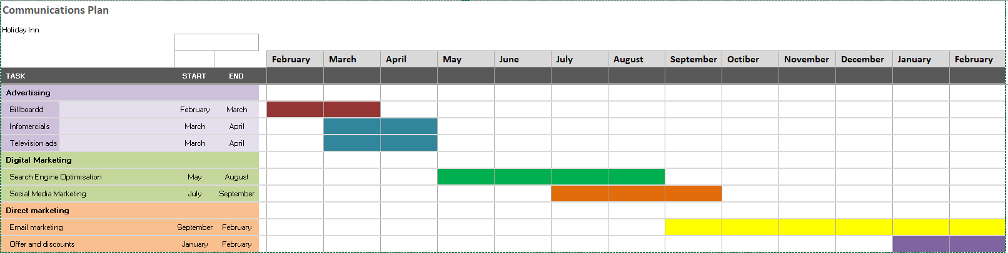
Holiday Inn will employ a variety of communication techniques to interact with its guests. These tactics include internet marketing, direct marketing, and advertising. Within three months, infomercials, billboard marketing, and television commercials are included into the advertising strategy. SMM is done in April and June, and SEO will be done from May to August. Offers and discounts may be found in direct marketing, and email marketing will be completed in five - six months.

Conclusions
In summary, the research examines Holiday Inn's marketing methods, including the use of situational analysis. As mentioned in the SWOT analysis, the organization is having communication problems. Families and companies are the target audience for segmentation. The intended audience is in the age range of 18 to 60. PEST and SMART objectives have been explored, as well as the marketing mix. Various tactics have been suggested to address problems such as bad ratings and communication.

References
Brandcredential (2023). Unveiling the Holiday Inn Marketing Strategy Brand Credential. Available at: https://www.brandcredential.com/post/unveiling-the-holiday-inn-marketing-strategy (Accessed: 02 March 2024).
GOWREA, V. (2021) SWOT analysis of Holiday Inn (Holiday inn swot) - www.howandwhat.net. Available at: https://www.howandwhat.net/swot-analysis-holiday-inn/ (Accessed: 02 March 2024).
Ihgplc, (2023). The holiday inn® brand partners with small business owners in next … Available at:
https://www.ihgplc.com/en/news-and-media/news-releases/2016/the-holiday-inn-brand-partners-with-small-business-owners-in-next-evolution-of-its-journey-to-extrao (Accessed: 1 March 2024).
Jobber, D. and Ellis-Chadwick, F (2020), Principles and practice of marketing. 9th ed. London:
Quintás, M.A., Martínez-Senra, A.I. and García-Pintos, A., (2023). Is the hotel industry really committed to the environment? Answering using the business models framework. Service Business, 17(1), pp.395-428.
Smith PR and Zook ZE (2020) Marketing Communications. 7 th ed, Kogan Page, London
Trustpilot, (2022). Holidayinn is rated ‘poor’ with 1.9 / 5 on Trustpilot. Available at:
https://www.trustpilot.com/review/www.holidayinn.com?search=communication&stars=1 (Accessed: 1 March 2024).
Visual-paradigm, (2022). Perceptual map for Hotels (2022) Perceptual Map For Hotels | Perceptual Map Template. Available at: https://online.visual-paradigm.com/diagrams/templates/perceptual-map/perceptual-map-for-hotels/ (Accessed: 1 March 2024).

Appendix


