

Postgraduate Dissertation coversheet & feedback form:

THIS SHEET MUST BE THE FIRST PAGE OF THE ASSIGNMENT YOU ARE SUBMITTING (DO NOT SEND AS A SEPARATE FILE)
For completion by student:
Student Name: Petra du Preez-Spaun

Student University Email: 29000686@student.tsd.ac.uk
Module code: AHAN7025 | Student ID number:  29000686 |  |  | Educational support needs:  No
Dissertation title: An Investigation into the Notions of Space or Place through the lens of District Six, Cape Town
Supervisor: Bernadette Brady |  | Word count: 20968
I confirm that this is my original work and that I have adhered to the University policy on plagiarism.
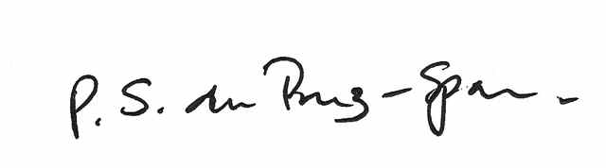
Signed ……………………
For completion by the first marker:
Comments:
This is an outstanding dissertation, very well structured, which I have no doubt as seeing of distinction standard.
You have skilfully taken a profoundly significant piece of contemporary social engineering set in the heart of post-war South African policy as applied to an urban relocation and examined its status in the context of a two thousand year old conceptual tension between ideas of space and place. From the outset you have placed your research in the centre of a fundamental theoretical issue and then set out to collect data in the real world which allow you to answer the theoretical question. And you have succeeded most commendably.
As you can see from my few comments in the text I have very few formal criticisms, and both those, and the comments which follow here should be seen more as suggestions for a more formal publication of your thesis – if you ever choose to go down that path.
Your introduction is exemplary. It clearly outlines the basic question of your work and the theoretical and practical means by which you intend to answer it. Your reflexive considerations were well flagged up as they are an important part of your particular research methodology. At the end of your work, in the absence of a clear way of obtaining an answer from past residents themselves, it is you who has to arraign the academic evidence for District Six being considered place or space, and you have to make that judgement. So reflexive considerations are important.
The literature review is the hardcore of this dissertation and it is very thorough and successful in setting out the complexities of the issue, and the application in SA politics and history of relocation. I enjoyed reading it a lot. I have made a brief comment about Descartes’ role – which I think could be more fleshed out in another version. I like the way you utilise Le Corbusier and his radical modernism as an example of pervasive space and incorporate this into SA housing policy: it’s a very effective argument. Your sections on the re-emergence of place in postmodernism and the enduring phenomenon of genius loci blend these issues together in a most effective way. I consider the Literature Review almost a stand-alone feature and quite a succinct ‘tour de force’.
The place of criticism in such a review is important and whilst you show your critical faculty in considering Plato and Aristotle and the lead into Descartes’ dualism, and later the various considerations of Le Corbusier, it would also be interesting to consider a critique of Casey. His intellectual quest or pet subject has been to shepherd the concept of place through the centuries to our post-modern present, but does he manage this without some omissions and evasions? For example contemporary geography clearly has a strong voice for space as well as place and there are lively discussions the nature of these ideas in some compilations which may have evaded Casey’s eye. Some postdate his book and some I know you are aware of, but see, Tuan Y-F (1977), Creswell (2004), Tilley (1994) and ‘Key Thinkers on Space and Place’ eds. P Hubbard and R . Kitchin, 2011, Sage.
The Findings and Discoveries chapter surveys very thoroughly a wide range of evidence about the history and attitudes regarding District Six. It’s presented in a readable and engaging style but remains academic and objective throughout. However, I did feel that this section might have benefited from a slightly more systematised approach in considering the basic question. So the rich material might have been summarised against a set of criteria or headings – each of which would have reflected a different way of answering the space vs. place, yes or no. By setting your findings out in this more systematic way prepares the reader for the way you might use this structure in your concluding chapter.
Your concluding chapter admirably rehearses all the previous material and allows you to reach a formal conclusion that District Six satisfies the criteria for being considered as Place. Most people in common parlance, I guess, would refer to their dwelling area/home/location as place rather than space. Indeed I am sure the relocated people referred to their new homes in the townships also as place, but perhaps without the passion and enthusiasm that they used the word with regard to the ‘good-old-days’ in District Six. So you have to settle your research question by the application not of how the residents refer to the location (place or space) – as indeed you point out – but how you, as the researcher, satisfy the academic criteria for place that you have opened up and come to make your own judgement. You do that in your concluding paragraphs, but as I have commented above I think you could improve this endpoint of your argument, by a more systematic examination of each of your criteria, e.g. Heidegger-type ‘place; Place as birthplace; Place and social relations; Place as historical dialogue; Place as genius loci....etc. You would arrive at the same answer but possibly in a stronger way.
Finally, I look forward to reading this research again in a more public version!

First Marker’s Mark: 73  Signature: Anthony Thorley |  |  | Date: 13.1.15

For completion by the second marker:

Comments:

This dissertation explores the notion of place verse space through the lens of a contemporary urban story. There is an array of academic opinions concerning the nature of space and whether it is the same or different to place. This work takes this theoretical debate and explores these arguments within the field via the history and views of the people involved with what is known as District Six in Cape Town, South Africa. It uses a case study technique to look at feelings and thoughts of a displaced community as they slowly come to terms with the loss of their homes, community and neighbourhoods. The findings of the research are then returned to the theoretical arguments to contribute insights or additional perspectives on this continuing academic debate. In this way the dissertation, makes a comment on the social history of Cape Town as well as adds original insights to the philosophical debates on space verses place. This is an excellent piece of work.

Your literature review is substantial as you have taken the challenge of defining space and place throughout history as well as its implications into the arguments of town planning and civil attitudes of the 1930s to slum and slum clearance. It is particular useful for the reader that you have summarised, in your conclusion, these this extensive literature to a compact listings of the three different theories of space and place – space as an extension of place, space as geometrical and superior and place emerging as having links to dwelling. This is excellent as it lays a solid foundation for the analyses of your field work.

A side comment on your use of Casey
You have made Casey’s arguments the central pillar of your work on space and place, this works well as you take a wide range of varying opinions from the Classical period right through to the contemporary and in a sense contrast them with Casey’s position. What I would suggest, in order to help justify this method, when, and if, you take this work further is that you add some background material on the fundamental importance of Casey’s arguments to the debate. It is his work which is one of the first contemporary pieces outside of Heidegger’s phenomenology, to challenge the almost consumption of ‘place’ by ‘space’. Certainly other scholars have followed Casey but he is one of the key champions of this early debate.

Fieldwork
Your manner of writing up your fieldwork is exemplary, the voices and images from your fieldwork are presented in such a way that the reader finds themselves standing in the midst of District Six and listening to the voices. Along with this engaging style you have weaved the material from your literature view back into the African voices that speak of place, dwelling, street signs, hospitals and community. This is a fine example of ethnological field work blended with archival files and put into an academic context via your literature.

Your findings
Your concluding chapter is brilliant and shows that you thinking deeply within the arguments on space and place in the light of your fieldwork. You summaries your work and then in energetic prose you pull all your arguments together to present an unshakeable conclusion that for the displaced residence of District Six, place has not be consumed by space, that place is linked to Heidegger’s dwelling and the spirit of place is very much alive.

Your dissertation cuts an original path through the growing debates around place and space and in this way it shows the value of ethnographical work to help unpack or explore philosophical questions. I look forward to seeing this work in a published format.

Second Marker’s Mark: 79%  Signature: Bernadette Brady | Date: January 2015
NB. All marks are provisional until confirmed by the final examination board.

For completion by the External Examiner:

Comments:

Proposed Mark: 76%

Signature of External Examiner:

Final Agreed Mark:

An Investigation into the Notions of Space or Place through the lens of District Six, Cape Town

Dissertation submitted in partial fulfilment of a M.A. in Cultural Astronomy and Astrology
University of Wales Trinity Saint David
2014

Petra du Preez-Spaun
Student Number 29000686

Submitted 18 September 2014

Acknowledgements

I would like to thank Dr. Nicholas Campion and Dr. Bernadette Brady for their dedicated and stimulating teaching for the MA in Cultural Astronomy and Astrology at the University of Wales, Trinity Saint David and Dr. Brady in particular, for her enthusiastic support and guidance in the development and writing up of this dissertation.

Statement of Originality

I declare that this dissertation is my own work, apart from where source material has been given credit. This work has not previously been included in a thesis or dissertation submitted to the University of Wales, Trinity Saint David or to any other institution for a degree or other qualification.

Word Count 20968
Abstract
Within the academy, there are contrasting arguments, opinions and theories of how space and place should be interpreted in the contemporary western world, yet there is a tendency to confuse the terms space and place or to use them interchangeably. This work uses District Six in Cape Town, South Africa, as a case study to explore and consider the arguments within the larger context of the academic question of the notions of space and of place. Moreover, it explores whether the previous residents view it as a space or a place, in addition to investigating the possible reasons why they have a special regard for District Six. Although the apartheid government is often held solely responsible for the destruction of District Six, this paper explores the possible effects that the views held in modernity on space and place may have had on this process. In doing so, it endeavours to trace a typology of space and of place commencing with Plato and Aristotle in antiquity, continuing with Descartes in the period of modernity through to Heidegger, Casey and Ingold, amongst others, in the postmodern era.
Table of Contents Page

Chapter 1: Introduction.…………………………………………………… 1
Aim of the Research Project………………………………….. 1
Academic Rationale…………………………………………… 1
Theories of Space and Place………………………………….. 3
History and Context of District Six…………………………... 5
Reflexive Considerations……………………………………… 12
Methodology…………………………………………………… 13
Ethical Considerations………………………………………… 14
Research Questions……………………………………………. 14

Chapter 2: Review of the Literature ……………………………………… 16
Introduction……………………………………………………. 16
Space and Place in Plato and Aristotle……………………….. 16
Platonic Dualism and Aristotelian Monism………………….. 20
Space, Place, Modernity and Descartes………………………. 21
Le Corbusier and Modernism………………………………… 24
Slumming and Urban Renewal……………………………….. 26
The Re-Emergence of Place in Post-Modernism…………….. 30
Dwelling Places…………………………………………………. 32
Place and Ritual………………………………………………… 33
The Home as Primary Sense of Place…………………………. 35
The genius loci - the Spirit of Place……………………………. 38
Summary of the Literature Review……………………………. 40
Chapter 3: Findings and Discussions………………………………………… 44
Introduction………………………………………………………. 44 The Place of Birth………………………………………………… 45
What is in a Name?………………………………………………. 48
Neighbours and Community…………………………………….. 54
The New Year Festival…………………………………………… 55
The Set Apart or Sacred…………………………………………. 60
Place and the Landscape…………………………………………. 63
By Way of the Body………………………………………………. 66
The Spirit of Kanala……………………………………………… 67
Place as Embedded in Being…………………………………….. 73

Chapter 4: Conclusions……………………………………………………….. 77

Bibliography……………………………………………………………………… 84

Appendix 1: Interview Release Form…………………………………………. 92

List of Figures Page

Fig 1 Map of Cape Town, showing District Six……………………….. 6

Fig 2 View of District Six, before the demolitions, c. 1960s…..……… 9

Fig 3 View of District Six, after the demolitions, c. 1999…………...… 10

Fig 4 The Seven Steps, off Hanover Street, District Six…………….... 49

Fig 5 The Original Street Names Signs……………………………….... 50

Fig 6 Double Storey Victorian terrace houses………………………… 51

Fig 7 Hanover Street, District Six……………………………………… 52

Fig 8 Keizersgracht Street, Zonnebloem……………………………… 53

Fig 9 The Coon Carnival……………………………………………….. 57

Fig 10 The "fruitcake" building………………………………………… 61

Fig 11 The original Beinkinstadt building, c, 1970s…………………… 62

Fig 12 Joe's sacred tree…........................................................................... 64

Chapter 1
Introduction

Aim of the Research Project
This research is focused on a disputed and contested area, called District Six, situated near the centre of the city of Cape Town, South Africa. In 1966, under the Group Areas Act of 1950, it was declared a whites only area and sixty thousand people of mixed colour were forcibly removed and displaced. Although most of the buildings were razed to the ground, the evacuees and their descendants hold the actual site and their memories of District Six in a special regard. This project explores the nature of this special regard in the light of the academic debates regarding the notions of space and the notions of place. The purpose of the research is to use the views and opinions of the previous residents of District Six to provide an insight into the different academic opinions about space and place in the contemporary western world view.

Academic Rationale
Within the academy, theorists have contrasting arguments, opinions and theories of how space and place should be interpreted in the contemporary western world. Edward Casey says that the difference between space and place is one of the best kept secrets and contends that in modernity, place has been dismissed and systematically overlooked in favour of space. For Casey, place raises questions of limit, boundary, location and surrounding, whereas space raises questions of the absolute, the infinite, the immense and the indefinitely extended. In Martin Heidegger's work, the interpretation of space and place is more complex. Instead of opposing the notions of space and place, Heidegger distinguishes between the notions of places, spaces and "space". The latter notion of "space", is what Heidegger understands as abstract space, or space as extension in length, breadth and depth, which he sees as a pure mathematical construction: 'The space provided for in this mathematical manner may be called "space," the "one" space as such.' Yet, this "space" contains no spaces and no places. It can thus be argued, that Heidegger distinguishes between abstract space as "space", places and something he calls spaces, which will be explored in the literature review in Chapter 2, in addition to other theories of space and place.

Within a South African academic context and with reference to District Six, David Chidester favours the idea of urban space over urban place and argues that as an urban space, District Six is being reclaimed as a site of sacred memory. In contrast to Chidester, Angela Impey, instead emphasises place over space: 'Land, locality and place attachment are key to the development process in post-apartheid South Africa. Finding one's place under the new dispensation involves a complex disentangling from the hegemonies of the past and a conscious re-evaluation of cultural identities and senses of place.' The special regard Duane Jethro has for District Six is apparent when he remembers that it was "remarkable, different, set apart" and that in the memory of its former residents, it was "that other place": 'When you entered District Six you entered Fairyland, as graffiti inscribed at its entrance once exclaimed.' According to Emile Durkheim, the idea of something being set apart ascribes a quality of sacredness to that something. To Durkheim, the sacred is not only limited to gods or spirits, but he advocates that 'a rock, a tree, a spring, a pebble, a piece of wood, a house,' can also be sacred. Mircea Eliade refers to the set apart as the "wholly other", and says that 'the sacred always manifests itself as a reality of a wholly different order from "natural" realities.' This seemingly contradicts Durkheim's perception that natural realities, like a rock or a tree, can be sacred, although Eliade concedes that the phenomenon of the sacred needs to be understood in all its complexity.

Theories of Space and Place
Based on the views of Casey and Heidegger, it can be argued that the association or relationship between space and place is a tenuous one. In the contemporary western world view, there is a tendency to use the notions of space and place interchangeably and to collapse them into having the same meaning. Michael R. Curry argues that the ideas of space and place are seminally ambiguous, but that the ubiquity of the word "place" in everyday discourse misled theorists into imagining that it always has been there. Both Curry and Casey argue the same point - that place was subsumed by space during the period of modernity. According to Curry, it was only in the 1960s that the concept of place began to re-emerge in academic discourse. This emergence, says Curry, was largely mediated through popular culture. As an example of this, Curry cites the positive effect that Jane Jacobs' work had on urban planning, whereby a new discourse emerged about how people interacted when in close proximity. Jacobs argued that in urban planning, one needed to look at the everyday activities of people living and working in neighbourhoods. She proposed that instead of simply viewing these neighbourhoods as regions, they should be viewed as places constructed through those everyday activities. This discourse, says Curry, moved in part into the social sciences and became formalized in environmental sciences.

Similarly, Casey contends that the premodern and the postmodern both understood place as being something other than space. Casey is of the opinion that it is a characteristically modern notion that place and space differ from each other only trivially and argues that modernists want to dissolve place into space. Contesting Alfred Whitehead's theory that simple location underscored the whole notion of nature in the seventeenth century, Casey argues that place is not simple location in a uniform geometrical space. Instead, Casey asserts, place is qualitative, relational, enclosing and 'the bedrock of our being-in-the-world.'

This research project endeavours to critically examine and comment on the various theories of space and place through the use of the thoughts and experiences of the people of District Six. It furthermore endeavours to analyse and discuss the association between space and place and in this context, it seeks to understand if and how ideas on space and place in modernity may have affected the lives of the previous residents of District Six. In addition to investigating notions of space and notions of place, this research also endeavours to explore the idea of District Six as being set apart or sacred. In taking this philosophical argument out into the field, my research and dissertation seek to make an empirical contribution to what till now has been a largely theoretical academic discourse.

History and Context of District Six
After the establishment of a European settlement at the Cape of Good Hope in South Africa in 1652, initially Dutch and later French, the central area of Cape Town became increasingly more populated. During the nineteenth century, a number of farms in the area were subdivided to form residential areas. One such farm was Zonnebloem, meaning sunflower, which lay directly under the part of Table Mountain known as Devil's Peak. After the emancipation of the slaves in 1834, there was a huge influx of people, mostly former slaves, into this area. Chris Schoeman says that between 1842 and 1854, the number of properties in this area more than doubled and with it, the population. In 1867, one such populated area near the centre of Cape Town was named the Sixth Municipal District of Cape Town or District Six. (See Fig 1) The original name of the farm, Zonnebloem, was the

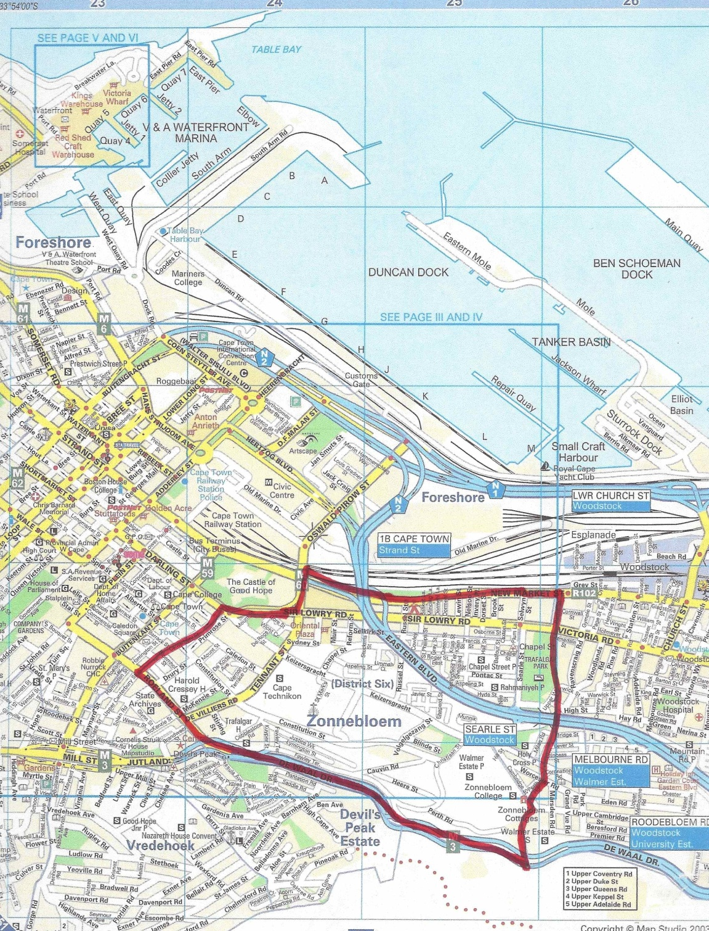
name that the apartheid government gave to District Six after it was demolished.
Fig 1 - Map of Cape Town, showing District Six, Copyright 2014 MapStudio.

During its early years, District Six was known as "Kanaladorp", a name that is a mixture of Malay and Dutch origin. Schoeman says that although the name may have referred to the system of canals that ran through the area, the more likely explanation is in reference to how the people helped each other in a spirit of community, the literal meaning of "kanala" being "if you please". Many of the houses in Kanaladorp, says Schoeman, were constructed by groups of friends working for one another. Vivian Bickford Smith says that since the 1840s, most of Cape Town's lower class areas were racially mixed, including Kanaladorp, and that whites, coloureds and Africans were neighbours and lived side by side. Schoeman says that it had developed into a 'cosmopolitan community, a melting pot of class, race and culture.'

The growth of District Six was accompanied by various problems like overcrowding, a lack of infrastructure and neglect by the authorities. Schoeman observes that the failure by the authorities to rectify these squalor conditions should be seen against the prevailing perceptions of the poor during Victorian times. In the late nineteenth Century, the majority of people in Cape Town were English speaking bourgeois, who like their counterparts in England, saw poverty as the consequence of a moral failure, and thus had little concern for the welfare of the overcrowded inhabitants of District Six. Schoeman proposes that it is understandable that under such circumstances as the severe overcrowding, slum conditions would have developed.

Although the forced removals are often solely attributed to be the work of the apartheid government, who came into power in 1948, it is a little known fact that the first forced removals from District Six happened in 1901, as a result of the bubonic plague that occurred during the Anglo-Boer War. African dockworkers were suspected of spreading the disease carried by fleas on rats in the hay imported to feed the horses of the British. Cape government officials used the Public Health Amendment Act of 1897 to forcibly move Africans into locations. The Slums Act of 1934 gave the Cape Town City Council the power to demolish many 'slum' buildings in District Six and subsequently over a thousand new homes were built, mainly for people of a mixed race group, the so-called coloured people. By the time the apartheid government came to power, many areas in Cape Town were already racially segregated, but District Six remained a mixed community, although populated mostly by coloured people. It was, however, the Group Areas Act of 1950 that aimed to altogether stop the presence of mixed residential areas in South Africa.

On 11 February 1966, the greater part of District Six was formally proclaimed an area of white settlement, in accordance with the Group Areas Act of 1950. Felicity Swanson and Jane Harries recall that although it was densely populated and over-

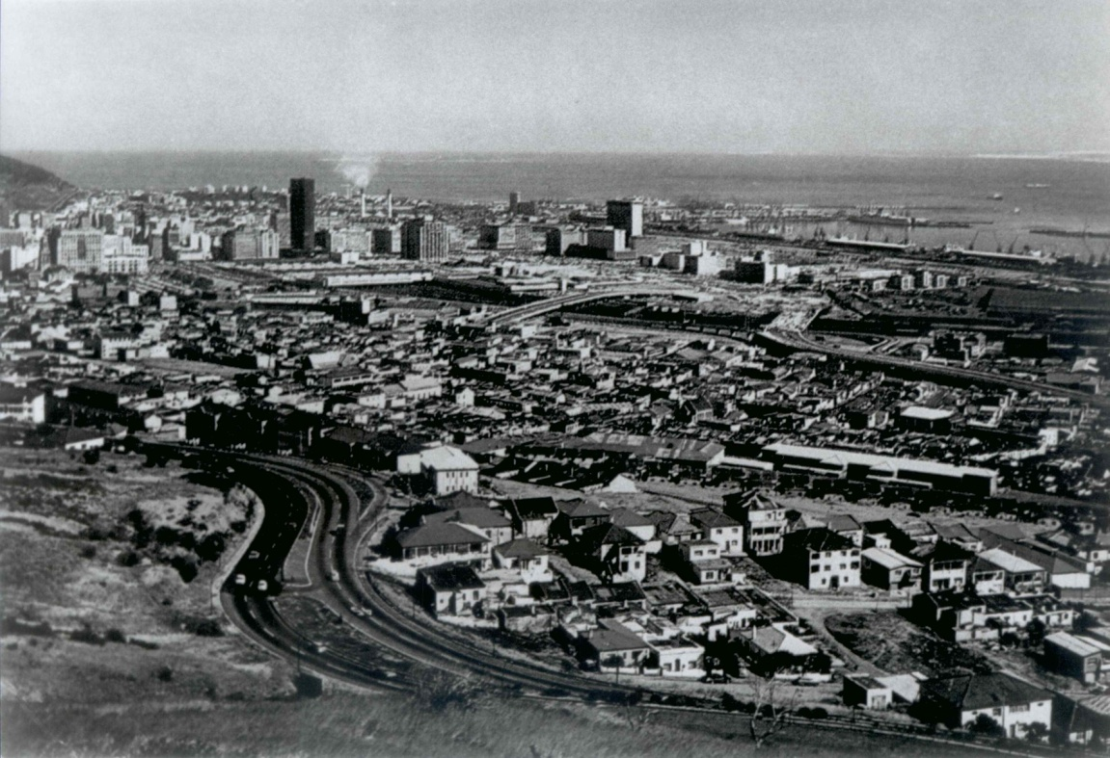
Fig 2 - View of District Six, before the demolitions, c. 1960s, photo District Six Museum collection.

crowded, District Six was similar in nature to the Left Bank in Paris, the East End of London and the Bronx in New York and that it had become known for the
cosmopolitan mix of residents and melting pot of cultures. Although considered a slum by outsiders, Swanson and Harries argue that 'the majority of people living there were law-abiding citizens with deeply rooted family and community ties and a strong sense of belonging.' With over twenty schools and colleges, eighteen churches, three mosques and four synagogues, community infrastructure was well established, indicative of a good degree of religious tolerance and cultural diversity. (See Fig 2) In spite of the squalor, 'there existed a joyous spirit and common bond amongst the inhabitants, a delicate network of relationships of people who had been living together for generations.' In the words of community worker Tahir Levy: 'We were poor, we were struggling - but it was home.' However, over a period of fifteen years and starting in 1968, some sixty thousand people were uprooted from their homes and forcibly removed. Almost all the buildings, except for the religious buildings, were bulldozed and razed to the ground. (See Fig 3) Virtually the whole of District Six was obliterated as it disappeared off the face of the earth. In the words of the poet Adam Small, a former resident, 'people were in fact bulldozed out of their lives', as he laments in a poem about District Six:
'The bulldozers …
they came
and knocked flat
everything here
everything, everything,
houses, hearts the lot,
everything God!'

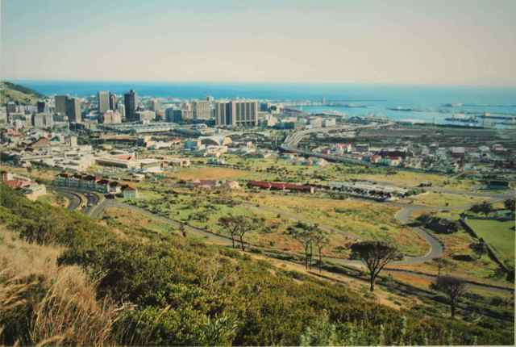
Fig 3 - View of District Six, after the demolitions, c. 1999, photo by Paul Grendon, District Six Museum Collection.

Although the then apartheid government had plans to build, amongst other things, a parliamentary complex on the empty site, a concerned group of people, calling themselves the "Hands Off District Six" group, successfully prevented the development of the barren land. 'If we cannot live on this land, we salt this earth. It should not be there for anyone else to live on until apartheid is abolished and the people of District Six can decide what to do with the land.' Salting the earth or sowing salt, is colloquially understood as a ritual of spreading salt on conquered land to symbolise a curse and prevent it from being re-inhabited. The South African poet Breyten Breytenbach references this phrase in an essay about Buchenwald, a site where World War II atrocities occurred, when he says: 'The town, too, should have been given over to the dark ink of time. No memorial, no ceremonies, just the salted earth forever.'

A program of land restitution is currently underway to rebuild homes on the site of District Six and to return the evictees to the original site. This restitution process was initiated in 1994, the year when South Africa had its first democratic elections. Although the District Six Redevelopment and Beneficiary Trust spearhead this process, the establishment of the District Six Museum in December 1994 served the purpose of keeping alive the memories of District Six. As part of the Museum's mission statement reads: 'The Museum seek to develop policies relating to heritage and memory that are both grounded in and seek to develop the interests of the poor and the dispossessed…' The program of restitution is not without controversy, as District Six has been a contested site for many years. As recently as June 2013, a group of forty activists, claiming to have ancestral rights to the land by virtue of their Khoi descendancy, occupied eleven units in a District Six apartment complex that was designated for returnees.

Reflexive Considerations
I come to this research project from a position of being a local, having lived in Cape Town for the past thirty five years. It was in my capacity as a professional astrologer, that I embarked upon the MA in Cultural Astronomy and Astrology at the University of Wales, Trinity Saint David, during the course of 2009. As part of the curriculum for the Sacred Geography module, I wrote a 4000-word essay on the notion of the home as being a sacred space, for which I received a distinction. My supervisor, Bernadette Brady, encouraged me to further investigate and explore the notions of space and the notions of place.

It should also be said that the home in which I have been living in for the past twelve years, is situated in such a manner that it overlooks the site of what once was the vibrant community of District Six. It would not be wrong to say that it has been staring me in the face for the past twelve years. As an eleventh generation white South African, I did not experience the prejudices, injustices and intolerances that people of colour experienced during the apartheid years. In this sense, my position in researching District Six puts me in an 'etic' (outsider) position, rather than an 'emic' (insider) position, in terms of Kenneth Pike's definitions. 'Descriptions or analyses from the etic standpoint are 'alien' in view, with criteria external to the system. Emic descriptions provide an internal view, with criteria chosen from within the system.'

Due consideration has also been given to the notions of experience-near and experience-distant concepts as explained and cited by Clifford Geertz, but initially developed by the psychoanalyst Heinz Kohut. Geertz concedes that it is a difficult and delicate task to grasp experience-near concepts of another people and to then contextualise these concepts in experience-distant theories. He advises that the trick lies in not getting oneself 'into some inner correspondence of spirit with your informants.' Yet, he encouragingly argues that most people use experience-near concepts spontaneously and colloquially, without recognizing that there are "concepts" involved at all. I hope to adopt such an approach to my respondents and my research project.

Methodology
My research methodology included literature reviews and fieldwork. My target group was the previous residents of District Six and I conducted four semi-structured interviews, three with previous residents and one with an employee at the District Six Museum, during April 2013 to obtain qualitative data. Martyn Denscombe is of the opinion that interviews provide a more suitable method of researching when they are applied to the exploration of more complex and subtle phenomena and when the researcher needs to gain insights into things such as people's opinions, feelings, emotions and experiences. Judith Bell also advocates the adaptability of the interview as research method and says that in her opinion, more can be gained with an interview than what a questionnaire can ever do.

In addition to the interviews, I also conducted a site walk with a previous resident who works as a guide at the District Six Museum and I attended two monthly meetings of the previous residents, called the Seven Steps group. At these meetings I sensed that some people felt uncomfortable with an outsider in their midst. Instead of conducting more interviews, I focused on articles and books written by previous residents in which they told their stories. I considered this to be a more appropriate and unbiased source of primary material.

Ethical Considerations
The interviewees were informed about the nature of the research project and that the interviews were going to be recorded and transcribed. They all completed and signed interview release forms and only one interviewee chose to be anonymous. A copy of the interview release form can be found in Appendix 1.

Research Questions
In using District Six as a case study to explore and consider the arguments within the larger context of the academic question of the notions of space and place, I wanted my research to provide some insights into these issues. However, because of the ambiguity between space and place, in addition to the task mentioned above of translating experience-near concepts into experience-distant theories, it was not feasible to ask interviewees the direct question of whether they regard District Six as a space or a place. It was therefore necessary to identify and clarify concepts and ideas through literature reviews, which are associated with the notion of space on the one hand and the notion of place on the other hand. These ideas and concepts were tested against the results of the fieldwork and the interviewees' experiences, to critically examine whether District Six is better suited to notions of space or notions of place. I also endeavoured to examine the results with a view to seeing if the data supported all or none of the academic arguments about space, place and the sacred.

In this chapter, I identified the objectives, aims and purpose of this research project, as well as the academic rationale. I identified some of the major theorists and their theories of space and place that will be discussed and examined. In addition to sketching the history, background and context of District Six, I also expressed my reflexive considerations, tabled my methodology and ethical considerations, before summarising the research questions I anticipated my research will provide some insights into. In Chapter 2, I will look at and review the literature concerned with theories of space and place, the effect of modernism on urban planning, as well as what constitutes the set apart or the sacred. Chapter 3 will present the findings and analysis of my fieldwork and observations in relation to the literature review, whilst Chapter 4 will deal with the conclusions that can be drawn from the literature review and the fieldwork, amongst others, whether the previous residents of District Six reflect it as having notions of space or notions of place.

Chapter 2
Review of the literature

Introduction
If, as Casey asserts, the difference between space and place is one of the best kept secrets, the notions of space and place invite an evaluation and discussion, as to how they are viewed by theorists in the contemporary western world. In this chapter, a literature review is undertaken to critically evaluate the notions of space and of place. At first, it endeavours to analyse how Plato and Aristotle viewed space and place; it then seeks to discuss and comment on later views of space and place, including the periods of modernity and postmodernism, to arrive at an understanding of the notions of space and place in the contemporary western world view, in order to then explore these notions within the experience of the people with links to District Six. The chapter closes with the summary of the literature review.

Space and Place in Plato and Aristotle
In the Timaeus, Plato (c. 428 - 348 BCE) proposes two orders or forms of existence, also known as his doctrine of Being and Becoming: one as a 'model, intelligible and always changeless, a second as an imitation of the model, something that possesses becoming and is visible.' Plato, however, concedes that these two orders alone are not sufficient to describe the creation of the universe and he introduces a third kind, which he calls the Receptacle of all Becoming - its wetnurse, but adds that '…to attempt to illuminate in words a kind that is difficult and vague.' In a further paragraph in the Timeaus, Plato again introduces the third kind, but instead of calling it the Receptacle, he calls it space: 'And the third type is space, which exists always and cannot be destroyed.' To Plato, space seems to precede place when he says: 'There are being, space, and becoming, three distinct things which existed even before the universe came to be.' Plato, however, also makes a reference to both place and space: '…everything that exists must of necessity be somewhere, in some place and occupying some space, and that which doesn't exist somewhere, whether on earth or in heaven, doesn't exist at all.' Francis Cornford succinctly sums up Plato's views on space and place in observing that: 'Space, is to him (Plato) the 'room' or place where things are.'

To Aristotle (c. 384 - 322 BCE), place, as opposed to space, was the intrinsically difficult idea to grasp: 'Place is thought to be something profound and difficult to grasp…' It is his opinion though, that any student of nature should have knowledge of place, just as the student must have knowledge of the infinite. Although Aristotle views place as a vessel or a container, he ultimately defines place as 'the first unchangeable limit of that which surrounds.' To illustrate what he means by place, he uses an example of a stationary vessel that contains a combination of air and water: 'Just as the vessel is a place which can be carried around, so place is a vessel which cannot be moved around.' Casey argues that to both Plato and Aristotle, to be, is to be in place and conversely, to be without place, is not to be at all.

To Aristotle, place is something that has power, by virtue that the locomotions of the natural simple bodies of fire, earth, air and water, naturally move to their own places, if not impeded. Aristotle calls these places their proper places and says that 'since necessarily bodies move either according to nature or contrary to nature, and these are determined by their proper places …' Peter K. Machamer suggests that this power of natural place is the power to make a natural unity amongst things that are alike by nature. These things are then in natural unity with their neighbours, continuous with its surrounding parts and in their proper places, whereby it is at rest by virtue of resting naturally in the whole. Casey similarly argues for a reciprocal belongingness of thing and place in Aristotle, for as Aristotle says: 'Just as every body is in a place, so in every place there is a body.'

Plato's Demiurge fashioned geometrical shapes for the primary bodies of fire, earth, air and water, in order to give them form, says Cornford. Casey refers to this concept as Plato's "ingrafted geometrism" and to Casey, the disparity between Plato and Aristotle on place lies in this notion of the Platonic "ingrafted geometrism" of the Timaeus versus an Aristotelian "physicalism" in the Physics. As Samuel Sambursky remarks: 'It never occurred to Aristotle that mathematical elements, for instance geometrical shapes, could be used as symbols to describe physical realities.' Jeff Malpas is of the opinion that spatial and topographical notions were not easily distinguishable from each other in Plato and Aristotle, but more importantly, that the modern idea of space as simple measurable extension, in terms of length, breadth and depth, did not provide the framework within which space and place were understood. Heidegger's view also supports this idea, in that he said the Greeks had no word for space, as it is understood in modernity: 'That is no accident; for they experienced the spatial on the basis not of extension but of place (topos).' Heidegger's interpretation of how the Greeks understood space is similar to how Cornford understands Plato's interpretation of space: 'A space is something that has been made room for… '

According to Heidegger and Malpas, Plato and Aristotle both understood space not in terms of extension, but in terms of place and it can be argued that Plato and Aristotle both viewed space and place as being interconnected or co-extensive. The essential difference between Plato and Aristotle on place lies in what Casey calls Plato's "ingrafted geometrism" versus Aristotle's "physicalism". It can furthermore be argued that this essential philosophical difference is born out of what is known as Plato's dualism versus Aristotle's monism.

Platonic Dualism and Aristotelian Monism
To Plato, the cosmos was divine and animated by soul: '… divine providence brought our world into being as a truly living thing, endowed with soul and intelligence.' Yet, Plato also separated body and soul: '… if we are ever to have pure knowledge, we must escape from the body and observe things in themselves with the soul by itself.' Essentially, to Plato, the soul resembles the divine and the body resembles the mortal. It is often said that the notion of dualism had its origin in Plato's thinking and according to Gunther Stent: 'Ever since Plato put forward the dualist doctrine that mind and body are fundamentally different, philosophers have argued about whether they are. This argument came to be known as the "mind-body problem.'" In contrast to this, says Stent, Aristotle advocated the anti-dualist doctrine of monism, since Aristotle viewed mental phenomena as being nothing other than bodily functions. Hendrik Lorenz says that 'According to Aristotle's theory, a soul is a particular kind of nature, a principle that accounts for change and rest in the particular case of living bodies, i.e. plants, nonhuman animals and human beings.' If to Plato, the soul was separable from the body, to Aristotle it was not, for as Aristotle says: '… the soul is neither without body nor a kind of body. For it is not a body but belongs to a body…'

Space, Place, Modernity and Descartes
Casey is of the opinion that it was Aristotle's unswerving commitment to the power of place that upheld the discussion on place for the next two thousand years, even though, according to Casey, place gradually lost out to space over this period, but particularly during the last three hundred years, the period of modernity. Casey argues that space started subsuming place in the sixteenth and seventeenth centuries, when the natural scientists and philosophers began to mathematize nature. According to Casey, it was especially the work of René Descartes (1596 - 1650) that had the direst consequence on the notion of place.

In Descartes' substances of res cogitans (the thinking thing) and res extensa (the extended thing), there is a clear distinction between mind and body, with mind being the former and matter being the latter, says Stuart Elden. Stent agrees that Descartes' contribution to the mind-body problem, in the form of what Stent calls the "substance dualism", was a notorious one. Said Descartes: 'I thereby concluded that I was a substance, of which the whole essence or nature consists in thinking, and which, in order to exist, needs no place and depends on no material thing…' This suggests, that to Descartes, only reason mattered and that place was superfluous and irrelevant. It has been argued that Descartes extended Plato's dualistic ideas, although Sarah Broadie asserts that there are fundamental differences between the two of them. In her opinion, Plato sees the body simply as an instrument of the soul and that the soul animates its body, because it is divine and godlike. This is vastly different to Descartes, says Broadie, who saw a "universal separability" between the mind and the body. It can be argued that this "universal separatism" and dualist approach contributed to Descartes viewing the body and the natural world as a machine, consisting merely of physical elements, for as he said: 'I should like you to consider that these functions follow from the mere arrangements of the machine's organs every bit as naturally as the movements of a clock.' The result, claims Albert G. A. Balz, is that Descartes advanced the mind-body dualism as an irresistible truth, which effectively resulted in isolating the soul from nature.

Descartes work in science and philosophy is seen by many, says John Cottingham, as synonymous with the birth of the modern era. In Casey's opinion, the transition from ancient to modern thinking occurred by the close of the seventeenth century, the Age of Enlightenment and at this time, says Casey, space and place along with it, became geometrized. Descartes' condemnation of place as mere geometric extension is evident in this statement: '… if we conceive a place to contain nothing but extension in length, breadth and depth, we do not usually say there is a body there; we just say there is space there - empty space….' It can thus be argued, that there is a correlation between Descartes' dualism and "universal separatism" - which resulted in viewing nature as a machine, effectively isolating the soul from nature - and between place being subsumed by space.

Casey argues that in Descartes' dualism where mind and body is separated, space subsumed place and that modernists actively suppressed place. Edward Relph also ascribes the neglect of place to the arrogance of modernism and rationalism. Relph says that in the early 1990s, the role being played by place in academic enquiry suddenly emerged from the background to the foreground, even though Curry claims that this transpired in the 1960s. To Relph, the most probable reason for this is the rise of postmodernism theories about diversity and difference, viewed against the decline of modernism's ordered, futuristic and monochrome view of the world.

James C. Scott is of the opinion that the Enlightenment created a strong aesthetic that favoured straight lines and visible order in the layout and planning of cities. According to Scott, nobody expressed this prejudice towards a geometric cityscape more clearly than Descartes. Descartes' dislike of an organic or natural layout for cities or towns can be seen from this observation he made about town planning and buildings: '… seeing how they are placed, with a big one here, a small one there, and how they cause the streets to bend and to be at different levels, one has the impression that they are more the product of chance than that of a human will operating according to reason.' Scott compares Descartes' vision for the urban environment to that of a scientific forest: '… streets laid out in straight lines intersecting at right angles, buildings of uniform design and size, the whole built according to a single overarching plan.' This is how the city of New York was laid out, which according to Reuben Skye Rose-Redwood, was done as a celebration of Descartes' philosophy. Lewis Mumford confirms the notion of streets laid out in straight lines and says that one of the triumphs of the modern period was its ability to 'organize space, to make it continuous, reduce it to measure and order.' This, it can be argued, is a clear indicator of how space triumphed over place, which according to Tim Ingold, resulted in a pre-occupation with linearity in modernity.

Le Corbusier and Modernism
The French architect, Le Corbusier (1887 - 1965), was born Charles-Édouard Jeanneret-Gris, but later became known only by the pseudonym, Le Corbusier. He is considered by many as a pioneer of modern architecture whose influence stretched all over the world and as shall be discussed at a later stage, he would become a key figure in the history of District Six. Le Corbusier approached urban planning in a similar manner to Descartes, says Scott, by putting the emphasis on making the city the reflection of a single, rational plan. Like Descartes, Le Corbusier also thought of the planned city as a large efficient machine and Le Corbusier's expression that the home is a machine for living, came to epitomise high modernism. To Scott, in high modernism, the past is rejected in favour of a desire to start with a clean slate: 'The more utopian the high modernism, the more thoroughgoing its implied critique of the existing society.' Le Corbusier's design utopia is found in his idea of the Radiant City and was based on 'the early modernist belief in the deterministic power of physical design to produce the desired social goals', says Keith Aoki. Everything old should be razed to the ground, and it its place, sixty-story skyscrapers in vast geometric arrays could be erected against the cleansed landscape. As Le Corbusier remarks, one could argue in a very inhumane tone: 'My scheme is brutal, because town existence and life itself is brutal: life is pitiless, it must defend itself, hemmed in as is on all sides by death. To overcome death, constant activity is necessary.' If constant activity is taken to have the opposite meaning of to be at rest, it can be argued that Le Corbusier indirectly favoured the notion of space over place, since a fundamental requirement for an Aristotelian understanding of place, according to Machamer, is to be at rest.

It is with almost religious fervour that Le Corbusier espouses the virtue of the geometrical right angle and with it space: 'The right angle is the essential and sufficient implement of action, because it enables us to determine space with an absolute exactness.' Similarly, Le Corbusier argues for the straight line and against the curved line, the latter which he calls 'ruinous, difficult and dangerous.' The superiority of man (or mind) over nature (or animal) is evident in his statement: 'The winding road is the Pack-Donkey's Way, the straight road is man's way.' In contrast to this, Ingold argues, albeit it thirty years later, that unlike the straight, geometric line drawn with a rule, there is more life in a meandering line drawn freehand. Ingold contends that human beings generate lines wherever they go by 'walking, talking and gesticulating.' This idea is central to Ingold's notion of wayfinding, which he describes as a unitary movement along paths as opposed to a singular movement between point A and point B.

Slumming and Urban Renewal
Within the South African context, it is commonly accepted that the reigning political party, the National Party, also known as the apartheid regime at the time, were the enforcers of the demolitions and forced removals of people from their homes in District Six in the 1960s and 1970s. Steven Robins, however, argues that South African urban planners appropriated Le Corbusier's ideas in the 1930s to reconfigure the urban landscape in South African cities. According to Swanson and Harries, District Six was so strategically positioned that it was regarded as prime real estate, which left it vulnerable to projects of urban renewal and slum clearance. Urban renewal and slum clearance are fiercely contested by Jacobs in her book, The Death and Life of great American Cities, written in 1961. Although applicable to the cities of the United States, her analysis and comments on slumming and unslumming can be said to have universal properties.

According to Jacobs, urban renewal laws fail to effectively address the vicious circle of slums. In her mind, the wiping away of slums and their populations merely shifts slums from one place to another. The South African architect, Revel Fox, agrees that it is a fallacy that slums are cleared up by knocking down buildings. 'What happens is that you take these poor people out of their existing environment and move them to another environment where another slum will develop.' Jacobs partially blames the urban renewal theorists of the early twentieth century for attempting to reshape cities, who according to her, 'began to assimilate the newer ideas on probability theory developed by physical science.' In her opinion, city planners began to act as if cities were problems in 'disorganized complexity, understandable purely by statistical analysis, predictable by the application of probability mathematics, manageable by conversion into groups of averages.' The conception of the city as '… a collection of separate file drawers' was well suited to the utopian view of Le Corbusier's Radiant City, argues Jacobs. Jacobs reserves her most scathing criticism for Le Corbusier whom she calls: 'The man with the most dramatic idea of how to get all this anti-city planning right into the citadels of iniquity themselves…'

Andre van Graan observes that Le Corbusier's ideas on slum clearance and urban renewal was the universal Zeitgeist in the 1930s, even followed by the town planners in remote South Africa. Jonny Steinberg notes that Le Corbusier's radical modernism was so popular amongst South African urban planners that his book The City of Tomorrow and its Planning was something of a bible in some circles. In 1938, ten years before the apartheid government came to power, Norman Hanson, an influential South African architect and member of the so-called Transvaal Group, attended a town planning congress in Johannesburg. His support for Le Corbusier's ideas is clear from this statement that Hanson is said to have made at this congress:
It is possible to achieve this radical reorganization by drastic methods only, by a fresh start on cleared ground. This ruthless eradication directed towards a revitalizing process we have, following Le Corbusier's lead, named the Surgical Method… through surgery we must create order, through organization we must make manifest the spirit of a new age …

The premise of Le Corbusier's ideas is based on his notion that the city was dying because it is not geometrically constructed. To him, to build on a clear site is to replace the "accidental" layout of the ground by a formal layout. This was implemented in Cape Town in an area known as the Cape Flats, on the edge of the city, which is where many previous residents of District Six ended up living. The idea of the Radiant City or its derivative, the Garden City, took shape in the form of cluster like townships, meant to foster village-like communities, complete with greenbelts to create open spaces, says Steinberg. Instead, on the barren, windswept Cape Flats, these clusters soon came to resemble a maze on the intraversable scrublands, where people became locked inside a labyrinth, protests Steinberg. He extensively addresses the social, financial, emotional and psychological effects that this had on the people in his book, The Number, written in 2004.

Scott says that Le Corbusier's objection to slums were twofold: the shabby nature of the slums and the conditions that they created, but also the 'potential revolutionary menace to the authorities', that made efficient police work difficult. Keith Aoki says that before and after World War I, a new utopianism influenced architects, builders and planners. According to Aoki, European modernists rejected the old structures of the nineteenth century city and attempted to address the entrenched economic, social, spatial and public health problems through modern design and planning. As part of a generation that saw the devastation of Europe during World War I, Le Corbusier sought to use architecture as a tool to not only physically rebuild the continent, but also to redesign its social fabric, says Aoki. Aoki furthermore observes that the idea behind Le Corbusier's Radiant City was to 'establish an efficient and salubrious life for residents of a functionally designed metropolis that would operate smoothly like a machine.' This has resonance with Scott's point of view when he says that Le Corbusier's new urban order was to be 'a lyrical marriage between Cartesian pure forms and the implacable requirements of the machine.' As previously argued, Scott said that Le Corbusier approached urban planning in a similar manner to Descartes. It should be noted that, according to Balz, it was Descartes' advancement of the mind-body dualism and his notion of "universal separatism" that resulted in isolating the soul from nature. Hence, Casey argues that in Descartes, space and place along with it, became geometrized, effectively subsuming place into (or under) space.

The Re-Emergence of Place in Post-Modernism
One of the early voices to draw attention to the notion of place in the postmodern period, was that of Heidegger. He addresses the notion of place, specifically dwelling place, in the essay "Building, Dwelling, Thinking." Heidegger argues that the real meaning of the verb, "to dwell", has been lost to us, but in using etymology, he traces its real meaning back to the old German word bauen, which he references back to the word Nachbar (neighbour in English). In Old English, the neahgebur signified the near-dweller and derivatives of bauen is to be found in 'buri, büren, beuren, beuron, all signifying dwelling, the abode, the place of dwelling.' To Heidegger, bauen, also means to cherish, to protect and to care, but to dwell also means to remain, to stay in a place. The idea of staying in a place implies a degree of stability, a view of place that is also found in the work of Michel de Certeau: 'A place is thus an instantaneous configuration of positions. It implies an indication of stability.' Akin to Aristotle, de Certeau also ascribes a quality of proper to place. To Aristotle, for a body to be in its proper or natural place, it has to be at rest in the same sense that a part rests naturally in its whole and which Machamer argues, suggests that Aristotle considered the power of natural place to be the power to confer rest. The law of the "proper", says de Certeau, rules in the place: 'the elements taken into consideration are beside one another, each situated in its own "proper" and distinct location, a location it defines.' Similarly to Aristotle, de Certeau also argues that the elements that constitute a place are like the parts that make up the whole and are therefore distributed in 'relationships of coexistence.' Space, in contrast to place, de Certeau articulates as being 'composed of intersections of mobile elements' and that it has none of the 'stability of a "proper."'

In keeping with Aristotle's notion of place, Heidegger also associates the notion of limit with place. Aristotle defined place as 'the first unchangeable limit of that which surrounds', whereas Heidegger views the limit or the boundary not as at which something stops, but rather from which something begins its presencing. Within that boundary, says Heidegger, is where something has been made room for and to him, this is the essence of the ancient meaning of the term space: 'A space is something that has been made room for, something that is cleared and free, namely within a boundary, a Greek peras.' Accordingly, says Heidegger, spaces (as the plural of a space, but not abstract "space") receive their being from locations. In Heidegger's terms, a location is not a mere site nor a simple location, but it comes into being in relation to the spaces it provides: 'the relation between location and space lies in the nature of these things qua locations, but so does the relation of the location to the man who lives at that location.' This also clarifies Heidegger position on space and place: to Heidegger the ancient meaning of space is to make room for something or what he calls spaces, but to him the modern meaning of "space" is abstract space as extension in length, breadth and depth. To Heidegger therefore, the meaning of place as location is essentially relational or coextensive.

Dwelling Places
Places destined for dwelling, are neither presented to us as already made, nor can they be made or built instantly or ex nihilo, says Casey, and even caves that have habitable caverns, call for cultivation. To Heidegger, that which we take under our care must be kept safe. To take under our care means to spare and preserve, which he cites as the basic character of dwelling. He also says that only when we are capable of dwelling, only then can we build. 'We do not dwell because we have built, but we build and have built, that is, because we are dwellers.' Following Heidegger, Casey says to dwell is to exercise patience-of-place and to be willing to cultivate the inhabitational possibilities of a particular residence. 'Such willingness shows that we care about how we live in that residence and that we care about it as a place for living well, not merely as a "machine for living" (in Le Corbusier's phrase).' Yet, says Casey, the cultivation of a domicile is not limited to decoration in the literal sense, but 'to cultivate its interior we must cultivate our interior; it is a matter of letting one interior speak to another.' To Casey, the most interior cultivation is found in the home. He argues that without such intimate cultivation, a house or an apartment remains a mere built place '… in which inhabitation has not yet occurred and home has not arisen.' The cultivation of built places localises caring and accordingly says Casey, we care about places as well as people, so much so that we can say that caring belongs to places.

For David Seamon, the way that Heidegger interprets dwelling, puts a particular emphasis on the built environment, because it supports and reflects a person and a community's way of being-in-the-world. 'The world in which we find ourselves completes us in what we are, and therefore the specific nature of the built environment becomes crucial.' This has important implications for architects, says Seamon, who should be more aware of how specific qualities of the built environment either enhance or stymie human experiences, even though these qualities are often ineffable or hard to pin down. Ingold has a similar point of view, as he regards houses as living organisms and he observes that like trees, they have life-histories, 'which consist in the unfolding of their relations with both human and non-human components of their environments.' Graham Harvey similarly says that 'Places are not only environments and ecologies but persons, individuals, agents, active and relational beings, participants in the wider ecology of life.' Heidegger, Casey, Ingold and Harvey thus all hold the opinion that the notion of place is relational in nature, in contrast to the notion of space, which Ingold argues is 'the most abstract, the most empty, the most detached from the realities of life and experience.'

Place and Ritual
Bob Trubshaw argues against the idea that places are simply physical, but insists that places have meanings that are conveyed primarily in myths and narratives, but also in ritual activities, like the annual celebration of the New Year. In this sense, says Trubshaw, some places gain importance from promises made during rituals there and that such places carry significance for future ritual activities. He cites the example of celebrating the New Year at Trafalgar Square or celebrating rites of passage: whether in a church or at a prehistoric stone circle. It can be argued that by repeating the ritual at the same place in the future, the place becomes closely tied to the ritual, thereby reinforcing the bond or tie between place, ritual and person. This is perhaps what Dylan Trigg refers to as: "We carry places with us", for as he argues, 'part of our experience of place is solidified by repetition and regularity.' The result, says Trigg, is that 'places habituate themselves in our bodies.'

To Eliade, the essence of New Year rituals encapsulates the idea of renewal. Eliade says that in Babylon, during the last days of the year and the first days of the New Year, the creation myth, the Enuma Elish, was solemnly recited. This annual repetition of the creation, whereby the New Year is a seen as a reactualization of the cosmogony, Eliade refers to as the sacred myth of the eternal return: 'With each New Year, a time that was "new," "pure," "holy" - because not yet worn - came into existence.' Eliade cites another ritual, that of the building sacrifice, which intimately involves the notion of dwelling place. According to Eliade, the history of religions, ethnology and folklore record that there are countless forms of symbolic or blood building sacrifices that are meant to benefit a structure or a dwelling place. If a construction or a dwelling place is to endure, says Eliade, it must be animated and receive life and a soul and therefore, it is sanctified through a ritual. Eliade disputes Le Corbusier's notion that the house is a machine for living in, by saying that it is not an object, but 'the universe that man constructs for himself by imitating the paradigmatic creation of the gods, the cosmogony.' This is the reason, says Eliade, why even in modern societies, with their high degree of desacralization, the festivities that comes with settling into a new home still preserve the memory of the festival exuberance that marked the incipit vita nova - here begins new life.

The Home as Primary Sense of Place
Andrew Thacker observes that Gaston Bachelard in his book, ironically called The Poetics of Space, situates the first and primary sense of place in an actual location - that of the home. Says Bachelard: 'The house is one of the greatest powers of integration for the thoughts, memories and dreams of humankind… Without it, man would be a dispersed thing.' Mihaly Csikszenmihalyi advocates that the home is not only a material shelter, but also a shelter for those things that make life meaningful. Tim Creswell also regards place as a meaningful location and he specifically mentions the process of naming places as a way in which space can be given meaning and become place. Christopher Tilley also stresses the vital importance of place names and says that without a name, a culturally significant site would not exist. To Tilley, the process of naming particular topographical features such as bays, mountains, settlements and sites actually create landscapes and he argues that: 'An unnamed place on a map is quite literally a blank space.' To Philip Sheldrake no name is arbitrary in the process of naming places: 'Every name, even a single word, is a code that, once understood, unlocks a world of associations.' The home, as a primary sense of place, therefore shelters meaningful things, which is conveyed in narrative and ritual, moreover, the naming of places also carry meaning and significance. To Heidegger, the meaningfulness of place is encapsulated in the notion of dwelling. To dwell, is to build in a particular way, not in the sense of construction, but in the sense of cultivating, nurturing, preserving and caring, in such a way that '… it tends the growth that ripens into its fruit of its own accord.'

Bachelard pays particular attention to the house we were born in as being physically inscribed in us, when he says 'the house we were born in has engraved within us the hierarchy of the various functions of inhabiting.' Casey takes a wider point of view and refers to all places of birth and childhood homes as being primal places or "ur-places." Harvey is of the opinion that places of birth conspire with other living persons in the formation of individuals' identities. In Harvey's animist point of view, the world is 'full of persons, only some of whom are human.' Harvey cites the example of how the places where placentas are buried become 'intimate, insistent authors of a person's future growth.' To Stephen Watson, a person's first place in the world 'commonly has more barbs than a fishhook; it has a thousand ways of getting under the skin and staying there.' Bachelard, Casey, Harvey and Watson therefore all attest to the importance of the place of birth, as being a place that is special or set apart.

In a similar manner to Seamon, Bachelard also alludes to the home having an ineffable quality. Bachelard comments that we are constantly re-imagining a body of images that will constitute either a proof or an illusion of stability. In the process of trying to distinguish these images, says Bachelard, we're actually attempting to describe the soul of the house. The contemporary architect Juhani Pallasmaa similarly considers a home or dwelling to have a soul and/or a psyche:
We architects are concerned with designing dwellings as architectural manifestations of space, structure, and order, but we seem unable to touch upon the more subtle, emotional, and diffuse aspects of home. Yet, it is the capacity of the dwelling to provide domicile in the world that matters to the individual dweller. The dwelling has its psyche and soul in addition to its formal and quantifiable qualities.

Consideration needs to be given to how terms like psyche, soul, spirit, animism or an ineffable quality are interpreted or understood. It is not within the scope of this study to draw clearer distinctions between these terms, but as Harvey points out, the 'problem with these words is that they suggest a single kind of being or thing.' Harvey suggests that a wide variety of other names are necessary to do justice to the diversity that 'spirit' or 'soul' refers to, especially within a given cultural context.

The genius loci - the Spirit of Place
At the risk of not giving due consideration to the need to draw clearer distinctions between the above terms, it can be argued that the ineffable quality referred to by Seamon, Bachelard and Pallasmaa, points to an animistic quality similar to soul and/or spirit and could relate to what David Abram calls a 'place-specific intelligence.' To Abram, each place has its own mind, its own psyche, 'a place-specific intelligence shared by all the humans that dwell therein, including all other non-human beings who live and make their way in that zone.' It can be argued that this intelligence is what is understood by the notion of the spirit of place, otherwise known as the genius loci.

According to Christian Norberg-Schultz, the genius loci is a Roman concept and stems from an ancient Roman belief that every independent being has its genius loci, a sort of guardian angel or tutelary spirit. This spirit gives life to people, but also to certain places, as it accompanies them from birth to death, in addition to determining their character or essence. Catherine Rigby claims that in Roman times the genius loci was commonly represented as a male demigod with a cornucopia and bowl, often accompanied by a snake, who did for the home, town or arena, what the birth genius did for the individual: providing both protection and good fortune. E.V. Walter says that the genius loci stood for the independent reality of a place and that it symbolized the place's generative energy as it pictured a '… specific personal, spiritual presence who animated and protected a place.' On the deepest level, says Walter, the image of a guardian spirit provided a way of representing the energy and definition, as well as a unifying principle and the ongoing continuity of place. E.C. Knowlton also espouses a similar unifying principle as Walter, when he says that '… a genius might be attached to a place and, representing a mystery or a divine quality, might stand for a unifying principle inherent in the place.' Norberg-Schulz insists that the genius loci has remained a living reality throughout history, even though it may not expressively have been named as such. Evidence for this idea is found in the contemporary western world: on the 4th of October 2008, the Quebec declaration on the preservation of the spirit of place was adopted in Quebec, Canada. In this declaration, the spirit of place is defined as:
'the tangible (buildings, sites, landscapes, routes, objects) and the intangible elements (memories, narratives, written documents, rituals, festivals, traditional knowledge, values, textures, colors, odors, etc.) that is to say the physical and the spiritual elements that give meaning, value, emotion and mystery to place.'

Casey suggests that a place is my familiaris - literally a "familiar spirit". 'As I know my way around my own house, so I know my way around all the familiar places of my "habitat": habitual body memory combines with awareness of place to bring about a circumstance in which "being is synonymous with being situated."' Trigg also emphasises the role of the body in experiencing place: 'As I move through place, so my body opens itself to a thick world of sensations, all received haptically.' Kazuo Matsubayashi observes that attachment to a place is a prerequisite for developing a sense of the spirit of the place and that caring evolves through attachment to a place. Michael Bell also cites the importance of place attachment when he says:
We attach our spirit to a place, and thus that place is attached to us. We animate it in our imaginations, we construct it in our minds, with the spirit we sense in our own person, just as we sense spirits in others. The place possesses us, and we possess it; we belong to the place, and the place belongs to us.

This supports Casey's argument of a reciprocal belongingness between place and person, as well as Heidegger's view that place is not only explicated by the relation between spaces and location, but also by the relation to the man who lives at that location. It furthermore suggests, that although ineffable, there is such a thing as the spirit of place. Casey cites Servius as having written many centuries ago: "Nullus enim locus sine genio est" - for no place is without its genius.

Summary of the Literature Review
This chapter considered the theories of space and place in Plato and Aristotle, the effect of Descartes' thinking on space and place in modernity, Descartes' subsequent effect on Le Corbusier's town planning strategies, before discussing the re-emergence of place in the postmodern world.

In Plato, space was viewed as primary, interpreted as the 'room or place where things are', but according to Casey, his work also revealed an "ingrafted geometrism." In Aristotle's "physicalism", more emphasis was put on place, which Aristotle saw as a vessel that cannot be carried around, a container and the first unchangeable limit of that which surrounds. In addition, in Aristotle, a topology of place emerged which ascribed power to place, as well as the notion of a proper place whereby things are in natural unity with their neighbours and continuous with their surrounding parts.

It is said that Descartes' dualism evolved out of Plato's dualism, the difference being that in Plato, the soul animated the body, because it was divine, but in Descartes, the "universal separatism" between body and mind, effectively resulted in the soul being isolated from nature and a new emphasis emerged on viewing nature as a machine. If Plato's universe was alive and animated by soul, Descartes rationalism defined the divine or God as being situated in space, but separated from the world. In the period of modernity, space took on a new meaning. It can be argued that up until the seventeenth century, space was viewed as the room (place) where things are. In the age of Enlightenment, space became organized, continuous and reduced to measure and order in which place was reduced to mere location, simply a dot on the matrix. Following Descartes' thinking, Le Corbusier strived to make the city a reflection of a single, rational plan - to run like a large efficient machine. Within a South African context, Le Corbusier's ideas on town planning, slum clearance and urban renewal were so popular, that his ideas became the universal Zeitgeist of the time.

With such a focus on space as measurable extension in the modern period, the notion of space gradually subsumed place, resulting in the neglect of place. However, as the idea of modernism with its ordered view of the world waned and the idea of postmodernism with its emphasis on diversity emerged, place re-emerged as a focal point in academia. Heidegger's distinction of spaces, places and "space" arguably clarifies the ambiguity between space and place. Within the postmodern framework for place, some of the themes that emerged as being important in the theorising of place appeared in the work of Heidegger, Bachelard and de Certeau, who all showed traces of an Aristotelian notion of place. An attitude of cultivation and care permeated Heidegger's sense of dwelling, which placed a subsequent emphasis on the built environment and particularly the home as the first and primary sense of place. This contradicts Le Corbusier's notion that the house is merely a machine for living, but emphasised the meaningfulness and relational aspects of place, conveyed in stories, in ritual and in the naming of places.

An ineffable quality was detected in dwelling places, which Abram described as 'place-specific intelligence' and which can be argued is something similar in nature to the persistent idea of the genius loci, the spirit of place. Descartes dualism may have removed the soul from nature, but the idea of the genius loci seemed to have persisted over the years and the evidence suggests that it be seen as a testimony to the enduring and unifying principle of place.

In summary, it can be said that the three theories of place which emerged from the literature are:
1. In Plato and Aristotle, place was prominent and space was understood in terms of place - as the place or room where things are. In addition, to be, was to be in place and to be without place, was not to be at all.
2. In the period of modernity, starting with Descartes, a new definition of space emerged as measurable, geometric extension in length, breadth and depth. Space and alongside it place, became geometrized, organised and reduced to measure and order, as the notion of space gradually subsumed the notion of place.
3. In the postmodern period, the notion of place re-emerged in academia and thinkers like Heidegger and later Casey, expressed new theories on place. Amongst others, they saw place as being something other than Cartesian abstract space. They discerned the notions of dwelling and dwelling places, as well as the meaningfulness of place, conveyed through stories, ritual and the naming of places and acknowledged a relational aspect between place as location and the human who bodily lives at that location.

In the next chapter, the actual experiences of the previous residents of District Six will be analysed against these theories of space and place to facilitate a discussion and analysis of whether District Six is better suited to a notion of space or a notion of place, in addition to discussing and analysing what it is about District Six that sets it apart.

Chapter 3
Findings and Discussions

Introduction
In this chapter, I present the findings of my fieldwork. My fieldwork included four semi-structured interviews, three of the four with previous residents Joe Schaffers, Noor Ebrahim and Beryl Naidoo, and one with an employee at the District Six Museum, who preferred to remain anonymous. These interviews were all conducted at the District Six Museum during April 2013. I furthermore conducted a site walk with Joe in October 2012, prior to my interview with him. Apart from numerous visits to the Museum, I also attended two monthly meetings where the previous residents met over tea or coffee, called the Seven Steps Group. In addition, my research included many of the personal stories and experiences of other previous residents, as portrayed in various books and articles, some sourced at the District Six Museum archive.

As reviewed and discussed in Chapter 2, the literature review, place re-emerged in the academy during the post-modern period. A number of theorists, amongst them Heidegger, Bachelard and Casey put forth theories that emphasised the importance of place in addition to the notion of place being distinct from the notion of space. Bachelard, for instance, pays particular attention to the house we were born in, which he calls an inhabited house in that it is physically inscribed in a person: ' … the house we were born in has engraved within us the hierarchy of the various functions of inhabiting.' He retrieves the word habit from habitat, but says that habit is too worn a word to express this passionate liaison of our bodies, which do not forget, with an unforgettable house like the house one was born in.

The Place of Birth
In African tradition, children's umbilical cords are buried in the grounds of the house they were born in, usually by the grandmother or mother, according to the Cape Town based sangoma, Rod Suskin. Melissa Davies is of the opinion that this is why Nelson Mandela's history will always be so deeply rooted at the home he lived in on Vilakazi Street in Soweto, Johannesburg. 'They come with it (the umbilical cord) and buried it under the tree just to introduce the kids to the ancestors, to the soil, because when we die we go back to the soil because so we just connecting to the earth, to the soil.' Harvey holds a similar point of view when he says that the places where placentas are buried become 'intimate, insistent authors of a person's future growth.' Casey also cites places of birth as being important, but takes a broader view than just considering births taking place at home, as he refers to all places of birth and childhood homes as being primal places or "ur-places."

According to Noor, who was born in 1944 and who was thirty one years old when forcibly removed from District Six, 60% to 70% of the former residents of District Six were born at the Peninsula Maternity Hospital. Nomvuyo Ngcelwane, one of the few African women who lived in District Six, writes in her memoirs that she remembers that the hospital was on the corner of Caledon and Mount Streets, having been born there herself. Beryl was also born at the Peninsula Maternity hospital on the 1st of June 1952 and was nineteen years old when she and her three month old baby boy were forcibly removed. Beryl's ancestry aptly reflects the melting pot of cultures of the previous residents of District Six. On her father's side of the family, her great-grandparents came from India. Their original surname was Owakah, but due to the difficulty in pronunciation, it was changed to Oaker. Beryl's mother's parents were of Jewish ancestry and had the surname Kreinstein. Beryl's father was a barber who owned three properties in District Six: 26, 28 and 30 William Street.

At the beginning of 2013, work commenced to demolish part of the Peninsula Maternity Hospital and to rebuild it to function as a community centre. When I attended a monthly meeting of the Seven Steps Group in March 2013, I witnessed a number of people feeling disgruntled about this demolition. In my interview with Beryl, I asked her about the people's response, to which she answered:
They could just have rebuilt it. I mean, rebuild the thing. Why do they…, that thing holds much, much more memories than…, for a lot of people. Like we
were born there. You know, the older people are now passed on, but like for us, it was at least part of the… of the memories, yes that we still hold so dear of the District.

Even though he was born at home and not at the Peninsula Maternity Hospital, Noor too indicated what a special place it was to him.
I'm upset, because… Because my baby daughter was born there in 1971… So last week I went, myself, Bonita and Chrisjan, so we stopped at various places, you know and then when I stopped here, … this is a very special place for us.

Noor's family home was situated at 247 Caledon Street in District Six, which is where he was born. Proudly showing me a photograph of the house, he recalls:
Ja, ja, it was a corner house. Now you know, it's funny, strange enough, you know, we didn't have a window in the lounge. You see, now this was the front door. This was like a store room. My grandfather, you know, he made ginger beer and he stored all the sugar in there.

Noor's grandfather had four wives, whom together, produced a total of thirty children, including Noor's father, all of whom were born at the house at 247 Caledon Street.

In my interview with Joe, he told me that he was also born at home, in July 1939 in Bloemhof Flats, probably the most well-known apartment block in District Six. He was born in the same year as this block of flats was first opened up to the general public, for as Joe fondly remembers:
We moved in when the cement was still wet.

When asking him what detail he could still remember about his family home in Bloemhof Flats, he replied:
It's just part of your life. I mean, I was there for 28 years. So I mean, I remember virtually everything.

According to Casey, the tie, the knot, between body and place is so thickly Gordian that it cannot be neatly severed at any one point. Says Casey: 'Just as we are always with a body, so being bodily, we are always within a place as well. Thanks to our body, we are in that place and part of it.' Trigg suggests that it is no coincidence that the phrase "heart of the city" adopts a bodily metaphor, for the heart of the city and the heart of the body both refer to a dynamic centre, which according to Trigg, 'has to do less with geometry and more with a gathering of force and energy.' It is thus poignant that Beryl's wish to return to District Six is expressed as such:
We will bring that life back, because the District, the people of the District, they used to say, was the heart of Cape Town.

What is in a Name?
Tim Cresswell is of the opinion that in the process of naming places, space can be given meaning and become place. At the centre of the District Six Museum, which opened its doors on the 10th of December 1994, is a large laminated map (7 m x 5 m), that is representative of the street layout and street names of what once was District Six. The Museum furthermore opened its doors with an exhibition called Streets: Retracing District Six. At the time and before the map was laminated, the former residents were given the opportunity to inscribe their names on the map, thereby returning their houses to the map by writing comments, descriptions, poems and stories, says Annie E. Coombes. In so doing, comments Charmaine McEachern, a researcher from the University of Adelaide, Australia, the previous residents wrote themselves into the map and made visible the histories that they carried with them, but were rendered invisible in the destruction of the area. To McEachern, the laminated map is very powerful and she thinks that it is 'the one site in the exhibition where people took over and turned it into something else, something living.'

At the time of the demolitions, not only were the buildings razed to the ground, but a new grid of streets and new street names were imposed over the existing order. This was a deliberate action to obscure the old layout of the District, says Antonia Malan and Elizabeth van Heyningen, as the main road, Hanover Street, in particular, was 'realigned and renamed and a famous local landmark, the Seven Steps, (see Fig 4) removed.'

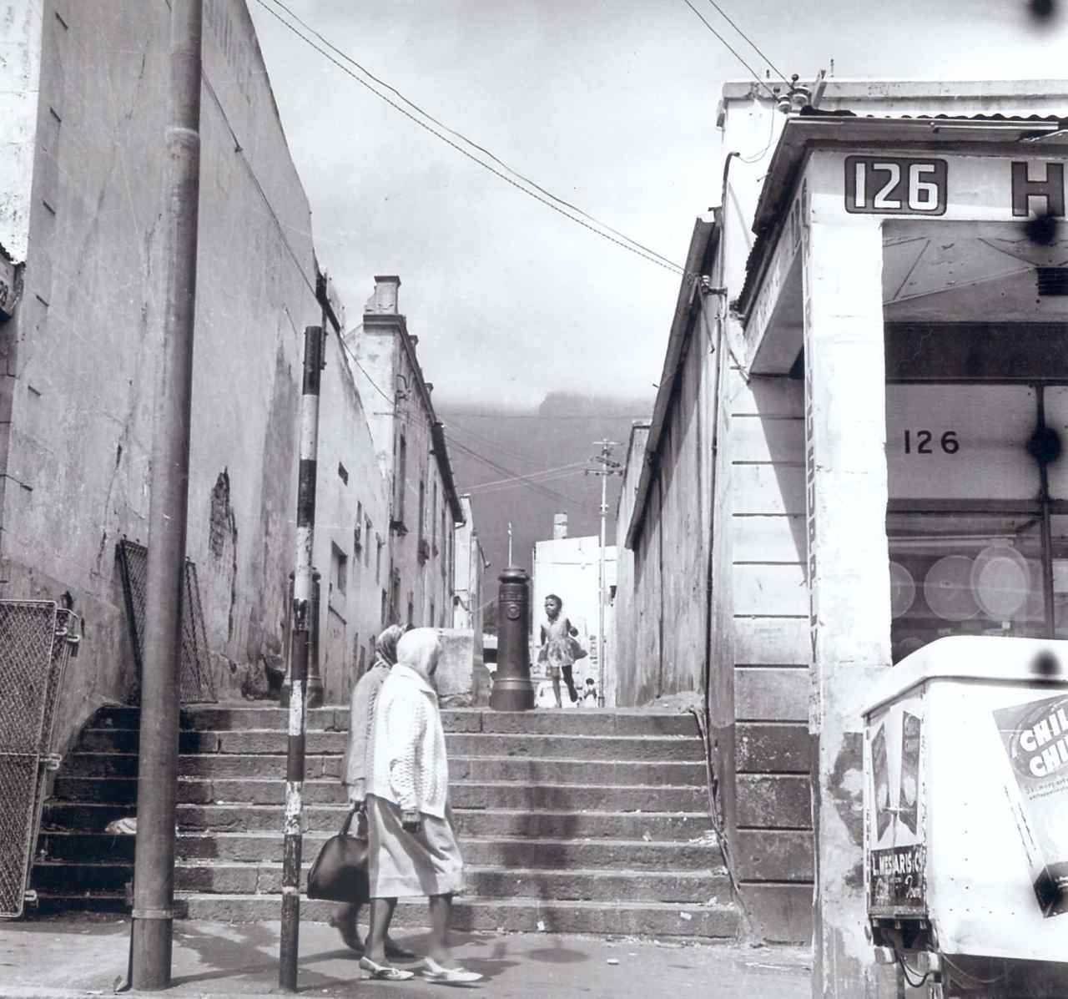
Fig 4 - The Seven Steps off Hanover Street, District Six, photo District Six Museum collection.

In addition to District Six being renamed Zonnebloem, Hanover Street was renamed and called Keizersgracht Street and Bloemhof Flats was renamed Skyeways. At the far end of the District Six Museum is a display of the original exhibition, Streets, Retracing District Six, towering two stories high (see Fig 5). These original street name signs were hidden by the supervisor of the demolitions, instead of being dumped with the rest of the rubble, as he was meant to do. Retrieved and now permanently exhibited in the Museum, the street name signs remain a powerful evocation of the District, says McEachern, as the 'proper names, Hanover, Tyne, Tennant, Clyde, Balmoral, Chapel and De Villiers evoke and provide a reality for people's memories.'

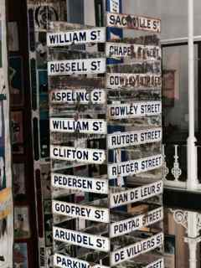
Fig 5 - Original Street Name Signs, photo by Petra du Preez-Spaun.

In my interview with Joe, he used his hands to gesticulate, or make lines as Ingold would say, how the different streets were interconnected. He made mention of a part of District Six that used to be called "Little England" and why this was so:
"Ja", because of the buildings themselves and then, of course, the street names… Windsor, Oxford, Cambridge, Ashley Street, Upper Ashley Street and of course, the names of buildings… like Beaufort House, Alphen, Colchester. All those very English names, very English…

In discussing the architectural style of the buildings, (see Fig 6) Joe comments:
Well, a lot of them were Victorian terrace houses and there were a lot of those. Even your double storey houses that you had in District Six, like Queen Anne Place, Coronation Place, buildings and stuff like that, they were all beautiful Victorian style…

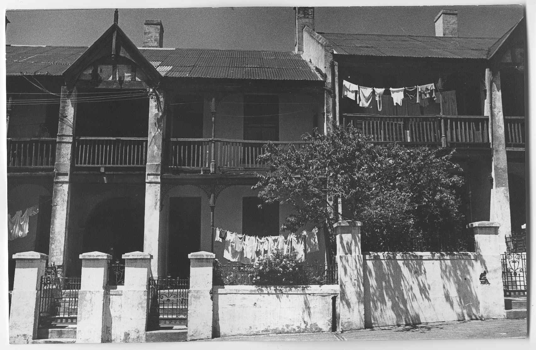
Fig 6 - Double storey Victorian terrace houses, photo by Jan Greshoff, District Six Museum collection.
Just how meaningful the street names are to the previous residents, can be seen in the fact that at least two of them, in recounting their lives in District Six, named their books after the street that they lived in. Hettie Adams' book is simply entitled William Street, District Six and in her book Adams says that she still dreams of that house in William Street. Linda Fortune's book is called The house in Tyne Street, Childhood Memories of District Six and she says that it was a semi-detached house, facing Aspeling Street and that 'when you stepped out of our front door and looked to your right, you saw Hanover Street, (see Fig 7) and also Table Mountain.'

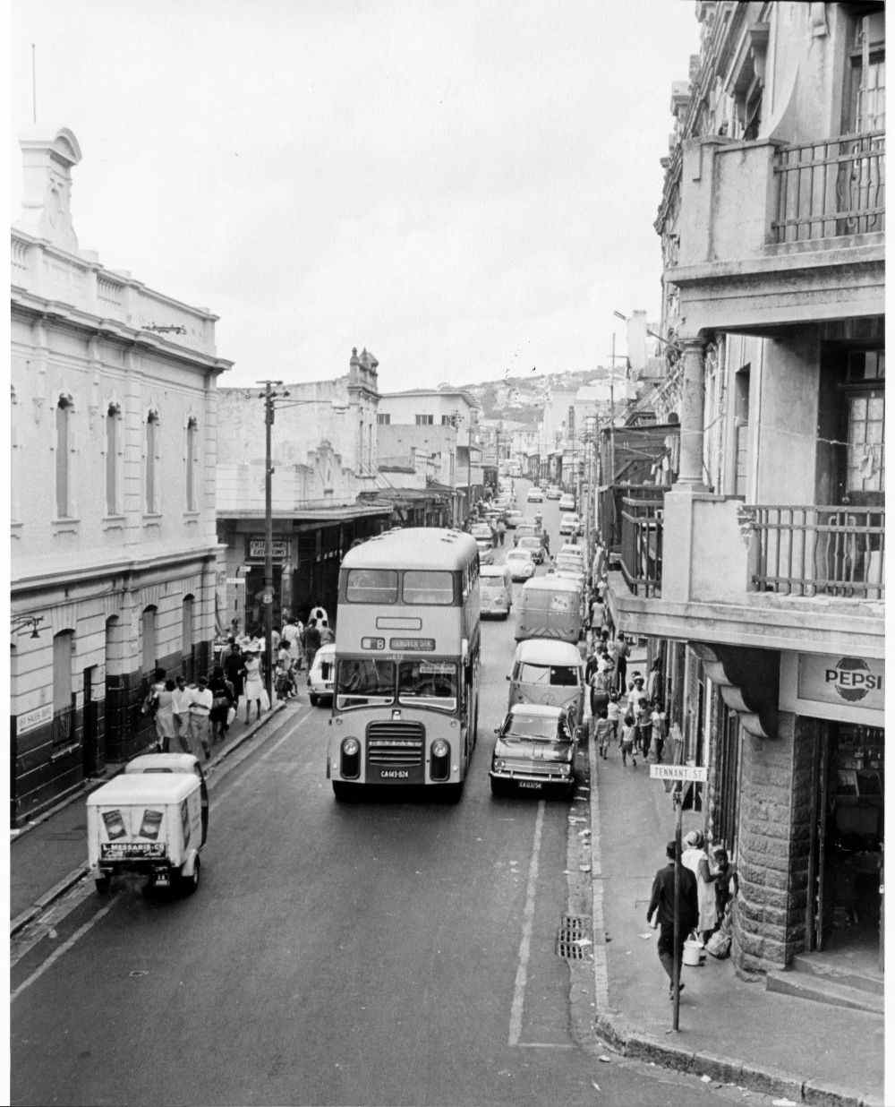
Fig 7 - Hanover Street, District Six, photo by Jackie Heyns, District Six Museum Collection.

In the process of relocating the previous residents to the new townships, in particular to a barren and windswept Cape Flats, officials attempted to maintain a link between the past and the future by naming the new housing complexes and streets after previous landmarks in District Six. An example of this is how Hanover Park on the Cape Flats was named after Hanover Street in District Six. Richard Rive, a former resident, writes that this act was done with a dose of malicious irony. Sheldrake advocates that no name is arbitrary in the naming of places, but that 'Every name, even a single word, is a code that, once understood, unlocks a world of associations.' The act of imposing a new grid of streets and new street names onto the existing landscape, (see Fig 8) in addition to attempting to ascribe the old names to the new landscape, seems to suggest that to the authorities, District Six was transportable or movable.

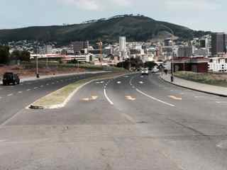
Fig 8 - Keizersgracht Street, Zonnebloem, photo by Petra du Preez-Spaun.

Places, however, unlike spaces, are not interchangeable and discardable, observes Lynda Schneecloth and Robert G. Shibly. This is in keeping with Aristotle's notion of place in that '… place is a vessel which cannot be moved around.' It can thus be argued that the authorities viewed District Six as a space and not a place, for as de Certeau says of space, in contrast to place, it is 'composed of intersections of mobile elements' and that it has none of the 'stability of a "proper."'

Neighbours and Community

Sofie M.M.A. Geschier advocates the idea that place can be described as a mental construct whereby 'physical space is pivotal in creating and sustaining social relationships.' Such social relationships can be understood to exist amongst people who live in the same neighbourhood. The Oxford English Dictionary defines neighbourhood as: 'a district or a community within a town or city' and 'the area surrounding a particular place, person or object.' To Machamer, a natural unity amongst neighbours is a prerequisite for understanding Aristotle's consideration of the power of natural place. Heidegger similarly understands the neahgebur (Old English for neighbour), to pertain to the near-dweller, the abode and the place of dwelling. In my interview with Joe, I asked him about the effect that being uprooted had on his life and those of his neighbours, to which he replied:
Well, it was soul destroying. Firstly, it was destruction of community, everything, the community was destroyed, your schools, your churches, your sports clubs. The very fabric of community was totally destroyed, because based on your divide and rule policies, it was easier to rule a disjointed, disorientated crowd, than having a strong community. So this was done as part of the whole process, where you find communities weren't taken out as communities. They were taken out individually and then thrown into different areas, to break up that community spirit.

Beryl has similar feelings about having lost the community spirit:
"Ja", but there's just not that camaraderieship anymore. Like you know, if it was something, a burden that was too heavy for me, I can come next door and come tell you… Today you go next door to tell your neighbour, your neighbour can't wait to go and tell the next one and the next one will tell the next one. That's not what it used to be…. Lived in harmony, yes…. Your child is my child. I'm going to look out for your child… And we also had harmony amongst ourselves there in, in District Six. We used to go to one another's houses. We were such a close-knit … (community)

Steinberg proposes that the neighbourhoods on the Cape Flats were built on the premise that people lived their lives in nuclear families. He goes as far as saying that it was a conceit of modernism to assume that nuclear families were synonymous with the twentieth century, when in fact the people of District Six had lived their lives in extended families, as Beryl testified. Steinberg contributes the continued drug and crime problem that still plagues the Cape Flats to this day, to the loss of this close network of extended family and community.

The New Year Festival
However, one annual and legendary activity that had a unique capacity to unite and bring together the community and people of District Six, was the celebration of the New Year in the form of what is known as the coon carnival or as it is colloquially known - "Tweede Nuwejaar" (Second New Year). This festival still happens every year, in spite of the District being obliterated, and runs over two days - the 1st and 2nd of January of every New Year. Casey, Heidegger and Cresswell all regard place as being a meaningful location, although Trubshaw adds that the meaning of place is also conveyed in ritual activities, like the annual celebration of New Year. Bonita Bennett and Chrischene Julius are of the opinion that the unique understanding of a particular neighbourhood can be seen as a way of how life is lived in that community, especially where local knowledge is linked to particular sites. They cite the example of how one of the best remembered features of Hanover Street was the annual carnival, which involved the whole community in a variety of cultural projects. This is in keeping with what Trubshaw says about how places gain importance by rituals being repeated at the same site or place, thereby reinforcing the bond between place, person and ritual every time the ritual is performed there.

Denis Martin claims that even though the New Year Festival has consistently been celebrated and performed in District Six since 1920, the festival has never been taken seriously nor thoroughly investigated - presumably from an academic point of view. Yet, the carnival was a joyous celebration of music, singing, marching and dancing, for young and old, and the one day that they, the people of District Six, owned the streets of Cape Town. Essentially, the coon troupes comprised of boys and men, young and old, dressed in shiny satin costumes consisting of a jacket, trousers, a hat and an umbrella, with painted faces using bright colours and glitter - all competing with one another to win the prize for the best troupe. (See Fig 9) Although the women did not participate in the actual troupes, their role involved the making of the costumes, since the costumes had to differ from one year to the next year, as well as the baking of treats for participants and spectators. Martin advocates that although the format of the coon carnival continues to change over the years, coon troupes served the purpose of creating networks that continued to link friends after the destruction of District Six. This suggests that the carnival needs to be enacted in District Six, it has never been suggested it could be moved. In this way, it is a District Six ritual that portrays the deep link between place and ritual, as Trubshaw has claimed. It can also be said that there is a link between the carnival and the place where it was born and Swanson and Harries view the coon carnival as a 'striking home-grown product of District Six.' For as a captain of one of the largest troupes said in 1994: 'But, like I said, I love this game. I was born into this game. When you was born in District Six, anyone who was born in District Six and he stays in the heart of District Six like me, I don't think he will leave it…'

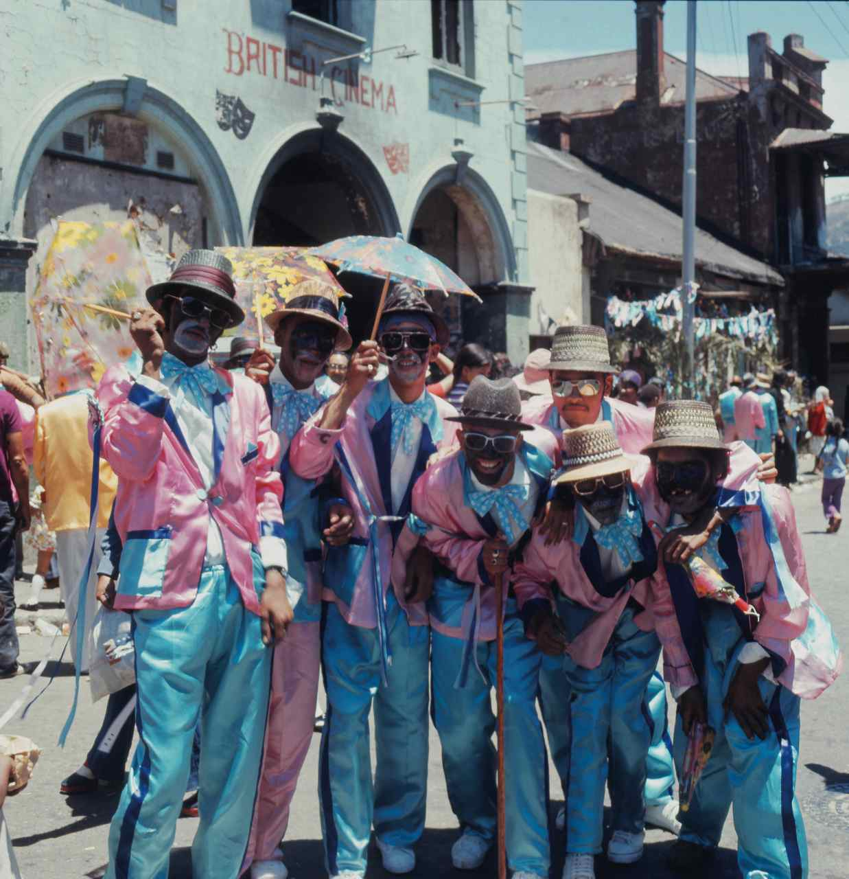
To Ngcelwane too, the New Year was special, since it was the Coon Carnival in District Six and young and old loved to watch. Even the township residents who would normally not come to town, flocked to town. She recalls and writes about carrying benches and chairs to Hanover Street to sit and watch the proceedings. Beryl, being a barber's daughter, equally remembers the New Year celebrations with great nostalgia.
Fig 9 - The Coon Carnival, photo by Günther Komnick.

So when it comes to New Year …, we would go and congregate at the barber in Caledon Street and at the barber in Hanover Street, because they must come up and down Hanover Street, the coons and they must come up and down Caledon Street… we will sit up all night and wait for these coons, because at 12 then they start coming out already… we would run after them and it was safe those years…

Martin is of the opinion that although Cape Town's coon carnival has some singular features, in itself it is not unique as it represents a type of festival found in most human societies. Like Eliade, Martin also sees the coon carnival as a rite of
renewal, 'shaped by the history of South Africa, informed by the type of social relations that developed in Cape Town during three centuries.' Martin furthermore observes that the New Year festival is celebrated in a delineated space, which is temporarily reorganised, as during the festival, many people from other parts of Cape Town descend on the city to partake in the festivities. In this sense, argues Martin, they invade the city and take possession of it and by marching through it, they give it new life, irrespective of whatever obstacles are in their way. It is particularly during this time that they enact the claim: 'We are Cape Town.' Thus, says Martin, '… renewal festivals affirm the victory of life: they show that in spite of the disappearance of individuals, communities survive, just as nature does.' This is in keeping with Eliade's interpretation of the sacred myth of the eternal return, whereby life is made new through the re-actualization of the cosmogony.

To George Manuel, a previous resident, 'the carnival has been District Six's gift to the gaiety of the Mother City (Cape Town) - a festival of mirth and saltant friskings.' Such a mood is suggestively captured in a stanza of a poem by Rive: 'The moon zig-zagged crazily across the sky bumping in a star or two on the way and bouncing off Table Mountain. After all it was New Year's Eve and District Six was hysterical with joy.' In my interview with Joe, he talks about the things people would do over the New Year celebrations and the mood that prevailed during that time.
"Ja" and the firms, the various factories and firms close and the people have this holiday spirit and that also allows itself, to lend itself, which is sort of, develops into cleaning of your house and cleaning out everything that's old and bringing in what's new again… People buying new furniture, you know,
upgrading and doing whatever they do. The monies that were saved now too,
for new clothing and whatever things they need for their house. So, it was just part of that spirit and then, of course, as I said, if you had to walk through
District Six, you would find a place like I. Levine and H. Levine, they were people who sold paints and hardware, they would be so busy with people
coming in and buying paint, buying linoleum, the "lino" that was laid on the floors…

This, as Joe confirmed, is an indication of how the people cared about their homes and did what they could within their financial means. Malan and Van Heyningen suggest that linoleum on the floors was replaced annually, either at the Muslim festival of Eid or at New Year. In one particular instance, an archaeological excavation at Number 75 Horstley Street revealed more than twenty layers of linoleum. Similarly, Bill Nasson, a previous resident, writes that the people's homes were characterised by pride and effort and that 'scrupulous care of special possessions, and a Scrubbs Ammonia obsession with cleaning, can be seen as a public demonstration of the triumph of working class households over poverty, grime and inadequate housing.' This is in keeping with what Heidegger sees as a fundamental aspect of dwelling: the cultivating, nurturing, caring and preserving of dwelling places. For Joe, this too is a justification for saying that all the buildings that were demolished could have been preserved and upgraded.
I mean, it was totally stupid, because it would have been cheaper to upgrade those buildings than to throw them down and rebuild them. I don't see the logic of it. You could rather have upgraded those buildings, because the buildings were solid structures. Their walls were thick, they were solid walls.

The Set Apart or Sacred
If, like Ingold argues, buildings, like trees, do have life histories, a good example of this is the twenty layers of linoleum excavated at No 75 Horstley Street. Another building with a significant life history, has a special place in Joe's heart. On the walking tour I did with him in October 2012, our first stop was a mere block away from the District Six Museum. Pointing to a brightly painted building, now hosting a world famous bakery, I witnessed a tinge of sadness in Joe's voice when he told me that he wished that they had not desecrated the building by painting it in so many colours. (See Fig 10 and 11) This building, at No. 38 Canterbury Street, used to be home to a business called M. Beinkinstadt, set up in 1903 when Moses Beinkinstadt emigrated from Lithuania. In addition to providing Cape Town's Jewry with all its cultural and religious requirements, it became an iconic landmark until the business was finally closed in 2008. In further discussing this matter with Joe in our interview, I asked him if he could elaborate on why he felt this particular building was desecrated.
Well, I feel that in my personal opinion, because I felt that, okay, I understand there is a business going there, I understand the business of advertising, but I just felt that the way the building was turned into a, almost a fruitcake type of thing. Just with all the various colourations on it, it that was supposed to be a historic building, then your outside of the building shouldn’t be, be changed to what, you know to what it is. They should try and retain it to its original status as much as possible, because a couple of buildings in District Six, has been, it's retained its … and gives dignity to the thing, but just to go along and just go and paint it up in those garish colours, it just was very upsetting.

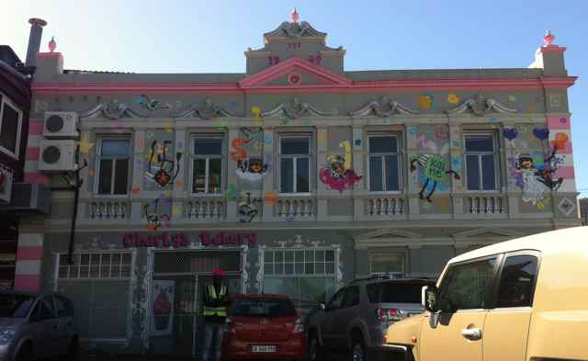
Fig 10 - The "fruitcake" building, photo by Petra du Preez-Spaun.

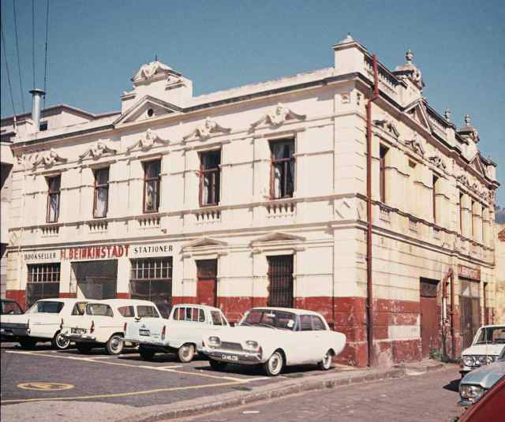
Fig 11 - The original Beinkinstadt building, c. 1970s, photo District Six Museum Collection.

My research revealed that this special regard that Joe has for this and the other buildings, can be viewed as being sacred to Joe. This furthermore affirms Belden Lane's theory that sacred ground can be trod upon without being entered, for as Lane observes: 'Sacred place, we have said seems to have an unaccountable identity distinct and separate from those who move in and through it.' In my interview with Interviewee Number Four, she reveals how to her, the sacred nature of the site of District Six is closely linked to the notion of it being salted earth:
… but we've always seen as the sort of salted earth, the sacred nature of the site.

In her understanding, the historical meaning of salted earth comes from Roman times:
… in medieval, sort of English times, in the Roman times, when, if you destroyed a village, you salted the earth to actually sort of prevent people from going back to it, in that sense.

This bears testimony to the sacredness of the whole of the District Six site, but also speaks of the commitment of the "Hands Off District Six" campaign, in successfully preventing the development of the barren land.

Place and the Landscape
The landscape and certain features of the landscape also seem to hold a special meaning for the former residents. Ingold describes the landscape as 'the world as it is known to those who dwell therein, who inhabit its places and journey along the paths connecting them.' Joe first pointed out a special palm tree when he accompanied me on a guided walk through District Six. (See Fig 12) With reference to that tree in my interview with him, he tells me about the history and meaningfulness of that tree in his life.
As far as I know, that tree was planted by - I think, as Noor said, it was the Behardien family that lived in that area in 1948. When he came from Mecca, they planted the seed. Now this grew into, of course, the tree that was there and as I said, for me, it just became a Tree of Resistance and it also became a Tree of Remembrance and it also meant a Tree of the Full Circle gone through, from your departure to your coming back. So that for me, signifies a… a landmark, for me, personally.

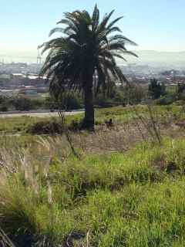
Fig 12 - Joe's sacred tree, photo by Petra du Preez-Spaun.

To Peggy Delport, District Six, the place, was 'simultaneously a landscape and an urban entity, a site with a distinct topographical identity: connected to mountain and sea, to slopes, to levels, to inner city, docks and harbour.' Bennett and Julius say that many layers of history are represented by the area known as District Six, but especially by the mountain that shapes and shields its southern extreme - Table Mountain. Chidester is of the opinion that Table Mountain is the city of Cape Town's central symbol, which he says has an 'awesome majesty', but that it is also a site of contradiction, since it has been experienced so differently by different residents. Former resident Fortuin recalls how she felt at the time of the forced removals and says she wanted to 'plant one foot on Devils' Peak and the other on Table Mountain and shout: "Let us stay, don’t force us to go. You are destroying our families and our lives!"' To Joe, the mountain takes on an anthropomorphic quality, as he recounts his thoughts.
Well, I think it's one of the, you don’t really get settings like that and I don't think, in any other part of the world where your, actually, your city is actually surrounded by your mountain. Its almost like it's encompassing your city. So if you look at your Signal Hill going down to the sea and your Devil's Peak coming from the other side, its almost like it's capturing the city - this whole area… it's like a pair of hands holding that city.

Beryl also remembers going up the mountain to collect pine cones, otherwise known as "Dennebolle" and recalls how fond her parents were of hiking.
My father used to love going on the mountain and we as children, used to play there on that mountain up there, because just behind the Bloemhof Flats, you could see the mountain from the Bloemhof Flats… I only went hiking long afterwards, I used to go hiking, because we were out of District Six already.

To Joe, the mountain was always a presence, first as a child and then as an older person and how at first he would explore the lower slopes and later he would climb right to the top. Ingold attests that through the exercises of climbing and descending and their appropriate muscular entailments the body feels the contours of the landscape and this gets incorporated into our bodily experience. Bachelard refers to this as our 'muscular consciousness' and whilst reliving the experience of climbing in his mind's eye, he feels certain that 'the road itself had muscles, or rather counter-muscles.' Trigg holds a similar point of view when he says that 'the totality of experience of place begins and ends with the body.'

By Way of the Body…
Another distinguishing feature of District Six was its close proximity to the inner city, which as Swanson and Harries have said, contributed to it being valued as prime real estate, since it was so strategically positioned. This also meant that walking was the preferred mode of transport amongst the former residents, for as Noor said:
I remember everybody used to walk from District Six to work. Everybody, most of the people work in town and in Woodstock… Now everybody used to walk, because it was so close by. That's why we were so fit, we used to walk. No cars, you know. I mean, I had a car, but we used to walk.

Bill Nasson agrees and writes that from everywhere, 'it was a short hop from home, workplace, or classroom to the street. The street was home to absorbing sights and a vibrant communal life, and it drew people like a magnet.' Nasson cites the example of how during peak working times, men would be obliged to work overtime in production factories and to sustain them, 'a son would be sent with tea or soup in a can, and meat or cheese sandwiches.' Bennett and Julius argue that the ability to walk the streets of a neighbourhood is a way of expressing familiarity and ownership.

Ingold advocates that the places made by walking form meshworks and are 'nodes in a network, knots formed by the convergence of paths.' Ingold also contends that walking is a profoundly social activity: 'that in their timings, rhythms and inflections, the feet respond as much as does the voice to the presence and activity of others. Social relations, we maintain, are not enacted in situ but are paced out along the ground.' De Certeau demonstrates that walking is to the urban system what the speech act is to language and that it is a 'process of appropriation of the topographical system on the part of the pedestrian.' Dolores Hayden thinks that people in a neighbourhood have 'a unique understanding of its landmarks, its sights, sounds, smells, its pedestrian patterns and social organizations.' It can be argued that this is what Casey refers to as my familiaris, a familiar spirit whereby intimate knowledge of one's habitat combines with place awareness to bring about a situation whereby "being is synonymous with being situated."

The Spirit of Kanala
A familiar spirit of a different kind existed in District Six and was called the spirit of Kanala. The spirit of Kanala refers to the spirit of mutual support that existed amongst the former residents, Kanaladorp being one of the older names for District Six. Achmat Davis, a previous resident, writes that the affinity of the working class culture bound the people of District Six into a community and that a consciousness of kind was bred by the poverty that prevailed. Schoeman too, acknowledges that poverty was the unifying force amongst people who were all in the same boat and equally poor. Out of this, a kind of solidarity developed that bound the people together by common circumstances. Swanson and Harries agree with the notion that poverty was a unifying factor and that a sense of neighbourliness and community spirit prevailed. They cite Ms N.N. as saying that this was a deep sense of kinship that shaped the social relationships between the residents, something uniquely South African and called ubuntu. The Oxford English Dictionary defines ubuntu as: 'A quality that includes the essential human virtues of compassion and humanity. Mr O.A., a previous resident, recalls the generosity of the residents in the tenement block were he grew up: 'When my mother made pudding, and so on, then I would take some to the different rooms. And that man who lived there, he worked in the docks. And then he brings sacks of …stockfish…. This is how we lived in the Cape. My father earned very little money. And we were never without food. We never went to bed hungry.' In my interview with Joe, I asked him what the spirit of Kanala meant to him, to which he replied:
Well, I think it's just a matter of, a spirit of sharing. People looked upon each other as another person, not another race, creed, colour or culture and I think that was the bottom line.

To Rive, writing of his experiences of District Six in the 1960's, the District was both urban and urbane. Urbane being defined by the Oxford English Dictionary as '(of a person, especially a man) courteous and refined in manner.' Rive argues that District Six became more than a geographically defined area, but says that the district had developed a separate and unique attitude, including something he calls a 'verbal dexterity'. This verbal dexterity enabled it to cultivate a macabre and biting sense of humour so as 'to laugh to keep from crying.' To Rive, the way in which District Six was set apart, stems from the fact that within its boundaries, no form of religious or colour discrimination was practised and that 'there was no observable apartheid since the District was one, big apartheid.' In describing District Six, Rive emulates an animistic quality when he writes: 'There were times when in spite of its sordidness, the District seemed like poetry. It effervesced and bubbled over.' It was this quality, Rive believed, that was not reported accurately and he contends that many of the newspapers that reported on the plight of the District failed to say, either deliberately or by default, that 'District Six had a mind and soul of its own.'

Although District Six is arguably the most well-known example of forced removals in South Africa, Joe pointed out the many other places where people were dispossessed.
Still, because, as I said, you've grown up there and it's not only District Six - you take each and every other area - I mean, there were forty two sites of forced removal out of the City of Cape Town… It was the largest concentration of forced removal. That was something similar to your Sophiatown.

Sophiatown, like District Six, was situated close to the city centre of Johannesburg. Although it is beyond the scope of this study to draw comparisons between District Six and Sophiatown, it is nevertheless interesting to note a similarity, in particular, a shared soulfulness. This is how one resident, a person called Modisane, remembered Sophiatown in 1984 after it was destroyed: 'All that remained of the township was its proud indestructible soul, an undying symbol for those who loved Sophiatown, and those who feared it.' Deborah M. Hart and Gordon H. Pirie suggest that 'the soul of Sophiatown was identifiable not only by its unique attributes but also in contrast with the soulless, municipality controlled, black urban "locations"…' Within a South African context, "location" was the popular name given to the townships to where people of colour were moved. It is perhaps not ironic that the townships were called "locations", for as has been discussed previously, following Descartes, in the period of modernity, space became organized, continuous and reduced to measure and order and place was reduced to mere location, simply a dot on the matrix. This is in sharp contrast to Heidegger to whom the relational aspect is of greater importance: 'the relation between location and space lies in the nature of these things qua locations, but so does the relation of the location to the man who lives at that location.'

Rive and Modisane's testimonies of soulfulness affirm the ineffable quality that Seamon, Pallasmaa and Bachelard have alluded to and what Abram calls a 'place-specific intelligence.' As has previously been argued, this is what can be understood by the notion of the spirit of place or the genius loci. Teresa Andresen and Mara Jose Curado are of the opinion that historic sites especially, are the bearers of the genius loci or place identity and they cite Coeterier as saying that 'It is what historic elements say, not about the genesis, but the genius of the place.' Andresen and Curado also argue that even though the genius loci is often comprised of the invisible heritage in the landscape, in the form of stories and legends that are known only to local people, outsiders can often sense the spirit of place.

One such narrative that powerfully conveys the spirit of place is the story of Noor and his pigeons. When Noor and his family were forcibly removed to a new home in an area called Athlone, he also relocated his prized racing pigeons, for whom he had built a pigeon loft, using the same wood that had made up the loft in District Six. After a period of three months, he decided to let them fly free and hoped that they would return to his new home. This, however, did not transpire and after a sleepless night, he drove past the now empty site of his old home in District Six, on his way to work. When I interviewed Noor about the story of his pigeons, he recounted:
… so when I came down Caledon Street from the church, of course, (which) now was bulldozed and everything and I stopped my car right opposite where the house used to be and I got out of my car and they (the pigeons) were all sitting… They were all sitting on … and I thought, "Yo" and they were, but this was unbelievable, honestly. They were facing the sea, the harbour and I tiptoed behind them. You know, normally, pigeons fly away. Some of them, you know, actually turned around. I could never forget. Like, they … slowly and they looked at "Ja", where is our home? Because they came back looking for the home… I went on my knees, "hey" and I cried, honestly.

So profound is the loss of sense of place in Noor's story that it suggests that the home is not a machine to live in, in Le Corbusier's words, but gives credence to Abram's idea that each place has its own mind, its own psyche, 'a place-specific intelligence shared by all the humans that dwell therein, including all other non-human beings who live and make their way in that zone.'

Of such importance is the preservation of the spirit of place, as can be seen in the Quebec declaration of 2008, that this notion is notably addressed within the District Six Draft Development Framework. It is the very first principle it strives to adhere to and is described as:
The Idea of Place and the District Six Site: The District Six site is of significance not only because of the social history associated with it but also because of its important physical qualities and the way these define the character of the place. With this understanding consideration has been given to the "genius loci" or "spirit" of the site - its setting as a place between mountain and sea;

Valmont Layne, the erstwhile director of the District Six Museum, also draws attention to the need to incorporate what was the spirit of District Six into the process of rebuilding District Six: '… what does it mean to rebuild District Six, in order to be true to the spirit of District Six, to the intentions of the people who founded this place… Christiaan Beyers cites Rosemary Ridd, who did research for her PhD in 1976 and 1978, as saying that 'local people impressed upon me that the District Six area possessed a spirit which outsiders could not grasp. They said that they could not tell me about it, but that I could only experience it for myself.' Brian Barrow agrees with this notion and writes that the people who dismissed District Six as a slum never really knew it, because they saw it only from the outside without knowing or caring about its soul. Beryl is hopeful that the spirit of District Six can be brought back, once the restitution process is complete and people yet again occupy the area.
If we can build that up, there will be a lot of goings on in the district. We will bring that life back, because the District, the people of the District, they used to say, was the heart of Cape Town.

It can be argued that what Beryl refers to in the above paragraph, is the relational aspect of people and places, as demonstrated by Heidegger or what Vivien Bickford-Smith describes as: 'People make places, but places also make people.' This too, is what Michael Bell says when he argues that: 'We attach our spirit to a place, and thus that place is attached to us.' Hart also supports the idea that people create places, but that personal lives are also intimately moulded by places and she furthermore contends that District Six afforded its occupants a deep sense of place and belonging, something that became clear as the pace of the removals accelerated. For as a former resident of District Six said definitively: 'You can take the people out of District Six, ou pellie (old pal), but you'll never take District Six out of the heart of the people.' This confirms Trigg's idea that the heart of the city and the heart of the body both refer to a dynamic centre, which 'has less to do with geometry and more with a gathering of force and energy.'

Place as Embedded in Being
In summary, it can be argued that the notion of District Six as a place is so deeply embedded in the being of the previous residents, that a variety of important notions associated with place can be extracted out of one single paragraph. In this paragraph, Joe describes his sense of devastation of having to leave District Six to me:
You imagine yourself living in an area for over fifty or sixty years and suddenly, somebody comes along and says, "No, you don't belong here anymore and you've got to get out of here" - you've been going to that church, you've been having your neighbours, you've been having all your friends, they are all here and suddenly, one morning you wake up and there is nobody around you. You are sitting amongst total strangers in terrible structures that they put together, that were thrown together by the then Nationalist government. All these barrack like structures that look exactly the same. There is nothing outside there, you're in a space and you can see Table Mountain way in the distance there.

Living in an area for over sixty years speaks of the stability that Joe associates with place. In Heidegger's notion of dwelling, to dwell means to remain, to stay in a place, which implies a degree of stability. Heidegger and de Certeau both emphasise the idea of stability in relation to place. It can also be said that there are traces of Aristotelian thinking on place in both de Certeau and Heidegger, since stability is implied when Aristotle says that 'place is a vessel that cannot be moved around.'

Not having his neighbours nearby appears to have had a disorientating effect on Joe. This confirms the importance of the community closeness that existed in District Six, of having your friends and your neighbours nearby. The idea of neighbours as near dwellers, relates to Heidegger's notion of dwelling. To dwell, also means to take care, to cherish and protect - a notion that was very meaningful to the previous residents when it came to New Year, when homes were spruced up and new linoleum were laid on the floors, an indication of the care, nurture and cultivation the people felt towards their homes. Machamer also speaks of the Aristotelian power of natural place to make a unity amongst things that are alike by nature, whereby these things are in natural unity with their neighbours. Poverty may have been the unifying factor, but by all accounts, the previous residents remember District Six as place where the community was cohesive.

Joe's reference to the terrible barrack structures that people were relocated to, speaks of the linearity favoured in modernity and the sameness of buildings constructed in modernity, or what Scott refers to as a scientific forest. This, it can be argued, is a testimony of the attempt to build the townships according to a single overarching plan, in the manner of Le Corbusier's ideal of his Radiant City. As discussed previously, it is ironic that these townships were referred to as locations, for in modernity, place was viewed as mere location, a dot on the matrix. These soulless, municipality controlled locations, could hardly be called places and it is perhaps not ironic, rather quite telling, that Joe refers to finding himself in a space (and not a place) in the above paragraph.

Joe cites the importance of the landscape as a notion of place in the form of the now-in-the-distance Table Mountain, for as Tilley says: 'People and environment are constitutive components of the same world.' Put differently, it can be said that place and people are co-extensive, a view held by Heidegger when he said that place is relational and not mere location. De Certeau also viewed the elements that constitute place as being distributed in 'relationships of coexistence'. Aristotle's essential definition of place is as 'the first unchangeable limit of that which surrounds' ties in with Heidegger's notion of a limit or a boundary. To Heidegger, a boundary is the place from which something begins its presencing. Historically speaking, Table Mountain has always been seen as the southern boundary of District Six. In this sense, it can be said that District Six begins its presencing from Table Mountain as its southern boundary.

In March 2014, work on the third phase of the District Six housing development commenced and as the Minister of Land Reform, Gugile Nkwinti, observed: 'We want to build … We want to start next week… We want old people, please, old people [are a] priority. That would be the best news for this Christmas: that all the old people are back in District Six.' Not everybody is so optimistic though and Interviewee Number Four is of the opinion that this will not happen in her lifetime:
… it's not in my lifetime… this process is a much longer… much more complex and that the full effect of it, you can only sort of, see within fifty years…

This affirms Casey's view that places destined for dwelling, cannot be made or built instantly or ex nihilo, but that they need to be cultivated, a view also held by Heidegger. For as Ingold observes: 'In an animic ontology, beings do not propel themselves across a ready-made world but rather issue forth through a world-in-formation, along the lines of their relationships.'

In this chapter, the views and ideas of the previous residents were documented alongside notions of place, especially postmodern notions of place, to establish the necessary evidence that District Six should be viewed as a notion of place and not a notion of space. In the final chapter, I will address conclusions that can be drawn from the literature review and the fieldwork to determine whether the evidence conclusively supports District Six as being a notion of space or a notion of place.

Chapter 4
Conclusions

In this chapter, the various arguments concerning space and place are drawn together in order to determine what conclusions may be deduced from the literature review and the fieldwork. The aim of this research project, as described in Chapter 1, was to use the views and opinions of the previous residents of District Six to provide an insight into the different academic theories of space and place. The question investigated therefore was: Should District Six be considered as a notion of space or a notion of place?

In Chapter 2, the literature review, it was discussed, amongst other things, how Casey argued that in the period of modernity, place was dismissed and systematically overlooked in favour of space. In his opinion, this happened during the course of the seventeenth century - the Age of Enlightenment - when the scientists started mathematizing nature. Casey cited the work of Descartes as having had the direst effect on place. In Descartes' dualism and "universal separatism", the body and nature came to be viewed as a machine, consisting only of physical elements. It has been said that Descartes dualism is an extension of Plato's dualism and it can be argued that Descartes' "universal separatism" evolved out of Plato's "ingrafted geometrism", even though Broadie asserts there are marked differences between Plato and Descartes. Heidegger and Malpas both argued that Plato and Aristotle did not view space in the modern sense of the word, whereby space, as abstract space is viewed as measurable extension in length, breadth and depth. Heidegger aptly identified three terms to distinguish between space and place: spaces - in the Greek sense where something has been made room for, places - as locations which are relational and coextensive and "space" as abstract space. It is the latter notion, "space", that the emphasis came to rest upon in modernity as geometric extension, in length, breadth and depth, which resulted in a new aesthetic that favoured straight lines, especially in the layout and planning of cities. The result, or triumph, as Mumford claimed, was that in modernity, space became organized and reduced to measure and order. Following in the footsteps of Descartes, Le Corbusier set about to make the city the reflection of a single, rational plan in which the city was treated as a large efficient machine. It has been argued that Le Corbusier's view of the home as a machine for living, should be seen as the epitome of high modernism.

In Chapter 3, the fieldwork was tested against the theories of space and place that emerged in Chapter 2, the literature review. The evidence suggests that Le Corbusier's influence stretched to the far corners of the world, including remote South Africa. South African urban planners religiously followed Le Corbusier's ideas, in their goal to surgically remove the perceived slums of District Six. Although the apartheid regime is often held responsible for the forced removals and demolition of District Six, Don Pinnock argues that it would be wrong to consider post-war urban re-planning as merely 'Afrikaner racism' or a 'frontier mentality'. It has been argued in this paper that the urban planning policies at the time were powerfully influenced by modernist thinking, in particular by the ideas of Le Corbusier, whose ideas in turn were influenced by Descartes' "universal separatism" between body and mind. To this day, the failed remains of the idealistic modernist idea of the Radiant City or the Garden City can be seen on the Cape Flats: 'Flying over the Flats on the descent into Cape Town International Airport, you can see the clusters in all their glory: concentric layers of streets, turned upon themselves, forming tight, hermetic circles, each surrounded by a barren wilderness of no-man's-land.'

However, in spite of this dire state of affairs, a notion that can only be associated with place and not with space - the spirit of place - consistently presented itself as having survived throughout history, albeit in various guises, as was discussed in the literature review and revealed within the fieldwork. Whether it has been called the genius loci, the spirit of place, a sense of place, an ineffable quality, a place-intelligence, the evidence suggests that the previous residents are resolute that District Six had its own soul or spirit. My research therefore does not support Alberto Pérez-Gomez' observation that in the period of modernity, the western world lost a cultural understanding of the genius loci. J. Donald Hughes holds a similar point of view of the modern West when he argues that it does not deny place, but it denies that place has any spirit. Yet, my research shows and as Norberg-Schulz has insisted, the genius loci has remained a living reality throughout history, even though it might not have been named that as such. Both Walter and Knowlton agree that another function or attribute of the genius loci, is to stand for a unifying principle inherent to place, an idea also supported by Crain Soudien, a previous resident:
The unity of District Six is the unity of South Africa. District Six, in these terms, is therefore not just an enclave but a point of resistance to the deformation of the real South Africa. The term enclave is therefore an insufficient and inappropriate metaphor for District Six. It is not a place apart. In some senses it is 'the' place.

Of such importance is the spirit of place in the rebuilding of District Six, that it is item number one on the list of the District Six Beneficiary Trust of matters to be accomplished. This is also in keeping with the Quebec declaration on the preservation of the spirit of place that was adopted in Quebec on the 4th of October 2008.

In addition to the spirit of place, other aspects that can be regarded as forming part of a typology of place emerged out of the fieldwork. Bachelard cited the home as primary sense of place as having great powers of integration. He paid specific attention to the home one was born in, whereas Casey took a wider stance and spoke of places of birth and childhood homes as "ur-places". My research showed the attachment and affection the previous residents have for the Peninsula Maternity Hospital, which confirms the close tie between places of birth and people. The importance of naming places is evident in how central the street signs exhibition is to the District Six Museum. It has furthermore been argued that the authorities viewed District Six as a space, in attempting to ascribe new names to the existing site and existing names to the new site. Yet, my work reveals that the previous residents overwhelmingly still refer to District Six as District Six and not Zonnebloem, to Bloemhof Flats and not Skyeways, to Hanover Street and not Keizersgracht Street. Heidegger's notion of near-dwelling and Aristotle's notion of a natural unity amongst neighbours affirmed the importance of community and neighbours in relation to the notion of place. The defiant reaction Joe had towards the desecration of the Beinkinstadt building confirms Lane's point of view that sacred ground can be trodden upon without being entered. The importance of ritual and place was noted in the celebration of the New Year and the coon carnival, as was the inhabitation of the landscape in relation to Table Mountain.

I argue that another way in which Aristotelian monism or "physicalism" can find an expression in the postmodern world, is in the relation that emerges between body and place: discussed by Casey as a thickly tied Gordian knot, experienced by Bachelard as a muscular consciousness and viewed by Trigg as places habituating themselves in our bodies. None of these theorists ascribe to the dualism of the mind-body problem, but instead support the Aristotelian monism notion that: 'Just as every body is in a place, so in every place there is a body.' In the light of this and based on my research, I argue that the Aristotelian notion of place has evolved, in a variety of ways, into the postmodern views of place in the contemporary western world as seen in the theories of place of, amongst others, Heidegger, Casey, Bachelard and Ingold. Like Aristotle, these theorists all argue for a relational, co-extensive and reciprocal belonging between people and place. To Heidegger, the relation of the location to the man who lives at that location was important, as was the cultivation, care and preservation of dwelling places. To Casey, place is relational, enclosing and the bedrock of our being-in-the-world. To Bachelard, there exists a passionate liaison between our bodies and places. For Ingold, living organisms inhabit environments and not space, people draw a living from the land and not from space, when we are at home, we are indoors, not in space, when we go outdoors, we are in the open, not in space and when we cast our eyes upwards, we see the sky, and not space. This is also Ingold's ultimate justification for arguing against the notion of space, of which he says: 'Space is nothing, and because it is nothing it cannot truly be inhabited at all.'

In contrast, it has been contended that Plato's dualism contributed to the mind-body problem that evolved into Descartes dualism of "universal separatism" in modernity. This in turn influenced Le Corbusier, in whose work evolved a pre-occupation with linearity and the right angle, which resulted in place being temporary suspended and space reigning supreme as extension in length, breadth and depth, during the period of modernity. Balz argued that as a result of Descartes advancing the mind-body dualism as an irresistible truth, the soul was effectively isolated from nature, for the emphasis in the modern period lay on viewing nature (and the home) as a machine. Yet, the evidence suggests that in post apartheid South Africa and in the postmodern era, place and with it the spirit of place, as well as the other notions associated with a typology of place, have re-emerged in a classic Aristotelian sense of ascribing power to place. In Casey view: 'To be, is to be in place and conversely, to be without place, is not to be at all.'

In returning to the three theories of place summarised at the end of the literature review in Chapter 2, it can be said that the people of District Six did not merely live in District Six, but that they dwelled there in the Heideggarian sense of the word. District Six was a dwelling place where neighbourliness mattered, where a sense of community thrived, where people cared about their dwelling places and where a relationship of coexistence and reciprocal belonging between the people and the place revealed the unique spirit and soul of the District. This, in conclusion, affirms that the previous residents' experience of District Six corresponded most aptly to a theory of place, in particular, Heidegger's theory of place. In sharp contrast to this notion of place, the authorities and the town planners followed a Cartesian theory of space, in keeping with the modernist and rationalist thinking of Le Corbusier. In this notion of space, the home was seen to be a machine for living, comprising only of physical bricks and mortar that could be demolished and reconstructed elsewhere. Moreover, these two sets of incompatible positions led to much human suffering for as Pinnock observes about the people of District Six: 'the emotional brutality dealt out to them in the name of rational urban planning has been incalculable.'

My research began by taking the theoretical discourse on notions of space and notions of place into the field so as to offer some empirical insights into this debate. Even though, in the contemporary western world, the notions of space and place may continue to be used as interchangeable and to many, their association remains ambiguous, what my research found through the experiences of the previous residents of District Six was not the empty, detached reality of abstract space, but instead, it found the vibrant, pulsing heart of a 'living' place.

Bibliography

Abram, David, The Spell of the Sensuous (New York: Vintage Books, 1996).

Adams, Hettie and Suttner, Hermione, William Street District Six (Diep River: Chameleon Press, 1988).

Andresen, Teresa and Curado, Mara Jose, 'Shaping the future of a cultural landscape: The Douro Valley wine region' in Landscape Interfaces: Cultural Heritage in Changing Landscapes, ed. by Hannes Palang and G. Fry (Dordrecht: Kluwer Academic Publishers, 2003).

Anscombe, Elizabeth and Geach, Peter, trans. and ed., Descartes Philosophical Writings (London: Nelson's University Paperbacks, 1971).

Aoki, Keith, 'Race, Space, and Place: The Relation Between Architectural Modernism, Post-Modernism, Urban Planning, and Gentrification', Fordham Urban Law Journal, Vol. 20, No. 4, 1992.

Aristotle, De Anima (On the Soul), ed. by Betty Radige, trans. by Hugh Lawson- Tancred (Penguin Books: London, 1986).

----------. On the Heavens I & II, ed. and trans. by Stuart Leggatt (Warminster: Aris & Phillips, 1995).

---------. Physics Book III and IV, ed. by J.L. Ackrill, trans. by Edward Hussey (Clarendon Aristotle Series, Oxford: Oxford University Press, 1983).

Bachelard, Gaston, The poetics of space (Boston: Beacon Press, 1964).

Balz, Albert G. A., 'Cartesian Refutations of Spinoza', The Philosophical Review, Vol. 46, No. 5, 1937.

Barrow, Brian, The Spirit of District Six (Cape Town: Human and Rousseau, 1997).

Bell, Judith, Doing your research project (Maidenhead: Open University Press, 2005).

Bell, Michael Mayerfeld, 'The Ghosts of Place', Theory and Society 26, No. 6, 1997

Bennett, Bonita and Julius, Chrischene, 'Where is District Six? Between landscape, site and Museum', in City, Site, Museum, ed. by Bonita Bennett, Chrischene Julius and Crain Soudien (Cape Town: District Six Museum, 2008).

Beyers, Christiaan, 'The Cultural Politics of 'Community' and Citizenship in the District Six Museum, Cape Town', in Anthropologica Special Issue: Citizenship, Politics and Locality: Anthropological Perspectives, ed. by Catherine Neveu, Vol. 50, No. 2, 2008.

---------. Christian, 'The "Book of Us": Will and Community in South Africa Land Restitution', in Tapestry of Memory, Evidence and Testimony in Life-Story Narratives, ed. by Nanci Adler and Selma Leydesdorff (New Brunswick: Transaction Publishers, 2013).

Bickford-Smith, Vivian, 'Mapping Cape Town: From Slavery to Apartheid' in Lost Communities, Living Memories: Remembering Forced Removals in Cape Town, ed. by Sean Field (Cape Town: New Africa Books, 2001).

----------. Vivien, van Heyningen, E. and Worden, Nigel, ed., Cape Town in the Twentieth Century: An Illustrated Social History (Cape Town: David Phillip Publishers, 1999).

Breytenbach, Breyten, 'A Visit to Buchenwald', MLN, Vol. 118, No. 5, Comparative Literature Issue, Dec 2003.

Broadie, Sarah, 'Soul and Body in Plato and Descartes', Proceedings of the Aristotelian Society, New Series, Vol. 101, 2001.

Building Progress District Six: http://mg.co.za/article/2014-03-08-district-six-land-claimants-closer-to-getting-houses.

Casey, Edward S., Getting Back into Place (Bloomington: Indiana University
Press, 2009).

----------. Edward S., The Fate of Place (Berkeley: University of California Press, 1998).

----------. Edward S., 'Smooth Spaces and Rough-Edged Places: The Hidden History of Place', The Review of Metaphysics, Vol. 51, no. 2, 1997.

---------. Edward S., Remembering, A Phenomenological Study (Bloomington: Indiana University Press, 1987).

Chidester, David, 'Mapping the Sacred in the Mother City: Religion and Urban Space in Cape Town South Africa', Journal for the study of religion vol. 13, no. 1-2, 2000.

Coombes, Annie E., History after apartheid: visual culture and public memory in a democratic South Africa (Durham: Duke University Press, 2003).

Cornford, Francis M., Plato's Cosmology, The Timaeus of Plato (Indianapolis: Hackett Publishing Company, 1997).

Cottingham, John, 'Descartes', in The Great Philosophers, from Socrates to Turing, ed. by Ray Monk and Frederic Raphael (London: Phoenix Paperback, 2000).

Cresswell, Tim, Place - a short introduction (Oxford: Blackwell Publishing, 2004).

Csikszentmihalyi, Mihaly and Rochberg-Halton, Eugene, The meaning of things: domestic symbols and the self (Cambridge: Cambridge University Press, 1981).

Curry, Michael R., 'Discursive Displacement and the Seminal Ambiguity of Space and Place', in The Handbook of New Media, ed. by Leah Lievrouw and Sonia Livingstone (London: Sage Publications, 2002).

de Certeau, Michel, The Practice of Everyday Life, trans. by Steven Randall (Berkeley: The University of California Press, 1988).

Delport, Peggy, 'Digging Deeper in District Six: features and interfaces in a curational landscape', in Recalling Community in Cape Town Creating and Curating the District Six Museum, ed. by Ciraj Rassool and Sandra Prosalendis (Cape Town: District Six Foundation, 2001).

Denscombe, Martyn, The Good Research Guide: For Small-Scale Social Research Projects (Maidenhead: Open University Press, 2010).

Descartes, René, Discourse on Method, trans. by F. E. Sutcliffe (London: Penguin Books, 1968).

----------. René, 'Treatise on Man' in The Nature of Life: Classical and Contemporary Perspective from Philosophy and Science, ed. by Mark A. Bedau and Carol E. Cleland (Cambridge: Cambridge University Press, 2010).

District Six Museum: http://www.districtsix.co.za.

Durkheim, Emile, The Elementary Forms of Religious Life, trans. by Carol Cosman (Oxford: Oxford University Press, 2001).

Ebrahim, Noor, Noor's Story, My Life in District Six (Athlone, Cape Town: IM Publishing, 1999).

Elden, Stuart, Speaking against Number: Heidegger, Language and the Politics of Calculation (Edinburgh: Edinburgh University Press, 2006).

Eliade, Mircea, The Sacred and the Profane (Orlando, Florida: Harcourt, Inc., 1987).

Fortune, Linda, The house in Tyne Street (Cape Town: Kwela Books, 1996).

Geertz, Clifford, Local Knowledge (London: Fontana Press, 1993).

Geschier, Sofie M.M. A. ''So there I sit in a Catch-22 situation': remembering and imagining trauma in the District Six Museum' in Recalling Community in Cape Town: Creating and Curating the District Six Museum, ed. by Ciraj Rassool and Sandra Prosalendis (Cape Town: District Six Foundation, 2001).

Hanson, Norman: http://www.oozebap.org/biblio/pdf/2011/Reflections%20on%20Identity%20i n%20Four%20African%20Cities.pdf.

Hart, Deborah M. and Pirie, Gordon H., 'The Sight and Soul of Sophiatown', Geographical Review, Vol. 74, No. 1, Jan 1984.

---------. Deborah M., 'Political Manipulation of Urban Space' in The Struggle for District Six, Past and Present, ed. by Shamil Jeppie and Crain Soudien (Cape Town: Buchu Books, 1990).

Harvey, Graham, Animism, Respecting the Living World (London: Hurst and
Company, 2005).

Hayden, Dolores, The Power of Place, Urban Landscapes as Public History, (Cambridge: MIT Press, 1995).

Heidegger, Martin, 'Building, Dwelling, Thinking,' in Poetry, Language, Thought, trans. Albert Hofstadter (New York: HarperCollins, 1971).

------------. Martin, An Introduction to Metaphysics (New Haven: Yale University Press, 1959).

Hughes, J. Donald, 'Spirit of Place in the Western World' in The Power of Place, ed. by James A. Swan (Bath: Gateway Books, 1993).

Impey, Angela, Proceeds of the conference: Hands on District Six (Cape Town:
Ford Foundation, 2005).

Ingold, Tim, The Perception of the Environment, Essays on Livelihood, Dwelling and Skill (Oxon: Routledge, 2011).

--------. Tim, Lines, a brief history (Abingdon: Routledge, 2007).

--------. Tim, Walking: http://www.abdn.ac.uk/anthropology/walking.php.

--------. Tim and Vergunst, Jo Lee, ed., Ways of Walking, Ethnography and Practice on Foot (Aldershot: Ashgate Publishing Limited, 2008).

--------. Tim, Being Alive, Essays on Movement, Knowledge and Description (London: Routledge, 2011).

Jacobs, Jane, The Death and Life of great American Cities (New York: Vintage Books, 1992).

Jethro, Duane, '"Waar Val Jy Uit?": District Six, Sacred Space, and Identity in Cape Town', Journal for the study of Religion, Vol. 22, No. 1, 2009.

Knowlton, E. C., 'The Genii of Spenser', Studies in Philology, Vol. 25, no. 4, 1928.

Lane, Belden, Landscapes of the Sacred (New York: Paulist Press, 1988).

Layne, Valmont, 'The District Six Museum: An Ordinary People's Place', The Public Historian, Vol. 30, No 1, February 2008.

Le Corbusier, The city of tomorrow and its planning (New York: Dover Publications, 1987).

Lorenz, Hendrik, Ancient Theories of Soul (Stanford Encyclopaedia of Philosophy, 2009): http://plato.stanford.edu/entries/ancient-soul/#4.

Machamer, Peter K., 'Aristotle on Natural Place and Natural Motion', Isis, Vol. 69, No. 3, 1978.

Malan, Antonia and van Heyningen, Elizabeth, 'Twice removed: Horstley Street in Cape Town's District Six, 1865 - 1982' in The Archaeology of Urban Landscapes: Explorations in Slumland, ed. by Alan Mayne and Tim Murray (Cambridge: Cambridge University Press, 2001).

Malpas, Jeff , 'Finding Place: Spatiality, Locality, and Subjectivity' in Philosophies of Place, ed. by Andrew Light and Jonathan M. Smith (Lanham: Rowman & Littlefield Publishers, Inc., 1998).

Mandela Home: http://www.3news.co.nz/Mandelas-home-a-fitting memorial/tabid/417/articleID/324193/Default.aspx.

Manuel, George, District Six (Cape Town: Longmans, 1967).

Martin, Denis-Constant, Coon Carnival: New Year in Cape Town: Past and Present, (Cape Town: David Philip Publishers (Pty) Ltd, 1999).

Matsubayashi, Kazuo, 'Spirit of Place', in The Power of Place, ed. by James Swan (Bath: Gateway Books, 1993).

McEachern, Charmaine, 'Mapping the Memories: Politics, Place and Identity in the District Six Museum, Cape Town', Social Identities: Journal for the Study of Race, Nation and Culture, 4:3, 1998.

-----------. Charmaine, Narratives of Nation Media, Memory and Representation in the Making of the New South Africa (New York: Nova Science Publishers Inc., 2002).

Mumford, Lewis, The city in History: Its origins, Its Transformations, and Its Prospects (New York: Harcourt Brace Jovanovich, 1961).

Nasson, Bill, 'Oral History and the Reconstruction of District Six' in The Struggle for District Six, Past and Present, ed. by Shamil Jeppie and Crain Soudien (Cape Town: Buchu Books, 1990).

Ngcelwane, Nomvuyo, Sala Kahle District Six - an African Woman's Perspective (Cape Town: Kwela Books, 1998).

Norberg-Schultz, Christian, Genius Loci - Towards a Phenomenology of Architecture
(New York: Rizzoli, 1984).

Oxford Dictionary of English (Oxford: Oxford University Press, 2005).

Pallasmaa, Juhani, 'Identity, Intimacy and Domicile - Notes on the Phenemenology of Home' in The Home: words, interpretations, meanings and environments, ed. by David N. Benjamin (Aldershot: Avebury, 1995).

Pérez-Gomez, Alberto, Built upon Love, architectural longing after ethics and aesthetics (Cambridge, Massachusetts: The MIT Press, 2008).

Pike, Kenneth L., 'Etic and Emic Standpoints for the Description of Behaviour', in Language and Thought, ed. by D.C. Hildum (Princeton NJ: D. van Norstrand Company, 1967).

Pinnock, Don, 'Ideology and urban planning: Blueprints of a garrison city', in Class, Caste and Color, ed. by Wilmot James and Mary Simons (New Brunswick: Transaction Publishers, 2009).

Plato, Complete Works, ed. by John M. Cooper, trans. by Donald J. Zeyl (Indianapolis: Hackett Publishing Company, Inc., 1997).

Relph, E., Place and placelessness (London: Pion Limited, 2008).

Rigby, Catherine E., Topographies of the Sacred: The poetics of Place in European
Romanticism (Virginia: University of Virginia Press, 2004).

Rive, Richard, 'District Six, Fact and Fiction', in The Struggle for District Six, ed. by Shamil Jeppie and Crain Soudien (Cape Town: Buchu Books, 1990).

----------. Richard, 'Moon over District Six', Transition, No. 8: Mar 1963.

Robins, Steven, Reflections on Identity in Four African cities, ed. by Simon Bekker and Anne Leildé (Cape Town: African Minds, 2006).

Rose-Redwood, Reuben Skye, Rationalizing the Landscape: Superimposing the Grid Upon the Island of Manhattan (MA Thesis, The Pennsylvania State University, August 2002).

Sambursky, Samuel, The Physical World of Late Antiquity (London: Routledge, Kegan & Paul, 1962).

Schneecloth, Lynda and Shibly, Robert G., 'Implacing Achitecture into the Practice of Placemaking' in Journal of Architectural Education (1984 -), Vol. 53, No. 3, Beyond Expert Culture, Feb 2000.

Schoeman, Chris, District Six - the Spirit of Kanala (Cape Town: Human & Rousseau (Pty) Ltd, 1994).

Scott, James C., Seeing like a State (New Haven: Yale University Press, 1998).

Seamon, David, http://www.arch.ksu.edu/seamon/Heidegger.htm.

Shain, Milton, convenor, The Jews of District 6, Another Time, Another Place (Cape Town: Jewish Publications South Africa, 2012).

Sheldrake, Philip, Spaces for the Sacred - Place, Memory and Identity (Baltimore: The John Hopkins University Press, 2001).

Soudien, Crain, 'District Six and its uses in the discussion about non-racialism', in Coloured by History Shaped by Place, New Perspectives on Coloured Identities in Cape Town, ed. by Zimitri Erasmus (Cape Town: Kwela Books, 2001).

Steinberg, Jonny, The Number (Johannesburg: Jonathan Ball Publishers, 2004).

Stent, Gunther S., 'Epistemic Dualism of Mind and Body', Proceedings of the American Philosophical Society, Vol. 142, No. 2, 1998.

Swanson, Felicity and Harries, Jane, ''Ja! So was District Six! But it was a beautiful place': Oral Histories, Memory and Identity' in Lost Communities, Living Memories: Remembering Forced Removals in Cape Town, ed. by Sean Field (Cape Town: New Africa Books, 2001).

Thacker, Andrew, Moving Through Modernity: Space and geography in Modernism (Manchester: Manchester University Press, 2009).

The Cape Times, 12 June 2013.

Tilley, Christopher, A phenomenology of landscape (Oxford: Berg Publishers, 1994).

Town Planning Congress: http://www.artefacts.co.za/main/Buildings/archframes.php?archid=691.

Trigg, Dylan, The Memory of Place - A Phenomenology of the Uncanny (Athens, Ohio: Ohio University Press, 2012).

Trubshaw, Bob, Sacred Places: Prehistory and popular imagination (Loughborough: Heart of Albion Press, 2005).

Unesco: http://whc.unesco.org/uploads/activities/documents/activity-646-2.pdf.

van Graan, Andre, 'Contested modernism: post Slums Act public housing in Cape Town', SAJAH, Vol. 24, No. 2, 2009.

Walter, E. V., Placeways (Chapel Hill: The University of North Carolina Press, 1988).

Watson, Stephen, Cape Town - A City Imagined and the Meanings of a Place (Johannesburg: Penguin Books, 2008).

Whitehead, Alfred, Science and the Modern World (Cambridge: Cambridge University Press, 2011).

Appendix 1 - Interview release form
INTERVIEW RELEASE FORM

Sophia Centre for the Study of Cosmology in Culture,
Department of Archaeology and Anthropology,
University of Wales, Trinity Saint David, Ceredigion, Wales, SA48 7ED, UK.

Petra du Preez-Spaun
19 Ben Avenue, Devil's Peak, Cape Town, 8001
Email: petra@astrozone.co.za

INTERVIEWEE DETAILS HERE:

Name: ________________________________________________________
Address:_______________________________________________________
Tel.:________________________
E Mail:_______________________________________

This form has been drawn up to respect in order to ensure that the material in your interview with STUDENT NAME is used only in accord with your wishes.

1. May we use your contribution:

a. for public reference. Yes No

b. for research purposes. Yes No

c. for academic presentations, e.g. in seminars and lectures. Yes No

d. in research material which may be published at a future date Yes No

2. May we use your name? Yes No

NB. Even when permission is given to use your name, all material will be cited anonymously unless explicitly requested otherwise.

Signature of interviewee _______________________________ date __________

Signature of interviewer _______________________________ date __________

Note to interviewee: if you have any questions or concerns, please address them to Dr Nick Campion, Director, Sophia Centre for the Study of Cosmology in Culture, Department of Archaeology and Anthropology, University of Wales, Trinty Saint David, Ceredigion, Wales, SA48 7ED, UK. E mail: n.campion@tsd.ac.uk

http://www.districtsix.co.za/, accessed 16 June 2012.
Edward S. Casey, Getting Back into Place (Bloomington: Indiana University Press, 2009), p. 352. [hereafter, Casey, Getting Back]
Edward S. Casey, The Fate of Place (Berkeley: University of California Press, 1998), p. 77. [hereafter, Casey, Fate of Place]
Martin Heidegger, 'Building, Dwelling, Thinking', in Poetry, Language, Thought, trans. by Albert Hofstadter (New York: HarperCollins, 1971), p. 153. [hereafter, Heidegger, 'Building, Dwelling, Thinking']
Heidegger, 'Building, Dwelling, Thinking', p. 153.
David Chidester, 'Mapping the Sacred in the Mother City: Religion and Urban Space in Cape Town South Africa', Journal for the study of religion, Vol. 13, No. 1-2, 2000, p. 7. [hereafter, 'Mapping the Sacred']
Angela Impey, Proceeds of the conference: Hands on District Six (Cape Town, Ford Foundation, 2005), p. 19.
Duane Jethro, '"Waar Val Jy Uit?": District Six, Sacred Space, and Identity in Cape Town', Journal for the study of Religion, Vol. 22, No. 1, 2009, p. 27.
Emile Durkheim, The Elementary Forms of Religious Life, trans. by Carol Cosman (Oxford: Oxford University Press, 2001), p. 46. [hereafter, Durkheim, Religious Life]
Durkheim, Religious Life, p. 37.
Mircea Eliade, The Sacred and the Profane (Orlando, Florida: Harcourt Inc., 1987), p. 10. [hereafter, Eliade, Sacred and Profane]
Eliade, Sacred and Profane, p. 10.
Michael R. Curry, 'Discursive Displacement and the Seminal Ambiguity of Space and Place' in The Handbook of New Media, ed. by Leah Lievrouw and Sonia Livingstone (London: Sage Publications, 2002), p. 502. [hereafter, Curry, 'Discursive Displacement']
Curry, 'Discursive Displacement', p. 513.
Curry, 'Discursive Displacement', p. 513.
Jane Jacobs, The Death and Life of great American Cities (New York: Vintage Books, 1992), p. 4. [hereafter, Jacobs, Death and Life]
15 Curry, 'Discursive Displacement', p. 513.
Edward S. Casey, 'Smooth Spaces and Rough-Edged Places: The Hidden History of Place', The Review Metaphysics, Vol. 51, no. 2, 1997, p. 271. [hereafter, Casey, 'Smooth Spaces']
Casey, 'Smooth Spaces', p. 272.
Alfred Whitehead, Science and the Modern World (Cambridge: Cambridge University Press, 2011), p. 61.
Casey, Getting Back, p. xvii.
http://www.districtsix.co.za, (accessed 30 August 2013).
Chris Schoeman, District Six - the Spirit of Kanala (Cape Town: Human & Rousseau (Pty) Ltd, 1994), p. 15. [hereafter, Schoeman, Spirit of Kanala]
Schoeman, Spirit of Kanala, p. 16.
Vivian Bickford-Smith, 'Mapping Cape Town: From Slavery to Apartheid' in Lost Communities, Living Memories: Remembering Forced Removals in Cape Town, ed. by Sean Field (Cape Town: New Africa Books, 2001), p. 16. [hereafter, Bickford-Smith, 'Mapping Cape Town']
Schoeman, Spirit of Kanala, p. 17.
Schoeman, Spirit of Kanala, p. 19.
Bickford-Smith, 'Mapping Cape Town', p. 17.
Bickford-Smith, 'Mapping Cape Town', p. 21.
Bickford-Smith, 'Mapping Cape Town', p. 23.
Felicity Swanson and Jane Harries, ''Ja! So was District Six! But it was a beautiful place': Oral Histories, Memory and Identity' in Lost Communities, Living Memories: Remembering Forced Removals in Cape Town, ed. by Sean Field (Cape Town: New Africa Books, 2001), p. 63. [hereafter, Swanson and Harries, 'Ja! So was District Six!']
Swanson and Harries, 'Ja! So was District Six!', p. 65.
Schoeman, Spirit of Kanala, p. 33.
Tahir Levy cited by Schoeman, Spirit of Kanala, p. 33.
http://www.districtsix.co.za/, accessed 16 June 2012.
Adam Small cited in Schoeman, Spirit of Kanala, p. 68.
Valmont Layne, 'The District Six Museum: An Ordinary People's Place', The Public Historian, Vol. 30, No 1, February 2008, p. 56. [hereafter, Layne, 'District Six Museum']
Layne, 'District Six Museum', p. 56.
Breyten Breytenbach, 'A Visit to Buchenwald', MLN, Vol. 118, No. 5, Comparative Literature Issue, Dec 2003, p. 1297.
http://www.districtsix.co.za, accessed 30 August 2013.
The Cape Times, 12 June 2013, p.5.
Kenneth L. Pike, 'Etic and Emic Standpoints for the Description of Behaviour', in Language and Thought, ed. by D.C. Hildum (Princeton NJ: D. van Norstrand Company, 1967), p. 38.
Clifford Geertz, Local Knowledge (London: Fontana Press, 1993), p. 57. [hereafter, Geertz, Local Knowledge]
Geertz, Local Knowledge, p. 58.
Martyn Denscombe, The Good Research Guide: For Small-Scale Social Research Projects (Maidenhead: Open University Press, 2010), p. 174.
Judith Bell, Doing your research project (Maidenhead: Open University Press, 2005), p. 157.
Casey, Getting Back, p. 352.
Plato, Timaeus, ed. by John Cooper, trans. by Donald J. Zeyl, Plato Complete Works (Cambridge: Hackett Publishing Company, 1997), 49a. [hereafter, Plato, Timaeus]
Plato, Timaeus 49a.
Plato, Timaeus 52b.
Plato, Timaeus 52d.
Plato, Timaeus 52b.
Francis M. Cornford, Plato's Cosmology, The Timaeus of Plato (Indianapolis: Hackett Publishing Company, 1997), p. 200. [hereafter, Cornford, Plato's Cosmology]
Aristotle, Physics Book III and IV, ed. by J.L. Ackrill, trans. by Edward Hussey, Clarendon Aristotle Series (Oxford: Oxford University Press, 1983), 212a 7-8. [hereafter, Aristotle, Physics]
Aristotle, Physics, 208a27.
Aristotle, Physics, 212a20.
Aristotle, Physics, 212a14-16.
Casey, Getting Back, p. 354.
Aristotle, Physics, 208b11.
Aristotle, On the Heavens I & II, ed. and trans. by Stuart Leggatt (Warminster: Aris & Phillips, 1995), I276a10.
Peter K. Machamer, 'Aristotle on Natural Place and Natural Motion', Isis, Vol. 69, No. 3, 1978, p. 379. [hereafter, Machamer, 'Aristotle']
Machamer, 'Aristotle', p. 379.
Aristotle, Physics, 209a25-26.
Cornford, Plato's Cosmology, p. 181.
Casey, Fate of Place, p. 57.
Samuel Sambursky, The Physical World of Late Antiquity (London: Routledge, Kegan & Paul, 1962), p. 32-33.
Jeff Malpas, 'Finding Place: Spatiality, Locality, and Subjectivity' in Philosophies of Place, ed. by Andrew Light and Jonathan M. Smith (Lanham: Rowman & Littlefield Publishers, Inc, 1998), p. 25.
Martin Heidegger, An Introduction to Metaphysics (New Haven: Yale University Press, 1959), p.66.
Heidegger, 'Building, Dwelling, Thinking', p. 152.
Plato, Timaeus, 30c.
Plato, Phaedo, ed. by John Cooper, trans. by Donald J. Zeyl, Plato Complete Works (Cambridge: Hackett Publishing Company, 1997), 66e. [hereafter, Plato, Phaedo]
Plato, Phaedo, 80a.
Gunther S. Stent, 'Epistemic Dualism of Mind and Body', Proceedings of the American Philosophical Society, Vol. 142, No. 2, 1998, p. 578. [hereafter, Stent, 'Dualism']
Stent, 'Dualism', p. 578.
Hendrik Lorenz, Ancient Theories of Soul, (Stanford Encyclopaedia of Philosophy, 2009), http://plato.stanford.edu/entries/ancient-soul/#4, accessed 20 March 2014.
Aristotle, De Anima (On the Soul), ed. by Betty Radige, trans. by Hugh Lawson-Tancred (London: Penguin Books, 1986), II. 414a 25-26.
Casey, Getting Back, p. 354.
Edward S. Casey, Remembering, A Phenomenological Study (Bloomington: Indiana University Press, 1987), p. 185.
Stuart Elden, Speaking against Number: Heidegger, Language and the Politics of Calculation (Edinburgh: Edinburgh University Press, 2006), p. 131.
Stent, 'Dualism', p. 579.
René Descartes, Discourse on Method, trans. by F. E. Sutcliffe (London: Penguin Books, 1968), p. 54. [hereafter, Descartes, Discourse on Method]
Sarah Broadie, 'Soul and Body in Plato and Descartes', Proceedings of the Aristotelian Society, New Series, Vol. 101, 2001, p. 295. [hereafter, Broadie, 'Soul and Body in Plato and Descartes']
Broadie, 'Soul and Body in Plato and Descartes', p. 305.
Broadie, 'Soul and Body in Plato and Descartes', p. 299.
René Descartes, 'Treatise on Man' in The Nature of Life: Classical and Contemporary Perspective from Philosophy and Science, ed. by Mark A. Bedau and Carol E. Cleland (Cambridge: Cambridge University Press, 2010), p. 20.
Albert G. A. Balz, 'Cartesian Refutations of Spinoza', The Philosophical Review, Vol. 46, No. 5, 1937, p. 479. [hereafter, Balz, 'Cartesian Refutations']
John Cottingham, 'Descartes', in The Great Philosophers, from Socrates to Turing, ed. by Ray Monk and Frederic Raphael (London: Phoenix Paperback, 2000), p. 95.
Casey, Fate of Place, p. 78.
Elizabeth Anscombe and Peter Geach, trans. and ed., Descartes Philosophical Writings (London: Nelson's University Paperbacks, 1971), p. 199.
Casey, Getting Back, p. xiv.
E. Relph, Place and placelessness (London: Pion Limited, 2008), p. 2. [hereafter, Relph, Placelessness]
Curry, 'Discursive Displacement', p. 513.
Relph, Placelessness, p. 2.
James C. Scott, Seeing like a State (New Haven: Yale University Press, 1998), p. 55. [hereafter, Scott, Seeing like a State]
Scott, Seeing like a State, p. 55.
Descartes, Discourse on Method, p.35.
Scott, Seeing like a State, p. 55.
Reuben Skye Rose-Redwood, Rationalizing the Landscape: Superimposing the Grid Upon the Island of Manhattan (MA Thesis, The Pennsylvania State University, August 2002), pp. 5 - 6.
Lewis Mumford, The City in History: Its origins, Its Transformations, and Its Prospects (New York: Harcourt Brace Jovanovich, 1961), p. 364. [hereafter, Mumford, The City in History]
Tim Ingold, Lines, a brief history (Abingdon: Routledge, 2007), p. 2. [hereafter, Ingold, Lines]
Scott, Seeing like a State, p. 111.
Scott, Seeing like a State, p. 115.
Scott, Seeing like a State, p. 115.
Keith Aoki, 'Race, Space, and Place: The Relation Between Architectural Modernism, Post-Modernism, Urban Planning and Gentrification', Fordham Urban Law Journal, Vol. 20, No. 4, 1992, p. 729. [hereafter, Aoki, 'Race, Space and Place']
Aoki, 'Race, Space and Place', p. 730.
Le Corbusier, The City of Tomorrow and its Planning (New York: Dover Publications, 1987), p. 298. [hereafter, Le Corbusier, City of Tomorrow]
Machamer, 'Aristotle', p. 379.
Le Corbusier, City of Tomorrow, p. 11.
Le Corbusier, City of Tomorrow, p. 10.
Le Corbusier, City of Tomorrow, p. 5.
Ingold, Lines, p. 166.
Ingold, Lines, p. 1.
Tim Ingold, The Perception of the Environment, Essays on Livelihood, Dwelling and Skill (Oxon: Routledge, 2011), p. 238. [hereafter, Ingold, Perception]
Steven Robins, Reflections on Identity in Four African cities, ed. by Simon Bekker and Anne Leildé (Cape Town: African Minds, 2006), p. 101.
Swanson and Harries, 'Ja! So was District Six!', p. 64.
Jacobs, Death and Life, p. 270.
Revel Fox cited by Schoeman, the Spirit of Kanala, p. 71.
Jacobs, Death and Life, p. 436.
Jacobs, Death and Life, p. 436.
Jacobs, Death and Life, p. 436.
Jacobs, Death and Life, p. 21.
Andre van Graan, 'Contested modernism: post Slums Act public housing in Cape Town', SAJAH, Vol. 24, No. 2, 2009, p. 32.
Jonny Steinberg, The Number (Johannesburg: Jonathan Ball Publishers, 2004), p. 111.
http://www.artefacts.co.za/main/Buildings/archframes.php?archid=691, accessed 13 Nov 2012
http://www.oozebap.org/biblio/pdf/2011/Reflections%20on%20Identity%20in%20Four%20African%20Cities.pdf, accessed 31 January 2013
Steinberg, The Number, p. 112.
Scott, Seeing like a State, p. 116.
Aoki: 'Race, Space and Place', p. 728.
Aoki: 'Race, Space and Place', p. 730.
Scott, Seeing like a State, p. 107.
Scott, Seeing like a State, p. 111.
Balz, 'Cartesian Refutations', p. 479.
Heidegger, 'Building, Dwelling, Thinking', p. 143.
Heidegger, 'Building, Dwelling, Thinking', p. 144.
Heidegger, 'Building, Dwelling, Thinking', p. 145.
Heidegger, 'Building, Dwelling, Thinking', p. 145.
Michel de Certeau, The Practice of Everyday Life, trans. by Steven Randall (Berkeley: The University of California Press, 1988), p. 117. [hereafter, de Certeau, Everyday Life]
Machamer, 'Aristotle', p. 379.
de Certeau, Everyday Life, p. 117.
de Certeau, Everyday Life, p. 117.
de Certeau, Everyday Life, p. 117.
Heidegger, 'Building, Dwelling, Thinking', p. 152.
Heidegger, 'Building, Dwelling, Thinking', p. 152.
Heidegger, 'Building, Dwelling, Thinking', p. 152.
Heidegger, 'Building, Dwelling, Thinking', p. 152.
Casey, Getting Back into Place, p. 174.
Heidegger, 'Building, Dwelling, Thinking', p. 149.
Heidegger, 'Building, Dwelling, Thinking', p. 146.
Casey, Getting Back into Place, p. 174.
Casey, Getting Back into Place, p. 174.
Casey, Getting Back into Place, p. 175.
Casey, Getting Back into Place, p. 175.
http://www.arch.ksu.edu/seamon/Heidegger.htm, accessed 5 July 2013.
http://www.arch.ksu.edu/seamon/Heidegger.htm, accessed 5 July 2013.
http://www.arch.ksu.edu/seamon/Heidegger.htm, accessed 5 July 2013.
Ingold, Perception, p. 187.
Graham Harvey, Animism, Respecting the Living World (London: Hurst and Company, 2005), p. 109. [hereafter, Harvey, Animism]
Ingold, Perception, p. 145.
Bob Trubshaw, Sacred Places: Prehistory and popular imagination (Loughborough: Heart of Albion Press, 2005), p. 1. [hereafter, Trubshaw, Sacred Places]
Trubshaw, Sacred Places, p. 1.
Trigg, Dylan, The Memory of Place, A phenomenology of the Uncanny (Athens, Ohio: University of Ohio Press, 2012), p. 11. [hereafter, Trigg, Memory of Place]
Trigg, Memory of Place, p. 10.
Eliade, Sacred and Profane, p. 77.
Eliade, Sacred and Profane, p. 76.
Eliade, Sacred and Profane, p. 56.
Eliade, Sacred and Profane, p. 57.
Eliade, Sacred and Profane, p. 57.
Andrew Thacker, Moving Through Modernity: Space and geography in Modernism (Manchester: Manchester University Press, 2009), p. 15.
Gaston Bachelard, The poetics of space (Boston: Beacon Press, 1964), p. 6. [hereafter, Bachelard, Poetics]
Mihaly Csikszentmihalyi and Eugene Rochberg-Halton, The meaning of things: domestic symbols and the self (Cambridge: Cambridge University Press, 1981), p. 139.
Tim Cresswell, Place - a short introduction (Oxford: Blackwell Publishing, 2004), p. 8
Christopher Tilley, A phenomenology of landscape (Oxford: Berg Publishers, 1994), p. 19. [hereafter, Tilley, Landscape]
Philip Sheldrake, Spaces for the Sacred - Place, Memory and Identity (Baltimore: The John Hopkins University Press, 2001), p. 17.
Heidegger, 'Building, Dwelling, Thinking', p. 145.
Bachelard, Poetics, p. 14.
Casey, Getting Back, p. xv.
Harvey, Animism, p. xviii.
Harvey, Animism, p. 109
Stephen Watson, Cape Town - A City Imagined and the Meanings of a Place (Johannesburg: Penguin Books, 2008), p. 206.
Bachelard, Poetics, p. 17.
Juhani Pallasmaa, 'Identity, Intimacy and Domicile - Notes on the Phenemenology of Home' in The Home: words, interpretations, meanings and environments, ed. by David. N. Benjamin (Aldershot: Avebury, 1995), p. 131.
Harvey, Animism, p. 121.
Harvey, Animism, p. 121.
David Abram, The Spell of the Sensuous (New York: Vintage Books, 1996), p. 262. [hereafter, Abram, Spell of the Sensuous]
Abram, Spell of the Sensuous, p. 262.
Christian Norberg-Schultz, Genius Loci - Towards a Phenomenology of Architecture (New York: Rizzoli, 1984), p. 18. [hereafter, Norberg-Schultz, Genius Loci]
Catherine E. Rigby, Topographies of the Sacred: The poetics of Place in European Romanticism (Virginia: University of Virginia Press, 2004), p. 56.
E. V. Walter, Placeways (Chapel Hill: The University of North Carolina Press, 1988), p.15. [hereafter, Walter, Placeways]
Walter, Placeways, p. 15.
E. C. Knowlton, 'The Genii of Spenser', Studies in Philology, Vol. 25, no. 4, 1928, p. 439.
Norberg-Schultz, Genius Loci, p. 18.
http://whc.unesco.org/uploads/activities/documents/activity-646-2.pdf, accessed 5 August 2013.
Casey, Fate of Place, p. 233.
Trigg, Memory of Place, p. 10.
Kazuo Matsubayashi, 'Spirit of Place', in The Power of Place, ed. by James Swan (Bath: Gateway Books, 1993), p. 339.
Michael Mayerfeld Bell, 'The Ghosts of Place', Theory and Society 26, no. 6, 1997, p. 824. [hereafter, Bell, 'Ghosts of Place']
Servius cited by Casey, Getting Back into Place, p. 303.
Bachelard, Poetics, p. 15.
Bachelard, Poetics, p. 15.
Conveyed to me in an email on 12 December 2013.
http://www.3news.co.nz/Mandelas-home-a-fitting-memorial/tabid/417/articleID/324193/Default.aspx, accessed 12 December 2013.
Darabile Mowakwane cited by Melissa Davies, http://www.3news.co.nz/Mandelas-home-a-fitting-memorial/tabid/417/articleID/324193/Default.aspx, accessed 12 December 2013.
Harvey, Animism, p. 109.
Casey, Getting Back, p. xv.
Nomvuyo Ngcelwane, Sala Kahle District Six - an African Woman's Perspective (Cape Town: Kwela Books, 1998), p. 10. [hereafter, Ngcelwane, Sala Kahle District Six]
Casey, Fate of Place, p. 235.
Casey, Fate of Place, p. 214.
Trigg, Memory and Place, p. 10.
Cresswell, Place, p. 8.
Ciraj Rassool and Sandra Prosalendis, ed., Recalling Community in Cape Town: Creating and Curating the District Six Museum (Cape Town: District Six Foundation, 2001), p. vii.
Annie E. Coombes, History after apartheid: visual culture and public memory in a democratic South Africa (Durham: Duke University Press, 2003), p. 131.
Charmaine McEachern, 'Mapping the Memories: Politics, Place and Identity in the District Six Museum, Cape Town', Social Identities: Journal for the Study of Race, Nation and Culture, 4:3, 1998, p. 457.
Antonia Malan and Elizabeth van Heyningen, 'Twice removed: Horstley Street in Cape Town's District Six 1865 - 1982' in The Archaeology of Urban Landscapes: Explorations in Slumland, ed. by Alan Mayne and Tim Murray (Cambridge: Cambridge University Press, 2001), p. 53. [hereafter, Malan and van Heyningen, 'Twice removed']
Charmaine McEachern, Narratives of Nation Media, Memory and Representation in the Making of the New South Africa (New York: Nova Science Publishers, Inc., 2002), p. 70.
Hettie Adams and Hermione Suttner, William Street District Six (Diep River: Chameleon Press, 1988), p. 57.
Linda Fortune, The house in Tyne Street (Cape Town: Kwela Books, 1996), p. 1. [hereafter, Fortune, Tyne Street]
Richard Rive, 'District Six, Fact and Fiction' in The Struggle for District Six, ed. by Shamil Jeppie and Crain Soudien (Cape Town: Buchu Books, 1990), p. 112. [hereafter, Rive, 'District Six']
Sheldrake, Spaces for the sacred, p. 17.
Lynda Schneecloth and Robert G. Shibly, 'Implacing Achitecture into the Practice of Placemaking', Journal of Architectural Education (1984 -), Vol. 53, No. 3, Beyond Expert Culture, Feb 2000, p. 133.
Aristotle, Physics, 212a14 -16.
De Certeau, Everyday Life, p. 117.
Sofie M.M. A. Geschier, ''So there I sit in a Catch-22 situation': remembering and imagining trauma in the District Six Museum' in Recalling Community in Cape Town: Creating and Curating the District Six Museum, ed. by Ciraj Rassool and Sandra Prosalendis (Cape Town: District Six Foundation, 2001), p. 40.
Oxford Dictionary of English (Oxford: Oxford University Press, 2005)
Machamer, Aristotle, p. 379.
Heidegger, 'Building, Dwelling, Thinking', p. 145.
Steinberg, The Number, p. 113.
Steinberg, The Number, p. 114.
Trubshaw, Sacred Places, p. 1.
Bonita Bennett and Chrischene Julius, 'Where is District Six? Between landscape, site and Museum' in City, Site, Museum, ed. by Bonita Bennett, Chrischene Julius and Crain Soudien (Cape Town: District Six Museum, 2008), p. 62 [hereafter, Bennett and Julius, 'Where is District Six?']
Denis-Constant Martin, Coon Carnival: New Year in Cape Town: Past and Present (Cape Town: David Philip Publishers (Pty) Ltd, 1999), p. 1. [hereafter Martin, Coon Carnival]
Swanson and Harries, 'Ja! So was District Six!', p. 74.
Martin, Coon Carnival, p. 9.
Swanson and Harries, 'Ja! So was District Six!', p. 75.
Martin, Coon Carnival, p. 41.
Swanson and Harries, 'Ja! So was District Six!', p. 74.
Previous resident cited in Martin, Coon Carnival, p. 14.
Ngcelwane, Sala Kahle District Six, p. 51.
Martin, Coon Carnival, p. 3.
Martin, Coon Carnival, p. 29.
Martin, Coon Carnival, p. 30.
Martin, Coon Carnival, p. 35.
Eliade, Sacred and Profane, p. 76.
George Manuel, District Six (Cape Town: Longmans, 1967), p. 112.
Richard Rive, 'Moon over District Six', Transition, No. 8: Mar 1963, p. 11.
Malan and van Heyningen, 'Twice removed', p. 51.
Bill Nasson, 'Oral History and the Reconstruction of District Six' in The Struggle for District Six, Past and Present, ed. by Shamil Jeppie and Crain Soudien (Cape Town: Buchu Books, 1990) p. 52. [hereafter, Nasson, 'Oral History']
Heidegger, 'Building, Dwelling, Thinking', p. 145.
The Jews of District 6, Another Time, Another Place, convenor Milton Shain (Cape Town: Jewish Publications South Africa, 2012), p. 43.
Belden Lane, Landscapes of the Sacred (New York: Paulist Press, 1988), p. 20. [hereafter, Lane, Landscapes]
Valmont Layne, 'The District Six Museum: An Ordinary People's Place', The Public Historian, Vol. 30, No 1, February 2008, p. 56. [hereafter, Layne, 'District Six Museum']
Ingold, Perception, p. 193.
Peggy Delport, 'Digging Deeper in District Six: features and interfaces in a curational landscape' in Recalling Community in Cape Town Creating and Curating the District Six Museum, ed. by Ciraj Rassool and Sandra Prosalendis (Cape Town: District Six Foundation, 2001), p. 154.
Bennett and Julius, Where is District Six?, p. 58.
Chidester, Mapping the Sacred, p. 17.
Fortuin, Tyne Street, p. i.
Ingold, Perception, p. 203.
Bachelard, Poetics, p. 11.
Trigg, Memory of Place, p. 10.
Swanson and Harries, 'Ja! So was District Six!', p. 64.
Nasson, 'Oral History', p. 56.
Nasson, 'Oral History', p. 53.
Bennett and Julius, 'Where is District Six?', p. 66.
http://www.abdn.ac.uk/anthropology/walking.php, accessed 19 May 2014.
Tim Ingold and Jo Lee Vergunst, ed., Ways of Walking, Ethnography and Practice on Foot (Aldershot: Ashgate Publishing Limited, 2008), p. 1.
de Certeau, Everyday Life, p. 98.
Dolores Hayden, The Power of Place, Urban Landscapes as Public History (Cambridge: MIT Press, 1995), p. 229.
Casey, Fate of Place, p. 233.
Achmat Davis cited by Schoeman, Spirit of Kanala, p. 42.
Schoeman, Spirit of Kanala, p. 43.
Swanson and Harries, 'Ja! So was District Six!', p. 76.
Oxford Dictionary of English (Oxford: Oxford University Press, 2005).
Mr. O.A. cited in Swanson and Harries, 'Ja! So was District Six!', p. 76.
Oxford Dictionary of English (Oxford: Oxford University Press, 2005).
Rive, 'District Six', p. 112.
Rive, 'District Six', p. 112.
Rive, 'District Six', p. 112.
Rive, 'District Six', p. 114.
Rive, 'District Six', p. 112.
Modisane cited in Deborah M. Hart and Gordon H. Pirie, 'The Sight and Soul of Sophiatown', Geographical Review, Vol. 74, No. 1, Jan 1984, p. 47. [hereafter, Hart and Pirie, Sophiatown]
Hart and Pirie, Sophiatown, p. 45.
Mumford, The City in History, p. 364.
Heidegger, 'Building, Dwelling, Thinking', p. 152.
Abram, Spell of the Sensuous, p. 262.
Coeterier cited in Teresa Andresen and Mara Jose Curado, 'Shaping the future of a cultural landscape: The Douro Valley wine region' in Landscape Interfaces: Cultural Heritage in Changing Landscapes, ed. by Hannes Palang and G. Fry (Dordrecht: Kluwer Academic Publishers, 2003), p. 128. [hereafter, Andresen and Curado, Shaping the Future]
Andresen and Curado, Shaping the Future, p. 128.
Noor Ebrahim, Noor's Story, My Life in District Six (Athlone, Cape Town: IM Publishing, 1999), p. 82.
Abram, Spell of the Sensuous, p. 262.
District Six Draft Development Framework, by email communication received from CJ on 13 April 2013.
Valmont Layne, cited by Christiaan Beyers in 'The Cultural Politics of 'Community' and Citizenship in the District Six Museum, Cape Town', Anthropologica Special Issue: Citizenship, Politics and Locality: Anthropological Perspectives, ed. Catherine Neveu, Vol. 50, No. 2, 2008, p. 31.
Rosemary Ridd, cited by Christiaan Beyers in 'The "Book of Us": Will and Community in South Africa Land Restitution', in Tapestry of Memory, Evidence and Testimony in Life-Story Narratives, ed. by Nanci Adler and Selma Leydesdorff (New Brunswick: Transaction Publishers, 2013), p. 183.
Brian Barrow, The Spirit of District Six (Cape Town: Human and Rousseau, 1997), p. 6.
Vivien Bickford-Smith, E. van Heyningen and Nigel Worden, ed., Cape Town in the Twentieth Century: An Illustrated Social History (Cape Town: David Phillip Publishers, 1999), p. 7. [hereafter, Bickford-Smith, Cape Town]
Bell, Ghosts of Place, p. 824.
Deborah M. Hart, 'Political Manipulation of Urban Space' in The Struggle for District Six, Past and Present, ed. by Shamil Jeppie and Crain Soudien (Cape Town: Buchu Books, 1990), p. 123.
Previous resident cited in Bickford-Smith, Cape Town, p. 183.
Trigg, Memory and Place, p. 10.
Heidegger, 'Building, Dwelling, Thinking', p. 145.
Aristotle, Physics, 212a14-16.
Scott, Seeing Like a State, p. 55.
Scott, Seeing Like a State, p. 111.
Tilley, Landscape, p. 23.
Heidegger, 'Building, Dwelling, Thinking', p. 152.
De Certeau, Everyday Life, p. 117.
Bennett and Julius, 'Where is District Six?', p. 58.
http://mg.co.za/article/2014-03-08-district-six-land-claimants-closer-to-getting-houses, (accessed 4 July 2014).
Casey, Getting Back into Place, p. 174.
Tim Ingold, Being Alive, Essays on Movement, Knowledge and Description (London: Routledge, 2011), p. 63. [hereafter, Ingold, Being Alive]
Casey, Getting Back, p. 352.
Descartes, Treatise on Man, p. 20.
Broadie, Soul and Body in Plato and Descartes, p. 36.
Scott, Seeing like a State, p. 55.
Mumford, The city in History, p. 364.
Don Pinnock, 'Ideology and urban planning: Blueprints of a garrison city' in Class, Caste and Color, ed. by Wilmot James and Mary Simons (New Brunswick: Transaction Publishers, 2009), p. 156. [hereafter, Pinnock, 'Ideology and urban Planning']
Steinberg, The Number, p. 112.
Alberto Pérez-Gomez, Built upon Love, architectural longing after ethics and aesthetics (Cambridge, Massachusetts: The MIT Press, 2008), p. 206.
J. Donald Hughes, 'Spirit of Place in the Western World' in The Power of Place, ed. by James A. Swan (Bath: Gateway Books, 1993), p. 23.
Norberg-Schultz, Genius Loci, p. 18.
Crain Soudien, 'District Six and its uses in the discussion about non-racialism' in Coloured by History Shaped by Place, New Perspectives on Coloured Identities in Cape Town, ed. by Zimitri Erasmus (Cape Town: Kwela Books, 2001), p. 125.
Lane, Landscapes, p. 20.
Aristotle, Physics, 209a25-26.
Ingold, Being Alive, p. 145.
Ingold, Being Alive, p. 145.
Balz, 'Cartesian Refutations', p. 479.
Casey, Getting Back, p. 354.
Pinnock, Ideology and Urban Planning, p. 168.

