Name: Aluma-Aci Kamure _________________

Student Number: 2519499_________________
__________________________________________________________

WORKSHEET 4 – TESTING (Dice Duel)

1 - Original code:
import random
from typing import Counter

#a) Write a program which generates three random numbers for the user,
# and then three for the computer. Add the numbers for each player
# the player with the highest total wins the round.

playChkYes = ["yes" , "yea", "y", "Y", "Yes"]

#Enter Program~?
print("Are you ready to roll your dice?")
userChoiceBegin = input()
print("\n")

while userChoiceBegin in playChkYes:
# -----How many rounds?-----

print("First to how many wins:")
tillNumOfWins = int(input())
programWins = 0
userWins = 0

while programWins < tillNumOfWins and userWins < tillNumOfWins: #until someone ==

#-----Program dice roles-----
print("here are my dice roles...")
programDiceRoles = []
while len(programDiceRoles) != 3:
programDiceRoles.append(random.randint(1,6))
for counter in range(0,len(programDiceRoles), 1):
print(programDiceRoles[counter], end=" ")
#####TOTAL
progrm_total = sum(programDiceRoles)
#print("\nMy total: ", progrm_total)
#-----Program dice roles DONE -----y
print("\n")
#-----User dice roles-----
print("Here are your dice roles...")
userDiceRoles= []
while len(userDiceRoles) != 3:
userDiceRoles.append(random.randint(1,6))
for counter in range(0,len(userDiceRoles), 1):
print(userDiceRoles[counter], end=" ")
#####TOTAL
user_total = sum(userDiceRoles)
#print("\nMy total: ", user_total)
#-----User dice roles DONE-----

print("\n")

#-----Who has HIGHEST ?-----
print(f"You rolled {user_total} and the computer rolled {progrm_total}")
if user_total > progrm_total:
print("You won!")
userWins = userWins + 1
elif user_total < progrm_total:
print("The computer won!")
programWins = programWins + 1
else:
print("Draw, no points")
#-----Who has HIGHEST DONE-----

# -----Current Scores-----
print(f"Current Scores are: You:{userWins} | Computer:{programWins}")
if programWins < userWins:
print("You WON this time!")

#-----play again?-----
print("Do you want to start again?")
userChoiceBegin = input()

"""

#store the ROUNDS in a list
0 is when USER wins
1 is when Computer wins
E.g, round[1] User wins, round[2] User loses, round[3]User wins
--(First till 2 wins)--
rounds[] = [1,0,1]
UserWin=2
programWins=1

"""

2 - Code Testing
For each test below (i – ix), run your code and show the results of the scenarios below. Present a screenshot of what happened when the programme ran. Did the programme behave correctly or did it do something unexpected, and if so, why?

Part a)
- Computer wins round
- User wins round
- Draw
- “Go again” – enter y
- “Go again” – enter n
- “Go again” – enter Y
- “Go again” – enter b

Part b)
- Show score/score tracking (depending on how you have implemented your program)
- Show an overall win (however this is achieved eg first to 5, best of 12 etc)

Part c)
x. Analyse your code and write a short paragraph commenting on the efficiency of the original code. Could efficiency be improved and if so comment on what is currently inefficient?

Part - a

Test: i. Computer wins round

Screenshot(s) of output:

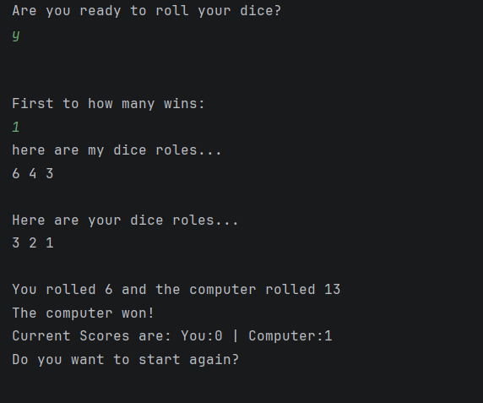

Result: Did the programme behave as expected ie syntactically and logically correct?

Yes, the programme behaved as expected and the output is logically correct.
The ask if the user to decide if they are, “…ready to roll…” some dice asking for an input. This is the opening to the game, yet the program does not specify ‘what kind of input’ the USER is supposed to make. While the expected response can be inferred; as a ‘yes or no question’, a clear directive of the desired input would be more meaningful. It would mean that the USER would provide an intentional input that the Program expects, allowing the Users to maintain an awareness of their inputs and what they specifically need do, to continue moving forward through the program.

The program follows up by requesting, “First to how many wins:”. Intending to use the value it receives, as a threshold that the User or Computer will use to declare victory in their competition with each other. Syntactically, however, this value is used to determine the number of ‘Dice Roll’-rounds that decare a winner. This is the minimum number of rounds that have to occur for a winner to be determined. A draw may occur for many rounds before a victor is declared. This value is a hard limit for the number of wins that the User or the Computer must gain individually.

Next, the program prints 3 random generated dice rolls for each and then calculates and displays the sum for each. It quickly compares the two totals to determine the winner; the one with the biggest number and again displays the result.
Finally declaring the score and asking if the User wants to start again.

Test: ii. User wins round

Screenshot(s) of output:

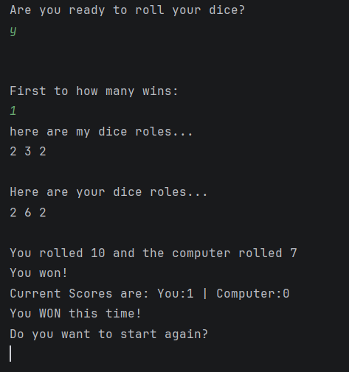
Result: Did the programme behave as expected ie syntactically and logically correct?

Yes, the programme behaved as expected and is logically correct. If flows the same as ‘Question i’, with the same flaws, and is given a point threshold (“First to how many wins”) of 1 point. It plays a single round, and displays the: rolls for each, the calculated totals, who won the round, and the current scores. The program concludes by asking the user if they would like to play again.

Test: iii. Draw

Screenshot(s) of output:

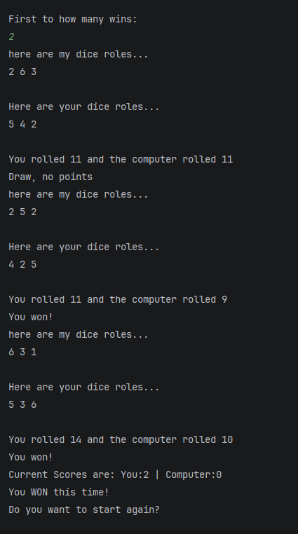
Result: Did the programme behave as expected ie syntactically and logically correct?

Yes, the programme behaved as expected and is logically correct. If flows the same as ‘Question i’, with the same flaws but is given a point threshold of 2. This created an instance where the ‘minimum number of rounds that have to occur’, exceeded the number of points set as a limit. 3 rounds were played; the 1st a draw, followed by 2 consecutive wins by the User.

Test: iv. “Go again” – enter y

Screenshot(s) of output:

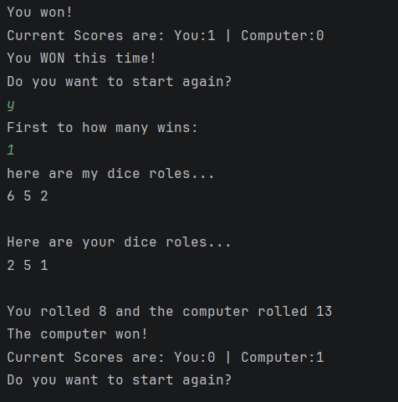

Result: Did the programme behave as expected ie syntactically and logically correct?

Yes, the programme behaved as expected but is logically flawed. The request to ‘start again’ could be more communicative; prompting the user to enter something specific rather than an inferred input. For instance, putting ‘( y / n )’ after the request to indicate an expected ‘Yes’ or ‘No’ response. Additionally, it may also benefit from an improved presentation style, that maintains visual consistency after each input.

Test: v. “Go again” – enter n

Screenshot(s) of output:

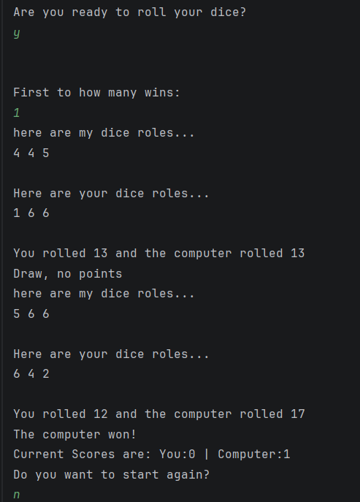
Result: Did the programme behave as expected ie syntactically and logically correct?

Yes, the programme behaved as expected but is logically flawed. After the program prompts to ‘start again’, entering ‘n’ ends the program. This could be communicated more directly.

Test: vi. “Go again” – enter Y

Screenshot(s) of output:

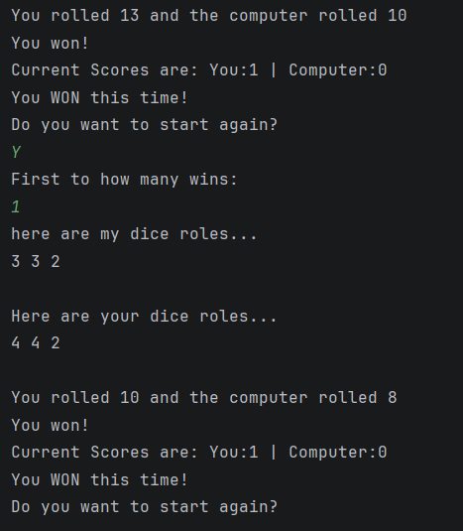
Result: Did the programme behave as expected ie syntactically and logically correct?

Yes, the programme behaved as expected but is logically flawed. After being prompted to ‘start again’ and entering ‘Y’, the programme begins another game of Dice Rolls. The programme could be more communicative and be more readable; the same issues in ‘Question iv’.

Test: vii. “Go again” – enter b

Screenshot(s) of output:

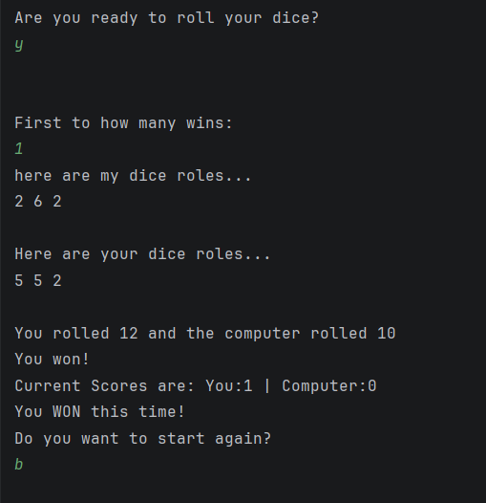

Result: Did the programme behave as expected ie syntactically and logically correct?

Yes, the programme behaved as expected but is logically flawed. Following a completed game of Dice Rolls, the user receives the prompt, “Do you want to start again?”. This a ‘yes or no’ question. After receiving ‘b’, the program choses to NOT to ‘start again’ because it does not recognise the input to mean ‘yes’.
To fix this, the programme could be more communicative regarding what it expects for a response; the same issue in ‘Question iv’

Part - b

Test: viii. Show score/score tracking (depending on how you have implemented your program)

Screenshot(s) of output:

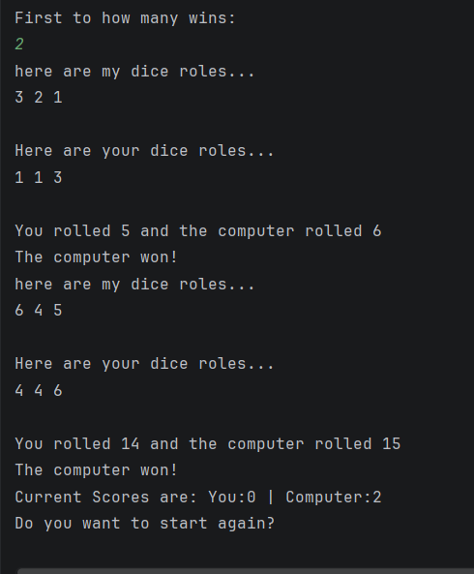

Result: Did the programme behave as expected ie syntactically and logically correct?

The program did not behave as expected. It only presented the scores after the entire game was complete, but it should have done this after every round. This would have given the user a visual progression of the duration of the game.

Test: viii. Show score/score tracking (depending on how you have implemented your program)

Screenshot(s) of output:

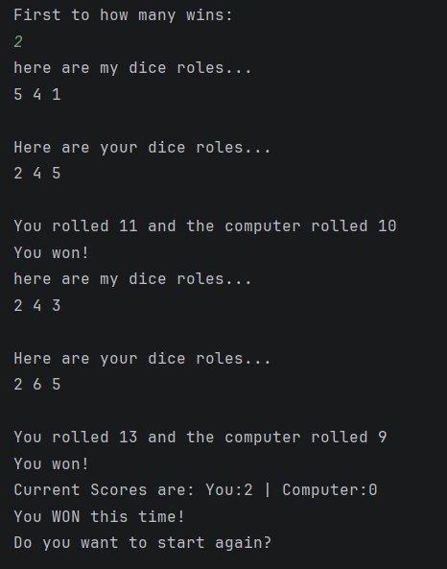

Result: Did the programme behave as expected ie syntactically and logically correct?

The program did not behave as expected. It only presented the scores after the entire game was complete, but it should have done this after every round.
The “Current Scores” section records and displays the number of wins the User and Computer each accumulate. This is a logical error that can be resolved by renaming this section to “Total Wins”. It should then declare the winner of the entire game; the winner being player who got to the predesignated number of wins first.

Part – c

  - Analysis of Original code
The original code repeats when Generating Printing and Summing the dice rolls for both the User and Computer. Combining these into one function, that executes consecutively, could increase efficiency. It would also allow for few mistakes in the event the code must be altered.
To improve readability the structure of the code can be broken into parts. For example, there could be a function for: one for rolling the dice and another for determining the pace of the game (i.e. “First to how many wins, displaying scores). Adjustments should be made to ensure the format of the output is more readable; it should be obvious when a round ends and another begins.

3 – Code Revisions
Consider the results of the above tests and your analysis of program efficiency and revisit your original code in order to address any tests that failed and/or improve code efficiency.

(Note: you may not be able to solve all of the problems that were encountered, but solve as many as you can.)

Paste your full revised code here:

import random
def oneRoundOfDiceVsComputer(): # <----- Func for a single round of dice 3 roles each -
# and RETURNS "Totals" for later use
# ------ Random Dice Rolls------
userDiceRoles = []
computerDiceRoles = []
while len(userDiceRoles) != 3 and len(computerDiceRoles) != 3:
userDiceRoles.append(random.randint(1, 6))
computerDiceRoles.append(random.randint(1, 6))
# ------ print results------
print("\nYou rolled...")
print(userDiceRoles, sep=" | ")
print(f" = {sum(userDiceRoles)}")
print("The Computer rolled...")
print(computerDiceRoles, sep=" | ")
print(f" = {sum(computerDiceRoles)}")
# ------ RESULTS -- SUBTRACT sum of rolls------
userTotal = sum(userDiceRoles)
computerTotal = sum(computerDiceRoles)
# ----- Who Won ? -----
if userTotal > computerTotal:
print("You won this round!")
elif userTotal < computerTotal:
print("The computer won this round!")
else:
print("Draw!")
# ------ result is saved and returned as an INT ------
n = userTotal - computerTotal
# if n = NEGATIVE = User Loss
# if n = POSITIVE = User Win
# if n = EQUAL = Draw
return n
# _____end of function
def main():
# ------ Want to Enter Program/Game~? ------
print("Are you ready to roll your dice?")
userChoiceBegin = input("Y/N?")
###-------- Check input --------#
while userChoiceBegin.strip().lower() not in ("y","n"):
print("Invalid input: Please enter 'y' or 'n'")
userChoiceBegin = input("Y/N?")
while userChoiceBegin.strip().lower() == "y":
# ------if user wants to play the Game... ------
if userChoiceBegin.strip().lower() == "y":
# ----- How many POINTS to Win ?-----
print("Great! before we start...\n", "How many points are needed to win? (in numbers)")
###-------- Check input: Point Limits --------#
while True:
pts2WinGame = input().strip()
#if input is a positive integer between 1 and 12
if pts2WinGame.isdigit() and 1 <= int(pts2WinGame) <= 12:
break
else:
print("Invalid input: Please enter a number between 1 - 12\n (Limited to 12 points to easily track progress)")
# ----- convert to int -----
pts2WinGame = int(pts2WinGame)
print(f"Okay! First to | {pts2WinGame} points | Wins the game!")
# ----- Store Points & rounds in following variables-----
userPoints = 0
computerPoints = 0
roundCount = 0
#----- Dice Rolls take place here -----
while computerPoints < pts2WinGame and userPoints < pts2WinGame:
print("______________________________")
roundCount += 1
print(f"\n | ROUND {roundCount} |")
roundResult = oneRoundOfDiceVsComputer()
# if result is NEGATIVE give Computer a point
if roundResult < 0:
computerPoints += 1
# if result is POSITIVE give User a point
elif roundResult > 0:
userPoints += 1
else: # if result is equal Do Nothing
continue
print(" | -------------------- |\n")
print("____Current Scores____")
print(f"User:{userPoints} | Computer:{computerPoints}")
#----- Conclude the Game -----
print("\n______________________________\n")
print("Overall...")
if userPoints > computerPoints:
print(f"You Beat the computer to {pts2WinGame} points!!")
print("You Won the Game!")
elif userPoints < computerPoints:
print(f"The Computer beat you to {pts2WinGame} points!!")
print("You lost the game :(")
# -----play again?-----
print("\n\nDo you want to start again?")
userChoiceBegin = input()
# ------if user DOES NOT want to play the Game... ------
else:
print("Thank for stopping by...\n Have a nice day!")
return
main()

