BA Business and Management

Nia Lewis

Economics of Sustainability

2,500-word essay

May 2021

Introduction

The UK tobacco industry amounts to 4,394,000 pounds revenue in 2021, this market is also predicted to grow 3.13% annually by 2025 (Statista, 2021). Cigarettes can be considered harmful to society as they produce a negative spill over costs on non-smokers, smoking is not only recognised as a bad habit for smokers although the multiple health risks and that can lead to premature death. Therefore, with the increasing numbers of premature deaths and diseases which reflects the risks and negative externalities of the tobacco industry and would increase if measures are not implemented to minimise the risk.

This essay will address the solutions implemented to the negative externalities of consumption for the tobacco industry in the United Kingdom and how effective these measures have been exploring the detrimental risks to society associated with the health risks and output of pollution by the use of toxic air pollutants.

An analysis of the tobacco industry and their failure to address the environmental issues prior to the indirect taxation and negative advertisements implemented. This will be reflected through demonstrative diagrams to provide a clear understanding of the market failures prior to the implementation of solutions.

The tobacco industry will also be analysed post indirect tax and negative advertisements to gain an insight of whether the implementation has changed the externalities of this particular industry. This will be evidenced with the use of credible academic sources including books, journals, articles and also reference to regulations and illustrative diagrams.

Market failure of the tobacco industry.

The tobacco epidemic is recognised as being one of the largest public health threats the globe has faced, with more than 8 million people dying from the consumption of tobacco yearly. 7 million of these deaths are the result of direct tobacco in comparison to 1.2 million that results of non-smokers who have been exposed to second-hand smoke (World Health Organization, 2020). Statistics reflect that 14.7% of British citizens reported smoking regularly (Statista, 2020). The use of second-hand smoke has also proven to be harmful increasing risks of lung cancer and heart disease to people who are exposed to passive smoking (NHS, 2018). Smoking is a major source of air pollution that not only harms human health but also the environment. The cost price of a cigarette fails to take into account the cost of poor health to the consumer, the addictive nature of the product and the health effects and potential harm the product has to others through passive smoking. These all have significant societal costs through NHS health treatments (Finch, 2020).

Market failure in relation to cigarette consumption can occur in the form of negative externalities, the use of cigarette smoking not only highlights the negative health effects but also identifies the environmental pollution that is generated through the use of realising toxic air pollutants. Cigarettes are harmful because they produce a negative externality, this is because the consumption has spill over effects on third parties which is not compensated. A negative externality occurs if an activity creates costs such as harm or discomfort for uninvolved people of a person’s activity, the costs are not picked up on the price of a market (California State University, n.d).

There are other effects of Tobacco use including the household income for some UK citizens as the addiction contributes to poverty cycle (Nawrot & Para, 2014). The tobacco industry also has a negative impact on the environment through the use of littering and the effects of toxic chemicals that seep into soil and waterways resulting in soil and water pollution (Karaman, 2019). Research has proved that the harmful chemicals contained within discarded butts, which includes nicotine, arsenic and heavy metals that impacts aquatic organisms as the discarded butts are acutely toxic. It is now being considered the long-term effects these detrimental issues have on water supply (World Health Organization, 2017). The core of the butt in cigarettes can take anywhere from 18 months to 10 years to decompose, during that time the cigarette filters are contained with tar, nicotine and other toxins that can leach into the ground (Howard, 2019).
Market failures can be corrected through the use of government intervention, an implementation of indirect tax was introduced in 1976 by the UK government. Although in 2010 the taxation has increased considerably in the UK. n. In 2009, tobacco taxes were increased 2% above inflation. The escalator was reinstated at 1% above inflation in 2010 and raised to 2% in 2011 and 5% in 2012 (GOV, 2015).

The negative externalities of cigarette consumption are seen to be detrimental to society, the marginal benefit for the consumer is greater than it is on society.

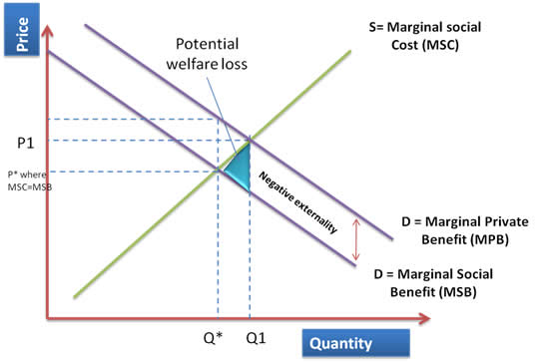

Figure 1 – Negative externalities of smoking cigarettes

Figure 1 reflects a diagram that reflects negative consumption externality of smoking, the marginal private benefit is not reflecting social benefit therefore the marginal social benefit lies below the marginal private benefit. The vertical difference between both MSB and MPB demonstrates the negative externality. Q* represents where the optimal level of consumption placed where the marginal social benefit meets the marginal social cost which is recognised as the equilibrium. However, due to the negative externality there is an over consumption of goods at Q1. The welfare loss can be identified due to the externality of production

Methods to improve market failure.

Solution one - Indirect Taxation

One solution that was implemented was to increase an indirect tax on consumption to reduce consumption. The purpose of this is to shift the marginal social cost curve upwards to marginal social cost-plus tax. The use of this control strategy will reduce consumption to the socially efficient level of output but will raise the price. The indirect tax could also be used to correct some of the negative externalities caused by smoking, the only limitation of this solution is the inelastic demand of cigarettes that may have been a barrier to this strategy.

Taxation is also the most commonly used tobacco control strategy globally, there has been substantial evidence that demonstrates that it has been effective in raising prices which has resulted in reduced smoking prevalence and related harms (Whitehead R et al, 2018).

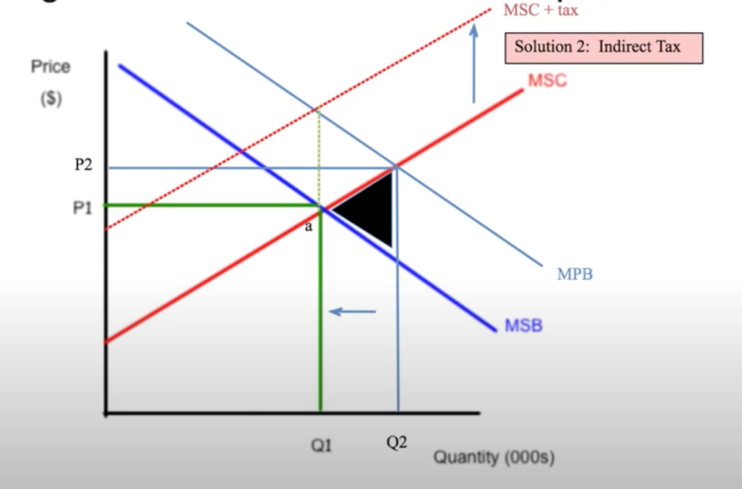
Figure 2 – Indirect tax on cigarettes

Figure 2 represents the indirect tax on cigars, the red dotted line in the diagram that corresponds to a return to the socially optimal level of output Q1 and a higher price of P2. Implementing an indirect tax on cigarettes to reduce the consumption of cigarettes from Q2 to Q1. The use of taxation will result in consumes paying a higher price for the goods although, the government would have addressed the negative externality by reducing the cost of the negative externality of consumption by reducing the consumption from Q2 back to Q1.

Market performance after indirect tax on smoking.

The principal investigator and director of the Tobacco Control Research Group stated that the use of increasing tax on cigarettes has led to a significant decline in tobacco sales, the underlying rate of decline in tobacco sales almost doubled after this indirect tax was implemented (Dunne, 2020).

‘’The current tax on cigarettes is made up of specific duty of £196.42 per cigarettes and an ad valorem rate of 16.5% of the recommended retail price Vat is charged in addition. a pack of 20 cigarettes with an RRP of £8 will be over 80% tax, while on some of the lowest price cigarettes tax can account for 90%’’ (Tobacco Manufactures Association, 2016).

Before the government implemented an indirect tax on smoking the externality was much greater, this is due to the price of cigarettes being considerably lower which created a higher demand and an increase of cigarette consumption. There was an increase in consumer surplus and a decrease in producer surplus (Hu, 2008).

The first implementation of indirect tax on cigarettes was in 1976 and has been increasing since then. The following graph reflects the change in smoking prevalence in the United Kingdom that has declined steadily over a period of time. Taxes on negative externalities of consumption are intended to make consumers/producers pay the social cost of the good, the indirect tax reduces the supply of both goods causing the equilibrium price to rise and the quantity demand to fall.

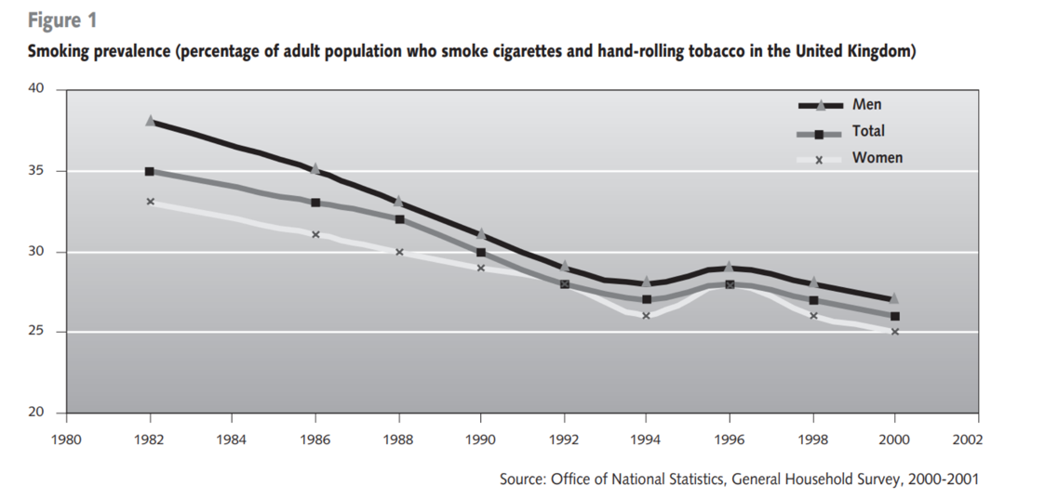

Figure 3 (World Health Organization, 2002).

Solutions two - Negative advertising campaign and standardised packaging.

The second solution for this negative externality was the use of a negative campaign whilst using standardised packaging to discourage people from using tobacco by reducing the appeal of products. Standardised packaging increases the efficacy of health warnings with the use of prominent graphic pictures on the packaging.

The purpose of this solution is to educate individuals about the health risks and dangers of smoking which would shift the marginal private benefit downward as it would result in less satisfaction whilst using tobacco as it would raise awareness about the serious effects that tobacco use takes on people’s health. However, it may be costly to create a negative smoking campaign although taxes within the UK could pay for this. As previously stated, inelastic demand may be considered a barrier to success for this strategy as educating and advertising may not be effective in reducing cigarette consumption.

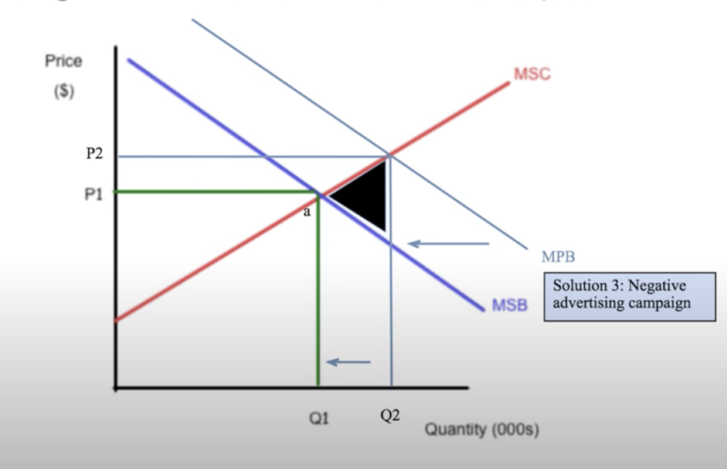

Figure 4 – Negative advertising campaign

Figure 4 represents a diagram that shows the intention of a campaign would be to move the marginal private benefit through advertising downward to meet the socially optimal point of a on the diagram, which in effectively would reduce the quantity consumed of cigarettes which would allow the welfare loss to be reduced as a result of the negative advertising campaign through the use of standardised packaging. The use of negative advertising has an intention to influence a negative perception of smoking for consumers which would move the marginal private benefit curve.

Market performance after standardised packaging on smoking.

May 2017, the UK became the third country to fully implement standardised tobacco packaging with the intention to cut the number of smokers by 300,000 (BBC, 2017). The use of standardised packaging reduced smokers ‘private benefit from smoking by reducing their utility of tobacco consumption.

The following as reflected in figure 5 represents a timeline of the proportion of smokers in Great Britain who have quit, the timeline also represents other solutions that have been implemented to reduce the size of the negative externality as previously demonstrated hypothetically. Since 2017 there has been the highest percentage of smokers who have quit and the lowest percentage of current smokers which reflects the positive progression of minimising the spill over costs that smoking has on the environment and the effects it has on third parties outside of the market.

The standardised packaging in 2017 was considered a success innovation from the government as statistics state that cigarette sales had decreased by approximately 20 million after plain packaging rules and tougher taxes were introduced in 2017. Another study found that net revenue for the tobacco industry fell 13% after the implementation of tougher policies from 231 million to a lower figure of 198 million (Guardian, 2020). It is also been proven that the use of ‘’fear appeals’’ are effective in motivating health behaviour change especially if there is information that educates how to avoid the fearful consequences (Tong et al, 2019).

A survey conducted by the office of national statistics also stated that in a survey of opinion and lifestyle smoking rates were 45% 10 years ago, three times higher than what they are today. Statistics reflect that 62% of those who reported that they smoked have quit, an impressive 11.8 million people (GOV, 2018). Which also reflects how the governments strategy to address the negative externalities have forced the negative externalities of consumption to the equilibrium.

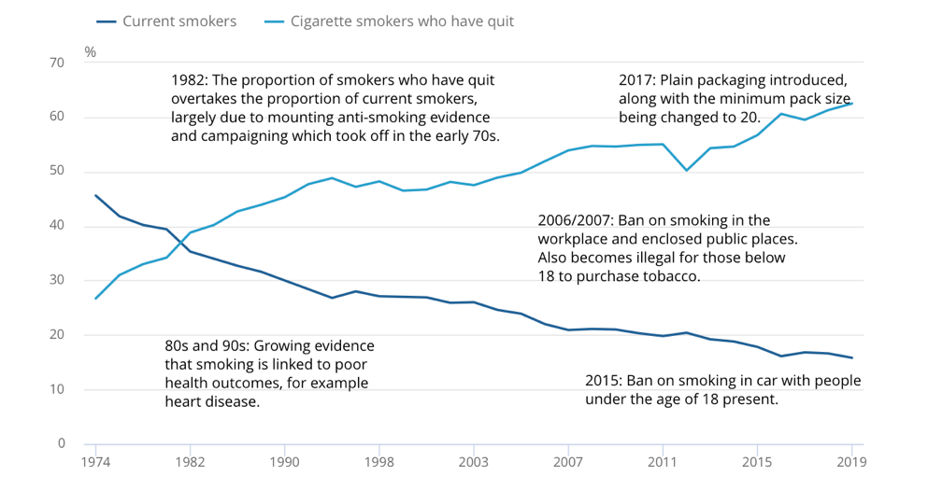

Figure 5 – The proportion of smokers who have quit, all aged 16 and above in the UK 1949-2019 (Statistics, Office for National, 2020).

Substitute for tobacco industry.

The below diagrams reflect the price adjustments of cigarettes and the cigarettes substitute, diagram 1 demonstrates the shift between S to S1 as a result of decreased demand of smoking due to the negative health advertisements and education for consumers which results in the price increasing as the price goes up and the quantity reduces. Although diagram 2 reflects how the use of substitutes influence a demand increase which for the tobacco industry would be the use of e-cigarette also recognised as ‘vaping’, the demand curve shifts to the right in diagram 2 from D to D1 which moves the market equilibrium to a new quantity price. Due to the increase of price the supply curve moves to the right which reduces the price but the quantity increases.

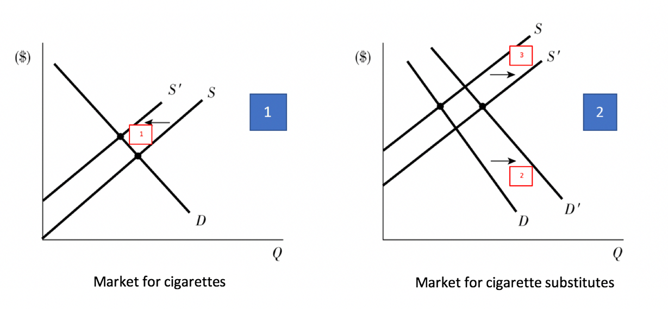

Figure 6 – Market for cigarettes and cigarette substitutes (Callan & Thomas, 2013).

Tobacco can be identified as a substitute which are goods in competitive demand and act as a replacement for another product (Riley, 2010). The diagram shows the process how the use of taxation would elevate the price of cigarettes and overtime the demand for tobacco substitutes would increase reflecting a wider market for e-cigarettes.

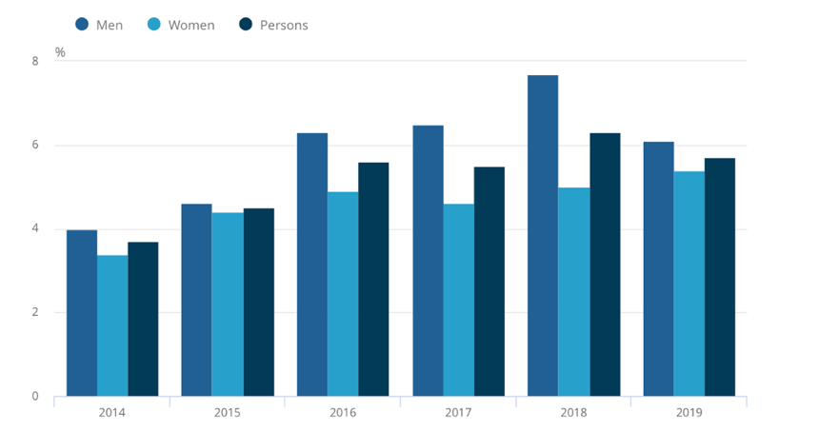

Figure 7- The proportion of current vapers in 2019 significantly increased since 2014
(Office for National Statistics, 2020).

The above diagram reflects the increased number of vapers in the UK from 2014-2019, since 2014 solutions have been implemented to overcome the negative externalities through the use of taxation and negative advertising through the use of standardised packaging. E-cigarettes have become a popular stop smoking aid in the UK, this is due to them being far less harmful than cigarettes, many of thousands of people in the UK have already stopped smoking with the help of e-cigarettes (NHS,2019). The Public Health of England also stated that e-cigarettes are 95% safer for human consumption than traditional cigarettes, reflecting the positive effects of this subsitute. When comparing the Figure 7 to Figure 8 it is clear the opposite direction of demand, this could be due to the sollutions imposed by the government although when comparing the data from both graphs, there is an evident use of e-cigarretes in males and smoking prevalence has decreased the most in England since 2011. Both of these graphs reflect the negative future of cigarette consumption and the positive future of e-ciggaretts.

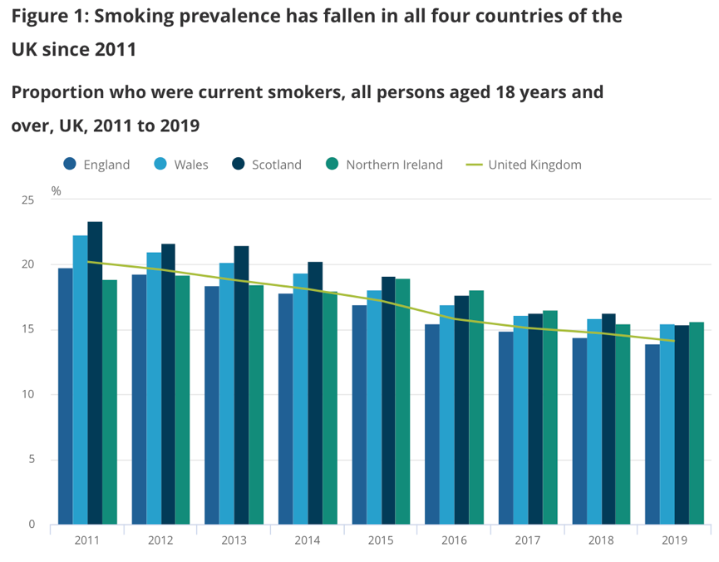

Figure 8- Smoking prevalence has fallen in all four countries of the UK since 2011
(Office for National Statistics, 2020).

\

Country comparison – 250

Utah is one of the countries in the world with the least number of smokers with a rate of 10.6% percentage of smokers.

TALK ABOUT OTHER ALTERNATIVES – Regulate it. LOOK AT HOW SOUTH KOREA HAVE FIXED THE EXTERNALITY AND HOW EFFECTIVE IT HAS BEEN.

Look at other countries and look at how they have overcome smoking as an issue.

HAVE OTHER COUNTRIES GONE FOR A MORE CONTROL AND DEMAND APPROACH – DO I THINK IT IS NEEDED.

Conclusion - 200

In conclusion, the tobacco industry was failing prior to the solutions implemented by the UK due to the social costs and negative health effects that consumers have faced. The solutions were implemented to change people’s behaviour the taxes imposed can be used to reduce the harmful effects of externalities. With a reduction on smoking within society there will be a decrease of cancer, lung disease, chronic bronchitis and other health effects (Centers for Disease Control and Prevention, 2020). There will also be less toxic air pollutants into the atmosphere and less environmental impacts such as soil and water pollutionf from toxic cigarette butts (World Health Organization, 2017). The solutions for the externalities have evidently been successful within the UK with a drastic change to the smoking prevelance since 2011. Although there are other solutions that could be considered to reduce the level of cigarette consumption its important the UK still impose future solutions to avoid further damage to the environment and the health of british citizens.
The cigarette market has also gained a substitute which in recent years has been popular, the demand of e-cigarettes has increased since the solutions have been imposed resulting in a positive health change of consumers, although E-cigarettes aren’t completely risk free, they carry a small fraction of the harmful risks. The increase of e-cigarettes reduces the negative externalities of smoking.

