Programs in C and Documentation
ACCA4017 – G Thomas

Isobel Sutcliffe – 1808257
1808257@student.uwstd.ac.uk

Contents
Section C 1
Pairs 1
1. Problem Identification 1
2. Annotated Code 3
3. Testing 7

Section C
Pairs

Problem Identification

- Check user wishes to play a memory game of matching pairs – Y or N

- If N then display polite message to the user;
- If Y then start the game – display message to the user.

- Limit number of matches to begin with (limited to 6 pairs).

- Declare variables for the number of go’s and matches achieved if Y.

- Consider timer to time the game – implemented, but unsure of accuracy.

- Shuffle the “cards” (allowing for an element of randomness).

- Display the array with “cards turned away” as X – not implemented as yet.

- Ask the user to select the 1st card for matching

- Validation around the user input, no negative numbers and no numbers above the maximum;
- If card has already been matched, then select another one;
- Show number, if card has not been matched.

- Ask the user to select the 2nd card for matching

- Validation around the user input, no negative numbers and no numbers above the maximum;
- If card has already been matched or selected as card 1, then select another one;
- Show number, if card has not been matched.

- Do the cards match

- If cards match – congratulations message;
- Change the cards to “found” so as to ensure they are not selected again;
- If cards do not match – commiseration message.

- Add this go to the number of go’s already taken.

- Add the match, if matched, to the number of matches.

- If the user has not reached the maximum number of matches (6 in the initial setup) then repeat steps vii. to ix.

- Once the maximum number of matches has been made, end game and timer if implemented.

- Ask user for initials – for the scoreboard

- Create a scoreboard with Initials; Matches; Go’s and Time;
- Ensure that the top five on the leader board are presented – not implemented as yet.

- Ask user if they would like another go return to step i.

Annotated Code

#include <stdio.h> // header file for standard input and output
#include <stdlib.h> // header file for standard library functions
#include <time.h> // header for declaring the timespec structure
#include <string.h> // library for common string functions

struct ScoreBoard
{
char name[5]; // declare variable for the question posed to the user
int gos = 0; // declare variable for cumulative go's
int match = 0; // declare variable for cumulative matches
double elasped = 0.0; // more precise numerical variable for the timing of the game
};
void main()
{
FILE *fp;
char answer; // declare variable for the question posed to the user

// Ask user if they would like to play a game of memory
printf("Would you like to play a memory game with me (Y or N)?\n");
scanf(" %c", &answer); // player enters their answer
while (answer == 'Y')
{
int pairs[12] = { 1,1,2,2,3,3,4,4,5,5,6,6 }; // hardcoded numbers for card array
int i, j, k, temp; // declare variables for array and loop shuffle
int card1, card2; // declare varialbes to mark index of cards in array
int low = 0; // lowest index range
int high = 11; // highest index range
int m = 0; // declare variable for scoreboard
struct ScoreBoard myscores[10]; // decalre structure to allow combined datetypes
time_t start, end; // declare variable for a timing element for the game

srand(time(NULL)); // seed randomness
time(&start); // timer started

// use for loop to shuffle cards, allowing k and j to be the card index place, where temp is a temporay storage place
for (i = 0; i < 100; i++)
{
k = rand() % (high - low + 1) + low;
j = rand() % (high - low + 1) + low;

temp = pairs[k];
pairs[k] = pairs[j];
pairs[j] = temp;
}

//printf("%d, %d, %d, %d, %d, %d, %d, %d, %d, %d, %d, %d \n \n", pairs[0], pairs[1], pairs[2], pairs[3], pairs[4], pairs[5], pairs[6], pairs[7], pairs[8], pairs[9], pairs[10], pairs[11]); // testing line commented put unless testing
printf(" 01 02 03 04 05 06 07 08 09 10 11 12\n"); // allows user to visualise the number spaces
printf(" X X X X X X X X X X X X\n");

while (myscores[m].match < 6) // while the match counter is less than 6, maximum number of matches go through loop
{
printf("Please enter the number of your first card selection (between 1 to 12): \n"); // first card
scanf("%d", &card1); // waiting for user input
card1 = card1 - 1; // talking 1 from the user input to ensure that the correct indexed card is returned

while (card1 < 0 || card1 >= 12) // validation rules around the card index
{
printf("This card location does not exist please choose another card, between 1 and 12.\n");
scanf("%d", &card1);
card1 = card1 - 1;
}

while (pairs[card1] == 0) // validation rule is the card has already been matched
{
printf("You have already matched that card.\n");
printf("Please select another card location: \n");
scanf("%d", &card1);
card1 = card1 - 1;
}
printf("Your card number is %d\n\n", pairs[card1]); // print the number associated with the card index

printf("Please enter the number of your second card selection (between 1 to 12)\n"); // second card to be selected and matched to
scanf("%d", &card2); // waiting for user input
card2 = card2 - 1; // talking 1 from the user input to ensure that the correct indexed card is returned
while (card2 < 0 || card2 >= 12) // validation rules around the card index
{
printf("This card location does not exist please choose another card, between 1 and 12.\n");
scanf("%d", &card2);
card2 = card2 - 1;
}

while (card2 == card1 || pairs[card2] == 0) // validation rule is the card has already been selected as card1 or matched
{
printf("You have already matched/selected that card, please pick another card location:\n");
scanf("%d", &card2);
card2 = card2 - 1;
}
if (pairs[card1] == pairs[card2]) // what the program is to do if both cards rteturn the same number
{
printf("IT'S A MATCH!\n"); // congratulationary message to user
myscores[m].match = myscores[m].match + 1; // record the match to "myscore[m].match" in readiness for adding to the ScoreBoard
pairs[card1] = 0; // alter the values of the matched card to ensure it is not used again
pairs[card2] = 0; // alter the values of the matched card to ensure it is not used again
}
else
{
printf("Unlucky.\n"); // commiseration message to user
}
myscores[m].gos = myscores[m].gos + 1; // record the match to "myscore[m].gos" in readiness for adding to the ScoreBoard
printf("You have now matched %d pairs\n", myscores[m].match); // number of matches the player has so far.
printf("Your number of go's is now %d\n", myscores[m].gos); // number of go's the player has had so far.
}

if (myscores[m].match == 6) // if the user has managed to match all 6 pairs
{
time(&end); // timer stopped
myscores[m].elasped = difftime(end, start);
printf("WELL DONE \n");
printf("You have taken %.2f seconds to complete the game.\n\n", myscores[m].elasped); // Should calculate the number of seconds a player has played for
printf("Enter your initials to for the on the score board:\n\n"); // enter initials for ScoreBoard
scanf("%s", &myscores[m].name); // User inputs initials (max 5 will be carried through)
printf("%s, %d, %d, %.2f\n", myscores[m].name, myscores[m].match, myscores[m].gos, myscores[m].elasped); // print on the screen the initials, no. of matches, no. of go's and time

fp = fopen("ScoreBoard.txt", "a"); // open the ScoreBoard file, allowing for alterations
fprintf(fp, "%s, %d, %d, %.2f\n", myscores[m].name, myscores[m].match, myscores[m].gos, myscores[m].elasped); // input into ScoreBoard text file
fclose(fp); // Close the text file
}

fp = fopen("ScoreBoard.txt", "r"); // open Scoreboard allowing readability (Not working currently)
if (fp == NULL) // If file does not open return error message
{
printf("Cannot open high score at present\n");
}

for (m = 0; m < 4; m++) // return the first 4 rows of information from the ScoreBoard text file
{
fscanf(fp, "%s", &myscores[m].name);
fscanf(fp, "%d", &myscores[m].match);
fscanf(fp, "%d", &myscores[m].gos);
fscanf(fp, "%.2f", &myscores[m].elasped);
}
fclose(fp);

for (i = 0; i < 4; i++) // for the 4 rows requested print the information
{
printf("%s, %d, %d, %.2f\n", myscores[m].name, myscores[m].match, myscores[m].gos, myscores[m].elasped); // format written rows should take
}

printf("Would you like another go (Y OR N)?\n"); // ask if player would like to go again
scanf(" %c", &answer); // user inputs their answer
}
printf("Thank you for playing today\n\n"); // if answer to play is "N"
}

Testing

  - Testing the question appears on the screen

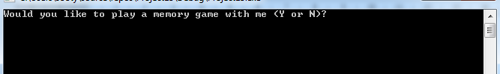

Result: As Expected. Question is asked as indicated/requested within the programme.

  - User responds with “Y”

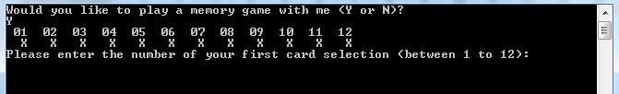

Result: As Expected. Initial question is answered with a “Y” for Yes, and the resulting lines are to show the cards numbered, currently from 1 to 12. The game then askes the user (Player) to choose their first card from 1 to 12.

  - User chooses a negative value for their first card choice.

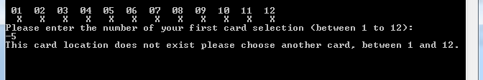

Result: As Expected. Programme indicates that this card location does not exist and the user must choose another card, between 1 and 12. Suggests loop code is working.

  - User is asked to choose their first card and chooses a card greater than 12.

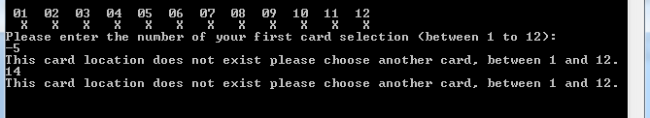

Result: As Expected. Programme indicates that this card location does not exist and the user must choose another card, between 1 and 12. Suggests loop code is working.

  - User enter a correct card number

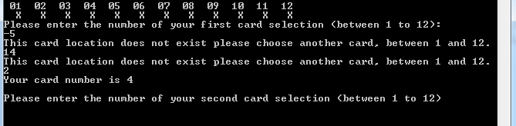

Result: As Expected. Programme indicates that this card location exists and provides the user with the card number. Followed by asking the user to select their second card.

  - User is asked to select their second card, and enters a negative valve

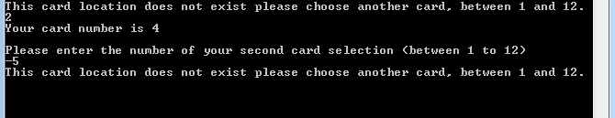

Result: As Expected. Programme indicates that this card location does not exist and the user must choose another card, between 1 and 12. Suggests loop code is working.

  - User is asked to select their second card and enters a value greater than 12

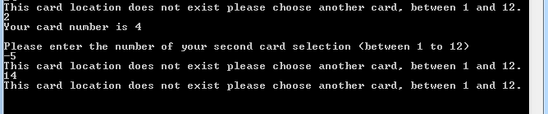

Result: As Expected. Programme indicates that this card location does not exist and the user must choose another card, between 1 and 12. Suggests loop code is working.

  - User is asked to select their second card and enters the same card value as in 3.5 (same as the first card).

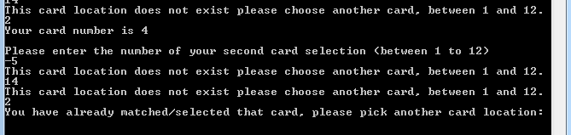

Result: As Expected. Programme indicates that this card location does exist but has been selected already and cannot be selected as the second card, user is asked to choose another card. Suggests loop code is working.

  - User enters a card location that is valid and was not in selected in the first card selection, but was unlucky in getting a match.

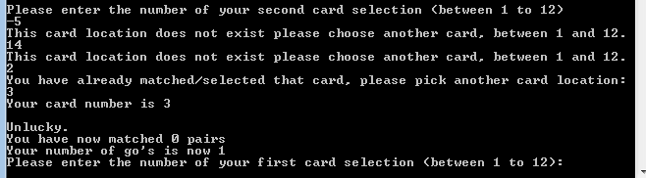

Result: As Expected. User is advised of the number their card location shows and that he has been unlucky in getting a match. They are also advised that they have matched no pairs yet and have had one go. The user is then asked to select his first card again. This suggests that the loop is working here.

  - User enters a card location that is valid and was not in selected in the first card selection, but is lucky in getting a match.

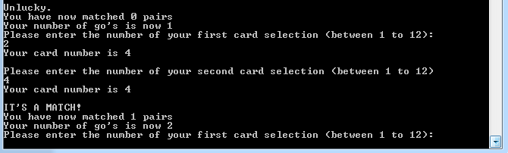

Result: As Expected. User is advised of the number their card location shows and that they have been lucky in getting a match. They are also advised that they have matched 1 pair/s and have had two goes. The user is then asked to select his first card again. This suggests that the loop is working here.

  - User is now halfway through the game

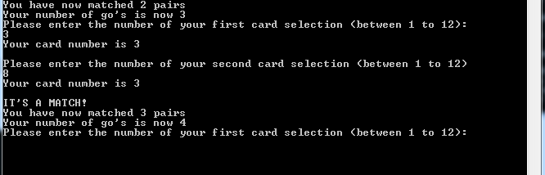

Result: As Expected. User is continually advised of the number their card location shows and that they have been un/lucky in getting a match. They are also advised of the number of pairs they have matched and the number of go’s they have had. The user is then asked to select his first card again. This suggests that the loop is working here.

  - User has matched all 6 pairs

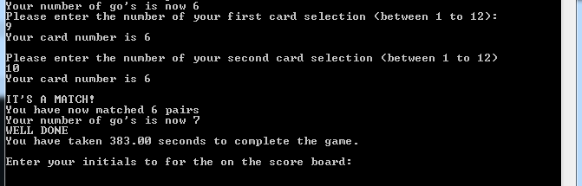

Result: As Expected. The user is advised they have reached 6 matches and the number of go’s they have had. At this point the user is then advised that they have finished and that it took them 383 seconds to complete the game. (Validity of the timing still needs to completed). The user is then asked to input their initials for the scoreboard.

  - User enters initials for the scoreboard. User is also asked if they would like to play again.

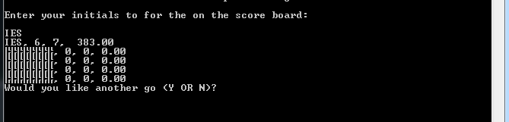

Result: The initials are added, the question around playing again is also asked, but there is still an issue to be addressed. The user sees their initials printed on the screen and can see the number of matches, Go’s and time taken against it. There currently is some issue with reading/writing of the text file that is sat behind the code, hence the garbage that appears straight after. This is supposed to show the top 4 players on the scoreboard.

  - User states they do not wish to play again

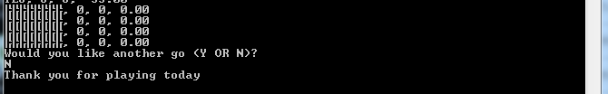

Result: As Expected. User advises that they do not wish to play again, message displays thanking them for playing today.

  - User states they wish to play again

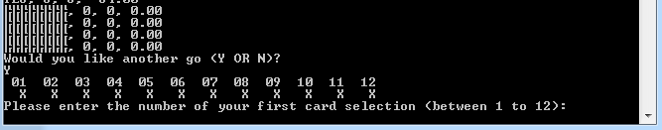

Result: As Expected. User advises that they do wish to play again, message displays as before. Suggesting that the game has looped back to the beginning.

  - The Text File that is being written to in relation to the scoreboard.



In light of the scoreboard not returning anything, it was put on hold. Some checks were run, to see if the file was being written to, and as the snippet above suggests the programme appears to be writing to the text file with no issue, so it can only be concluded that there is an error of the reading from the file back into the programme.

There would appear to be many ways to produce a working game. Initial thoughts were on creating functions with pointers to the array, but as things moved on, it proved quite challenging to maintain the initial momentum and time consuming. This would be the way to go forward if looking to create a more user-friendly game in terms of allowing the user to choose the number of pairs to look for, allowing for more challenging game as well. Possibly with a multi-dimensional array.

