

Assignment 1
Subject Name: Digital Marketing
Subject Code: LCMB7010
Lecturer: Dr Amitave Banik
Course: MBA Marketing Management
Semester: 2

Chosen Company: Samsung
Student Name: Varun Joseph Sony
Student Number: 2129151
Submission Date: 03/05/2023
Word Count: 5081

Table of Contents
Introduction 4
Digital Marketing 4
Company Background and Overview 5
Digital Marketing Analysis 7
Identification of Digital Assets 7
Website 7
Social Media Accounts 8
Customer Relationship Management System (CRM) 8
Marketing Information System (MIS) 11
Enterprise Resource Planning System (ERP) 13
Internal and External Communication Structural Flows 14
8Ps Marketing Mix 16
Digital Strategy Plan 17
Customer Lifecycle Framework 18
Digital Growth Framework 20
Push Pull Strategy 22
Sweet Spot 23
LFM Algorithm 24
Promotions for Products and Services 24
Machine Learning in Digital Marketing 25
Importance 26
Applications 27
Customer Segmentation 28
K-means Clustering Algorithm 28
Forecasting Decisions 30
Recommendations 30
Conclusion 32
References 33
Appendix 1 39
Samsung’s Retail Distribution Channels 39
PESTLE 39
SWOT 41
Samsung Summarised Annual Statements 42
Income Statements 42
Balance Sheet 42
Cash Flow 43
Appendix 2 43
Benefits of Digital Marketing 43
Strengths and Weaknesses of Samsung's Digital Marketing Strategy 44

Introduction
The core aim of this report is to critically analyse the digital marketing capabilities and strategies of Samsung Electronics Co Ltd. With a specific focus on the official company website and social media presence, the report will also provide a detailed insight into the digital assets as well as the internal and external structural flows of the company. The key digital promotional strategies employed by the company will also be analysed in this report. Additionally, the report will also explore the capabilities of machine learning and Artificial Intelligence in the field of digital marketing and how it can be utilised to create effective digital marketing strategies and expedite the return of investment (ROI).

Digital Marketing
In layman terms, digital marketing is the concept of using digital channel and technologies to promote and market products and services. The concept utilises a wide range of strategies and tools that could leverage the internet and digital media to engage with the target audience. Digital marketing uses various channels such as social media, search engines, emails, mobile applications, and websites (Chaffey & Ellis-Chadwick, 2020; Hien & Nhu, 2022).
One of the key advantages of digital marketing is its capabilities in customer segmentation. Digital marketing helps companies to collect specific customer data like consumer behaviour, buying patterns and frequency of purchases (Wang, 2022). Data analysts can then utilise these data to create highly targeted digital marketing strategies that could reach the potential customers in a very short span of time. In short, digital marketing helps companies to customise the marketing campaigns to make them more effective and generate better ROI.
Another advantage of digital marketing is its ability to monitor the results in real-time. This helps companies to monitor the performance of their ad campaigns in real-time and, adjust as required (Epstein & Yuthas, 2007). In other words, digital marketing helps companies to optimise their ad campaigns for maximum benefits and drive business growth.
Digital marketing encompasses a wide range of strategies and tools such as search engine optimization (SEO), (SEM) social media marketing, email marketing, content marketing and influencer marketing (Rosario et al., 2022). Each one of these tactics has several advantages and can be employed alone or in unison with other tactics to create an effective digital marketing campaign.
In other words, digital marketing has become a pivotal strategy for modern day organizations to create financially feasible and highly targeted campaigns to reach their target audiences. Similarly, the ability of digital marketing to provide real-time monitoring will also help companies to make informed decisions in future marketing campaigns.

Company Background and Overview
Samsung was founded in 1938 as a trading company by Lee Byung-Chul in Daegu, South Korea. During the initial days, the company focused on the trade of dried fish and vegetables to China but later expanded into the sales of textiles and insurance (Zhou, 2020). By the 1960s Samsung shifted its focus to the electronic industry and in 1969, the company released its first black and white TV. The company is now on of the global leader in the manufacturing of electronics consumer goods and has created numerous innovative products such as the world's first 40-inch TFT-LCD TV in 2004, and the Galaxy S series of smartphones in 2010. The company is headquartered in South Korea and has manufacturing as well as research and development facilities in other major economies like United States, China, Japan, India, Germany, France, and the United Kingdom. Samsung also employs more than 320,000 employees and sell its products in almost every country in the world. The following table provides the key stats of the company:
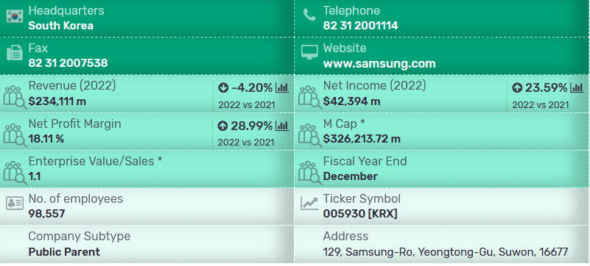
Source: Marketline
In 2022, the company generated 302.2 trillion won ($245.7 billion) in revenue, compared to the 279.6 trillion won ($227.4 billion) in collected in 2021 (Toh, 2023). The following chart illustrates the global revenue of Samsung:
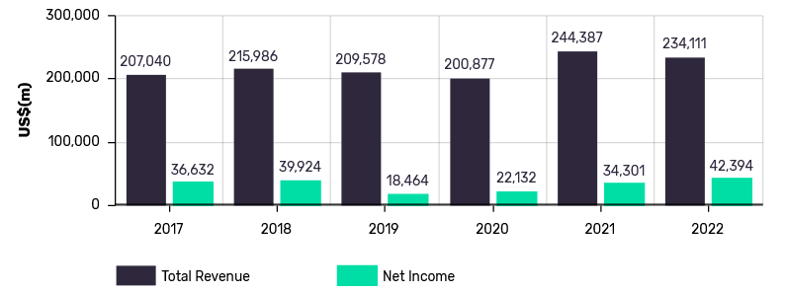
Source: Marketline

Digital Marketing Analysis
Digital marketing analysis is the process of evaluating a company’s online marketing strategies and techniques. This will help companies to identify its strengths and weaknesses as well as opportunities, that can be leveraged for business growth (Profiletree, 2023).

Identification of Digital Assets
Digital assets refer to all the online platforms and assets used and managed by the company to engage with its customers and to promote its products. Samsung uses numerous digital assets in its operations such as:
- Website
- Social Media Accounts
- Marketing Information System
- Customer Relationship Management System
- Enterprise Resource Planning System
Each of these assets will be discussed in detail, in the following sections.

Website
The website is the primary digital asset of Samsung for promoting and selling its products and services. The website is well structured and user friendly and provides a seamless navigation structure, which helps its customers to find what they are looking for quickly. The website holds a range of information such as product descriptions, reviews as well as an online store to purchase the products.
The following table shows the URLs of Samsung’s official online store in some of the most important global economies.
Country | Samsung Shopping Website
United States | https://www.samsung.com/us/shop/
United Kingdom | https://www.samsung.com/uk/shop/
Canada | https://www.samsung.com/ca/shop/
Australia | https://www.samsung.com/au/shop/
India | https://shop.samsung.com/in/
China | https://www.samsung.com/cn/shop/
Japan | https://www.samsung.com/jp/shop/
Germany | https://www.samsung.com/de/shop/
France | https://www.samsung.com/fr/shop/
South Korea | https://www.samsung.com/sec/

Social Media Accounts
Samsung also has established a strong presence in social media platforms such as Facebook, Twitter, Instagram, and LinkedIn. The company leverages these platforms to engage with its customers, promote its products and services, and share content.
The following table provides the links to Samsung's official social media accounts:
Platform | Account Link
YouTube | https://www.youtube.com/@Samsung
Facebook | https://www.facebook.com/SamsungGlobal/
Instagram | https://www.instagram.com/samsung/
Tik Tok | https://www.tiktok.com/@samsung
Twitter | https://twitter.com/Samsung
LinkedIn | https://www.linkedin.com/company/samsung-electronics/

Customer Relationship Management System (CRM)
CRM systems are used by businesses to manage and analyse their interactions with the customers and potential customers. The system assists in streamlining procedures, automating jobs, and providing a thorough view of client data, which helps in sales, customer service, and marketing activities. Features like contact management, lead management, sales forecasting, and customer analytics are frequently included in CRM systems (Tohidi & Jabbari, 2012).
The following flowchart illustrates the functioning of a CRM system:
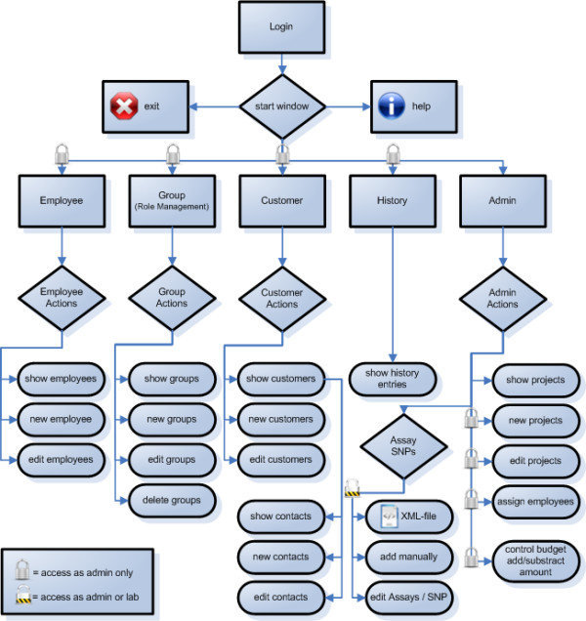
Source: (Schönherr et al., 2009)
eCRM (Electronic Customer Relationship Management) System is a subset of CRM that focuses on digital channels such as email, social media, and websites to manage customer interactions (Dawn & Guha, 2010). Businesses may personalise interactions, track consumer behaviour, and communicate with customers across a variety of channels with an eCRM system. Features like email marketing, social media management, online analytics, and mobile marketing are included in eCRM systems.
The following diagram illustrates the operation of an eCRM system:
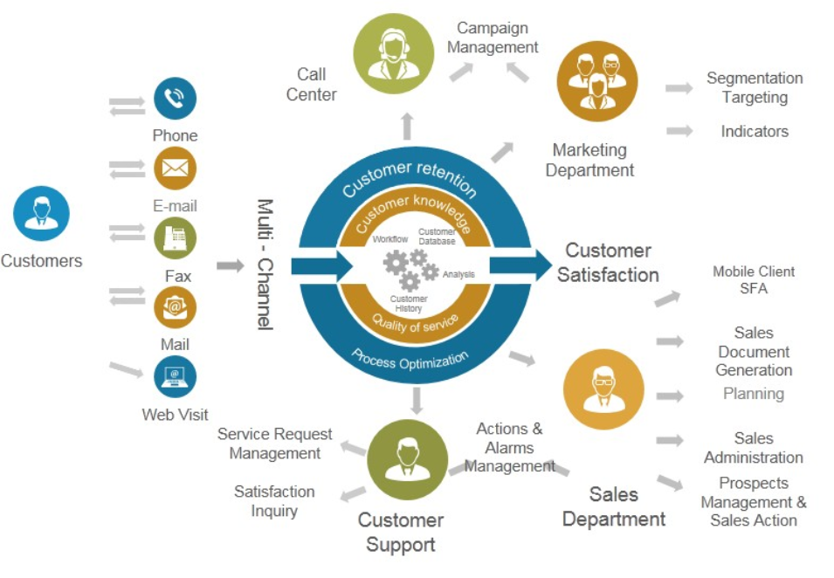
Source: https://www.slidegeeks.com/continuous-improvement/product/process-of-e-crm-ppt-powerpoint-presentation-professional
DBMS systems such as SAP HANA, Oracle Database, Salesforce, and Microsoft SQL Server can be used to store and analyse customer data, including contact information, purchase history, preferences, and behaviours (Gil-Gomez et al., 2019). Samsung, for instance uses Salesforce, a cloud-based CRM platform, to manage its customer data and customer engagements. These data are then used to create highly targeted marketing campaigns (Salesforce, 2022).

Marketing Information System (MIS)
Marketing Information Systems are used to store and analyse marketing data such as sales data, marketing campaign data and customer data. It provides marketers with accurate and timely information that is necessary to make effective marketing decisions (Harmon, 2002).
The following diagram depicts the primary components of a MIS, the environmental elements monitored by the system, and the varieties of marketing choices sought to be supported by the MIS:
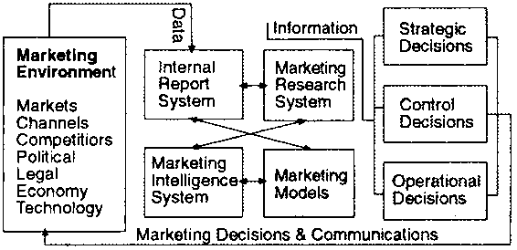
Source: https://www.fao.org/3/w3241e/w3241e0a.htm
The functioning of an MIS system includes the following stages (Indeed, 2023):
- Data Collection: This is the initial stage where data is captured through social media, surveys, and customer feedbacks.
- Data Analysis: Here, the collected data is analysed to identify patterns and trends using statistics and data modelling techniques.
- Information Storage: This pertains to the storage of the analysed data in data warehouses.
- Information Retrieval: This is the stage where the marketing professionals’ access and analyse the stored data to analyse customer behaviour, preferences, and buying patterns.
- Information Dissemination: In this final stage, the processed data is disseminated to the relevant stakeholders like marketing managers, sales teams, product managers, and other decision-makers.
The following gif illustrates the flow of information in MIS:
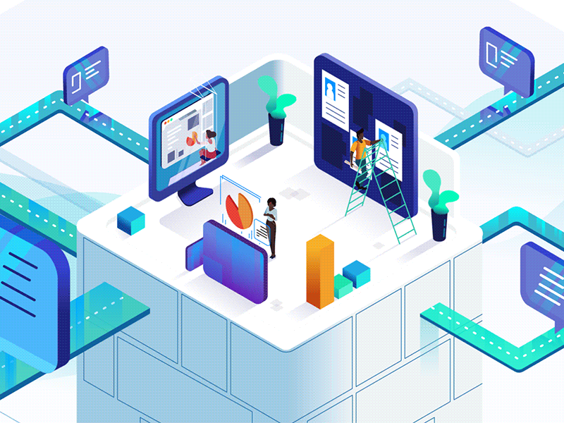
Source: https://www.pinterest.co.uk/pin/434667801532566874/
DBMS systems such as MySQL, PostgreSQL, Adobe Marketing Cloud, and MongoDB are generally used as MIS systems (Brien & Stafford, 1968). Samsung has been reported to use Adobe Marketing Cloud for marketing automation (Apps Run the World, 2018).

Enterprise Resource Planning System (ERP)
ERP systems are designed to integrate and streamline all aspects of a company’s operation, from finance and accounting to supply chain and inventory management. By providing a centralised database, ERP systems helps to improve control and reduce costs in business operations (Matende & Ogao, 2013). The following image illustrates the ERP system structure:
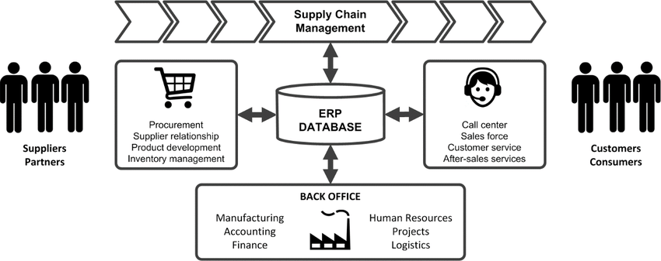
Source: (Belfo et al., 2016)
ERP systems frequently incorporate modules for handling many business operations, including purchasing, production scheduling, inventory management, and financial management (Katuu, 2020). To meet the requirements of a firm, these modules can be adjusted and customised.
The following diagram illustrates the operational flow in an organization, from manufacturing and post sales support. An ERP system will incorporate all these operations under a single centralised database, for accurate control and supervision.
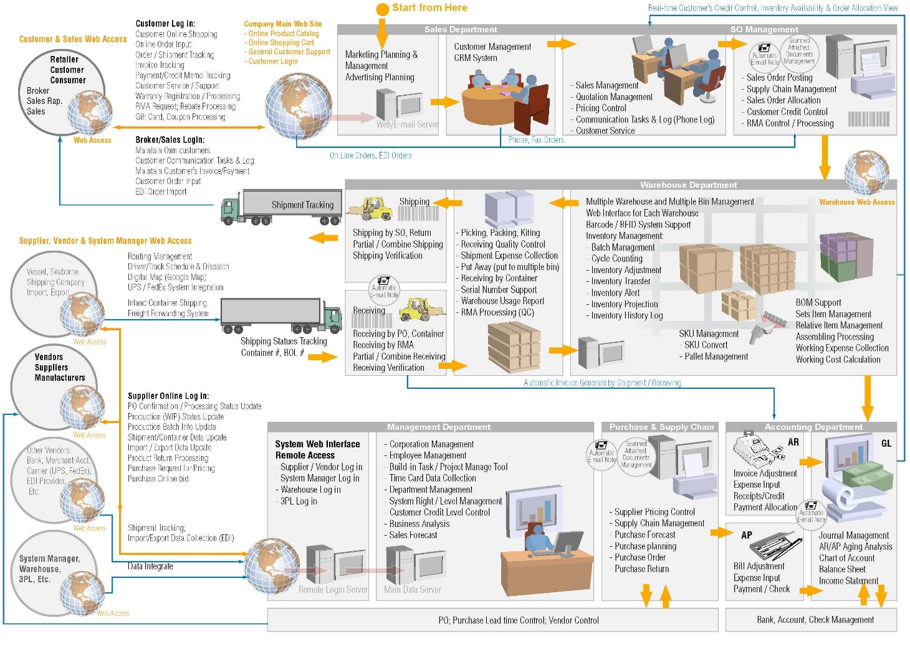
Source: https://hotcore.info/babki/erp-system-flow-chart.htm
There are numerous renowned ERP systems such as SAP ERP, Oracle ERP Cloud and Microsoft Dynamics 365. Samsung for instance, has developed and employed an N-ERP (the next-generation ERP) system across its 120 global offices (Samsung, 2022).

Internal and External Communication Structural Flows
Internal and external communication structural flows refer to the way information flows within an organization and between an organization and external stakeholders. The type of information shared, the amount of hierarchy, and the communication routes employed all influence the structural flow of communication (Gupta& Govindarajan, 1991; Cornelissen & Thorpe, 2001).

The following diagram illustrates the organizational architecture and communication flow structure in a firm:
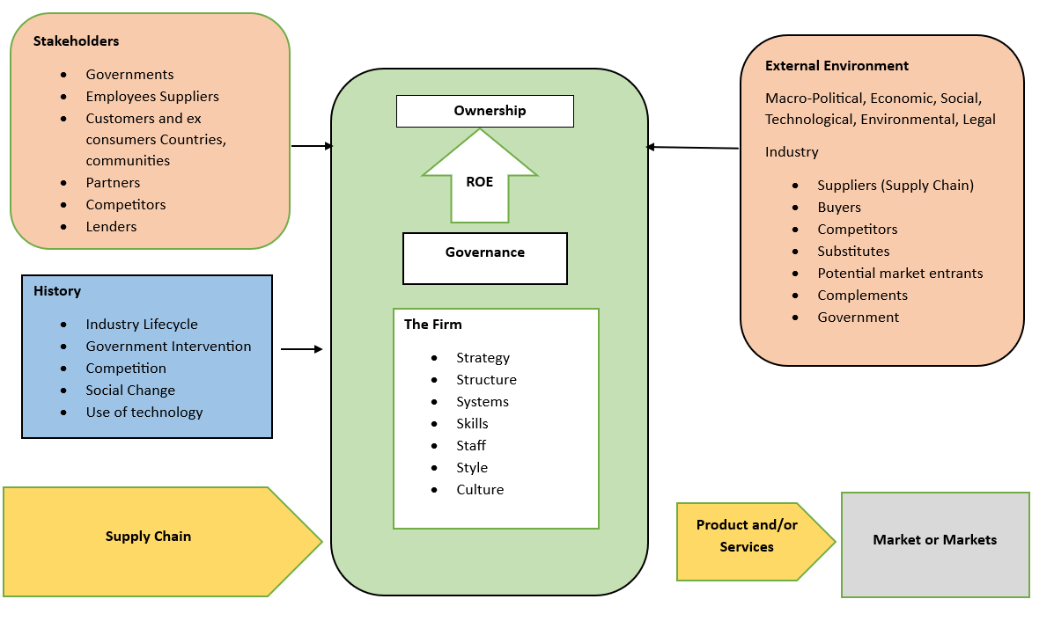
Source: Author’s creation
Internal communication structural flow refers to flow of information within an organization. Intranet systems are an example of internal communication system. The main object of internal communication is to inform and engage with employs on their duties and objectives (Robson & Tourish, 2005). For instance, Samsung’s global digital marketing team can use intranet systems to communicate and collaborate with digital marketing teams of different companies. This will help the global team to share new digital marketing policies and best practices with the local teams.
On the other hand, external communication structural flow refers to flow of information between an organization and its external stakeholders, such as customers, suppliers, and distributors (Lunenburg, 2010). Main channels used in external communication are social media, press releases and websites. The primary objective in external communication is to foster a positive relationship with the external stakeholders and to improve the brand image and reputation. For instance, Samsung’s social media team creates engaging posts, and stories on social media, that showcase Samsung's latest products. Samsung also uses twitter to engage with its customers and provide customer support. This will Samsung to establish a strong relationship with its customers and improve the brand image.

8Ps Marketing Mix
The 8Ps marketing mix framework is used by businesses to develop and implement their marketing strategies. It includes eight elements: product, price, promotion, place, people, process, physical evidence, and productivity (Parmer et al., 2021). Samsung uses the framework as follows:
- Product: Samsung offers numerous products from home appliances to smartphones. The company tries to differentiate these products from those of the competitors with the help of innovation and quality.
- Price: The company employs competitive pricing strategies for its mid-range products and uses premium pricing strategy for its high-end products.
- Promotion: The company uses various channels like TV ads, digital marketing, social media, and sponsorships, to promote its products.
- Place: Samsung has a robust distribution network that consists of physical stores, online distribution channels, and collaborations with mobile carriers. The company also operates in more than 80 countries in the world.
- People: The company has a highly skilled and trained workforce who are renowned for providing exceptional customer service.
- Process: The company uses state of the art processes and equipment to manufacture its product.
- Physical Evidence: The company designs its product with modern and stylish designs to improve its brand image. The company also have flagship stores and experience centres that provide an immersive experience to tits customers.
- Productivity: The company analyses its performance with the help of matrices like sales revenue, market share and customer feedback.

Digital Strategy Plan
SOSTAC is a framework that helps businesses to implement marketing strategies. The acronym stands for Situation Analysis, Objectives, Strategy, Tactics, Action, and Control (Reed, 2014). The following image shows the framework and the main parameters affecting each of the 6 main factors:
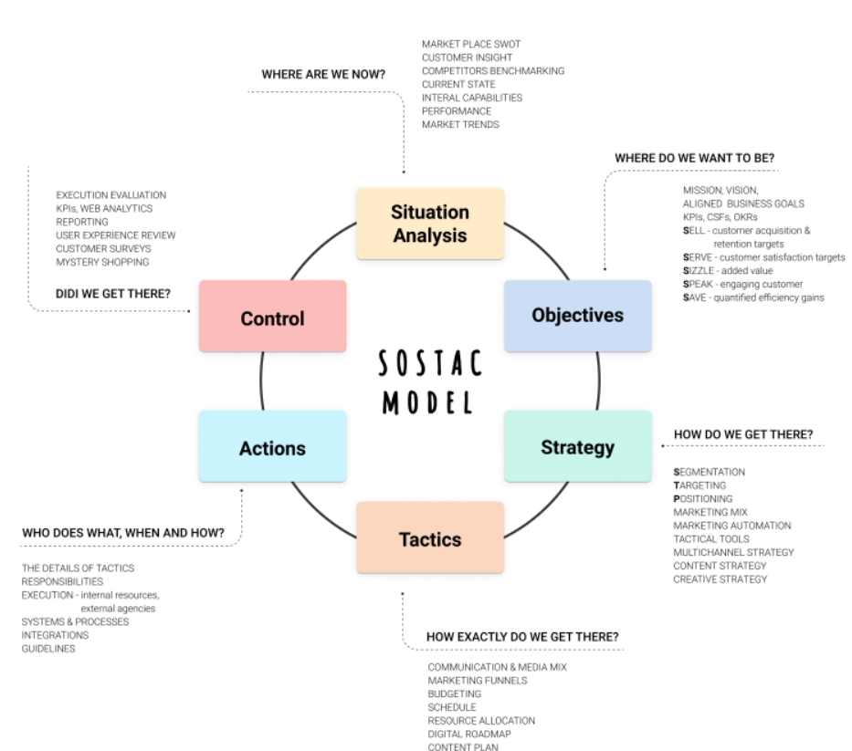
Source: https://oppido.com/using-the-sostac-model-to-build-an-efficient-marketing-plan/
Samsung can employ the framework to create a digital marketing plan, as follows:
- Situation Analysis: Samsung could analyse its current digital marketing strategies to identify threats and opportunities. This can be done by analysing the website traffic, social media metrics, online reviews, and customer feedback to gain insights into its digital presence
- Objectives: Based on the analysis, Samsung can develop SMART (Specific, Measurable, Achievable, Relevant, and Time-bound) objectives (Ogbeiwi, 2017), such as increasing the web traffic or social media engagement.
- Strategy: The company can develop a new digital marketing strategy based on the objectives and company goals. For instance, Samsung can promote its new smart phone through social media influencers.
- Tactics: The company can implement the strategy with the help of tactics like search engine optimization (SEO), pay-per-click (PPC) advertising, email marketing, social media marketing, and content marketing.
- Action: The tactics can then be executed by creating and publishing content, launching campaigns, and monitoring performance.
- Control: The company should also monitor the strategy to analyse its effectiveness. This can be done by tracking website traffic, conversion rates, social media engagement, and other relevant metrics.

Customer Lifecycle Framework
The customer lifecycle is a marketing framework used to analyse the different stages of customer journey, from initial awareness of a product or service to post-purchase evaluation and repurchase. The framework generally consists of 6 major stages, each stage pertaining to a certain point in the customer journey (Santouridis, & Tsachtani, 2015; Stauss et al., 2007).

The following image illustrates the ideal customer journey in a business:
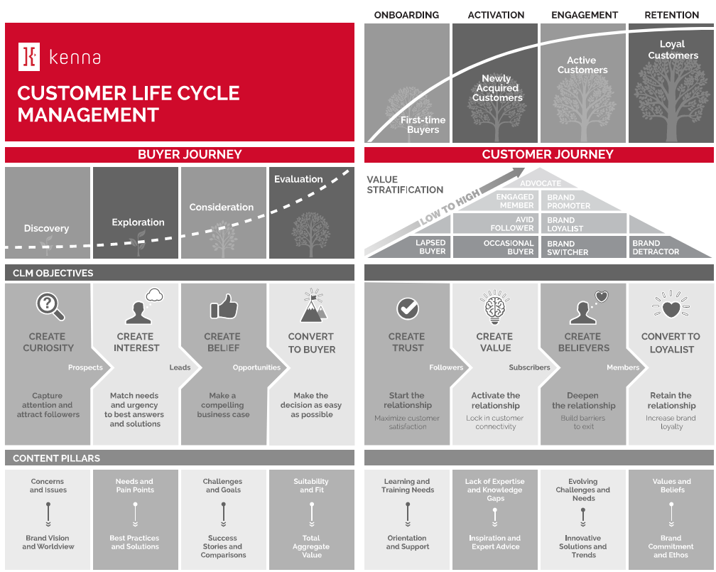
Source: https://www.customerfirstthinking.ca/wp-content/uploads/2019/11/CustomerLifeCycleManagement_Framework_V5.svg
Samsung can implement the customer lifecycle model in their operations, as follows:
- Awareness: The initial stage where the customer becomes aware of a product or service. Samsung can create awareness through search engine optimization (SEO), social media marketing, and content marketing.
- Interest: Here the customers are encouraged to interact with the product and the brand. Samsung can create interest by creating interactive content, messaging or through chatbots.
- Convert: Here the interested customers are converted into potential clients. Samsung can achieve this with email marketing and targeted advertisements.
- Nurture: Post conversion stage where the company starts to build a relationship with the customer. Samsung can implement this with the help of loyalty programs, email newsletters, and personalized offers.
- Retention: Here the company tries to retain the customer for the long run, in order to encourage them to make repeated purchases. Samsung can retain its customers by employing tactics like upselling, cross-selling, and personalized recommendations.
- Advocacy: In this final stage, the casual customers are converted into brand loyal customers, who becomes an advocate of the brand and encourage others to purchase the products. Strategies like referral programs, loyalty programs, customer testimonials and user-generated contents.

Digital Growth Framework
The digital growth framework is a digital marketing tool that will help businesses to achieve their growth objectives. It consists of a sequence of interconnected steps that helps businesses to enhance their online presence, increase website traffic, and convert that traffic into sales (Verhoef et al., 2021). Samsung can implement the framework by following these steps:
- Discovery: Samsung can identify its target customers with the help of market research techniques such as surveys, focus groups, and customer reviews. This will help the company to gather insights about its customer needs and preferences.
- Strategy: Based on these insights, Samsung can define its digital marketing objectives which can be content marketing, SEO, PPC advertising, social media marketing, and email marketing.
- Implementation: Samsung can then proceed to implement this strategy by using techniques such as optimising its website for search engines, launching focused PPC campaigns, interacting with customers on social media, and delivering tailored emails to its subscribers.
- Optimization: Once the strategy is implemented Samsung should regularly monitor it to identify areas of improvement and optimise performance. Tools like Google Analytics can be used for this process.
- Scaling: As soon as the campaign is optimised, Samsung can scale it by increasing the budget and expanding the reach. The company can also use marketing automation tools like Salesforce Marketing Cloud and HubSpot to streamline and automate the process.
The following image illustrates the 5 steps in creating a sound digital marketing strategy:
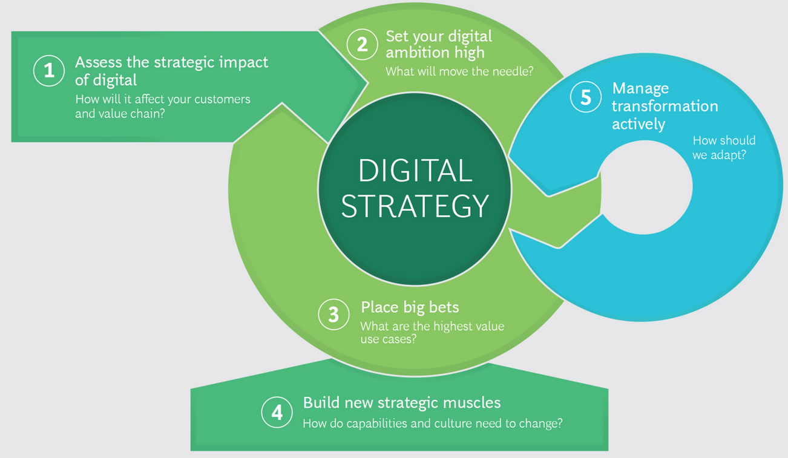
Source: https://www.bcg.com/publications/2019/five-rules-digital-strategy

Push Pull Strategy
The push-pull marketing strategy combines two different strategies to promote and sell products and services. The push strategy entails promoting a good or service to the target market by using advertising, cold calling, and other techniques. On the other hand, the pull strategy focuses on building a strong brand identity and reputation that attracts customers to the good or service (Brocato, 2010).
Samsung can apply the strategy as follows:
- Push Strategy: Samsung can run paid campaigns and email marketing to reach its target audience and promote its products.
- Pull Strategy: Samsung can use pull strategy to create brand awareness with the help of techniques like creating engaging and informative content, such as blog posts, videos, and infographics, that highlights its products.
The following image shows the key push and pull marketing channels for a business:
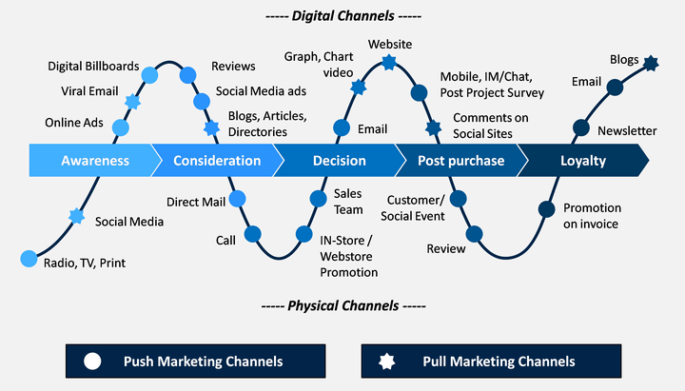
Source: https://www.sketchbubble.com/en/presentation-push-vs-pull-marketing.html

Sweet Spot
The "sweet spot" in marketing is the ideal meeting point of three crucial components of a business strategy: the requirements and wishes of the consumer, the firm's strengths and skills, and the environment of competition in which the company operates. When a business discovers its sweet spot, it has discovered a distinctive and advantageous position in the market that enables it to stand out from rivals while also meeting the demands and preferences of its target clients. The following image illustrates the sweet spot, in context of digital marketing:
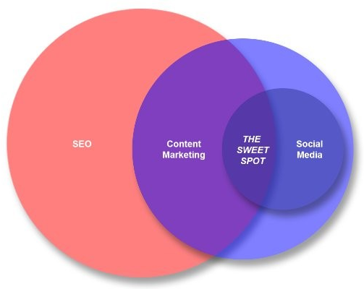
Source: https://www.linkedin.com/pulse/digital-marketing-sweet-spot-content-social-media-seo-bob-turner/
Samsung has created its sweet spot by creating high-quality and innovative technology products that satisfy the needs and desires of its target customers. Additionally, the company has made its products unique by investing heavily in marketing and brand awareness. These factors have helped Samsung to create a sustainable competitive advantage, which in turn helps the company to become a market leader.

LFM Algorithm
The LFM (Life-Time Value with RFM Analysis) algorithm is a marketing tool that could help businesses to segment its customers. RFM analysis evaluates customers based on three metrics: Recency, Frequency, and Monetary value. It will help companies to identify its most valuable customers and create bespoke marketing strategies to target them (Khajvand et al., 2011). The LFM algorithm will also help to calculate customer lifetime value (CLV), the total value a customer can bring to the company in his/her lifetime. The following image illustrates the difference in CLVs across two customers:
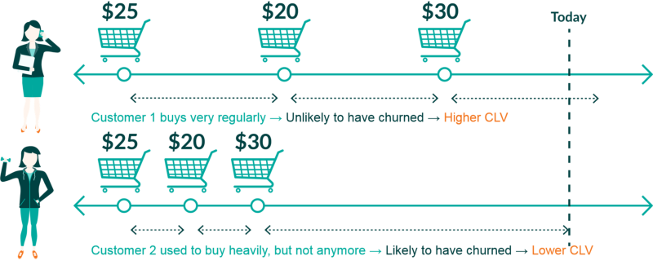
Source: https://www.wearemarketing.com/blog/what-is-customer-lifetime-value.html
In short, the LFM algorithm will help businesses to optimize their marketing efforts and increase customer engagement and retention.

Promotions for Products and Services
Samsung employs numerous strategies to promote its products and services. Some of them are as follows:
- Discounts and Sales Promotion: Samsung regularly provides discounts and other offers on its products such as buy-one-get-one-free deals or cashback offers. These offers will attract customers to purchase the product and drive sales.
- Social Media Contests: Samsung also organises contests in on its social media platforms to engage with the customers and promote its products. For instance, the company might ask its users to share a few words about their favourite Samsung products, to enter a lucky draw and win a prize.
- Email Marketing: The company also uses email marketing to reach its customers. For instance, Samsung sends newsletters to its customers showcasing a new product or service.
- Influencer Marketing: Samsung collaborates with influencers to promote its products. For instance, Samsung might partner with a tech reviewer on YouTube to promote its new smartphone.
- Trade-In Programs: The company also organises trade-in programs where customers can exchange their old devices like smartphones for a newer one.
- Product Launch Events: Samsung also hold product launch events regularly to showcase new products. These events help Samsung to get media attention and create brand awareness.

Machine Learning in Digital Marketing
AI, or artificial intelligence pertains to computer systems that are capable of doing activities that traditionally require human intelligence, such as speech recognition, decision-making, and language translation. AI systems can gather data, identify trends, and use that data to forecast the future and provide recommendations (Collins et al., 2021).
Machine Learning (ML) is a field in Artificial Intelligence (AI) that involves the developing of algorithms and statistical data models. These models help computer systems to analyse, learn and make predictions from the data. This is different from the traditional method of programming where a programmer writes a code to perform a particular function or solve a particular problem. In machine learning, a computer is trained to identify patterns or relationships in the data and make predictions based on that data.
Machine Learning can be categorised into three types (Bell, 2022), which are:
- Supervised Learning: In supervised learning, the computer is trained on a labelled dataset, which shows the correct answer. The computer then learns to predict the correct answer with the help of the input data. For instance, it can be used in credit risk assessment. By training the computer on the previous credit histories of customers, it can predict whether new customers will default on the loans.
- Unsupervised Learning: Here, the computer is given an unlabelled dataset and is trained to find patterns on its own. For instance, it can be used for anomaly detection. By providing unlabelled readings from an equipment, a computer can be trained to find anomalies or issues with it.
- Reinforcement Learning: Here, the computer learns through a trial-and-error method and receives feedback in the form of rewards or punishments. Example is a recommendation system. By providing the consumer behaviour on the company website, the computer can be trained to recommend products that are most likely of interest to them.

Importance
In digital marketing, machine learning can be leveraged to perform a wide variety of tasks; from marketing intelligence and customer segmentation to forecasting decisions. ML algorithms can analyse large amounts of data and identify patterns in consumer behaviour. This will help to create personalised promotions and advertisement campaigns (Ullal et al., 2021).
Machine Learning can also increase the efficiency of businesses. For example, ML can help businesses to automate repetitive tasks like email marketing and content postings on social media. This will help businesses to free up their time and resources and concentrate on other critical operations (Ullal et al., 2021).
In other words, machine learning provides businesses with the tools they require to optimise their operations. The personalised approach provided by ML will help to improve customer engagement, increase conversion rates, and drive sales. Hence, its pivotal for organizations to leverage ML strategies to have a sustained competitive advantage.

Applications
Being an innovative and customer centric organization, Samsung has applied ML principles across a plethora of its operations. Some of them are as follows:
- Personalisation: Samsung leverages ML to analyse customer data and personalise its marketing campaigns. For instance, Samsung takes user data from Samsung Members App to provide customised discounts and offers.
- Predictive Analytics: Samsung also uses ML to analyse data and make predictions on future purchases (IBM, 2022). For instance, Samsung applies machine learning algorithms to predict which products are likely to be popular soon and adjust its discounts accordingly.
- Chatbots: The company uses AI powered chatbots to provide customer support and query redressals. It also helps the company to automate its customer service process and reduce delays in customer service (Misischia et al., 2022).
- Voice Assistants: Samsung uses ML powered voice assistants to improve customer experiences. For instance, Samsung’s voice assistant, Bixby, can provide information and recommend products for purchase based on user preferences and previous purchases (Prabhu & Bhat, 2020).
- Image Recognition: Samsung also uses image recognition technology to provide more seamless customer experience. For instance, Bixby Vision feature present in Samsung devices like smartphones can identify real world objects and help users to find where they can purchase them (Prabhu & Bhat, 2020).

Customer Segmentation
Customer segmentation is the process of dividing the customer base of a company into several different groups in accordance with their buying preferences, needs, and characteristics. The concept is important in the field of digital marketing as it will help businesses to tailor their marketing strategies to reach specific set of people. This will create higher customer satisfaction, loyalty, and revenue (Wang, 2022). ML can revolutionize customer segmentation in digital marketing by providing accurate and data driven techniques of segmentation.
Applying ML for customer segmentation have the following benefits (Biskupska, 2021):
- Data Analysing Capabilities: ML can handle large amounts of data on customer buying behaviour, demographics, and preferences. ML could then identify patterns and relationships form this data to provide a more accurate segmentation.
- Identify Hidden Customer Segments: ML can also help to identify customer segments that will be hidden or non-obvious to traditional segmentation techniques. For instance, ML could identify people who have visited the Samsung website but left without purchasing. This data will create a new dataset of potential customers for the company. Traditional segmentation techniques will not be able to do the same as they segment on variables like age and gender.
- Agile Segmentation: ML can also help businesses to dynamically adjust the customer segmentation techniques. For instance, ML can help Samsung to collect customer data from numerous sources like social media and website at the same time and dynamically adjust its segments.

K-means Clustering Algorithm
This is a popular unsupervised machine learning algorithm used to subdivide a dataset into groups or clusters. It is widely used for consumer segmentation, exploratory data analysis, and image compression (Li et al., 2022). The following diagram shows the application of the algorithm for customer segmentation:
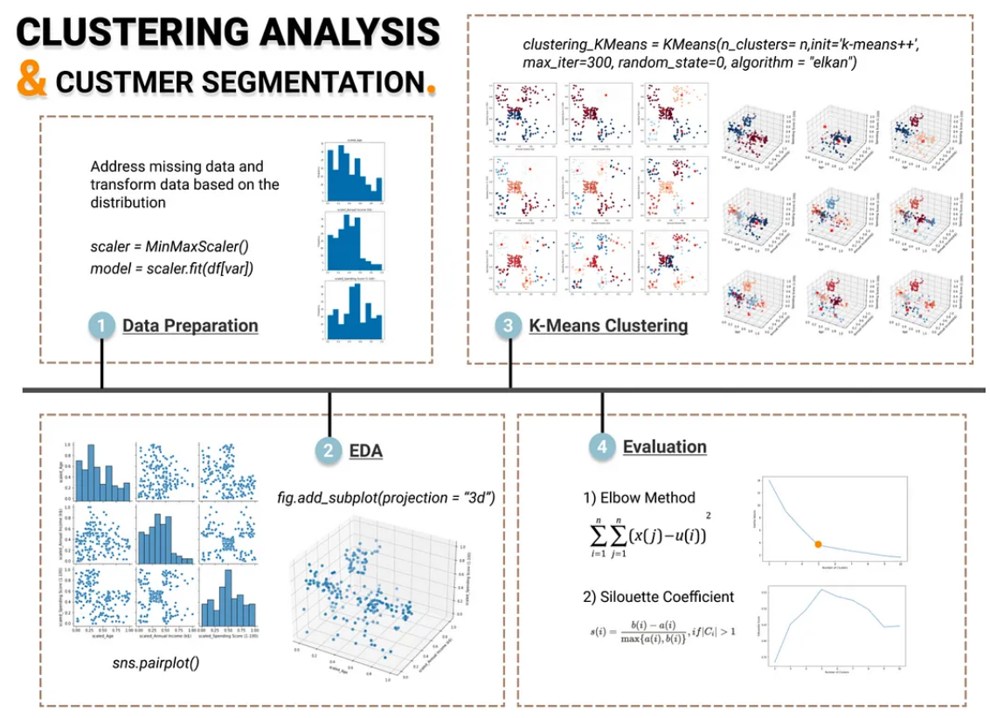
Source: https://towardsdatascience.com/clustering-algorithm-for-customer-segmentation-e2d79e28cbc3
Samsung can implement the algorithm in the following steps:
  - Obtain customer information from a range of sources.
  - Pre-process the data by removing missing values, normalizing the data, and transforming variables if needed.
  - Choose pertinent features that can be used to pinpoint consumer groupings.
  - Utilise methods like the elbow approach or silhouette analysis to determine the ideal number of clusters.
  - Utilise the best number of clusters identified in step d to apply the K-means clustering algorithm to the data.
  - Analyse each cluster's features to create client profiles
  - Create tailored marketing strategies for each consumer category using the customer profiles.

Forecasting Decisions
Machine Learning can be used to forecast numerous business decisions. This is because it can analyse large amounts of data and identify patterns from it. Samsung can apply ML in the following areas (Wasserbacher & Spindler, 2021; Żbikowski & Antosiuk, 2021):
- Sales Forecasting: ML can help Samsung to analyse historical sales data, consumer behaviour and market trends. This information can then be used to make informed decisions on inventory and production so the company won’t produce excess products.
- Demand Forecasting: By analysing key factors like social media activities and google search trends, Samsung can accurately predict the demand for its products. This information can be used to adjust the prices and promotions of the products, to increase their demand.
- Supply Chain Forecasting: ML can also help the company to predict supply chain delays. This will help the company to avoid or overcome them more effectively.
- Financial Forecasting: ML can help Samsung to predict financial outcomes such as revenue, by analysing sales and market trends.

Recommendations
Samsung can improve its digital marketing strategy with the help of following recommendations:
- Increase Personalization: Samsung can leverage machine learning algorithms to personalize its marketing campaigns, content, and product recommendations based on user behavior and preferences. For example, by analyzing user data, Samsung can provide personalized product recommendations, emails, and social media content.
- Enhance the User Experience: Samsung should focus on creating a seamless user experience across all digital channels. This can be achieved by optimizing the website and mobile app performance, simplifying the checkout process, and providing personalized and relevant content.
- Leverage Social Media Influencers: Samsung can collaborate with social media influencers to promote its products and reach a wider audience. For example, Samsung can partner with popular tech bloggers, vloggers, and Instagram influencers to showcase its products and create buzz around new releases.
- Invest in Video Marketing: It is an effective medium for attracting customers and showcasing products. Samsung can utilise video marketing techniques to promote its brand, display its products, and offer training and user manuals.
- Improve Search Engine Marketing (SEM): To boost visibility and increase website traffic, Samsung should invest on improving its search engine marketing methods. Use of pertinent keywords, production of high-quality content, and structural optimisation of the website can help to improve it.
- Leverage Artificial Intelligence: Samsung can improve its marketing efforts by using AI and machine learning techniques. For instance, Samsung can boost product suggestions with image recognition technology, improve customer care and support with chatbots, and enhance marketing efforts with predictive analytics.
- Enhance Consumer Engagement: Samsung should concentrate on enhancing client engagement by giving personalised accurate information, rewards programmes, and excellent customer service.

Conclusion
In conclusion, this report has analysed Samsung's digital marketing strategy in depth, covering various aspects such as the company's digital assets, CRM and marketing information systems, internal and external communication structural flows, information architecture, and the use of machine learning and AI.
Overall, Samsung has a strong digital marketing strategy, but there are areas for improvement. The company's strengths lie in its use of data and technology to create personalized experiences for its customers, its use of social media, and its ability to stay ahead of trends in the market.

References
- Anjard, R.P. (1993) “The basics of DBMS (Data Base Management Systems) for Quality Professionals,” Microelectronics Reliability, 33(2), pp. 211–220. Available at: https://doi.org/10.1016/0026-2714(93)90482-e.
- Apps Run The World (2018) Samsung Electronics Philippines selects Adobe Marketing Cloud (ex omniture) for Marketing Automation, Apps Run The World - Apps Research & Buyer Insight. Apps Run The World. Available at: https://www.appsruntheworld.com/customers-database/purchases/view/samsung-electronics-philippines-philippines-selects-adobe-marketing-cloud-ex-omniture-for-marketing-automation (Accessed: April 19, 2023).
- Bell, J.P. (2022) “What Is Machine Learning?,” Machine Learning and the City, pp. 207–216. Available at: https://doi.org/10.1002/9781119815075.ch18.
- Biskupska, M. (2021) How to use machine learning for customer segmentation | Whites Agency. Available at: https://whites.agency/blog/how-to-use-machine-learning-for-customer-segmentation/.
- Brien, R.H. and Stafford, J.E. (1968) “Marketing information systems: A new dimension for marketing research,” Journal of Marketing, 32(3), pp. 19–23. Available at: https://doi.org/10.1177/002224296803200304.
- Brocato, D., 2010. Push and pull marketing strategies. Wiley International Encyclopedia of Marketing.
- Chaffey, D. and Ellis-Chadwick, F. (2020) Digital Marketing. Harlow, Essex: Pearson.
- Collins, C.M. et al. (2021) “Artificial intelligence in information systems research: A systematic literature review and research agenda,” International Journal of Information Management, 60, p. 102383. Available at: https://doi.org/10.1016/j.ijinfomgt.2021.102383.
- Cornelissen, J. P., & Thorpe, R. (2001). The Organisation of External Communication Disciplines in UK Companies: A Conceptual and Empirical Analysis of Dimensions and Determinants. The Journal of Business Communication (1973), 38(4), 413–438. https://doi.org/10.1177/002194360103800402
- Croudace, L. (2022) How our spending has changed since the end of coronavirus (covid-19) restrictions, How our spending has changed since the end of coronavirus (COVID-19) restrictions - Office for National Statistics. Office for National Statistics. Available at: https://www.ons.gov.uk/businessindustryandtrade/retailindustry/articles/howourspendinghaschangedsincetheendofcoronaviruscovid19restrictions/2022-07-11 (Accessed: April 19, 2023).
- Dawn, S.K. and Guha, A. (2010) ‘E-CRM: A critical analysis by developing an effective model’, Asia Pacific Business Review, 6(3), pp. 106–114. doi:10.1177/097324701000600309.
- Epstein, M.J. and Yuthas, K. (2007) Evaluating the effectiveness of internet marketing efficiencies. Mississauga, Ontario: CMA Canada.
- Gil-Gomez, H. et al. (2019) “Customer relationship management: Digital Transformation and Sustainable Business Model Innovation,” Economic Research-Ekonomska Istraživanja, 33(1), pp. 2733–2750. Available at: https://doi.org/10.1080/1331677x.2019.1676283.
- Gupta, A.K. and Govindarajan, V., 1991. Knowledge flows and the structure of control within multinational corporations. Academy of management review, 16(4), pp.768-792.
- Harmon, R.R., 2002. Marketing Information Systems. Encyclopedia of information systems, 3, pp.137-151.
- Hien, N.N. and Nhu, T.N. (2022) “The effect of digital marketing transformation trends on consumers’ purchase intention in B2B businesses: The moderating role of Brand Awareness,” Cogent Business & Management, 9(1), pp. 1–24. Available at: https://doi.org/10.1080/23311975.2022.2105285.
- IBM (2022) How to use Predictive analytics in your marketing campaigns: IBM Watson Advertising, IBM. Available at: https://www.ibm.com/watson-advertising/thought-leadership/how-to-use-predictive-analytics-in-advertising (Accessed: 03 May 2023).
- Indeed (2023) Guide to marketing information systems and WHY THEY MATTER, Indeed. Available at: https://www.indeed.com/career-advice/career-development/marketing-information-system (Accessed: 03 May 2023).
- Katuu, S. (2020) ‘Enterprise resource planning: Past, present, and future’, New Review of Information Networking, 25(1), pp. 37–46. doi:10.1080/13614576.2020.1742770.
- Khajvand, M. et al. (2011) “Estimating customer lifetime value based on RFM analysis of customer purchase behavior: Case study,” Procedia Computer Science, 3, pp. 57–63. Available at: https://doi.org/10.1016/j.procs.2010.12.011.
- Li, Y. et al. (2022) “Customer Segmentation Using K-Means Clustering and the Hybrid Particle Swarm Optimization Algorithm,” The Computer Journal [Preprint]. Available at: https://doi.org/10.1093/comjnl/bxab206.
- Lunenburg, F.C., 2010. Formal communication channels: Upward, downward, horizontal, and external. Focus on Colleges, Universities, and Schools, 4(1), pp.1-7.
- Matende, S. and Ogao, P. (2013) ‘Enterprise resource planning (ERP) system implementation: A case for user participation’, Procedia Technology, 9, pp. 518–526. doi:10.1016/j.protcy.2013.12.058.
- Misischia, C.V., Poecze, F. and Strauss, C. (2022) “Chatbots in customer service: Their relevance and impact on service quality,” Procedia Computer Science, 201, pp. 421–428. Available at: https://doi.org/10.1016/j.procs.2022.03.055.
- Ogbeiwi, O. (2017) ‘Why written objectives need to be really smart’, British Journal of Healthcare Management, 23(7), pp. 324–336. doi:10.12968/bjhc.2017.23.7.324.
- Parmer, L.L., Dillard, J.E. and Lin, Y.-C. (2021) ‘The 8PS marketing mix and the buyer decision-making process’, Journal of Marketing Development and Competitiveness, 15(4), pp. 32–44. doi:10.33423/jmdc.v15i4.4774.
- Prabhu, S. and Bhat, S. (2020) “Application of Artificial Intelligence in Samsung – A Case Study,” Zenodo (CERN European Organization for Nuclear Research) [Preprint]. Available at: https://doi.org/10.5281/zenodo.4427264.
- Profiletree (2023) Digital Marketing Analysis: How to do research for a digital strategy?, ProfileTree. ProfileTree. Available at: https://profiletree.com/digital-marketing-analysis/ (Accessed: April 19, 2023).
- Reed, D. (2014) ‘SOSTAC: The guide to the perfect digital marketing plan’, Journal of Direct, Data and Digital Marketing Practice, 16(2), pp. 146–147. doi:10.1057/dddmp.2014.79.
- Robson, P.J.A. and Tourish, D. (2005) “Managing internal communication: An organizational case study,” Corporate Communications: An International Journal, 10(3), pp. 213–222. Available at: https://doi.org/10.1108/13563280510614474.
- Rosario, A., R., R. and Pillai, V. (2022) “A study on digital marketing and its types: A deep review of pros and cons,” Integrated Journal for Research in Arts and Humanities, 2(4), pp. 140–145. Available at: https://doi.org/10.55544/ijrah.2.4.76.
- Salesforce (2022) How Salesforce is Transforming Samsung's Sales Performance, Salesforce. Salesforce. Available at: https://www.salesforce.com/video/297926/ (Accessed: April 19, 2023).
- Samsung (2021) Samsung Experience Store - Design Your Experience Online, Samsung levant. Samsung . Available at: https://www.samsung.com/levant/samsung-experience-store/about/ (Accessed: April 19, 2023).
- Samsung (2022) Samsung Electronics expands the next generation ERP system to 120 offices worldwide, Samsung Global Newsroom. Available at: https://news.samsung.com/global/samsung-electronics-expands-the-next-generation-erp-system-to-120-offices-worldwide (Accessed: 03 May 2023).
- Santouridis, I. and Tsachtani, E. (2015) ‘Investigating the impact of CRM resources on CRM processes: A customer life-cycle based approach in the case of a Greek bank’, Procedia Economics and Finance, 19, pp. 304–313. doi:10.1016/s2212-5671(15)00031-3.
- Song, I.-Y. (2009) “Data Warehouse,” Encyclopedia of Database Systems, pp. 657–658. Available at: https://doi.org/10.1007/978-0-387-39940-9_882.
- Stauss, B., Gouthier, M. and Seidel, W. (2007) ‘Satisfaction measurement within the customer relationship life cycle’, Advances in Services Innovations, pp. 205–220. doi:10.1007/978-3-540-29860-1_11.
- Toh, M. (2023) Samsung profits sink to 8-year low as smartphone and PC demand drops | CNN business, CNN. Cable News Network. Available at: https://edition.cnn.com/2023/01/30/tech/samsung-electronics-earnings-q4-2022-intl-hnk/index.html (Accessed: April 19, 2023).
- Tohidi, H. and Jabbari, M.M. (2012) ‘The necessity of using CRM’, Procedia Technology, 1, pp. 514–516. doi:10.1016/j.protcy.2012.02.110.
- Ullal, M.S. et al. (2021) “The Role of Machine Learning in Digital Marketing,” SAGE Open, 11(4), p. 215824402110503. Available at: https://doi.org/10.1177/21582440211050394.
- Veleva, S.S. and Tsvetanova, A.I. (2019) “Characteristics of the digital marketing advantages and disadvantages,” IOP Conference Series: Materials Science and Engineering, 940(1), p. 012065. Available at: https://doi.org/10.1088/1757-899x/940/1/012065.
- Verhoef, P.C. et al. (2021) “Digital transformation: A multidisciplinary reflection and research agenda,” Journal of Business Research, 122, pp. 889–901. Available at: https://doi.org/10.1016/j.jbusres.2019.09.022.
- Wang, C. (2022) ‘Efficient Customer Segmentation in digital marketing using Deep Learning with swarm intelligence approach’, Information Processing & Management, 59(6), p. 103085. doi:10.1016/j.ipm.2022.103085.
- Wang, C. (2022) “Efficient Customer Segmentation in digital marketing using Deep Learning with swarm intelligence approach,” Information Processing & Management, 59(6), p. 103085. Available at: https://doi.org/10.1016/j.ipm.2022.103085.
- Wasserbacher, H. and Spindler, M. (2021) “Machine learning for financial forecasting, planning and analysis: recent developments and pitfalls,” Digital Finance, 4(1), pp. 63–88. Available at: https://doi.org/10.1007/s42521-021-00046-2.
- Żbikowski, K. and Antosiuk, P. (2021) “A machine learning, bias-free approach for predicting business success using Crunchbase data,” Information Processing and Management, 58(4), p. 102555. Available at: https://doi.org/10.1016/j.ipm.2021.102555.
- Zhou, Y. (2020) “The Samsung Story,” Nature Electronics, 3(5), pp. 234–234. Available at: https://doi.org/10.1038/s41928-020-0418-8.

Appendix 1

Samsung’s Retail Distribution Channels
Samsung has a significant presence in the retail industry and sells its products through several channels of sales like:
- Samsung.com: Samsung's official website, Samsung.com, is a major sales channel of the company. Customers can view and purchase a wide range of products like smartphones, wearables, and home appliances.
- Samsung Experience Stores: These are the company’s flagship retail stores where customers can see and try its products. They provide an interactive user experience and regularly holds events and promotions to attract customers (Samsung, 2021).
- Third Party Sellers: The company also sells its products through third party online and offline sellers like Amazon and Argos. It helps the company to reach a wider audience and generate more revenue.
Overall, the core purpose of Samsung’s retail strategy is to provide its customers with a seamless and valuable experience. By providing its products across several sales channels and an interactive purchase environment, the company is not only generating revenue, it is also creating a community of brand loyal customers.

PESTLE
PESTLE analysis is used to examine how external influences affect a firm. Here are some illustrations of each factor in relation to Samsung's digital marketing:
- Political: The regulatory environment in which a corporation operates can be impacted by political issues. When the Galaxy Note 7 cellphones started exploding owing to battery problems in 2016, Samsung was confronted with a political catastrophe. This resulted in a global recall and damaged the company's reputation.

- Economic: The economic climate in which a business operates is referred to as an economic element. The COVID-19 epidemic had an impact on Samsung's sales in 2020 as people's purchasing power fell. Samsung was able to counteract this decline, nevertheless, by seeing an increase in sales of its electronics goods.
- Sociocultural: The socioeconomic and cultural context in which a firm operates is referred to as a sociocultural element. Samsung has been successful in capitalising on the growing consumer trend of a greater reliance on technology in daily life. The business has been successful in establishing itself as a lifestyle brand that provides cutting-edge and superior goods.
- Technological: The technological environment in which a firm operates is referred to as a technological component. Samsung has long been at the forefront of technical advancement and has successfully taken advantage of this. By introducing smart appliances and home automation systems, for instance, the company has been able to establish a strong position in the smart home industry.
- Legal: The laws and rules that apply to a firm are referred to as legal considerations. Over the years, Samsung has encountered numerous legal issues, such as claims of price fixing and lawsuits for patent infringement. The reputation and financial performance of the organisation may suffer as a result of these legal issues.
- Environmental: The effect that a business has on the environment is referred to as an environmental factor. Samsung has been working to lessen its influence on the environment by introducing eco-friendly products, lowering its carbon footprint, and enhancing the sustainability of its supply chain. For instance, Samsung wants to use less plastic in its product packaging as part of its eco-friendly packaging programme.

SWOT
SWOT analysis is used to evaluate a company's opportunities, threats, weaknesses, and strengths. Here are some illustrations of each factor in relation to Samsung's digital marketing:
Strengths
- Brand recognition: Samsung is a well-known company with a solid track record for producing high-quality, cutting-edge goods. It benefits from this in the very competitive digital economy.
- Technology advancement: Samsung has a long history of technology advancement and has been successful in introducing new goods and features before its rivals. As a result, the business can establish a powerful market presence.
- Diversification: Samsung has a diverse product portfolio, which enables it to cater to a wide range of customers across different markets.
Weaknesses
- Dependence on suppliers: For the parts that make up its products, Samsung is incredibly reliant on its suppliers. As a result, there is a chance that the supply chain may be disrupted, which could hurt the business's performance.
- Lack of differentiation: Samsung confronts fierce rivalry in various product areas and finds it difficult to set itself apart from its rivals. This can reduce the market share of the business.
- Overpricing perception: Some customers believe that Samsung items are overpriced, which may have a detrimental effect on sales.
Opportunities
- Growth in emerging markets: Samsung has the chance to increase its market share in developing nations where the demand for digital products is rising.
- Increasing online sales: As e-commerce continues to grow, Samsung has the chance to do so by expanding its online customer base.
- Demand for environmentally friendly products is on the rise. Samsung can take advantage of this trend by releasing environmentally friendly items.
Threats
- Samsung is up under fierce competition from other digital behemoths like Apple and Huawei, which could affect its market share.
- Technology disruption: In order to stay competitive, Samsung must keep up with technological breakthroughs as the digital market is continuously changing.
- Legal and regulatory issues: Samsung could run into legal and regulatory issues, like antitrust investigations, that could harm its reputation and financial results.

Samsung Summarised Annual Statements
Parameter Name | Currency | 2018 | 2019 | 2020 | 2021 | 2022

Income Statements
Total Revenue | KRW | 243771415.00 | 230400881.00 | 236806988.00 | 279604799.00 | 302231360.00
Gross Profit | KRW | 111377004.00 | 83161332.00 | 92318692.00 | 113193457.00 | 112189590.00
Operating Income | KRW | 58885094.00 | 27768509.00 | 35993876.00 | 51633856.00 | 43376630.00
Net Income | KRW | 43890877.00 | 21505054.00 | 26090846.00 | 39243791.00 | 54730018.00
Diluted Normalized EPS | KRW | 6429.26 | 3164.10 | 3966.89 | 5770.77 | 8050.98

Balance Sheet
Total Current Assets | KRW | 174697424.00 | 181385260.00 | 198215579.00 | 218163185.00 | 218470581.00
Total Assets | KRW | 339357244.00 | 352564497.00 | 378235718.00 | 426621158.00 | 448424507.00
Total Current Liabilities | KRW | 69081510.00 | 63782764.00 | 75604351.00 | 88117133.00 | 78344852.00
Total Liabilities | KRW | 99288251.00 | 97649025.00 | 110565387.00 | 130383461.00 | 103238365.00
Total Equity | KRW | 240068993.00 | 254915472.00 | 267670331.00 | 296237697.00 | 345186142.00
Total Common Shares Outstanding | KRW | 6792.67 | 6792.67 | 6792.67 | 6792.67 | 6792.67

Cash Flow
Cash from Operating Activities | KRW | 67126050.00 | 45978175.00 | 64453009.00 | 66687633.00 | 61642148.00
Cash from Investing Activities | KRW | -52240453.00 | -39948171.00 | -53628591.00 | -33047763.00 | -31602804.00
Cash from Financing Activities | KRW | -15090222.00 | -9484510.00 | -8327839.00 | -23991033.00 | -19390049.00
Net Change in Cash | KRW | -204625.00 | -3454506.00 | 2496579.00 | 9648837.00 | 10649295.00
Source: Marketline

Appendix 2

Benefits of Digital Marketing
The pandemic of Covid 19 has forced customers to shift from the traditional method of offline shopping into the new online shopping (Croudace, 2022). Hence, companies are scaling their online capabilities and assets to attract most of these people to purchase from them. In other words, companies must adapt to these changes in consumer behaviour and devise innovative digital marketing strategies, to survive in the current business scenarios.
Retail companies can harvest numerous benefits from employing digital marketing strategies (Veleva & Tsvetanova, 2019). Some of them are as follows:
- Wider Audience Reach: One of the key advantages of digital marketing is its ability to reach a wider audience. As the world is becoming more technologically connected, the usage of digital devices like PCs, smartphones and tablets is getting increased every day. This provides companies with a great opportunity to reach their target customers. Hence, by applying digital marketing strategies, companies can not only reach a wider audience, they can also increase the traffic to their digital assets like websites and social media pages.
- Data Analytics: Digital marketing also helps retail organizations to analyse their consumer behaviour and preferences. With the help of data analytics companies could get an insight into the needs, wants and purchasing habits of their customers. This will help to create tailor made advertisements which in turn results in higher revenue generation.
- Cost Effective: Digital marketing is generally more cost effective in comparison with traditional marketing channels like television, audio and print advertising. This is particularly helpful for new companies with limited marketing budget.

Strengths and Weaknesses of Samsung's Digital Marketing Strategy
The digital marketing strategy of Samsung has several strengths such as:
- Strong Brand Image: Samsung is a globally renowned branch with strong presence in almost every market in the world. This will help the company reach its target audience more quickly.
- Diverse Product Range: The company manufactures numerous products from consumer electric goods to smartphones. This helps the company to access diverse customer bases, which in turn increases the revenue.
- Social Media Presence: Samsung also has a strong social media presence which helps the company to engage with its customers and build strong relationships.
- Innovative Products: The company is known for numerous innovative products like the Galaxy S series, which helps it to differentiate itself from the competitors.
- Strong Distribution Network: The company has a very robust supply chain network which helps it to reach the customers quickly and safely.
However, the strategy also has a few weaknesses such as:
- Intense Competition: Samsung faces intense competition from companies like Apple, Huawei, and Xiaomi, which could affect the market share of the company.
- Limited SEO Focus: The official Samsung website lacks proper SEO optimisation, which could impact its visibility on search engines.
- Limited Focus on Content Marketing: The company also has a limited focus on content marketing, which could limit its customer engagement capabilities.
- Limited Focus on Influencer Marketing: Samsung lacks a proper influencer marketing policy. This could hamper its brand image among young people who looks up to influencers, for product recommendations.

