Certificate of Higher Education Skills for Workplace (Health and Social Care)
LCHS4001 Academic and Employability Skills
Practical portfolio of work
Marcel Macovei
Student ID:2521005

Table of Contents
Task 1: Individual Video 2
Task 2: Reflective Activity 7
Task 3: Report 11
3.1 Introduction 11
3.2 The chosen role within the health and social care sector and examples of role-specific duties and responsibilities 11
3.3 Three essential skills for this role and why they are significant 12
3.4 Three separate strategies to improve these skills and how they would help me 13
3.5 Conclusion 13
References 14

Task 1: Individual Video
Slide 1: Title
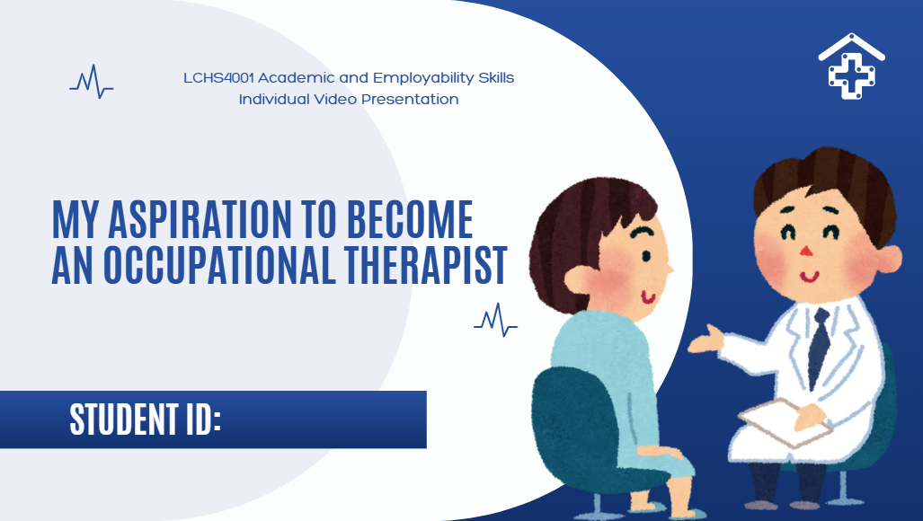
Slide 2: Contents
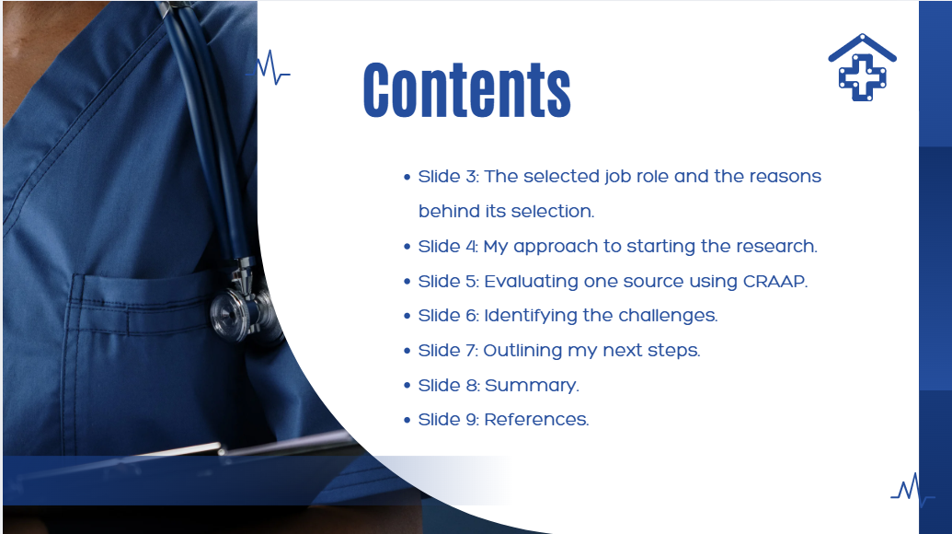
Slide 3: The selected job role and the reasons behind its selection
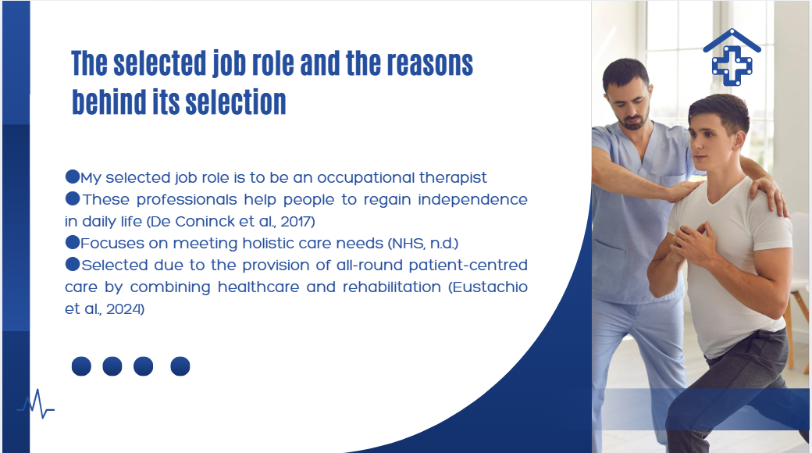
Slide 4: My approach to starting the research

Slide 5: Evaluating one source using CRAAP
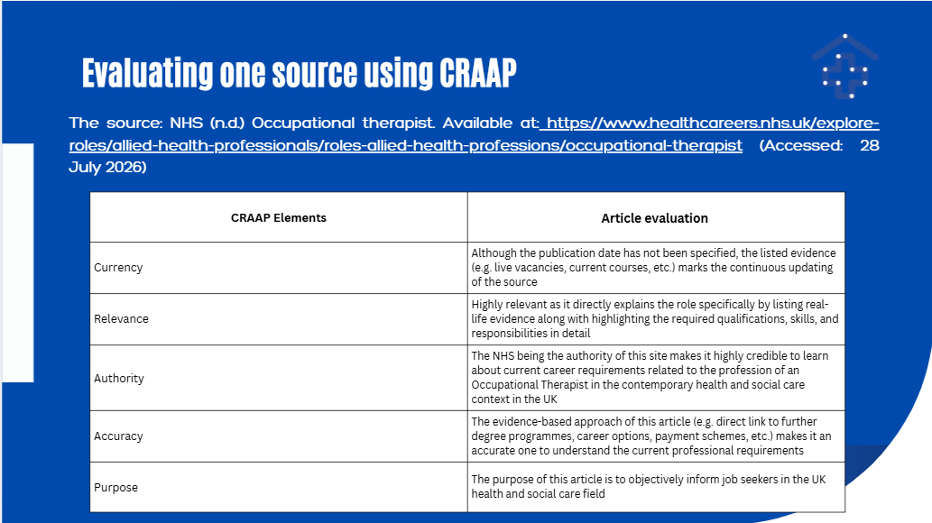
Slide 6: Identifying the challenges
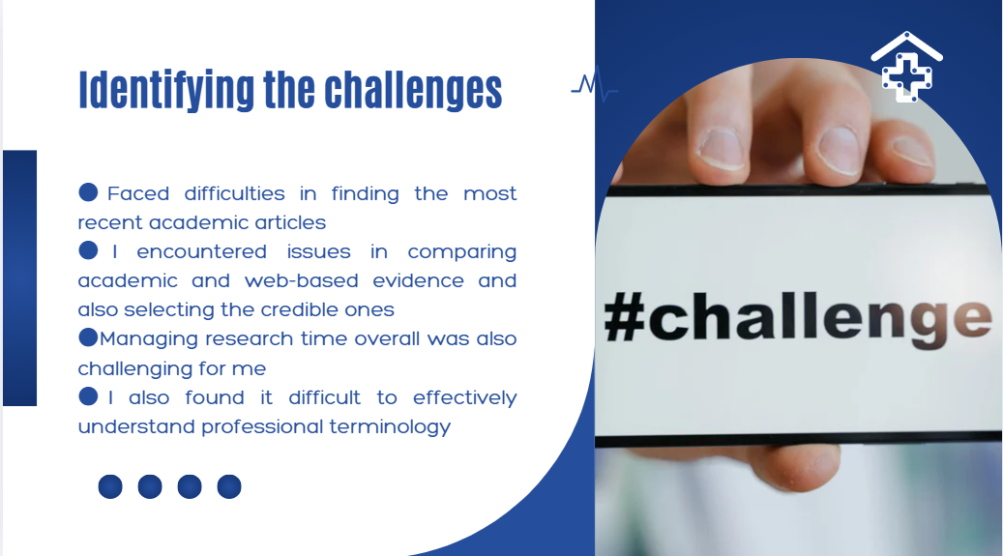
Slide 7: Outlining my next steps
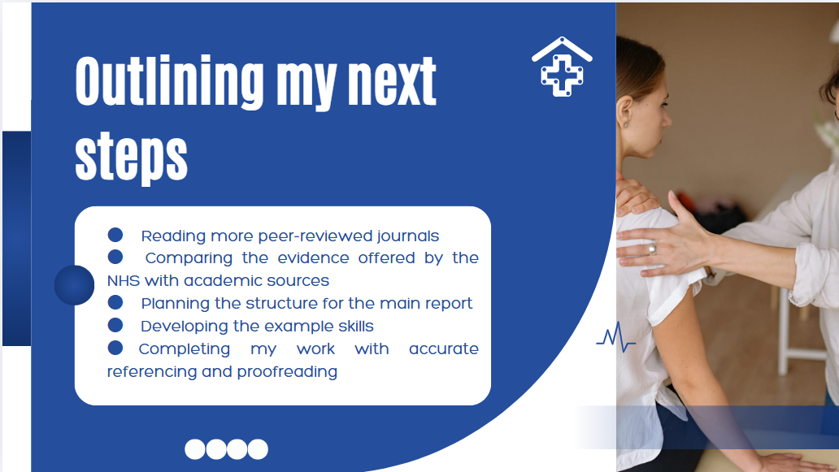
Slide 8: Summary
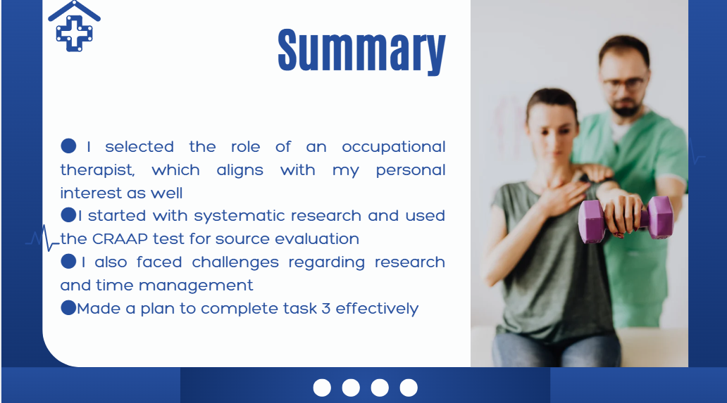
Slide 9: References
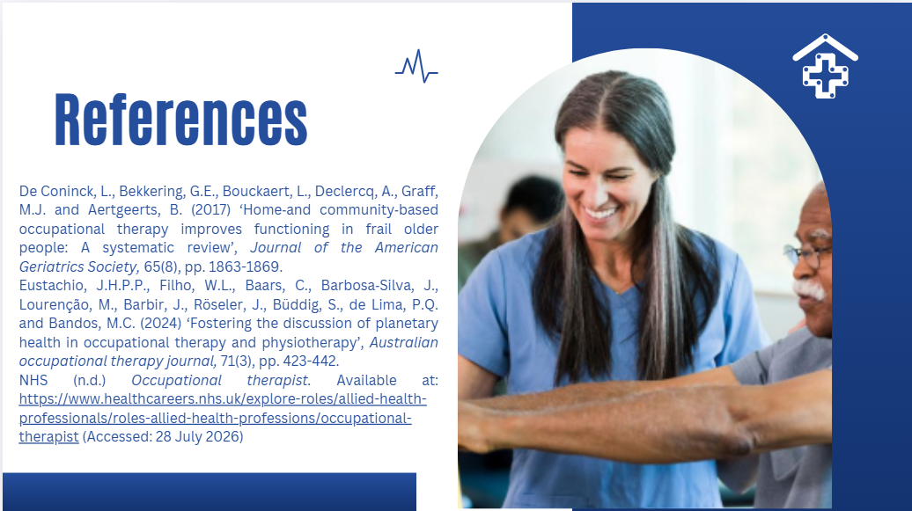

Task 2: Reflective Activity
Reflective Stages | Notes/Ideas
What: Description  1. What was your presentation about?  2. What went well? (What were you happy with?)  3. What was difficult? (What problems did you have?)  4. You can also include how you felt before, during, and after the presentation | - My presentation focused on the role of an Occupational Therapist in the UK health and social care sector.  - I explained why I selected this profession.  - I discussed my research process, including the sources and keywords I used.  - I evaluated the NHS Health Careers website using the CRAAP test.  - I identified research challenges and outlined my next steps for completing the report.  - I organised my presentation logically and followed the required structure.  - I explained my ideas clearly using simple language.  - I stayed focused on the assessment requirements.  - My slides were clear and supported my spoken explanation.  - I felt slightly nervous before presenting.  - I found it difficult to keep within the time limit while covering every point.  - I was unsure whether I was speaking at the right pace.  - With time, I got my confidence back  - I felt a sense of relief after completing the presentation when I found I had completed it successfully
So What: The Implications of the Situation  1. What did you learn about your presentation skills?  2. What would you do differently next time?  3. What does this experience tell you about how you work or prepare? | ·  - Preparation increased my confidence.  - A clear structure helped me present ideas more effectively.  - Using keywords instead of reading a script made my presentation sound more natural.  - Practise more to improve fluency and timing.  - Maintain better eye contact with the audience at a slow pace.  - Include more role-specific examples to strengthen my explanation.  - I perform better when I plan my work in advance.  - Using credible sources improves the quality of my work and confidence in presenting
Now What?: The Action Plan  Think about how to improve in the future:  1. What will you do next time to make your presentation better?  2. What will help you stick to your plan? (e.g. setting goals, getting support)  Be specific – What exactly will you practise?  For example:  Will you practise speaking in front of a friend?  Will you use a checklist to plan your presentation? | - Practising my presentation several times and recording myself before delivering it.  - Preparing concise cue cards instead of relying on slides.  - Creating a weekly study schedule and setting personal deadlines.  - Asking classmates or my lecturer for feedback after practising.  - Speaking confidently and managing time.  - Improving pronunciation and eye contact.  - Researching and referencing academic sources more effectively for Task 3
Any other thoughts?

Task 3: Report

3.1 Introduction
In the contemporary health and social care context in the UK, the profession of occupational therapist (OT) is emerging. This job role is gaining ample significance due to its emphasis on enabling people to positively participate in meaningful daily activities regardless of their physical, cognitive, or even mental health issues (De Coninck et al., 2017). As per the article by NHS (n.d.), these professionals work with individuals across various age groups in diverse professional or social settings, for instance, hospitals, care homes, schools, community settings, or even at residential spaces of individuals to improve the quality of life of the needy ones by satisfying their unique needs. Thus, considering this chosen job role, this report critically examines the specific duties and responsibilities of these professionals in the UK health and social care setting, along with the three skills and their improvement strategies for me to deliver safer and high-quality patient care in the future.

3.2 The chosen role within the health and social care sector and examples of role-specific duties and responsibilities
An occupational therapist, in line with the views of Reitz et al. (2020), can be regarded as an allied health professional who supports individuals of all ages to overcome their physical, social, developmental, or even mental health challenges that hinder their abilities to carry out everyday activities. In the UK health and social care context, occupational therapists need to work in varied settings, such as NHS hospitals, adult care homes, a GP’s practice, or even within specific residential areas of clients (National Careers Service, n.d.). The primary focus of this job role is to promote independence. It is also a core responsibility of occupational therapists to improve the well-being of patients and, at the same time, enable individuals to meaningfully participate in daily activities, such as education, work, or even self-care, too. Considering the views of Morris and Jenkins (2018), one of the core responsibilities of an occupational therapist is to assess effectively the physical, emotional, cognitive, and environmental needs in order to ensure their holistic well-being. For instance, after encountering a stroke, an occupational therapist needs to critically evaluate the abilities of the patient to move safely around the rooms or do basic self-care activities before suggesting a rehabilitation plan. On the other hand, another important responsibility in this context can be the provision of personalised intervention with safety. Lindström and Isaksson (2017), in this context, claimed that when an occupational therapist effectively delivers personalised intervention, patients become more able to work independently or regain their confidence level. If seen from the contemporary health and social care context, the formation of multidisciplinary teams (MDT) has emerged as a key practice. It is another key duty for occupational therapists to actively collaborate with diverse professionals, such as doctors, nurses, therapists, social workers, and many others, to deliver effective person-centred care through a coordinated approach (HCPC, 2023). Along with regularly monitoring the progress level of patients and making necessary adjustments to the developed interventions, occupational therapists need to regularly educate patients as well as their families and carers regarding the rehabilitation strategies to ensure long-term recovery and well-being for individuals.

3.3 Three essential skills for this role and why they are significant
For this profession of an OT, first of all, effective communication is fundamental as the professionals require continually interacting with multidisciplinary experts as well as patients and their related parties. As per the professional standards outlined by HCPC (2023), occupational therapists need to have a strong proficiency in verbal and non-verbal communication. This can ensure not only producing comprehensive care and support plans but also encouraging patients to positively share their concerns to make effective decisions. For instance, while working with a patient who recovered from an accident, an occupational therapist needs to explain relevant exercises and adaptive techniques to ensure the patient can perform them safely at home. Thus, effective communication skills are vital for occupational therapists to deliver safe and person-centred care.
Further, empathy is essential to build robust therapeutic relationships based on trust (Barañao et al., 2024). Occupational therapists often work with vulnerable and sensitive patients. For instance, while dealing with an elderly patient with dementia, it is required for the OT to understand the unique emotional challenges the person encounters in order to adapt activities accordingly to boost lost confidence. Thus, here, demonstrating empathy can ensure that the professional respects the unique needs and emotions of the patients and is able to deliver compassionate care.
Problem-solving with clinical reasoning is another vital skill for OTs as the circumstances of every patient are unique. OTs need to critically assess the complexity of such situations to determine the barriers accurately and develop practical solutions to cater to the unique individual needs (Hagelskjær et al., 2024). For instance, for an older adult who is at risk of falling at home, an OT can recommend environmental modifications and daily living strategies by visiting the location to improve the safety of the person. Thus, this skill ensures that the OT is capable of developing evidence-based interventions to ensure utmost safety while delivering care as per the evolving needs of patients.

3.4 Three separate strategies to improve these skills and how they would help me
In line with the identified three skills, relevant strategies have been developed here to establish myself as an effective OT. To improve verbal and non-verbal communication skills, participation in supervised clinical settings as an intern can help, as it can offer the scope to work directly with patients under the guidance of experienced professionals. Such a measure can help me find a hands-on learning opportunity to carry out professional responsibilities in an MDT setting. It is also noteworthy that I can regularly collect feedback from my supervisors to find areas for further improvement. Besides, practising reflective analysis regularly can shape empathetic abilities (Perkins and Schmid, 2019). Reflecting consistently on my experiences of dealing with patients and evaluating how well I can understand their emotions and needs can help me improve my practices continually, especially in delivering a more compassionate and person-centred care. To improve problem-solving with clinical reasoning abilities, it is essential to undertake continuous professional development (CPD). For instance, by participating in simulation exercises, workshops, and even evidence-based training, the ability to solve real-life problems based on effective decisions can be enhanced. I think such CPD training would help me work on real case scenarios to understand how to make evidence-based rehabilitation plans and thus can support my professional development in terms of delivering high-quality care.

3.5 Conclusion
Thus, to draw a conclusion to this report, it can be stated that the role of an occupational therapist is becoming highly significant in the contemporary UK health and social care context and beyond. With the core responsibility to improve the quality of life of individuals through a personalised rehabilitation plan, these professionals require collaborating with multidisciplinary teams and wider stakeholders. The core skills, like empathy, communication, and problem-solving, are required to be adopted to achieve success in this career role, which can be attained through participating in a supervised clinical setting, developing a regular habit of reflection and pursuing CPD activities in the future.

References
Barañao, E.L., Alfonso, C.M., Soriano, A.J.A., Layno, V.W.T., Tuquib, K.D.V. and Villanueva, L.J.T. (2024) ‘The Lived Experiences of Occupational Therapists in Building Trust with their Patients’, Ignatian International Journal for Multidisciplinary Research, 2(5), pp. 758-786.
De Coninck, L., Bekkering, G.E., Bouckaert, L., Declercq, A., Graff, M.J. and Aertgeerts, B. (2017) ‘Home‐and community‐based occupational therapy improves functioning in frail older people: A systematic review’, Journal of the American Geriatrics Society, 65(8), pp. 1863-1869.
Eustachio, J.H.P.P., Filho, W.L., Baars, C., Barbosa‐Silva, J., Lourenção, M., Barbir, J., Röseler, J., Büddig, S., de Lima, P.Q. and Bandos, M.C. (2024) ‘Fostering the discussion of planetary health in occupational therapy and physiotherapy’, Australian occupational therapy journal, 71(3), pp. 423-442.
Hagelskjær, V., Wæhrens, E.E., von Bülow, C. and Nielsen, K.T. (2024) ‘Qualitative realist evaluation of an occupational therapy intervention programme (ABLE), addressing ability to perform activities of daily living among persons with chronic conditions’, BMC Health Services Research, 24(1), p. 9.
HCPC (2023) Occupational therapists. Available at: https://www.hcpc-uk.org/standards/standards-of-proficiency/occupational-therapists/ (Accessed: 29 July 2026)
Lindström, M. and Isaksson, G. (2017) ‘Personalized occupational transformations: Narratives from two occupational therapists’ experiences with complex therapeutic processes’, Occupational Therapy in Mental Health, 33(1), pp. 15-30.
Morris, D.M. and Jenkins, G.R. (2018) ‘Preparing physical and occupational therapists to be health promotion practitioners: a call for action’, International journal of environmental research and public health, 15(2), p. 392.
National Careers Service (n.d.) Occupational therapist. Available at: https://nationalcareers.service.gov.uk/job-profiles/occupational-therapist (Accessed: 29 July 2026)
NHS (n.d.) Occupational therapist. Available at: https://www.healthcareers.nhs.uk/explore-roles/allied-health-professionals/roles-allied-health-professions/occupational-therapist (Accessed: 28 July 2026)
Perkins, N.A. and Schmid, A.A. (2019) ‘Increasing emotional intelligence through self-reflection journals: Implications for occupational therapy students as emerging clinicians’, Journal of Occupational Therapy Education, 3(3), p. 5.
Reitz, M.S., Scaffa, M.E. and Dorsey, J. (2020) ‘Occupational therapy in the promotion of health and well-being’, American Journal of Occupational Therapy, 74(3), pp. 74034200101-740342001014.

