DS 1 Template

Konya Gamanga

Using Module to support my learning

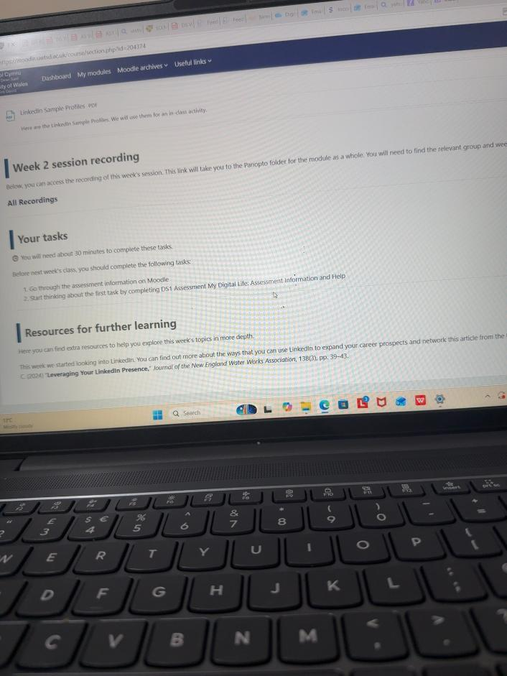
This photo shows me using Module on my laptop to access the Week 2 learning materials. I can see links to the slides, PowerPoint, session recording and weekly tasks. This is one way I use digital tools for my studies because it allows me to find information outside the classroom and return to the materials when I need to check something.
What I can do and what I find difficult
I can open the module page and find the weekly resources. However, I found it difficult to locate the full DS1 instructions because I was unsure which link to open. Seeing the weekly materials did not immediately tell me what I needed to submit. This showed me that opening Module and understanding the assessment area are different skills.
My next step
I want to become more confident finding the assessment information, template and submission area. Before my next assignment, I will check these sections early and write down the deadline and required file format. If something is unclear, I will ask my tutor before the deadline so I have
time to prepare my work.

2.Outlook and word documents
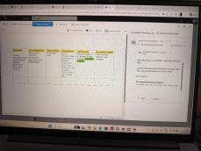
What my photo shows
This photo shows Outlook with the Word reading-log template open as an attachment. My tutor sent the template to help students begin their own reading log. It shows that I can access a university email and view an attached document. Opening the template helps me understand the layout before I start adding information.
How I should use the Reading Log
The Reading Log is a table for keeping a record of the sources I read. For each source, I should record its title, author or organization, publication date, link or file name, full reference and a reason for choosing it. I should use the example row to understand the format, then add sources .I have actually read rather than treating the example as my own research. The CRAAP questions help me explain my choice: is the source current, relevant to my topic,
written by a suitable author, supported by evidence, and clear about its purpose? Recording these details as I read will help me find the source again and prepare my references. The Week 3 slides connect this activity to organizing sources and supporting the DS1 and DS3 assessments.
What I want to improve
Being able to view a Word attachment does not show that I can confidently edit and format a document. I want to practise downloading the template, saving my own copy with a clear name and entering information neatly into the table. I also want to check the required referencing style before completing the full-reference column.

Working through online guidance
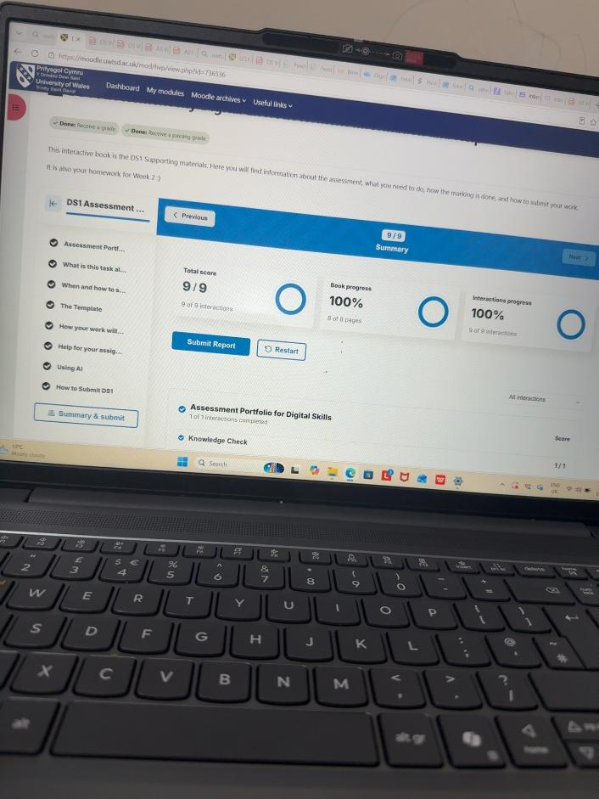
What my photo shows
This photo shows the DS1 support book on Module. The screen displays 9/9 pages completed and 100% progress. It is evidence that I worked through the online guidance. Completing these activities is separate from preparing and uploading my assessment document, so I still need to check the actual submission area.
What the DS1 guidance explains
The guidance explains that DS1 is about the digital tools I already use, the things I feel confident doing and the skills I want to improve. It asks for a few screenshots or photos and a short reflection in simple language. The example gives an idea of how to present the work, but it does not mean I must use the same apps or claim the same skills.
What I learned from this experience
At first, I thought finishing every page meant I had done everything required. I now understand that completing guidance, writing a draft and submitting an assignment are separate steps. This is useful because it helps me identify exactly what I have finished and what I still need to do, rather than relying only on a progress percentage.
My next step
For future assessments, I will read the task information alongside the template and marking criteria. After uploading my file, I will check the submission status or receipt. I will also ask my tutor if I am unsure whether a task is practice, a draft or a final submission.

My reflection and development plan
My digital life
I use my phone and laptop to check emails, access Module and open documents for my studies. I feel comfortable reading messages in Outlook and opening weekly learning materials, but I am still building my confidence with the assessment sections. My photos show that I can view a Word attachment and work through online guidance, although I need more practice editing
documents and managing the final submission process. I used to think I needed to read every word to find an answer. Practising scanning helped me
look for names, numbers and key words more quickly. I want to continue practising this skill while remembering that I still need to read important sections carefully to understand their meaning. This will help me find information efficiently without missing the instructions or taking
information out of context. I want to improve how I organise files and record sources. The Reading Log gives me a structure for keeping the details of what I read, while the CRAAP questions remind me to check the quality
of the information. I need to make my decisions based on the source itself, rather than assuming that every online result is suitable for university work.
My practical next steps
Finding instructions: At the start of each task, I will locate the brief, template and submission page, then note the deadline and file requirements.
Using Word and organizing files: I will practise saving and editing my own copy of a document and use a clear folder for each module.
Searching and recording sources: I will use relevant search words, read suitable sources and record their details in my Reading Log as I go.
Checking my progress: I will review what I can do independently and ask for help with the steps that still confuse me.

My Short Reflection
- Write 5–8 simple sentences about your digital life.
- You can use the sentence starters below if helpful.

Sentence starters
- I use digital tools to …
- I feel confident when I …
- I want to improve …
- I often use these tools: …
- I sometimes feel nervous about …
- I hope this module will help me …
- Digital skills are important for me because …
You can write more if you want.

Submission Checklist
Before you submit, please check:
​​​ ☐ I added 4–6 screenshots
☐ I wrote short sentences for each screenshot
☐ I wrote my short reflection
☐ My work is my own
☐ My file opens correctly
​​☐ My file opens correctly

