

Student Names: | Sara Castañares Esteban (1817439)
Module No: | BMSW4001
Module Title: | Academic and employability skills
Lecturer: | Dr Sylvia Hoffman

TABLE OF CONTENTS

- CV’s AND APPLICATION FORMS
  - INTRODUCTION
  - WHAT TO CONSIDER IN A CV
  - PROFESSIONAL OBJECTIVES
  - REFERENCES
  - COVERING LETTER

- DRISCOLL MODLE
- PRESENTATION IN CLASS
  - UNFAIR PRACTICE
- 5 TIPS TO IMPROVE YOUR CRITICAL THINKING
- INDIVIDUAL TASK
- REFERENCES

- CV’s AND APPLICATION FORMS

  - INTRODUCTION

Why is very important a curriculum vitae?

When you need to be chosen, the companies apply a lot of filters until they have exactly the profile that they are looking for.

The first filter to be called to a in interview is the correct presentation of your skills, experience and studies. You need to sell yourself exposing the reasons to be chosen.

When you are looking for a job, you should follow some steps, a usual mistake that people used to make is a poorly written, a curriculum vitae no clear with misspellings or impersonal words. It has to be clear that this is only a professional way to write for a future job position.

The point is trying to capture the attention and interest of the person who will decide if we will be the perfect candidate for the job, for this we need a good writing, clear, organized, concise and dynamic CV.

We need to describe as short as possible, is better a description of one line than four. An extensive CV with a lot of sheets will be rejected. So be concise is one of the great points.

When you finish, read it and be critical with yourself, Are you the perfect candidate? Is formal or informal? Any doubt? Show it to someone else to have a second neutral opinion.

(Visa Empresarial, 2013)

1.2 WHAT TO CONSIDER IN A CV.

• It must include four basic pillars: personal data, important educational aspects, work experience and work projections.
• Some technical words are not recommended because they make it difficult to read.
• Although there is a great deal of knowledge, we will strive to have the curriculum vitae on a list.
• The CV is not a biography, only the most important and valuable experiences should be published.
• In the presentation, try to be creative by highlighting the fair level of formality or informality of the company you are applying to.

  - PROFESSIONAL OBJECTIVES

So, when expressing in the curriculum your professional objectives you should consider issues such as what skills and competencies you have acquired up to this point, your previous experience, your studies and complementary training, in addition to what is your interest in the position to which you send your CV, What do you expect from the company that could hire you and what do you want to contribute if you get the job.

Logically, your professional objectives are expected to be in line with the position you aspire to: you must have the appropriate training required, a related professional experience and skills that make you fit to perform the functions to be fulfilled.

(Shopcv, 2018)

  - REFERENCES

The references in a resume are those people or contacts to whom a potential employer can go to ask or clarify doubts about the experience or qualities of a candidate in their previous jobs.
When providing the references, either directly to the coach, or through your CV, you must give the details of 2 or 3 contacts, including their names, telephone numbers and professional relationship that you had in the past.
There are two ways to put the references: the first is limited to providing the name and contact details; the second, less used also includes a small fragment written (or approved) by said contact, which explains the candidate's performance or professional qualities.
In some cases, especially those of those professionals with little experience (recent graduates, for example), academic references are a good option to complement the CV and provide the coach with more information about the candidate.
Providing names of friends and family is not recommended in these cases, it is better to simply offer professional contacts, preferably from supervisors or direct superiors.
(CV-Coach, 2016)

  - COVERING LETTER

The important things you should research before writing are: Who will be receiving and reading your letter The skills and experience mentioned in the job description The company and its culture Their competitors and market position The sector and any recent news or trends The organisation’s aims for 2019 and beyond Building up a good knowledge of the company and industry helps you to tailor your cover letter for each company you apply to, and shows your passion for the job and sector.

However, every letter you write should be tailored to the specific job role or company you’re applying for.
There’s a basic format for writing a cover letter that you can follow each time, an A4 page is enough space, is simple, nobody wants to read more than 3000 words covering letter. During the research, try to find the name of the person who will read this letter.
(CV-Library, 2019)

- DRISCOLL MODLE

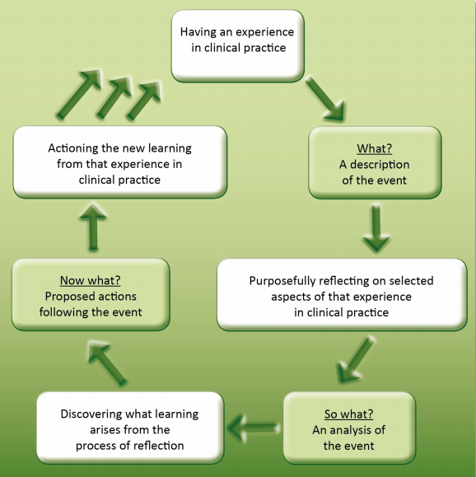

The ‘What?’ model of structured reflection.

What?
So, what's that?
What's it?
We can begin to analyze our experiences and learn from them by asking ourselves these three simple questions. First, we will define the context in which the situation or experience was to put up. It gives us a clear understanding of what we're dealing with.
Then we should think about the experience by asking' so what? What have we learned from the experience? The final stage asks us to reflect on the action we are going to take as a result of this reflection. Will we change our behavior, try something new, or continue as we are? It's important to remember that as a result of contemplation, nothing changes, and we believe we're doing it.

- PRESENTATION IN CLASS

We were practicing in the class about a presentation, my theme was “Unfair Practice’.

I started introducing myself, making clear the point that I was going to talk about asking questions to the public. When you interact with the people making them participle in your presentation, they get more information because you are sharing straightly with them.
Looking to the eyes to don’t lose the connection, moving in my place with confidence to show that I know what I’m talking about.

Using the hands to get their attention, speaking high and clear and trying to don’t have a look to the paper where I wrote all the information about it.

I recognize that if I prepare a little bit more, the presentation could be better, it’s only practice and practice at home.

3.1 UNFAIR PRACTICE UNIVERSITY

In the case of assesments of work, not submitted for University qualifications, they take the power to check any doubt, the full Unfair Practice Procedure should be taken as having precedence.

Students in any doubt about what constitutes unfair practice are urged to seek clarification from their module tutor, reflection group tutor or the Director of Studies.

Examples of unfair practices:

- Copy or use in any other way the work of any other candidate.
- Use the work of any other person(s), such as phrases or passages from books or from the internet and submit it for assessment as though it were one’s own work. We should avoid plagiarism how we learnt the last term.

- If a tutor has evidence that unfair practice has occurred in relation to work submitted as a piece of coursework or a project, or any other work completed under non-examination conditions, they shall report the matter to the Director of Studies as soon as possible.

- If an invigilator or a marker suspects that unfair practice has occurred in an examination, they shall report the matter to the Director of Studies as soon as possible with any relevant evidence.

- Pay a company who makes your assessments for you.

A couple of weeks ago, all of us we received an e-mail:

“We have been informed of some suspicious activity happening in and around the canpus in the form of business cards being circulated about ‘academic help’ with ‘assigment and dissertation writing’.
We would like to make it very clear that we find it totally unacceptable and no one should engage in this sort of activity or use such services. We would like to remind that using third party services for writing assignment or any other coursework is a very serious academic offence (unfair practice). The penalties for such practice range from failure in the module to being withdrawn from the course”.

So, being honest, is better to be productive or ask for help in case we need it.

- 5 TIPS TO IMPROVE YOUR CRITICAL THINKING

In life or work, we need to take a lot of decisions, some of them will be right or wrong, but we need to think ourselves, don’t leave the people or marketing strategies take a decision for us.

The perfect option to choose is improving our chances, we need to reveal the hidden problems, manipulations and try to make the better decision. Or at least, choose one of them in a very critical way.

If the critical part sounds negative, it is, it’s true, instead to choose an easy way because sounds good and quick, a person who use critical thinking, wait and examinant the alternatives.

With the help of your tools, you will avoid all the options, only saving the information more useful and trustful.

The tips are:

- Formulate the question.
You need to know what you are looking for. It’s not easy, but you have to be precise.

- Gather your information.
There are a lot of information, so you need to have a clear idea about what determinizing the most irrelevant.

- Apply the information.
You need to ask many questions to yourself, like concepts, assumptions, interpretation, logically sound.

- Consider the implication.
Think always about the consequences.

- Explore other points of view.
Negative or positive opinions about it, you have to make a balance about all the points.

- INDIVIDUAL TASK

Based in our exercises in class, I learnt a lot about what I shouldn’t talk about myself in the curriculum vitae and make it shorter and more specific.
Also, I didn’t know that is very important the research about the company, to know more about the questions that they can ask you about why you are interested to work in there.
I thought that the skills is not a place to show in a curriculum, but I can describe my skills and knowledge to sell myself better. It’s true that in an interview, in a trial or face to face you can show more of yourself, but they can have hundreds or thousands of cv’s for this position and you need to show them what you are capable of.

- REFERENCES

https://visaempresarial.com/pe/noticias/la-importancia-de-un-buen-curriculum-vitae_247

https://shopcv.com/hacer-cv/objetivos

http://blog.cv-coach.com/es/las-referencias-en-un-curriculum-vitae-como-y-cuando-incluirlas/



