Commingled Human Remains Report
Commingled is an ambiguous definition in archaeology, as commingled is characterised by way of a mixed assortment in materials, therefore commingled remains as explained by Ubelaker in 2002 are a mixed array of whole or fragmented skeletal remains of two or more individuals (Lambacher, 2016). Commingled remains are not restricted to just one species as it can be found in all species, however the most intriguing and unique commingled remains identified in the archaeological record, belong to that of humans. The reasoning for their uniqueness is the plethora of archaeological evidence, categories and even sub categories for the reasoning and action that would have occurred for human remains to become commingled. Commingled can be identified in many arrangements and can be categorised and in some cases even subcategorised depending on how the archaeologist wants to display and document the archaeological data. The data can be categorised into human intervention and naturally occurring intervention; these are the two main categories that then branch off into sub categories (Lambacher 2016). To show how these two categories branch off it is easier to demonstrate through a flow chart:
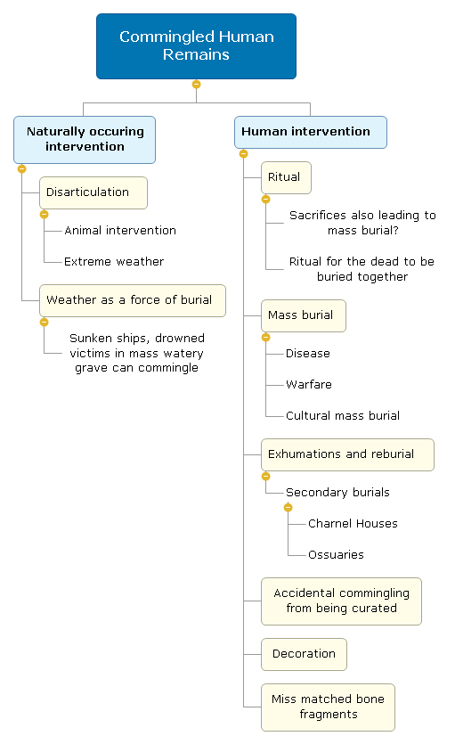
Figure 1:

As demonstrated above there are many sub categories that also branch out into further sub categories. The complexness of this taphonomic environment are so varied and require so much careful work and analyses to identify the commingled remains it makes it undeniably and distinctively difficult to excavate (Osterholtz 2013). The difficulty comes from the fact that when approaching a commingled remains environment archaeologists are not always aware of the fact it is commingled and when they are aware, knowing how to extract the commingled remains without damaging and/or loosing remains can prove a tricky endeavour, the same difficulty arises when analysing the commingled remains in a laboratory (Roberts 2009). Nonetheless this is not the only difficulty that surfaces when dealing with commingled remains, interpreting the taphonomic history behind the commingled remains in itself brings many difficulties. This difficulty arises from the fact that there are various reasons for taphonomic history of a commingled assemblage, this leads to difficulty in finding patterns and mortuary behaviours (Lambacher 2016).
Human intervention with human remains is a long-standing tradition that has been an operating function of our society since the Middle Palaeolithic when our ancestors would bury multiple human remains in one grave and by the Neolithic we were disturbing the resting places of our friends and family and reburying them (Vars 2011). Human intervention is a purposeful act in addition to be a subsequent part of human nature spanning millennia. Humans have developed many different methods to alter the taphonomic assemblage of skeletal remains, this altercation with skeletal remains and their taphonomy has trickled down to several categories resulting in a commingled taphonomic environment: Primary Mass burials, Secondary burials, exhumation/decoration and fragmentation. Primary burials are when the deceased are buried and are permanently cut from the living world, with primary burials there is no future intent to exhume the deceased however there are cases where the skeletal remains are exhumed for reburial, this makes it a secondary burial. Conversely secondary burials do not have to start their taphonomic life as a primary burial, as skeletal remains of secondary burials are actually intended to be exhumed and viewed by that society; secondary burials can result in numerous reburials, consequently disarticulation and fragmentation can become a blatant problem when evaluating the taphonomic history of the skeletal remains (Osterholtz 2013).
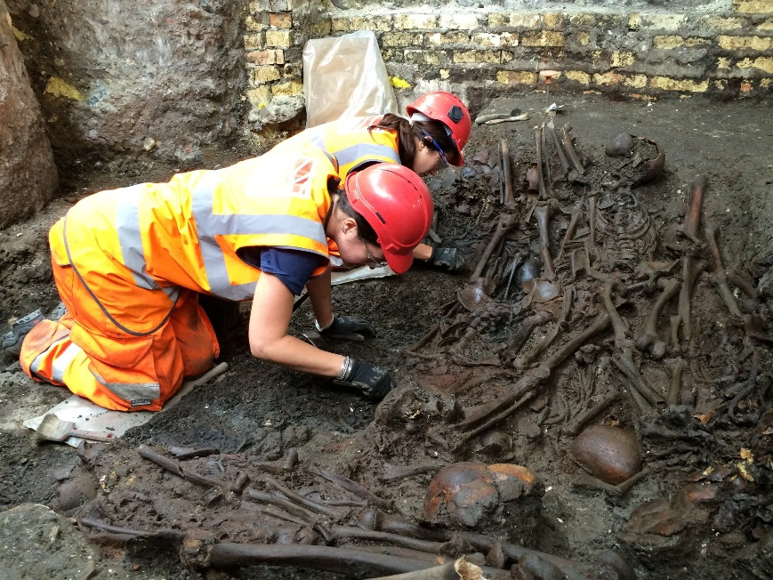
Commingling of human remains within mass graves occurs as a result of decomposition of the tissues of the bodies, the gradual decomposition means that over times the skeletal remains sink into each other and mix together (Lambacher 2013). When it is all boiled down mass graves are created for one reason: quick burial of a many people at once to prevent the spread of disease. Whether the deceased died from warfare, plagues, natural disasters or work-related death the dead carry disease and attract animals such as rats that carry diseases, this has been well known fact through history, because of this there are a vast amount of mass graves around the world, all of which that have their own taphonomic assemblage that tells its own unique story. One case of mass grave excavated by MOLA in 2015, dates back to 1665 in Liverpool Street, London; it was the last major break out of The Great Plague. During excavation a headstone was found stating 1665 that was dated to being buried at the same time as the plague victims, there is also archaeological evidence of the victims being buried in thin wooden boxes, however these have rotted away fairly quickly as the 30 skeletal remains are drastically mingled as seen in figure 2. This evidence that during times of disease and mass death people were buried quickly, this is evident from the fact that this mass grave was located outside of the Bedlam grave yard that was in use at this current time, had coffins/boxes that were quickly put together and a group of 30 people who share the same grave (Dempsey 2015).
Figure 2:
In comparison to primary burials, secondary burials are not the end of ‘connections’ between the living and the dead, for many cultures, the practice of burying the dead is the signifying act of that someone no longer has a connection to the community/ world of the living, on the contrary many cultures also do not view the deceased as dead as such but in fact in the next process of the life cycle (Pearson 2003). This is to do with our understanding of skeletal remains, there are many cultures that view skeletal remains as material objects/ beings, to be moved and shared as an integral part within the community (Hamilakis, 2013). This experience of secondary burial is a communal action, one of the nicer reasons for commingled remains to exist. A case study of this communal action of reburial and dispersed remains is from Neolithic Britain. In Wor Barrow in Dorset, Pitt Rivers excavated a chamber that was buried deep within an earth mound, inside this chamber 3 articulated skeletons and 3 bundles of skeletal remains of long bones and a skull and were missing the other bones and were placed in position that was indicative of reburial and transportation. Rivers went on to explain that often in Neolithic depositions there would be fragments and bones missing and would be deposited in an unusual manner; Rivers went on to explain that this depositional pattern occurred as a result of secondary burial and that the place of deposition was because the ‘tombs’ weren’t as such a final resting place but a ‘place of transformation’ where the dead continued to serve as an integral part of human society (Hamilakis, 2013).
Alternatively, human intervention creating a taphonomic history of commingled remains is not always purposeful there are accidents that happen, there are also unfortunate research methods that creates disarticulation and the mixing of human remains. Unfortunately, like any other discipline there are guidelines and research methods that have to be followed to streamline the work and make the excavations more efficient in theory, regrettably this does not always work out in practice. There is a spatial rule of anything being close enough together will be collected together as one set of remains, belonging to one individual (Voeller, 2015); this rule or research method in theory is supposed to help in extraction of remains and help the archaeologist/ osteologist, unfortunately in practice this does not always happen and as a result you have the mixed/ commingled remains of at two or more individuals. There is a case of this from Chile, in 1973 a horrendous crime was committed, and 5 men were murdered, however only one man was identified, the unidentified remains were placed in a communal grave in the town where their bodies were found; in 2006 the case reopened as there was an outcry from the identified victim’s family for them to be reunited with their families. However as the bodies had decade in the same communal grave they as of yet had not become commingled but when they were exhumed many of the bones displaced themselves slightly and as a result the nearest bones were collectively clumped together as one individual; what makes this is that when DNA testing was done it was carried out on the big bones such as the tibias and they were used to solve the case however the small bones and fragments were just grouped together under the spatial rule this resulted in disarticulation and commingling of the remains (Varas, 2012). As this commingling is through human interaction that was specifically carried out in this specific way it can be argued that this is purposeful human interaction, however it is not purposeful as there was no intent behind the action to commingle the remains but was actually an accidental by product of an effort to ensure a more streamlined and effective model of work.
As already expressed commingled remains are not always the product of human intervention, natural intervention similarly is as formidable process that can occur. Natural intervention occurs through many processes; however a prominent source of intervention is a product of animal life, particularly that of the carnivores. Carnivorous animals will scavenge and feast on the recently deceased carcasses of humans if the human remains are: excarnated or not buried deep enough. Whilst excarnation is a human choice it is not by human hands that the remains themselves become disarticulated, it is by the animal eating and removing the remains from the initial sight of excarnation, resulting in disarticulation of human remains over a distance; animals will even take the remains back to their den or bury them thus scattering the remains which can result in remains becoming commingled. An example of commingling would be entering an animals den and finding several individuals remains in scattered in one resting place (Maraitis, 2010). Comparatively natural/ animal interaction does not affect the taphonomic a=environment as greatly or as often as what human interactions do, it still plays a vital role in the commingling and disarticulation of remains, it lacks pattern and consistency, yet it is a factor of commingled human remains taphonomy.
Whilst there is no one pattern that connects all forms of commingled remains there are patterns within each category and sub category, for example within Human intervention: Mass burials follow the pattern that any point of warfare or high amount of disease there will be mass burials, conversely also within human intervention category there are secondary burials/ reburials, and these do not follow the same patterning as mass burials. Reburials itself can be further subcategorised into different patterns such as: over population within a graveyard, results in exhumation and reburials into charnel houses moreover there are also reburials that happen because of cultural implications that belong to the society of the skeletal remains. The circumstances in addition to the patterning of commingled human remains are so unique to each and every taphonomic environment it would be to simplistic and ignorant to apply one distinct pattern to the whole of commingled human remains. There are domineering characteristics typical of commingled human remains, which is that typically it is human interaction that is the root cause of it; this characteristic is not applicable to all categories of commingled remains such as disarticulation or remains from animals and natural disasters. There is also no one distinct pattern that argues that there is intent behind the commingling of human remains, yes there are such cases of purposeful commingled remains such as the case of St. Peter whose remains were found to actually be the disarticulation of 2 men in there 50s another man in his 40s, a woman in her 70s and several animal bones (Richardson 2012); on the other hand there are remains that were the product of accidental disarticulation that happened because of accidents during curation. Even more bizarrely there is a category, Natural intervention, that has no patterning or consistency nor is a common denominator when it comes to taphonomic history of commingled remains, yet it cannot and should not be disputed as being a significant impacting category of commingled human remains. Commingled remains are a subject that has in recent years started to gain moment and is being talked about, and new methodologies and theories are being developed by archaeologists and osteologists to help solve the impracticality of extraction and analysis of commingled remains; but yet commingled remains are not a new subject. The complexity of this taphonomic environment are striking, it’s an old subject with ideas that are new, it has no overall pattern yet has many patterns as well, there is no one reasoning behind its creation, it expands over many branches as to why it occurs, it is the most unique taphonomic environment to address that is what makes it so distinct.

References:
- Andrew Dempsey. (2015). Figure2, Mass burial uncovered at Crossrail Liverpool Street site_204843. Available: http://www.crossrail.co.uk/news/articles/suspected-1665-great-plague-pit-unearthed-at-crossrail-liverpool-street-site. Last accessed 10/05/2018.
- Andrew Dempsey. (2015). SUSPECTED 1665 GREAT PLAGUE PIT UNEARTHED AT CROSSRAIL LIVERPOOL STREET SITE. Available: http://www.crossrail.co.uk/news/articles/suspected-1665-great-plague-pit-unearthed-at-crossrail-liverpool-street-site. Last accessed 10/05/2018.
-Yabbis Hamilakis, Mark Pluciennik and Sarah Tarlow (2013). Thinking through the Body, Archaeologies of Corporeality. 2nd ed. New York, USA: Plenum Publishers. 41-42.
-Jessica Staples. Figure 1, 10/05/2018.
- Nicole Lambacher, Karina Gerdau-Radonic, Emma Bonthorne, Francisco Jose Valle de Tarazaga Montero. (2016). Evaluating three methods to estimate the number of individuals from a commingled context. Journal of Archaeological Science: Reports. Volume 10, pages 674-683.
- Kondtsntinos Maraitis and Chara Spiliopoulou. (2010). Forensic implications of carnivore scavenging on human remains recovered from outdoor locations in Greece. Journal of Forensic and Legal Medicine. 17 (6), 298-303.
- Anna J. Osterholtz, Kathryn M. Baustian, Debra L. Martin (2013). Commingled and Disarticulated Human Remains: Working Toward Improved Theory, Method, and Data. New York: Springer. 67-68.
- Mike Parker Pearson. (2003) The archaeology of death and burial. 2nd ed. Gloucestershire, UK: Sutton Publishing Limited. 121-133.
- Joseph T. Rihardson. (2012). The Bones of St. Peter. Available: http://lonelypilgrim.com/2012/05/17/the-bones-of-st-peter/. Last accessed 10/05/2018.
- Charlotte A Roberts (2009). Human remains in archaeology: a handbook. York, UK: Cambridge University Press. 43, 45, 78.
- Claudia Garrido Vars, Marisol Intriago Leiva. (2011). Managing commingled remains from mass graves: Considerations, implications and recommendations from a human rights case in Chile. Forensic Science International. 219 (1-3), 19-24.
- Sarah Voeller. (2015). Using GIS to Reassociate Commingled Remains.Available: https://repository.lib.ncsu.edu/handle/1840.16/10419. Last accessed 10/05/2018.

Bibliography:
-A. Boddington, A.N. Garland and R.C. Janaway (1987). Death, Decay and reconstruction, Approaches to archaeology and forensic science. Manchester, UK: Manchester University Press. 50 - 72.
-John Hunter, Barrie Simpson, Caroline Sturdy Colls (2013). Forensic approaches to buried remains. West Sussex, UK: John Wiley & Sons, Ltd. 19-22.
- Simon Mays (2010). The archaeology of Human Bones. 2nd ed. Oxon, UK: Routledge. 15-19 & 31-35.
- Maria Naiyana Panakhyo. (2013). Evaluation of the Methodolgy for addressing the commingled reamisn from The Lewis Jones Cave Ossuary. Available: http://acumen.lib.ua.edu/content/u0015/0000001/0001368/u0015_0000001_0001368.pdf. Last accessed 10/05/2018.
-Lets recycle. (2009). EXCLUSIVE: Expert confirms correct spelling of commingled. Available: https://www.letsrecycle.com/news/latest-news/exclusive-expert-confirms-correct-spelling-of-commingled/. Last accessed 9/05/2018.
- Joanna R. Sofaer (2006). The Body as Material Culture, A theoretical Osteoarcaeology . Cambridge UK: Cambridge University Press. 14-19.
- Tony Waldron (2001). Shadows in the soil, Human Bones and Archaeology. Gloucestershire, UK: Tempus Publishing Ltd. 41-49.

