

Financial Management LCMB7002
Olena Kokorieva
Student ID 2239903
Lecturer: Dr Shengfeng Mei
Report

Word Count: 5147 words

Table of Contents
Table of Contents 2
1. Financial Health Check 4
1.1 Introduction 4
1.2 Analysis of Financial Statements 4
1.3 Financial Ratio Analysis 6
1.3.1 Profitability 6
1.3.2 Liquidity 7
1.3.3 Efficiency 7
1.3.4 Gearing 7
1.3.5 Investment and Cash Flow 8
1.4 Trends, Strengths and Potential Threats 8
1.5 Industry Benchmark Comparison 8
1.6 Summary of Financial Health 10
2. Working Capital Management Analysis 10
2.1 Assessment of the Cash Operating Cycle 10
2.2 Strategies to Improve Liquidity through Working Capital Reforms 10
2.3 Comparison of Short-Term and Long-Term Financing Options 11
2.4 Summary of Working Capital Management 12
3 Strategic Financial Restructuring Plan 12
3.1 Recommended Financial Restructuring Options 12
3.2 Impact on Shareholder Value, Debt Structure and Operational Flexibility 13
3.3 International and Ethical Considerations 14
3.4 Summary of Strategic Financial Restructuring 15
4 Investment Appraisal and Capital Budgeting 15
4.1 Introduction 15
4.2 Investment Appraisal Results 15
4.3 Evaluation of the Three Projects 16
4.4 Recommended Project 17
4.5 Capital Rationing 18
4.6 Summary 18
5. Critical Reflection on AI Usage 18
5.1 Tool Disclosure 18
5.2 Critical Evaluation and Verification of AI Output 19
5.3 Contribution Analysis 19
5.4 Ethical and Professional Reflection 20
References 21
Appendices 23

1. Financial Health Check

1.1 Introduction
Marriott International, Inc. is one of the world's largest hospitality companies, operating more than 9,000 properties across over 140 countries and territories through more than 30 hotel brands (Marriott International, 2025). Its predominantly asset-light model relies on management, franchise and licensing agreements, supporting international expansion while limiting capital investment.
The hospitality industry experienced substantial change between 2021 and 2025, including post-pandemic recovery, inflation and changing travel demand. The recovery of international tourism created opportunities for global hotel operators while introducing new financial challenges (UN Tourism, 2025).
This section evaluates Marriott's financial health from 2021–2025 using audited annual reports and financial ratios covering profitability, liquidity, efficiency, gearing, investment and cash flow. It also identifies key trends and risks and compares Marriott with Hilton and Hyatt to assess its position relative to industry competitors.

1.2 Analysis of Financial Statements
Marriott International's financial statements (see Appendices A–C) demonstrate a strong recovery between 2021 and 2025, supported by the recovery of global travel and the company's asset-light business model. Financial statement analysis provides the foundation for assessing financial performance and sustainability (Atrill and McLaney, 2024).
The Income Statement (see Appendix A) shows substantial growth over the period. Revenue increased from approximately US$13.9 billion in 2021 to US$26.2 billion in 2025, supported by recovering travel demand, higher room rates and expansion of Marriott's global portfolio. This trend reflects the wider recovery of international tourism following the pandemic (UN Tourism, 2025). Net income also increased substantially compared with 2021, although performance fluctuated during the period, demonstrating continued exposure to operating and financing pressures.

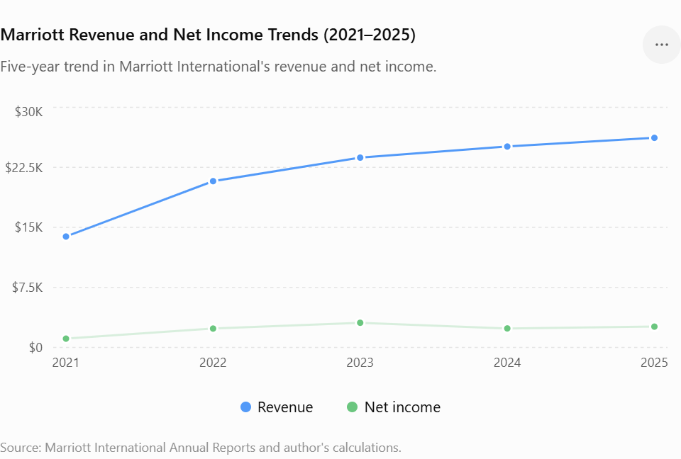
Figure 1. Marriott Revenue and Net Income Trends (2021–2025).
Source: Marriott International Annual Reports (2022–2026) and author's calculations.
As illustrated in Figure 1, revenue increased consistently throughout the period, while net income showed greater volatility, including a decline in 2024 followed by a recovery in 2025.
The Balance Sheet (see Appendix B) reflects Marriott's asset-light strategy, which relies heavily on management and franchise agreements rather than hotel ownership. This supports global expansion with relatively limited investment in physical assets. However, substantial liabilities and negative shareholders' equity remain important financial concerns. Share repurchases have contributed to the equity deficit, affecting the interpretation of leverage and ROE.
The Statement of Cash Flows (see Appendix C) demonstrates strong cash generation from Marriott's core operations. Improved operating cash flows provided internal funding for investment, dividends and share repurchases, increasing financial flexibility and reducing dependence on external financing (Brigham and Ehrhardt, 2020).
Overall, Marriott's statements indicate substantial post-pandemic recovery and stronger financial performance, particularly in revenue and cash generation. However, high liabilities and negative equity remain potential risks. These issues are examined further through the financial ratio analysis presented in Appendix D.

1.3 Financial Ratio Analysis
Financial ratio analysis evaluates profitability, liquidity, efficiency, gearing, investment and cash flow performance and helps identify changes in financial performance over time (Atrill and McLaney, 2024). Detailed calculations for 2021–2025 are presented in Appendix D – Financial Ratio Analysis and Supporting Calculations (2021–2025).

1.3.1 Profitability
Marriott's profitability ratios (see Appendix D) demonstrate a strong post-pandemic recovery. Gross profit margin remained relatively stable at approximately 20–22%, suggesting effective cost control despite inflationary pressures.
Operating margin increased from 12.69% in 2021 to 15.81% in 2025, indicating improved operational efficiency as travel demand recovered. Similarly, net profit margin increased from 7.93% to 9.93%, although performance fluctuated during the period. The improvement suggests that Marriott successfully converted revenue growth into stronger earnings despite higher operating and financing costs.
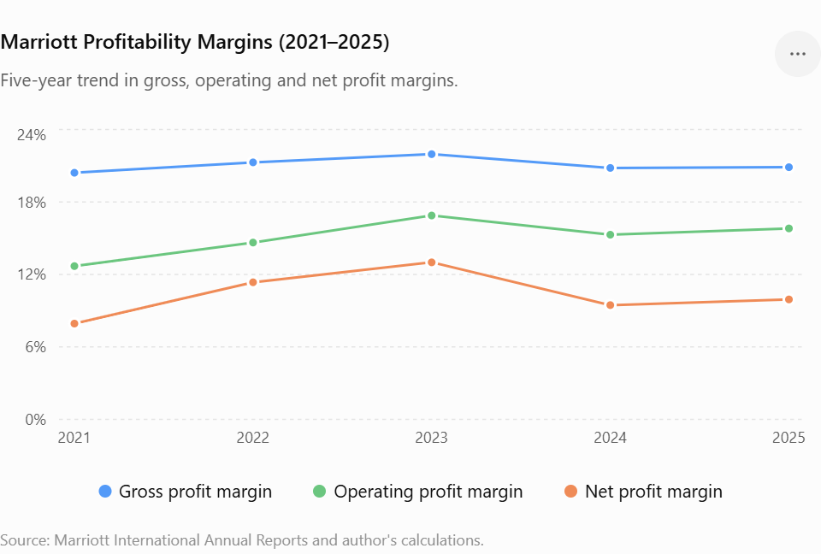
Figure 2. Marriott Profitability Margins (2021–2025).
Source: Marriott International Annual Reports (2022–2026) and author's calculations.
As illustrated in Figure 2, Marriott's profitability improved strongly during the post-pandemic recovery, peaking in 2023 before declining in 2024 and partially recovering in 2025.
Overall, the profitability trend demonstrates improved operational performance and financial resilience. However, fluctuations in margins also indicate continued exposure to inflation, labour costs and wider economic conditions (Brigham and Ehrhardt, 2020).

1.3.2 Liquidity
Marriott's liquidity ratios (see Appendix D) remained below the conventional benchmark of 1 throughout 2021–2025. The current ratio increased slightly from 0.40 in 2024 to 0.43 in 2025, while the quick ratio improved from 0.37 to 0.39, indicating a modest improvement in short-term liquidity.
The cash ratio remained particularly low, ranging between 0.04 and 0.22, indicating limited cash reserves relative to current liabilities. However, Marriott consistently generated positive operating cash flows (see Appendix C), reducing its dependence on large cash balances. Therefore, although low liquidity represents a potential financial risk, it should be considered alongside Marriott's strong cash-generating capability and asset-light operating model (Brigham and Ehrhardt, 2020).

1.3.3 Efficiency
Marriott's efficiency ratios (see Appendix D) demonstrate improved asset utilisation between 2021 and 2025. Asset turnover increased from 0.54 in 2021 to 0.95 in 2025, indicating that the company generated substantially more revenue from its asset base as travel demand recovered.
Fixed asset turnover also remained high, exceeding 13 times in most recent years. This reflects Marriott's asset-light strategy, which relies primarily on franchise and management agreements rather than extensive ownership of hotel properties. Overall, these trends indicate efficient use of assets and support the operational advantages of Marriott's business model (Gitman, Juchau and Flanagan, 2022).

1.3.4 Gearing
Gearing ratios assess the extent to which a company relies on debt financing and its ability to meet associated financing costs (Atrill and McLaney, 2024). Marriott's gearing position (see Appendix D) reflects relatively high financial leverage, although its strong operating performance supports its ability to service debt.
The Interest Coverage Ratio increased from 4.48 in 2021 to 5.61 in 2025, indicating that Marriott generated sufficient operating profit to meet its interest obligations. However, shareholders' equity became negative from 2023 to 2025, largely because of substantial share repurchases. Consequently, the Debt-to-Equity ratio and ROE are not meaningful for these years and should be interpreted with caution.
Although Marriott's strong profitability and cash generation reduce some of the risks associated with leverage, its high debt levels and negative equity increase financial exposure, particularly during periods of higher interest rates or weaker travel demand. Therefore, careful debt management remains important for maintaining long-term financial resilience.

1.3.5 Investment and Cash Flow
Marriott's investment and cash flow ratios (see Appendix D) indicate improving financial performance. ROA increased from 4.8% in 2021 to 9.4% in 2025, demonstrating stronger profit generation from the company's asset base. The P/E ratio fluctuated considerably, reflecting changing market expectations during the post-pandemic recovery.
The Operating Cash Flow Ratio improved from 0.18 in 2021 to 0.38 in 2025, though it fluctuated over the period, reaching 0.41 in 2023 before declining to 0.32 in 2024 and then recovering in 2025. This indicates an overall improvement in Marriott's ability to generate operating cash relative to its current liabilities. Free Cash Flow Margin also remained positive, increasing from 7.2% in 2021 to 10.0% in 2025, providing greater flexibility for investment, dividends and share repurchases.
Overall, these trends demonstrate strong cash generation and financial resilience, although fluctuations in the Operating Cash Flow Ratio highlight the importance of continued liquidity management (Brealey et al., 2023).

1.4 Trends, Strengths and Potential Threats
Overall, Marriott demonstrated a strong financial recovery between 2021 and 2025, characterised by revenue growth, improving profitability, greater asset efficiency and stronger cash generation (see Appendices A–D). These trends indicate improved financial resilience following the pandemic despite inflationary and economic pressures.
A major strength is Marriott's asset-light business model, which supports global expansion while limiting investment in owned properties and contributing to high asset utilisation. Strong operating and free cash flows provide additional financial flexibility for investment and shareholder returns (Marriott International, 2026).
However, several risks remain. Marriott's low liquidity ratios and relatively high leverage increase exposure to financial pressure if operating cash flows weaken. Negative shareholders' equity resulting partly from substantial share repurchases also complicates the company's capital structure. Furthermore, external threats including inflation, geopolitical uncertainty, economic downturns and changing travel demand could negatively affect occupancy, costs and profitability.
Therefore, although Marriott's overall financial position has strengthened, careful management of liquidity, leverage and external market risks remains important for maintaining long-term financial resilience.

1.5 Industry Benchmark Comparison
Industry benchmarking helps assess Marriott's financial performance relative to major competitors. The 2025 comparison with Hilton and Hyatt covers profitability, liquidity and efficiency (see Appendix E – Industry Benchmark Analysis).
Marriott's operating margin of 15.81% was below Hilton's 22.37% but slightly above Hyatt's 15.20%. Similarly, Marriott's net margin of 9.93% was below Hilton's 12.10% but above Hyatt's 8.90%, indicating competitive profitability but potential for further improvement.
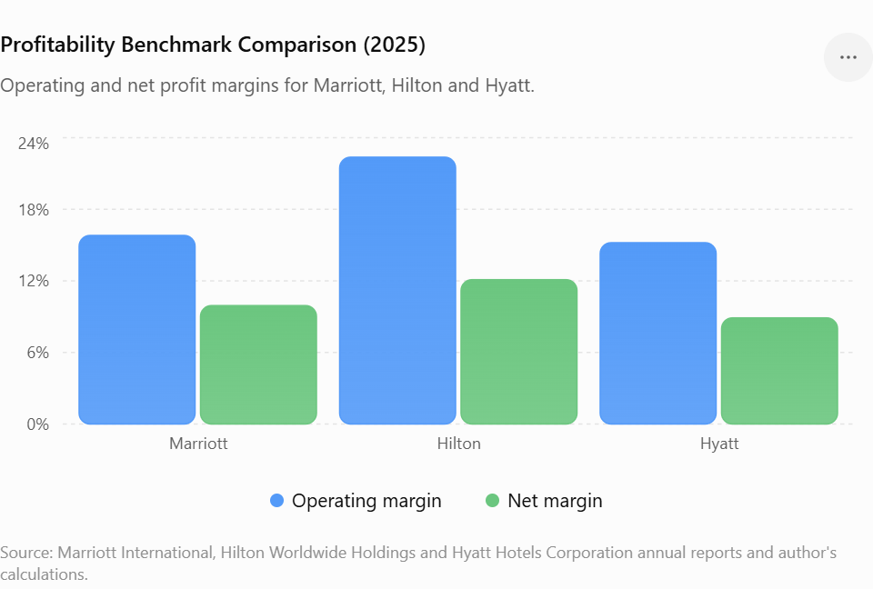
Figure 3. Profitability Benchmark Comparison (2025).
Source: Marriott International, Hilton Worldwide Holdings and Hyatt Hotels Corporation annual reports and author's calculations.
Liquidity represents a greater concern. Marriott's current ratio of 0.43 was below both Hilton (0.61) and Hyatt (0.74). Although all three ratios remain below 1, Marriott has the weakest short-term liquidity position, suggesting greater dependence on continued operating cash generation to meet current obligations. This supports the liquidity risk identified in Section 1.3.2.
The additional cash flow comparison also indicates a relative weakness. Marriott's Operating Cash Flow Ratio of 0.38 was below Hilton's 0.49 and Hyatt's 0.44 (see Appendix E). This suggests that Marriott generated less operating cash relative to its current liabilities than both competitors in 2025, reinforcing the need for careful liquidity management.
However, Marriott achieved the highest asset turnover of 0.95, compared with Hilton (0.72) and Hyatt (0.58), demonstrating stronger asset utilisation and supporting the effectiveness of its asset-light model.
Overall, the benchmark indicates that Marriott performs strongly in asset efficiency and remains competitive in profitability, but its comparatively weaker liquidity and operating cash flow coverage represent important financial risks requiring continued monitoring (Atrill and McLaney, 2024).

1.6 Summary of Financial Health
Overall, Marriott demonstrated strong financial performance between 2021 and 2025, supported by improving profitability, operational efficiency and cash generation. Although liquidity and leverage require continued monitoring, the company remains financially resilient and well positioned for future growth. The following section evaluates Marriott's working capital management and liquidity strategy.

2. Working Capital Management Analysis

2.1 Assessment of the Cash Operating Cycle
Working capital management ensures that an organisation can meet its short-term obligations while maintaining operational efficiency. A key measure is the Cash Conversion Cycle (CCC), which assesses how efficiently operating resources are converted into cash (Atrill and McLaney, 2024).
Marriott's CCC calculations are presented in Appendix F – Cash Conversion Cycle (CCC) Analysis. The results indicate that the cycle became shorter and more stable following the post-pandemic recovery, remaining at approximately 26 days in the later years. This suggests improved working capital efficiency and more effective management of short-term resources.
Unlike manufacturing companies, Marriott operates in the hospitality sector, where inventory levels are relatively low because services cannot be stored. Therefore, its CCC is influenced primarily by receivable and payable days. Customer payments are often received through credit cards, online bookings and corporate accounts, supporting relatively efficient cash collection. Digital reservation and payment systems can further accelerate this process.
Marriott can also preserve liquidity by managing supplier payment terms effectively. Maintaining favourable payment periods allows the company to retain cash for longer without increasing external financing requirements. However, extending payment periods excessively could negatively affect supplier relationships and should therefore be carefully managed.
Overall, Marriott's relatively short and stable CCC indicates effective working capital management, supporting liquidity and financial flexibility while reducing short-term funding pressure.

2.2 Strategies to Improve Liquidity through Working Capital Reforms
Although Marriott demonstrates effective working capital management, further reforms could strengthen liquidity and financial resilience during periods of economic uncertainty.
First, Marriott could expand digital payment systems and AI-supported cash flow forecasting. Increasing direct online payments and automated processing could shorten receivable collection periods, while predictive analytics could forecast cash inflows, seasonal demand and potential collection risks. This would enable management to optimise cash reserves and make better short-term financing decisions (Brigham and Ehrhardt, 2020).
Marriott could also improve supplier payment management by negotiating flexible payment terms. Longer payment periods can preserve cash and strengthen short-term liquidity; however, excessive delays could damage supplier relationships. Where sufficient cash is available, early-payment discounts could also reduce costs and improve working capital efficiency.
Another priority is disciplined operating and capital expenditure management. Marriott's asset-light model already reduces investment in owned properties, but controlling expenditure remains important during periods of inflation and economic uncertainty. This would help preserve operating cash flows and financial flexibility.
Finally, Marriott should maintain adequate liquidity reserves and committed credit facilities. Its liquidity ratios remain relatively low (see Appendix D), despite strong operating cash generation. Maintaining access to cash and credit would provide additional protection against unexpected reductions in travel demand or other economic disruptions.

2.3 Comparison of Short-Term and Long-Term Financing Options
Organisations typically finance their operations through a combination of short-term and long-term sources of finance. The choice between these alternatives depends on financing costs, liquidity requirements, investment objectives and risk tolerance (Brealey, Myers and Allen, 2023).
Short-term financing generally includes bank overdrafts, revolving credit facilities, trade credit and short-term loans. These financing methods are typically less expensive than long-term borrowing and provide greater flexibility for managing temporary cash flow shortages or seasonal fluctuations in working capital. However, short-term finance exposes organisations to refinancing risk and interest rate volatility because borrowing must be renewed regularly. During periods of economic uncertainty or rising interest rates, excessive dependence on short-term borrowing may increase financial risk.
Long-term financing includes corporate bonds, long-term bank loans, lease financing and equity financing. These funding sources provide greater financial stability because repayment periods extend over many years and interest costs are generally more predictable. Long-term finance is particularly appropriate for strategic investments, such as technology development, hotel expansion and digital transformation projects, which generate returns over extended periods. However, long-term financing usually involves higher overall financing costs and reduces financial flexibility because organisations remain committed to repayments for longer periods.
Given Marriott's financial position, long-term financing appears more appropriate for supporting strategic growth initiatives, while short-term financing should be reserved primarily for temporary working capital requirements. Marriott generates consistently strong operating cash flows (see Appendix C) and maintains a relatively stable Cash Conversion Cycle (see Appendix F), reducing its dependence on short-term borrowing to finance day-to-day operations. Furthermore, the company's asset-light business model requires lower levels of capital investment than traditional hotel ownership models, allowing internally generated cash flows to finance a substantial proportion of ongoing operations.
Nevertheless, maintaining access to short-term credit facilities remains important to provide flexibility during periods of seasonal demand fluctuations or unexpected economic shocks. A balanced financing strategy combining strong internally generated cash flows, prudent long-term borrowing and limited short-term financing would enable Marriott to maintain liquidity while supporting sustainable long-term growth.
Overall, Marriott's current working capital management is effective and supports the company's financial performance. Continued investment in digital financial management, improved cash forecasting and prudent financing decisions would further strengthen liquidity while enhancing long-term financial resilience.

2.4 Summary of Working Capital Management
Overall, Marriott maintained effective working capital management through a stable Cash Conversion Cycle and strong operating cash flows. While further improvements in liquidity management are possible, the company demonstrates sufficient financial flexibility to support its operations. The next section proposes strategic financial restructuring options to strengthen Marriott's long-term financial position.

3 Strategic Financial Restructuring Plan

3.1 Recommended Financial Restructuring Options
Financial restructuring can strengthen financial stability and long-term shareholder value through changes to capital structure, assets and financing strategy (Brealey, Myers and Allen, 2023). Based on the analysis in Sections 1 and 2, Marriott remains financially strong but could further reduce financial risk and improve flexibility.
First, Marriott should continue a selective asset-light divestiture strategy, disposing of non-core owned properties while expanding management and franchise agreements. This could release capital, improve asset efficiency and generate cash for strategic investment without limiting global expansion.
Second, Marriott should rebalance its capital structure. The company maintains relatively high leverage and negative shareholders' equity, partly due to substantial share repurchases. Capital structure is particularly important within the hospitality industry because financing decisions influence financial risk and long-term performance (Guahk, 2020). Moderating future buybacks and directing more operating cash flow towards debt reduction could lower interest costs and strengthen financial resilience, particularly during periods of higher borrowing costs.
Third, targeted acquisitions and strategic partnerships are preferable to a large-scale merger. Marriott already has an extensive global portfolio; therefore, selective investments in luxury, lifestyle, technology or sustainable hospitality businesses could support growth while limiting integration risk. A major equity injection is also unnecessary given Marriott's strong operating cash generation and could dilute existing shareholders.
Finally, Marriott should continue investing in digital transformation and AI, particularly revenue management, demand forecasting and customer personalisation. These technologies could improve pricing, occupancy and operational efficiency while supporting long-term competitiveness.
Overall, these options provide a balanced restructuring approach focused on financial resilience, targeted growth and efficient capital allocation.

3.2 Impact on Shareholder Value, Debt Structure and Operational Flexibility
The proposed restructuring could strengthen Marriott's financial position while supporting long-term shareholder value. Reducing debt through internally generated cash flows would lower financial leverage and future interest expenses. Although debt can enhance shareholder returns during periods of growth, excessive leverage increases financial risk, particularly during economic downturns and periods of higher interest rates (Atrill and McLaney, 2024).
Temporarily moderating share repurchases may reduce short-term earnings per share growth; however, using additional cash for debt reduction could strengthen the balance sheet and improve long-term financial resilience. This represents a trade-off between immediate shareholder distributions and sustainable value creation.
The asset-light divestiture strategy would further increase operational flexibility. Reducing capital invested in owned properties while expanding franchise and management agreements enables Marriott to enter new markets with lower financial exposure and respond more quickly to changing demand.
Investment in AI and digital technologies could also improve forecasting, revenue management and customer experience while reducing operating costs. Together, these restructuring initiatives would provide Marriott with greater flexibility to respond to market changes and pursue future investment opportunities.
Overall, the strategy balances shareholder value, debt reduction and operational flexibility, supporting sustainable growth without significantly increasing Marriott's financial risk.

3.3 International and Ethical Considerations
As one of the world's largest multinational hospitality companies, Marriott must consider international financial risks alongside ethical and sustainability responsibilities when implementing any restructuring strategy.
One significant international consideration is currency risk. Marriott generates substantial revenues across multiple geographical regions while reporting its financial results in US dollars. Exchange rate fluctuations may affect reported revenue, operating profits and cash flows. Expanding the use of natural hedging strategies and financial hedging instruments could reduce exposure to currency volatility and improve financial stability (Brigham and Ehrhardt, 2020).
Inflation also remains a significant challenge for the hospitality industry. Rising labour costs, utility expenses and food prices place pressure on operating margins and profitability. Marriott should continue implementing dynamic pricing strategies, operational efficiency programmes and technology investments to offset inflationary pressures while maintaining service quality.
International taxation represents another important consideration. Marriott operates across numerous tax jurisdictions with different corporate tax regulations and reporting requirements. Maintaining transparent tax planning practices while ensuring full compliance with international tax legislation is essential for protecting corporate reputation and reducing regulatory risk. Ethical tax management should prioritise compliance rather than aggressive tax avoidance strategies.
Environmental, Social and Governance (ESG) considerations should also remain central to Marriott's long-term financial strategy. Investors increasingly evaluate organisations based on sustainability performance alongside financial results. Marriott has already committed to reducing carbon emissions, improving energy efficiency and promoting responsible tourism through its Serve 360 sustainability programme (Marriott International, 2026). Continued investment in renewable energy, sustainable hotel operations and responsible supply chain management would strengthen stakeholder confidence while supporting long-term business sustainability.
Furthermore, restructuring initiatives should consider their social impact. Any asset disposals, operational changes or technology investments should be implemented responsibly, ensuring employees receive appropriate support, retraining and development opportunities. Maintaining strong employee engagement while embracing digital transformation will help preserve Marriott's service quality and organisational culture.
Overall, successful financial restructuring requires balancing financial performance with responsible corporate governance, sustainable business practices and long-term stakeholder value. Integrating financial discipline with ethical decision-making will strengthen Marriott's competitive advantage while supporting sustainable growth within an increasingly complex international business environment.

3.4 Summary of Strategic Financial Restructuring
Overall, the proposed restructuring strategy strengthens Marriott's financial resilience by supporting sustainable growth, improving operational flexibility and reducing financial risk. Combining prudent financial management with responsible international and ESG practices will help the company maintain its competitive advantage and create long-term value for shareholders.

4 Investment Appraisal and Capital Budgeting

4.1 Introduction
Investment appraisal supports capital budgeting decisions by assessing whether proposed projects are likely to generate sufficient returns and create shareholder value (Brealey, Myers and Allen, 2023). This section evaluates three £50 million investment projects using Payback Period (PBP), Accounting Rate of Return (ARR), Net Present Value (NPV), Profitability Index (PI) and Internal Rate of Return (IRR). An 8% discount rate and straight-line depreciation to zero are applied. Detailed calculations are presented in Appendix G – Investment Appraisal and Capital Budgeting Calculations. The results are then considered alongside Marriott's financial position and relevant non-financial risks to determine the most appropriate investment decision.

4.2 Investment Appraisal Results
The investment appraisal results show clear differences between the three projects (see Appendix G – Investment Appraisal and Capital Budgeting Calculations). Each method considers a different aspect of investment performance; therefore, the results should be evaluated together rather than relying on a single measure.
The Payback Period (PBP) measures how quickly the initial investment is recovered. Project C has the shortest payback at 3.60 years, compared with 4.50 years for Project A and 4.55 years for Project B. Faster recovery reduces investment risk and is particularly relevant given Marriott's relatively low liquidity ratios. However, PBP ignores both the time value of money and cash flows after the payback point (Atrill and McLaney, 2024).
The Accounting Rate of Return (ARR) measures average accounting profit relative to the initial investment. Project C produces the highest ARR at 6.0%, compared with 2.0% for B and 1.6% for A. Although this indicates stronger accounting profitability, ARR does not account for the timing of cash flows.
The Net Present Value (NPV) incorporates the time value of money and directly measures value creation. At the 8% discount rate, Project C generates a positive NPV of £0.86 million, whereas Projects A and B generate NPVs of −£6.54 million and −£6.08 million respectively. Therefore, only Project C is expected to increase shareholder value.
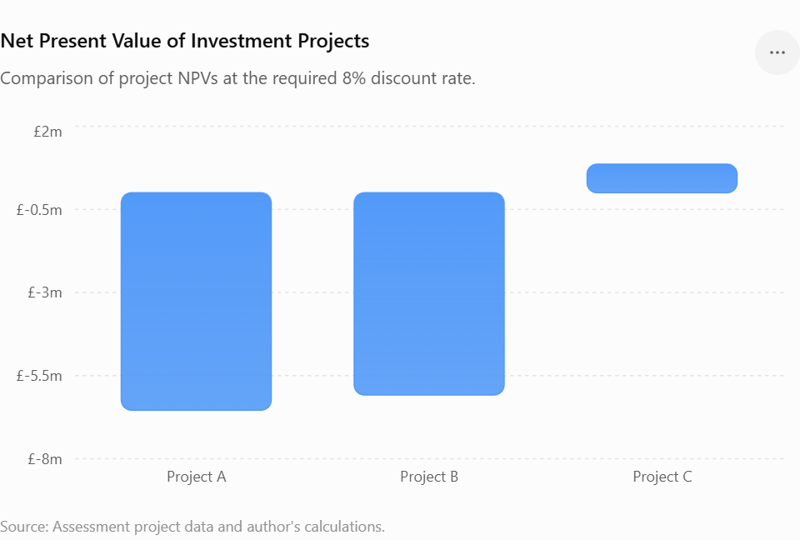
Figure 4. Net Present Value of Investment Projects at an 8% Discount Rate.
Source: Assessment project data and author's calculations.
As illustrated in Figure 4, Project C is the only investment with a positive NPV, indicating that it is the only project expected to increase shareholder value at the required 8% rate of return.
The Profitability Index (PI) confirms this result. Project C has a PI of 1.017, meaning the present value of its inflows exceeds the initial investment. In contrast, A (0.869) and B (0.878) have PIs below 1 and therefore fail the acceptance criterion.
Finally, IRR measures the rate at which NPV becomes zero. Project C achieves 8.59%, slightly above the required 8%, while A (2.72%) and B (3.26%) remain substantially below it. Overall, all five methods favour Project C, although its narrow margin above the required return suggests sensitivity to changes in cash flows or the cost of capital (Brealey, Myers and Allen, 2023).

4.3 Evaluation of the Three Projects
The three projects present different financial characteristics (see Appendix G). Project A benefits from relatively strong early cash inflows; however, its negative NPV and IRR significantly below the 8% required return indicate that it would reduce shareholder value. Therefore, it should be rejected.
Project B provides the most stable cash-flow pattern, generating £11 million annually. This predictability may reduce forecasting risk and support financial planning. Nevertheless, it has the longest payback period and fails the NPV, PI and IRR acceptance criteria. Therefore, stable cash flows do not compensate for its insufficient return.
Project C has greater variation in cash flows, with significant returns concentrated in Years 3 and 4, increasing exposure to forecasting uncertainty. However, it is the only project with a positive NPV, PI above 1 and IRR above the required 8%, while also providing the shortest payback period. Consequently, Project C offers the strongest financial case, although its relatively small positive NPV suggests that changes in expected cash flows or the cost of capital could affect its viability (Brealey, Myers and Allen, 2023).

4.4 Recommended Project
As CFO, I would recommend that Marriott International proceeds with Project C. The investment appraisal provides the strongest financial justification for this project (see Appendix G – Investment Appraisal and Capital Budgeting Calculations). Project C is the only alternative generating a positive NPV (£0.86 million), a PI above 1 (1.017) and an IRR (8.59%) exceeding the required 8% return. It also provides the shortest payback period of 3.60 years, allowing Marriott to recover its £50 million investment more quickly.
This recommendation is consistent with Marriott's existing financial position. The five-year analysis demonstrated improving profitability, with a 9.93% net profit margin and 9.4% ROA in 2025, alongside stronger operating cash generation (see Appendix D). However, Marriott's current ratio remained relatively low at 0.43, suggesting that liquidity should continue to be carefully managed. Project C's shorter payback period is therefore particularly beneficial because it limits the period for which capital is committed. Furthermore, Marriott's relatively stable Cash Conversion Cycle (see Appendix F) and improving operating cash flows (see Appendix C) provide additional capacity to support the investment.
Nevertheless, financial measures alone should not determine the final decision. Project C's returns depend heavily on cash inflows in Years 3 and 4, making it vulnerable to inflation, economic disruption and political or geopolitical risks that could reduce international travel demand. Scenario and sensitivity analysis should therefore be undertaken before final approval. Marriott should also consider whether the investment strengthens customer loyalty, for example through improvements in service quality, digital experience or the Marriott Bonvoy ecosystem.
Finally, the project should be consistent with Marriott's ESG commitments, including responsible resource use, carbon reduction and ethical employment practices (Marriott International, 2026). Subject to satisfactory risk and ESG assessment, Project C offers the strongest balance between financial return, liquidity protection and long-term strategic value.

4.5 Capital Rationing
Capital rationing occurs when an organisation has limited investment funds and must select the combination of projects that maximises shareholder value (Brealey, Myers and Allen, 2023). In this scenario, Marriott has a maximum investment budget of £100 million, meaning that the company could undertake up to two of the three proposed projects. The detailed capital rationing calculations are presented in Appendix G – Investment Appraisal and Capital Budgeting Calculations.
The results indicate that the combination of Projects B and C produces the highest combined Profitability Index (0.948) and the least negative Net Present Value (-£5.22 million) among the three possible investment portfolios. In comparison, Projects A and B generate the lowest combined NPV (-£12.62 million), while Projects A and C produce a combined NPV of -£5.68 million.
Although the B+C portfolio represents the strongest combination under the £100 million investment constraint, its combined NPV remains negative and the combined Profitability Index is below 1.0. According to investment appraisal theory, projects with a negative NPV reduce shareholder wealth and should therefore be rejected (Atrill and McLaney, 2024).
Consequently, from a financial management perspective, Marriott should not invest the full £100 million simply because the capital is available. Instead, the company should undertake only Project C, which is the only investment that generates a positive NPV (£0.86 million), a Profitability Index greater than 1.0 and an Internal Rate of Return exceeding the required 8% discount rate. The remaining £50 million could be retained for future positive-NPV investment opportunities, debt reduction or strategic initiatives that strengthen Marriott's long-term financial position.

4.6 Summary
Overall, the investment appraisal identifies Project C as the strongest option, as it is the only project that meets the key NPV, PI and IRR acceptance criteria. Although B+C represents the best two-project combination under the £100 million constraint, its negative NPV means that investing solely in Project C provides a stronger approach to protecting shareholder value and maintaining Marriott's financial flexibility.

5. Critical Reflection on AI Usage

5.1 Tool Disclosure
Artificial Intelligence was used as a supporting tool throughout the development of this report. I used ChatGPT (OpenAI) to help structure sections of the report, explain financial concepts, organise financial information, support calculations and improve the clarity of my academic writing. AI was also helpful in creating structured Excel tables for the five-year financial statements, ratio analysis, Cash Conversion Cycle and investment appraisal calculations. My use of ChatGPT is formally disclosed in the AI Usage Acknowledgement submitted with this assessment.
The weekly homework activities provided by the lecturer were particularly helpful in guiding this process. Completing the financial analysis step by step encouraged me to work consistently rather than attempting the entire assessment close to the deadline. Each activity contributed to the final report, particularly the preparation of financial statements, ratios and Excel calculations. This became especially valuable when the submission deadline was unexpectedly moved one week earlier. Although this initially created additional pressure, a significant proportion of the numerical analysis had already been completed, making the change considerably less stressful.

5.2 Critical Evaluation and Verification of AI Output
I did not treat AI-generated information as automatically accurate. Financial figures were checked against Marriott's annual reports, and calculations were reviewed using the original income statement, balance sheet, and cash-flow data. Investment appraisal calculations were also checked against the project information and the 8% discount rate specified in the assessment brief.
My previous experience working as a bookkeeper in Ukraine influenced this approach. Working with financial information taught me that even a small numerical or classification error can significantly affect the final result. This experience helped me recognise the importance of checking source documents rather than relying only on automatically generated outputs.
There were practical examples of errors during this assessment. When some investment-ratio figures were transferred into Excel, numerical values were incorrectly interpreted as dates, producing unrealistic results. These had to be identified and corrected. Another issue concerned Marriott's negative shareholders' equity, which meant that ROE could not be interpreted normally. These examples demonstrated that AI can produce convincing outputs while still requiring human verification and professional judgement. This is consistent with research showing that although large language models can support financial analysis, their reliability and consistency can vary across financial and accounting tasks (Kim, Muhn and Nikolaev, 2024; Wang and Wang, 2025).

5.3 Contribution Analysis
AI contributed mainly to organisation, calculation support, explanation and presentation, while the final analysis and decisions remained my responsibility. I selected Marriott, reviewed the financial evidence, considered which trends were important and connected the results with the company's financial position and strategy. This reflects the developing role of AI and digital technologies in finance, where technology can support analysis while professional judgement remains important in interpreting information and making decisions (IFAC, 2022).
My employment at Waitrose also influenced how I approached the report. Working within a large organisation has given me practical experience of how operational decisions, customer demand, staffing and day-to-day business activities can influence wider business performance. This helped me consider financial ratios as indicators of real business activity rather than simply numerical calculations.
The investment appraisal illustrates the distinction between AI support and my own judgement. AI assisted with PBP, ARR, NPV, PI and IRR calculations, but I evaluated the results and concluded that Project C was preferable. I also considered Marriott's liquidity and financial flexibility when deciding that using the entire £100 million investment budget would not necessarily represent the best financial decision.

5.4 Ethical and Professional Reflection
This experience highlighted several ethical and professional issues associated with the use of AI in financial management. Transparency is essential because organisations and stakeholders should understand when AI has contributed to financial analysis or decision-making. Data privacy is equally important, particularly when financial systems contain confidential corporate, employee or customer information. The increasing use of AI in accounting therefore requires appropriate governance and responsible professional practice (IFAC, 2026a).
The greatest professional risk is over-reliance on AI. Executive financial decisions can affect shareholders, employees, customers and other stakeholders, while AI may generate inaccurate information or fail to fully understand the wider organisational context. My experience with both bookkeeping and this assessment reinforced the importance of checking calculations, verifying information against reliable sources and questioning results that appear unrealistic. This approach reflects professional accounting principles that emphasise professional judgement, scepticism and ethical behaviour (IFAC, 2026b).
Overall, I found AI extremely useful for improving efficiency, organisation and understanding, particularly alongside the lecturer's structured weekly tasks. However, in a professional financial role, I would use AI as a decision-support tool rather than a replacement for human judgement. Final responsibility must remain with qualified professionals who can verify evidence, consider the wider business context and remain accountable for financial decisions.

References
Atrill, P. and McLaney, E. (2024) Accounting and Finance for Non-Specialists. 12th edn. Harlow: Pearson. Available at: Pearson – Accounting and Finance for Non-Specialists (Accessed: 18 July 2026).
Brealey, R.A., Myers, S.C., Allen, F. and Edmans, A. (2023) Principles of Corporate Finance. 14th edn. New York: McGraw Hill. Available at: McGraw Hill – Principles of Corporate Finance (Accessed: 29 July 2026).
Brigham, E.F. and Ehrhardt, M.C. (2020) Financial Management: Theory & Practice. 16th edn. Boston, MA: Cengage. Available at: Cengage – Financial Management: Theory & Practice (Accessed: 7 August 2026).
Guahk, S. (2020) ‘Determinants of Capital Structure of the Hospitality Industry’, Industry Promotion Research, 5(3), pp. 31–36. Available at: KCI – Determinants of Capital Structure of the Hospitality Industry (Accessed: 9 August 2026).
Hilton Worldwide Holdings Inc. (2025) Annual Report 2024. Available at: Hilton Investor Relations (Accessed: 31 July 2026).
Hilton Worldwide Holdings Inc. (2026) Annual Report 2025. Available at: Hilton Investor Relations (Accessed: 31 July 2026).
Hyatt Hotels Corporation (2026) Annual Report 2025. Available at: Hyatt Investor Relations (Accessed: 31 July 2026).
International Federation of Accountants (IFAC) (2022) Digital Transformation and the Role of Accounting and Finance Professionals in this New Era. Available at: IFAC – Artificial Intelligence & Technology (Accessed: 9 August 2026).
International Federation of Accountants (IFAC) (2026a) Artificial Intelligence & Accounting. Available at: IFAC – Artificial Intelligence & Accounting (Accessed: 9 August 2026).
International Federation of Accountants (IFAC) (2026b) IES 4: Initial Professional Development – Professional Values, Ethics, and Attitudes. Available at: IFAC – IES 4 (Accessed: 9 August 2026).
Kim, A., Muhn, M. and Nikolaev, V. (2024) ‘Financial Statement Analysis with Large Language Models’. arXiv. Available at: Financial Statement Analysis with Large Language Models (Accessed: 3 August 2026).
Marriott International, Inc. (2025) Annual Report 2024. Available at: Marriott International – Annual Reports (Accessed: 16 July 2026).
Marriott International, Inc. (2026) Annual Report 2025. Available at: Marriott International – 2025 Annual Report / Form 10-K (Accessed: 16 July 2026).
UN Tourism (2025) World Tourism Barometer, January 2025. Madrid: UN Tourism. Available at: UN Tourism – World Tourism Barometer January 2025 (Accessed: 4 August 2026).
Wang, J.J. and Wang, V.X. (2025) ‘Assessing Consistency and Reproducibility in the Outputs of Large Language Models: Evidence Across Diverse Finance and Accounting Tasks’. arXiv. Available at: Assessing Consistency and Reproducibility in LLM Outputs (Accessed: 1 August 2026).

Appendices
Appendix A – Consolidated Income Statements (2021–2025)
Table A1. Consolidated Income Statement (2021–2025). Source: Marriott International Annual Reports and author.
Income Statement (USD millions) | 2025 |  | 2024 | 2023 | 2022 | 2021
INCOME STATEMENT
Total Revenues | 26 186 |  | 25 100 | 23 713 | 20 773 | 13 857
Cost of Revenues | 20 964 |  | 20 128 | 18 733 | 16 215 | 11 056
Gross Profit | 5 222 |  | 4 972 | 4 980 | 4 558 | 2 801
OPERATING EXPENSES
General, Administrative & Other Expenses | 1 083 |  | 1 128 | 1 045 | 1 084 | 1 043
Operating Income | 4 139 |  | 3 844 | 3 935 | 3 474 | 1 758
OTHER INCOME / EXPENSE
Interest Expense (Net) | (738) |  | (655) | (535) | (377) | (392)
Other Income (Expense), Net | 11 |  | (38) | (11) | 17 | (186)
Income Before Taxes | 3 412 |  | 3 151 | 3 389 | 3 114 | 1 180
Income Tax Expense | (793) |  | (739) | (309) | (526) | (152)
NET INCOME | 2 601 |  | 2 375 | 3 083 | 2 357 | 1 099
Source |  | Marriott International Annual Reports 2021-2025
Official annual reports page |  | https://marriott.gcs-web.com/annual

Appendix B – Consolidated Balance Sheets (2021–2025)
Table B1. Consolidated Balance Sheet (2021–2025). Source: Marriott International Annual Reports and author.
MARRIOTT INTERNATIONAL, INC.
Consolidated Balance Sheets - 5 Year Comparison (USD millions)
As of December 31 | 2025 | 2024 | 2023 | 2022 | 2021
ASSETS
Current assets
Cash and equivalents | 358 | 396 | 338 | 507 | 1 393
Accounts and notes receivable, net | 2 909 | 2 795 | 2 712 | 2 571 | 1 982
Prepaid expenses and other | 317 | 294 | 261 | 235 | 251
Total current assets | 3 584 | 3 485 | 3 311 | 3 313 | 3 626
Non-current assets
Property and equipment, net | 1 954 | 1 833 | 1 581 | 1 585 | 1 503
Intangible assets
Brands | 6 207 | 5 770 | 5 907 | 5 812 | 5 979
Contract acquisition costs and other | 4 129 | 3 718 | 3 283 | 2 935 | 2 947
Goodwill | 8 907 | 8 731 | 8 886 | 8 872 | 9 073
Total intangible assets | 19 243 | 18 219 | 18 076 | 17 619 | 17 999
Equity method investments | 298 | 298 | 308 | 335 | 387
Notes receivable, net | 151 | 136 | 138 | 152 | 144
Deferred tax assets | 570 | 650 | 673 | 240 | 228
Operating lease assets | 941 | 845 | 929 | 987 | 1 062
Other noncurrent assets | 799 | 716 | 658 | 584 | 604
TOTAL ASSETS | 27 540 | 26 182 | 25 674 | 24 815 | 25 553
LIABILITIES
Current liabilities
Current portion of long-term debt | 1 209 | 1 309 | 553 | 684 | 805
Accounts payable | 814 | 763 | 738 | 746 | 726
Accrued payroll and benefits | 1 438 | 1 449 | 1 390 | 1 299 | 1 187
Liability for guest loyalty program (current) | 3 497 | 3 487 | 3 328 | 3 314 | 2 522
Accrued expenses and other | 1 440 | 1 641 | 1 753 | 1 296 | 1 167
Total current liabilities | 8 398 | 8 649 | 7 762 | 7 339 | 6 407
Non-current liabilities
Long-term debt | 14 995 | 13 138 | 11 320 | 9 380 | 9 333
Liability for guest loyalty program (non-current) | 4 495 | 4 032 | 3 678 | 3 280 | 3 949
Deferred tax liabilities | 79 | 81 | 209 | 313 | 169
Deferred revenue | 1 200 | 1 103 | 1 018 | 1 059 | 1 181
Operating lease liabilities | 879 | 794 | 887 | 1 034 | 1 098
Other noncurrent liabilities | 1 265 | 1 377 | 1 482 | 1 842 | 2 002
TOTAL LIABILITIES | 31 311 | 29 174 | 26 356 | 24 247 | 24 139
SHAREHOLDERS' EQUITY (DEFICIT)
Class A Common Stock | 5 | 5 | 5 | 5 | 5
Additional paid-in-capital | 6 352 | 6 179 | 6 051 | 5 965 | 5 892
Retained earnings | 18 414 | 16 531 | 14 838 | 12 342 | 10 305
Treasury stock, at cost | (27 900) | (24 644) | (20 929) | (17 015) | (14 446)
Accumulated other comprehensive loss | (642) | (1 063) | (647) | (729) | (342)
TOTAL SHAREHOLDERS' EQUITY (DEFICIT) | (3 771) | (2 992) | (682) | 568 | 1 414
TOTAL LIABILITIES & SHAREHOLDERS' EQUITY | 27 540 | 26 182 | 25 674 | 24 815 | 25 553
Source | Marriott International Annual Reports 2021-2025, Consolidated Balance Sheets
Official annual reports page | https://marriott.gcs-web.com/annual
Appendix C – Consolidated Statements of Cash Flows (2021–2025)
Table C1. Consolidated Statement of Cash Flows (2021–2025). Source: Marriott International Annual Reports and author.
MARRIOTT INTERNATIONAL, INC.
CONSOLIDATED STATEMENTS OF CASH FLOWS
Fiscal Years 2025, 2024, 2023, 2022, and 2021 (in millions)
Cash Flow Statement (USD millions) | 2025 | 2024 | 2023 | 2022 | 2021
OPERATING ACTIVITIES
Net income | 2 601 | 2 375 | 3 083 | 2 358 | 1 099
Depreciation, amortization, and other | 599 | 492 | 277 | 282 | 295
Stock-based compensation | 236 | 237 | 205 | 192 | 182
Income taxes | (277) | (172) | (612) | 280 | (281)
Liability for guest loyalty program | 473 | 514 | 301 | (119) | (28)
Contract acquisition costs | (434) | (341) | (221) | (149) | (210)
Merger-related charges and other | (15) | (278) | 47 | (8) | (10)
Working capital changes | (147) | (82) | 69 | (542) | 110
Loss on extinguishment of debt | — | — | — | — | 164
Other | 176 | 4 | 21 | 69 | (144)
Net cash provided by operating activities | 3 212 | 2 749 | 3 170 | 2 363 | 1 177
INVESTING ACTIVITIES
Capital and technology expenditures | (604) | (750) | (452) | (332) | (183)
Asset acquisition(s) | (350) | (26) | (101) | — | —
Dispositions | 9 | 16 | 71 | 1 | 12
Loan advances | (35) | (10) | (77) | (11) | (13)
Loan collections | 22 | 36 | 61 | 14 | 40
Other | 10 | — | 33 | 31 | (43)
Net cash used in investing activities | (948) | (734) | (465) | (297) | (187)
FINANCING ACTIVITIES
Commercial paper/Credit Facility, net | (403) | 163 | 546 | (182) | 150
Issuance of long-term debt | 3 436 | 2 948 | 1 918 | 983 | 1 793
Repayment of long-term debt | (1 309) | (558) | (684) | (804) | (2 174)
Issuance of Class A Common Stock | 92 | 73 | 29 | — | 2
Debt extinguishment costs | — | — | — | — | (155)
Dividends paid | (718) | (682) | (587) | (321) | —
Purchase of treasury stock | (3 300) | (3 762) | (3 953) | (2 566) | —
Stock-based compensation withholding taxes | (116) | (138) | (108) | (89) | (90)
Other | — | — | (25) | 17 | 11
Net cash used in financing activities | (2 318) | (1 956) | (2 864) | (2 962) | (463)
(DECREASE) INCREASE IN CASH, CASH EQUIVALENTS, AND RESTRICTED CASH | (54) | 59 | (159) | (896) | 527
CASH, CASH EQUIVALENTS, AND RESTRICTED CASH, beginning of period | 425 | 366 | 525 | 1 421 | 894
CASH, CASH EQUIVALENTS, AND RESTRICTED CASH, end of period | 371 | 425 | 366 | 525 | 1 421
Sources | 2025 Annual Report | 2025 Annual Report | 2025 / 2023 Annual Reports | 2023 Annual Report | 2023 Annual Report

Appendix D – Financial Ratio Analysis and Supporting Calculations (2021–2025)
Table D1. Financial Ratio Analysis (2021–2025). Source: Annual reports and author's calculations.
Ratio | 2025 | 2024 | 2023 | 2022 | 2021
Gross Margin % | 19,94 | 19,81 | 21 | 21,94 | 20,21
Operating Margin % | 15,81 | 15,31 | 16,59 | 16,72 | 12,69
Net Profit Margin % | 9,93 | 9,46 | 13 | 11,35 | 7,93
Current Ratio | 0,43 | 0,4 | 0,43 | 0,45 | 0,57
Quick Ratio | 0,39 | 0,37 | 0,39 | 0,42 | 0,53
Cash Ratio | 0,04 | 0,05 | 0,04 | 0,07 | 0,22
Asset Turnover | 0,95 | 0,96 | 0,92 | 0,84 | 0,54
Fixed Asset Turnover | 13,4 | 13,69 | 15 | 13,11 | 9,22
Interest Coverage | 5,61 | 5,87 | 7,36 | 9,21 | 4,48
Debt/Equity | 4,3 | 4,83 | 17,41 | 17,72 | 7,17
Additional Ratios | 2025 | 2024 | 2023 | 2022 | 2021
ROE | NM | NM | NM | NM | NM
ROA (%) | 9,4 | 8,8 | 11,2 | 9,2 | 4,8
P/E Ratio | 29,1 | 33,4 | 22,1 | 20,6 | 42,5
Operating Cash Flow Ratio | 0,38 | 0,32 | 0,41 | 0,32 | 0,18
Free Cash Flow Margin (%) | 10 | 8 | 11,5 | 9,8 | 7,2

Appendix E – Industry Benchmark Analysis
Table 1E– Financial Ratio Benchmark Comparison (2025). Source: Marriott, Hilton and Hyatt annual reports and author's calculations.
Ratio | Marriott | Hilton | Hyatt | Comment
Operating Margin | 15,81% | 22,37% | 15,20% | Hilton highest
Net Margin | 9,93% | 12,10% | 8,90% | Marriott above Hyatt
Current Ratio | 0,43 | 0,61 | 0,74 | Marriott lowest liquidity
Asset Turnover | 0,95 | 0,72 | 0,58 | Marriott most efficient
Table E2. Additional Industry Ratio Benchmark Comparison (2025). Source: Marriott, Hilton and Hyatt annual reports and author's calculations.
Additional Ratio (2025) | Marriott | Hilton | Hyatt | Benchmark Analysis
ROE | NM | NM | 5.8% | Marriott and Hilton report shareholders' deficits due to significant share repurchases, making ROE not meaningful. Hyatt reports positive equity and a positive ROE.
ROA (%) | 9.4% | 8.5% | 4.2% | Marriott achieved the highest return on assets, indicating it generated more profit from each dollar invested in assets than Hilton or Hyatt.
P/E Ratio | 29,1 | 35,1 | 31,8 | Marriott's valuation is lower than Hilton's but slightly below Hyatt's, suggesting investors expect continued growth while valuing Hilton more highly.
Operating Cash Flow Ratio | 0.38 | 0.49 | 0.44 | Marriott generated an operating cash flow ratio of 0.38, below Hilton and Hyatt in this benchmark, indicating weaker operating cash coverage of current liabilities in 2025.
Free Cash Flow Margin (%) | 10.0% | 8.6% | 7.8% | Marriott generated the highest proportion of free cash flow from revenue, providing greater financial flexibility for dividends, share buybacks and future investment.

Appendix F – Cash Conversion Cycle (CCC) Analysis
Table F1. Cash Conversion Cycle Analysis (2021–2025). Source: Annual reports and author's calculations.
Calculation | 2025 | 2024 | 2023 | 2022 | 2021
Opening receivables | 2,795 | 2,712 | 2,571 | 1,982 | 1,768
Closing receivables | 2,909 | 2,795 | 2,712 | 2,571 | 1,982
Average receivables | 2,852.0 | 2,753.5 | 2,641.5 | 2,276.5 | 1,875.0
Revenue | 26,186 | 25,1 | 23,713 | 20,773 | 13,857
Receivable Days | 39.75 | 40.04 | 40.66 | 40.00 | 49.39
Opening accounts payable | 763 | 738 | 746 | 726 | 527
Closing accounts payable | 814 | 763 | 738 | 746 | 726
Average accounts payable | 788.5 | 750.5 | 742.0 | 736.0 | 626.5
Cost of revenues | 20,964 | 20,128 | 18,733 | 16,215 | 11,056
Payable Days | 13.73 | 13.61 | 14.46 | 16.57 | 20.68
Inventory Days | 0.00 | 0.00 | 0.00 | 0.00 | 0.00
Cash Conversion Cycle | 26.02 days | 26.43 days | 26.20 days | 23.43 days | 28.71 days

Appendix G – Investment Appraisal and Capital Budgeting Calculations
Project Information
Project | Initial Investment (£m) | Discount Rate | Life (Years)
Project A | 50 | 0,08 | 5
Project B | 50 | 0,08 | 5
Project C | 50 | 0,08 | 5
Table G1. Project Cash Flows
Year | Project A | Project B | Project C
Initial Investment | -50 | -50 | -50
Year 1 | 10 | 11 | 5
Year 2 | 12 | 11 | 10
Year 3 | 14 | 11 | 20
Year 4 | 10 | 11 | 25
Year 5 | 8 | 11 | 5
Table G2. Discount Factors (8%)
Year | Factor
1 | 0,9259
2 | 0,8573
3 | 0,7938
4 | 0,735
5 | 0,6806
Table G3. Present Value of Cash Inflows
Year | Project A | Project B | Project C
1 | 9,26 | 10,19 | 4,63
2 | 10,29 | 9,43 | 8,57
3 | 11,11 | 8,73 | 15,88
4 | 7,35 | 8,09 | 18,38
5 | 5,44 | 7,49 | 3,4
Total PV | 43,46 | 43,92 | 50,86
Table G4. Payback Period
Project | Payback (Years)
Project A | 4,5
Project B | 4,55
Project C | 3,6
Table G5. Accounting Rate of Return (ARR)
Project | Average Annual Profit (£m) | ARR (%)
Project A | 0,8 | 1,6
Project B | 1 | 2
Project C | 3 | 6
Table G6. Net Present Value (NPV)
Project | Total PV | Initial Investment | NPV (£m)
Project A | 43,46 | 50 | -6,54
Project B | 43,92 | 50 | -6,08
Project C | 50,86 | 50 | 0,86
Table G7. Profitability Index (PI)
Project | PI
Project A | 0,869
Project B | 0,878
Project C | 1,017
Table G8. Internal Rate of Return (IRR)
Project | IRR (%)
Project A | 2,72
Project B | 3,26
Project C | 8,59
Table G9. Investment Appraisal Results. Source: Assessment data and author's calculations.

Table G9. Summary of Investment Appraisal Results
Method | Project A | Project B | Project C | Preferred
Payback Period | 4,5 | 4,55 | 3,6 | Project C
ARR (%) | 1,6 | 2 | 6 | Project C
NPV (£m) | -6,54 | -6,08 | 0,86 | Project C
PI | 0,869 | 0,878 | 1,017 | Project C
IRR (%) | 2,72 | 3,26 | 8,59 | Project C
Table G10. Capital Rationing Analysis. Source: Assessment data and author's calculations.
Table G10. Capital Rationing Analysis (£100 Million Budget) | Table G10. Capital Rationing Analysis (£100 Million Budget)
Combination | Initial Investment (£m) | Combined NPV (£m) | Combined PI | Financial Decision
Project A + Project B | 100 | -12.62 | 0.874 | Reject
Project A + Project C | 100 | -5.68 | 0.943 | Reject
Project B + Project C | 100 | -5.22 | 0.948 | Best combination under the £100m constraint, but still reject because NPV is negative

