Module title: Marketing Essentials BMIH4005
Title: Sheraton Hotel’s Marketing Plan in the Current Climate
(Presentation Note)

Student Name : Kvetoslava Tancosova
Student ID : 2132429
Lecturer’s name : Ruth Taylor-Davies

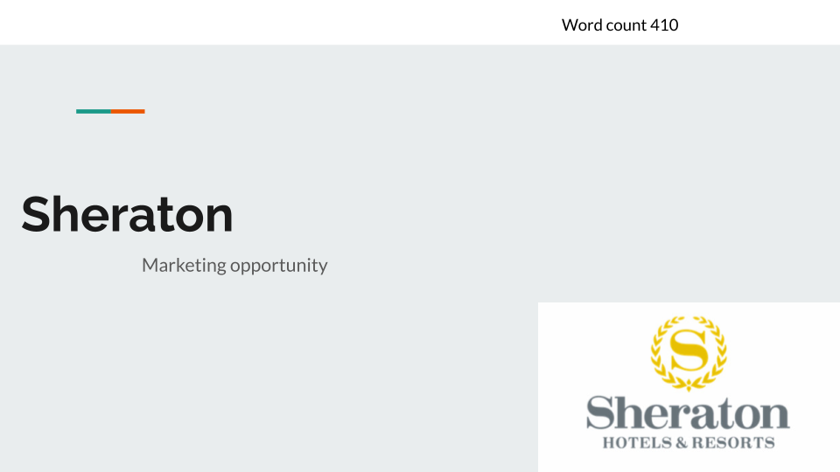

Introduction
Sheraton Hotels & Resorts is a division of Marriott International, which operates hotels all over the world. Sheraton has 446 hotels with a total of 155,617 rooms around the globe (Sheraton Hotels & Resorts, 2023). These hotels were in the Americas, Africa, the Asia Pacific region, Latin America, the Middle East, Europe, and the Caribbean. The goal of the marketing strategy is to find a promising promotional opening for the Sheraton hotel chain and develop an appropriate PR approach. The hotel's management and interested parties will benefit from the idea. SOSTAC, the 4'Ps, and Bowmans are some of the primary areas and frameworks that were utilised to structure the strategy. The purpose of this marketing plan is to analyse the existing market situation and develop a communication strategy for Sheraton Hotel that will allow them to take advantage of a marketing opportunity. The management team of the Sheraton hotel is the target audience for this strategy report.

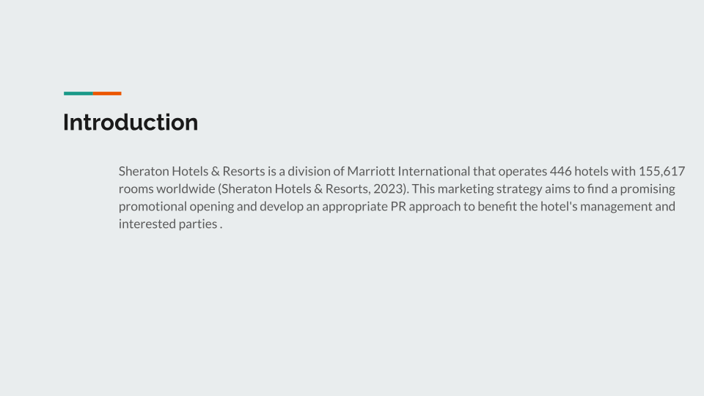

Situation Analysis

SWOT analysis

Strengths
- The organisation's geographic reach is a strength. It influences the company's target market and accessibility (Team, 2017).
- The large product selection may grow the client base and balance losses from a single category of goods with gains from another (Philip, 2005).
- Social media presence and management may boost positive e-WOM and build consumer connections.

Weaknesses
- Environmentalists might criticise the company's waste handling and lack of sustainability.
- Leadership styles that don't match strategic goals might leave a corporation directionless.
- When it conflicts with strategic/business goals, organisational culture becomes a major vulnerability (Housden, 2007).

Opportunities
- Business organisations might benefit from the exponential population expansion, especially in client categories (International Labour Office. Sectoral Activities Programme, 2010).
- Good market awareness may help a firm capitalise on shifting client tastes and preferences.
- New technologies that aid product/service creation and delivery may be used to integrate innovation into corporate operations.

Threats
- Sheraton is threatened by shifting laws and tougher rules.
- It complicates legal compliance for businesses.
- Failure to comply with new requirements risks costly lawsuits.
- The company's client base is affected by the growing number among direct and indirect rivals.

Customers: Segmentation and Targeting/ Customer profile
The clientele of Sheraton is varied and includes both business and upscale vacationers (ABC News, 2022). Based on their demands and preferences, including location, amenities, and pricing, the corporation divides its clientele into different groups. Sheraton generally caters to middle-aged, wealthy tourists who desire upscale rooms and attentive service.

Competitors: Perceptual positioning map, Bowman’s strategy clock
Other high-end hotel chains, such as Hilton, Marriott, and Hyatt, are Sheraton's main rivals (Hollander, 2020). The perceptual positioning mapping and Bowman's strategy clock may be used to evaluate its standing in relation to rivals. Sheraton is in a privileged position in the industry thanks to the merits of its name, products, and services. But it has to compete with other high-end chains, so it needs to offer something special to its customers in terms of price and service if it wants to succeed (Kotler, Kartajaya and Setiawan, 2017).

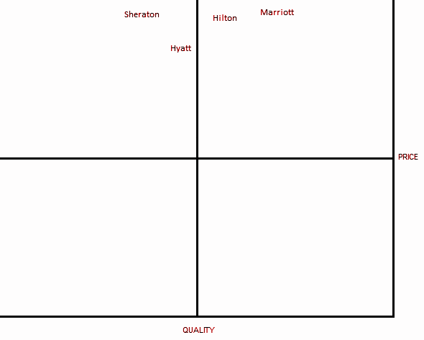
Perceptual positioning map of Sheraton

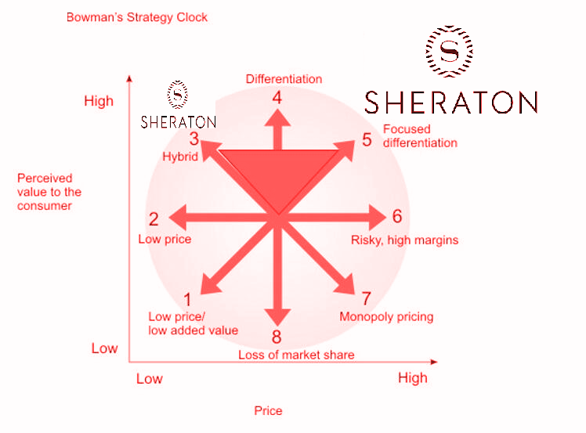
Bowman's strategy clock "Sheraton"

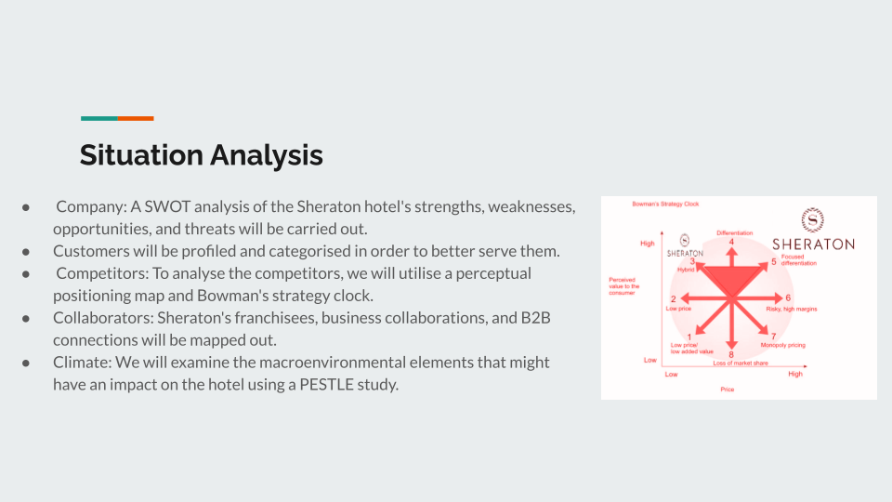

Collaborators
Marriott International operates the Sheraton hotel chain. Because of this, Sheraton works with a wide range of businesses in the hospitality sector and beyond. Partners of Sheraton include the following:
Sheraton participates in Marriott International's reward programme, Marriott Bonvoy. Through this programme, guests of Sheraton hotels and other Marriott International hotels can accumulate points during their stays (Marriott International, 2023). Sheraton offers a co-branded credit card with American Express, and users may use it for Marriott Bonvoy points.
United Airlines: Thanks to a connection with United, guests of Sheraton hotels may accrue miles in the airline's MileagePlus reward programme.
Hertz: Thanks to Sheraton's connection with Hertz, guests may collect Marriott Bonvoy points on their Hertz car rentals.
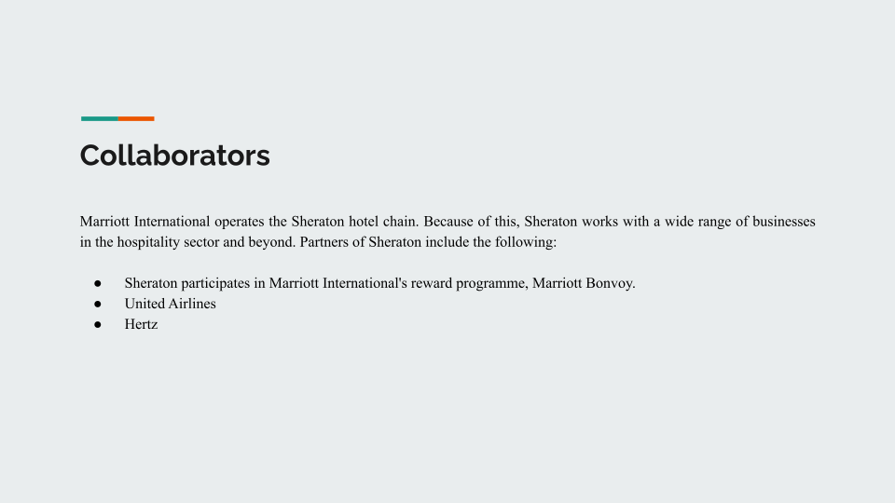

PESTLE
PESTLE analysis may analyse Sheraton's macro environment.
Political: Government laws and visa rules might affect hotel expansion. Taxation, employment, and travel restrictions affecting the hospitality industry; political stability and government support for tourism in different regions where Sheraton operates. Ukraine war impact, Economic expansion, currency fluctuations, and inflation impact travellers' hotel bookings (Maglione, 2023)
Economic: Exchange rates and the value of currencies may influence tourist demand and revenues; economic downturns can affect discretionary expenditure on travel and hospitality; economic growth and growing earnings can stimulate demand for luxury services in hospitality.
Social: Hospitality customer preferences and trends, such as rising interest in sustainable and environmentally conscious practices. Ageing populations, including changing family arrangements, may alter travel habits and hospitality service demand. Social changes may affect Sheraton's reputation and brand image.
Technological: Online booking systems and smartphone apps may help Sheraton reach consumers and enhance guest experiences. Technology may also cause problems, like cyberattacks and Airbnb disruptions.
Legal: compliance with the worldwide and local hospitality sector rules and regulations, including health and safety, data privacy, and employment requirements.
Environmental: Consumers increasingly consider global warming, emissions, and disposal of waste while choosing hotels. Environmental regulations like carbon emissions reduction objectives might affect Sheraton's operations and expenses.
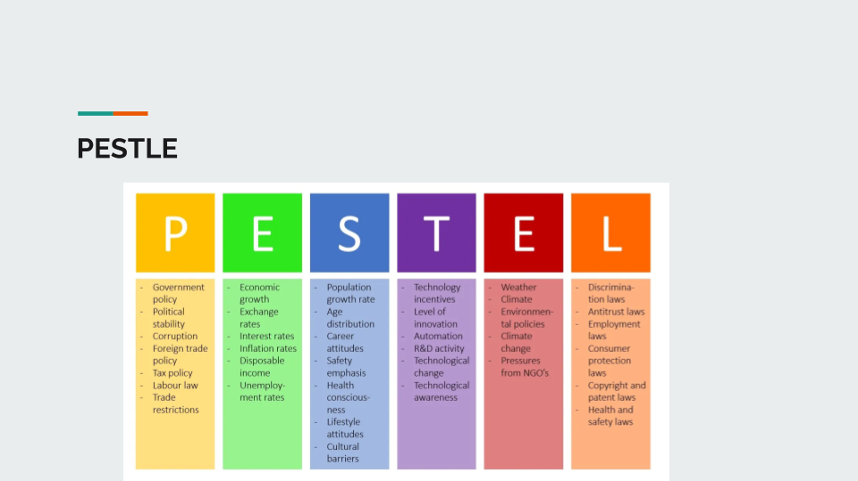

Objectives
The goal of the next 12 months is to raise occupancy rates by 15% via strategic marketing campaigns that highlight Sheraton's unique value offer and establish the hotel as the premier choice for high-end business and leisure travellers in the area.

Strategy
Sheraton's core promise aims to provide a feeling of community and luxury for guests. High-quality beds, exercise centres, and on-site food choices, as well as events and public areas, set the company apart (Clow, 2012). Sheraton may utilise social media, email, and advertising to convey this value offer. By promoting favourable evaluations and word-of-mouth marketing, the company may utilise its current client base (Chaffey and Chadwick, 2019). Sheraton targets business and leisure travellers who appreciate comfort, elegance, and community by linking the value offered to consumer categories. This can position the organisation as one that fosters community rather than merely offering a bed. Sheraton may also segment its guests to customise its services and facilities. Business travellers may choose conference rooms and technology, while leisure travellers may prefer on-site food and pleasure. Sheraton may improve its marketing approach by tying its value offer to certain client categories.
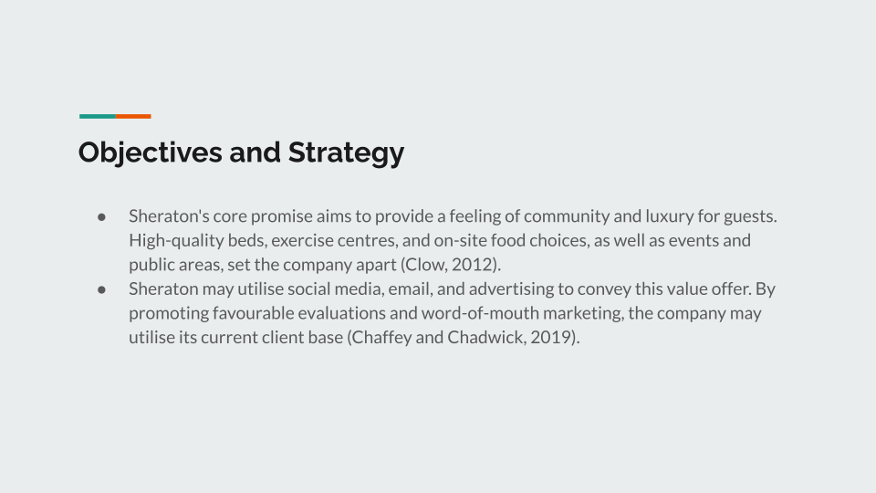

Marketing mix
Product: Sheraton should provide visitors a unique and extraordinary experience with exquisite amenities, personal services, including state-of-the-art facilities. To attract green travellers, the hotel should provide eco-friendly solutions. To enhance the visitor experience, Sheraton should engage with nearby enterprises and attractions (Ghauri and Cateora, 2014).
Place (Distribution): Sheraton should market online and offline. The hotel's website should be current, simple to use, and provide online booking. Sheraton should also use social media to engage prospective visitors and promote its unique features (Rahayu, Utami et al., 2018). To reach more people offline, the lodging establishment should collaborate with travel brokers and airlines.
Price: Sheraton should examine its target market's pricing approach. For families, business travellers, and luxury seekers, the hotel should provide multiple pricing ranges. The hotel may also give repeat clients and long-term visitors unique packages and discounts.
Promotion: Sheraton should promote its services via conventional advertising, web advertising, PR, and event marketing. The hotel should concentrate on branding and client loyalty. Sheraton should also employ user-generated content to boost brand recognition and social media engagement (Ryan, 2016). Influencers including travel bloggers may help the hotel market its services.
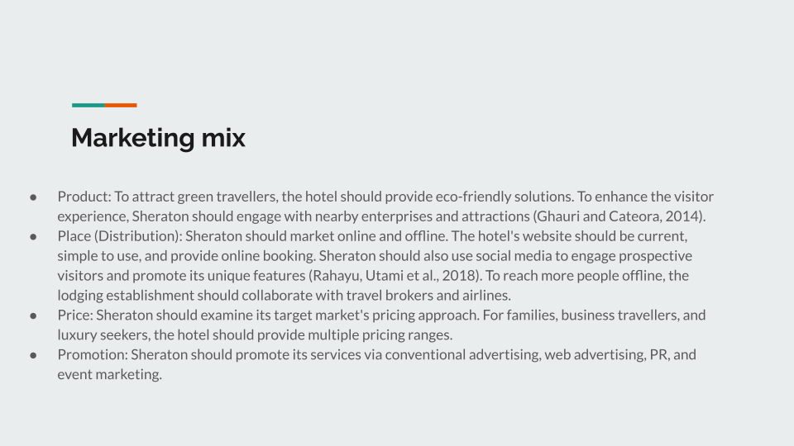

Action
The marketing channels include:
- SEO to enhance search engine rankings.
- Email marketing to Sheraton-interested prospects
- Social media influencer marketing to advertise our hotel.
- Events and collaborations to reach more customers.
Market research indicates that our target demographic is more likely to utilise social media and email marketing (Ryan, 2016). SEO improves search engine rankings, while influencer marketing reaches younger groups. Finally, events and collaborations let us reach more people and form industry ties.
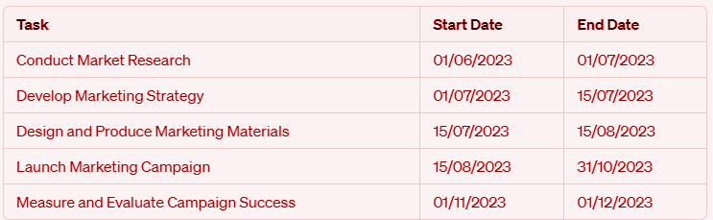
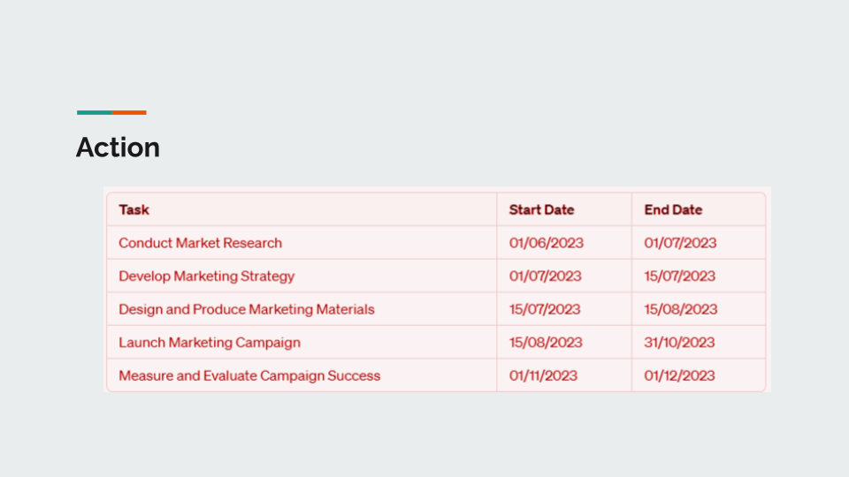

Control
The marketing strategy will be evaluated using quantitative and qualitative measures.
- Website traffic statistics, social media interaction, and direct reservations will all be measured quantitatively. Email, ad spending, and social media conversion rates will be tracked (Ryan, 2016).
- Qualitative measurements will assess customer satisfaction and Sheraton brand perceptions. They can poll consumers and monitor social media to improve.
- The Net Promoter Score (NPS) gauges consumers' probability to promote our brand. We measure customer happiness and loyalty by measuring the NPS score.
- Their objective is brand recognition, direct bookings, and customer pleasure. These stats let us assess our marketing efforts and make modifications.
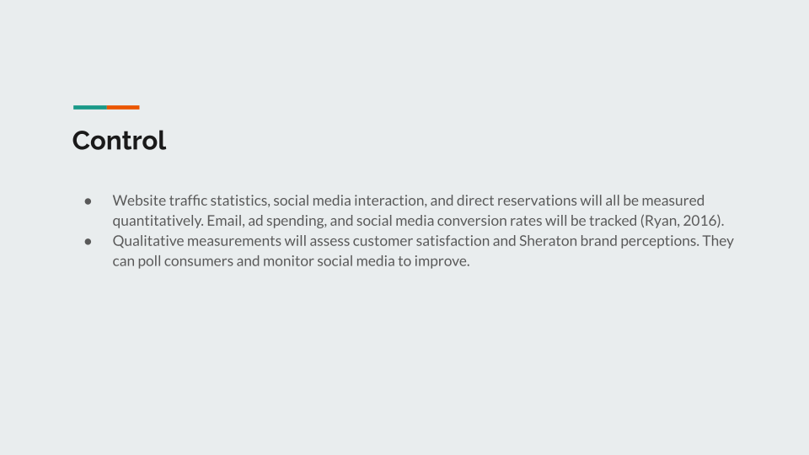

Conclusion
The Sheraton hotel marketing strategy addressed the problem of expanding brand recognition and attracting more consumers in the present environment. The plan proposes a complete marketing strategy with a clear value argument, focused segmentation including location, and a successful advertising mix to solve this problem. To reach more clients, use social media and influencers, invest in SEO, and use personalised email marketing campaigns. The strategy also advises assessing performance by internet traffic, conversion rates, and customer satisfaction. This marketing campaign will succeed if it addresses Sheraton's target customers' particular wants and preferences. Sheraton can stay competitive and attract new customers in today's shifting industry by analysing and adjusting its marketing plan based on performance data.

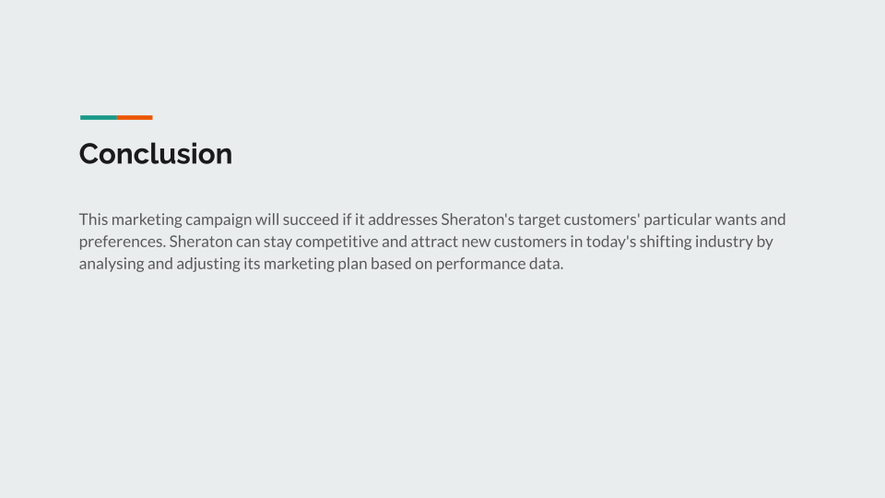

References
Chaffey, D. and Ellis Chadwick, F. (2019). Digital marketing. Pearson uk.
Clow, K.E. (2012). Integrated advertising, promotion and marketing communications, 4/e. Pearson Education India.
Ghauri, P.N. and Cateora, P.R. (2014). International marketing. 4th ed. London: Mcgraw-Hill.
Hollander, J. (2020). Hotel Brands & Chains: Marriott, Hyatt, Hilton, IHG (Who Owns What?). [online] Hotel Tech Report. Available at: https://hoteltechreport.com/news/hotel-brand-guide [Accessed 5 May 2023].
Housden, M. (2007). Marketing research and information. Routledge.
International Labour Office. Sectoral Activities Programme (2010). Developments and challenges in the hospitality and tourism sector : issues paper for discussion at the Global Dialogue Forum on New Developments and Challenges in the Hospitality and Tourism Sector and their Impact on Employment, Human Resources Development and Industrial Relations, Geneva 2010. Geneva: Ilo.
Kotler, P., Kartajaya, H. and Setiawan, I. (2017). Marketing 4.0 : moving from traditional to digital. Hoboken, New Jersey: John Wiley & Sons, Inc., Cop.
Maglione, A. (2023). The impact of inflation on tourism: navigating the economic storm. [online] Regiondo. Available at: https://pro.regiondo.com/blog/the-impact-of-inflation-on-tourism-navigating-the-economic-storm/ [Accessed 5 May 2023].
Marriott International. (2023). Terms & Conditions | Loyalty Rewards Program | Marriott Bonvoy. [online] Available at: https://www.marriott.com/loyalty/terms/default.mi [Accessed 5 May 2023].
News, A.B.C. (2022). Sheraton has designs with a fresh look. [online] ABC News. Available at: https://abcnews.go.com/Travel/story?id=5654225&page=1 [Accessed 5 May 2023].
Philip, K. (2005). Principles of Marketing. Harlow: Pearson/Prentice Hall.
Rahayu, Alsya Utami, Herawaty, I., NR, S., Prafitriyani, A.S., Afini, Amita Putri and Kautsar, Angga Prawira (2018). Marketing 4.0: a digital transformation in pharmaceutical industry to reach customer brand experience. Farmaka, 16(1), pp.80–85.
Ryan, D. (2016). Understanding digital marketing: marketing strategies for engaging the digital generation. Kogan Page Publishers.
Sheraton Hotels & Resorts. (2023). Sheraton Hotels & Resorts. [online] Available at: https://sheraton.marriott.com/ [Accessed 5 May 2023].
Team, T.B. (2017). THE GEOGRAPHY OF MARKETING. [online] Brand2Global. Available at: https://www.brand2global.com/the-geography-of-marketing/ [Accessed 5 May 2023].



