Name | Joan McDonald
Student Number | 1714477
Module Title | Introduction to Physiology
Module Code | BMHP5003
Lecturer | Mumtaz Goolam
Submission Deadline | Friday 6th November 2020

The Skeletal System
Types of bones Compact (dense) bone: hardest and strongest type of bone. It supports the body weight also forms the outer layer of the bone. Protect the spongy bone that is located inside the bone. Cancellous (spongy) bone: lighter than compact bone, which help reduce the weight of the skeleton and make it easier for the movement between muscles and bones (McGuinness, 2002). 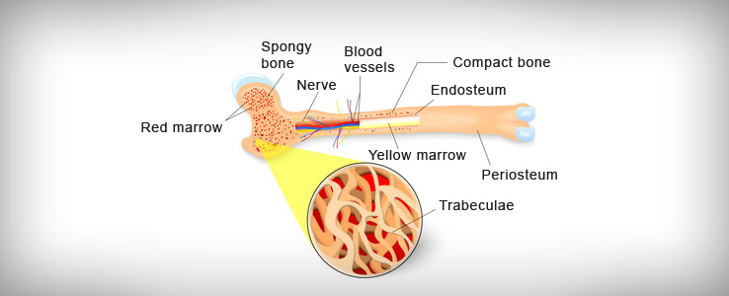
The Skeletal system is the bone structure for holding the body upright. Bones is a living, growing tissue, that form the basis of the skeleton. There are 206 bones in an adult skeletal system. They work together with the muscular system to support posture and movement within the body. Bone is the hardest tissue in the body and when fully developed it is composed of 20% of water, 30 to 40% organic material and 40 to 50% inorganic material. It is made up mostly of collagen and calcium. Collagen is a protein that provides a soft framework. Calcium and phosphate are a mineral that adds strength and hardens the framework. The combination of calcium and collagen makes the bone strong and flexible enough to aid and undergo forces. More than 99% of the body’s calcium contain in the bones (Abrahams, 2009a).
Classification of bones are according to their size and shape Long bones function as levers; they move when muscles contract e.g. Humerus, Femur Short bones provide stability and support as well as some limited motion e.g.: Wrist, Ankles Irregular bones tend to have more complex shapes e.g. vertebrae that support the spine and facial bones Flat bones serve as points of attachment for muscles and often protect internal organs e.g.: Ribs, Sternum Sesamoid bones protect tendons from compressive forces e.g.: Patellae(kneecap) (6.2 Bone Classification, 2020)
Joints formed the link between the bones where two or more of them meet. There are three main types of Joints: Fixed (Cranium), Slightly movables (Vertebrae)and the Synovial. Synovial fluid provides nourishment and lubricates the joints hold together by ligament
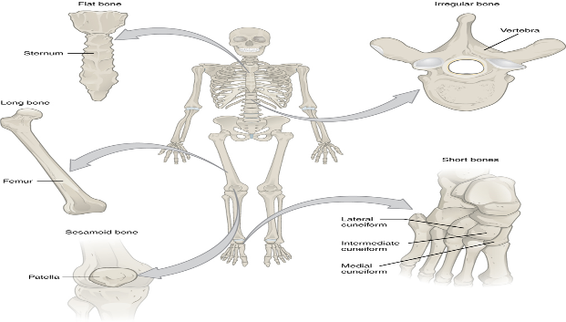

Function of the bones Support structural framework of the body and an attachment for the soft tissue and organs. Protect internal organs in the ribs cage like the heart and lung. Produce red and white blood cell that is essential for the processes such as transportation of oxygen. Store minerals, fat and calcium and serves as a reservoir for these important minerals Movement-The bones and joints work with muscles to enable movement in the body between the muscles. This allow us to walk and run also allowing a wide range of other movements. Bones act as a lever for muscles without the bones, muscles would not be able to work. Movement occur when the muscles contract then pulls on the bones. Bones are mostly rough surface unregistered, this allow attachment to muscles tendons, ligaments and cartilage that connects them. (Ross and Wilson, 1990).

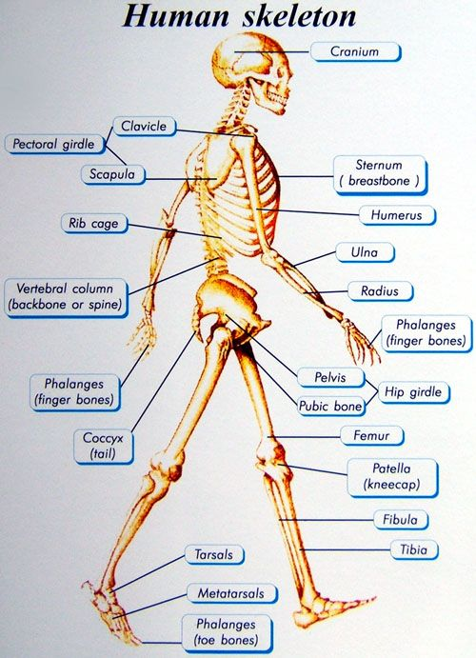

Bone cells Bones are not a static tissue but need to be constantly maintained and remodelled. There are three main cell types involved in this process. Osteoblasts: These are responsible for creating new bone and repairing older bone. Osteoblasts produce a protein mixture called osteoid, which is mineralized and becomes bone. They also manufacture hormones, including prostaglandins. Osteocytes: These are inactive osteoblasts that have become trapped in the bone that they have created. They maintain connections to other osteocytes and osteoblasts. They are important for communication within bone tissue/ Osteoclasts: These are large cells with more than one nucleus. Their job is to break down bone (bone resorbing cells). They release enzymes and acids to dissolve minerals in bone and digest them. This process is called resorption. Osteoclasts help remodel injured bones and create pathways for nerves and blood vessels to travel through (Newman, 2018a).

Diseases of the Bone Osteoporosis is a bone disease where there is a reduction in bone mineral density. Causes by ageing, having inadequate calcium, a vitamin D deficiency, consuming excessive alcohol, or through smoking and the lack of hormone and the prolonged use of steroids. This increases the risks of fractures happening, prevention is important because although there is treatment, a cure is yet to be found (Newman, 2018b). Women are more likely to develop osteoporosis. This is because woman generally have smaller, thinner bones than men. Women can lose bone tissue more rapidly than men after menopause. This is due to the sharp decline in production of the hormone oestrogen. Produced by the ovaries, oestrogen has been shown to have a protective effect on bone. After menopause, bone loss in women greatly exceed that in men. However, by the age 65 woman and men tend to lose bone tissue at the same rate (Bones.nih.gov.2020). 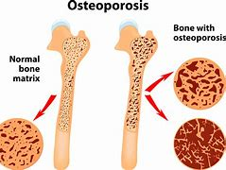

Development of Bones
Skeletal development start growing in the foetus from about six weeks after fertilisation. This continued until the next 25 years, most bones start from the primitive embryonic tissue. This tissue is recognised as cartilage that gradually turned to born through a process called Ossification (Abrahams,2009b).

Care for the Bones
Bones tend to lose strength as we grow older, but as we get older there is a lot we can do to maintain or prevent bone density, by following steps that will help to improve and maintain bone health. Being inactive makes your bones and muscles lose strength. This increases the risk of osteoporosis, falls and fractures. Good nutrition and regular exercise are primary sources for keeping the bones healthy throughout one’s lifetime. This include plenty of calcium in your diet, keeping regular check on your vitamin D as it is needed to absorb the calcium also maintain a stable, healthy weight Don’t smoke or drink excessively(mayoclinic.org,2019).

The skeletal bones are divided into two groups; axial skeleton; consists of 80 bones, skull, vertebrae column, ribs, sternum, and Spine, the skull rest under vertebral column it is divided into two parts. Cranium is made up of several flat irregular bones that protects the brain. Appendicular Skeleton has 126 bones, the upper and lower limbs, The pelvic girdle, and the pectoral girdles.

References
Abrahams, P., 2009a.Physiology -All you need to know about how your body works. London: Amber Books.
Abrahams, P., 2009b. Physiology- All you need to know about how your body works. London: Amber Books.
Bones.nih.gov. 2020. Osteoporosis Overview | NIH Osteoporosis and Related Bone Diseases National Resource Centre. [online] Available at: https://www.bones.nih.gov/health-info/bone/osteoporosis/overview (Accessed 27 October 2020)
Cliffsnotes.com. 2020. Functions of Bones. [online] Available at: https://www.cliffsnotes.com/study-guides/anatomy-and-physiology/bones-and-skeletal-tissues/functions-of-bones (Accessed 27 October 2020).
Hsdinfo.com. 2020. Skeletal System Diseases | Health Symptoms and Diseases. [online] Available at: https://www.hsdinfo.com/skeletal-system-diseases/ (Accessed 27 October 2020).
Mayo Clinic. 2020. How to Keep Your Bones Healthy. [online] Available at: https://www.mayoclinic.org/healthy-lifestyle/adult-health/in-depth/bone-health/art-20045060 (Accessed 30 October 2020).
McGuinness, H., 2002. Anatomy & Physiology Therapy Basics. 2nd edition
Newman, T., 2018a. Bones: Types, Structure, and Function. [online] Available at: https://www.medicalnewstoday.com/articles/320444 (Accessed 27 October 2020)
Newman, T., 2018b. Bones: Types, Structure, and Function. [online] Available at: https://www.medicalnewstoday.com/articles/320444 (Accessed 27 October 2020)
nhs.uk. 2020. The NHS Website. [online] Available at: https://www.nhs.uk Accessed 27 October 2020).
Opentextbc.ca. 2020. 6.2 Bone Classification. [online] Available at: https://opentextbc.ca/anatomyandphysiology/chapter/6-3-bone-classification/ (Accessed 20 October 2020).
Wilson, K.J., (1990) Ross and Wilson Anatomy and Physiology in Health and Illness (7th Edition) London: Churchill Livingstone

