UWTSD
WISA



Engine performance characteristics
Motorcycle/ Motorsport/ vehicle technology.

Luke Davies
2305546
26/03/25
Contents
1 Introduction 1
1.1 Aims 1
1.2 Objective 1
2 How the Dynamometer Works 2
3 Experimental procedure 3
3.1 Dynamometer setup 3
3.2 Engine test types 3
3.3 Test procedure 4
4 Results 6
4.1 Calculations 7
4.1.1 Engine torque 7
4.1.2 Brake power 7
4.1.3 Corrected power 7
4.1.4 Brake mean effective pressure (BMEP) 8
4.1.5 Specific fuel consumption (SFC) 8
4.1.6 Thermal efficiency 8
5 Graphs and Analysis 9
5.1 specific fuel consumption against engine speed 9
5.2 Torque against engine speed 10
5.3 Corrected Brake power against engine speed 11
6 Conclusion 12
7 Evaluation 12
8 References 13

Equations

Equation 1 Torque Equation 7
Equation 2 Power Equation 7
Equation 3 Corrected power equation 7
Equation 4 Brake mean effective pressure equation 7
Equation 5 Specific fuel consumption equation 8
Equation 6 Thermal efficiency equation 8
Equation 7 Horsepower Equation 11

Figures

Figure 1 Showing parameter table for sweep test (Uwtsd WISA Workshops, 2020b) 4
Figure 2 Showing test results on a graph (Uwtsd WISA Workshops, 2020b) 4
Figure 3 Showing test results in dynamometer software (Uwtsd WISA Workshops, 2020b) 5
Figure 4 Table of Results 6
Figure 5 Graph of specific fuel consumption against speed 9
Figure 6 Graph showing Torque against speed 10
Figure 7 Graph showing corrected brake power against speed 11

Introduction

Aims
This report aims to research the performance characteristics of the Honda D16 engine. Through the use of an engine dynamometer. It will look at how and why the engine speed affects the specific fuel consumption, torque, and power.

Objective
- To use the engine dynamometer to collect the engines performance data
- How to set up the engine dynamometer for testing
- Use the data to calculate the engine’s power, torque, Brake mean effective pressure (BMEP), specific fuel consumption (SFC), and overall thermal efficiency.
- Plot graphs showing the engine speed against specific fuel consumption, torque, and brake power.
- Discuss why the engine speed affects different engine characteristics.
- Look at ways in which the test could be improved.

How the Dynamometer Works
An eddy current dynamometer measures an engine's torque using electromagnetic resistance generated by an electromagnet. The engine is connected to the dynamometer via a shaft that spins the rotor. This rotor rotates within an outer casing that houses the electromagnets, referred to as the stator. As the rotor spins, it induces eddy currents, which create a counteracting force against the engine's torque, thereby applying a braking force. This action causes the outer casing to rotate. The extent of this rotation is measured using a strain gauge, which converts the measurement into an electronic signal that is transmitted to the computer system for conversion into a load value.(schenck, 2001)

Experimental procedure

Dynamometer setup
The engine dynamometer consists of many different systems. The dynamometer accurately measures the engine's torque. There is a cooling system to help cool both the dynamometer and the engine during testing. The dyno cell is also fitted with an exhaust extraction system to help eliminate harmful gasses produced by the engine. To control and measure the fuel flow to the engine there are a series of fuel pumps and filters connected to a fuel regulator allowing testing of both carburettor and fuel injection engines. Sensor recorder modules are used to collect data from the engine's sensors which are then fed into the dynamometer software. Using this software, the operator can also control the engine speed and monitor the operation of both the dyno and engine. (Uwtsd WISA Workshops, 2020a)

Engine test types
The engine is tested using a p-curve test. There are two types of p-curve tests. A step test increases the engine speed in stepped increments and momentarily holds it at a specific rpm. This allows for a more accurate reading of engine data and can be used to target specific rpm ranges. Which is beneficial when troubleshooting engine faults. However, this type of test does create a lot of heat due to the engine being held at specific rpm. The other type of test is a sweep test. Where the engine is taken through the rev range and data is collected at set points without being held at a specific rpm. This reduces temperature build up and wear on the engine but does mean that the data is not as accurate as a step test. (Uwtsd WISA Workshops, 2020b)

Test procedure
Before carrying out a sweep test, the test parameters must be entered into the dyno software as shown in figure 1. First the start and end rpm’s must be set, as well as the data log points. This tells the software at what points data should be collected. And finally, the total test time. Once these have been entered the test can be carried out.
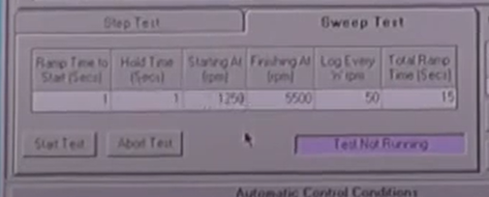
Figure 1 Showing parameter table for sweep test (Uwtsd WISA Workshops, 2020b)
Once the dynamometer has completed the test and collected the data. The data is displayed on a graph as well as logged in the data table as shown in figure 2 and 3.

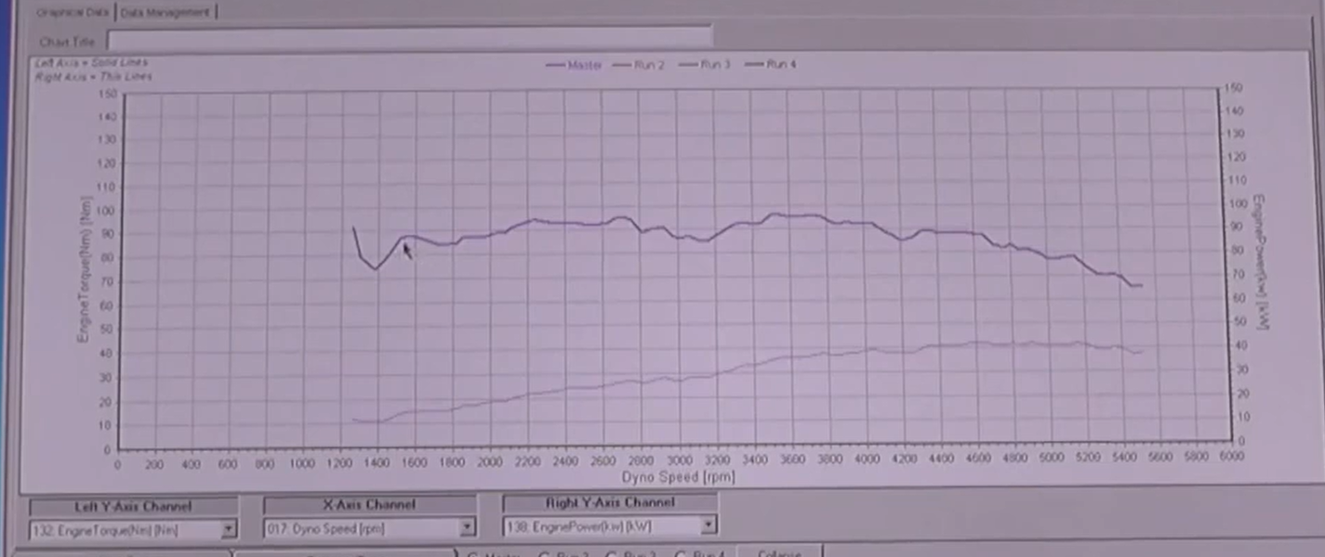
Figure 2 Showing test results on a graph (Uwtsd WISA Workshops, 2020b)

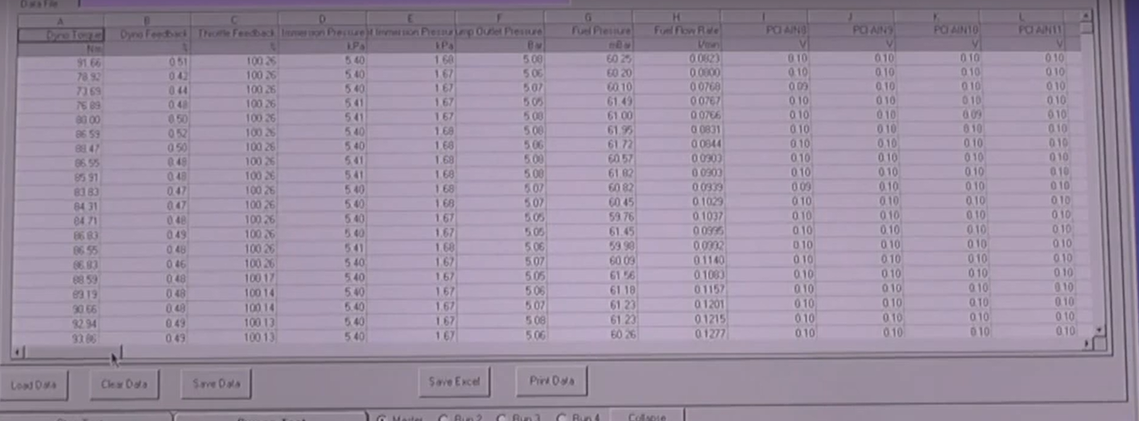
Figure 3 Showing test results in dynamometer software (Uwtsd WISA Workshops, 2020b)

Results
Figure 4 Table of results

Calculations
Following the sweep test the dynamometer logged the engine load, engine speed, fuel flow rate and lambda. Using this data, it is possible to calculate other engine parameters such as (Harrison Andrew, 2025b)

Engine torque
Using the equation
$τ=F×D$
Equation 1 Torque equation
Where F is the load force and D is the length of the calibration arm.

Brake power
Using the equation
$P=\frac{2π×N×τ}{60}$
Equation 2 Power equation
where N is the engine speed in rpm and $τ$ is the torque. The 2 pi is a full revolution of the engine in radians. Which is then divided by 60 to give the work done per second. Which is also known as watts.

Corrected power
Using the equation
$Ps=\frac{1.01325}{pa}×\sqrt{\frac{Ta}{293}}×P$
Equation 3 Corrected power equation
The 1.01325 is used to represent standard pressure in bar and the 293 represents the standard temperature in kelvins. Pa is the ambient pressure, and Ta is the ambient temperature at the time of testing the engine.

Brake mean effective pressure (BMEP)
Bmep can be calculated Using the equation
$Bmep=\frac{2×π×τ×L}{D}$ .
Equation 4 Brake mean effective pressure equation.
The 2 pi is a full revolution shown in radians. $τ$ Is the torque produced by the engine. L is the load measured by the dynamometer and D is the displacement of the engine.

Specific fuel consumption (SFC)
SFC can be calculated using the equation
$sfc=\frac{v×0.75×3600}{t×1000×P}$
Equation 5 Specific fuel consumption equation
V is the volume of fuel in cubic centimeters. T is the time in seconds and P is power produced by the engine. 0.75 is the specific gravity of fuel, this is used to convert the fuel flow into kilograms. This is then times by 3600 to calculate the fuel used per hour. This is all divided by 1000 to convert the fuel flow into liters.

Thermal efficiency
This can be calculated by using the equation
$ηt=\frac{BP}{sfc×cv}$
Equation 6 Thermal efficiency equation
where the BP is the brake power in kilowatts. SFC is specific fuel consumption in kilograms per second and cv is the calorific value of fuel.

Graphs and Analysis

specific fuel consumption against engine speed

Figure 5 Graph of specific fuel consumption against speed
The graph in figure 5 shows how the specific fuel consumption (SFC) changes in relation to engine speed. At the beginning of the rev range the SFC is high. Due to the low engine speed, the airflow into and out of the cylinder is reduced. Which in turn reduces the engines’ volumetric efficiency. Whilst also reducing the amount of turbulent air, which is needed to ensure adequate mixing of the fuel mixture. Due to low engine speeds, the friction of bearings and pistons has more of an effect on the engine, as there is not enough power being produced to easily overcome them.(Harrison Andrew, 2025a) As the engine speed increases to between 1500 -2500 rpm the SFC reaches its lowest point. Due to the increased engine speed, the airflow into the cylinder is optimized, allowing a good cylinder fill and there for improved volumetric efficiency. The increased airflow also becomes more turbulent resulting in a better mix of the air and fuel and a more complete combustion. As the engine reaches higher rpm the temperatures within the cylinder increase, meaning that the air is less dense resulting in lower volumetric efficiency and a less complete combustion. If the cylinder temperature gets too high the air-fuel mixture may ignite early and cause the engine to knock. To prevent this from happening extra fuel is added to help cool the cylinders. These factors lead to increased fuel consumption at higher rpm.(The Carizon, 2021)

Torque against engine speed

Figure 6 Graph showing Torque against speed
The graph in figure 6 shows the torque slowly increasing through the rev range before reaching peak torque at around 2500 rpm before dropping off at higher engine speeds. To maximize the engines torque the intake valve is timed to stay open until just after bottom dead Centre. This allows extra air to be drawn into the cylinder, due to the difference in pressure between the cylinder and intake manifold. However, this only happens at an optimum rev range. At lower rpm the piston forces the air back out the intake valve due to the lack of pressure. Resulting in lower volumetric efficiency and torque. As the engine reaches its maximum rpm the friction in both the bearings and pistons increases. As well as the force needed to expel the exhaust gases from the cylinder which causes a decrease in engine torque.(deechitpoudel, 2021)

Corrected Brake power against engine speed

Figure 7 Graph showing corrected brake power against speed
The power graph in figure 7 shows that the engines’ power increases with engine speed until the maximum rpm is reached. By looking at the equation of power
$P=\frac{T×rpm}{5252}$
Equation 7 Horsepower equation
The two factors that affect the engine’s power are Torque and rpm. So as the torque increases so does the power. Although the torque curve in figure 6 shows that the engines torque drops after 4000 rpm, the increasing speed of the engine means that the power will continue to increase, though at a slower rate. (Sherman Don, 2016)

Conclusion
After looking at the results of the graphs. The engine looks to be designed for a commuter type vehicle and prioritises fuel efficiency over peak power. Looking at the SFC graph in figure 5 it shows the engine to be most efficient between 1500 and 3000 rpm. This suggests that the engine is most suited to motorway or around town driving. The torque curve has a smooth shape with no big spikes and peaks at around 2000-3000 rpm giving the engine better drivability for day-to-day use. However, the power curve graph does indicate that the engine is significantly down on power. Which could be down to the modifications made to the airbox and exhaust system. 115

Evaluation
Due to a fault with the dynamometer the test was not able to be carried out and the results used were from a previous test. In the future it would be beneficial to carry out the test in person to get a better understanding of how the dynamometer works and get hands-on experience with using the dyno software. Further improvements could be made to the engine performance as the results show it to be down on power at the time of testing. Using the original airbox could solve this problem.

References
deechitpoudel (2021) thermodynamics - Why does the torque of an internal combustion engine increase with its rpm at low rpm range? - Engineering Stack Exchange. Available at: https://engineering.stackexchange.com/questions/47670/why-does-the-torque-of-an-internal-combustion-engine-increase-with-its-rpm-at-lo (Accessed: 29 March 2025).
Harrison Andrew (2025a) ‘Motorsport and Vehicle Technology lecture’. Iq building Swansea, 28 January.
Harrison Andrew (2025b) Powertrain_25 week 4. Available at: https://uowtsd-my.sharepoint.com/personal/andrew_harrison_uwtsd_ac_uk/_layouts/15/Doc.aspx?sourcedoc={c9dd2410-c111-4550-b00f-0a3dc3baa55d}&action=view&wd=target%28Lecture%20Notes.one%7Cab796523-684d-4952-84b9-95a1ebd8661c%2FWeek%204%7C15038c3a-407b-4404-bd84-701e93e9c677%2F%29&wdorigin=NavigationUrl (Accessed: 29 March 2025).
Schenck (2001) Technical specification Eddy - current Dynamometer w series. Available at: https://teams.microsoft.com/v2/ (Accessed: 29 March 2025).
Sherman Don (2016) Horsepower vs. Torque: What’s the Difference? Available at: https://www.caranddriver.com/news/a15347872/horsepower-vs-torque-whats-the-difference/ (Accessed: 29 March 2025).
The Carizon (2021) Engine Knock & Pre-Ignition Explained - Understanding Cars - YouTube. Available at: https://www.youtube.com/watch?v=Ed8D7sj_nEk (Accessed: 28 March 2025).
Uwtsd WISA Workshops (2020a) Engine Dynamometer Overview - YouTube. Available at: https://www.youtube.com/watch?v=-WajOAp2LUE (Accessed: 29 March 2025).
Uwtsd WISA Workshops (2020b) Engine Dynamometer testing - YouTube. Available at: https://www.youtube.com/watch?v=VD9OPoaAcJU (Accessed: 29 March 2025).

