Abdurahman Ibrahim (P150461)
University of wales Trinity St david Project Management
Project Initiation Document for Halo Emergency Logistical Provisions (H.E.L.P.)

Table of Contents
Introduction:
Strategic vision, goals & objectives:
Project definition:
The Project Parameters:
Business Case:
Risk Analysis:
Who?:
Brief chart:
Project Diagram:

Introduction
Strategic vision, goals & objectives:
Project definition
The main objective of the Project is to provide food, water and medicine among other necessary resources required by these communities after a disaster occurs in their environment.
The client is pursuing this project because it makes it easier for the communication to be made and then action to be taken immediately after the communities take the necessary steps to get into contact with the client through the website which will be provided by the student.
The problem that will be solved by this project is easier communication and quick measurement methods of providing the required aid in the areas affected by disaster, communication between workers and aid staff in the UK and workers that go to the areas affected and also the government who will provide the required funds.
The project is about providing these communities with the food, water, medicine and clothes among other things they might need after going through such a traumatic event.
The goals of this project is to provide to more people and in a much more efficient manner than the previous methods that were used before to aid people in a crisis after a disaster happened in their community.
The success of this project would be defined by the numbers and analytics recorded by the worker that was put in place to do this job, research will be done on the previous method and success rate, then the numbers will be compared, if the numbers and efficiency among other things are much higher this will mean this webpage idea the student brought was a success.
The Project Parameters:
The budget for this project as the student was by the client is provided by the uk government and also charity companies will be contacted and providing the company with support through the website which will be created by the student, these funds will be put together and used to provide the client and company with the supplies that any given disaster situation needs.
There will also be some workers who are put to the task of liaising with the UK government and aid agencies near the area to provide the supplies after being contacted through the website.
This project will have the timeline of a 3 month starting plan where everything will be put into place regarding the website completion, making the links with the other staff through the website contacting the charity organisation of choice to collaborate on this project.
The student envisions the collaboration with the client to go smoothly and according to the given timeline of 3 months to start up the website that everything will go through, if the student works according to this timeline then the client will continue to work with the student and in due course provide more opportunities.
The team will work towards the platform being created that provides all the contacts needed for the project and communication will go through.

The in scope part of the project is just completing the website with everything involved.
The out of scope part is contacting the parties that will be involved in providing the supplies, getting all the contact details, contacting the client, office stapled in the communities chosen, provide internet connection, provide video entry slot in website, provide daily updates for the required supplies etc.
The project boundaries that the team shall not cross is the time limit of three months to complete all the above mentioned scenarios.
The products delivered will be food, water, clothes, and media devices for the team abroad with the required internet connection so they can contact the student through the webpage for amount the certain are needs of the products.
The constraints will be things like thieves, more disasters happening, having a safe route for delivering the products etc.
Business Case
•Benefits: Why are you carrying out this project, and what benefits do you expect it to deliver? Include information on how these benefits will be measured
As mentioned before the reason this project is being carried out is to help people in need in disaster ridden countries, the benefits we expect to deliver with help of this project is making it easier for communication to be made and then action to be taken immediately after the communities take the necessary steps to get into contact with the client through the website which will be provided by the student.
These benefits will be measured by comparing the old method used and its success to the success of the new method which will have a place to report numbers helped to the client through the webpage.
There were other courses of action considered but it would require much more workers and the student found the webpage method to be easier to use and faster for all parties involved.
The benefit for the client will be measured through success rate, so if this project is a success and he is providing for more people his monetary gain will be increased by the profiteers, also he will be exempt from paying tax because of these acts.

Risk Analysis
There will always be risks with every project, some of the risks will be the products being robbed, a wrong number of products to be delivered, taking too long to deliver etc.
These risks could be prevented by having a risk prevention team to provide things like security for each shipment, having a worker make sure the numbers are correct or even more provided just in case.
These same people will be put in place if anything goes wrong to manage these risks.
Who?
The staff required will team at home who will be contacted for the supplies, the student who will be creating the webpage, the staff sent to the location of the disaster who will stay there and contact the staff located in the uk for the products and the exact demands needed, the security team that will manage risks like security breaches abroad and online security for hackers, the risk management team, connection and video service providers etc.
Brief project chart below:
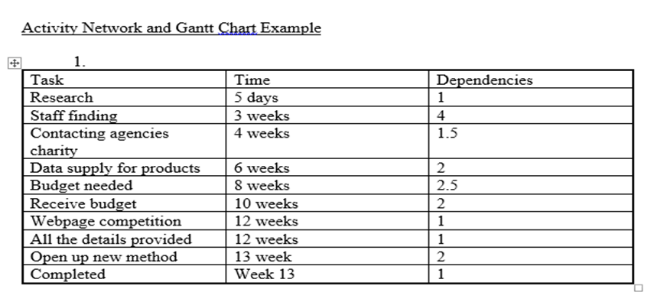
Project diagram:

