Kai Probert - 2200897
2200897@student.uwtsd.Ac.uk
Digital forensics – research and analysis task 1 + 3 (ACCD5000)

ToC (Table of Contents)
Table of Contents
ToC (Table of Contents) 1
Task 1 – Research on Digital Forensics 1
Task 3 – Forensic Report 2
Introduction 2
Chain Of Custody 2
Investigation Methodology 2
Investigation 3
Key Findings 6
Tools used 12
Result of Findings and Conclusion 12
References 13

Task 1 – Research on Digital Forensics
Computer forensics is a branch of the much more complex concept of Digital Forensics. Computer Forensics is a processed done by forensic analysists, in which they analyse data from computer forensic cases that can vary from computers and digital evidence storage. Principles similar to data recovery are typically used in this field, but with additional practices to have a clear trail for legal representation. Digital forensics is the larger scope of computer forensics. It includes the same base principles of data gathering but covers a much larger scope. In the case of computer forensics, data retrieval and analysis only occur on computers, while digital forensics is any device, be it IoT tablets, servers etc.^{[1]} Digital forensics can also include investigations on social networks, email, and network traffic. It is a broader scope that covers all bases, including computer forensics.
Digital forensics has existed almost as long as the computer, since the early 1980s, as soon as crimes could be committed on a computer, a way to analyse them was required, this is why Digital Forensics now exists. It originally existed mostly as a form of data recovery and investigations into early cyber-crime. It evolved overtime into a formalized method with laws intended to stop cyber-crime. The path of computer forensics is similar, but its creation was due to the expansion of digital forensics as the threat grew to more platforms over time. The creation of tools since the turn of the century especially have provided invaluable help to investigators when checking for specific things in an investigation. There are lots of tools that now automate what would have previously been a manual task, allowing for a faster, more efficient, and higher accuracy investigation. Laws like the Computer Misuse Act (CMA1990) where pivotal in making cyber offenses illegal and allow for convictions and arrests to be made.^{[2]} CMA1990 does not explicitly define a computer, as it can take many forms and cyber-crime is more expansive now than ever.
One of the most well-known and documented cases of use of digital and computer forensics is the Dennis Rader case. Dennis Rader was a serial killer between 1974-1991, who used to flaunt his actions by sending letters to the media. A floppy he sent to the media was intercepted by the FBI, through checking metadata from a deleted word document, they were able to find the church he was a member of this subsequently led to his arrest.^{[3]} Other real-world examples of digital forensics are Corporate Investigations, like data breaches and whistleblowing. Using methods of digital investigation cases like these are able to be solved due to someone leaving a trace. Incident response is also a big part of digital forensics, as a company being hacked will require professionals to analyse the company and look for what has been breached, what caused it and how it will impact the company in future.

Task 3 – Forensic Report

Introduction
I will be investigating a potential cyber bullying case through a provided evidence file. I will be conducting research, investigating, and laying out my findings in a non-bias form, to provide the necessary evidence to support or deny the claims. I will use a multitude of computer forensic tools that will assist me in my investigation. In doing so, I hope to make meaningful connections that can provide evidence in the given case. A professional report will be written, outlining the findings of the investigation, while following all procedures required to keep a provable professional set of results.

Chain Of Custody
The evidence given was contained on a 16gb SanDisk USB flash drive. Contained on this where, 4. E0x Files, CSV files and a text document. Niteesh Kaliyamurthy was the initial holder of the evidence. This was then passed on to Jon Morgan, who gained custody of the drive on the 11th of march, 2024 and 17:00 hours. A copy of this drive was made using FTK Imager by Jon, using a isolated virtual machine with write blocking Registry Edits for all USB devices. FTK imager verified the copy and created two Checksums related to the drive. Separate hashes were computed for each E0x file using HashCalc. Transfer of custody from Jon to Me took place on the 11th of March, 2024 at 21:00 hours, using cloud storage. I then downloaded these files from the cloud. The purpose of the transfer was for analysis of the documents.

Investigation Methodology
The goal of this investigation is to find any proof of cyber-bullying. A investigation will be conducted using a isolated, protected, virtual environment that will provide clear evidence to the existence of or nonexistence of, cyber-bullying. A forensic copy of the drive was made, and then passed onto me where I downloaded the documents onto my virtual machine. Doing this was intended to prove integrity of data. An investigation of the contents of the drive will ensue, and a interpretation of my findings will be done. I will reconstruct any events that I find, doing so to find a clear timeline of events. All steps in the investigation will be documented in-case of the findings being used in court.

Investigation
I started my investigation by configuring my virtual machine to write-block any usb devices on the machine. I did this by creating a DWORD in registry editor. I named the key “SecureDevicePolicy” to make it clear what the purpose of the dword was. I then created the dword inside of the SecureDevicePolicy key, and named it BlockWrite, as the dword blocks any write access to external drives. This meant that any external drive that is plugged into the virtual environment, will not have write access. This ensures that the environment I am going to work in is safe and secure for my investigation.
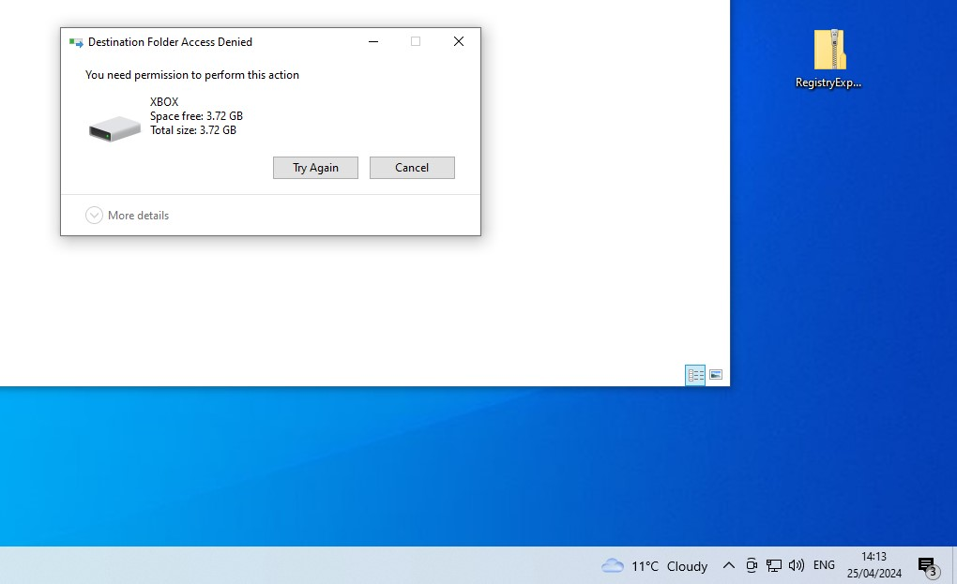
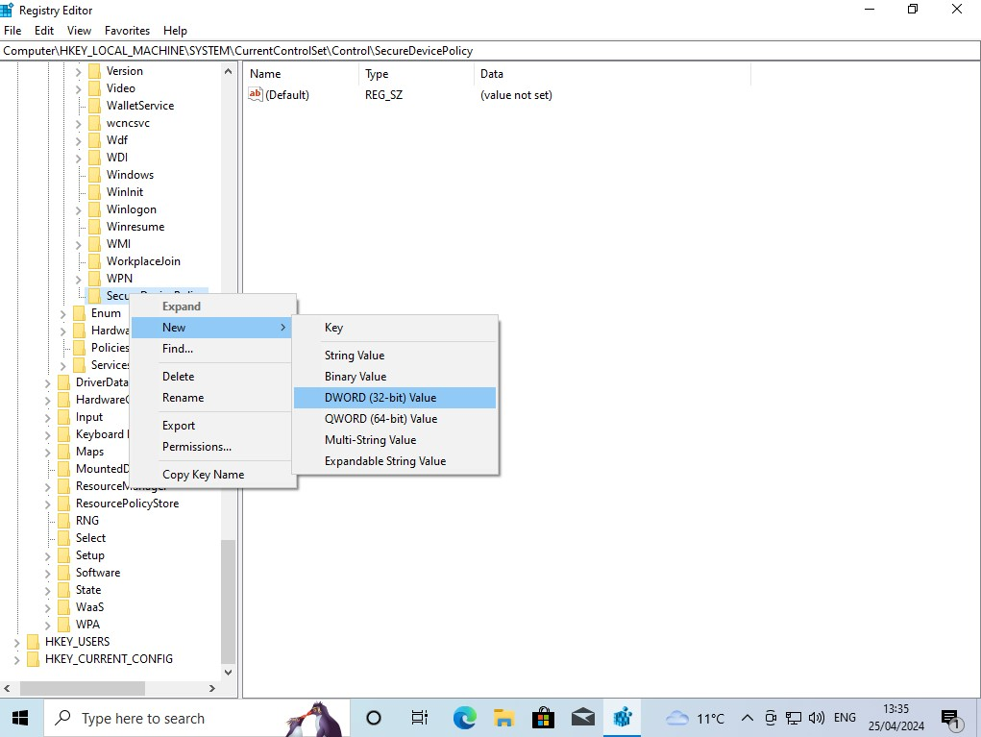

I next downloaded the evidence onto my virtual machine, and entered it into FTK, to analyse and export the files. Using FTK I could see that the e0x files (original copies made using FTK) have files stored inside. In the [root] directory of the drive, the was all of the evidence that had been supplied to me. Inside I found, images, excel files, text files, rar files, mp4’s, c++ code and files that did not have extensions.
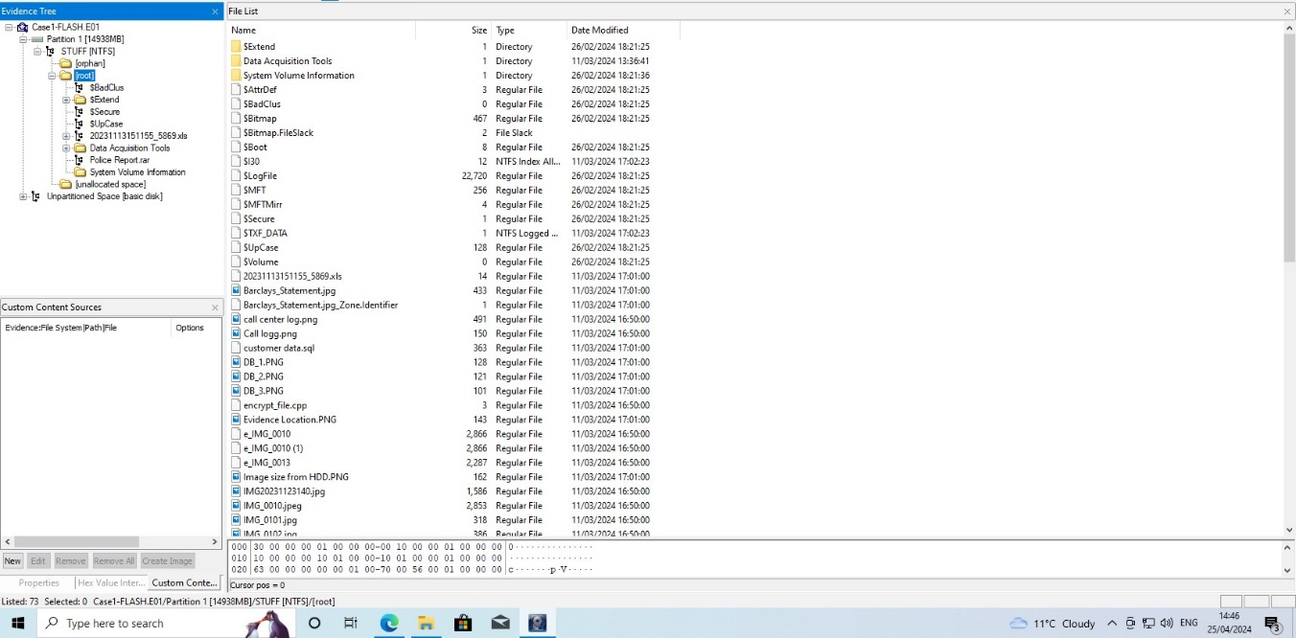

I first started by looking through all of the files to get an idea of what I will be working with. The images where conversations that had taken place across multiple platforms (WhatsApp, X (Formerly Twitter) and Instagram. These I believe are key to the investigation. Other images included a bank statement, a call log supplied by a phone company, A iPhone screenshot of recent calls and a photo of a block of flats.
I first investigated the zip file and tried to investigate its contents. When trying to open the zip file using 7zip, I found that it was password protected. Looking around the files I found “Readme.txt”. This file once opened contained 2 passwords. I knew this because the file had “passwords for files” at the top. 1. Kali and 2. Qk;87R]_w3dmBGcb[#TX=4. I tried both passwords on this zip file and the second password successfully opened the zip. Once opened I found 2 files, e_PoliceReport-CS-01 and e_PoliceReport-CS-02. Both of these files also did not have file extensions.
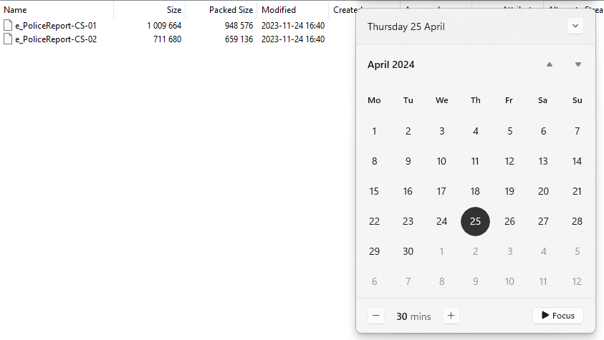
I believed that the seemingly encrypted files were going to be key to this investigation. So, I started by looking around the files to find anything that could help with decryption. I found ecnryptfile.cpp, which was a C++ program that was used to encrypt the files that lacked extensions. Opening the file in Visual Studio showed me C code that hinted towards the encryption and decryption of these files. To unencrypt the files, I used g++, and ran 2 commands that successfully unencrypted the files. Command 1 was : g++ encypt_file.cpp -o encrypt.exe. This compiled the C++ code. I then ran : ./encrypt.exe “PoliceReport-CS-01 PoliceReport1.png decrypt. This decrypted the file and converted it to a png. After running this for the second image, I looked to see its contents. It was a two-page police report for a successful Cyber Bullying conviction for “Justine Elias” AKA Egos_Dark. This name appears in the text conversations previously mentioned.

Key Findings
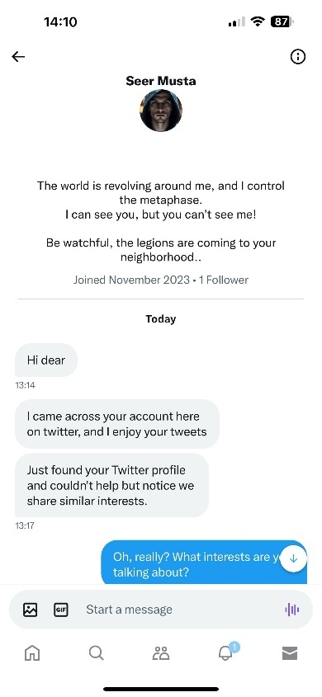
Looking through the conversations, we can find that messages were sent from the Twitter account Seer Musta.
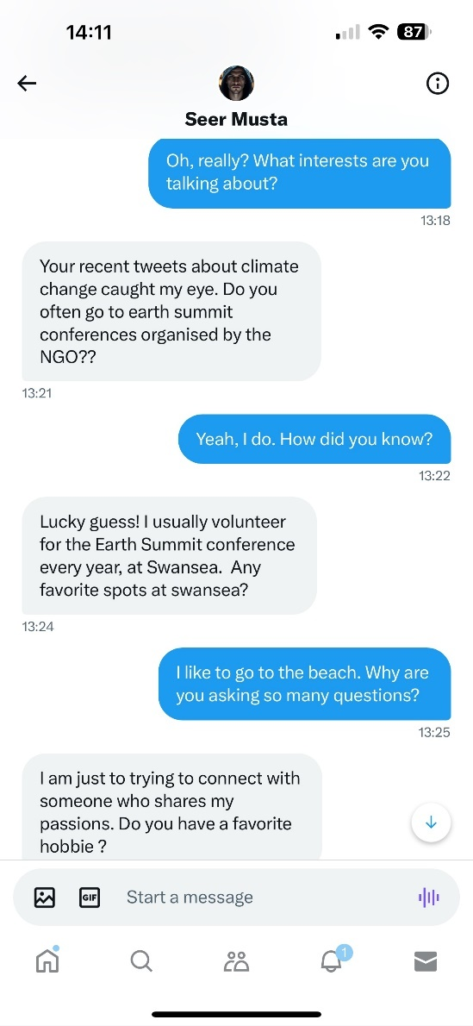
As seen in the messages, Musta has started a DM with Emmy James, Twitter EmmyJames123. We know this thanks to a later conversation where she gives her handle to Musta. Without previous conversations with Emmy, he knows some of her interests, possibly via other social medias.
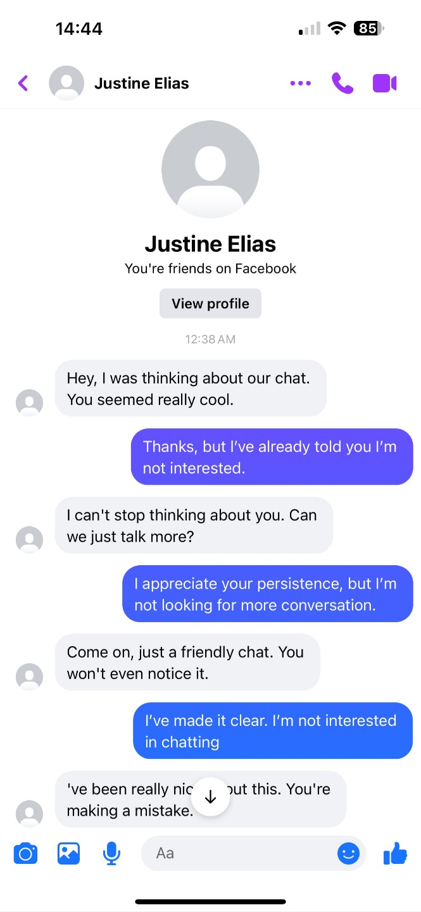

These texts from Facebook Messenger show us more. Justine Elias (The same name that was given on the police report), is yet again in contact with Emmy. We know thanks to the police report that Justine has used multiple accounts before to harass somebody.
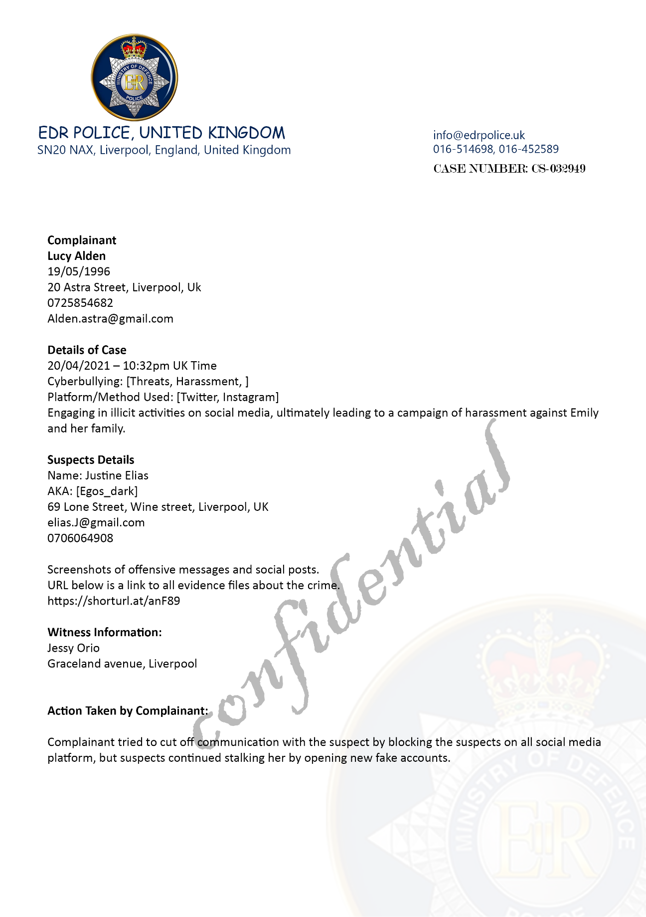

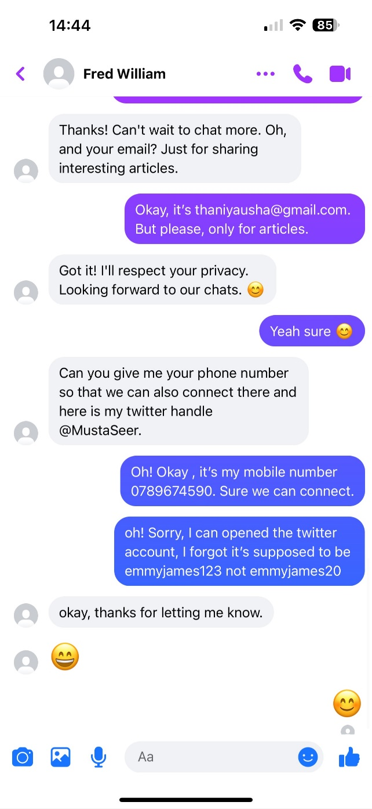
This image tells us that “Fred William” is MustaSeer, as hes given Emmy his handle, @MustaSeer. We also know that the other person must be Emmy, as she has given her twitter handle in this conversation also.

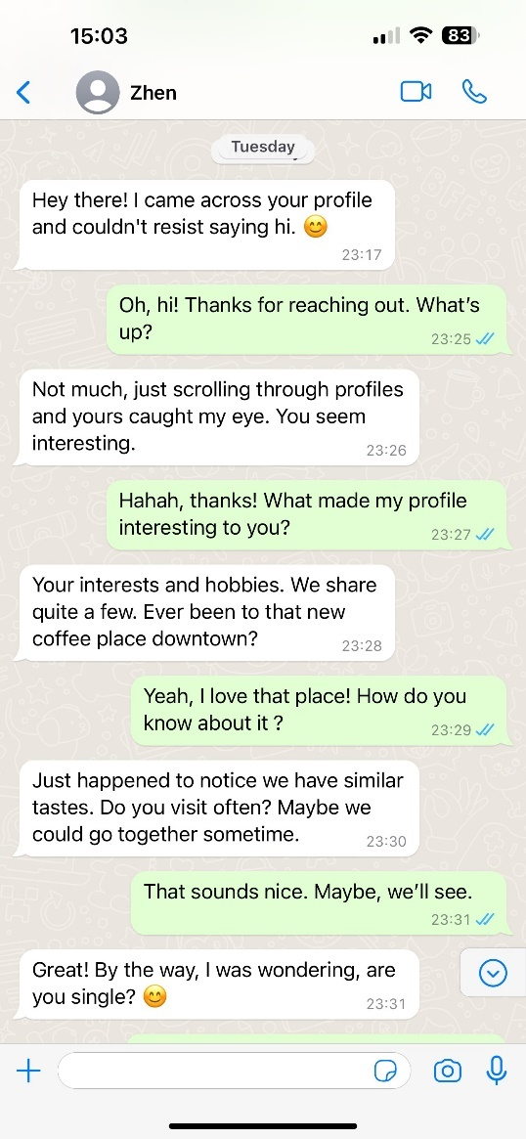
These whatsapp messages from “Zhen”, who is likely Justine, are very forward and intrusive. “Zhen” or Justine, got Emmy’s phone number from the previous conversation on Facebook. She gave Justine her number, Email and Twitter account. The conversation with Fred William is likely first contact, as an exchange of information takes place during this conversation, one that allowed Emmy to know the twitter handle and Justine her phone number, email, and twitter.

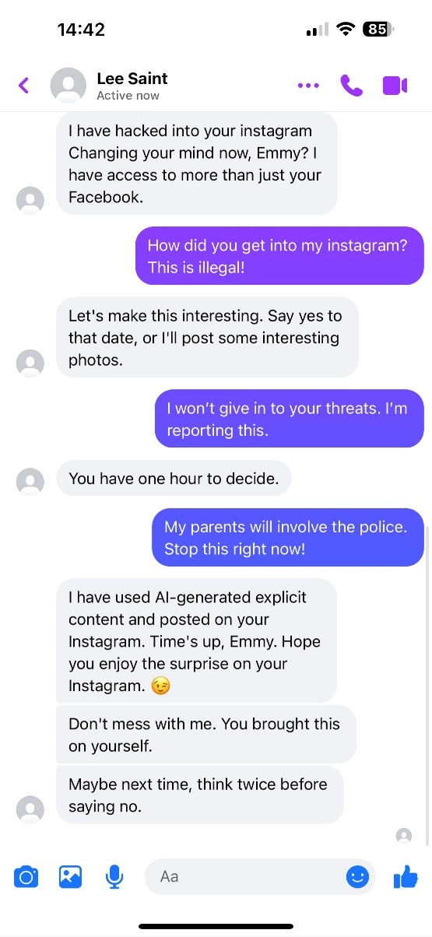
This conversation between Lee Saint and Emmy is the most problematic. “Lee” is constantly aggressive and claims to have hacked her Instagram while also creation Explicit AI images of Emmy without consent. She denies going on a date with “Lee” multiple times through the conversation, but Lee does not back down.

Tools used
FTK was used to export and investigate the contents of the drive.
Autopsy was used for file carving to check for any hidden data or deleted data.
Msys2 was used to compile the C++ code and decrypt the encrypted files.

Result of Findings and Conclusion
Overall, looking at the evidence given after my research I believe that this is a clear case of Cyber-Bullying. Thanks to the police report from a previous case, we know that our offender, Justine, has priors for cyber-bullying and harassment. We know that he was involved in this case due to one of the account names being his real name. We know that Emmy is our victim as she has given out account information that correlates to her. I believe the conversation with “Fred” was the first conversation between Justine and Emmy. As he states, “I just saw your profile and seen we have similar interests”. “Fred” then proceeded to find out as much as they could about Emmy, some of this information was likely used to aid Justine in hacking Emmy’s Instagram. Thanks to Justine socially engineering Emmy, he from this point forwards has all the information he requires to answer any secret questions that appear when trying to sign into her account. The conversation with SeerMusta likely came next. As Justine is able to gain more information about Emmy like where she spends her time and in what areas. The WhatsApp conversation with “Zhen” likely came after this. Due to Emmy giving her phone number to Fred in the conversation previously. This is likely the 3rd conversation due to the previous twitter conversation talking directly about certain places she likes going, so Justine was able to follow her home, or track her some somehow, using this information. The conversation with Justine Elias account comes next. Where he presses her more about going on a date, she declines once more. He also knows what she looks like as he says, “I saw your recent post, you looked really nice.” Towards the end of the conversation Justine becomes aggressive and tells Emmy that “you will see we are meant to be together.” The final text conversation from “Lee” is where Justine pressures Emmy incredible amounts, proceeds to hack her Instagram and create explicit images using AI against her.
Overall, I believe this is a clear case of cyber-bullying that is admissible in court. Justine having prior convictions for the same crime also helps with tying the knots together.

References
[1]
B. Annie and F. Amber, “ What is digital forensics? ,” Feb. 16, 2024. https://www.ibm.com/topics/digital-forensics.
[2]
CPS, “Cybercrime - prosecution guidance,” Jan. 31, 2024. https://www.cps.gov.uk/legal-guidance/cybercrime-prosecution-guidance.
[3]
“Unlocking the Mysteries of Cybersecurity: Real-Life Examples of Digital Forensics.” https://www.subrosacyber.com/blog/digital-forensics-examples.

