Stop Searches In the Police Force – Are Police Stop Searches in the South Wales Valleys disproportionate on People with BAME Ethnicities and are police utilising legitimate powers to conduct them?

BSc (Hons) Professional Policing Practice

Acknowledgements

Firstly, I want to thank my dissertation tutor, Jonathan, for all his help and support throughout this process.
I would also like to give thanks to the university and the police training unit for their support and tools that are available to aide learning.
I want to thank all my colleagues for being there as a support mechanism when I need them and also want to thank them for taking the time to be a part of the research element in this dissertation.

Declaration

This work has not previously been accepted in substance for any degree and is not being concurrently submitted in candidature for any degree.
Signed: J Coppin Date: 24/03/2023

STATEMENT 1
This dissertation is being submitted in partial fulfilment of the requirements for the degree of BA.
Signed: J Coppin Date: 24/03/2023

STATEMENT 2
This dissertation is the result of my own independent work/investigation, except where otherwise stated.
Other sources are acknowledged by footnotes giving explicit references. A bibliography is appended.
Signed: J Coppin Date: 24/03/2023

STATEMENT 3
I hereby give consent for my dissertation, if accepted, to be available for photocopying and for interlibrary loan, and for the title and summary to be made available to outside organisations.
Signed: J Coppin Date: 24/03/2023

STATEMENT 4
I hereby give consent for my dissertation, if accepted, to be available on the university’s IT system to those who have consent to use the system.
Signed: J Coppin Date: 24/03/2023

Table of Context
Contents
Acknowledgements 2
Declaration 2
1.0 Chapter One – Introduction 6
1.2 Disproportionality in Stop and Search 7
1.3 Legitimacy in Stop and Search 7
2.0 Chapter Two - Literature Review 7
2.1 Introduction of Literature Review 8
2.1.2 Background and History 8
2.2 Police Powers to conduct Stop Searches 9
2.3 – Stop & Search Data compared by Ethnicity 9
2.4 Population Statistics 10
2.5 Legitimacy and Disproportionality in the South Wales Valleys 11
2.6 Aims and Objectives 11
2.7 How the research findings can lead to the actual dissertation question. 11
2.8 Conclusion 12
3.0 Chapter Three: Methodology 12
3.1 Introduction 12
3.2 Research Onion 13
3.3 Research Philosophy 13
3.4 Research Approach 14
3.5 Ethical Considerations 14
3.6 The Researchers Choice & Strategy 14
3.7 Time Horizons 15
3.8 Sample 15
3.9 Limitations 15
3.10 Conclusion 16
4.0 Chapter Four: Analysis of Results 16
4.1 Introduction 16
4.2 Business Intelligence Data Analysis on Disproportionately 16
4.3 Business Intelligence Tool Outcome of Search by Ethnicity 17
4.3.1 Business Intelligence Tool BWV usage 17
4.4 Questionnaire – Question 1 - Are You a serving police constable based in a response role in the South Wales Valleys? 18
4.5 Question 2 - If You are not based on response please state your role in the police 18
4.6 Question 3 - What is your Ethnicity? 19
4.7 Question 4 - In the last 12 months approximately how many persons have you stopped and searched under any legitimate police act (PACE etc.) 19
4.8 Question 5 - Out of these stop searches approximately how many resulted in further police action being taken? (I.e arrest, Cannabis warning given etc.) 20
4.9 Question 6 - Out of your total amount of persons stop & searched in the last 12 months, please select which ethnic categories were searched. 21
4.10 Question 7 - If you have selected multiple tick boxes for question 5 then please state the total amount of how many people were stop and searched, separated by each ethnic category (i.e. White ethnicity made up 50% of total persons stop & searched) If you have only selected one tick box for Question 5 then please go to the next question. 21
4.11 Question 8 - Have any of your stop and searches lead to a complaint being made against you? 22
4.12 Question 9 - What is your opinion on the current legislation for police stop and search and do you feel backed by your force when conducting stop and searches? 22
4.13 Question 10 - Is there anything you believe the college of policing or your force should change or update on the current legislation surrounding police stop and search? If Yes then please explain. 23
5.0 Chapter Five: Findings, Conclusions and Recommendations 24
5.1 Introduction 24
5.2 Were the objectives achieved? 24
5.3 Main Findings 24
5.4 Limitations 25
5.5 Further Research 26
5.6 Conclusion 26
5.7 Recommendations 27
Bibliography 28
Appendix 31
Appendix 1 Questionnaire 31
Appendix 2 – Graphs from Questionnaire Results 35
Appendix 3 – Research Proposal 38
Appendix 4 – Ethics Form 44

Chapter One – Introduction

Stop and search is an essential policing tool that has been used in various countries, including the United Kingdom. The use of stop and search has been surrounded by controversy and criticism, with concerns raised about its effectiveness, proportionality, and legitimacy. Stop and search has been accused of causing racial disparities, where people from certain ethnic backgrounds are more likely to be stopped and searched than others. This has led to questions about the legitimacy of stop and search, as well as its impact on trust and confidence in the police.
In the United Kingdom, the use of stop and search is regulated by the Police and Criminal Evidence Act 1984 (PACE) and the accompanying codes of practice. These codes of practice set out the rules and procedures that the police must follow when carrying out stop and search.
Despite the existence of these regulations, concerns about the disproportionate use of stop and search have continued. A recent report by Her Majesty's Inspectorate of Constabulary and Fire & Rescue Services (HMICFRS) found that black people were nine times more likely to be stopped and searched than white people in England and Wales. The same report found that the use of stop and search was not always effective in detecting crime, with only 17% of stop and searches resulting in an arrest.
The South Wales Valleys is a region in South Wales that has experienced significant social and economic changes over the last few decades. The region has a diverse population, with people from different ethnic backgrounds living together. This dissertation seeks to explore the use of stop and search by the police in the South Wales Valleys, with a particular focus on disproportionality and legitimacy.
The dissertation will begin by providing a brief overview of the history and development of police stop and search powers in the UK. This will be followed by a literature review of previous research on the use of stop and search powers by the police, with a focus on studies that have examined the disproportionality and legitimacy of these practices. The methodology section will then outline the research design and data collection methods used in this study, before presenting and analysing the findings. The conclusion will draw together the key findings of the study, discussing their implications for policy and practice, and highlighting areas for future research.

1.2 Disproportionality in Stop and Search

Despite the legislative framework and the guidance provided by the Codes of Practice, there has been concern that stop and search powers are used disproportionately against certain groups of people. This concern has been supported by research, which has found that certain groups, such as young people, ethnic minorities, and people from lower socio-economic backgrounds, are more likely to be stopped and searched by police officers. For example, a study by the Equality and Human Rights Commission (EHRC) found that black people were over six times more likely to be stopped and searched than white people in England and Wales. (Equality and Human Rights Commission, 2010)
Research has consistently shown that ethnic minority groups are disproportionately stopped and searched compared to white individuals. This has led to concerns about racial profiling and discrimination in policing. A study by Shiner and Newburn found that black people were seven times more likely to be stopped and searched than white people in London. (Shiner & Newton, 1999)
In the South Wales Valleys, there is limited research on the disproportionality of stop and searches. However, a report by the Equality and Human Rights Commission (EHRC) (2010) found that black and Asian individuals were more likely to be stopped and searched in Wales than white individuals. The report also highlighted concerns about the potential for racial profiling and discrimination in the police's use of stop and search tactics. (Equality and Human Rights Commission, 2010)

1.3 Legitimacy in Stop and Search

The legitimacy of stop and search has also been questioned. Legitimacy is defined in the Oxford dictionary as “conformity to the law or to rules” However when it comes to legitimacy in policing some popular concepts are that “Legitimacy is the belief that legal authorities have the moral right to administer and enforce the law and that people are obliged to obey the law” (Tyler, 1990).
However other research (Jackson, et al., 2012) states that police legitimacy is a multi-dimensional concept with three interlinked elements, which forms the basis of the framework for police legitimacy, these are:
- 1) The obligation to obey
- 2) Moral alignment or normative justifiability
- 3) And Legality

Chapter Two - Literature Review

2.1 Introduction of Literature Review

This chapter of the dissertation has a purpose of analysing and reviewing relevant literature and previous research from accredited sources, that are linked to the topic of police stop searches. This is so a greater understanding of the existing research around police stop & search, including the legitimacy and disproportionality of it can be gained for the reader, and so the researchers own knowledge is displayed on the matter. This will be done by examining literature from an accredited search engine named Google Scholar which is designed to search and display scholarly literature and academic resources from verified and respected sources. Also being used to help achieve the objective is the UWTSD e-learning online library, this along with Google Scholar will display a large variety of sources such as textbooks, reports and professional publications that are verified and authorised, whilst also looking into any incidents where police may have abused their power or targeted people based on race.

2.1.2 Background and History

Police stop and search powers in the UK have a long history, dating back to the 1824 Vagrancy Act, which empowered police officers to stop and search any person found in a public place suspected of being a vagrant or a suspected criminal. This power was later expanded with the introduction of the Police and Criminal Evidence Act (PACE) in 1984, which granted police officers the power to stop and search anyone they reasonably suspect of being in possession of illegal drugs, stolen property, offensive weapons, or items that could be used to commit a crime.
A number of studies have highlighted the over-representation of ethnic minorities in police stop and search statistics, suggesting that these groups are being unfairly targeted by the police (House of Commons Home of Affairs Comittee, 2019) & (Fitzgerald, 2014)
One of the key criticisms of police stop and search practices is that they can undermine the legitimacy of the police in the eyes of the public, particularly among those who feel unfairly targeted or victimized by these practices (Tyler, 1990). This can have serious implications for police-community relations, with research suggesting that negative experiences of stop and search can lead to feelings of resentment, anger, and mistrust towards the police (Jackson, et al., 2012) & (Bowling et al., 2008).
There have been several attempts to address the disproportionality and legitimacy of police stop and search practices in the UK, with initiatives such as the Macpherson Report (1999) and the subsequent introduction of the Police and Justice Act (2006) seeking to increase accountability and transparency in police stop and search procedures. However, despite these efforts, concerns about the disproportionate targeting of certain groups and the negative impact of these practices on police-community relations persist.
Research on the use of police stop and search powers in the UK has tended to focus on two main areas: the extent and nature of disproportionality in stop and search statistics, and the impact of stop and search on police-community relations. Studies examining the former have consistently found evidence of over-representation of ethnic minorities in stop and search statistics, with some studies suggesting that this over-representation is not fully explained by differences in offending rates (Hood, 2014; Millie, 2008; Rowe, 2007).

2.2 Police Powers to conduct Stop Searches

According to the college of police “The primary purpose of stop and search powers is to enable officers to allay or confirm suspicions about individuals without exercising their power of arrest.” (College of Policing , 2017)
The most common powers police officer's use according to Bowling (Bowling & Phillips, 2017) is those “under section 1 of the Police and Criminal Evidence Act 1984, section 23 of the Misuse of Drugs Act 1971 and section 60 of the Criminal Justice and Public Order Act 1994. Additionally, vehicles may be stopped under section 163 of the Road Traffic Act 1988 and searched under section 4 of the Police and Criminal Evidence Act 1984”.
Some of the acts / legislation that police use for searching individuals are listed below including what the act means:
- Section 1 of the Police and Criminal Evidence Act 1984 (PACE): This law allows the police to stop and search individuals if they have reasonable suspicion that they are in possession of stolen property, prohibited items (such as drugs, weapons, or explosives), or evidence of an offence.
- Section 23 of the Misuse of Drugs Act 1971: This law allows the police to stop and search individuals if they have reasonable suspicion that the person is in possession of controlled drugs.
- Section 60 of the Criminal Justice and Public Order Act 1994: This law allows the police to stop and search individuals without reasonable suspicion in a specific area and time if they believe that serious violence may occur or has occurred.
- Section 44 of the Terrorism Act 2000: This law allows the police to stop and search individuals without reasonable suspicion if they believe that a person or vehicle may be involved in terrorism.
- Section 47A of the Firearms Act 1968: This law allows the police to stop and search individuals without reasonable suspicion if they believe that a person is in possession of a firearm, ammunition, or explosive.

(Legislation.Gov, 2023)

Bowler mentions that “reasonable suspicion can never be supported based on personal factors alone without reliable or supporting intelligence or information or some specific behaviour by the person concerned. For example, a person’s race, age, appearance, or the fact that the person is known to have a previous conviction, cannot be used alone or in combination with each other as the reason for searching that person.” (Bowling & Phillips, 2017).

2.3 – Stop & Search Data compared by Ethnicity

In March 2010 the equality and human rights commission published a report called “Stop and Think” which was a critical review of the stop & search powers in England and Wales. This report revealed that “if you are black, you are at least six times as likely to be stopped and searched by the police in England and Wales as a white person. If you are Asian, you are around twice as likely to be stopped and searched as a white person.” (Equality and Human Rights Commission, 2010). The report also reveals that when you break the statistics down for stop and searches into ethnic categories then the results per 1000 people changes drastically. It shows that the black population has the highest rate with a rate of 129 per 1000 people, People with Asian ethnicity was 40 per 1000 people and it was only 17 per 1000 people for those of white ethnicity. This report also finds that “over the period 2001/02 to 2007/08 the disproportionality ratios climbed slowly: from 4.9 to 7.6 for the black/white disproportionality ratio and from 1.5 to 2.3 for the Asian/white disproportionality ratio.” (Equality and Human Rights Commission, 2010). Also mentioned by the committee was the excess in stop searches that were conducted, “150,000 ‘excess’ stop and searches were conducted on black people than would be expected if they were stopped and searched at the same rate as the white population. This is the majority of the 172,000 black stops and searches in total. There were similarly 52,000 ‘excess’ stops and searches conducted on Asian people out of a total of 90,000.” (Equality and Human Rights Commission, 2010).
When comparing the statistics from 2010 to more recent data in 2021, it is apparent that stop searches have decreased in the total amount however, the disproportionality between whites and blacks have not, the data shows that there was 7.5 stop and searches for every 1000 white people compared to 52.6 for every 1000 Black people, whilst the total number is decreasing, the data now suggest that individuals from Black / Black British background are 7 times more likely to be searched compared to those from a White ethnic background, higher than the data originally composed in 2010. There was a total of 697,405 stop and searches between the months of April 2020 – March 2021, which was an increase of 135,808 (24%) compared with the previous year and is the highest number since the year ending in March 2014. However, this is still a decrease of 41% from the total stop searches made in 2011 which was 1,179,746. (Home Office, 2022).

2.4 Population Statistics

The population of what is considered as the “main” areas in the South Wales Valleys have been listed below to showcase the difference between ethnic groups and therefore can assist with gaining a perception on disproportionate stop searches when compared and combined with the researchers’ own findings in later chapters. The findings are accurate according to the latest UK census 2021 (Office For National Statistics, 2021)
- Merthyr Tydfil has a population of 43,565 (Not including the districts surrounding), of which 93.3% of residents are White, 1.5% are Black, and 0.3% are middle eastern / Asia.

- Tonypandy has a population of 3559, of which 97% of the population is White, 1,1% are Black, and 0.6 % are Middle Eastern / Asian

- Aberdare West / Llwycoed has a population of 9648, of which 97.4% are white, 0.6% are Black and 0.1% are Middle Eastern / Asian.

- Aberdare East has a population of 6870, 95.9% are white, 1.4% are Black and 0.2% are middle Eastern / Asian.

- Pontypridd Town (Not including surrounding areas such as Church Village and Llantrisant) has a population of 2911, of which 93.9% of the population is White, 2.7% are Black and 0.8% are Middle Eastern / Asian.

- The Rhondda Cynon Taff (RCT) is a county borough that houses 5 valleys, some of the towns that are included are; Aberdare, Mountain Ash, Pontypridd, Llantrisant, Maerdy, Hirwaun, Tonypandy, Tonyrefail and Treorchy. The whole of Rhondda Cynon Taf has a population of 237,651, of which 96.3% are White, 0.5% are Black and 1.2% are Middle Eastern / Asian.

2.5 Legitimacy and Disproportionality in the South Wales Valleys

A recent study by Llanstad and Gravelle conducted in 2020 examined the legitimacy and disproportionality of stop and searches in the South Wales Valleys. The study found that the police's use of stop and search was perceived as illegitimate by some individuals, particularly those who had been stopped and searched multiple times. The study also found that ethnic minority individuals were overrepresented in stop and searches in the South Wales Valleys.
The study recommends that the police improve their communication with the public to increase understanding and trust. The study also recommends that the police review their policies and procedures to ensure that they are not inadvertently discriminating against certain groups. (Llanstad & Gravelle, 2020)

2.6 Aims and Objectives

To review the literature on stop and search, with a particular focus on disproportionality and legitimacy.
To examine the extent to which stop and search is used by the police in the South Wales Valleys and if any further police action is taken.
To assess the levels of disproportionality in stop and search in the South Wales Valleys.
To obtain information from serving police officers regarding their stop search data.
Combine own findings with existing literature to assess levels of disproportionality around stop searches in the South Wales Valleys and provide recommendations based on the findings.

2.7 How the research findings can lead to the actual dissertation question.

If there are huge discrepancies in the South Wales Valleys on Stop & Searches then there needs to be a clear reason as to why, as there are far less BAME ethnic groups in the Valleys compared to other regions in the UK. This study hopes to shine the spotlight on stop & searches and to inform the readers on information that they would otherwise be unaware of. With this increased attention it is hoped that there will be more discussion and openness around the topic of police stop searches.

2.8 Conclusion

The limited research on stop and searches in the South Wales Valleys suggests that the police in this area may need to address the issue of legitimacy and disproportionality in their use of this tactic. The recommendations from the study by Llanstad and Gravelle provide a starting point for the police in the South Wales Valleys to address these issues and improve their relationship with the community, however there is a clear lack of information and data available to the public surrounding this topic.

3.0 Chapter Three: Methodology

3.1 Introduction

This chapter will explain to the reader how the study will be carried out and how the data will be collected, which is referred to the chapters title “the Methodology”.
The two main types of research are qualitative research and quantitative research.
Quantitative Research: This research method involves collecting and analysing numerical data to identify patterns, relationships, and trends. It is a structured approach that relies on statistical analysis to draw conclusions from data. (Creswell, 2014). The main characteristics of quantitative research include:
- Large Sample Sizes
- Controlled Conditions
- Statistical Analysis, to identify patterns and relationships in the data
(Polit & Beck, 2012)

Qualitative Research: This research method involves collecting and analysing non-numerical data such as words, images, and observations to understand social and cultural phenomena. It is a more flexible and open-ended approach that relies on interpretation and contextualization of data. (Creswell, 2014). This data cannot be easily quantified but it can provide valuable insights into peoples opinions, experiences and perspectives.
The main characteristics of qualitative research include:
- Small sample sizes
- Naturalistic Settings
- Interpretive Analysis
(Denzin & Lincoln, 2018)

This dissertation will adopt a mixed-methods approach that combines quantitative and qualitative data collection and analysis.

3.2 Research Onion

The research onion is a conceptual framework that provides a systematic and structured approach to designing and conducting research. It was developed by Saunders et al. (2018) and consists of six layers or stages, each of which represents a different aspect of the research process. (Saunders, et al., 2018)
The research Onion is displayed in Figure 1 and is further explained below.
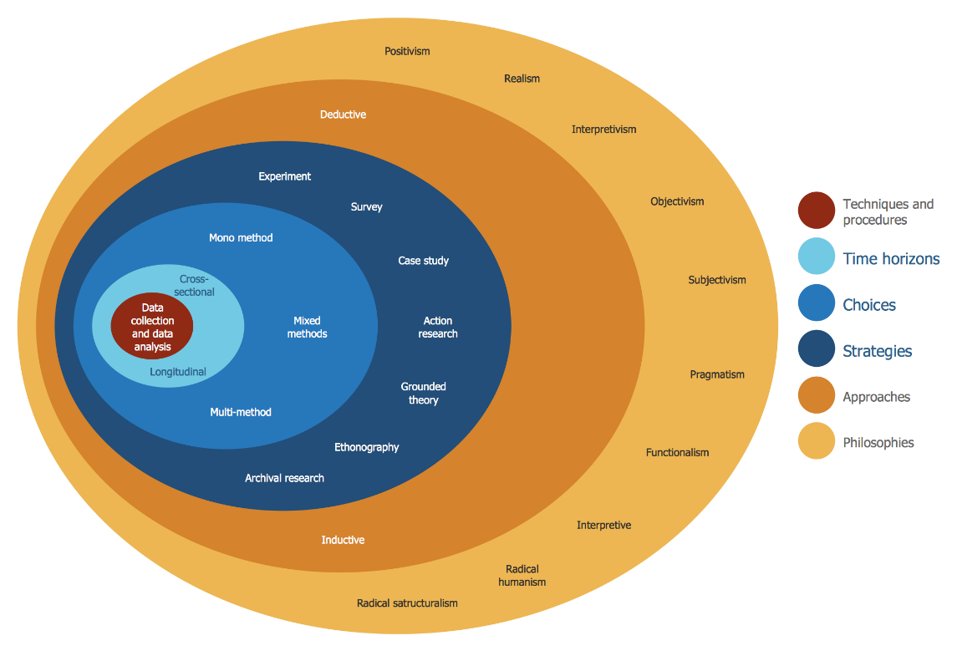
Figure 1

(ConceptDraw, 2023)

By following the research onion model, researchers can ensure that their research is systematic, rigorous, and well-designed, which increases the validity and reliability of their findings. (Bryman & Bell, 2019)

3.3 Research Philosophy

The researcher will use positivism philosophy in this study. Positivism is a research paradigm that assumes that knowledge can be gained through empirical observation and measurement, and that there is an objective reality that can be studied and understood through scientific methods. In the context of surveys and data analysis, positivism involves collecting and analysing quantitative data using standardized methods, such as surveys, questionnaires, and statistical techniques, to identify patterns, relationships, and correlations between variables. Positivists seek to establish causal relationships and generalize their findings to the broader population, and they often use deductive reasoning to test hypotheses and theories. (Bryman, 2016)
(Saunders, et al., 2018)

3.4 Research Approach

Deductive and inductive are two types of research approaches used in various fields. Deductive approach is a top-down approach where researchers start with a theory or hypothesis and then test it with empirical data. In this approach, researchers formulate a hypothesis, design an experiment, collect data, and analyse the results to either support or reject the hypothesis. This is the method that will be used by the researcher.

3.5 Ethical Considerations

The researcher will not mention or publish any personal details of the subjects from the police stop & searches. The researcher has kept all persons involved in the research as anonymous and has not included personal details that could lead to a data protection issue, the only questions asked that are personal to the persons participating in the survey are the ethnicity of said person and if they are a serving police officer in the South Wales Valleys, these were asked as they are relevant to the research and are necessary to analyse the findings which are needed for the conclusion, but will not lead to any participants being identified and will ensure anonymity is maintained. Participants participate on their own accord and are not forced into doing so.

3.6 The Researchers Choice & Strategy

The researcher will use 2 different research strategies, one being the researcher will create a questionnaire using the platform “Google Forms” which will then be accessible online, where participants can click on a shared hyperlink which will then display all questions. This option was chosen as the survey can be administered to large groups of people at once, making data collection more efficient and more cost effective than other methods. It also allows for the participants to have anonymity when answering, which could encourage the respondents to be more honest in their answers, particularly on sensitive topics (Tourangeau & Yan, 2007).
The researcher will also use data direct from police’s database, the tool is called the Business Intelligence Tool (BI Tool) and is not accessible to the public. This will be used so data which cannot be gained through conventional research can be obtained. The data will include statistics of stop searches in specific areas and will also include the ratio of disproportionality whilst showing other specifics such as the outcome of the search. The researcher has had permission from authorised persons in the police force to use and share this information in the dissertation as no actual sensitive data will be released.

3.7 Time Horizons

The researcher will use the cross-sectional method regarding the time horizon and this is due to the research being conducted over a short period of time and is the most appropriate as the study hopes to gain the opinions and data from participants and how they feel now. The study is not looking to see how these opinions change over a period, hence why the cross-sectional method is most suited to use for this study.
An explanation of the two different time horizons are as follows
Cross-sectional – Studies that are conducted at a specific point in time and involve the collection of data from a sample of individuals r units at that time. These are useful for describing the prevalence or distribution of a particular phenomenon. (Kelsey & Thompson, 1986)
Longitudinal Studies – These are studies that are conducted over an extended period of time and involve collecting data from the same sample of individuals or units at multiple points in time. (Johnson & Wichern, 2007)

3.8 Sample

In this study the researcher hopes to have between 40-80 participants involved in the questionnaire. This will allow for a generous amount of data to be collected.
The size of the sample is important because it affects the accuracy of the results. A larger sample size generally leads to more accurate results, as it reduces the effect of random variation and increases the precision of the estimates. However, a larger sample size also increases the cost and time required to collect data. Therefore between 40-80 participants is deemed suitable however the actual sample size will depend on the number of participants partaking. (Babbie, 2016)
The sample collected for the BI tool consists of all data collected by South Wales Police Databases which has been neatly organised into tables so the researcher can easily obtain the data as it is already available on the SWP database, the sample size of this is very large as it contains all stop search figures in the South Walers Valleys.
The importance of sampling lies in the fact that it allows researchers to make inferences about the characteristics of the entire population based on the information collected from the sample. By studying a sample, researchers can draw conclusions about the population with a certain degree of accuracy, without having to collect data from every individual in the population, which would be impractical and time-consuming. (Bryman, 2016)

3.9 Limitations

As this dissertation is only 8000 words this puts a restraint on the researcher to try and attempt to compact a variety of research and findings into a relatively small number of words.
There is a lack of other studies conducted that show the stop searches in the South Wales Valleys and their disproportionality and legitimacy, therefore making It harder for the researcher to spot any key patterns or trends in the data. Finally, only police officers are being questioned in this survey meaning that the perception of the members of the public, the people getting searched by the police will not be known. This means that there is a gap in the research as ideally the publics findings would be compared with the police constable findings, so patterns and similarities can be identified and analysed.

3.10 Conclusion

This Chapter has specified the various components of the research methodology and highlighted what the researcher will do to conduct the research ethically whilst explaining what forms of data will be collected and how.

4.0 Chapter Four: Analysis of Results

4.1 Introduction

The purpose of this chapter is to present the findings of the analysis conducted to examine the disproportionate and legitimacy of police stop searches in the South Wales Valleys. The chapter begins by providing an overview of the data collected and the analytical methods used to investigate the research questions. The results of the analysis are then presented in detail, followed by a discussion of the key findings and their implications for policing practice and policy.
The BI Tool displays BAME Ethnicities including Black Ethnicity as well as including a separate section for only Black Ethnicity. The BI Tool data was collected from 1st of January 2021 – 1st January 2023. The questionnaire had a total of 15 responses from serving police officers and will be analysed below.

4.2 Business Intelligence Data Analysis on Disproportionately

It is worth noting that the BI Tool can only look at statistics when it comes to the South Wales Valleys for only the following areas:
Merthyr, Maesteg, Rhonnda, Taff and Cynon. This is due to combing smaller towns with less data into a larger section so it can be more easily interpretated, for example Tonypandy is included as part of the Rhondda as a whole and Taffs Well is included along with the other Taff regions in the Taff section.
  - Looking at the data for Rhondda, it had a total amount of 984 searches. Of which 933 were on people of White Ethnicity, 13 were on persons of BAME ethnicities and 1 was on persons of Black Ethnicity. The disproportionately rate according to the data for BAME Ethnicity was 0.7% and for Black Ethnicity alone it was 0.3%.
  - Merthyr Tydfil had a total amount of searches of 578. Of which 536 were on white ethnicity, 16 were on persons of BAME ethnicity and 3 were on persons of black ethnicity. The disproportionality rate according to the data was 1.2% for BAME ethnicity and 2.2% for Black ethnicity.
  - Taff had a total number of searches of 685, of which 647 were on persons white ethnicity, 24 were on persons of BAME Ethnicity, 8 were on persons of Black Ethnicity.. The disproportionately rate was 1% for BAME ethnicity and 1.5% for Black ethnicity.
  - Maesteg had a total amount of searches of 326. Of which 286 were on white ethnicity, 5 were on persons of BAME ethnicity and 2 were on persons of black ethnicity. The disproportionality rate according to the data was 1.1% for BAME ethnicity and 3.7% for Black ethnicity.
  - Cynon had a total amount of searches of 320. Of which 284 were on white ethnicity, 5 were on persons of BAME ethnicity and 1 were on persons of black ethnicity. The disproportionality rate according to the data was 0.8% for BAME ethnicity and 0.8% for Black ethnicity.

4.3 Business Intelligence Tool Outcome of Search by Ethnicity

This section looks at the outcome for the stop and searches and how this varies by ethnicity. This section covers the entirety of the Mid-Glamorgan area which also includes Bridgend which is not included in this research as a Valley as it is a city.
White Ethnicity had 71.8% result in No Further action (NFA) and a positive principle action of 24.1% and a positive secondary action as the remainder.
Black Ethnicity had a 76.1% result in NFA and had a positive principle action of 17.4& with the remainder being positive secondary action.
Asian Ethnicity had a 56.1% result in NFA and had a positive principle action of 36.6% with the remainder being positive secondary action.
Mixed Ethnicity had a 70.6% result in NFA and had a positive principle action of 26.5% with the remainder being positive secondary outcome.
Other Ethnicity had a 75% result in NFA and had a positive principle outcome of the remaining 25%.
People who refused to state their ethnicity 71.8% resulted in NFA and there was 19.2% which resulted in a positive principle action, the remaining 9& resulted in a positive secondary action

4.3.1 Business Intelligence Tool BWV usage

This was researched as it gives an understanding and overview of how many officers utilised their Body Worn Video cameras when conducting the stop and search, it can be suggested that if there is a high number of officers not utilising their cameras then they are possibly conduiting illegitimate searches.

The BI Tool shows that a total of 97.6% of officers utilised their BWV and a total of only 2.4% did not use their cameras.

4.4 Questionnaire – Question 1 - Are You a serving police constable based in a response role in the South Wales Valleys?

This question was asked to ascertain the type of person answering this questionnaire as this questionnaire aims to target people solely in the police.
Out of the 15 responses 12 people stated that they were a serving police officer based in response in the South Wales Valleys the other 3 stated that they were not, however, these 3 persons then stated their role in the police in question 2.
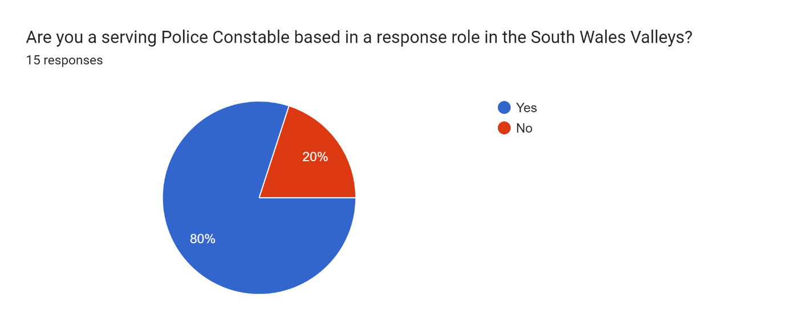

4.5 Question 2 - If You are not based on response please state your role in the police

This was posed as mentioned in 4.4, as it allows for the researcher to gather information from officers not based on response and therefore gives a broader outlook on the data as it gives officers in other departments a chance to voice their opinion and statistics.

There were 3 answers to this question which confirmed what role in the police the 3 participants who selected “No” for question 1 were.
The 3 answers were:
- 2 participants stated that they worked in the HUB
- 1 Participant stated that they worked on ARV (Armed Response Vehicle)
This clarified that out of the 15 participants, 12 were on response, 1 was on a proactive role of armed response and the other 2 participants were in an investigative role in the HUB.

4.6 Question 3 - What is your Ethnicity?

This was asked as it is relevant to the research, the research is about disproportionality in police stop & search so it is necessary for the research to ascertain the officer’s ethnicity. This is so analysis can be made if officers stop and search people of other ethnic backgrounds than themselves and if so how much it equates to their stop and search.

Out of the 15 responses, 14 stated that they were of White Ethnicity and 1 stated that they were of Mixed or Multiple Ethnic Groups.
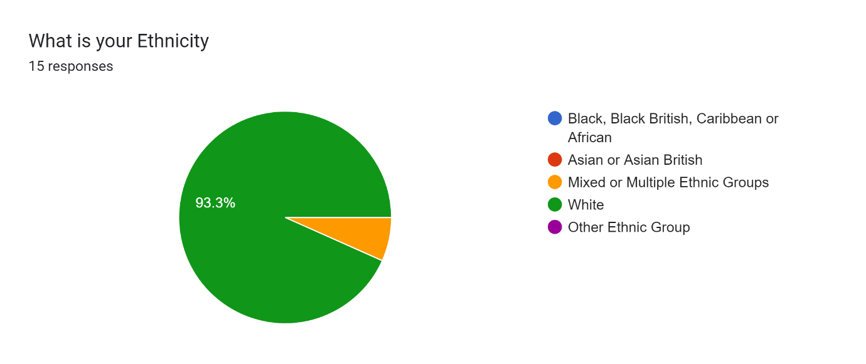

4.7 Question 4 - In the last 12 months approximately how many persons have you stopped and searched under any legitimate police act (PACE etc.)

This was posed as it is another question relevant for the research, to ascertain if there is any disproportionately. It was written as “approximately” as it would be nearly impossible for the officers to recall the exact number of searches.
Out of the 15 responses
- 3 Participants selected that they searched 2 persons.
- 1 Participant stated that they searched 4 persons.
- 1 participant stated that they searched 5 persons.
- 2 participants selected that they searched 10 persons.
- 1 participant stated that they searched 12 persons.
- 1 participant stated that they searched 14 persons.
- 2 participants stated that they searched 15 persons.
- 1 Participant stated that they searched 21 persons.
- 1 participant stated that they searched 32 persons.
- 1 participant stated that they searched 50 persons.
- 1 participant stated that they searched 70 persons.
The average amount of people stop and searched out of the 15 participants is 17.6 persons in 12 months. This also shows that a total of 264 searches were conducted by 15 participants over a 12-month period.

4.8 Question 5 - Out of these stop searches approximately how many resulted in further police action being taken? (I.e arrest, Cannabis warning given etc.)

This question was asked as from this a sense of legitimacy can be gauged, as it is not possible for the officers to recall what exactly lead them to stop and search everyone and is not appropriate to record the data as such.

Out of the 15 participants
- 2 participants stated that 0 searches resulted in further action being taken.
- 2 participants stated that 1 search resulted in further action being taken.
- 3 participants stated that 2 searches resulted in further action being taken.
- 2 participants stated that 3 searches resulted in further action being taken.
- 1 participant stated that 4 searches resulted in further action being taken.
- 2 participants stated that 5 searches resulted in further action being taken.
- 1 participant stated that 8 searches resulted in further action being taken.
- 1 participant stated that 12 searches resulted in further action being taken.
- 1 participant stated that 50 searches resulted in further action being taken.

The average amount of searches (Per officer) that resulted in further police action being taken was 6.5 searches.
Out of 264 total searches only 98 resulted in further police action being taken.

4.9 Question 6 - Out of your total amount of persons stop & searched in the last 12 months, please select which ethnic categories were searched.

This was posed as it directly links to the dissertation question, without this it would not be possibly to have a gauge on any disproportionate stop searches by ethnicity.

Out of the 15 participants, it was found that:
- 100% of participants selected that they searched persons of White Ethnicity.
- 3 participants selected that they searched persons of Black, Black British, Caribbean or African Ethnicity.
- 3 participants selected that they searched persons of Mixed or Multiple Ethnic Groups
- 1 Participant selected that they searched persons of Asian or Asian British Ethnicity.

This shows that out of the 15 participants 46.7% of them have searched people with non-white ethnicity.
- 20% of participants have searched people with Black ethnicity.
- 6.7% of Participants have searched people with Asian or Asian British Ethnicity.
- 20% of Participants have searched people of a mixed or multiple ethnic groups.

4.10 Question 7 - If you have selected multiple tick boxes for question 5 then please state the total amount of how many people were stop and searched, separated by each ethnic category (i.e. White ethnicity made up 50% of total persons stop & searched) If you have only selected one tick box for Question 5 then please go to the next question.

This was asked as it will give data on how many persons in total were stop and searched divided by ethnicity, as total numbers alone without ethnicity cannot aide the research as much.

Out of the 15 respondents
- 9 participants stated that all of their searches were only conducted on persons of white ethnicity. Meaning 100 searches were conducted on only persons of White ethnicity.
- 1 participant stated out of their 12 searches, 11 were conducted on persons of white ethnicity and 1 person was of Black, Black British, Caribbean, or African ethnicity.
- 1 participant stated that out of their 14 searches, 13 persons were of white ethnicity and 1 were of persons with a Black, Black British, Caribbean, or African ethnicity.
- 1 participant stated that out of their 15 searches, 13 persons of a white ethnicity and 2 were of persons with a Black, Black British, Caribbean, or African ethnicity.
- 1 participant stated that out of their 21 searches, 19 were conducted on persons with white ethnicity and 2 were on persons with a mixed or multiple ethnic groups.
- 1 participant stated that out of their 32 searches 16 persons were of white ethnicity and 16 were of persons with a Asian or Asian British Ethnicity.
- 1 participant stated that out of their 70 searches, 35 persons were of white ethnicity, 7 were persons of Black, Black British, Caribbean, or African ethnicity and 7 persons were of mixed or multiple ethnic groups, leaving 21 searches unaccounted for.
This data shows that out of the total number of 264 stop and searches conducted by 15 police officers in the south Wales valleys:
- 207 persons were of White Ethnicity
- 11 persons were of Black, Black British, Caribbean or African ethnicity
- 9 persons were of mixed or multiple ethnic groups
- 16 persons were of Asian or Asian British Ethnicity
And there were 21 unaccounted for searches.

4.11 Question 8 - Have any of your stop and searches lead to a complaint being made against you?

This question was asked to observe how many complaints an officer had, which therefore could give an insight in how ethically that officer is conducting their stop and searches as it could be assumed an officer with a complaint ratio of 100% is doing something wrong when it comes to stop searches.

Out of 15 participants
14 stated that none of their searches had led to a complaint being made against them.
1 stated that they have had a complaint made against them as a result from their stop and search.

4.12 Question 9 - What is your opinion on the current legislation for police stop and search and do you feel backed by your force when conducting stop and searches?

This question allows for the officers to give their honest anonymous opinion about the current legislation for stop and search, this will benefit the research as it could highlight any concerns actual police officers have and it will also allow the researcher to analyse how many feel like they are backed by their force when conducting searches. A correlation could then be made as if officers do not feel backed by their force this may result in them avoiding stopping and searching people.

Out of the 15 respondents there was little criticism of the actual legislation. 66% of participants stated in some form that they believe there is too much scrutiny over their stop searches. Only 13% actively stated that they had negative views around the actual legislation with comments such as it is “Archaic” and “needs updating” being used.
The main criticism was the officers feeling not backed by their force.
Other comments that were mentioned are:
“Need support from government and organisation to back officers to carry out more routine stop searches”.
“Made to feel like I am wrong for what I'm doing”.
“Officers get too much unfair criticism”.
“Increase in scrutiny”.
“over explain and justify even what are basic searches with overwhelming grounds”.

4.13 Question 10 - Is there anything you believe the college of policing or your force should change or update on the current legislation surrounding police stop and search? If Yes then please explain.

This was posed to ascertain officers believe that changes should be made to the legislation on stop and search, this is beneficial as it will aide the researcher in conducting their conclusion and will help them to suggest what (if any) actions should be made or altered going forward.

Out of the 15 respondents 26% stated that they would not change anything about the current legislation and 40% stated that they believe more grounds should be given to officers when conducting more stop searches and that the legislation should be altered in some way.
Other comments mentioned were:
“More robust use of sec 60 when the grounds exist”.
“More stop search grounds”.
“There needs to be greater public awareness of the benefits of it”.
“More guidance around what is “reasonable grounds” for stop and search”.
“Possibly be retrained on the grounds side of it as if they are changing and being more scrutinised”.

5.0 Chapter Five: Findings, Conclusions and Recommendations

5.1 Introduction

This chapter aims to further analyse the findings from the previous chapter and to create a conclusion from the research questions. In this chapter the researcher will outline any limitations regarding the research and make suggestions for any other future work conducted on this topic area such as further independent research.
The researcher will set out to make recommendations to organisations involved surrounding this topic area, so any issues around this topic can be highlighted and possible changes brought forward.

5.2 Were the objectives achieved?

The main objectives of this study was to analyse the stop search data in the South Wales Valleys and to ascertain if there was any disproportionality in the data which has been achieved.
The objectives were:
- To review the literature on stop and search, with a particular focus on disproportionality and legitimacy.
- To examine and review the extent to which stop and search is used by the police in the UK and also in the South Wales Valleys and if any further police action is taken.
- To assess the levels of disproportionality in stop and search in the South Wales Valleys.
- To Gather and assess the data which shows total stop search numbers in the South Wales Valleys
- To obtain information from serving police officers regarding their stop search data and if they feel supported by the organisation whilst carrying out stop and Searches.

The objectives were achieved through the researcher completing an extensive lengthy literature review outlining previous data on stop searches in the UK including Wales. The researcher collected a vast amount of data which showcases the amount of stop search figures conducted in the South Wales valleys with an emphasis on the disproportionality rate whilst also obtaining information from serving police officers showcasing their opinions and data on their stop searches.

5.3 Main Findings

The main findings highlighted in this study does support the literature review in that there is disproportionality in stop searches in the south Wales valleys as with the rest of the UK.
The questionnaire found that an approximate total of 264 searches were conducted in a 12-month period by 15 serving police officers, 21 of these lacked information surrounding ethnicity so therefore cannot be included in the research, giving an approximate total of searches of 243. Out of these 243 searches 36 of them were conducted on people of BAME ethnicity, making up 14.8% of the total searches conducted by the 15 officers. As stated in Chapter 2 Literature review, the total amount of the population percentage that was made up from BAME Ethnicities across the south Wales Valleys was approximately 1.7% (Total of All of RCT, Aberdare, Merthyr and Tonypandy) according to the combination of the data from the latest 2021 census and gave a total figure of 5057 persons of BAME ethnicity. From analysing the questionnaire this shows there is a disproportionality of 13.1% which is a shocking find.
The questionnaire also found that that a total of 46.7% of the 15 participants stated they have searched a person of BAME ethnicity, if there was no disproportionality then this finding should be considerably lower, given that the total population across the whole valleys is only 1.7% BAME ethnicity.
The BI Tool found that the lowest disproportionality rate was 0.7% and this was the Rhondda area, and the Highest disproportionality rate was 1.2% and this was in the Merthyr Tydfil. Area. These figures are not drastic as the ones presented in the survey however, they still show a positive disproportionality rate which shows there is disproportionality according to the official police database, albeit is lower than the survey findings it is still something that needs improvement.
The questionnaire also found that out of the 15 participants who were all serving police officers, only 1 of them had a complaint as a result of their stop and search over a 12-month period. This suggests that the legitimacy in the police stop search procedure is sound. This can be suggested as the subjects being searched would be given a digital receipt of the search and can choose to make a complaint if they felt the search was conducted unlawfully.
The BI Tool also found that 97.6% of officers conducting stop & searches used their BWV, this suggests that 97.6% of the searches could be confirmed to be lawful, as the searches are then reviewed and critiqued by a senior officer, and it is likely an unlawful search captured on BWV will have likely been spotted and picked up and accordingly dealt with. Although there was 2.4% of officers that did not utilise their BWV this cannot prove or deny legitimacy in the search as there could be numerous reasons why the BWV was not used such as a faulty camera.

The questionnaire findings also showed that approximately 37% of the total amount of stop and searches conducted by the 15 participants had a positive police outcome / action from them. This can suggest that as 37% had a positive outcome then at least 37% of the searches were conducted on legitimate grounds as offences were identified as being committed. However the data shows that approximately 63% of the total stop searches resulted in NFA, this cannot prove or disprove the legitimacy in the search as the exact circumstances of the search is unknown and this will be further discussed in the limitations section of this chapter.

5.4 Limitations

One main limitation of this research is the researcher had to conduct a full dissertation in conjunction with working full time as a police officer in an investigative role. This limited the amount of time that could have otherwise been dedicated to the research. With a larger time scale the researcher could have created a larger questionnaire and with more time available they could have then distributed the survey to more participants. This could have given more opinions and therefore would have provided a greater amount of valuable data; it would have also given more time for a more diverse role in the police to be questioned as these would have provided more data as the majority of data only came from response.
Another limitation was that only 15 serving police officers filled out the questionnaire, this was despite it being distributed to over 50 officers. This is likely due to the influx of student officers studying PCDA and therefore more and more questionnaires are being distributed to serving full time police officers, it can be assumed that due to the constant bombardment of surveys then it is likely that serving police officers are simply choosing to not fill out the surveys as they also have time constraints with full time work.
Another limitation was the data used in the Police BI Tool to show disproportionality is from using the census in 2011, this is now over 10 years old and a new census has since been released. This therefore could be showing inaccurate information and the actual disproportionality rate could be higher or lower however due to the non-updated data it is impossible to say.
Another Limitation is that the legitimacy of the stop and searches cannot be fully confirmed due to having a lack of information of each stop and search studied. Whilst officers in the questionnaire showcased how many resulted in further action as did the BI tool, it is impossible to ascertain the true legitimacy of the search as this data simply does not exist.

5.5 Further Research

There is potential for more research surrounding this topic in the South Wales Area. The scope of the research was primarily conducted by officers in the Merthyr / Cynon area so a true representation of the entirety of south Wales could not be gained from this research. This means that there is scope for this research to be conducted across the true full area of South Wales. There is possibility of further research to conduct a broader analysis of the data as only 15 participants were questioned.
Further research could also look into speaking to actual BAME members of the community and those who have been stop and searched to gain more data and a different perspective on the research area, which could not have been done by the researcher due to the ethical dilemmas.

5.6 Conclusion

The researcher’s dissertation has successfully showcased the key findings of the investigation and data available, whilst also achieving the aims originally set out. The opinions and data collection from serving police officers have been obtained and analysed and taken into account and their responses have been reiterated and showcased to the reader. The disproportionality rates have been identified and presented and all relevant information surrounding stop searches and the disproportionality rates were gathered prior to conducting the questionnaire. The legitimacy of police stop searches were questioned and the answers from the serving police officers and the police databases were obtained and presented as such to the reader, however as mentioned in the limitations, the full legitimacy will need to be further researched to ascertain the true legitimacy and to make a clear statement on the legitimacy. The main question of the dissertation surrounding disproportionality in stop searches was answered and it was identified that there is disproportionate stop searches even in the south Wales Valleys. But there is a clear need for further research into this area to truly answer are the police stop searches legitimate in the South Wales Valleys? and new up to date information is needed to answer the true level of disproportionately of stop searches in South Wales Valleys.

5.7 Recommendations

The first recommendation is for South Wales Police to provide new forms of training and guidance surrounding stop searches, this is made based on the numerous officer feedback obtained from the questionnaire which clearly showed officers felt that the grounds needed to be updated, there is constant scrutiny over stop searches, and that officers are potentially avoiding stop searches due to this. If new clear guidance is provided, then it will encourage more officers to conduct lawful stop searches. Some officers also felt that they were not backed by their force, this could be due to lack of knowledge surrounding stop searches, as the senior officers reviewing the searches are likely far more aware of any new guidelines and what constitutes as grounds. Regular up to date training will provide officers and the public reassurance when it comes to stop searches.
The second recommendation is for more data to be made available to the public surrounding stop searches regarding their legitimacy. Whilst the outcome of the search is documented and the ethnicity of those searched are documented, the actual reason for the search being conducted in the first place is not documented. If this data is made available then it will give new researchers a chance to truly examine the legitimacy of police stop searches, as it could be highlighted that officers used legitimate grounds when conducting searches so they are not basing their opinion solely on if a positive outcome was used.
The third recommendation is that South Wales Police needs to update their data in the BI Tool to the correct up to date census to truly provide a more accurate figure of disproportionality in stop searches, this will then allow new researchers to conduct a more accurate study.

(Word Count- 8740)

Bibliography

Bibliography
Babbie, E., 2016. The Practise of social research. 14th Edition ed. s.l.:Cengage Learning .

BBC, 2020. BBC News - George Floyd - What Happened in the final moments of his life. [Online]
Available at: https://www.bbc.co.uk/news/world-us-canada-52861726
[Accessed 25th November 2022].

Bowling, B., 2008. Criminal Justice Matters, s.l.: s.n.

Bowling, B. & Phillips, C., 2017. Disproportionate and Discriminatory: Reviewing the Evidence on Police Stop and Search. [Online]
Available at: https://web-s-ebscohost-com.ezproxy.uwtsd.ac.uk/ehost/pdfviewer/pdfviewer?vid=0&sid=03542705-c624-4e98-82f6-44e714932ccf%40redis
[Accessed 20th November 2022].
Bryman, A., 2016. Social Research methods. 5th edition ed. s.l.:oxford university press.

Bryman, A., 2016. Social Research Methods, s.l.: Oxford University Press .

Bryman, A. & Bell, E., 2019. Business Research methods, s.l.: Oxford University Press.

College of Policing , 2017. College of Policing. [Online]
Available at: https://www.college.police.uk/app/stop-and-search/stop-and-search
[Accessed 20th November 2022].

ConceptDraw, 2023. ConceptDraw. [Online]
Available at: https://www.conceptdraw.com/solution-park/management-stakeholder-onion-diagrams
[Accessed 1st February 2023].

Creswell, J., 2014. Research Design: Qualitative, Quantitative and mixed methods approaches., s.l.: Sage Publications.

Denzin, N. & Lincoln, Y., 2018. The Sage Handbook of Qualitative research , s.l.: Sage Publications.

Equality and Human Rights Commission, 2010. Stop and Think - A critical review of the use of stop and search powers in England And Wales, s.l.: Equlaity and Human Rights Comission.

Fitzgerald, R., 2014. Tripping Over Molehills: Ethics and the ethnography of police work. Qualitative Research, pp. 288-304.

Home Office, 2013. Gov.uk - PACE Codes of Practise. [Online]
Available at: https://www.gov.uk/guidance/police-and-criminal-evidence-act-1984-pace-codes-of-practice
[Accessed 20th November 2022].

Home Office, 2022. National statistics - Police powers and procedures: Stop and search and arrests, England and Wales, year ending 31 March 2021 second edition. [Online]
Available at: https://www.gov.uk/government/statistics/police-powers-and-procedures-stop-and-search-and-arrests-england-and-wales-year-ending-31-march-2021/police-powers-and-procedures-stop-and-search-and-arrests-england-and-wales-year-ending-31-march-2021
[Accessed 30th November 2022].

House of Commons Home of Affairs Comittee, 2019. Home Office Preparedness for covid-19: Implications for policing and wider society. [Online]
Available at: https://publications.parliament.uk/pa/cm5801/cmselect/cmhaff/363/363.pdf
[Accessed 20th November 2022].

Jackson, J. et al., 2012. Why do people conform with the law? Legitimacy and the influence of legal institutions.. In: Why do people conform with the law? Legitimacy and the influence of legal institutions.. s.l.:British Journal Of Crminology, pp. 1051-1071 .

Johnson, R. & Wichern, D., 2007. Applied Multivariate statistical analysis. s.l.:Pearson Prentice Hall.

Kelsey, J. & Thompson, W., 1986. Cross sectional studies. In Methods in Observational Epidmiology. In: Cross sectional studies. In Methods in Observational Epidmiology. s.l.:Oxford University Press, pp. 97-118.

Krosnick, J., 1999. Survey Research: Annual Review of Psychology , s.l.: Sage Publications.
Legislation.Gov, 2023. Legislation.Gov. [Online]
Available at: https://www.legislation.gov.uk/search
[Accessed 1st December 2022].

Llanstad, J. & Gravelle, J., 2020. Stop and Search in the South Wales Valleys: Perceptions of legitimacy and disproportionality.. International Journal of Police Science & Management , pp. 208-218.

Office For National Statistics, 2021. Gov.Wales. [Online]
Available at: https://www.gov.wales/ethnic-group-national-identity-language-and-religion-wales-census-2021-html#:~:text=Main%20points%201%20Ethnic%20group%20On%20Census%20Day%2C,identity%20...%203%20Language%20...%204%20Religion%20
[Accessed 1st december 2022].

Polit, D. & Beck, C., 2012. Nursing Research: Gathering and Assessing evidence for nursing practise, s.l.: Lippincott Williams & Wilkins.

Saunders, M., Lewis, P. & Thornhill, A., 2018. Research Methods for business students , s.l.: Pearson Education Limited.

Shiner, M. & Newton, T., 1999. Definitely maybe? The Home Office, The Police and the calculation of Stop & search ratios. British Journal of Criminology, pp. 196-210.

Tourangeau, R. & Yan, T., 2007. Sensitive questions in Surveys. Psychological Bulletin, pp. 859-883.

Tyler, T., 1990. Why People Obey the Law. 2nd edition ed. s.l.:Yale University.

Appendix

Appendix 1 Questionnaire
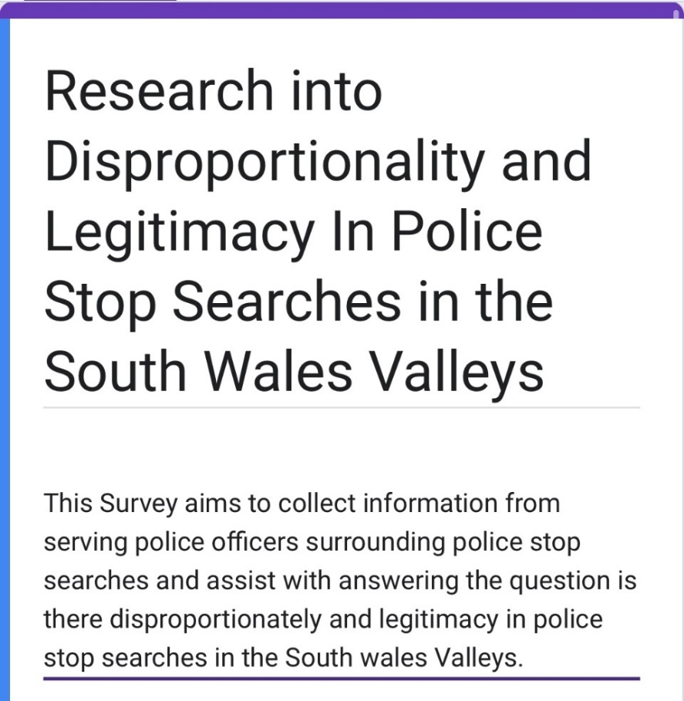

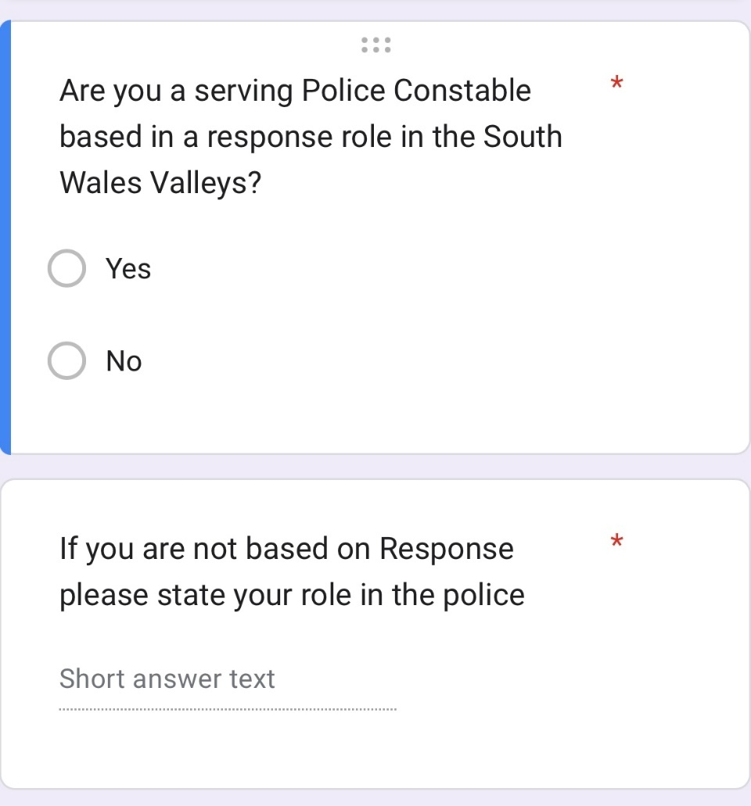

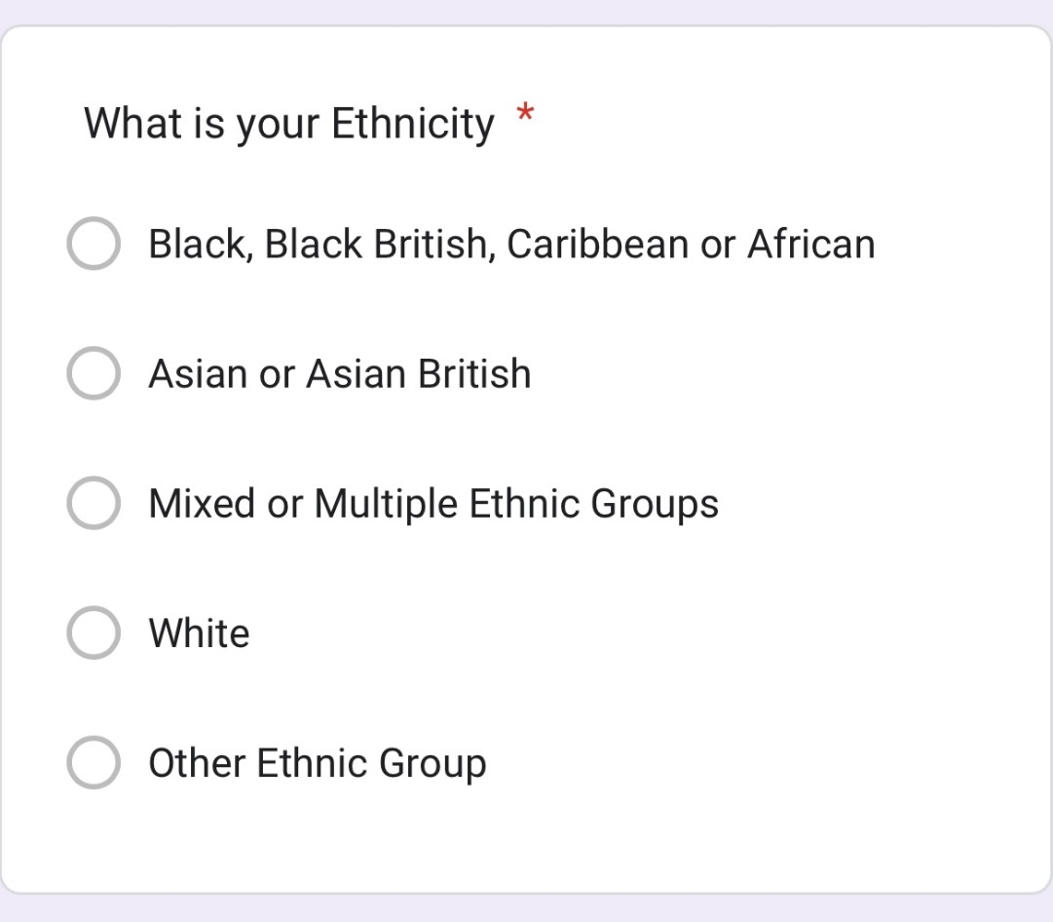

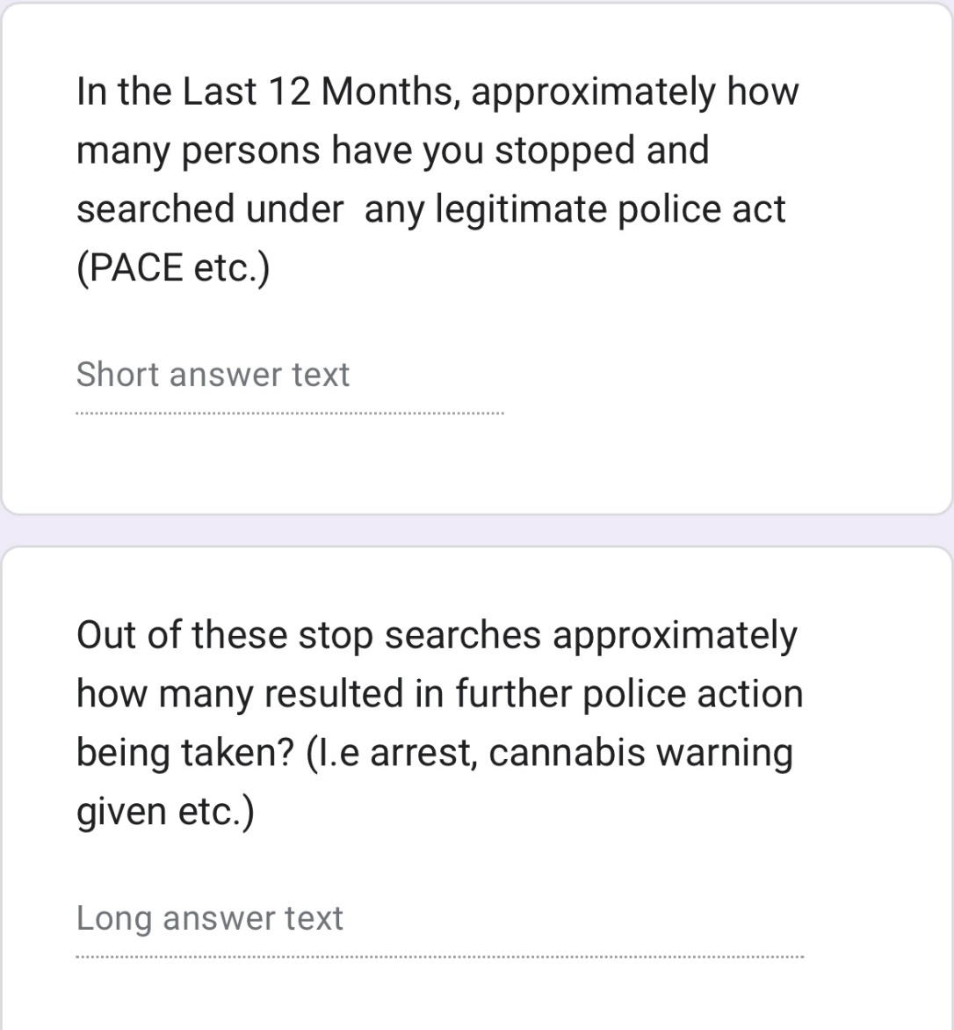

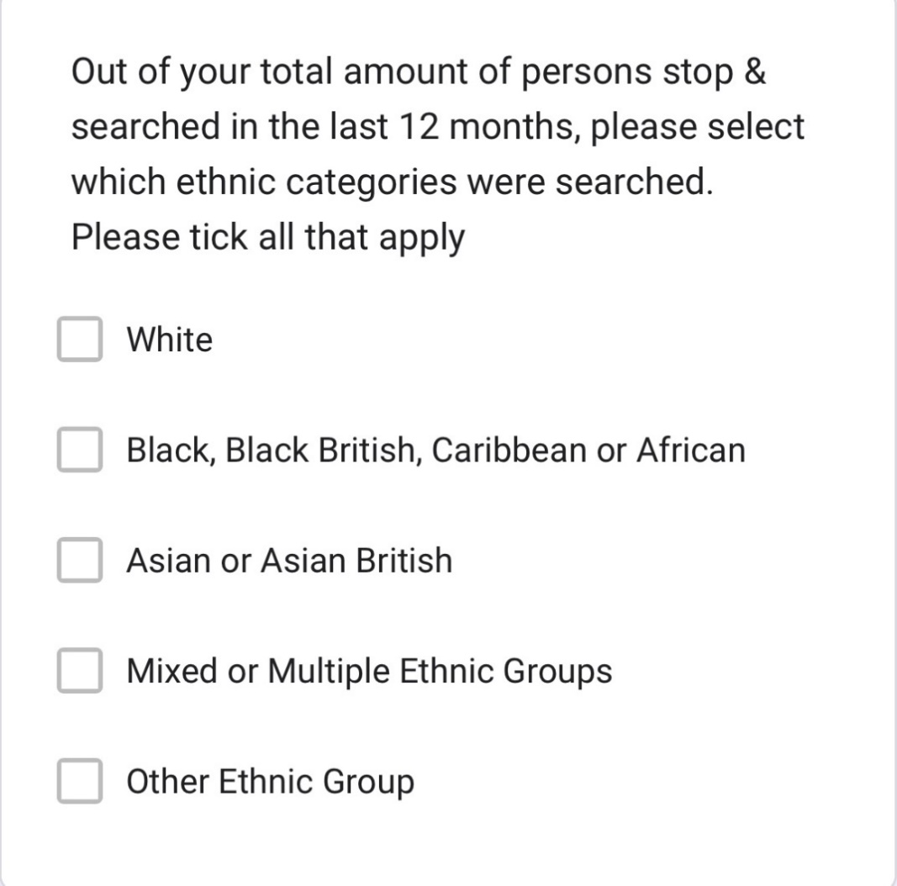

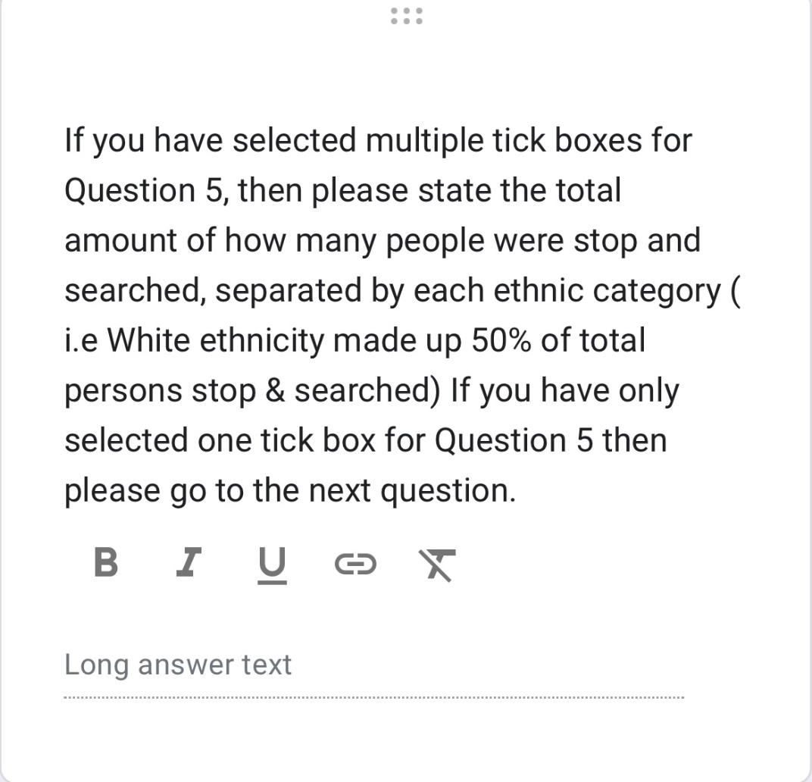

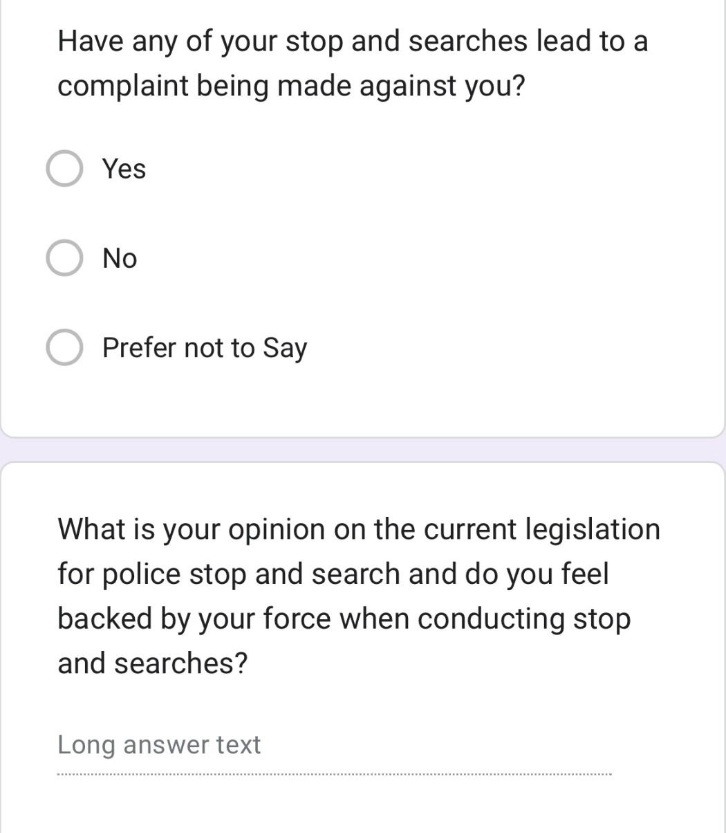

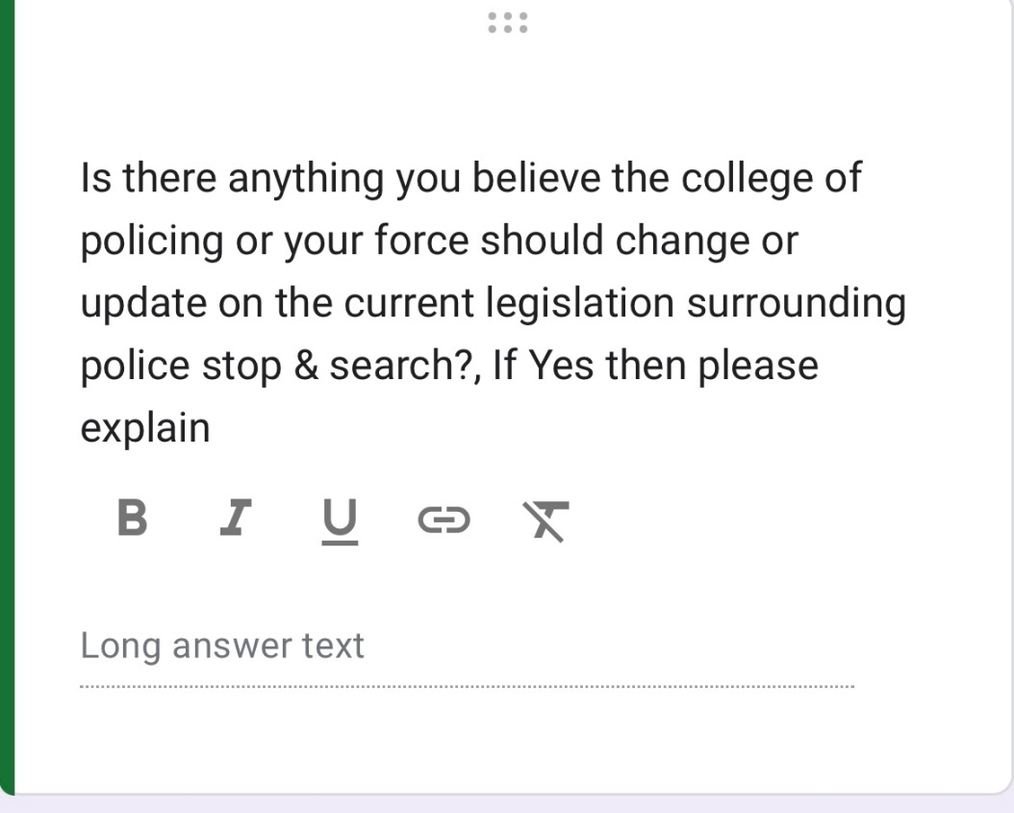

Appendix 2 – Graphs from Questionnaire Results

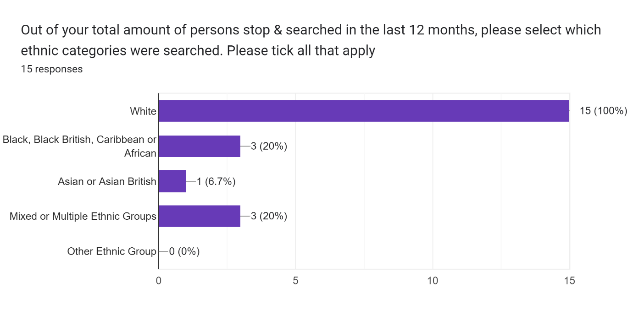

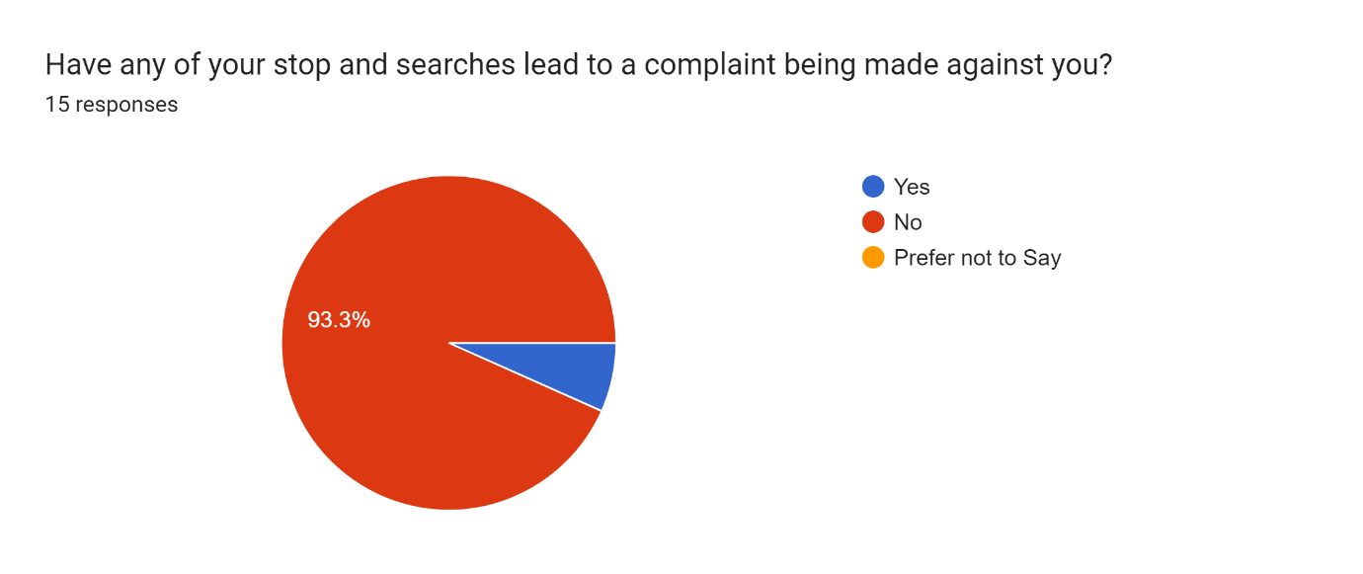

Appendix 3 – Research Proposal



UNDERGRADUATE DISSERTATION
RESEARCH PROPOSAL FORM

NAME: James Coppin | STUDENT ID No.: 1922402
DRAFT RESEARCH TITLE QUESTION:

Are Police Stop Searches in South Wales Disproportionate and Legitimate?

INTRODUCTION:

This dissertation will examine the issues of disproportionality and legitimacy in police stop searches in the South Wales Valleys. The purpose of this study is to investigate the extent to which those of ethnic minorities are disproportionately affected by police stop and search practices in the South Wales Valleys.

In recent years, there has been growing concern regarding the disproportionate use of stop and search powers by police officers on individuals from Black, Asian and Minority Ethnic (BAME) communities. The overrepresentation of BAME individuals in police stop and search statistics has been found in multiple studies across the UK, suggesting a possible bias in policing practices. South Wales Police like the majority of forces in the UK has also faced criticism over the disproportionate use of stop and search powers on BAME individuals. There is a need for a comprehensive study to explore the legitimacy of police stop and searches on BAME individuals in the South Wales Valleys and the disproportionality rate of them.

Literature Review:

Police stop searches refer to the power of the police to stop and search individuals they believe may be carrying illegal drugs, weapons or other illicit items. In the UK, the use of stop and search powers by the police has been a controversial issue, particularly in relation to its disproportionate use on individuals from Black, Asian and Minority Ethnic (BAME) backgrounds. This literature review aims to explore the existing research on the disproportionate use of police stop and search powers on BAME individuals in the South Wales Valleys, and whether the use of these powers is legitimate.

Background:

The use of stop and search powers has been a contentious issue in the UK for several decades, with concerns over its disproportionate use on BAME individuals. In 1999, the Macpherson Report into the murder of Stephen Lawrence highlighted institutional racism within the police and called for reforms in the way stop and search powers were used. However, despite the introduction of new regulations, research has continued to suggest that the use of stop and search powers remains disproportionately high for BAME individuals. (Tyler & Wakslak, 2004)

Disproportionality of stop and search:

Several studies have examined the disproportionality of police stop and search on BAME individuals in the UK. For example, a 2019 report by the Equality and Human Rights Commission found that Black people were over nine times more likely to be stopped and searched than White people in England and Wales (Equality and Human Rights Commission, 2019). A similar trend has been observed in the South Wales Valleys, with a 2017 report by the Welsh Government finding that BAME individuals were more likely to be stopped and searched than their White counterparts. (Welsh Government , 2017).

Legitimacy of stop and search:

The legitimacy of police stop and search powers has been widely debated in the literature. Some argue that the use of stop and search powers is a legitimate policing tool that can help prevent crime and improve community safety. Others, however, suggest that the use of these powers can erode trust between the police and communities, particularly when used disproportionately on BAME individuals.

Research has shown that the perceived legitimacy of stop and search powers can vary depending on a range of factors, including the ethnicity of the person being searched, the reason for the search and the behaviour of the police officer conducting the search. A 2018 study by the College of Policing found that BAME individuals were less likely to perceive stop and search as legitimate than White individuals. (College of Policing , 2018)

Conclusion:

In conclusion, the use of police stop and search powers on BAME individuals in the South Wales Valleys is a complex issue that has been widely debated in the literature. Existing research suggests that there is a clear disproportionality in the use of these powers on BAME individuals, which raises concerns over its legitimacy. Further research is needed to understand the factors that contribute to this disproportionality and to identify ways in which the use of stop and search powers can be made more effective and legitimate, while also addressing concerns over racial bias and discrimination.

SUMMARY OF RESEARCH OBJECTIVES:

- What is the extent of disproportionality in police stop and searches on BAME individuals in the South Wales Valleys?
- What are the factors that influence police officers to conduct stop and searches on BAME individuals in the South Wales Valleys?
- To what extent are police stop and searches on BAME individuals in the South Wales Valleys considered legitimate?
- Gather data from serving police officers surrounding their own stop searches.
- Combine own findings with existing literature to assess levels of disproportionality around stop searches in the South Wales Valleys and provide recommendations based on the findings.
SUMMARY OF METHODOLOGY INCLUDING LIMITATIONS AND EXPECTED OUTCOMES:
The research design will be a mixed-methods approach consisting of quantitative and qualitative data. This approach will allow for a comprehensive analysis of the data collected, and triangulation of results to increase the credibility and reliability of findings.
I plan to use a mix of both quantitative and qualitative research methods in the hope of achieving an unbiased answer that is fair in its approach.
The quantitative data will be obtained from police records of stop and searches on BAME individuals in the South Wales Valleys over a period of two years. The data will be analysed using statistical tools to examine the extent of disproportionality in stop and searches on BAME individuals. The qualitative data will be collected through the use of open-ended questions in a questionnaire that will be distributed to serving police officers.

Data Analysis:
Quantitative data will be analysed using descriptive statistics and inferential statistics. Descriptive statistics such as frequencies, percentages, and measures of central tendency will be used to describe the data.
Qualitative data will be analysed using thematic analysis. This method involves identifying patterns in the data and developing themes that capture the essence of the data.

Expected outcomes: The study is expected to contribute to the understanding of the relationship between police stop and search practices and the disproportionate targeting of BAME ethnicities in the South Wales Valleys. The study is also expected to provide insights into the perceived legitimacy of the police stop and search practices among BAME communities in the South Wales Valleys.

Limitations: The study may face limitations due to the availability of data, the willingness of participants to engage in the study, and potential biases in the police stop and search records. However, these limitations will be addressed by using multiple methods and triangulating data to increase the credibility and reliability of the findings.

Overall, the dissertation will provide an in-depth analysis of the relationship between police stop and search practices, disproportionality, and legitimacy among BAME ethnicities in the South Wales Valleys.

SUMMARY OF SAMPLING FRAMEWORK:

The sample used in the research will be on serving police officers and hope to reach a 30-90 police officers, the sample will be gained by sharing an online hyperlink with serving police officers so they can gain access to a questionnaire around the subject of stop searches in the south Wales Valleys.
The other sample will be data from a police database called the BI Tool, which is a verified collection of data officially from the SWP database.

ETHICAL ISSUES:

The study will adhere to ethical principles of research, including informed consent, confidentiality, and anonymity. The participants will be informed of the purpose of the study, the nature of the research, and their rights as participants. They will be given the opportunity to withdraw from the study at any time. The study will also adhere to ethical guidelines for analysing officer police data.
TIME SCALE:

The timescale is shown below over the span of 8 months, month 1 being August 2022 to Month 8 which is March 2023

Month 1-2: Literature review and research design

Conduct a comprehensive literature review on the topic of police stop and searches on BAME individuals and legitimacy theory.
Finalise the research questions, hypotheses, and research design.
Develop a sampling strategy for both the quantitative and qualitative data.

Month 3-4: Data collection and analysis

Obtain the necessary data from South Wales Police on stop and searches conducted on BAME individuals in the South Wales Valleys.
Share questionnaire with serving police officers gathering their stop and search data and analyse the data accordingly.
Analyse the quantitative data using statistical tools to determine the extent of disproportionality in stop and searches on BAME individuals.
Conduct a thematic analysis of the qualitative data to identify factors that influence police officers to conduct stop and searches and to explore the legitimacy of such actions.

Month 5-6: Results and discussion

Compile the results of the quantitative and qualitative data analysis and structure them commenting on the data found.
Interpret and discuss the findings in light of the research questions and hypotheses.
Evaluate the legitimacy of stop and searches on BAME individuals in the South Wales Valleys.

Month 7-8: Conclusion and recommendations

Synthesise the key findings and draw conclusions.
Develop recommendations for policy and practice in policing and to promote greater transparency and accountability in the use of stop and search powers.
Identify areas for future research on the topic.
Also, in this month
I will make Final revisions and submission.
Proofread and finalise the dissertation.
Submit the dissertation by the deadline.

REFERENCE LIST:

(Equality and Human Rights Commission, 2019)

(Welsh Government , 2017)

(Tyler & Wakslak, 2004)

(Jackson, Bradford, Stanko, & Hohl, 2013)

(College of Policing , 2018)

Bibliography
College of Policing . (2018). The College of Policing. Retrieved from Evidence Review: Perceptions of legitimacy and confidence in the police: https://whatworks.college.police.uk/evidence-review/perceptions-of-legitimacy-and-confidence-in-the-police/Pages/default.aspx

Equality and Human Rights Commission. (2019). Equality and Human Rights Commission . Retrieved from Stop & Think 2019: https://www.equalityhumanrights.com/en/publication-download/stop-and-think-critical-review-use-stop-and-search-powers-england-and-wales

Jackson, J., Bradford, B., Stanko, E., & Hohl, K. (2013). Just Authority? Trust in the police in England and Wales . Routledge.
Tyler, T., & Wakslak, C. (2004). Profiling and police legitimacy: Procedural justice, attributions of motive, and acceptance of police authority. Criminology, 253-282.

Welsh Government . (2017). Gov.Wales. Retrieved from Analysis of stop and search data in Wales 2013-2015: https://gov.wales/analysis-stop-and-search-data-wales-2013-2015

Appendix 4 – Ethics Form

APPLICATION FOR ETHICAL APPROVAL

In order for research to result in benefit and minimise risk of harm, it must be conducted ethically. A researcher may not be covered by the University’s insurance if ethical approval has not been obtained prior to commencement.

The University follows the OECD Frascati manual definition of research activity: “creative work undertaken on a systematic basis in order to increase the stock of knowledge, including knowledge of man, culture and society, and the use of this stock of knowledge to devise new applications”. As such this covers activities undertaken by members of staff, postgraduate research students, and both taught postgraduate and undergraduate students working on dissertations/projects.

The individual undertaking the research activity is known as the “principal researcher”.

Ethical approval is not required for routine audits, performance reviews, quality assurance studies, testing within normal educational requirements, and literary or artistic criticism.

Please read the notes for guidance before completing ALL sections of the form.

This form must be completed and approved prior to undertaking any research activity. Please see Checklist for details of process for different categories of application.

Delete the Guidance Notes at the end of the form BEFORE submitting your application

SECTION A: About You (Principal Researcher)
Full Name: |  | James Coppin
Tick all boxes which apply: |  | Member of staff: | ☐ | Honorary research fellow: | ☐
Undergraduate Student | ☒ | Taught Postgraduate Student | ☐ | Postgraduate Research Student | ☐

Institute/Academic Discipline/Centre: | University Trinity of St Davids
Campus: | N/A
E-mail address: | 1922402@student.uwtsd.ac.uk
Contact Telephone Number: | 07956170849
For students:
Student Number: | 1922402
Programme of Study: | Professional policing, police science
Director of Studies/Supervisor: | Sarah Jones

SECTION B: Approval for Research Activity
Has the research activity received approval in principle?  (please check the Guidance Notes as to the appropriate approval process for different levels of research by different categories of individual) |  | YES | ☒ | NO | ☐
 |  |  |  | Date
If Yes, please indicate source of approval (and date where known): Approval in principle must be obtained from the relevant source prior to seeking ethical approval | Research Degrees Committee |  | ☒
 | Institute Research Committee |  | ☐
 | Other (write in) |  | ☐

SECTION C: Internal and External Ethical Guidance Materials
Please list the core ethical guidance documents that have been referred to during the completion of this form (including any discipline-specific codes of research ethics, and also any specific ethical guidance relating to the proposed methodology). Please tick to confirm that your research proposal adheres to these codes and guidelines.
UWTSD Research Ethics & Integrity Code of Practice | ☒
UWTSD Research Data Management Policy | ☒
 | ☐

SECTION D: External Collaborative Research Activity
Does the research activity involve collaborators outside of the University? |  | YES | ☐ | NO | ☒
If Yes, please provide the name of the external organisation and name and contact details for the main contact person and confirmation this person has consented to their personal data being shared.as part of this collaboration.
Institution
Contact person name
Contact person e-mail address

Has this individual consented to sharing their details on this form? |  | YES | ☐ | NO |  |  | ☒
Are you in receipt of a KESS scholarship? |  | YES | ☐ | NO |  |  | ☒
Is your research externally funded |  | YES | ☐ | NO |  |  | ☒
Are you specifically employed to undertake this research in either a paid or voluntary capacity? | Voluntary | YES | ☐ | NO |  | ☒
 | Employed | YES | ☐ | NO |  | ☒
Is the research being undertaken within an existing UWTSD Athrofa Professional Learning Partnership (APLP) | If YES then the permission question below does not need to be answered. | YES | ☐ | NO |  |  | ☒
Permission to undertake the research has been provided by the partner organisation | (If YES attach copy)  If NO the application cannot continue | YES | ☐ | NO |  |  | ☒

Where research activity is carried out in collaboration with an external organisation
Does this organisation have its own ethics approval system? | YES | ☐ | NO | ☐
If Yes, please attach a copy of any final approval (or interim approval) from the organisation

SECTION E: Details of Research Activity
Indicative title: | Stop Searches In the Police Force – Are Police Stop Searches in the South Wales Valleys disproportionate and are police utilising legitimate powers to conduct them?
Proposed start date: | 01/08/2022 | Proposed end date: | 20/03/2023
Introduction to the Research (maximum 300 words)
Ensure that you write for a Non-Specialist Audience when outlining your response to the three points below:
- Purpose of Research Activity
- Proposed Research Question
- Aims of Research Activity
- Objectives of Research Activity
Demonstrate, briefly, how Existing Research has informed the proposed activity and explain
- What the research activity will add to the body of knowledge
- How it addresses an area of importance.
Purpose of Research Activity

The purpose of this study is to investigate if there is a disproportionate amount of police stop searches on people with BAME ethnicities.

The other purpose is to investigate if the stop searches conducted in the South Wales valleys are legitimate.

Stop searches are routinely scrutinised and there is a growing media attention around police discriminating people of BAME origins.

The research will aim to look at the data surround police stop and searches conducted in the south Wales valleys and will aim to gain data from serving police officers to ascertain the amount of people stop searched by officers and the data surrounding their ethnicity.

(this box should expand as you type)
Research Question

Stop Searches In the Police Force – Are Police Stop Searches in the South Wales Valleys disproportionate and are police utilising legitimate powers to conduct them?

(this box should expand as you type)
Aims of Research Activity

(this box should expand as you type)
Objectives of Research Activity
The objectives are to find out if fellow colleagues believe if the police force is racist, if there is institutional racism in the police and if they feel they have contributed to any act that may portray the police force as racist. I plan to keep all personal details confidential and to do this in an efficient manner.

(this box should expand as you type)
Proposed methods (maximum 600 words)
Provide a brief summary of all the methods that may be used in the research activity, making it clear what specific techniques may be used. If methods other than those listed in this section are deemed appropriate later, additional ethical approval for those methods will be needed.
I plan to utilise a questionnaire which will consist of numerous questions that will ask officers if they feel there is any racism in the job they work for, whilst also asking for statistics from the officer's day to day role such as stop & searches.
This questionnaire will be available to all officers that click the link and will be available to all officers regardless of rank. The questionnaire will be confidential and will only obtain information on the officer's ethnic background, their length of service and their rank, this will be used to then create graphs such as pie charts so it can be used in my work to prove or disprove certain topics in my work.

I also plan to utilise the internet to gain much of my work, this will come from reports made from credited authors in the form of essays or simply published articles, all of these used will be referenced accordingly. I will also be using websites such as government websites (Gov.uk) and the office for national statistics for a wider field of research that will allow me to see vast statistics that I am simply not able to carry out by myself, these will then be used in conjunction with my own findings to see if certain views are consistent or not when compared with day-to-day workers.

I also plan to interview a small number of officers for South-Wales Police, this will be done at my place of work to numerous members of my team, this will be done to allow the participants to go into greater depth into their answers and for me to further question their answer given so greater insight can be achieved compared to simply filling out a yes or no question. All participants details will be kept confidential, no personal details will be obtained.

(this box should expand as you type)

Location of research activity
Identify all locations where research activity will take place.
Merthyr Tydfil & Aberdare
(this box should expand as you type)
Research activity outside of the UK
If research activity will take place overseas, you are responsible for ensuring that local ethical considerations are complied with and that the relevant permissions are sought. Specify any local guidelines (e.g. from local professional associations/learned societies/universities) that exist and whether these involve any ethical stipulations beyond those usual in the UK (provide details of any licenses or permissions required). Also specify whether there are any specific ethical issues raised by the local context in which the research activity is taking place, for example, particular cultural and/or legal sensitivities or vulnerabilities of participants.
N/A

(this box should expand as you type)
Use of documentation not in the public domain: Are any documents NOT publicly available? | NO | ☐
 | YES | ☒
If Yes, please provide details here of how you will gain access to specific documentation that is not in the public domain and that this is in accordance with prevailing data protection law of the country in question and England and Wales.

I will utilise the BI Tool to access the data surrounding police stop searches in the area of South Wales Valleys. This Tool is gained access to via south Wales police internal computing systems /documents. I will ensure that the relevant permission is gained before I use the information ensuring I have the authorised permission and I will ensure only numerical data is shared and no data of any sensitive or personal nature is shared. (Whilst in the process of completing this form Authorisation from the relevant persons in SWP was gained).

(this box should expand as you type)

SECTION F: Scope of Research Activity
Will the research activity include: | YES | NO
Use of a questionnaire or similar research instrument? | ☒ | ☐
Use of interviews? | ☐ | ☒
Use of diaries? | ☐ | ☒
Participant observation with their knowledge? | ☐ | ☒
Participant observation without their knowledge? | ☐ | ☒
Use of video or audio recording? | ☐ | ☒
Access to personal or confidential information without the participants’ specific consent? | ☐ | ☒
Administration of any questions, test stimuli, presentation that may be experienced as physically, mentally or emotionally harmful / offensive? | ☐ | ☒
Performance of any acts which may cause embarrassment or affect self-esteem? | ☐ | ☒
Investigation of participants involved in illegal activities? | ☐ | ☒
Use of procedures that involve deception? | ☐ | ☒
Administration of any substance, agent or placebo? | ☐ | ☒
Working with live vertebrate animals? | ☐ | ☒
Other primary data collection methods, please explain in this box  For example, ‘focus groups’. Please indicate the type of data collection method(s) in this box and tick the accompany box. | ☐ | ☒
Details of any other primary data collection method:  (this box should expand as you type) | ☐ | ☒
If NO to every question, then the research activity is (ethically) low risk and may be exempt from some of the following sections (please refer to Guidance Notes).

If YES to any question, then no research activity should be undertaken until full ethical approval has been obtained.

SECTION G: Intended Participants
Who are the intended participants: | YES | NO
Students or staff at the University? | ☐ | ☒
Adults (over the age of 18 and competent to give consent)? | ☒ | ☐
Vulnerable adults? | ☐ | ☒
Children and Young People under the age of 18? (Consent from Parent, Carer or Guardian will be required) | ☐ | ☒
Prisoners? | ☐ | ☒
Young offenders? | ☐ | ☒
Those who could be considered to have a particularly dependent relationship with the investigator or a gatekeeper? | ☐ | ☒
People engaged in illegal activities? | ☐ | ☒
Others (please identify specifically any group who may be unable to give consent) please indicate here and tick the appropriate box. | ☐ | ☒
Other – please indicate here:  (this box should expand as you type) | ☐ | ☒

Participant numbers and source
Provide an estimate of the expected number of participants. How will you identify participants and how will they be recruited?
How many participants are expected? | I anticipate there being between 30-80 participants.  (this box should expand as you type)
Who will the participants be? | Police constables employed by South Wales Police  (this box should expand as you type)
How will you identify the participants? | Each participant will be automatically assigned a number when they partake in the questionnaire, this will allow me to identify each participant through numbers alone no personal details such as names / other sensitive information will be asked. I will be able to view the survey and see what each number stated in the survey.  (this box should expand as you type)

Information for participants: | YES | NO | N/A
Will you describe the main research procedures to participants in advance, so that they are informed about what to expect? | ☒ | ☐ | ☐
Will you tell participants that their participation is voluntary? | ☒ | ☐ | ☐
Will you obtain written consent for participation? | ☒ | ☐ | ☐
Will you explain to participants that refusal to participate in the research will not affect their treatment or education (if relevant)? | ☐ | ☐ | ☒
If the research is observational, will you ask participants for their consent to being observed? | ☐ | ☐ | ☒
Will you tell participants that they may withdraw from the research at any time and for any reason? | ☒ | ☐ | ☐
With questionnaires, will you give participants the option of omitting questions they do not want to answer? | ☒ | ☐ | ☐
Will you tell participants that their data will be treated with full confidentiality and that, if published, it will not be identifiable as theirs? | ☒ | ☐ | ☐
Will you debrief participants at the end of their participation, in a way appropriate to the type of research undertaken? | ☒ | ☐ | ☐
If NO to any of above questions, please give an explanation
(this box should expand as you type)

Information for participants: | YES | NO | N/A
Will participants be paid? | ☐ | ☒ | ☐
Is specialist electrical or other equipment to be used with participants? | ☐ | ☒ | ☐
Are there any financial or other interests to the investigator or University arising from this study? | ☐ | ☒ | ☐
Will the research activity involve deliberately misleading participants in any way, or the partial or full concealment of the specific study aims? | ☐ | ☒ | ☐
If YES to any question, please provide full details
(this box should expand as you type)

SECTION H: Anticipated Risks

Outline any anticipated risks that may adversely affect any of the participants, the researchers and/or the University, and the steps that will be taken to address them.

If you have completed a full risk assessment (for example as required by a laboratory, or external research collaborator) you may append that to this form.
Full risk assessment completed and appended? |  | Yes | ☐
 |  | No | ☐
Risks to participants
For example: emotional distress, financial disclosure, physical harm, transfer of personal data, sensitive organisational information
Risk to Participant:  I deem there to be low risks to the participant in emotional distress.  (this box should expand as you type) | How will you mitigate the Risk to Participant  This will be upheld as there will be no personal details obtained, no stressful questions asked, no personal stories to be shared and the participant will be allowed to stop at any time. The topic can be seen as controversial and could be seen as a delicate topic to some of the participants, so this is why I have deemed it to be a low risk, however by upholding keeping personal details and experiences out of the questions this should ensure the participants feel no emotional distress.  (this box should expand as you type)
If research activity may include sensitive, embarrassing or upsetting topics (e.g. sexual activity, drug use) or issues likely to disclose information requiring further action (e.g. criminal activity), give details of the procedures to deal with these issues, including any support/advice (e.g. helpline numbers) to be offered to participants. Note that where applicable, consent procedures should make it clear that if something potentially or actually illegal is discovered in the course of a project, it may need to be disclosed to the proper authorities
N/A

(this box should expand as you type)
Risks to investigator
For example: personal safety, physical harm, emotional distress, risk of accusation of harm/impropriety, conflict of interest
Risk to Investigator:  No Risks identified  (this box should expand as you type) | How will you mitigate the Risk to Investigator:  N/A  (this box should expand as you type)
University/institutional risks
For example: adverse publicity, financial loss, data protection
Risk to University:  A Negative view on the university  (this box should expand as you type) | How will you mitigate the Risk to University:  No connection to the university will be mentioned in my research methods so the participants will have no access to any of the universities documents or student information, nor will they be able to gain any opinions on the university which could result in the university losing money. The investigator will be shown as the person responsible for all questions asked. The good standing of the university will be kept in mind at all times.  (this box should expand as you type)

Disclosure and Barring Service
If the research activity involves children or vulnerable adults, a Disclosure and Barring Service (DBS) certificate must be obtained before any contact with such participants. | YES | NO | N/A
Does your research require you to hold a current DBS Certificate? | ☐ | ☐ | ☒

SECTION I: Feedback, Consent and Confidentiality
Feedback
What de-briefing and feedback will be provided to participants, how will this be done and when?
The feedback will be placed on a shared free website that will be become available upon completion of the questionnaire.

(this box should expand as you type)
Informed consent
Describe the arrangements to inform potential participants, before providing consent, of what is involved in participating. Describe the arrangements for participants to provide full consent before data collection begins. If gaining consent in this way is inappropriate, explain how consent will be obtained and recorded in accordance with prevailing data protection legislation.
For online questionnaires all participants will be fully briefed on the terms and conditions of gathering consent, and they will be presented with an option to leave the questionnaire or to continue. All participation is on a voluntary basis.

(this box should expand as you type)
Confidentiality / Anonymity
Set out how anonymity of participants and confidentiality will be ensured in any outputs. If anonymity is not being offered, explain why this is the case.
Confidentiality and anonymity will be guaranteed by the researcher.

I will use protected files that only myself has access too via my passwords. I will not obtain any personal information that directly links the participant to their answer, these include gender and age. Information such as ethnic background will only be gained upon consent of the participant, and this will not be linked to the participant in any way. Also, the participants name will never be inputted, mainly as it is irrelevant to my research but also further ensures the participants details cannot be linked directly to them upon completion. Encrypted files will also be used as a further security protection measure. I will not report on individual level data findings to the public and will often only be reporting on aggregate findings.

(this box should expand as you type)

SECTION J: Data Protection and Storage
In completing this section refer to the University’s Research Data Management Policy and the extensive resources on the University’s Research Data Management web pages (http://uwtsd.ac.uk/library/research-data-management/).
Does the research activity involve personal data (as defined by the General Data Protection Regulation 2016 “GDPR” and the Data Protection Act 2018 “DPA”)? | YES | NO
“Personal data” means any information relating to an identified or identifiable natural person (‘data subject’). An identifiable natural person is one who can be identified, directly or indirectly, in particular by reference to an identifier such as a name, an identification number, location data, an online identifier or to one or more factors specific to the physical, physiological, genetic, mental, economic, cultural or social identity of that natural person. | ☐ | ☒
If YES, provide a description of the data and explain why this data needs to be collected:
N/A no personal details asked.

(this box should expand as you type)
Does it involve special category data (as defined by the GDPR)? | YES | NO
“Special category data” means sensitive personal data consisting of information as to the data subjects’ –  (a) racial or ethnic origin,  (b) political opinions,  (c ) religious beliefs or other beliefs of a similar nature,  (d) membership of a trade union (within the meaning of the Trade Union and Labour Relations (Consolidation) Act 1992),  (e) physical or mental health or condition,  (f) sexual life,  (g) genetics,  (h) biometric data (as used for ID purposes), | ☒ | ☐
If YES, provide a description of the special category data and explain why this data needs to be collected:
Ethnic origin will be asked as it directly correlates with my question and can be used to ascertain does the officers searches differ when ethnicity is a factor. This option needs to be asked as it will allow me to see the view of those from different ethnic origins and thus, I will be able to evaluate their opinions compared to online research and those from different ethnic origins. Also, this will allow me to directly see if there are any correlations with answers given and ethnic origins and to see if there is a lack of ethnic origins taking part in the survey which could therefore influence the findings.

(this box should expand as you type)
Will the research activity involve storing personal data and/or special category data on one of the following: | YES | NO
Manual files (i.e. in paper form)? | ☐ | ☒
University computers? | ☐ | ☒
Private company computers? | ☐ | ☒
Home or other personal computers? | ☐ | ☒
Laptop computers/ CDs/ Portable disk-drives/ memory sticks? | ☒ | ☐
“Cloud” storage or websites? | ☐ | ☒
Other – specify: | ☐ | ☒
For all stored data, explain the measures in place to ensure the security of the data collected, data confidentiality, including details of password protection, encryption, anonymisation and pseudonymisation:
- I will ensure no personal information from the participant is collected in such a way where the participant can be linked to their answers.
- I will prevent any unauthorised access to the information in a way of a strong password, only myself will know this password and it will be defined as strong as it will contain more than 8 characters including numbers and symbols such as !@£, contain a mix of letters (upper and lower case) and there will be no meaning to the password. The laptop is password protected which only myself has access too.

(this box should expand as you type)
All Data Storage
Will the research activity involve any of the following activities: | YES | NO
Electronic transfer of data in any form? | ☐ | ☒
Sharing of data with others at the University? | ☐ | ☒
Sharing of data with other organisations? | ☐ | ☒
Export of data outside the European Union or importing of data from outside the UK? | ☐ | ☒
Use of personal addresses, postcodes, faxes, emails or telephone numbers? | ☐ | ☒
Publication of data that might allow identification of individuals? | ☐ | ☒
Use of data management system? | ☐ | ☒
Data archiving? | ☐ | ☒
If YES to any question, please provide full details, explaining how this will be conducted in accordance with the GDPR and DPA (and/or any international equivalent):
N/A

(this box should expand as you type)
List all who will have access to the data generated by the research activity:
Myself – The Researcher

(this box should expand as you type)
List who will have control of, and act as custodian(s) for, data generated by the research activity:
Only Myself – The Researcher

(this box should expand as you type)
Give details of data storage arrangements, including security measures in place to protect the data, where data will be stored, how long for, and in what form. Will data be archived – if so how and if not why not.
Data will be stored on my local laptop and through the use of the university office 365 with authorised access given to only myself and protected via a strong password. If access has to be used via a “dropbox” like system then it will be ensured that this is created with only myself as the person with access with access gained whilst using only encrypted websites that have been made safe via firewall and anti-malware / virus software running on the device where access is gained.

(this box should expand as you type)
Please indicate if your data will be stored in the UWTSD Research Data Repository (see https://researchdata.uwtsd.ac.uk/ ). If so please explain. (Most relevant to academic staff)
N/A

(this box should expand as you type)
Confirm that you have read the UWTSD guidance on data management (see https://www.uwtsd.ac.uk/library/research-data-management/) | YES | ☒
 | NO | ☐
Confirm that you are aware that you need to keep all data until after your research has completed or the end of your funding | YES | ☒
 | NO | ☐

SECTION K: Declaration
The information which I have provided is correct and complete to the best of my knowledge. I have attempted to identify any risks and issues related to the research activity and acknowledge my obligations and the rights of the participants.

In submitting this application I hereby confirm that I undertake to ensure that the above named research activity will meet the University’s Research Ethics and Integrity Code of Practice which is published on the website: https://www.uwtsd.ac.uk/research/research-ethics/
Signature of applicant: | J Coppin | Date: 10/10/2022

For STUDENT Submissions:
Director of Studies/Supervisor: |  | Date:
Signature: |  | Date:

For STAFF Submissions:
Academic Director/ Assistant Dean: |  | Date:
Signature: |  | Date:

Checklist: Please complete the checklist below to ensure that you have completed the form according to the guidelines and attached any required documentation:
☒ | I have read the guidance notes supplied before completing the form.
☒ | I have completed ALL RELEVANT sections of the form in full.
☒ | I confirm that the research activity has received approval in principle
☐ | I have attached a copy of final/interim approval from external organisation (where appropriate)
☐ | I have attached a full risk assessment (and have NOT completed Section H of this form) (where appropriate) ONLY TICK IF YOU HAVE ATTACHED A FULL RISK ASSESSMENT
☒ | I understand that it is my responsibility to ensure that the above named research activity will meet the University’s Research Ethics and Integrity Code of Practice.
☒ | I understand that before commencing data collection all documents aimed at respondents (including information sheets, consent forms, questionnaires, interview schedules etc.) must be confirmed by the DoS/Supervisor, module tutor or Academic Director.
☒ | I have deleted the guidance notes before submitting the PG2 for consideration

RESEARCH STUDENTS AND STAFF ONLY
All communications relating to this application during its processing must be in writing and emailed to pgresearch@uwtsd.ac.uk , with the title ‘Ethical Approval’ followed by your name.
You will be informed of the outcome of your claim by email; therefore it is important that you check your University and personal email accounts regularly.

STUDENTS ON UNDERGRADUATE OR TAUGHT MASTERS PROGRAMMES should submit this form (and receive the outcome) via systems explained to you by the supervisor/module leader.

This form is available electronically from the Academic Office web pages: https://www.uwtsd.ac.uk/academic-office/appendices-and-forms/

Application Process

All staff research projects and all research students must submit the Ethical Approval Form to the University Research Ethics Committee via the Academic Office (pgresearch@uwtsd.ac.uk). Staff research directly in relation to personal study for taught undergraduate or Masters programmes should be submitted via the Institute procedures explained below.

Taught masters and taught undergraduate research Ethical Approval Forms are considered within Institutes. Institutes will provide details of the specific processes for this. Where the Ethical issues within any single ethical application are of particular concern the Institute will refer these to the University Research Ethics Committee. Any student activity that involves the collection of primary data needs to undergo Ethical approval, this includes assignment work as well as dissertations.

