Management Economics

Contents
Introduction 1
Nike’s Product Description 1
Nike’s Demand and Market Equilibrium 1
Price of substitutes 1
Price of complements 2
Consumer Income 2
Consumer tastes & preferences 3
Consumer expectations of price 3
Demographics 4
Nike’s Price Elasticity of Demand 4
Conclusion and recommendations 9

Introduction
The vision and drive of two men, Bill Bowerman and Phil Knight, led to the creation of Nike. When the former was a trainer in Oregon, he ran into the latter, a dedicated sports fan named Knight. Quickly, they discovered that they had a passion for creating innovative running shoes that could also turn a profit. In 1963, Knight was able to strike a deal with Tiger, a Japanese mass - production firm, for the original batch of shoes, which were marketed under the Blue-Ribbon Sports brand name. The company's first year was such a smashing success that its founders had to bring on a dedicated salesperson; by 1971, the Nike name and logo had been established as household names. From that point on, the company's success skyrocketed. It has been said that Nike's meteoric rise to prominence can be traced to the company's strategic decision to recast athletics as a means of self-expression rather than merely a fun and healthy hobby.

Nike’s Product Description
The industry's product range represented the attitude the corporation had taken. Nike's core offerings, which include apparel and footwear for sports including running, basketball, football, men's fitness, women's mentoring, and golf, are clearly focused on the realm of sports. However, it also includes products that are clearly influenced by sports and are worn as symbols of a particular way of life. Sports apparel follows the same design philosophy, and so does a wide variety of additional equipment and accessories, including watches, sunglasses, gloves, socks, backpacks, sports balls, and technological devices. Even though they are all created with the same ambitious standards of quality and creativity, some of the items are more easily categorized as lifestyle items than competitive ones (Mangundap and Rumokoy, 2018).

Nike’s Demand and Market Equilibrium

Price of substitutes
Nike has stiff competition from a myriad of other companies in the marketplace. Increased market saturation is a reliable indicator of why increased sales data has been trending downward. Nike's growth has slowed due to the high penetration in the market created by the competitor firm and the overall oversupply in the market. In an already challenging environment, Nike faces more difficulty in repeating its prior growth due to the ferocity of its rivals. Brands like Adidas, Puma, and others have been pouring serious money into their advertising, making it tough for the brand to break through. Even though Nike's direct competitors are few, the competition between them is fierce. Competitors offering similar performance at lower prices pose a threat to Nike's world influence in the sports shoe market. This poses a moderate threat to Nike because consumers have alternatives to the brand to consider. Sportswear and equipment from Nike's competitors perform similarly, so consumers are not particularly interested in trying anything else. The low costs of switching increase this likelihood.

Price of complements
Shoes and socks are complements, therefore if the price of shoes drops, consumers will buy more of them, and in turn, more socks will be purchased. Nike frequently lowers the price of a staple item while raising the price of a related product to stimulate sales. It seems like a package like that would be good for buyers. There is a negative cross elasticity of demand for things that are complimentary. This indicates that consumers will buy less of the accessory if the price of the main item rises because the accessory usually is not worth buying on its own. As a result, businesses see a dramatic loss in revenue and retailers are forced to lower the price of their core product to break even. Products that are "complementary" to the core product are like it in many ways. As a result, the need for the secondary good is driven by interest in the former. Either Nike sells them together or promotes a secondary product after the primary product has been sold. In this approach, they will be able to boost sales (Keller, 2015).

Consumer Income
A product's price has a significant impact on its sales volume. The demand drops when the price rises, but it rises again when the price drops. As a company, Nike is savvy enough to know how to attract buyers at any cost. The spending habits of these consumers are determined by their income level. The demand for Nike will be affected by the amount of money that is available. When income rises, so does demand, but when income falls, so does demand. Because of their widespread fame and the success of their endorsement deals with professional athletes, Nike continues to sell out of its items regularly. People have developed a strong preference for Nike and are ready to part with significant sums of money to indulge this craving. Looking back, we can observe that Nike has consistently increased their sales. The popularity of Nike has skyrocketed, making the company a household name around the world. Their fastest-growing product categories include shoes and clothes. People are increasingly willing to pay a premium for Nike products. Customers have engaged favorably to Nike's marketing of its products as superior, and the company's purposeful strategy has been widely accepted.

Consumer tastes & preferences
Nike's upper management has acknowledged that consumers' habits fluctuate over time. A customer's decision to buy is influenced by their intentions and preferences. This consumer has a strong propensity to switch to Nike sports shoes on a regular basis, and a timely push to buy the product is likely to increase sales and spread positive word of mouth, both of which are excellent ways to bring in more customers. In the previous few decades, Nike has gone from a small sportswear company to a household name. Nike spends a lot of money on market research to determine how long a product's effectiveness lasts based on how many people buy it and for what they buy it. Nike values the ability to anticipate and meet the needs of its customers. Consumers may develop a favorable impression of Nike as a brand due to the distinctive features of its sports shoes. The consumer cares most about the product performance and how well it fits in with the user's own sense of style (Hitomi, 2017).

Consumer expectations of price
In addition to pricing its items competitively, Nike employs a value-based pricing approach that considers customers' estimations of the worth of the brand's wares. Nike is committed to maintaining the best quality stuff at the correct price to guarantee the best consumer experience, while other firms exploit the idea of selling goods at the lowest price possible to generate more sales. Using this method, the corporation may gauge the highest possible price at which its customers would be willing to purchase items like athletic footwear, apparel, and accessories. It was a great idea on Nike's part to poll customers on their willingness to pay for specific products. Nike was able to increase earnings and sell more goods after realizing the value of its products in the eyes of its target market and responding accordingly by raising prices. With the growing cost of living taking its toll on consumer spending, sneakerheads are thinking twice before dropping a bundle on the latest pair of shoes, which could lead to a downturn in revenue for Nike Inc in the following months.

Demographics
First-quarter 2023 revenue for Nike was reported at $12.7 billion, up 4 percent from the prior year quarter and ahead of consensus estimate driven by strong growth in direct and digital sales. Worldwide, Nike Inc. reaches out to broad groups of its target consumers through advertising. Brand recognition and customer propensity to buy are both boosted by this component of the communication strategy, which emphasizes the company's sporting items. Nike is shifting its strategy to prioritize sales directly to consumers by closing wholesale contracts and redirecting resources to its own retail outlets. That has improved communication with its target audience (Elisa and Nike, 2020).
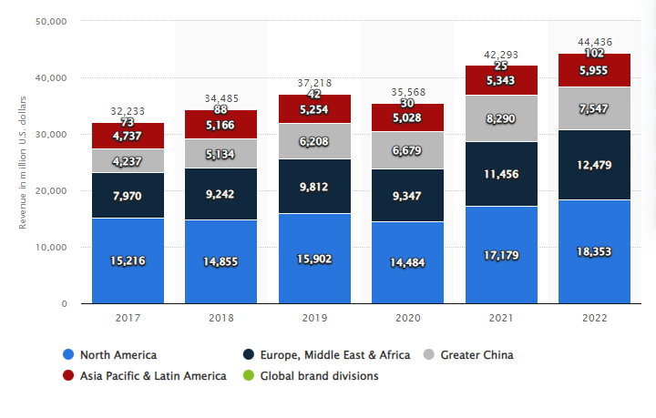
Figure 1: Nike’s Sales revenue
From 2009 to 2022, regional sales for Nike are displayed globally. During the fiscal year ending on May 31, 2022, Nike North America generated around $18.35 billion in sales. The corporation made approximately $12.5 billion in sales throughout Europe, the Middle East, and Africa that year.

Nike’s Price Elasticity of Demand
When there is a shift in the pricing of goods, there is also a shift in the demand and supply for those goods and services, but in the reverse way. This is how the law of supply and demand works, and it happens even when other parameters remain the same. The nature of the item in question determines the degree to which supply, and demand can be readjusted to meet changing conditions. For example, the response of the demand or supply for certain goods to changes in price is greater than the response of those for other products. The idea of the elasticity of products is presented because of this. The degree to which a change in price affects the commodity is proportional to the price elasticity of the item. In this section, we will discuss the price elasticity or inelasticity of sports gear products, specifically in respect to how they react to shifts in price. The amount of an item or service that does not change in response to a change in its price is said to be inelastic. Consumers' lack of price sensitivity in their buying behavior is indicative of inelastic demand. This phenomenon also occurs when the cost of the product or service decreases; nonetheless, it does not affect consumers' purchasing patterns. A good is perfectly inelastic if there is no change in demand regardless of the price of the good; nevertheless, there is no such thing as an inelastic good or service. In contrast to elastic, which is characterized by major shifts in demand in response to price movements inelastic markets do not experience such shifts. Things that are necessary, such as medicine, are regarded as being inelastic, but luxury items, such as going on a cruise or purchasing an expensive watch, are regarded as being elastic. Since Nike's products are considered luxury items, their prices are subject to change. For illustration, the consumption for the premium Nike shoe product is particularly sensitive to fluctuations in price since prospective buyers can choose not to purchase the product if they believe it to be too expensive (Copes, 2019).
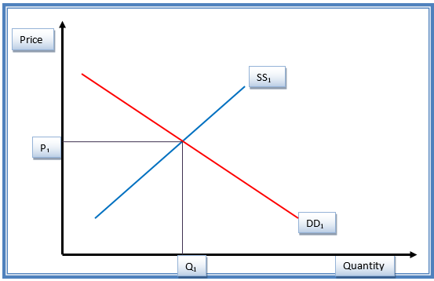
Figure 2: Pre-price-hike demand for and supply of Nike goods
The original equilibrium state of the Nike items can be seen in Figure 1, before any adjustments were made to the prices of the products. The demand curve is represented by DD1, while the supply curve is shown by SS1. The price and quantity at equilibrium are denoted by P1 and Q1, correspondingly.
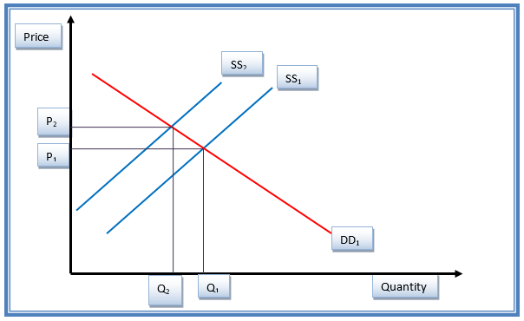
Figure 3: Effects of price fluctuations on Nike product demand and supply
An upward movement of the supply curve from SS1 to SS2 is shown in figure 2. This shift occurs because of an increase in the price of Nike shoes in comparison to other items that are perfect substitutes, such as Adidas shoes. This results in a new posture that is balanced. The price went risen from P1 to P2 after an increase. This is an indication that the clients' demand has decreased. The price increase will have the overall effect of decreasing demand because of its effect on the market. The price elasticity of the Nike shoe product is estimated to be 0.7 before the calculation.
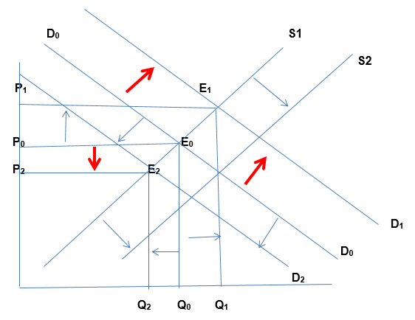
Figure 4: Income elasticity affects Nike product offerings
A luxury item, such as a Nike shoe, is sensitive to changes in income. The demand for Nike shoes will rise in tandem with the revenue of a household because of this correlation. This causes the quantity demanded for the item to shift outwards from D0 to D1, and a second equilibrium is reached at point E1, with price P1 and a greater quantity Q1 (Blackburn, 2012). On the other hand, when there is a decrease in income, there is a decrease in individuals' total disposable income. Because a Nike product is considered a luxury good, its demand will fall, which will lead to a reduction in the quantity of products that customers want to buy. The initial price of P0 will eventually be replaced with the lower price of P2. At the point designated as E2, a fresh equilibrium will be found. The income elasticity of the Nike shoe is fixed at 0.5 as a starting point (Andreeva and Kiante, 2012). This is demonstrated in the example below. Because the luxury goods offered by Nike, Adidas, and the other big competitors in this oligopolistic market are identical and fall within a price range that is comparable to one another, their income elasticity of demand is comparable. If the price of a Nike jersey goes up by 5%, there will be a 10% rise in demand for an Adidas jersey. This indicates that the price difference for these two alternatives and other items in the same category is equal to 2. It would appear that Nike possesses flawless alternatives to the goods. Because the products fall into the luxury goods category, economists consider them to be price elastic. This is because every change in the prices leads to a commensurate change in the demand for the products. Because of their product variety, price competition systems, aggressive marketing, and smart marketing strategy, Nike has established a dominant worldwide image, which positions the company well for continued expansion in the years to come (Amaldoss and He, 2018).

Conclusion and recommendations
As there are numerous items that are functionally equivalent to Nike's, the company would be wise to implement strategic limiting costing to maintain a competitive edge. However, the usefulness of the sylos hypothesis presents an opportunity for Nike. The sylos hypothesis is based on the simplistic and oversimplified premise that in the presence of a new competitor in each market, the existing player will continue to produce at the same rate it had been. Therefore, the holder may not feel as threatened by the new entrant's entry into the market as the sylos postulate would suggest. This point of view is meaningless because a new entrant will struggle to function within an entire manufacturing module, whereas Nike's existing products will have output at ideal levels. In addition, the holders will have a competitive edge over the new entrant, while the latter will be saddled with sunk expenses. According to the foregoing consideration, the sylos hypothesis, which uses limited pricing to benefit Nike's well-known brands, may be anti-competitive. Historically, the equilibrium rates for the industry's sylo function have been determined by the demand and supply factors prior to the introduction of limit pricing. In the short term, the limits placed on prices will be rigid. The limit on pricing, however, will be flexible in the long term.

References
Amaldoss, W. and He, C., 2018. Reference-dependent utility, product variety, and price competition. Management Science, 64(9), pp.4302-4316.
Andreeva, T. and Kianto, A., 2012. Does knowledge management really matter? Linking knowledge management practices, competitiveness and economic performance. Journal of knowledge management.
Blackburn, W.R., 2012. The sustainability handbook: The complete management guide to achieving social, economic and environmental responsibility. Routledge.
Copes, P., 2019. A critical review of the individual quota as a device in fisheries management (pp. 311-324). Routledge.
Elisa, P. and Nike, K., 2020. Environmental and climate change impacts of eighteen biomass-based plants in the alpine region: A comparative analysis. Journal of Cleaner Production, 242, p.118449.
Hitomi, K., 2017. Manufacturing Systems Engineering: A unified approach to manufacturing technology, productionmanagement, and industrial economics. Routledge.
Kamien, M.I. and Schwartz, N.L., 2012. Dynamic optimization: the calculus of variations and optimal control in economics and management. courier corporation.
Keller, G., 2015. Statistics for management and economics, abbreviated. Cengage Learning.
Mangundap, B.C.and Rumokoy, F.S., 2018. Comparative Research of Consumer Purchase Intention Towards Original And Counterfeit Product Of Nike Shoes In Manado. Jurnal EMBA: Jurnal Riset Ekonomi, Manajemen, Bisnis dan Akuntansi, 6(1).
Ramaswamy, K.V., 2018. Technological change, automation and employment: A short review of theory and evidence. International Review of Business and Economics, 2(2), p.1.
Urbanik, D. and Jao, D., 2020. New techniques for SIDH-based NIKE. Journal of Mathematical Cryptology, 14(1), pp.120-128.

