Contributing to resourcing and talent planning in the organisation

Jodie Barnett

CIPD course number: 5ARTP

CIPD Membership number: 2224083X

Word count: 2,770 words

By signing below, I confirm that the work/evidence presented is my own, unaided work. I understand the regulations pertaining to candidate malpractice and the action that may be taken as a result.

Signed: 
Date: 23rd May 2021

Contents page
- Personal statement LO1
- Personal statement LO2
- Personal statement LO3
Appendices
- NPTCBC Workforce plan 2018-2022 (first few pages)
- Learning, Training and Development programme 2019-2020 (first few pages)
- Head of Service Workforce Planning group agenda
- Example of redeployment spreadsheet
- NPTCBC Recruitment and Selection Policy (first few pages)
- Business case for external advertising requests
- Data on Waste Services
- Smart & Connected Digital Strategy 2018-2022 (first few pages)
- Swansea Council’s managing the employment establishment policy (first few pages)
- Architectural employee retirement age bi-query report
- Succession planning toolkit (first few pages)
- Email request from manager to review R & S training slides
- Recruitment & Selection PowerPoint slides (few slides)
- Witness testimonies following attendance at training sessions

EVIDENCE MATRIX


Personal statement for LO1 (including reference list)
LO1 – Be able to review and evaluate an organisation’s approach to talent planning.
Talent planning or otherwise known as workforce planning is the process of balancing supply and demand – in other words, identifying skills against numbers required. This includes an analysis of the current workforce, defining future workforce requirements, identifying the gap between both and devising an action plan. Such a process can help an organisation achieve their mission, goals and strategic plan.
CIPD (2020b) argues that “it’s about getting the right number of people with the right skills employed in the right place at the right time, at the right cost and on the right contract to deliver…”
Neath Port Talbot County Borough Council (NPTCBC) emphasises similarities within their aim of workforce planning:
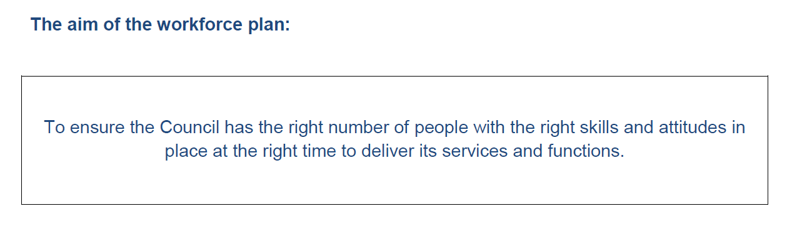
CIPD (2020a) states that any talent planning process should align with both the organisational goals and strategic objectives. Adopting such a process strategically, can help an organisation build a workforce that is able to enhance sustainable performance, encourage learning and development and add employer brand value.
There are many more benefits to the implementation of talent planning processes within an organisation which includes:
- Reduction in labour costs
- Being able to Identify and react to changing customer requirements
- Increase employee retention
- Ascertain approaches to boost people development
- Target insufficiencies
- Improve productivity/talent management
- Improve employees’ work-life balance
HR Zone (2021) defines workforce planning as a process that ensures an organisation has the human capital that is able to perform effectively now and in the future. Such a process includes identification of both current and future needs and cost effective methods for recruiting and retaining valued individuals. Furthermore, a continual workforce analysis approach should be adopted ensuring that the workforce remains efficient. They also add that strategic workforce planning is aligned to the organisation’s largely business objectives and seeks to analyse its long term vision.
CIPD (2020b) argues that the implementation of any process should refer to the stages of workforce planning (figure 1) which involves the gathering information, analysing it to identify future needs for people and skills and transforming this into an action plan in order to develop and shape its current workforce.
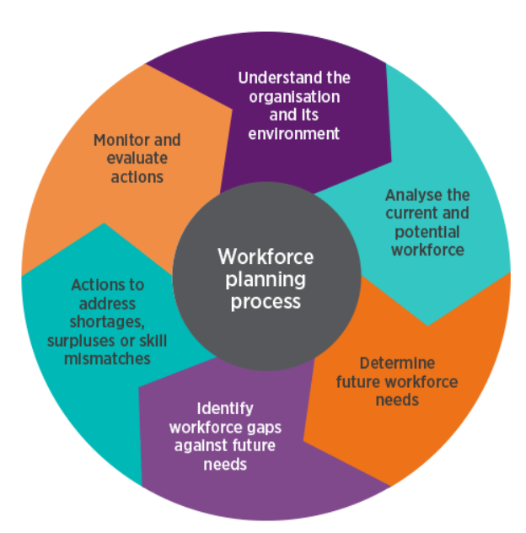
Figure 1 – CIPD website
NPTCBC (2018) has implemented a Workforce Planning Strategy 2018-2022 (appendix 1). The plan highlights that public sector is facing difficult and uncertain times with challenging financial pressures, along with social, economic, demographic and legislative changes. With this in mind, the council sets out its intentions to shape the workforce to create a bright future that will attract, retain and motivate the best employees with the right skills in order to efficiently deliver services to the community.
This plan includes an analysis of the current workforce and highlights that in order to identify future workforce demands, the council would need to align current data with their purpose, vision and values. These includes a number of strategic plans:
- Corporate Plan Strategic Objectives and priorities 2017-2022 which includes their well-being objective
- Medium Term Financial Plan
- Asset Management Plan
- Risk and Governance
- Corporate Change Programme
The medium term financial plan particularly drew my attention with financial pressures on public sector organisations to reduce budget costs due to stringent Welsh Government funding. The council has already established a Head of Service Workforce Planning Group, which consists of corporate directors and trade unions. The group’s key priorities are safeguarding its workforce from compulsory redundancies to the maximum extent possible, whilst seeking redeployment opportunities, identifying skills gaps and reviewing learning and development initiatives in order to retain and develop its existing workforce.
Our Learning, Training and Development Section implement training programmes on a yearly basis in line with legislative changes and service provisions, working in close partnership with neighbouring external organisations such as NPT Colleges and the NHS (appendix 2).
The group meets on a fortnightly basis to discuss and address workforce planning. I have attached the last agenda items that were discussed as an example (appendix 3). The group is very much focussed on dealing with workforce planning issues as and when they arise with reliance very much on management forecasting through NPTCBC succession planning toolkit. It is evident that the Workforce Planning Strategy 2018-2022 priorities over recent years have changed due to the current pandemic with much focus being placed on redeployment of employees to front line services last year.
Directorate representatives and HR were tasked with identifying those employees who were available for redeployment to ensure that vital services continued (appendix 4). This included the implementation of the NPT safe and well scheme, which provided those vulnerable people within the Borough with essential goods during lockdown.
The workforce planning group’s restriction on external recruitment has ensured that those employees deemed at risk of redundancy or medical redeployment are given first consideration during any recruitment and selection process, as well as offering career development opportunities for other employees. I have attached the recruitment and selection policy which outlines this (appendix 5). Any requests for external advertising must be done so through completion of a robust business case for consideration through the group (appendix 6). These processes highlight the council’s workforce planning strategy and dedication to retain and develop within.
The above process can be difficult to sustain particularly in those services with high turnover rates. Waste services is a large section which seeks to recruit Waste Operatives on a quarterly basis due to high turnover and sickness absence rates. The shift rota and physicality of the role are contributors to the above reasons. I have retrieved data for the period of 2018-2019 (pre-COVID19) using the council’s internal bi-query reporting tool to identify leaving reasons and number of recruitment advertisements (appendix 7).
The Architectural Section has been identified as a potential need to address skills shortages in the near future due to many experienced employees approaching retirement age (appendix 10). The recruitment process has already commenced and research undertaken on identifying competitive salaries with other local authorities to ensure that the service has experience to replace those leaving. A Market Pay supplement is currently being considered to attract experienced Architects.
In order to combat the fall in the number of appointments during the last two years and ensure that the service remains fully operational, the Council joined forces with Matrix-SCM (2021) limited – specialists in managing and improving recruitment supply, through reliable hiring. Through the use of technology, struggling recruiting managers are able to identify suitable applicants for urgent placement where the necessary pre-employment checks have already been undertaken.
It is recommended that completion of a PESTLE analysis to identify external factors that could affect the organisation. CIPD (2020c) argues that the use of such a framework will help organisations gain an understanding into those external influences that may impact on the business. This process also allows HR and management to assess any potential risks specific to their industry and will help gain insight on their decisions – this includes workforce planning.
It is evident that technological factors will shape any future workforce planning processes due to the current pandemic. NPTCBC aims to create a ‘blended’ approach following the easing of lockdown restrictions, where most employees will be expected to work from home, with a few days office based. The Council had already implemented a Smart & Connected Digital Strategy 2018-2022 (appendix 8), pre-COVID19 and more recently have developed a digital Partners Directory. The aim of our Digital Partners is to help other staff to gain digital confidence and overcome any barriers to getting digitally active in both the workplace and their personal lives.
On undertaking a comparison with another local authority, the City & County of Swansea, there was little evidence of a workforce planning strategy in line with NPTCBC. They have implemented a ‘managing the employment establishment’ policy which they have highlighted is a short version pending a HR policy review (appendix 9). They have referenced the purpose of the policy is to maintain accurate establishment information that is critical to forward planning from a budgetary and workforce planning perspective. I was unable to find further information relating to their workforce planning process.

References
CIPD. (2020a). Talent management (Online) Available at: https://www.cipd.co.uk/knowledge/strategy/resourcing/talent-factsheet (Accessed 03 May 2021)
CIPD. (2020b). Workforce planning (Online) Available at: https://www.cipd.co.uk/knowledge/strategy/organisational-development/workforce-planning-factsheet (Accessed 03 May 2021)
CIPD. (2020c). PESTLE analysis (Online) Available at: https://www.cipd.co.uk/knowledge/strategy/organisational-development/pestle-analysis-factsheet (Accessed 14 May 2021)
HR Zone. (2021). What is workforce planning? (Online) Available at: https://www.hrzone.com/hr-glossary/what-is-workforce-planning (Accessed 03 May 2021)
Matrix-SCM. (2021). About us (Online) Available at: https://www.matrix-scm.com/about (Accessed 08 May 2021)
NPTCBC. (2018). Workforce plan 2018-2022 (online) Available at: https://democracy.npt.gov.uk/documents/s40327/Workforce%20Plan%20report%20App%201.pdf (Accessed 03 May 2021)
NPTCBC. (2019). Learning, Training and Development programme 2019-2020
NPTCBC. (2018). Recruitment and Selection Policy & Procedure (Online) Available at: http://umbraco.npt.gov.uk:700/1996 (Accessed 08 May 2021)
NPTCBC. (2018). Smart & Connected Digital Strategy 2018-2022 (Online) Available at: http://intranet.neath-porttalbot.gov.uk/pdf/Smart_and_Connected_Strategy_web.pdf (Accessed 12 May 2021)
NPTCBC. (2021). Bi-query reporting tool (run 08 May 2021)
NPTCBC. (2021). Bi-query reporting tool (run 14 May 2021)
Swansea Council. (2021). Managing the establishment policy (Online) Available at: https://www.swansea.gov.uk/councilpolicysearch?articleid=19886&q=talent+planning&searchmethod=ANY&continue=Continue (Accessed 14 May 2021)

APPENDIX 1 - NPTCBC Workforce Plan 2018-2022 (first few pages) 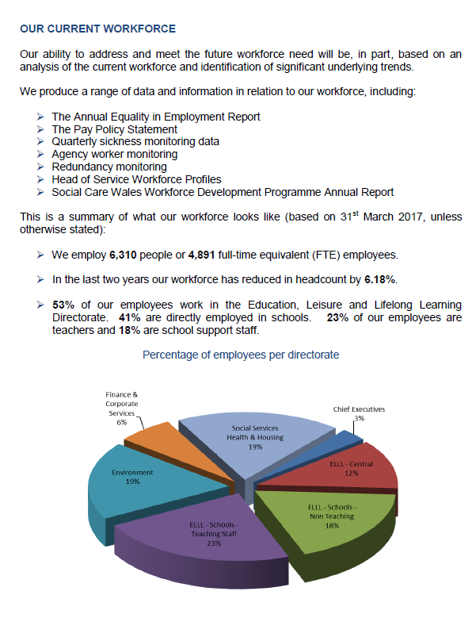



APPENDIX 2 - Learning, Training and Development programme 2019-2020 (first few pages)
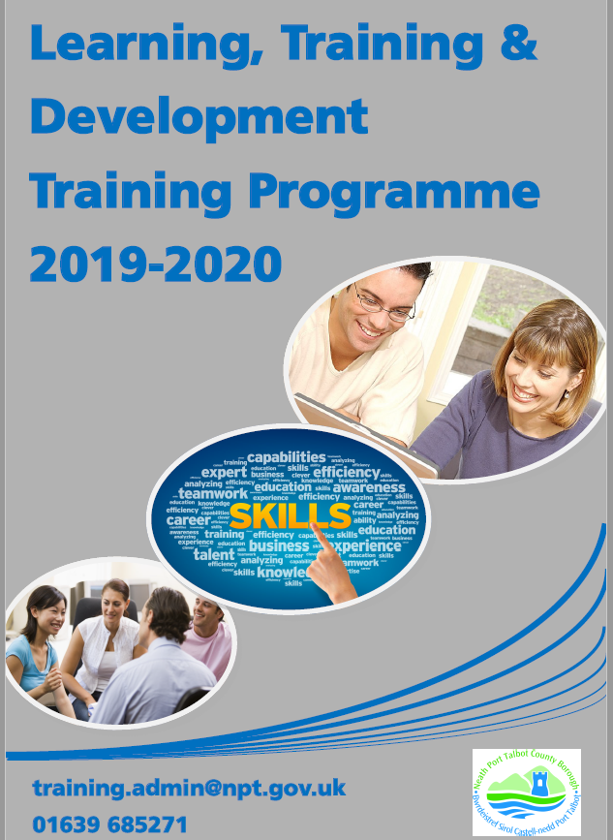



APPENDIX 3 – Head of Service Workforce Planning group agenda
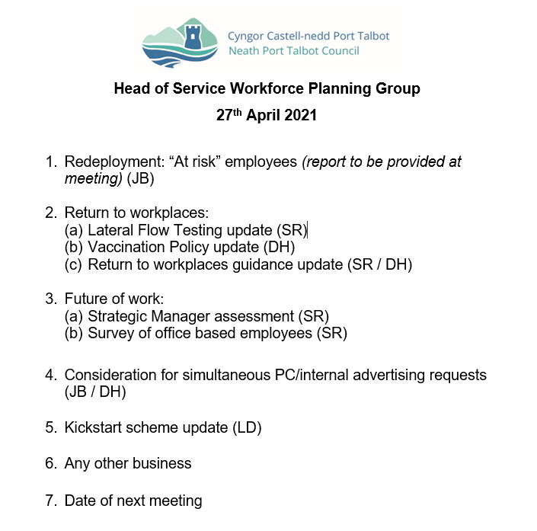

APPENDIX 4 – Example of redeployment spreadsheet

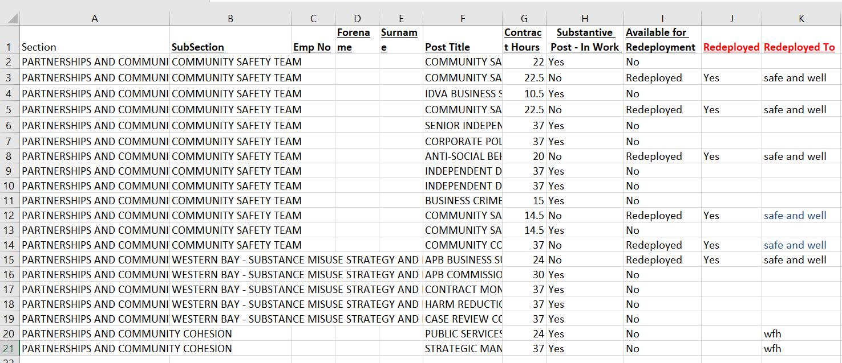
APPENDIX 5 – NPTCBC Recruitment and Selection Policy (first few pages)







APPENDIX 6 – Business case for external advertising requests


APPENDIX 7 – Data on Waste Services

APPENDIX 8 - Smart & Connected Digital Strategy 2018-2022




APPENDIX 9 – Swansea Council’s managing the employment establishment policy (first few pages)
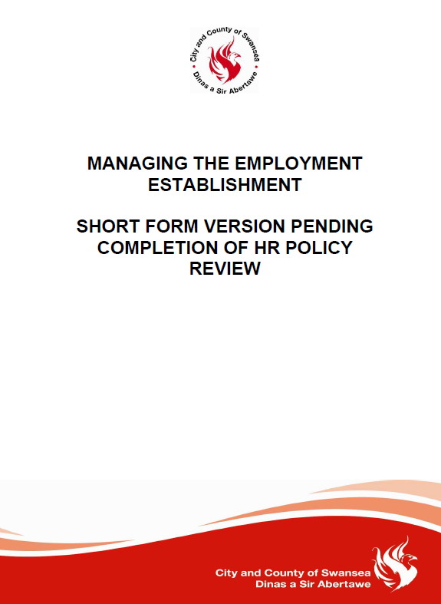

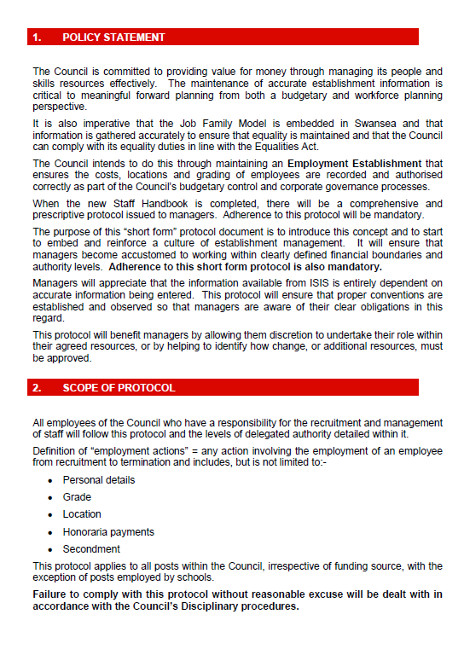

APPENDIX 10 - Architectural employee retirement age bi-query report


Personal statement for LO2 (including reference list)
LO2 – Be able to recommend ways to improve an organisation’s approach to talent planning.

Wilkinson & Taylor (2016) state that any workforce plan can vary according to both scope and timescales, however, they emphasise that there are four stages in talent planning, which are:

- Forecasting demand for future skills
- Forecasting supply for future skills
- Identifying the skills gaps between demand and supply
- Plans to fill any gaps

NPTCBC currently has a well establishment workforce planning strategy in place through its 2018-2022 plan – it is clear that this is also aligned with other corporate business strategies which CIPD highlights the importance of. NPTCBC (2021) also has a succession planning process in place to assist managers with preparing and identifying future leaders for business-critical roles within their services (appendix 11).

Wilkinson & Taylor (2016) argue that succession planning can help an organisation to have sufficient numbers of people with the ability, personal attributes, knowledge and necessary experience to enable them to step into higher level roles when needed. This will help create a smooth transition between roles, reacting quickly to changes, whilst enabling acting up opportunities.

The creation of a Head of Service Workforce Planning Group has allowed the organisation to analyse and address any workforce issues, including those identified during recent unprecedented circumstances. With the urgency to redeploy employees to different front line services ensuring that these services were not disrupted during the current pandemic.

Since the group was implemented in 2011, the number of employees deemed at risk through redundancy has dropped significantly from just under 500 employees to 52 employees at present. Another example of the impact the group has had on addressing workforce issues.

However, taking into account the significant impact of the COVID19 pandemic on organisations, it is important that organisations review their workforce planning processes, including succession planning. NPTCBC workforce plan was implemented pre-COVID, over 3 years ago, with changes in service provisions and processes that have had an impact on the workforce. CIPD (2020a) states that such an unprecedented situation has formed an urgent need for organisations of all sizes to undertake workforce planning.

It is recommended that NPTCBC undertakes a review of its current workforce plan 2018-2022 to ensure that it is still fit for purpose taking into account of any workforce changes following the pandemic situation.
Jacobs (2020) argues the need for organisations to rethink their workforce planning processes post-COVID with redundancies and restructures becoming a fact of life for the foreseeable future thanks to the impact of the pandemic. Conferring about the CIPD (2020b) People Profession 2030 research which underlined the need for organisations to expect internal change around operating models, structures and processes, which will be a key future trend.
References
CIPD. (2020a). Workforce planning (Online) Available at: https://www.cipd.co.uk/knowledge/strategy/organisational-development/workforce-planning-factsheet (Accessed 15 May 2021)
CIPD. (2020b). People Profession 2030: a collective view of future trends (Online) Available at: https://www.cipd.co.uk/knowledge/strategy/hr/people-profession-2030-future-trends (Accessed 15 May 2021)
Jacobs, K. (2020). Skills HR will need in 2021: Restructuring your business with confidence (Online) Available at: https://www.peoplemanagement.co.uk/long-reads/articles/skills-hr-need-2021-confident-restructuring-business (Accessed 15 May 2021)
NPTCBC. (2021). Succession planning toolkit (Online) Available at: http://umbraco.npt.gov.uk:700/1996 (Accessed 18 May 2021)
Wilkinson, K & Taylor, S., 2016. Resourcing and talent planning In. Human Resource Management: People and organisations. 2nd ed. London: CIPD, pp 51-61.

APPENDIX 11 – Succession planning toolkit (first few pages)
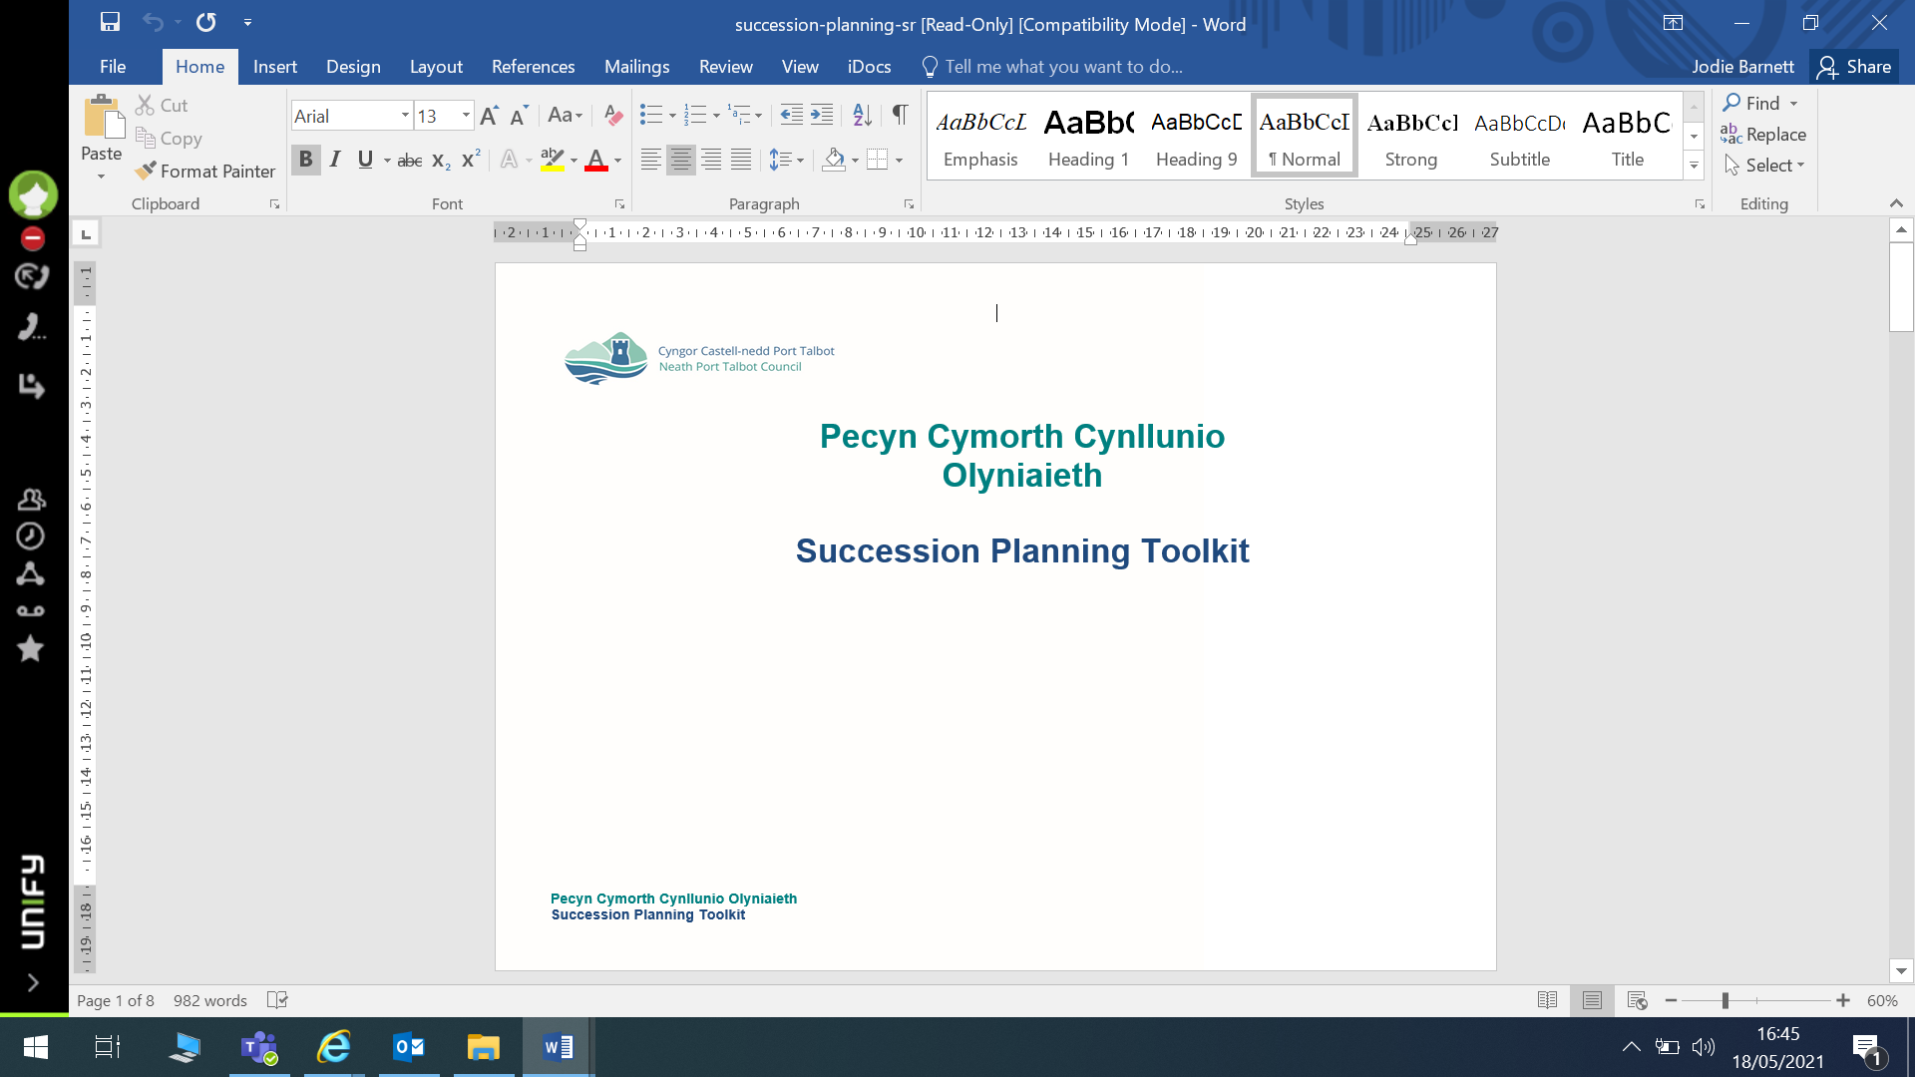





LO3 – Be able to contribute to people resourcing activities
Taylor (2019) states that resourcing forms a key part of a generalist HR role that undertakes activities that are central to organisations that employee people. These activities include recruitment, selection, retention, performance management, change management, employee well-being, HR planning and dismissals.
CIPD (2018) emphasises the importance of resourcing within an organisation and argues that this should involve the attraction and selection of individuals into the right position at the right time for the right cost. Such an approach should be done through the use of workforce planning data and knowledge.
NPTCBC has a very stringent approach on practicing safe recruitment across all services - this includes any recruitment and selection process that is undertaken. There are also many legislative processes that must be adhered to when undertaken any recruitment and selection. CIPD (2021) refers to the Equality Act 2010 as the most significant example, making it unlawful for employers to discriminate against job applicants and employees because of the ‘protected characteristics’ as outlined:
- Age
- Sex
- Disability
- Race
- Religion or belief
- Gender reassignment
- Sexual orientation
- Pregnancy and maternity
- Marriage and civil partnership

NPTCBC’s recruitment and selection policy and procedure (appendix 5) emphasises this as well as other legislation that falls within this remit including the Welsh Language Act 2016. As part of our recruitment and selection process, all recruiting managers must attend training undertaken by a HR representative. Within my role as HR Business Manager, I am responsible for conducting the recruitment and selection training and ensuring that all recruiting managers are fully aware of the Council’s process as well as the various legislation associated with it. All managers must attend this training prior to undertaking any recruitment and selection activities. Such an approach, ensures that the Council operates fairly and consistently.
I was requested by my manager to review and amend the current recruitment and selection training slides to incorporate conducting via the MS Teams online platform method. It was imperative that any information here would provide managers with an understanding of the Council’s processes as well as the legalities involved (appendix 12).
It was important that the slides were creative for online viewing, to ensure that these were easily understood and all audiences are kept well engaged throughout the presentation. It is my responsibility to regularly review and amend any slides taking into account any legislative and procedural changes. Many further training sessions have been arranged over the coming months. I have provided a few of the recruitment and selection training PowerPoint slides for information (appendix 13).
I also included a few demonstration videos – ‘how not to conduct an interview’ as well as guidance notes on current interviewing processes under the current circumstances, using video call. I have devised an interactive quiz for the end of each training session to motivate as well as identifying whether any audiences have taken on board what was discussed. This is a fun way of keeping an audience engaged.
I have received feedback from a number of sessions, with attendees finding the training very useful and informative. Many advised that they were confident that they had attained sound knowledge and understanding of the Council’s recruitment and selection process when representing their service. I have included some feedback responses from those who had attended (appendix 14).
The new CIPD (2018) profession map highlights the importance of ‘resourcing’ within the specialist knowledge area. It refers to the need for those involved in any resourcing activity should be focused on “understanding the candidate experience, designing effective assessment and selection approaches and, overall, how to make effective recruitment decisions”.
This approach is reflective in our recruitment and selection training, ensuring that all managers involved are fully aware and understanding of their role in such processes.
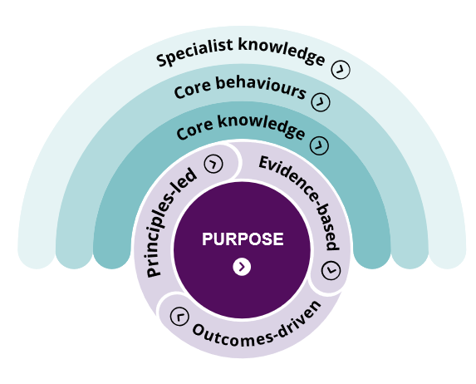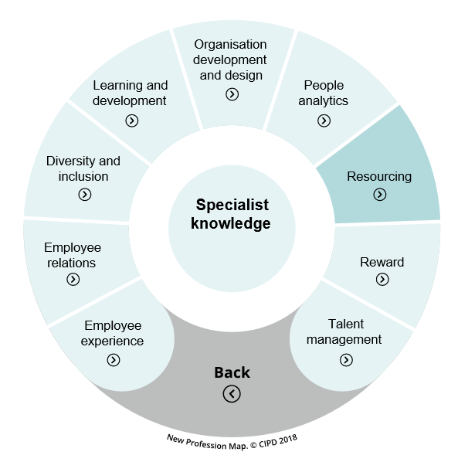
CIPD profession map 2018

When reflecting on the standards set within this specialist knowledge area, I feel i am between the foundation and associate level, having knowledge and experience in different areas of both. For example, I feel I am at the foundation level for understanding my organisations approach to workforce planning and at associate level when it comes to conducting a fair and objective assessment.

References
CIPD. (2018). Resourcing (Online) Available at: https://peopleprofession.cipd.org/profession-map/specialist-knowledge/resourcing (Accessed 22 May 2021)
CIPD. (2021). Recruitment and selection Q&As (Online) Available at: https://www.cipd.co.uk/knowledge/fundamentals/emp-law/recruitment/questions (Accessed 20 May 2021)
NPTCBC. (2021). Recruitment and Selection policy & procedure (Online) Available at: http://umbraco.npt.gov.uk:700/1996 (Accessed 20 May 2021)
Taylor, S. (2019). Resourcing and talent management. 7th ed. London: CIPD.

APPENDIX 12 – Email request from manager to review R & S training slides

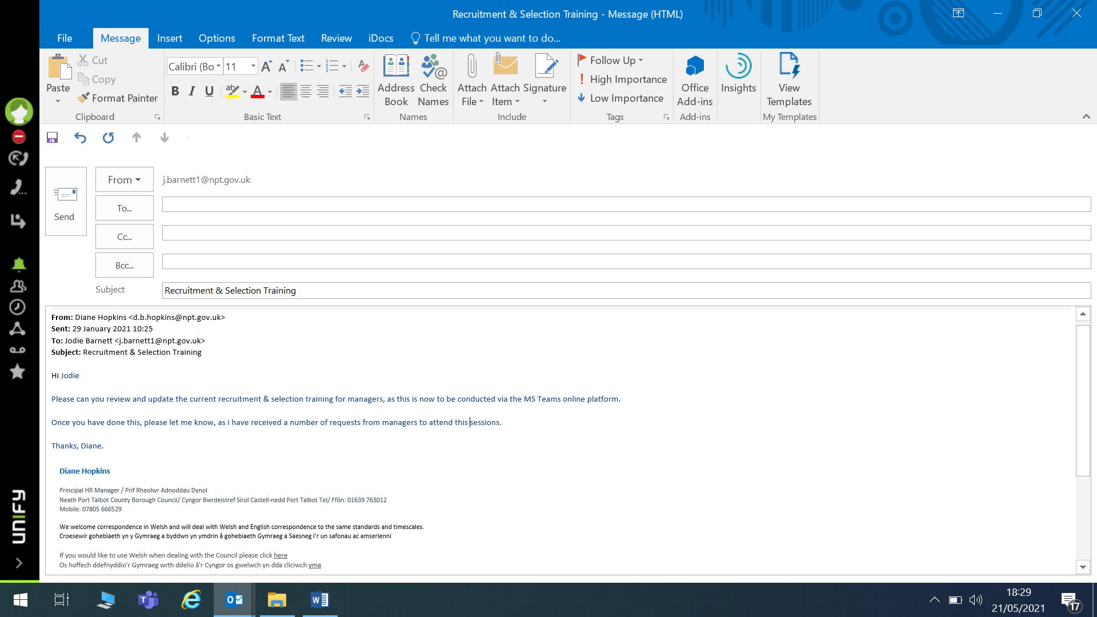

APPENDIX 13 – Recruitment & Selection PowerPoint slides (few slides)
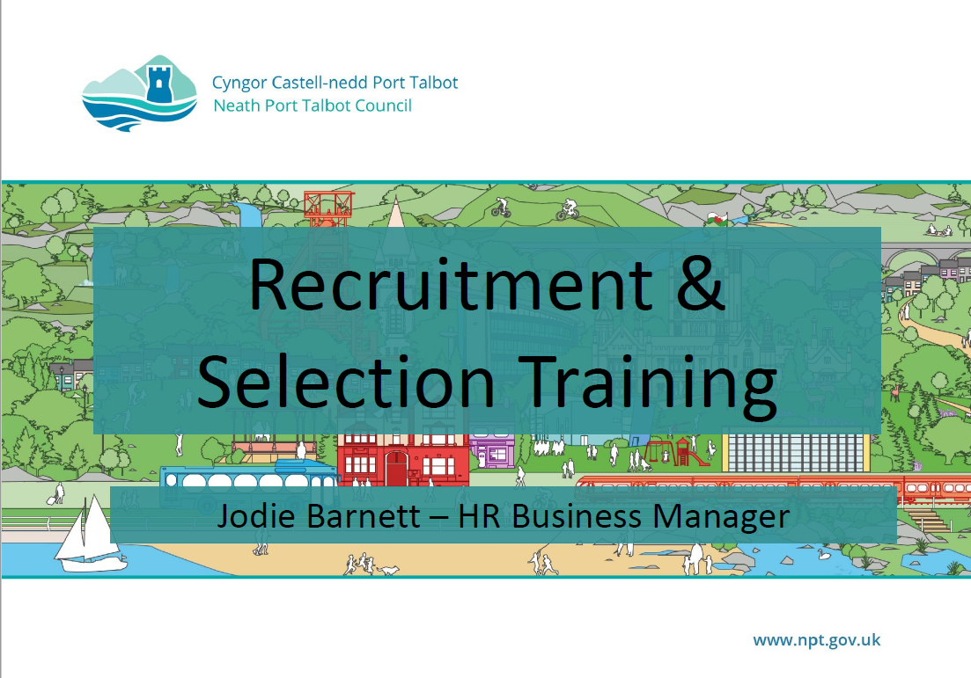
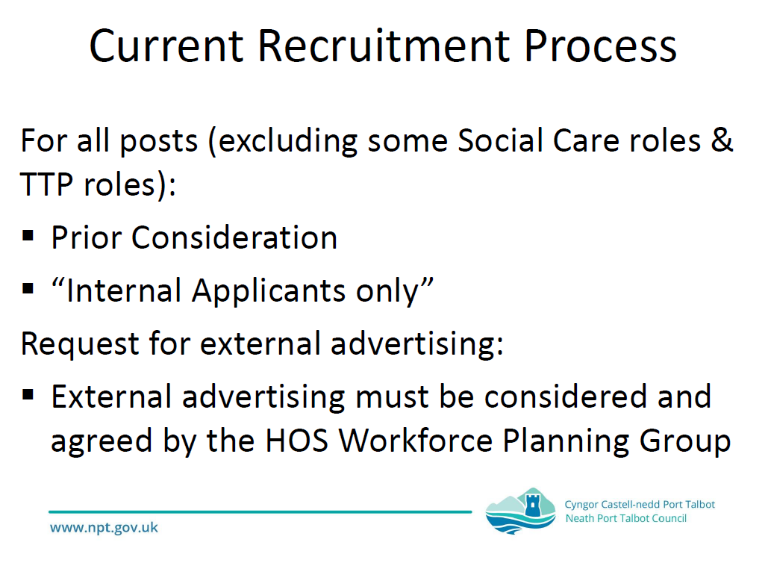
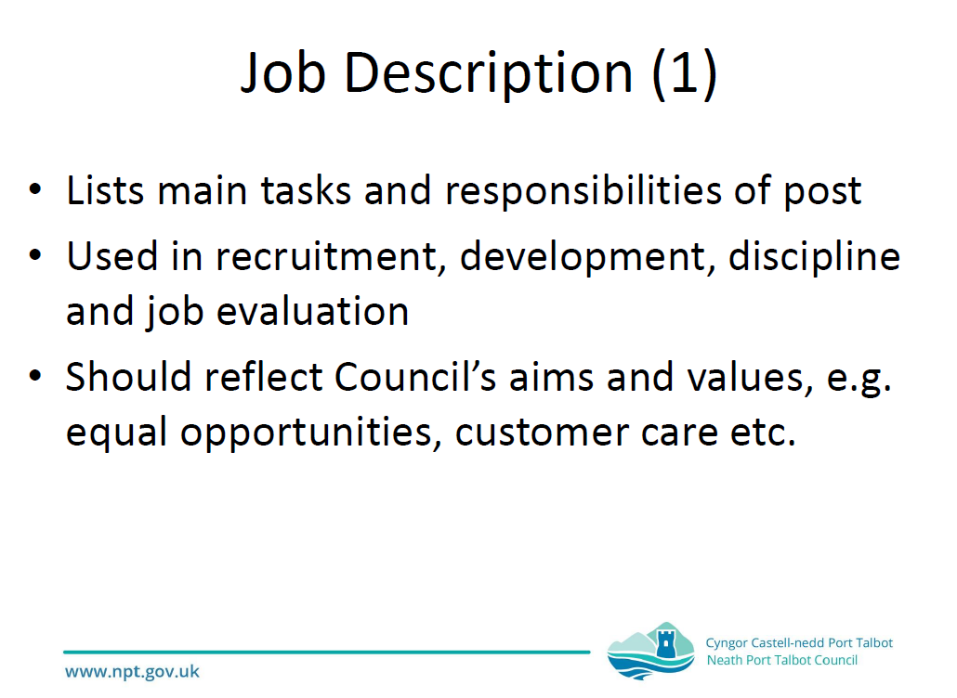
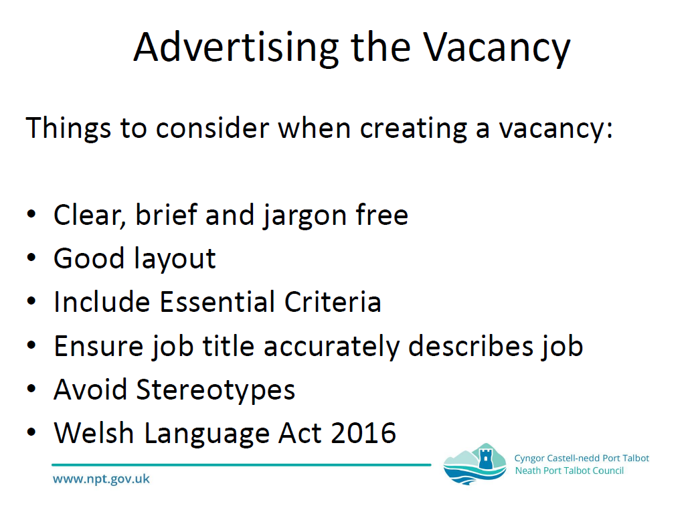

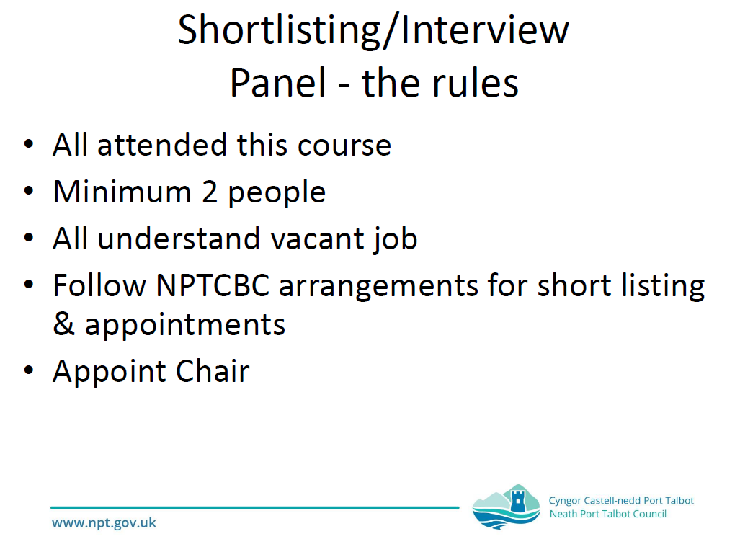
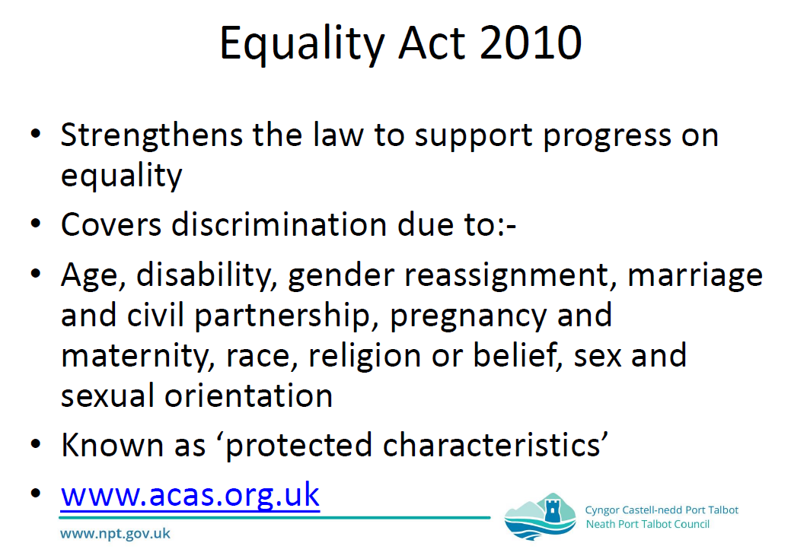

APPENDIX 13 – Feedback responses following attendance at training sessions




