

LLEOLIAD: Coleg Sir Gar  LEFEL 6  CYFNOD ARHOLIADAU  MAI 2024 | LOCATION: Coleg Sir Gar  LEVEL 6  EXAMINATION PERIOD  MAY 2024

CÔD Y MODWL: SGEE6001
MODULE CODE: SGEE6001

ELECTRONEG GRYM A GYRWYR
POWER ELECTRONICS AND DRIVES

amser: 2½ awr
TIME: 2½ HOURS

ATEBWCH pedwar CWESTIWN ALLAN O pump

answer FOUR quESTIONS out of FIVE

Equipment or materials required. Please select from the following:
Adnoddau neu ddefnyddiau sydd eu hangen.

Cyfrifiannell/Calculator

Question 1
In figure Q1 below, the battery voltage E = 24V, its capacity is 200Wh and the average charging current should be Idc = 5A. The primary input voltage Vp = 120V at 60HZ with the transformer having a turn ratio of n = 2:1

a) Draw the relative output waveforms of Vs, Vs – E and i_{L,} and use relevant equations to explain the operation of the circuit.
[9]

b) Calculate:

- The conduction angle of the diode [6]
- The current limiting resistance value of R [8]
- The PIV of the diode [2]

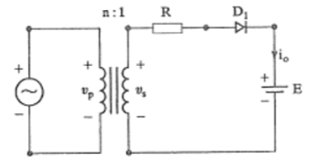
R
i_{L}
Vp
Vs = Vm Sin wt
E
D1
n : 1
Figure Q1

Total = 25 marks

Question 2
a)
(i) Explain with the aid of diagrams the methods of protection that can be established for thyristors in power circuits.
[7]

(ii) From the protection circuit established in part (i), derive the equations to select values for the RLC components, and explain the circuit operation to justify the equations.
[12]

b) An SCR circuit is operated with a supply Vs of 400V, the dv/dt value is 500V/µs and di/dt
is 20 A/µs. Calculate the values of the RLC circuit parameters for a damping ratio of 0.5.

[6]

Total = 25 marks

Question 3

Figure Q3 shows the voltage for one phase of a three-phase balanced delta connected load. The maximum value is 240V with a load resistance and inductance per phase of 0.2Ω and 3mH respectively. The operating frequency of the inverter is 60HZ.

a) Using the parameters in the waveform in figure Q3:

(i) Derive the equation which gives the Fourier Series for the voltage up to the 7th harmonic. [15]

(ii) Draw the spectrum representation for the voltages up to the 7th harmonic.

[3]
b) Determine the RMS phase current for each harmonic and the total RMS current up to the
7th harmonic
[7]
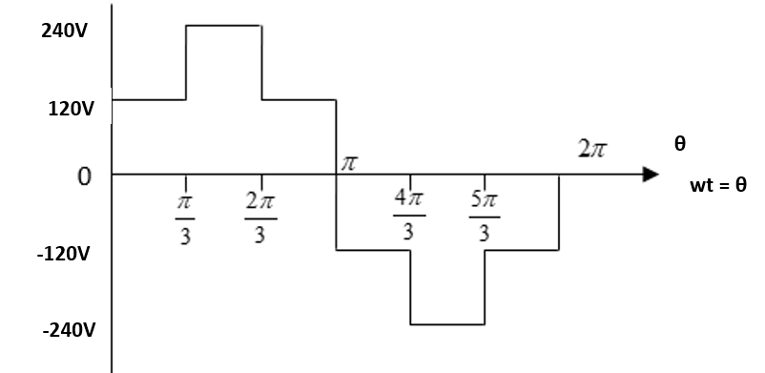
Figure Q3
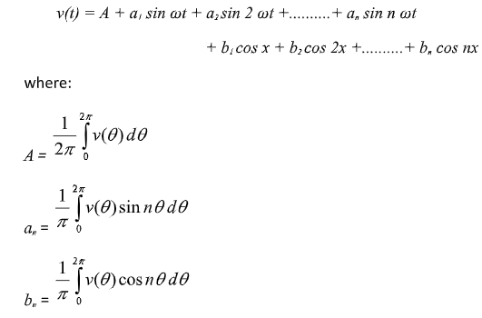
Total = 25 marks

Question 4

A full wave-controlled bridge rectifier has a 120V source at 60HZ with R = 10Ω, L = 20mH and α = 60⁰

a)
(i) Draw the circuit and waveforms for discontinuous current and output voltage
[7]

(ii) Derive an expression for the average voltage
[4]
b)
(i) Calculate the average voltage and average load current
[7]

(ii) Calculate the power absorbed by the load
[7]

Total = 25 marks

Question 5

a)
(i) Draw an approximation diagram of an equivalent circuit per phase of an induction motor when referred to the stator.
[4]
(ii) Derive an expression for the stator current per phase
[4]
(iii) Derive an expression for the per phase torque produced
[4]

b) Using the formulae derived in part (a) and the parameters given below of a star connected three-
phase induction motor, calculate:

(i) Stator current
[8]
(ii) Total torque produced

[5]
Poles = 6
Stator line voltage = 415V@ 60Hz
Rotor speed = 1140rpm
Stator leakage impedance = (0.7 + j2.0)Ω/phase
Rotor standstill impedance (referred to stator) = (0.6+ j2.0) Ω/phase
No load current = (1.7 – j6.5) A/phase

Total marks = 25

Diwedd/End

