

Student name: Oluwaseun Akran
Module Name: Community Care and Development
Assignment Title: Assessment Component 2 Written Assignment Report
Module Code: BMHP 6022
Lecturer Name: Laila Surani
Date: 25 November 2022
Student I.D: 1908389

Contents…………………………………………………………………………………………..Page
- Introduction………………………………………………………………………. 3

2.0 Discussion and analysis...................................................................................... 3
2.1 Camden Community Characteristics and Demographics…………………………4
2.2 Two Development efforts in Camden Community……………………………........ 4
2.3 Principles that support Community Development…………………………………..8
2.4 Digital media and technologies to address domestic violence and drug abuse.9
2.5 Theory for domestic violence and drug abuse………………………………………..9
2.6 Legislation and Policy Impact for support and growth of a community………….11
3.0 Recommendations…………………………………………………………………...........11
4.0 Conclusion…………………………………………………………………………………..12
5.0 References…………………………………………………………………………………..13

1.0 Introduction
Community comprises of group of people living together with shared identity, belief system and interaction among the people aimed at improving social, economic as well as environmental situation. The action of the people in the community makes the community to be strong and make good decisions about the use of resources. Zeuli and Radel (2005) indicate that community members with shared characteristics are aimed to improve quality of life within the community and at the same time to increase the community internal capacity to build on community development. This implies that community development is driven by the actions of the people within a community for the purpose of improving the quality of life. This is not surprising because at Camden Borough, there is evidence of strong community activism a swell as a powerful shared understanding that is making people in Camden to work together in developing the community (Camden, Report, 2018). This report selects Camden Community and draw attention to its characteristics, demographics and development effort and methods to communicate this information.
The rest of the report is divided into four sections. Section one describes the characteristics and demographics of Camden Community. This is followed by two development efforts in Camden community, principles of community development, detailing use of media and social communications to persuade the community of the message, policy for community development highlight of recommendations and the final section conclude the report.
2.0 Discussion and Analysis
Camden Community Characteristics and Demographics
Camden Community has a strong sense of activism and a powerful shared understanding that made Camden a strong place or community which is driving the local people to work together in developing the community. Camden (2018) indicate that the shared belief and values of the community has made the community to make difficult decisions and at the same time talk about competing interests as well as finite resources. This has made Camden community a unique place, thus, the uniqueness is built on certain defined characteristics recognized by the Equality Act 2010 e.g. Median age, sex, disability, gender reassignment, sexual orientation, marriage civil partnership, pregnancy and maternity, religion or belief and race and ethnicity (Camden 2021). According to Camden (2021), the population at Camden is young with a median age of 38.9 years, two years younger than England average. The sex characteristics in Camden are split at 50.4% for men and 49.6% for women meaning there are more men compared to women. In the case of disability, it is recorded that one in seven people at Camden is with long term health condition or disability which reduces these person daily activities. In the area of race, it is recorded that a sizeable proportion (34%) of people at Camden are from Black, Asian and other communities and there are three largest religious groups at Camden e.g., Christian (38%), Muslim (14%) and Jewish (5%). Although, there are other smaller religious groups in Camden e.g., Hindu (2%) and Buddhist (1%). In addition, the Camden has a low fertility rate and 2011 censure record showed that 30% of Camden residents are married and 0.9% is in civil partnership. No acceptable measure for the Gay and Lesbian group because it varies (Camden Report, 2021).
Two Development efforts in Camden Community
This report selects drug abuse and domestic violence as two development efforts at Camden Community. Evidence showed that Camden is grouped as Cluster E of the highest need of opiate treatment, thus, in 2011/12 Camden community is estimated to have two thousand and sixty (2,060) opiate users, representing 13 per 1,000. This means that the uses of opiate in Camden are more than the cluster average of 10 per 1,000 people. See figure 1 for the prevalence of opiate use in Partnership Cluster E.

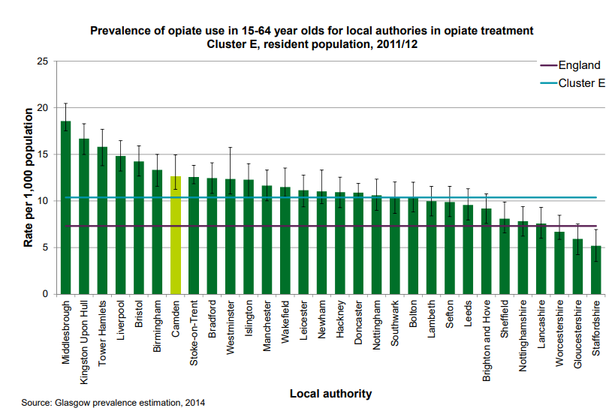
Source: Camden (2014) adapted by Student (2022)
Again in 2011/12 it was estimated that in Camden there was eight hundred and forty (840) injecting drug users, representing 5 per 1000 population which is more that the cluster average of 3 per 1000 people. See figure 2 of the prevalence of injecting drug use in partnership Cluster E.
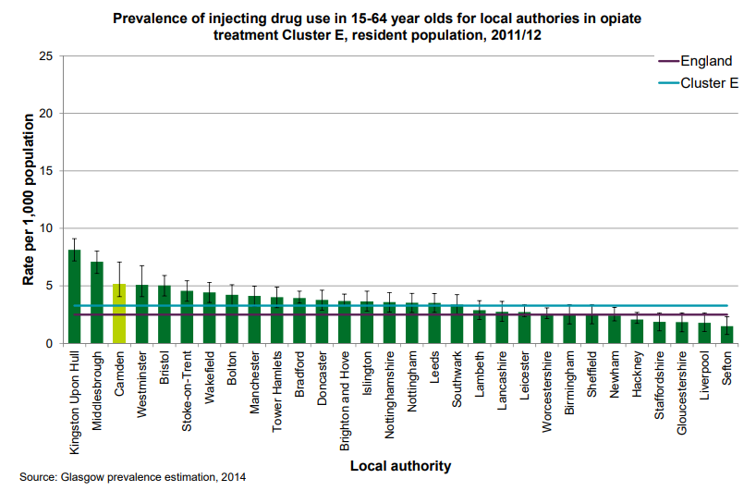
Source: Camden (2014) adapted by Student (2022)
Last, Camden (2014) indicate that in 2011/2012, at Camden Borough, there was one thousand and eight hundred and sixty (1,860) crack cocaine users representing 12 per 1000 population meaning that it is more than the cluster average of 9 per 1000 people. See figure 3 for the prevalence of crack cocaine use in partnership Cluster E.

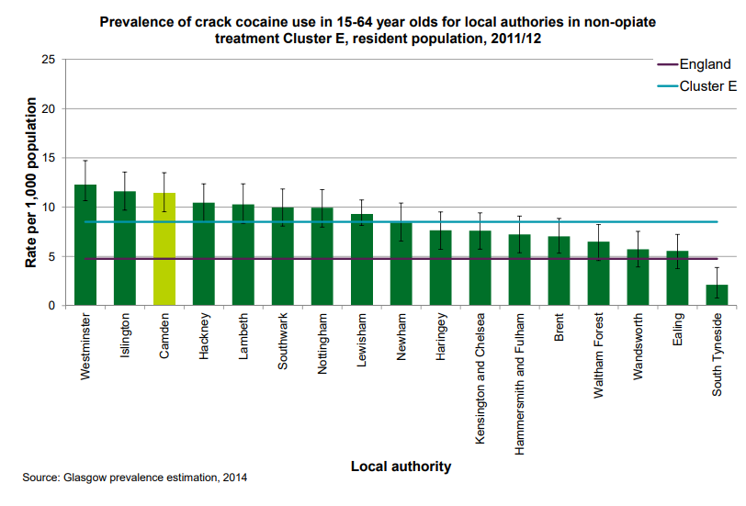
Source: Camden (2014) adapted by Student (2022)
Domestic abuse often called domestic crime or violence is regarded as an act of controlling of threatening another person as a violent behavior thereby causing physical pain, suffering or at times death Domestic Abuse Act (2021) see domestic abuse in two forms. First, the perpetrator of the abuse and second the victim of the abuse. The Act made it clear that victim is a person who has experienced the abuse. Health watch Camden (2021) supports this definition and attests that domestic abuse is an incident or pattern of controlling, coercive, threatening, and degrading or a violent behavior including sexual abuse. Domestic abuse is in different forms and some of these are coercive control, psychological or emotional abuse, physical or sexual abuse, financial or economic abuse, harassment or stalking including online or digital abuse. This abuse victims cut across different strands in the society from age, gender, socio-economic factor and ethnicity. The fact is that women are exposed to domestic abuse compared to men. Healthwatch Camden (2021) revealed that larger proportion (95%) of women living in is subjected to domestic violence and surprisingly, larger proportion of perpetrators (94%) is men meaning that women are always prey to any form of domestic abuse and men are the perpetrators in Camden community.
Principles that support Community Development
Empowerment: This is fundamental in community development because the local people are given the authority to take actions for improvement. Kenny (2007) attests that empowerment drives thing to happen is a community because the members are given the power to take decisions or action necessary for local improvement. This is a motivator to get things done, this, at Camden Community; the local resident can be empowered to support Camden Council to address the issue of domestic abuse and drug abuse. Helplines can be opened to provide support for victims of domestic violence and drug abuse.
Character and appearance: This is also crucial for community development because the distinct appearance and sensory association of a community provide a clear identity of the community. According to Kenny (2007) appearance and sensory association of a community enable people to have a good look of the community and a strong influence for the community reputation. Without any doubt every community have positive and negative influences and Camden Community I no exception, hence, it is important that having a unique appearance of Camden by solving drug abuse an domestic abuse may provide a feeling belongingness in the community.
Inclusion and Diversity: The increasing accommodation of inclusion and diversity in communities bring success to communities. Diversity is when people from different diverse groups are connected together and inclusion is when everybody is included in the needs of then community where every person is embraced irrespective of race, religion, and ethnicity. Drawing on this, to address the issue of domestic violence and drug abuse at Camden Community, it is important that the support must be inclusive and diverse.
Collaboration and Participation: Community development can succeed when every person in the community work collaboratively to improve the community. Kenny (2007) attests that collaboration and participation help to integrate local people from different background together in a community, to have access to different resources that improve the community. This shows that local community members are given the chance to freely interact and work collaboratively to meet the community objectives which are improvement. These principles can work well to address the issue of domestic abuse and drug abuse at Camden community where local residents can provide support for victims of domestic violence and also help people suffering from drug abuse.
Digital media and Technologies to address domestic violence and drug abuse
The increasing level of domestic violence in societies is alarming and they are of different forms. United Nations Office on Drugs and Crime (2018) attest that about 137 women globally are killed each day by domestic violence. In addition, United States Department of Justice in Moog and Slakoff (2021) attest that domestic violence is done by family members, roommate, and intimate partner. Moreover, larger proportion (95%) of intimate partner violence is caused by men globally. Again drug abuse in Camden Council is also a concern. Thus, in view of this evidence of drug abuse and domestic violence, the role of technology is crucial. Camden council establishes the online chat service with trained workers to handle cases of drug abuse. There is also the integrated Camden alcohol service to provide support with alcohol abuse. In the case of domestic violence, Camden provides talk help line to support victims of domestic abuse and at the same time a website where victims can log their complaints. For example, Camden Council invested in the Coordinated Entry system using the internet, mobile phone, and social media platforms like Facebook, linkedin, Instagram and Twitter to coordinate and manage resources for people facing any form of domestic violence and drug abuse (Camden Council, 2007).
Theories for Domestic violence and Drug abuse
Domestic violence is underpinned by several theories and for the purpose of this report Abraham Maslow Hierarchy of need theory is used to align with domestic abuse and drug abuse. Abraham Maslow hierarchy of needs can be used to address issue of domestic abuse perpetrated to victims and drug abuse victims, because addressing or providing basic needs of abuse victims e.g., domestic abuse victims and drug abuse victims may drive or encourage these victims to be able to socially interact with other services, promote their own health and wellbeing and most importantly, Maslow theory motivate the domestic abuse victims and drug abuse victims to climb the ladder of the Maslow hierarchy needs, thus, given opportunity to the victims to climb and reach their self-actualization dream.
According to Maslow (1948) in BPP (2014) human motivation highlighted five basic needs which may satisfy human beings, and the needs are arranged in hierarchy e.g., physiological needs, (e.g., salary, stable employment, food and drinks, clothing), security needs, (e.g., stable physical and emotional environment issues, like benefits, pension, safe work environment and work practices, job security), belongingness needs (e.g., social acceptance like friendship or cooperation on the job, feeling and love), esteem (e.g., positive self-image, job recognition, achievement) and self-actualization needs (e.g., autonomy at workplace, challenging work and personal growth). Thus, when the victims of domestic abuse are given the physiological needs, it gives them the chance to climb to the next needs. Figure 1 for Maslow Hierarchy of needs model
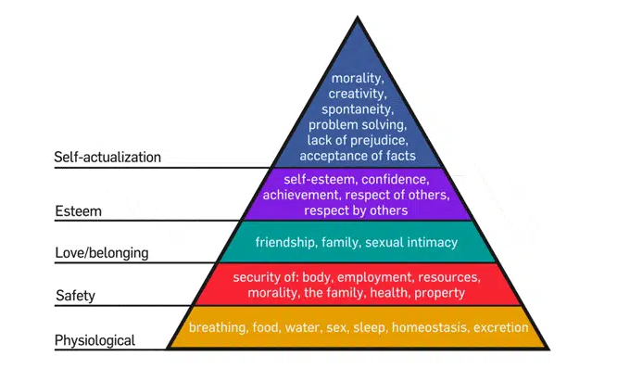
BPP (2014) adapted by Student (2022)
However, when the domestic abuse victims are allowed to live and survive independently, the Maslow theory may want to be used to explore the isolation of the victims to provide a sense of safety and security for the victims so that they can be integrated and feel happy and confident to living amongst the people and with family, thus, motivating them to climb the ladder of Maslow model. In view of this, Camden Council may tap into the Maslow hierarchy of needs theory to help victims of domestic abuse and drug abuse victims by making sure that the isolated victims are supported with the physiological needs of food, clothing and shelter so that they can feel comfortable, happy and willing to integrate with their family and loved ones. In addition, Camden Council can also support the victims of domestic abuse and drug abuse with safety needs by providing them with job and pension benefits to be secured and safe to interact and live with loved ones. This in fact may encourage these victims to embrace the belonging needs of creating friendship at work and outside work and be happy. In view of this, these victims can then strong enough to climb the hierarchy of Maslow to the self-actualization.
Legislation and Policy Impact for support and growth of a community
The increasing wave of domestic abuse and drug abuse in the UK has compelled the government to rethink decisions on how this threat to public health is tackled. In view of this, the UK government in 2021 passed the domestic abuse Act 2021 with the focus on increasing awareness and to inform the response to domestic abuse. In addition, the domestic abuse Act also provides standards and to promote best practice. In view of this, the domestic abuse Act has empowered local authorities which Camden Council is part off to use this Act to prevent and protect victims of domestic abuse. To make this succeed, the domestic abuse Act 2021 ensure that authorities like Camden Council and other bodies must promote awareness about domestic abuse in their local area. Also to protect and support victims, hence, the government set up the Domestic Abuse Commissioner, (DAC), Domestic Abuse Protection Notice (DAPN), and Domestic Abuse Protection Order (DAPO). Again, the Domestic Abuse Act ensure the bodies to implement Act like local authorities like Camden Council must hold perpetrators o account, and helping the victims to provide their best evidence in criminal courts using video evidence, screens and other measures and last, to provide better performance in response to domestic abuse. (Homes Office, 2022)
However, in 2015, the UK passed a policy on drug misuse and dependency to reduce the number of people across the UK misusing illegal drugs as well as other harmful drugs and at the same to increase the number of people who have successfully recovered from the misuse of drugs. In addition, the policy added that it as to restrict the supply of drugs and also identify and prosecute people involved in misuse of drugs. Further, the policy also ensures that young people live healthy lives and educated to know the danger of misuse of drugs. Camden Council can tap into this policy to protect and help drug users to recover from the misuse of hard drugs. Also to support young people to avoid using drugs ad live a healthy lives.
Recommendations
Camden Borough should provide clear policies to address rising wave of domestic violence and drug abuse.
Camden Borough should use information and communication technologies to connect victims of domestic violence and drug abuse.
Camden Borough should improve on their socio-economic policies to help the deprived areas.
Camden Borough should invest more on local infrastructure development.
The local residents should be more engaged in community matters.
Camden Borough should enact local policies and legislation to strengthen existing safeguard victims of domestic abuse and drug abuse.
Conclusion
Community development is fundamental for community improvement; hence, it is important for local residents to be part of community interaction as this reduces challenges which community are faced with. Camden Council improvement is driven by the local residents and the policy and commitment for the council in addressing issues of domestic violence and drug abuse. This report has provided understanding about Camden Community and its characteristics, demographics and development effort and methods of communication to address the challenges.

References
Camden Report (2018) Camden (2025) (online). Available at: https://www3.camden.gov.uk/2025/wp-content/uploads/2018/07/Camden-2025.pdf Accessed 12/12/2022).
Camden Report (2020) An Introduction to Camden (online). Available at: https://camdenrenewal.com/wp-content/uploads/2020/10/Introduction-to-Camden-v1.pdf Accessed 12/12/2022.
Camden (2014) Camden Profile: Public Health Intelligence Alcohol and Substance Misuse Needs Assessment (online). Available at : publichealth.intelligence@inslington.gov.uk Accessed 12/12/2022.
Corvo, K., Dutton, D. & Chen, W. (2008). Toward Evidence-Based Practice with Domestic Violence Perpetrators. Journal of Aggression, Maltreatment & Trauma, 16(2), 111-130.
Camden Council (2021) Camden Safeguarding Adults Partnership Board Strategy 2018 to 2021: Safeguarding is everybody’s business (online). Available at: https://www.camden.gov.uk/documents/20142/0/Camden+Safeguarding+Adults+Partnership+Board+2018+to+2021+Strategy+-+FINAL.pdf/915fc115-518d-803f-9375-2d70cad1b8a5 Accessed 13/12/2022.
Health watch Camden (2021) Surviving Domestic Abuse: Improving System that support Victim (online). Available at: https://healthwatchcamden.co.uk/sites/default/files/surviving_domestic_abuse_healthwatch_camden_2021_final_.pdf. Accessed 12/12/2021.
Moog, E.P., and Slakoff, D.C. (2021) As Technology evolves, so does Domestic Violence: Modern Day Tech Abuse and Possible Solutions: Emerald Publishing Limited.
Mitchell, C. & Anglin, D. (2009). Intimate partner violence: A health-based perspective. London: Oxford.
Home Office (2022) Domestic Abuse: Statutory Guidance (online). Available at: https://assets.publishing.service.gov.uk/government/uploads/system/uploads/attachment_data/file/1089015/Domestic_Abuse_Act_2021_Statutory_Guidance.pdf. Accessed 13/12/2022.
Zeuli, K., and Radel, J. (2005) Cooperatives as a Community Development Strategy: Linking Theory and Practice. The Journal of Regional Analysis ad Policy, Vol. 35, (1): p 43-53

