Worksheet 4
ARP and Routing Tables
I opened CMD on my server 1 and run ‘arp –a’ to find out what devices / IP addresses are currently connected to my device. As you can see below 192.168.100.2 which is my client 1 is showing up in my ARP table as it is connected to the device through an internal network. The ARP table also shows the IP addresses of the devices and their MAC address.
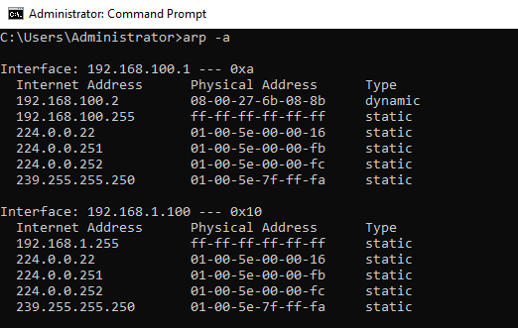

Then I ran ‘route print’ to show the routing table information on the server. This shows the IP addresses, subnet masks, gateway, interface and metric of all the routes that this server knows about.
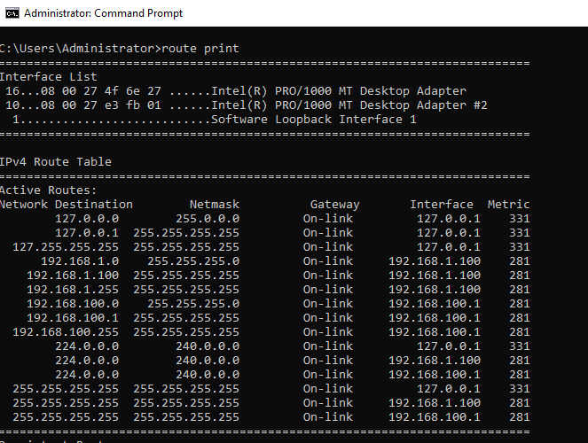

FTP Server
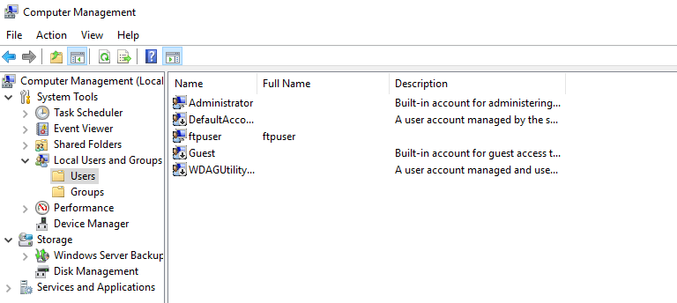
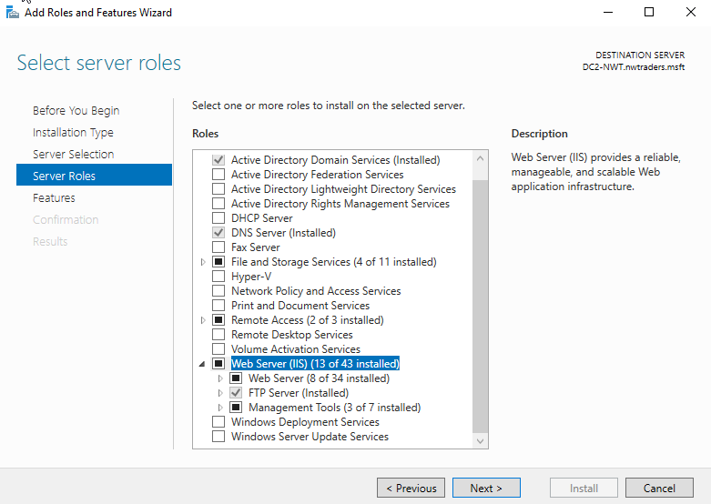
On my second server installed the Web Server Role and FTP Server so that I could use this server to transfer files between my devices.

I created a new user in Active Directory so that I could use this account to test the FTP service to see if it works properly.
I configured the FTP service giving it a site name and choosing the root drive.

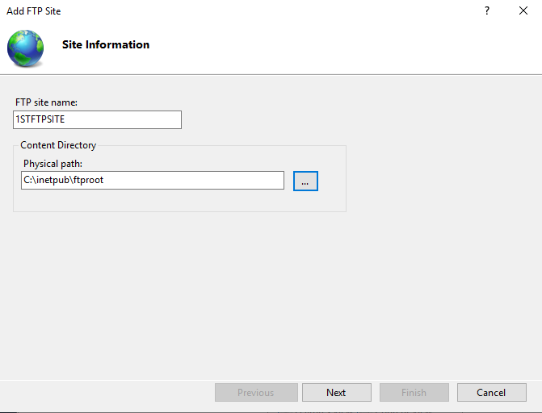

I set the authentication to basic and only allowed access to a specific user which was the account previously created ‘ftpuser’. If this was set to all then anyone would be able to use this FTP service which could be a major security flaw if not configured correctly.

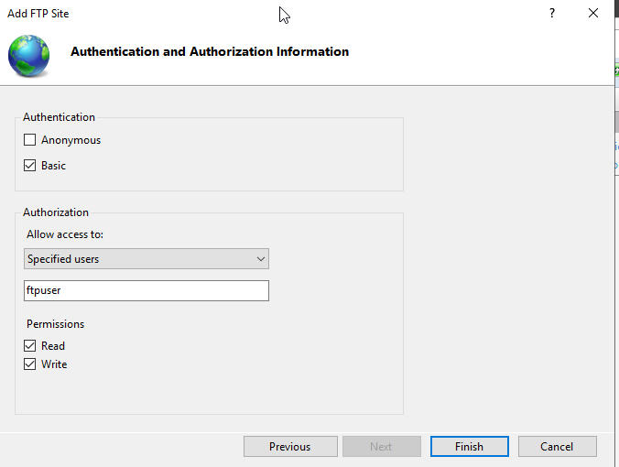
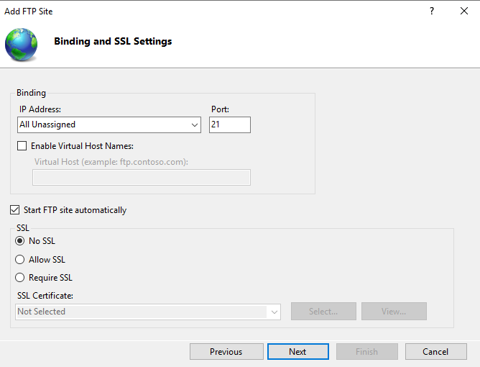

Below shows the home screen where you can make various changes such as set a welcome message as I have shown below or look at logs showing who has used the FTP service.
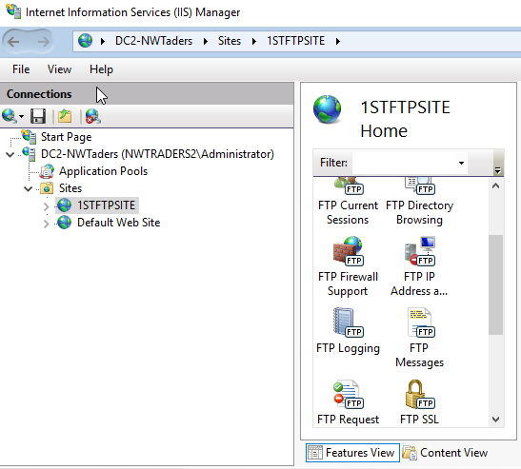

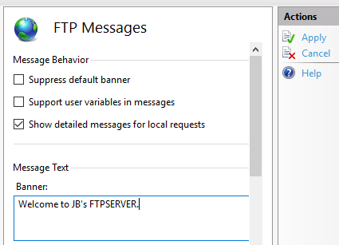

Lastly, before testing to see if it worked I had to give ‘ftpuser’ permissions to be able to save and modify folders within C:\Inetpub\ftproot as within this even if the account could connect to the FTP service the account would not be able to transfer any files to the folder I needed to transfer to.
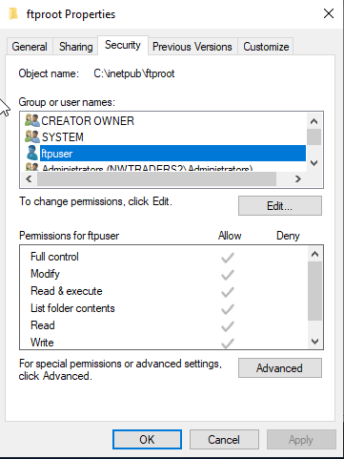

I connected to the FTP service hosted on server 2 with my client 2 VM. I opened CMD and entered the ‘ftp 192.168.101.1’ which connected me to the server 2 FTB service. As you can see below I was greeted with the welcome message and all I had to do now was sign-in using the ‘ftpuser’ credentials and transfer the text file that I created across which was successful.
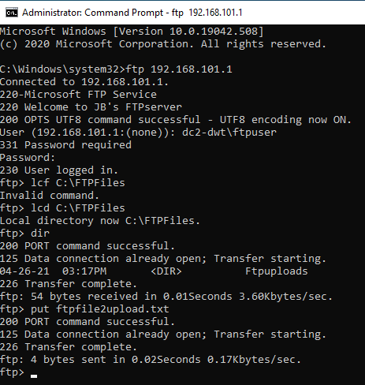

Confirmation of FTP working as the file showed up in the ‘ftproot’ folder on server 2.
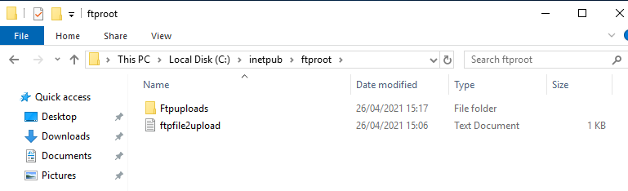

Configuring remote access

I installed the ‘Remote Access’ Server Role on both of my servers including the Direct Access and VPN, and Routing.
At this stage, I hadn’t joined my server 2 a domain as I didn’t need to, however, at this stage I was met with an error when trying to install remote access on my second server I needed to join it to a domain so I did so.
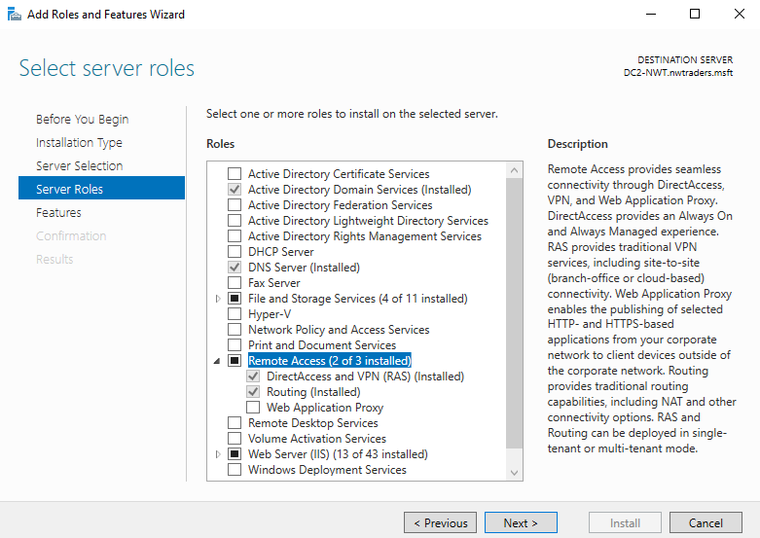

Once the role was installed I opened the ‘Routing and Remote Access’ program and configured it. We are using LAN routing for this as all of the VMs are connected, however, if they were not then I would have to use a different configuration.
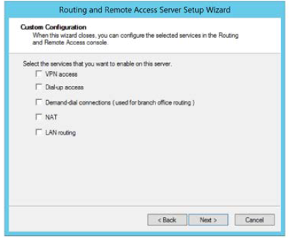

I then added a new protocol called ‘RIP Version 2 for Internet Protocol’

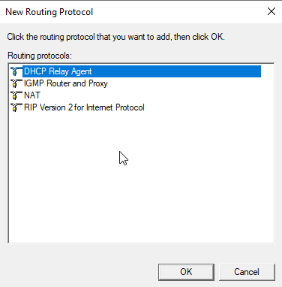

I then configured both servers by adding the private and public networks.

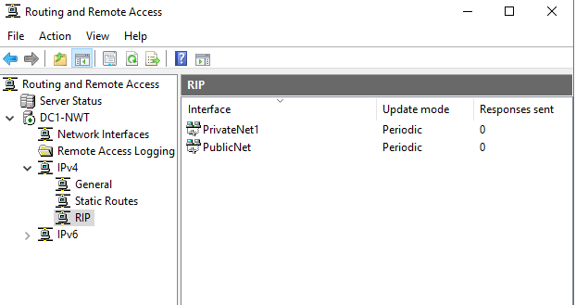

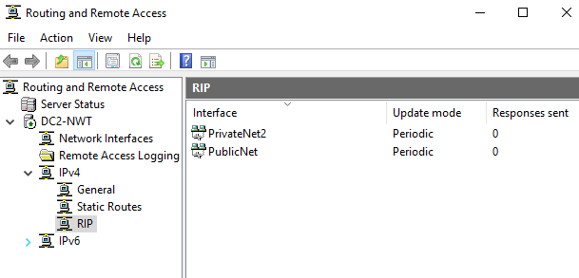

Once both servers were configured properly I pinged the private and public network of each server from the other server which both of them were successful on each server.
Ping from server 2 to server 1 PublicNet successful.
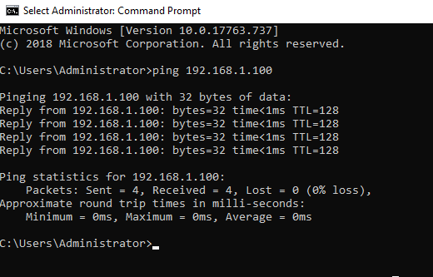

Ping from server 1 to server PublicNet successful.
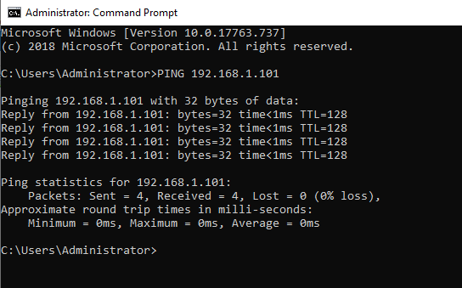

Ping between client 1 and client 2 private network successful.
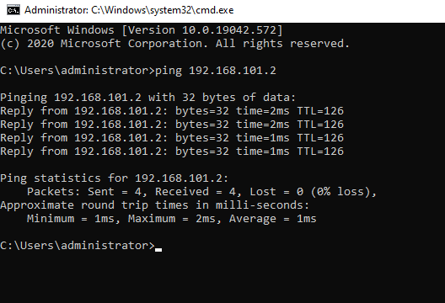

Observation:
Now that the private networks know about each other they are able to ping one another as before I was getting the error message ‘PING: transmit failed. General Failure.’ But now as you can see the clients are able to ping each other.

Packet filtering
Filter 1:
I configured an inbound service on server 1 that will stop anyone in PrivateNet1 from pinging the router firewall service.
The IP address is the server 1 PrivateNet1 address and the subnet mask is set to 255.255.255.255 as it is the exact host I was targeting.
I left the ICMP field empty as this auto completes.
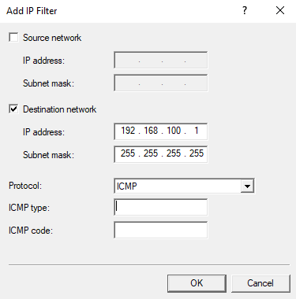

I configured the inbound filter so that it should receive all packets except those met with the criteria that has been configured as shown below.
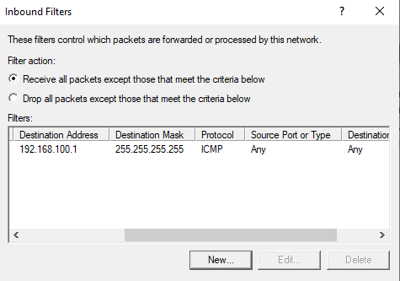

Ping from client 1 to server 1 PrivateNet1 unsuccessful as expected.
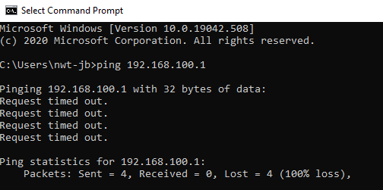

Filter 2:
On this filter, I used an outbound filter to restrict access to hosts in PrivateNet2.

On server 2 outbound configuration:
I set the destination port to 21 as this is the port that FTP uses for connecting. The IP address is set to server 2s PrivateNet IP and the subnet mask is 255.255.255.255 as I am targeting that specific server.
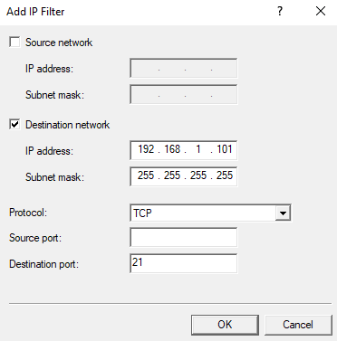

I configured the outbound filter to transmit all packets except those that meet the criteria that I had configured as shown below.
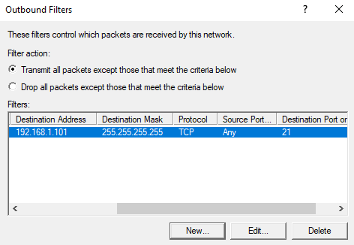

I set the destination port to 20 as this is the port that FTP uses for data transfer. The IP address is set to server 2s PrivateNet IP and the subnet mask is 255.255.255.255 as I am targeting that specific server.
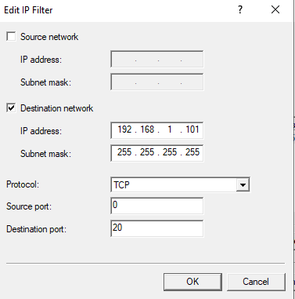

I configured an inbound filter so that it will drop all packets except what I configured which is hosts in PrivateNet2 as shown below.
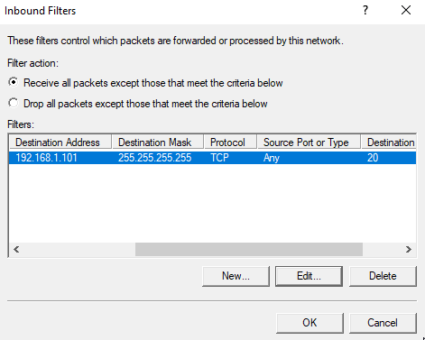

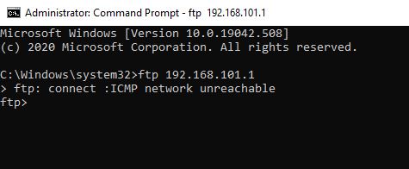
I was unable to connect to the FTP server from server 1 as expected.

Filter 3:
I have configured a filter to only allow client 1 in PrivateNet1 to access the FTP Service running on server 2
I set the destination port to 21 as this is the port that FTP uses for connecting. The IP address is set to client 1s IP address and the subnet mask is 255.255.255.255 as I am only allowing client 1 access from the PrivateNet1 network.

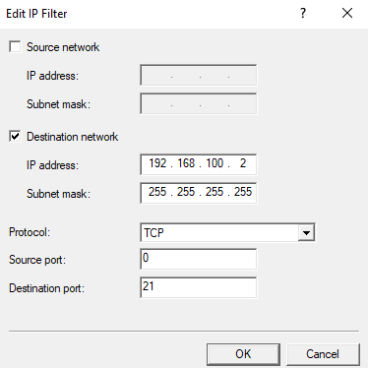

The inbound filter is set to drop all packets except those that meet the requirements as I only want to allow client 1.
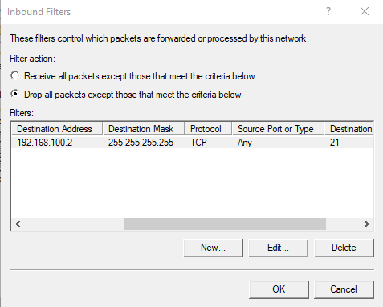

Questions
Failover clustering
A failover cluster is a set of computer servers that work together to provide either high availability (HA) or continuous availability (CA). If one of the servers goes down then another node in the cluster can take the workload of the server with minimum to no downtime through a process called failover. Some failover clusters use physical servers only whereas others involve virtual machines [1].
The main purpose of a failover cluster is to provide either high availability or continuous availability for applications and services. Continuous clusters allows end-users to keep using applications and services without experiencing any downtime if a server fails. High availability can cause a brief interruption in service for customers but the system will recover automatically with minimal downtime. A cluster is made up of two or more nodes or servers that can transfer data and software to process the data through physical cables or a dedicated secure network [1].
While continuous availability failover clusters are designed for 100% availability, high availability clusters attempt 99.999% availability. This is known as the five nines. This downtime amounts to no more than 5.26 minutes yearly. Although continuous availability clusters offer greater availability and are extremely reliable they do come at a cost as they require more hardware to run [1].
High availability clusters work by having groups of independent servers share resources throughout the system. All devices in a failover cluster have access to shared storage, high availability clusters also include a monitoring connection that servers use to check the performance and health of the other servers. The two devices in the cluster will never be active at the same time, while one is working the other is passive. When one of the devices on the cluster fails the other device recognises the other is down with the use of the monitoring and then configures itself to be the active device [1].
Using this does run the risk as the shared storage is a single point of failure but with the use of RAID 6 along with RAID 10, ensures the service will continue even if both hard drives fail. Another point of failure is it both servers are plugged into the same electricity grid but this can be resolved by having a UPS connected to each server which will keep them powered on long enough for the electricity issue to be resolved [1].
Continuous availability failover clusters consist of multiple systems that share a single copy of a computer’s OS. Software commands issued by one system are also executed on the other systems. Continuous availability requires that the organisation use formatted computer equipment and a secondary UPS. In this failover, the operating system has an interface where an IT professional operating the system can check critical data at specific points during an incident. Continuous availability can only be achieved using an exact copy of the physical and virtual machine running the service [1].
Continuous availability can continue to work if a range of different failures occurs. Such as a hard drive failure, a computer process failure, an issue with the power or if there is an issue with a network component. The point of failure can instantly be detected and a backup component or procedure will take its place without any downtime or interruption [1].
Installing failover cluster features on servers

I was having some difficulties installing the failover cluster feature on my two servers, after realising the install was not where it was supposed to be I tried installing through PowerShell but still could not install it (see screenshots below).

Where the failover cluster should be available to install:
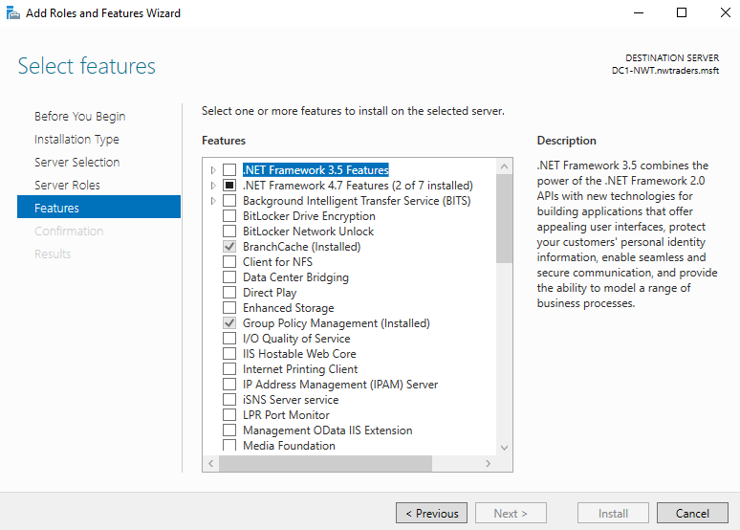

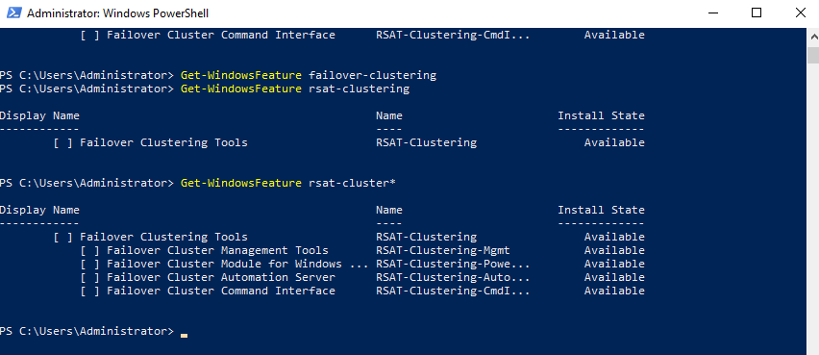
Attempt to install through PowerShell:

Although they show as available they will not install.

After some further troubleshooting and research, I found it is due to my servers being on Windows Server 2019 Essentials which does not have the failover cluster feature available. This was confirmed by a website comparing the differences between the essentials version and the standard [2].

Screenshots taken from Microsoft website due to the issue installing failover clustering feature [3]:

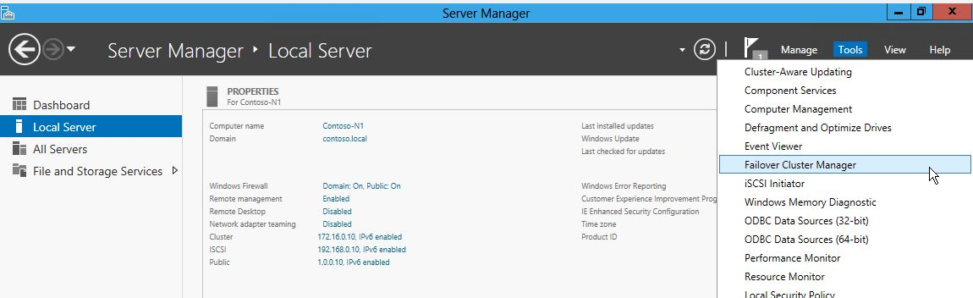
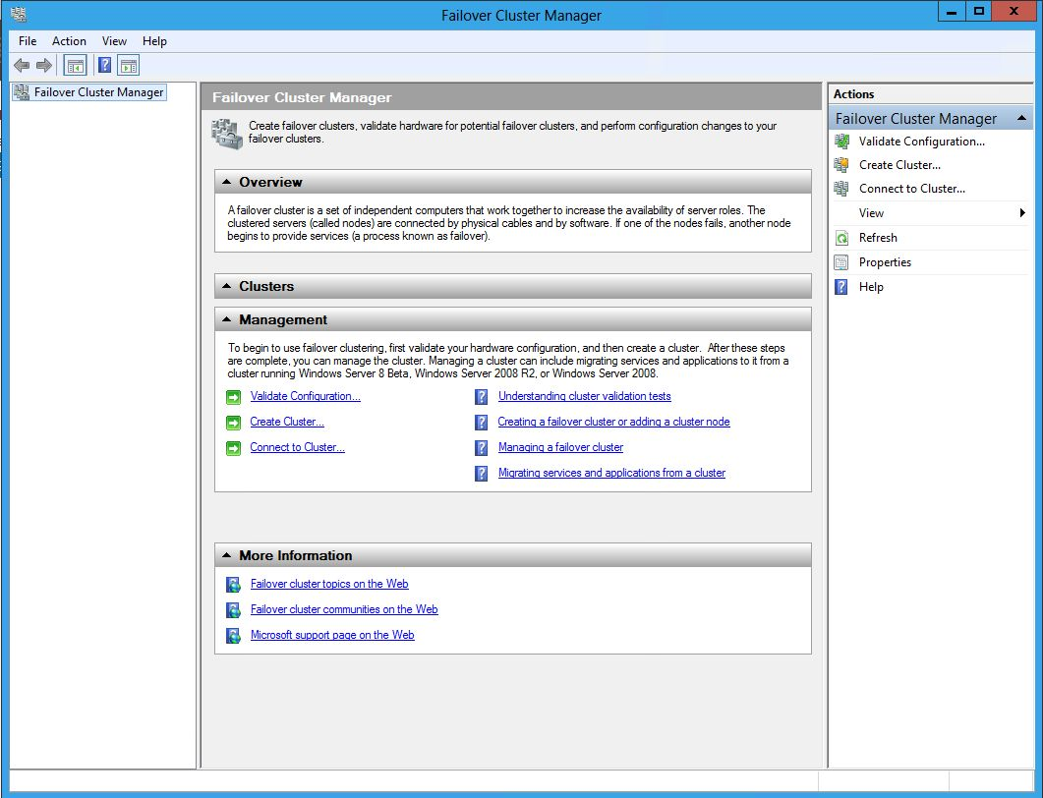

[4]
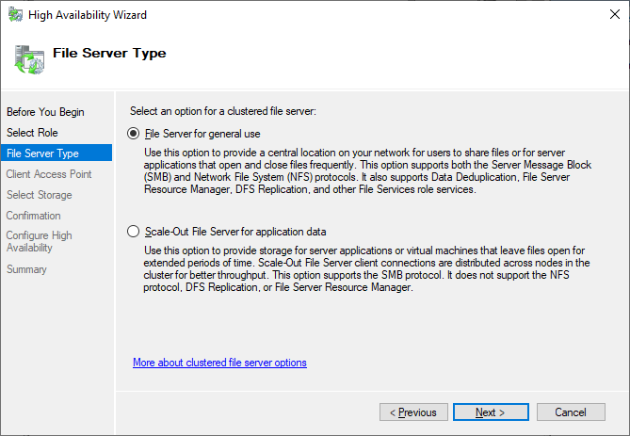

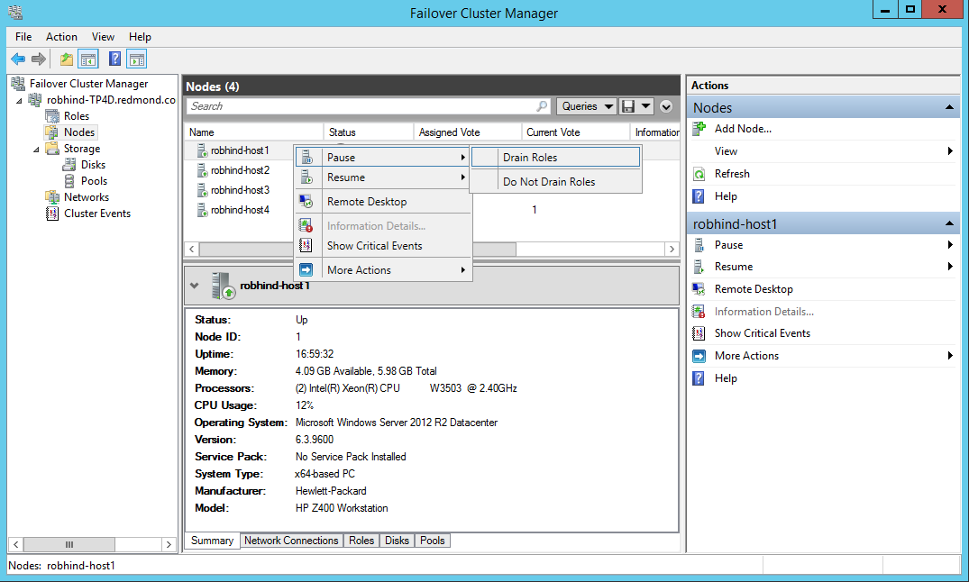
[5]
Network policy

The policy follows generic requirements founded on CESG best practices and industry standards that are applicable to all systems and must be embraced as an integral component across the network.
This includes:
Confidentiality – ensuring that information is accessible only to those authorised to have access.
Integrity – safeguarding the accuracy and completeness of information and processing methods.
Availability – ensuring that authorised users have access to information and associated assets when required.

Remote Access is an increasing business need for access to data or transfer through mobile networks or laptops. Working from home or agile working has become essential due to the recent Covid-19 pandemic. Remote access is key the company working as some staff are unable to go into the office so much work from home which could be for the foreseeable future. Laptops, desktops or virtual machines that are connecting externally must go through two-factor authentication before being allowed on the network.

To control access a combination of user standards, hardware and software controls need to be employed. The ability to lock hardware facilities is important to ensure that the system is protected and data is not used or copied in an inappropriate manner or deleted either accidentally or deliberately. Therefore, all systems and applications will have a documented set of security standards that will be used to educate and inform users, as well as providing a basis for monitoring, auditing and regulating usage.

Anti-virus
Anti-virus solutions are in place on the perimeter of the network and incorporated as part of the standard desktop and laptop specification. Windows Defender must be installed and up to date on all devices on the network. Any device that is not up to date with the latest anti-virus updates will be taken off the network.

Appropriate audit controls deployed
Effective and regular auditing of systems is important to monitor and control access, and both manual and software solutions must be employed to prevent, detect and resolve security weaknesses.

Appropriate encryption solutions deployed
All portable devices such as USB pens and CD disk drives must be Full Drive Encrypted with the current standard encryption software. Only fully encrypted drives supplied by the IT department can be used to stop users from plugging unauthorised devices into devices on the network. Any not encrypted device will be blocked unless it has been approved by IT for a short period of time.

Independent health checks commissioned
Independent health checks need to be implemented at regular intervals to confirm the integrity of systems and preventative measures. Internal and external checks and audits must be done to ensure the security of the network.

Asset Register
Accountability for assets helps to ensure that the appropriate level of protection is afforded and maintained. Therefore all major assets used for or in support of processing the organisation’s information will be listed in an inventory of assets. This will include hardware such as desktops, laptops, printers and servers. By keeping up to date with what inventory is held it makes it easier to track where all the equipment is which stops devices going missing and makes it easier to upgrade devices when they come to the end of life. Communications equipment including network devices, mobile telephones will also be tracked as well as software and licenses.

Penetration tests
Periodically externally sourced penetration tests will be undertaken to simulate the activities of an unauthorised intruder attempting to gain access to the network and any system or application. These tests improve the overall security of the network as any vulnerability found by the penetration tests can be resolved so that a real attacker will not be able to exploit this vulnerability.

Access to Systems

Users will not be granted access to systems until all of the appropriate measures have been completed. This includes any new staff member or 3rd party user filling out network user’s forms before being allowed access to the network. This is to stop any unauthorised accounts from getting created as they will not be done until a manager has approved them.

Training and Awareness
All users must be trained and made aware of the dangers of cyber attackers and data protection before being allowed access to the network. E-learning modules will have to be completed by new staff before they are allowed to use the systems. There will also be regular reminders send out in emails to all users reminding them of simple but important information such as not to open attachments or links from suspicious-looking emails or websites. All staff will receive a specific briefing about confidentiality, computer misuse, and unauthorised access to information.

Breaches of Security

Any security incident or occurrence that has the potential to compromise the organisation, staff, information or other assets, must be reported to a manager or the IT department.

Documentation

Security policy and standards will be documented on the Intranet for all users to be able to read. All activity relating to security measures and decisions impacting upon people will be documented.
References
[1]"Failover Clusters | What is Failover Clustering?", ServerWatch, 2021. [Online]. Available: https://www.serverwatch.com/server-news/failover-cluster/

[2]M. O'Shea, "Windows Server 2019 Essentials Roles And Features", intunedin.net, 2018. [Online]. Available: https://intunedin.net/2018/12/01/windows-server-2019-essentials-roles-and-features/

[3]"Installing the Failover Cluster Feature and Tools in Windows Server 2012", TECHCOMMUNITY.MICROSOFT.COM. [Online]. Available: https://techcommunity.microsoft.com/t5/failover-clustering/installing-the-failover-cluster-feature-and-tools-in-windows/ba-p/371733

[4]"Failover Cluster Step-by-Step Guide: Configuring a Two-Node File Server Failover Cluster", Docs.microsoft.com, 2021. [Online]. Available: https://docs.microsoft.com/en-us/previous-versions/windows/it-pro/windows-server-2008-R2-and-2008/cc731844(v=ws.10)?redirectedfrom=MSDN

[5]"Cluster Operating System Rolling Upgrade", Docs.microsoft.com. [Online]. Available: https://docs.microsoft.com/en-us/windows-server/failover-clustering/cluster-operating-system-rolling-upgrade

