

Assessment component 1
Written report

Student Name: Rusti Monica

Student Number: 1909952

Lecture name: Bianca Sanfilippo

Module name: Children, Young People and Families

Module Code: BMHP5004
Count words: 2821

Table of Contents

Introduction ………………………………………………………………………………..…3
Presentation of case study …………………………………………………………………....4
Domestic abuse related to the case study and specific issue…………………………………4
Factors contributing to the risk of vulnerability of the children and their impact……………6
Policy and the impact of vulnerability on the children, young people, and family………..…7
Action of agency in the specific case study by own critical evaluation…………………..…..8
Recommendation and a purpose solution for the case study………………………………….9
Conclusion…………………………………………………………………………………...11
Reference…………………………………………………………………………………..…12

Introduction

On the main report I will analyse the main case study and important elements of vulnerability in children, young people, and families.
This report focuses on the challenge of critical analysis by a case study, viewed from health and social care perspective based on evaluation of the health and social care agencies involved in the case study and any relevant policy which currently apply.
It is about how to increase recommendations and a purpose solution for the case study with scope that will bring the desired results.
On the main report, is to provide a review of the evidence on the interrelationship of parental conflict and substance misuse, relate and evaluate the evidence for the impact of all the factors which are contributing on changing outcomes for children.

Presentation of the case study
On the main report, the case study analyses present a family facing adversity.
Family facing adversity include specific issue same as domestic violence, vulnerability involve the child life and environment.
The family is located in Leeds and is composed by a mother and five children, mother was married two times.
Laura has 33 years old, a single mother and is having 4 kids, age between 6 to 15 with the ex-partner, and in the present have another child with another partner. At the point of recommendation, the main reason and problem with the family is the high level of anti-social behaviour and the children exposed on risk.
In case study, the family had been given a housing attention and were at risk of eviction. Mother was dependent on alcohol and amphetamines (drugs), which affected her capability to parent the children properly and meet their needs. She’d made allegations of domestic violence and abuse against her previous and current partners.
However, the family was facing adversities, as a parent were involved with issues as alcohol, drugs, and domestic violence problem.
In the main case study family was in the risk of eviction from own house. Children occur a very low attendance on school. The family were unaffected to working with agencies - and agencies felt that both fathers had very limited contribution or interest to provide care for the children.
Domestic abuse related to the case study and specific issue
By Welsh Government (2017) Domestic abuse or violence is defined as any type of monitoring, violent behaviour between people in a relationship, includes: emotional health problem, physical problem, and psychological problem.

In addition, of the most significant risks which can lead to child abuse and neglect are: domestic abuse, substance misuse used or mental health problems created from alcohol (Sidebotham et al, 2016).
Facing adversity in a family can affect a child’s physical and mental health, the impact it has on their lives since are growing up – causing anxiety, insomnia and making it difficult in future to concentrate at school or build friendships.
In addition, sometimes it’s possible to decrease the risk of maltreatment to children whose families are affected by these difficulties and bad habit, parents need to understand the importance of improving a good relationship to achieve together and provide new parenting assistances and knowledge to take better actions in future for own child.
However, when families facing adversity, on the main report, specifically I’m focusing to follow a difficult situation in family where parents are involved in domestic violence using drugs and/or alcohol (substance misuse) having a great impact affecting own actions growth the risk of harm to own children which need help (Cleaver, Unell and Aldgate, 2011).

By Public Health Wales (2018) Children needs care in their life, avoid any growing up with adversity and domestic violence will bring a long-term negative impact on future life.
According to Acquah et al. 2017 when a family in involved in a conflict is defined as “conflicts that happen between parents that are frequent, intense and poorly resolved.” Review “Parental conflict’ as a term encompasses a spectrum of behaviours and the evidence shows that impacts on children about the co-occurrence of domestic abuse and substance misuse.
In line with McGovern, 2018 substance misuse is defined as “either alcohol use above low risk levels or non-medicinal use of drugs prohibited by law” contained a strong impact by separating or divorcing couples.
On the other hand, children are deemed to be at risk but this can be seen with increased to stressors and adversity, to draw out potential differences between the impact on outcomes for children which are not attending to go to school or achieve good results where there is parental conflict combined with mother using drug and alcohol affecting life of children.

Factors contributing to the risk of vulnerability of the children
According to Brooks, N (2003), the above definition of vulnerability is referred to injury, damage, or harm as a part of sensitivity by health and safety of a child physical and emotional.
Sometimes more than one factor appears in family.
On the main case study, the factors which are contributing to the risk are: mother is dependent on alcohol and drugs, fathers are facing abuse on the main family.
By Ferguson et. Al., 2014 parental separation or divorce includes an extensive range of family problems, by exposing the children to interparental conflict.
On the main case study, the impact of coexisting parental separation/divorce and substance misuse on outcomes affect children, and this is bringing the intervention of agency and a social care (McLaughlin et al,.2015).
On the other hand, is more likely to be restrained in terms of representing factors such as economic, social vulnerability, physical and political, affect health and education status on the case study, preparation, and coping ability to particular risks.
The main ten risk factors found on the case study by the social care intervention are: parental depression; parental physical disability; parental substance misuse; parental alcoholism; parental domestic violence; financial stress; parental worklessness; parental teenage; lack of basic skills and overcapacity.
On the main case study, the risk factors measured are parental domestic abuse, parental alcoholism, and parental substance misuse.
The other stages include different parental factors same as; (relationship between parent and child), individual level factors (the characteristics and attributes of the child), and social factors (including sociodemographic characteristics of the family and the wider social environment).
In addition, were no changes found in familial disclosure which are having as principal cause of aggressive attitude.
Emotional and physical abuse and neglect on a child is happened when their parents are drinking or using drugs or their parents say horrible things to them when they are under the influence of alcohol/drugs making the children vulnerable and carry an aggressive attitude in society.
A child is vulnerability on parents which have no care for them, the same is in the case study presented, a child need love and protection from a mother and father, a child needs to grow with education, support, and opportunity to achieve good results in life, not in bad influence which can affect the child emotional and physical.
Policy and the impact of vulnerability on the children, young people, and family
In the publication, the National Resource Centre on Child Maltreatment (1999) define that a child is vulnerability when a child's capacity for self-protection is not made, associating vulnerability primarily with age, and the importance of self-protection.
According to the (NSPCC,2019), parental misuses lead to neglect, referred to fail to care for properly, the parental misuse leads the children on risk without care and protecting them.
On the main purpose of the case study, parents expose the children to the risk having a great impact on them, all five children are having bad result on school and in society, because mother neglect them occur a negative effect on own children which need intervention of local authority.
The local authority in this case has the safeguarding responsibility to protect children from harm and abuse based on the Children Act 2004.
Section 11 of the Children Act 2004 places CCGs under a legislative duty to make arrangements for the agency and social worker to ensure that, in satisfying of own functions need to stay focused on precaution and promote the welfare of children and family.
By the Public Health Wales (2018) Safeguarding Children is defined for a variety of procedures and methods tacked to keep children safe is including: child protection, safe recruitment, statutory duties, patient safety, and partnership with agencies working between organisations to protect and promote the safety of children, family, and young people.
According to the Children Act, all public and private services and agencies must work in partnership and in multi-agency to safeguard children.

Source: Moodle 2021(Last Accessed on 30 July 2021)

The children Act 2004 states that all organisation working with children are responsible for safeguarding. These includes: schools, local authority, NHS, private healthcare providers, children services, police, agency within the criminal justice system, including officer, youth offender team, etc.
The 1989 Children Act, carried together and simplified existing legislation relating to the care of children in order to provide a positive result in all areas and protect vulnerable children.
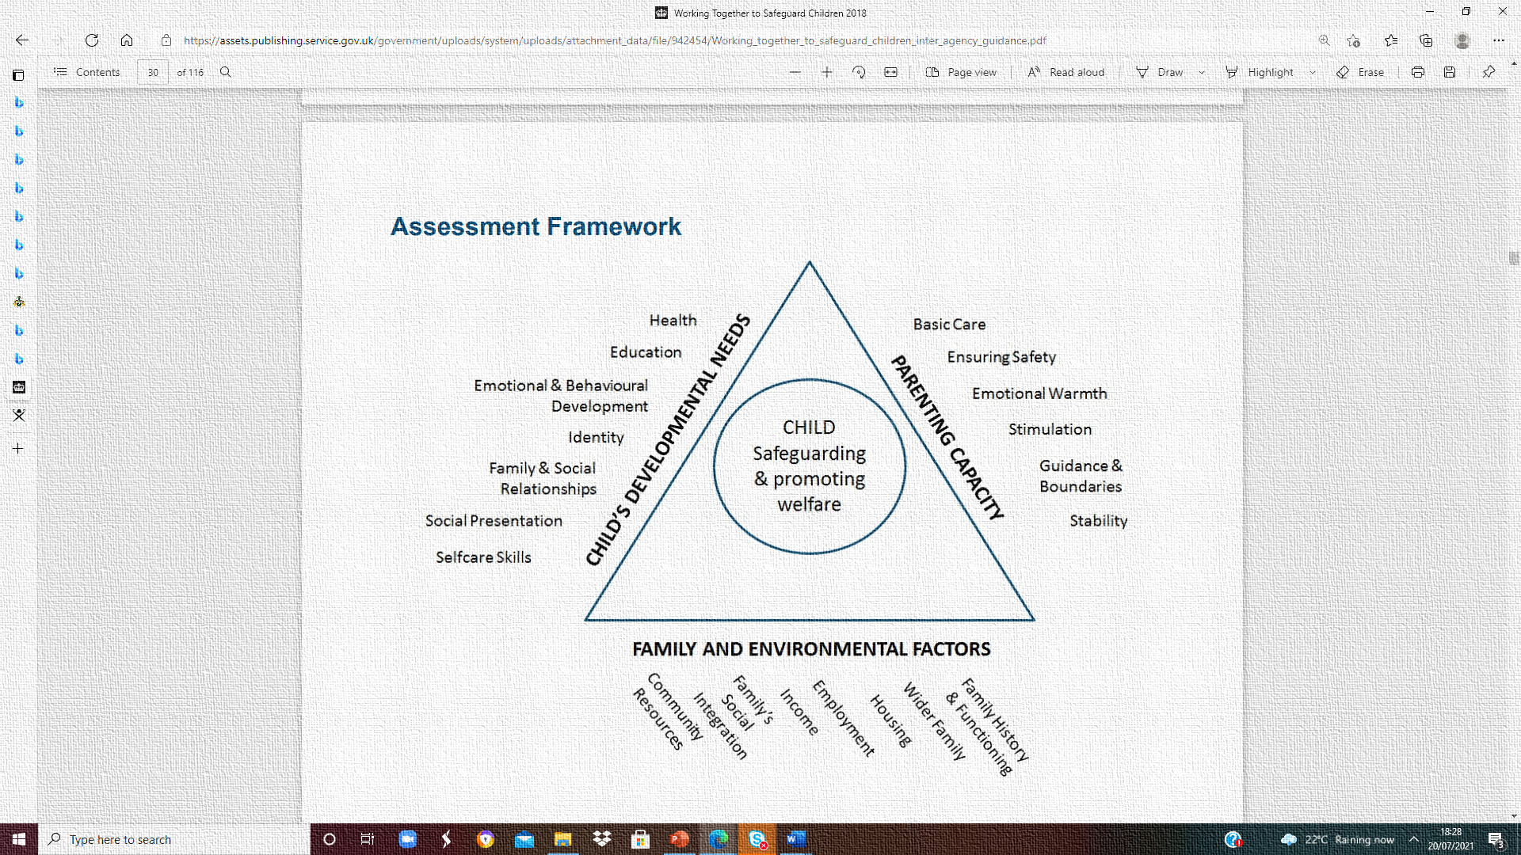
In addition, by Children Act 1989 a child In Need, is defined as a child who is unlikely to achieve or maintain an accurate level of health or development of the specific needs are; the level of vulnerability of a child, the resources or professional services can chance as a priority and observe clear objectives identified for the child for apposite periods to achieve objectives on the intervention.

Action of agency in the specific case study by own critical evaluation

To provide a child help need to ensure support as soon is possible for the problem to be avoid at any point in a child’s life, from the foundation years through to the teenage years.
A report from agencies that had worked with the family in the past reported that both fathers had very incomplete contribution or interest in parenting and care for the children.
A valuation order by the Children's Court about family needs to evaluate the following:
- the impact of the parental responsibility needs to be effective related to intervention is to provide safety for children.
An early help, can also avoid further problems rising when in family are emerging parental mental health issues or drug and alcohol misuse providing violence.
The agency and local authority should also continue to develop their understanding of domestic violence of the main case which includes controlling family from perpetrators of domestic abuse, and the impact on the children
To enable this, agency should consider what physical activity is needed and how they will monitor and evaluate the effectiveness of any action, the social policies play a key role in the lives of children and their families to provide help in problem found.

Children’s lives are considerably affected by the type and quality of welfare provision available, and their needs are met through a variety of policy measures, including; education, health, social services, and social assistance.

The action of agency needs to be fairly without affecting the children or any member of family, need to increase help associated with good results in future.
The changes of family need to be in a good way to avoid any psychologic problem, health problem and issues by being affected by a complexity of negative results.
The work of social service can be linked by Maslow Theory by the intervention which was based on meeting the physiological and safety needs. The social intervention started from basic needs of housing (physiological), safety, love, esteem, and self-actualization.

Recommendation and a purpose solution for the case study
By the 1989 Children Act a family need to be kept together.
In the years preceding by the Children Act (1989) provide a series of high-profile child abuse cases had generated a public discussion on how to protect vulnerable children.
The Equality Act 2010 which places a responsibility on public authorities regard to the need and to eliminate discrimination and promote equality of opportunity of identification of necessity and risk faced by the child.

The intervention of agency was clearly helpful because on the main family with needs was included activity designed to make an immediate impact and helping with practical responsibilities in the home associated with cleaning and washing clothes. This helped the family to develop motivation, skills, and a routine for avoiding any problems in future.
For fathers revisited previous assumptions that had been made about their parenting and now they have an important role in children life to offer them a better future.

The agency worked with the children’s schools to address and manage the impact that Laura’s emotional state had on the children and helped Laura to attend Leeds Addiction Unit for help with her alcohol and drug problems.
The court decided all children can live together rather than in local authority care, and they are settling in well. They are now no longer subject to interim care orders. Their attendance and behaviour at school has improved. and is progressing well (Fergusson D, 2014).
There are no concerns regarding anti-social behaviour or offending.
The father is getting the help he needs from the agencies there to help him and has sought support about housing and parenting advice.
As a recommendation for the agency which support the family is to maintain a strong relationship to avoid any problems in future.
Keeping the family on the same way, will bring good results and children will grow up in a better society with better perspective and results (Children’s Workforce Development,2011).

Conclusion

The particular type on the case study results to be a function of the severity consequences occurred by parents and probability of occurrence of the risk which expose the children, involve the local authority and agency to mediate any particular disclosure of family.
The local authorities have towards looked after children, with an essential support for the family and promoting the educational help for children.
In conclusion, the main family of the case study presented being supported by the agency was involved in different activity and ensure to obtain the necessary needs.

By Bronfenbrenner theory, agency was according good service to the children and is important to create more universal services regarding to the system used and the influence of social environment on human development.

References
- Acquah, D., Sellers, R., Stock, L and Harold, G. (2017) ‘Interparental conflict and outcomes for children in the contexts of poverty and economic pressure’, Early Intervention Foundation. Available: https://www.eif.org.uk/report/interparental-conflict-and-outcomes-for-children-in-the-contexts-of-poverty-and-economic-pressure/. Accessed: 01/08/2019.
- Brooks, N. (2003). Vulnerability, risk, and adaptation: A conceptual framework, Tyndall Centre Working Paper 38.
- Children’s Workforce Development Council (CWDC) (2011) Providing Intense Support for Families with Multiple and Complex Needs: Manager Guidance. London: CWDC [Online] Available at: https://assets.publishing.service.gov.uk/gov ernment/uploads/system/uploads/attachment_data/file/193509/Managers_Guide_Refresh ed.pdf (Accessed 5th February 2020)
- Cleaver, H., Unell, I. and Aldgate, J. (2011) Children’s needs: parenting capacity: child abuse: parental mental illness, learning disability, substance misuse, and domestic violence. London: The Stationery Office (TSO).
- Fergusson, D., McLeod, G., Horwood, L.J. (2014) ‘Parental separation/divorce in childhood and partnership outcomes at age 30’, The Journal of Child Psychology and Psychiatry, 55(4), pp:352-360.
- McGovern, R., Gilvarry, E., Addison, M., Alderson, H., Carr, L., Geijer-Simpson, E., Hrisos, N., Lingam, R., Minos, D., Smart, D and Kaner, E. (2018) ‘Addressing the impact of nondependent parental substance misuse upon children’, Public Health England.Available: http://www.fuse.ac.uk/research/earlylifeandadolescence/outputsfromprogramme/McGovern_Addressing%20the%20impact%20of%20parental%20non-dependent%20substance%20misuse%20upon%20the%20child_PS_FINAL%20DRAFT.pdf. Accessed: 12/06/2019.
- McLaughlin, A., O’Neill, T., McCartan, C., Percy, A., McCann, M., Perra, O and Higgins, K. (2015) ‘Parental Alcohol Use and Resilience in Young People in Northern Ireland: A study of family, peer and school processes’, Institute of Child Care Research. Available: https://research.hscni.net/sites/default/files/Final%20Report_1.pdf. Accessed: 12/06/2019.
- Public Health England. (2018) ‘Problem parental drug and alcohol use: a toolkit for local authorities’ Available: https://www.gov.uk/government/publications/parental-alcohol-and-drug-use-understanding-the-problem. Accessed: 12/06/2019.
- Public Health Wales (2018) Cymru Well Wales: Adverse Childhood Experiences (ACEs) [wales.nhs.uk/sitesplus/888/ page/88524] [Accessed 13/02/2018].
- Radford, L. et al (2011) Child abuse and neglect in the UK today. London: NSPCC Scottish Government (2017) Children’s social work statistics: additional tables 2015-16.
- Sidebotham, P. et al (2016) Pathways to harm, pathways to protection: a triennial analysis of serious case reviews 2011 to 2014: final report. London: Department for Education (DfE).
- Welsh Government (2017) Data mining Wales: The annual profile for substance misuse 2016-17. [Cardiff]: Welsh Government.

