Thomas Evans p145653
Thomas Evans
145653
Responsive Web Development
UWTSD

Table of contents
-Introduction
-Implementation
-Responsiveness
-Evaluation

Introduction
For this assignment, the author of this report was tasked to create a website. The brief states that the website must work with all major browsers. The brief also states that the website must work responsively on any screen stating that the website must be mobile compatible to some degree. The author of this report must use the techniques taught in this module amongst techniques learned from independent study to create a website that is responsive whilst still containing all the content that is needed for the website to bring in the target audience. Firstly, in this report the author of this report will discuss the purpose of the website and its subject matter. Secondly, the report will discuss how the author of this report achieved the level of responsibility when creating the website stating the learning sources used to create it. Finally, in the evaluation section the report will consist of the the problems that were crossed when developing the website and the ways in which they were solved. Also, there will be a section discussing the improvements that could be made if the project was revisited at a later date.

Implementation
For the purpose of this task the author of this report decided to create a website for a small business in which he holds a part time job. The business does not currently have a website and believes that it could increase the business’s exposure. The business the website is being created for is a bar in Swansea called ‘La Cantina’.
The purpose of the website will be to promote the bar as well as provide a platform for the user to make bookings for the available function room inside of the venue. The website will also provide a platform outside of social media to display the venues drinks offers and hold a gallery of images taken inside of the venue. The opening hours will also be displayed on the website.
The website’s target audience is anyone who might attend the venue and will be used to draw in more customers going forward. The main target audience the bar wishes to appeal to is to students as the venue wishes to gain more popularity on student nights and believes it will greatly improve the amount of money the venue is able to take.
The webpage will be made using 6 pages. A home page, menu, bookings, gallery, contact us and opening hours. The home page will be a simple welcoming page with a slogan or perhaps a link to social media with some images of the drinks available. The menu page will have a summary of the offers available on each day. The bookings page will provide details on the function room and show the prices and facilities available to any possible customers. The gallery will contain a plethora of images from the venue of both the venue itself and some of the extravagant drinks available on at the venue. The contact us page will provide contact details for the venues management for arranging future bookings and inquires. The opening hours will contain the websites opening hours.
The website will conform to the colour scheme of the venue and all resources used inside of the venue and the staff uniform. Using mainly burgundy yellow and white.

Responsiveness
For the creation of this website the author of this report and the developer of the website used a series of the resources used from the Moodle page for this module and used w3 schools the assist in learning how to create a responsive website.
The author of this website created a simple responsive website by using the line of code.
<meta name="viewport" content="width=device-width, initial-scale=1.0">

This code allows the website to change the size of the webpage to scale to the size of the devices screen. This is the main thing used to make the website responsive as well as using responsive images which fit can fit nicely to the scale of any device.
Home page
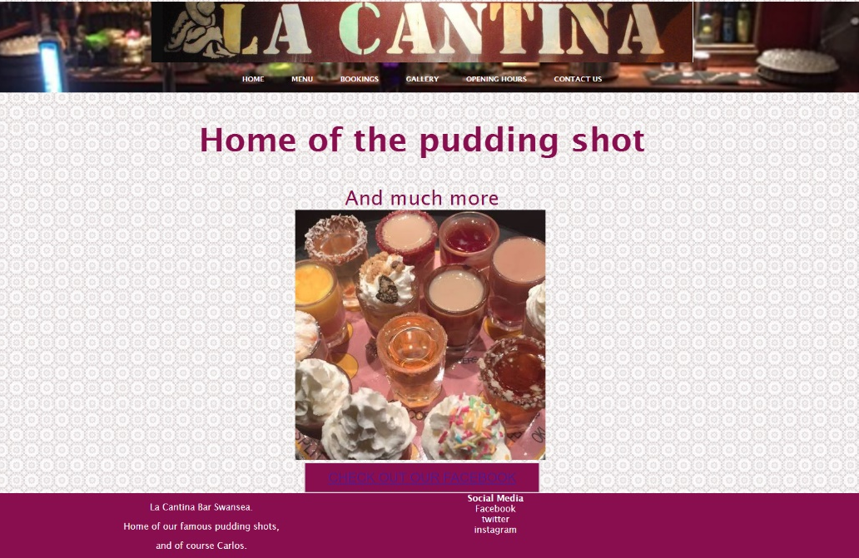
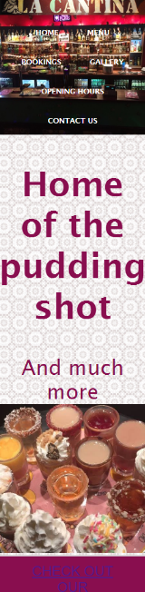

Above are screenshots of the website both displayed in a large window and a small one similar to a mobile. These screenshots show that the home page is clearly responsive as everything on the page reshapes nicely and everything on the page has rendered correctly. As discussed earlier in the report the home page is a simple welcome to webpage with a slogan, image and button to lead top social media page.

Menu
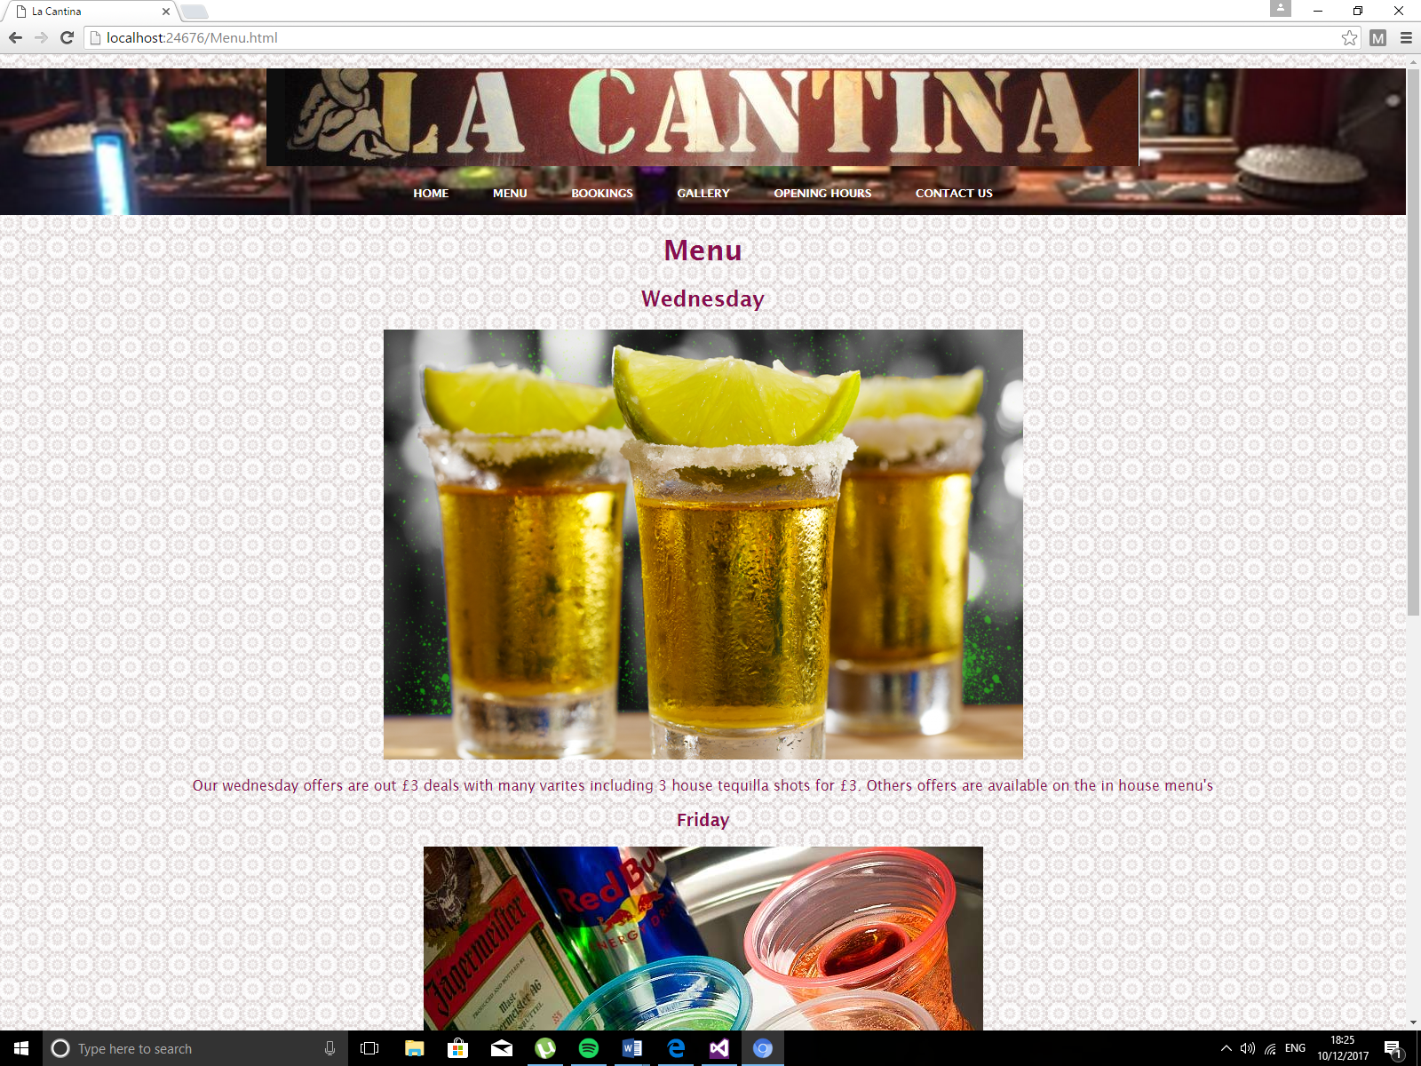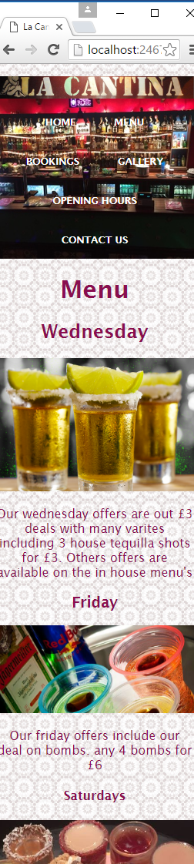
Above are screenshots of the menu page both in a large and small window as can be seen the page effectively displays the offers for each day the venue is open and does it in a responsive manner with all images and text reshaping appropriately. The page shows the 3 nights a week that the bar is open and then displays the main offers for that night along with a description the offer. The page also states that more offers are available inside the venue.
Bookings

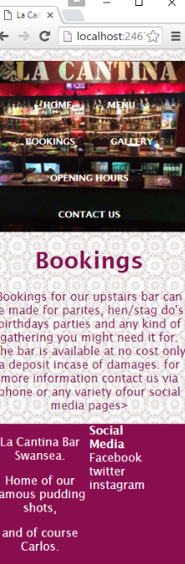
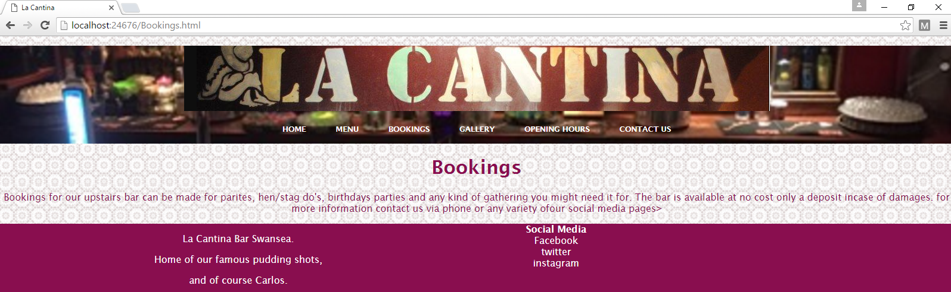
The third page of the website bookings is simply a paragraph with information concerning bookings. As can be seen the page does this effectively and responsively with the text the changing and reshaping effectively so that the page can be used in both large and small windows. Therefore, the page is responsive and fit for mobile.

Gallery
Unfortunately, when developing the gallery section of this report the author of this report was unable to fix an issue that appeared when it came to be testing the website for screenshots therefore this page would need to be revisited at a later date.
Opening times and contact us
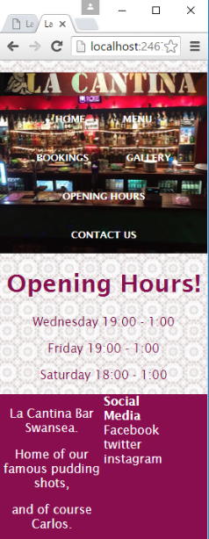
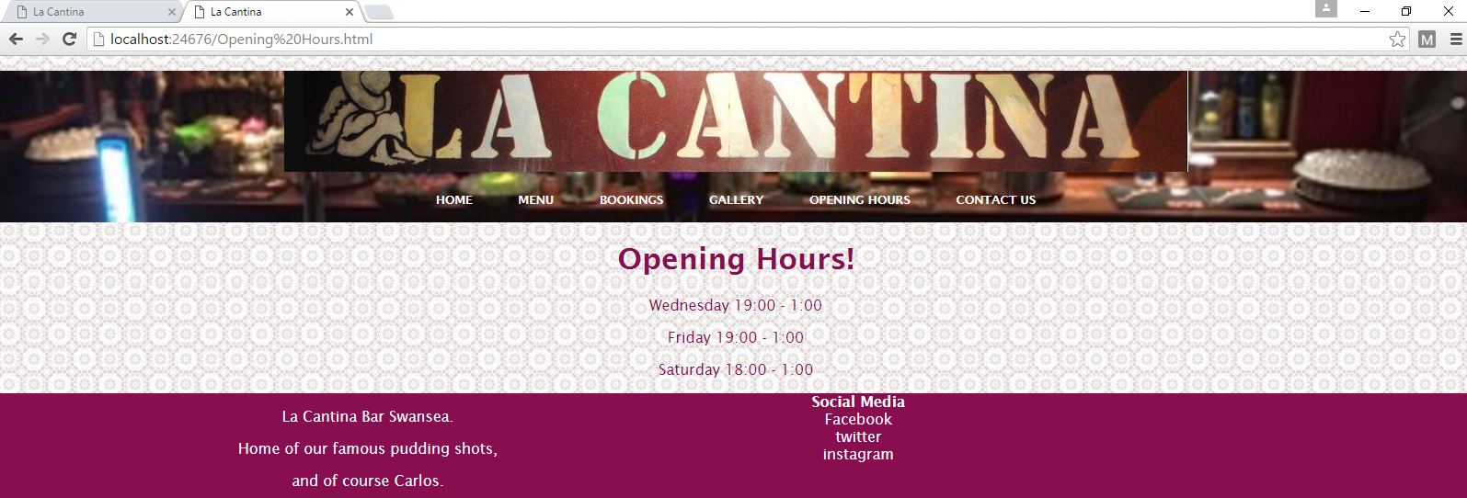
As can be seen by the screenshots above the website works effectively and responsively. The website effectively displays the days and times the venue is open. The contact us page is similar as the page only contains text and a button there fore it is also responsive and effectively does its purpose. It can be seen below.
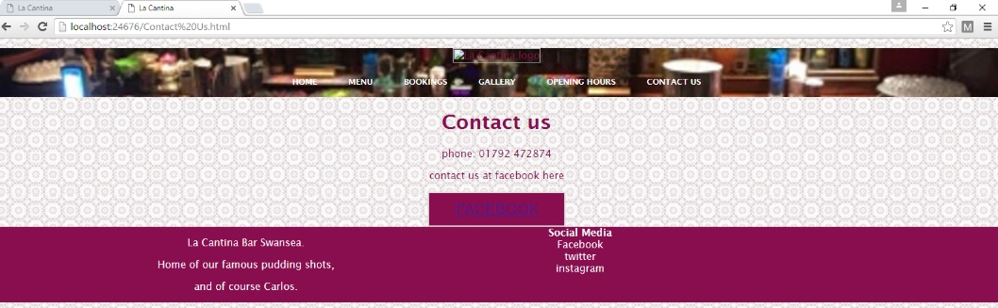
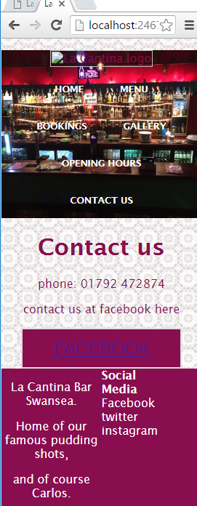

Evaluation
When developing this website, the author of this report came across a few errors when it came to ensure that website was responsible. Most of which came to finding images that were responsive and that were suitable for the website. Most of the images used are images taken inside the venue. Also, the issue that has restricted the author of this report discussing the gallery page from the website. This error is yet to be solved as the issue has only been uncovered when writing this report. Unfortunate due to time restraints the issue cannot be fixed before the deadline for this report.
Looking back on task 1 the developer of the website and author of this report believes that the task can be considered a success despite the errors that have found during this report. As the website (despite the gallery page) I completely responsive and works effectively. All the working pages do what they were intended to do and as such are a success. The brief tasked the author of this report to create a responsive website and the website creating for this report is exactly that a completely responsive website.
Despite this it is obvious that much could be improved with the website. The bookings page could be greatly improved by providing a platform for users to be able to make booking through the website by using a php booking system to connect the website to a server-side database. The gallery page could be greatly improved by ensuring that the page functions correctly. The contact us page could be improved by the system allowing the user to leave a message for the venue staff via the website. In future add more images to the website and use higher quality images and improve the overall design of the website to make it more drawing to users. Improve the websites footer to ensure that the links to the venues social media accounts work. Finally the author of the report feels that the website could be greatly improved both functionally and design wise by adding JavaScript to the website to add more features or design quirks.

marking criteria and Student FEEDBACK

This section details the assessment criteria. The extent to which these are demonstrated by you determines your mark. The marks available for each criterion are shown. Lecturers will use the space provided to comment on the achievement of the task(s), including those areas in which you have performed well and areas that would benefit from development/improvement.

Common Assessment Criteria Applied (Assignment 1) | Marks available | Marks  awarded
1. Research-informed Literature
Extent of research and/or own reading, selection of credible sources, application of appropriate referencing conventions.
Unfortunately, there is little or no evidence of the use of appropriate reference sources. The submitted work does not include a reference list or bibliography. The mark given is for the reference to the W3 schools website in the write-up. (Grade mark: 10.00%) | 5 | 0.5
2. Knowledge and Understanding of Subject
Extent of knowledge and understanding of concepts and underlying principles associated with the discipline.
Unfortunately, does not demonstrate a satisfactory understanding of responsive web design and applying a mobile first strategy. Although you have used percentage widths, there is no real implementation of responsive web design (RWD) concepts and the website is more of the much earlier, fluid layout, which is not a responsive web design. While the images do use one of the recommended settings for achieving responsive images, but because the rest of the RWD concepts are absent, there are some issues. To further illustrate the lack of RWD concepts, there is not even one media query in use in the implemented website. Media queries are at the core for achieving a responsive web design. Additionally, the implemented website lacks some basic website concepts - see comments under practical application and deployment. (Grade mark: 26.67%) | 15 | 4
3. Analysis
Analysis, evaluation and synthesis; logic, argument and judgement; analytical reflection; organisation of ideas and evidence
The provided evaluation of the implemented website is weak and does not really provide a critical review of the website. The challenges are not really described or discussed in detail, you simply mention that you had some errors on some pages and they are yet to be solved. The future recommendations are satisfactory. (Grade mark: 40.00%) | 15 | 6
4. Practical Application and Deployment
Deployment of methods, materials, tools and techniques; application of concepts; formulation of innovative and creative solutions to solve problems.
There was no submission for the class tutorial exercise, as such no marks have been awarded for this element of the assignment.  A basic attempt featuring a rather simple website. Unfortunately, the website does not implement RWD concepts and basic website features are not implemented correctly. For example, for your menu you have ended up with white text on a white background as you have not correctly implemented the background image. Most of the menu links are also not working - see your report for details. The core functionality and content of the website also needs to be improved. (Grade mark: 35.00%) | 60 | 21
5. Skills for Professional Practice
Attributes in professional practice: individual and collaborative working; deployment of appropriate media; presentation and organisation.
The report is of average standard. (Grade mark: 50.00%) | 5 | 2.5

Assignment Mark (Assessment marks are subject to ratification at the Exam Board. These comments and marks are to give feedback on module work and are for guidance only until they are confirmed. ) | Late Submission Penalties (tick if appropriate) |  | 34%
 | Up to one week late |  | 34%
 | 1st/2nd/3rd attempt? |  | 34%

