
Involvement of public sector in effective water usage and lowering water scarcity
BA Public Services

Module Name：corporate social responsibility in the public sector
Module Code：BMPS6004
student name：Lanxin Li
Student ID：1900865

Table of Contents
1.0 Introduction 2
2.0 Role of Public Sector in Facilitating Clean Water and Sanitation 2
3.0 The Initiative 3
4.0 Stakeholders of the Initiative 3
5.0 Involvement of Public Sector in the Initiative 4
6.0 Purpose of the Initiative 5
7.0 Assessment of the Initiative 6
8.0 Success of Transparency in Reporting 7
9.0 Conclusions 7
10.References 8

Introduction
CSR initiatives undertaken by public sector can have a significant impact in attaining the Sustainable Development Goals (SDGs) of UN because nearly half of the governments across the globe are involved in the supply of large quantities of important public goods and services. Additionally, it is also actively involved in boosting the private sector to promote CSR. Now CSR or Corporate Social Responsibility is defined by McWilliams & Siegel (2001) as a self-regulating model for business, which facilitates a firm to be socially answerable to itself, all its stakeholders and the society on a whole. The SDGs were adopted by the member states of UN in 2015 for ending poverty, protecting the planet and ensuring prosperity and peace by 2030 across the globe (UNDP, 2020).
The UN inspires the public sector to initiate efforts of minimising the adverse impact on the environment. Presently, two-third of the world population does not have basic parameters of SDG measurements on sanitation facilities, safe access to drinking water and hand washing, thus requiring immediate attention (Obeng, 2020). In this regard, the aim of the underlying essay is to assess the importance of the involvement of public sector in provision of clean water and sanitation, with specific reference to addressing the issue of water scarcity and effective utilisation of water.

Role of Public Sector in Facilitating Clean Water and Sanitation
Public sector is defined by Tucker (2011), as an amalgamation of government along with other publicly funded or controlled parastatals, enterprises, agencies and other entities delivering public goods, services and programmes. As discussed above, public sector is not only responsible for its involvement in enhancing the condition of the environment and the society but also has to regulate the CSR initiatives of the private sector. As described in a report by United Nations (2018), regulations, license to abstract water and dispose and provision of services are extended operations of the legislative system. It is the right of the public sector comprising of regulators and line ministries, wherein, as argued by Braadbaart (2012), a crucial role of the regulators would be monitoring initiatives or benchmark of operators for improving the ability and inspire competitive pressure for complying with the high standards of performance.
As shown in a report by World Bank (2004) a decline in the interest of private sector towards CSR would compel the public sector to motivate the private sector, especially things involving investments. It is due to this reason that majority of the public-private partnerships (PPP) have public sector funding majority of the portion. Furthermore, private sector was seen to finance only 10% of the investments in sanitation and water supply in developing nations. This is primarily due to sustainability issues related to reforms required in sanitation and water supply sector. Hence, majority of the consumers of the world are connected to numerous networks owned and operated by public utilities, with public funding being the major source of funding for expanding sanitation facilities and supply of water. Due to the high financial burden on the public sector, it is advised that instead of subsidizing the installation of hardware by the individuals, the government should invest in promoting sanitation, thus increasing its demand.

The Initiative
The initiative specifically focusses on usage of water and its scarcity. As shown in a report by UN (2017), target 6.4 aims at maintaining sufficient water for all, the environment as well as the economy by raising the efficient usage of water across different sectors of the society by 2030. Furthermore, emphasis was on sustainable withdrawal as well as supply of freshwater to lower the frequency of people suffering from water scarcity. Agricultural industry is the biggest consumer of water, responsible for 70% of its withdrawals and managing this activity itself can significantly lower water scarcity. Due to this reason, Lambooy (2011) shows that several tools have been generated to lower the corporate use of freshwater. One such water reporting instrument is the 2007 Global Water Tool, which was unfortunately suspended in 2019. However, India Water Tool (IWT) was developed later along with the mandatory disclosure of ‘water footprint’ of firms to help developing countries like India. This process would involve quantifying the water usage of the firms and disclosing it. As shown in a report by McKinsey (2009), big corporations can lower the water usage in their respective operations through effective cooling systems, utilising wastewater, reuse and reduction in leakages. Additionally, firms can try to relocate plants away from regions facing water scarcity.

Stakeholders of the Initiative
Water scarcity has two dimensions, how much water and where. The people involved in this initiative ranges from the industries, to the employees, to the society on a whole. Industries require water for their machinery, packaging and products and employees. However, according to Chaklader & Gautam (2013), implementing costly methods of conservation will not serve the purpose, instead firms must understand their water requirements in comparison to the availability of water in the locality.
According to Phelan (2013), image-conscious firms that are managing water inefficiently would be subjected to increased costs as well as the operational risks arising from it. This would be followed by regulatory and reputational perils, along with risking the employees’ health, product and market risk as well as financial risks imposed by investors. As part of the National Water Mission undertaken by Indian government for mitigation of risks of water scarcity, 14 firms from various sectors collaborated with world Business Council for Sustainable Development (WBCSD) for developing India Water Tool, which would benefit all the stakeholders. In addition to helping firms control their utilisation of water, it would also assess the sites wherein there is a breach of quality standards of national drinking water, in terms of salinity, fluoride, nitrate, iron, arsenic and chloride content. IWT2 is a platform based on GIS-web that integrates 14 datasets provided through the Central Pollution Control Board, Ministry of Water Resources, India Meteorological Department and Central Ground Water Board, along with the stress parameters from Columbia and WRI (CII Water Institute, 2019).

Involvement of Public Sector in the Initiative
Public sectors across the globe are responding to the afore-mentioned challenges of measuring the “water footprint” of firms. One such proposal is highlighted by Phelan (2013), wherein the Indian government proposed essential modifications in water management strategies. It comprises of large-scale reforms in irrigations, development of a water database and participatory aquifer management. Furthermore, enhanced efficiency of water utilisation in the industries is amongst the top features of the proposal. The government also proposed to make it compulsory for firms to contain data about water footprint in the annual reports. Additionally, public sector plays an important role in the provision of data for the development of the India Water Tool, as the tool relies on groundwater data provided by the government on block-by-block source (WBCSD, 2019). This initiative by the public sector helps in value addition to the tools and models of each firm dealing with management of water. The real-time data provided by the public sector has helped firms address their water footprint. Figure 1 below highlights the way, government sector administers IWT for water governance.
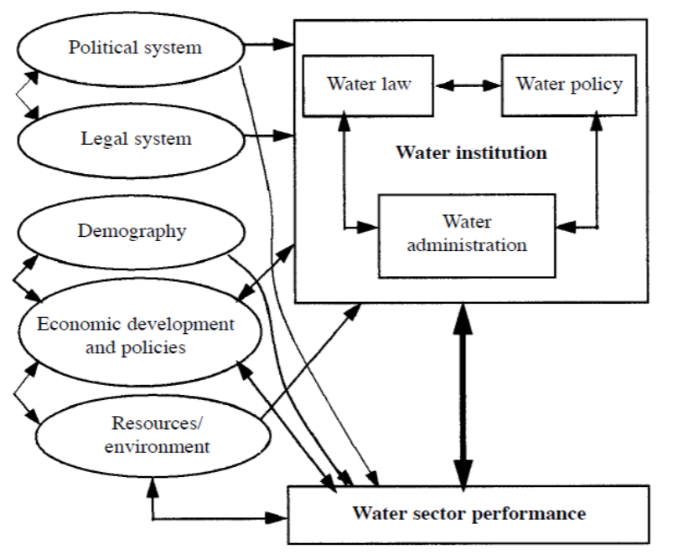
Figure 1 (Role of Public Sector in Water Governance)
Source: (Ahmed & Araral, 2019)

Purpose of the Initiative
The Water Tool under discussion is Indian-specific and according to Phelan (2013) helps firms recognise the potential availability of water and risk in quality across different sites. The purpose initially was to enhance quality and availability of groundwater. For instance, it would shed light on the number of sites of the firms and the percentage of the production over-exploiting water resources or the critical aquifers.
As shown in a report by WBCSD (2019), businesses have been facing considerable risks doe to scarcity of water but simultaneously have enough opportunities to gain from the acknowledgement of this challenge. The sustainable management of water involves availability of data with adequate granularity to the general public, which is possible with the IWT 3.0. The widespread applicability of the tool has resulted in over 300 firms from diverse industries joining it in a span of just two years.

Assessment of the Initiative
India Water Tool is regarded as a first step in the strategy of corporate water management and should be complemented with a complete water stewardship approach, identified clearly in the core business, along with becoming a part of social investment. The recent modification in the tool has made it user-friendly, thereby making water data from public sources and other firms available to all the stakeholders. As shown by Phelan (2013), the tool helps in assessing new projects. For instances, the maps and charts developed by the tool facilitates the companies to enhance their communications regarding water risk, using internal guidelines and policies. The results obtained are used by some firms for educating the supply chain partners and assessing the needs of capacity building and training. While the remaining firms work towards improving publicly disclosed water goals, for better alignment with the concerns of specific regions and risks, which are dependent on the insights achieved through the application of the India Water Tool. To conclude, IWT is a good example of businesses collaborating successfully to address the issues around water and sanitation. Its constant update is proof to its adoption by firms and the rising demand for this tool, which is compelling the makers to update it, as per the changing demands.
However, the 100 most water-intensive firms across the globe have an issue of poor management and disclosures in terms of the opportunities and risks associated with water issues. In this regard, a study by Lambooy (2011) indicated that firms should ideally bear the responsibility of their adverse influence on water bodies, specifically, when it tends to affect the access of public for water resources in regions with scarcity of freshwater or/and weak public sector. The central role in water management is held by the public sector, as majority of the nations are dependent on it for provision of water services. However, this was not free of loopholes and resulted in disputes regarding water quality, efficiency of supply along with reliability of services. According to Comair, et al. (2013), even in developed nations, the competency of public sector was less than private systems. In this regard, it is necessary that for coordination, provision of oversight an fulfilment of the legislative mandate, public sector should engage in creation of accountable and empowering policy, as well as a regulatory environment for all the entities belonging to the non-state category, thereby ensuring that they facilitate affordable facilities, thereby improving the sanitation demand in their constituencies (Mulumba, et al., 2014).

Success of Transparency in Reporting
According to WBCSD (2019), since its inception, the tool has been updated twice to increase its usability. It provides real-time data on water management of firms captured through US Geological Survey (USGS) and NASA. It also enhances the reporting through measures like questionnaire dealing with Carbon Disclosure Project’s Water. The initiative also proposes to make comprehensive audits of water utilisation a recurrent affair of the industrial activities, which would focus on both quality as well as quantity of the efforts. Additionally, it enhances the transparency of reporting by providing data from as microscopic level as watersheds to macro-level of national data. This would help in providing a complete picture of the health of the watershed, which in turn can help in determining the likelihood of recharge of water, as well as management of the demand for it. This would play an important role in solidification of the Indian water management system at a local level in a sustainable manner. This step would be followed by ranking of necessary actions in water-scarce sites, detailed assessments of the site, environmental tracking of data at internal level and assessment of future projects.

Conclusions
The aim of the underlying essay was to assess the importance of the involvement of public sector in provision of clean water and sanitation, with specific reference to addressing the issue of water scarcity and effective utilisation of water. For this purpose, the report analysed the implementation and progress of India Water Tool, developed in 2017 to address the issue of water scarcity in a developing economy like India. The public sector played a crucial role in its successful implementation by provision of dataset to the stakeholders for assessment of each firm’s water management. Additionally, the tool also intimated the firms about the quality of drinking water in their localities for them to take prompt actions. The modification of the tool has only enhanced its ability to provide large dataset quickly and efficiently. Hence, it can be concluded that public sector plays an important role in not just executing the CSR initiatives to attain SDGs but also has the additional responsibility of regulating private sector firms towards fulfilment of the development goals.

10.References
Ahmed, M. & Araral, E., 2019. Water Governance in India: Evidence on Water Law, Policy and Administration from Eight India States. Water, XI(10), pp. 2071-2090.
Braadbaart, O., 2012. North-South Transfer of the Paradigm of Piped Water: The Role of the Public Sector in Water and Sanitation Services. In: Water and Sanitation Services. Washington DC: Routledge, pp. 99-113.
Chaklader, B. & Gautam, N., 2013. Efficient Water Management through Public-Private Partnerhsip Model: An Experiment in CSR by Coca-Cola India. Vikalpa, XXXVIII(4), pp. 97-104.
CII Water Institute, 2019. India Water Tool. [Online]
Available at: http://www.cii-twi.in/india-water-tool.html
[Accessed 14 April 2020].
Comair, G. F. et al., 2013. Water Resources Management in the Jordan River Basin. Water and Environment Journal, XXVII(4), pp. 495-504.
Lambooy, T., 2011. Corporate Social Responsibility: Sustainable Water Use. Journal of Cleaner Production, XIX(8), pp. 852-866.
McKinsey, 2009. The Global Corporate Footprint: Risks, Opportunities and Management Options. [Online]
Available at: https://www.mckinsey.com/~/media/mckinsey/dotcom/client_service/Sustainability/PDFs/Report_Large_Water_Users.aspx
[Accessed 11 April 2020].
McWilliams, A. & Siegel, D., 2001. Corporate Social Responsibility: A Theory of the Firm Perspective. The Academy of Management Review, XXVI(1), pp. 117-127.
Mulumba, J. N., Nothomb, C., Potter, A. & Snel, M., 2014. Striking the Balance: What is the Role of the Public Sector in Sanitation as a Service and as a Business?. Waterlines, XXXIII(3), pp. 195-210.
Obeng, P. A., 2020. Factors Associated with Perception of Bad Odor by Users of Ventilated Improved Pit Latrines in Cape Coast, Ghana. International Journal of Energy and Water Resources, IV(1), pp. 55-62.
Phelan, J., 2013. Indian Industry Collaborates on Water Management to Increase Transparency. [Online]
Available at: https://www.theguardian.com/sustainable-business/indian-industry-water-management-transparency
[Accessed 11 April 2020].
Tucker, I. B., 2011. Economics for Today. 7th ed. Mason: South-Western Cengage Learning.
UN, 2017. Target 6.4-Water Use and Scarcity. [Online]
Available at: https://www.sdg6monitoring.org/indicators/target-64/
[Accessed 10 April 2020].
UNDP, 2020. Sustainable Development Goals. [Online]
Available at: https://www.undp.org/content/undp/en/home/sustainable-development-goals.html
[Accessed 1 April 2020].
United Nations, 2018. Sustainable Development Goal 6: Synthesis Report on Water and Sanitation, Geneva, Switzerland: UN.
WBCSD, 2019. India Water Tool 3.0 – New and Improved Platform for Stakeholders to Mitigate and Manage Water Risk in India. [Online]
Available at: https://www.wbcsd.org/Programs/Food-and-Nature/Water/News/New-and-Improved-Platform-for-Stakeholders-to-Mitigate-and-Manage-Water-Risk-in-India
[Accessed 13 April 2020].
World Bank, 2004. Public and Private Sector Roles in Water Supply and Sanitation Services, Washington DC: The World Bank group.

