Ensure you have a suitable environment open, and that you have a working instance of Jupyter Notebook.

- Open Anaconda Navigator and ensure you are in the environment that you set up. Click ‘Launch’ on the Jupyter Notebook tab.
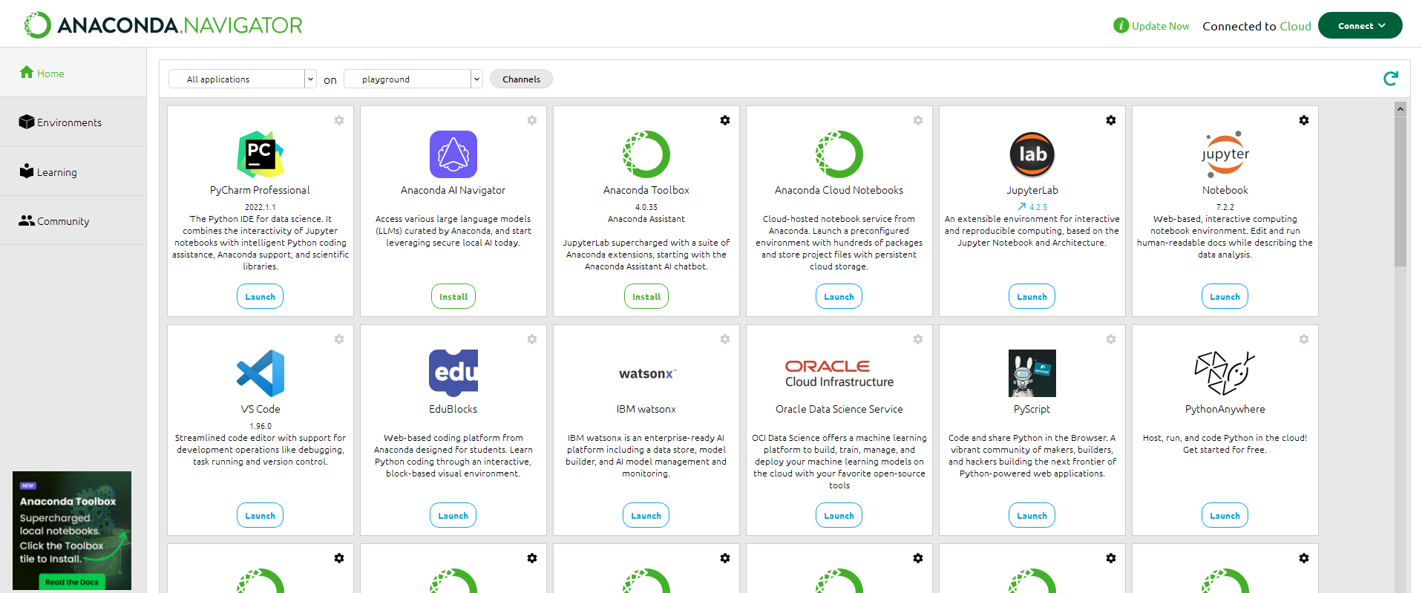

- Once the Jupyter Notebook tab opens in a browser window, choose ‘New’ and in the dropdown menu choose ‘Python 3 (ipykernel)’.
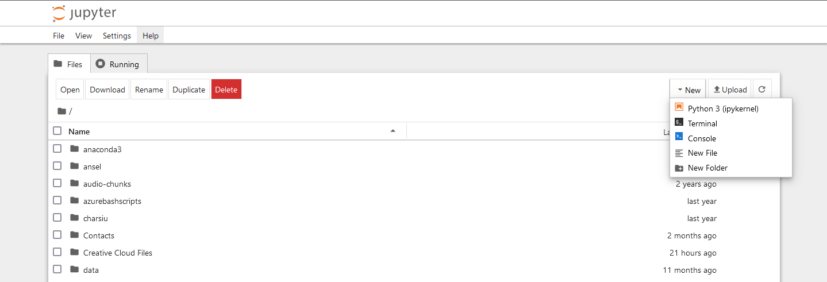

- Once a notebook window is opened, you can start coding. Ensure ALL CODE is typed from the GREYED CELL in the images.
Firstly import the packages you will need. For this tutorial you will need:
  - Numpy
  - Pandas
  - train_test_split (from sklearn.model_selection)
  - GradientBoostingClassifier and GradientBoostingRegressor (from sklearn.ensemble).
  - Metrics (from sklearn)

Numpy, Pandas, Seaborn and matplotlib.pyplot (see next step) will be imported using an alias (a variable to use in stead of the full name). This will be quite common with several packages. Importing packages will always be the first step. Once you have coded a cell in Notebook, you will need to click the ‘run’ button to run that cell (looks like a play button, see below).

import numpy as np
import pandas as pd
from sklearn.model_selection import train_test_split, GridSearchCV
from sklearn.ensemble import RandomForestClassifier, RandomForestRegressor
from sklearn import metrics

- As a note, remember you can name your notebook to be saved for later reference.

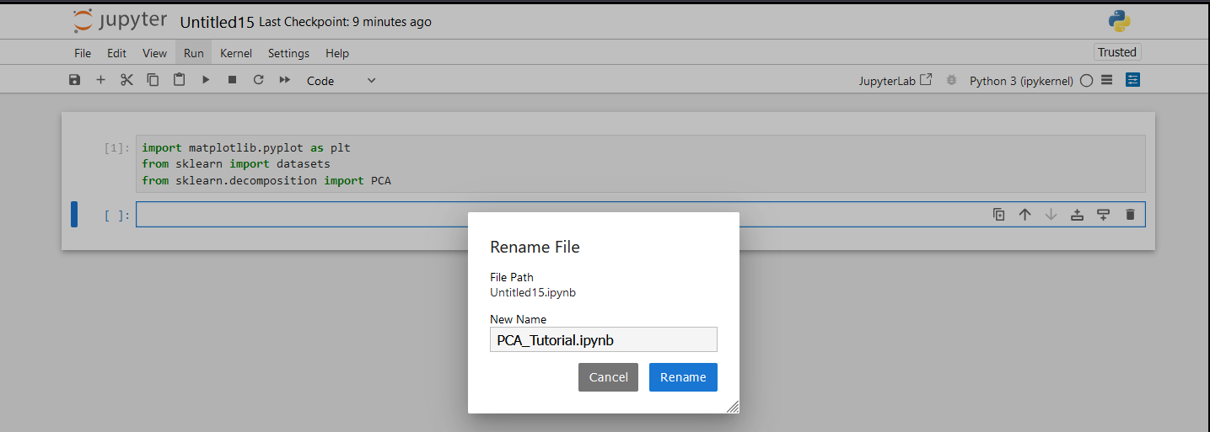

- Run the following cells to show the parameters that can be fine tuned for both the regressor and the classifier. Run the cells.
# this step is just to demonstrate the adjustable parameters within the algorithm and not a necessary step
# Specifically look at n_estimators (how many individual trees to build) and max_depth (how deep each tree will go)
# Also notice in this classifier we will use a learning rate as discussed in the lecture
GradientBoostingClassifier().get_params()

# this step is just to demonstrate the adjustable parameters within the algorithm and not a necessary step
GradientBoostingRegressor().get_params()

From the lectures, which parameters do you recognise?
What do these parameters do?

- Load the diabetes dataset that should already be downloaded from a previous tutorial. This can be downloaded from Moodle if you do not have it. Set it to a suitable folder and use that folder for the path (ideally the folder you are in as shown in the example). Check the size and shape of the dataset as we explore it. Run the cell.
# load the dataset (stored in a variable)
diabetes = pd.read_csv('./diabetes.csv', sep=',',header = 0)

print ("The length of the dataset is ", len(diabetes))
print("The shape of the dataset (Number of columns / features) is ", diabetes.shape)

How many datapoints does the dataset have (What is its size)?
How many attributes does the dataset have(What is its shape)?

- While we explore the dataset we can look at the data as we did previously with the head() method. Run the cell.
diabetes.head()

Enter 10 or 20 as a parameter within the brackets. What happens?

- Also we will explore the information of the data. Run the cell.
diabetes.info()
What does this show you?
What does it all mean?
- Now split the dataset into train and test sets using train_test_split() method and set it to a 20 / 80% split, random_state will allow it to randomly split the set as opposed to splitting it in a linear form. We will also print the info of the train set here too. Run the cell.
# split the data into train and test using the SciKitLearn package
train,test=train_test_split(diabetes,test_size=0.20,random_state=42)
# view the information
train.info()

What do you notice different to the last info that you printed?
Try different splits like 25 / 75.

- Now we need to take the labels / classifications and set them to their own variable (y). Then we need to remove them from the main dataset by dropping the column. We will also drop irrelevant columns and set the rest of the dataset to its variable X. We will do this for the train and test set. Lastly we will test the info again, this time on the test set. Run the cell.
# Ensure only labels are saved in y variables
y_train=train['Outcome']
y_test=test['Outcome']
#drop the unwanted / irrelevant columns, features are stored in X variables
X_train=train.drop(['PatientId','Outcome'],axis=1)
X_test=test.drop(['PatientId','Outcome'],axis=1)
# view the information
X_test.info()

What do you notice this time with entries?
What is different?

- At this point, to make it easy for us to read the headings and labels, we need to extract the labels away into a numpy array. We will also do this for the numerical attribute values and show the headings by slicing the columns so we can caption the tree splits. Run the cell.
#extract labelled results
mtarget = diabetes["Outcome"].values
mtarget = np.array(mtarget, dtype='int') #array of class targets results Has diabetes=1, Does not have diabetes=0
values = np.array(diabetes.values,dtype='int') #array of attribute values for training data
values = values[:,1:9] #slice-> cols 1,2,3 and 4 kept. cols 0 and 9 excluded.
targetNames=['Diabetes','No Diabetes']
feature_names=list(diabetes)

feature_names=feature_names[1:9] #slice-> cols 1,2,3 and 4 kept. cols 0 and 5 excluded.
feature_names

- Now we are ready to create a model. We will create a classifier algorithm first using the default parameters. This will be stored in a variable. We can then fit the training data to the model to train it using our created variables, ‘values’ (attributes) and ‘mtarget’ (labels). Run the cell.
# Set a model into a variable
gb_clf = GradientBoostingClassifier()
# Fit the data to the model
gb_clf.fit(values, mtarget)

- Predict with the model using the test dataset (only the data) and print the predictions. We can then print the length too. Run the cell.
# Test the model
y_pred_gb = gb_clf.predict(X_test)
print(y_pred_gb)
len(y_pred_gb)

Want does the prediction look like?
How many predictions were made?

- We can print the test labels (the ground truth) to see what the predictions should look like. Run the cell.
print(y_test)

- We now evaluate the model’s predictions against the ground truth test data using metrics from sklearn (One code example is shown, figre out what to replace to create the results output for the default model). The metrics show how accurate and precise the model is through the confusion matrix and classification report, as well as showing the recall and f1-score as we learned in the data lectures. Run this cell for both predictions.
# display the metrics of the model's classification through confusion matrix and classification report
# (accuracy / precision / recall / f1)
print(metrics.confusion_matrix(y_test, y_pred_gb))

print(metrics.classification_report(y_test, y_pred_gb, digits=3))

How accurate is the model overall?

- We will now use Pandas to create a dataframe for each model (one code example is shown, figure out what to replace to create the default dataframe). This will allow us to view the predictions and ground truths side by side. It will also allow us to generate a heatmap confusion matrix. Be careful with variable names here for the reasons mentioned above. Run this cell for both dataframes.
# use Pandas to create a dataframe to view the ground truth and classifications side by side
data = {'Actual': y_test,
'Predicted': y_pred_gb }
df = pd.DataFrame(data)
print(df)

What do you notice from the output?

- Now using Seaborn and matplotlib.pyplot (we need to import these still), we can generate a heatmap confusion matrix from the dataframe and plot it using matplotlib.pyplot. For the fun of it we will reprint the classification report too. We can do this for both models, figure out how. Remember you only need to import packages once though. Run the cells.
# Use Seaborn to create a confusion matrix heatmap and MatPlotLib to display
import matplotlib.pyplot as plt
import seaborn as sn
confusion_matrix = pd.crosstab(df['Actual'], df['Predicted'], rownames=['Actual'], colnames=['Predicted'])
sn.heatmap(confusion_matrix, annot=True)
plt.show()
print(metrics.classification_report(y_test, y_pred_gb, digits=3))

- Now let’s figure out the best parameters for classifier. Let’s use the default algorithm and change the n_estimators and max_depth parameters (you can change as many as you want) using cross validation. First create the function for running the results. Run the cell.

def print_results(results):
print('The Best Parameters are: {}\n'.format(results.best_params_))
means = results.cv_results_['mean_test_score']
stds = results.cv_results_['std_test_score']

for mean, std, params in zip(means, stds, results.cv_results_['params']):
print('{} (=/-{}) for {}'.format(round(mean, 3), round(std * 2, 3), params))

- Then create the arrays of parameters we want to change and create the cross validation variable using GridSearchCV. Fit the algorithm with the data and print the results. Run the cell.
parameters = {
'n_estimators' : [5, 50, 250],
'max_depth' : [2,4,8,16,32, None]
}

cv = GridSearchCV(gb_clf, parameters, cv = 5)
cv.fit(values, mtarget)

print_results(cv)

What are the best parameters to use?
What is the best accuracy from these parameters?

- Let’s take a look at how the training scores and the cross validation scores compare. For this we will import learning_curve from sklearn.model_selection. We will then create three new variables using the new import for sizes and scores (train and test (validation)). Run the cell.
from sklearn.model_selection import learning_curve
train_sizes_gb, train_scores_gb, test_scores_gb = learning_curve(GradientBoostingClassifier(), values, mtarget, cv=10, scoring='accuracy', n_jobs=-1, train_sizes=np.linspace(0.01, 1.0, 50))

- Then set variables for the mean and standard deviations using numpy arrays. Run the cell.
train_mean = np.mean(train_scores, axis=1)
train_std = np.std(train_scores, axis=1)

test_mean = np.mean(test_scores, axis=1)
test_std = np.std(test_scores, axis=1)

- Create the graph / plot using matplotlib.pyplot (using the alias plt).
plt.subplots(1, figsize=(10,10))
plt.plot(train_sizes_gb, train_mean_gb, '--', color="#111111", label="Training score")
plt.plot(train_sizes_gb, test_mean_gb, color="#111111", label="Cross-validation score")

plt.fill_between(train_sizes_gb, train_mean_gb - train_std_gb, train_mean_gb + train_std_gb, color="#DDDDDD")
plt.fill_between(train_sizes_gb, test_mean_gb - test_std_gb, test_mean_gb + test_std_gb, color="#DDDDDD")

plt.title("Learning Curve")
plt.xlabel("Training Set Size"), plt.ylabel("Accuracy Score"), plt.legend(loc="best")
plt.tight_layout()
plt.show()

What is the grey area in this plot?
What can be seen and diagnosed from this graph?
What do the trends mean in this graph?
How would you interpret this?

