Is there a significant association between gender and university course choice?
Chi-square for independence between Psychology and Computing students.
ECPS4010

Abstract
Gender segregation within certain academic fields has been known to exist for many years now. An example of this would be within psychology and computing, it’s said that computing tends to be male dominated whereas psychology tends to be female dominated (Radford, 1995). There have been studies and critical reviews carried out to find out why this phenomenon occurs (Biemmi, 2015, & Jiang, 2017). The research wanted to further investigate this topic, so a study was carried out. The aim of this study is to further investigate whether there is a significant association between gender and course choices, the course choices being psychology and computing. From the aid of previous literature, the researcher hypothesise was that females are significantly more likely to choose psychology as a course, and males are significantly more likely to choose computing as a course. A chi² was used to calculate the results, and it was found that there was no significant association between gender and course choice X²(1, N = 32) = 3.14, p> .05, thus contradicting much of the previous literature. Limitations and future directions are discussed in relation to course options and options for gender.

Introduction
There are many academic fields that experience gender segregation. Research was carried out looking at two fields, computer studies which can be regarded as male dominated and psychology which can be regarded as female dominated. Both fields have changed drastically in content and methods over the last few years. However there have not been any sufficient attempts in explaining gender segregation differences in cognitive abilities. On the other hand, personality factors have been given more attention. The goal of the study is to investigate the relationship between student aims and gender segregation within computing or computer studies and psychology students. Key aspects that will be looked at are the comparative significance of personal and social variables compared to cognitive abilities. Furthermore, it looks at how ‘masculine’ the females that take a computing degree are and how ‘feminine’ the males that take a psychology degree are (Radford, 1995).
The results from the findings firstly suggest that gender segregation needs to be understood in the terms of personality, social differences, interests as well as cognitive abilities. And that the former individual differences may perhaps be the most important. Secondly within a highly segregated field there tend to be differences within gender characteristics with the minority genders within that field. An example of this would be a female taking a computing degree, dominated by males may be more ‘masculine’ in their interests and possibly in some of their personality traits compared to the average female student. The results of the study held well with both personality and cognitive abilities in computing, however psychology held well for cognitive abilities but personality characteristics not so much (Radford, 1995).
Furthermore, a critical review was done to review the most common factors in explaining the gender discrepancies within Science, Technology, Engineering and Mathematics (STEM). This was done to see why women are more present in some STEM’s than others. As research shows that women acquire more than half of the U.S. undergraduate degrees in chemistry, biology, and math. While there are less than 20% of women taking Physics, Engineering, and computer science degrees. A model was introduced with three overarching factors, this was not to try and explain the large gender gap in the participation in engineering, physics, and computer science compared to mathematics, chemistry, and biology. From this it was discovered that because of a lack of early exposure and experience with engineering, physics, and computer science created a gender gap in self-efficacy. If there were attempts in increasing women’s participation on these subjects as well as changing the strong stigma around masculine culture, this may potentially benefit with the gender gap within these subjects. Early experiences for both boys and girls with signals of equal belonging with positive reinforcement for success can be a start in changing masculine culture regarding these subjects (Jiang, 2017).
Cultural factors can also play a part in gender segregation, which in turn can affect choses within life and education. There was research done looking at gender in schools and the culture within Italy. Gender inequality continues to be a prominent aspect within the Italian education system. The writer argues that gender stereotypes within education do not only negatively influence female students but also male. Within Italy’s educational system there’s still misogyny that influences males to take more masculine subjects and females to take more feminine subjects. This was not only found within Italian education but also found within other countries. One of the most prominent reasons this phenomenon happens is because of the type of high school (HS) they go to (general HS, technical HS, and vocational HS). Females make 48.6% of the total enrolment, however the enrolment distribution is not equally distributed as it’s based on the type of school they go to. The segregation of gender is so extensive that the field of study they go into is determined within the different schools (Biemmi, 2015). An example of this would be social science HS and language arts HS will enroll mostly girls so the subject will be female dominated, whereas technical HS’s will be dominated by males because of the enrolment process (Biemmi, 2015).
The aim of this study is to further investigate whether there is a significant association between gender and course choices, the course choices being psychology and computing. From the literature above, the researcher hypothesise was that females are significantly more likely to choose psychology as a course, and males are significantly more likely to choose computing as a course.
Methods

Participants
Thirty-two undergraduate students were recruited via opportunity sampling to take part in this study (15 male and 17 female). Participants took part in this study during a module workshop, this was done within one psychology class and one computing class. The age ranged between 18 and 43. The mean age of participants was 25.91, with the SD (standard deviation) being 6.12.

Design
The variables included in this study were categorical, and therefore a chi-square test for independence was used to explore the association between these variables. The first variable was gender (Male or Female) and the second carriable included in the study was current university course (Psychology or Computing).

Materials
Participants were asked to record their gender, age, and indicate the course they were currently studying on. The choices were between Psychology and Computing. This was done using Qualtrics. A consent and debrief form were created this can be found within Appendix 1 (consent) and 2 (debrief)

Procedure
Date collection took place during a module workshop. One psychology module lead introduced the study during a scheduled class and one module lead from the discipline of computing did the same. During the workshop, participants were provided with a brief oral description of what that study would entail. Participants were informed that they would be required to give consent and complete the three questions contained on Qualtrics (found in Appendix 3). After the completion of the task, they were debrided on the aim of the study. Once data collection had taken part in both classes, the researcher summarized the data into one excel document ready to distribute for analysis.

Results

After the collection of the data the researcher summarized the data into an excel document, this can be found within Appendix 4. A chi-square for independence was calculated (Appendix 5) to explore the association between gender and university course. The Formula for the calculation was X²(1, N = 32) = 3.14, p> .05. This shows that there was no significant association between gender and university course, therefore the hypothesis that females are significantly more likely to choose psychology as a course, and males are significantly more likely to choose computing as a course must be rejected.

Discussion

This study hypothesised that females are significantly more likely to choose psychology as a course and males computing. However, as shown above this hypothesis must be rejected as the findings of this study have proven that there is no significant association between gender and course choice. Due to the results found showing that there is no association between gender and course choice this contradicts previous findings found within the literature.
Biemmi (2015) research looked at gender and culture within schools in Italy. Research found that there is misogyny that influences students’ choice of subjects and that this was also found within other countries. Furthermore, it was said that the type of school peoples went to influence the field of study they would go onto. However, this may not be the case for the educational system within the UK as the results found would have been different according to this research.
Another piece of contradictory literature is a critical review done on gender discrepancies in Science, Technology, Engineering, and Mathematics (STEM) by Jiang (2017). This review suggested that the lack of early exposure in engineering, physics, and computer science is a potential reason for gender segregation in these subjects. And that with early experiences available for boys and girls from a young age will help with the change in masculine culture within these subjects. Although this piece of literature contradicts the findings, the suggestion for change regarding the viewpoint of masculine and feminine subjects may have influenced the progression of education thus influencing the findings.
Like other studies there are many strengths and limitations to this study. The strengths being that it was a relatively easy study, it was ministered online with dichotomous choices. Participants were asked three questions: gender, age, and course. However, a weakness of this study could potentially be that there were not enough course choices available. The aim of this study was to examine whether there was a significant association between gender and course choice but there was a choice only two options for course choices. Findings by Turner et al (1999) shows that there are gender gaps in many subjects such as Humanities, economics, and other sciences etc. This study can be improved by having more course choices available. Another potential limitation being the choices for gender. Within the questionnaire there were three options for gender: Males, Female and other. This could be improved by having more options such as nonbinary.
In conclusion, the findings from this study found that there is no significant association between gender and course choice. Although changes to this study can be made, the results from this study have shown that there is no gender gap between psychology and computing students, suggesting that there is more of an equal gender distribution within these subjects.

Reference list:

Biemmi, I. (2015). Gender in Schools and Culture: Taking Stock of Education in Italy. Gender and Education, 27(7), 812-827. https://doi.org/10.1080/09540253.2015.1103841

Jiang, L., Cheryan, S., Ziegler, S. A., & Montoya, A. K. (2017). Why Are Some STEM Fields More Gender Balanced Than Others?. Psychology Bulletin, 143(1), 1-35. http://dx.doi.org/10.1037/bul0000052

Radford. J, & Holdstock. L. (1995). Gender Differences in Higher Education Aims between Computing and Psychology Students. Research in Science & Technological Education, 13(2), 163-176. http://www.tandfonline.com/action/showCitFormats?doi=10.1080/0263514950130206

Turner, S. E., & Bowen, W. G. (1999). Choice of Major: The Changing (unchanging) Gender Gap. Journal Sage pub. Choice of Major: The Changing (Unchanging) Gender Gap (sagepub.com)

Appendix:
Appendix 1)
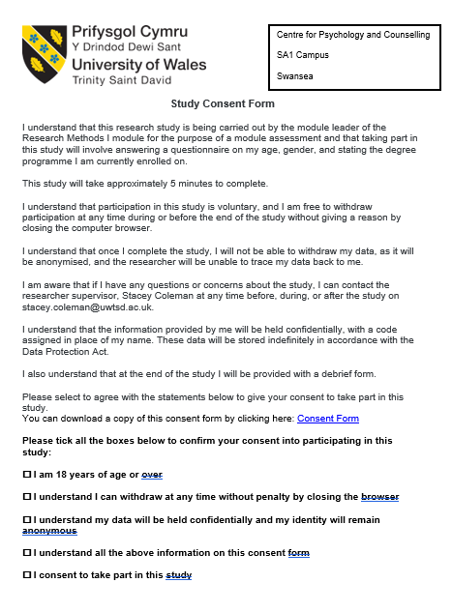

Appendix 2)
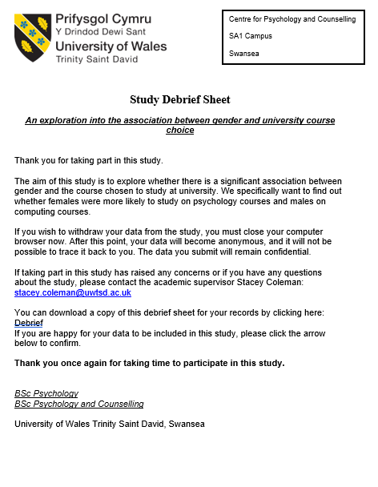
Appendix 3)
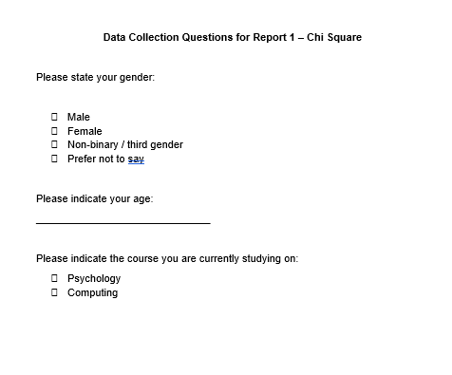

Appendix 4)
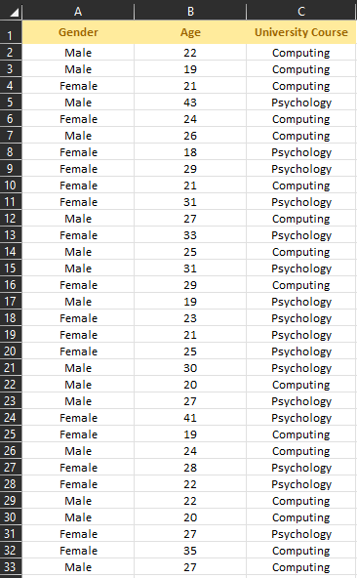

Appendix 5)


