DS 1 Template

My Screenshots/Photos
- Please add 4–6 screenshots or photos of your digital life.
- You can use your phone or laptop.
- For each screenshot, write one or two sentences explaining what it shows.

Screenshot/Photo 1
Facebook
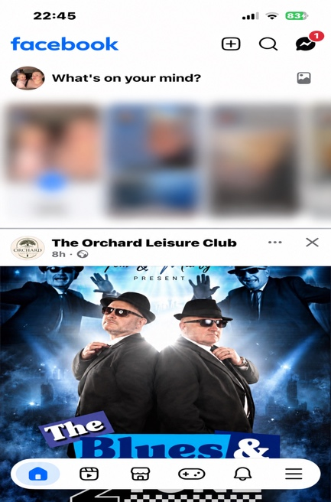
This app keeps me up to date with events/social activities that are happening around me. I also use this app to keep in contact with family/friends.

Screenshot/Photo 2
Outlook
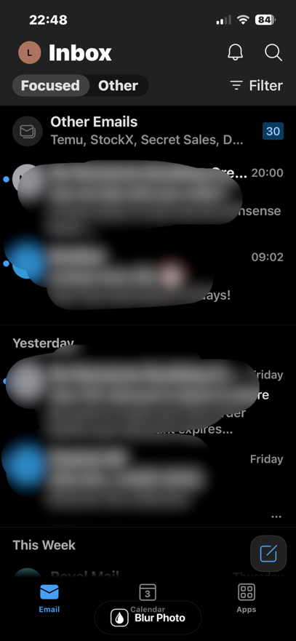
This app I use on a regular basis as it’s where I receive all my emails on.

Screenshot/Photo 3
WhatsApp
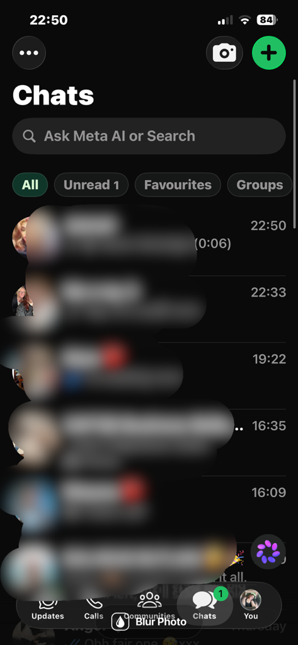
I use this app very regularly to keep in contact with people, it is also the app I use to keep in contact with the others in this class to discuss university related topics.

Screenshot/Photo 4
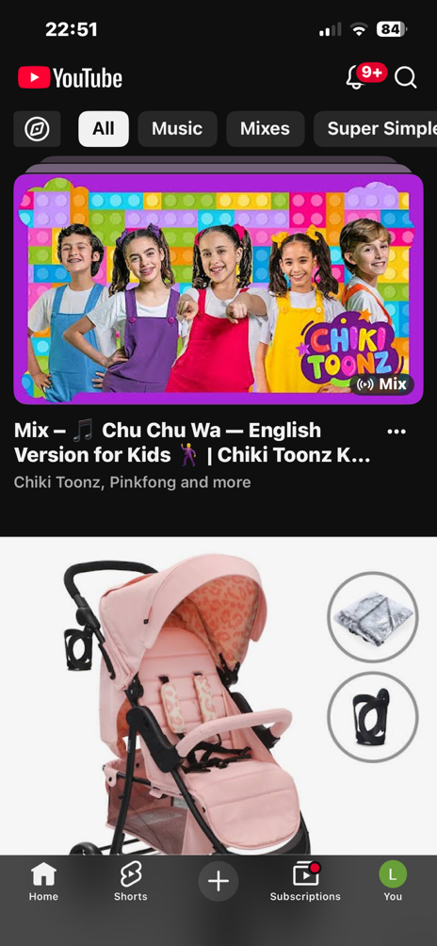
YouTube

I use this app in day to day life, to help me understand certain things as I can watch tutorials if I need help on how to do something. It is also the app I enjoy to listen to music on.

Screenshot/Photo 5
Snapchat
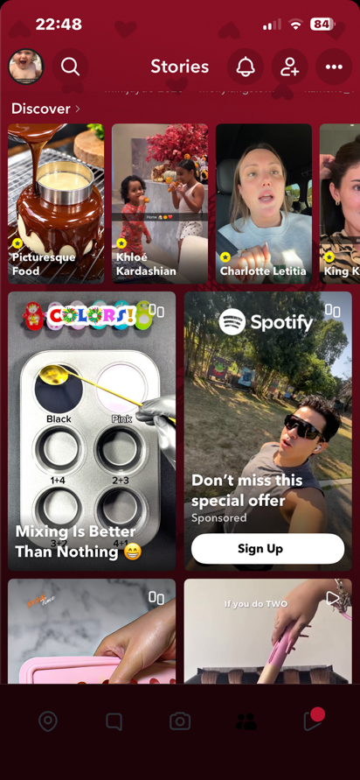
This app is my main source of communication with others, it’s where I also take all my pictures as it stores them and will not lose them which can be a risk using your normal phones camera.

My Short Reflection
I use digital tools in my everyday life, all my digital apps help me get through day to day with communication and keeping up to date on things. I do want to improve on using certain apps such as word as I am not the most confident with using it I can do the basics but I would like to be able to understand everything. I hope with module will help me improve my skills and give me the skills I need for my future life goals and business plans.

