

MODULE CODE: Digital Skills for Personal Development and Business Growth BMSW4008

ASSESSMENT COMPONENT: PORTFOLIO

STUDENT NAME: Amanda Barlow

STUDENT NUMBER: 2506923

LECTURER: Philipa Fitzgerald
DATE: 11 December 2025
Contents
Task 1 3
Assessment of Digital Skills 3
References 3
Task 2 4
LinkedIn Learning Certificates for Office365 4
Task 3 5
Essay on Relevance of Excel in professional and personal life. 5
References 5
Task 4 6
7 Minute Reflective Presentation 6
References 6

AI Acknowledgement
I have not presented any AI generated materials as my own work.

Task 1

Assessment of Digital Skills
Portfolio Example
Image 1
Screen shot of your JISC report
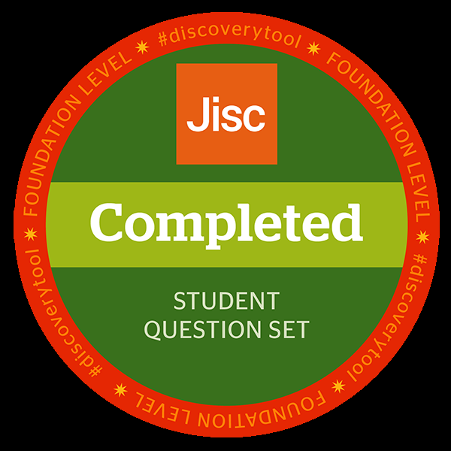

Jisc discovery tool - Teaching in HE
Issued by Jisc

700 words on your assessment of digital skills Plus recommendations and badges you have completed because of this report
I am currently in my first year at university and starting my studies as a mature student. Studying in an unfamiliar environment with extremely limited experience in using computers has been challenging. As a student I am aware of the importance of Digital Skills for studies and daily life. Starting university as a mature student I have realised that communication, research, and academic tasks are essential in this digital era. (Burroughs, 2019,) Reflecting on my own digital skills will help me evaluate myself so that I can understand my strengths and weaknesses as I continue my studies.

During the first weeks of my course, I felt very overwhelmed by the digital tools that I had to learn. The lack of skills affected my confidence, and I questioned myself weather or not I could keep up with my course, as younger students knew what this was all about. In the beginning everything seemed bewildering, even the tasks that required logging into such as online learning systems, navigating library resources and electronic submissions seemed complexed. I decided that I would give this course a chance and acknowledged to myself, it was going to be a new challenge.

Having limited digital skills, my personal strengths are motivation, willingness to learn and being open to new challenges. (Serrano, Lopez & Garcia, 2023) In Microsoft Word I have learnt how to create and format documents by changing fonts, adjusting spacing, and use of headings. I can save and organise files which helps me to produce clear and academic assignments PowerPoint to create a digital presentation, and this involved creating slides, inserting images, text, and designs. I have presented ideas clearly, organised information visually and communicated in my class as part of my assignment. Using Microsoft Excel I can now produce simple spreadsheets, enter data using basic formulas. I can create a simple expense spreadsheet using Excel as part of my ongoing assignments.

Email and online communication are skills I have learnt to send and reply to professionally. I can attach files and organise my inbox. I have participated online in discussions using messaging to collaborate with my classmates. Digital organisation and file management has been important for my studies as it has meant that I can save and name files, so that I can organise and keep track of my assignments and deadlines in a digitally organised manner. Resources, I accessed for learning are LinkedIn learning, Jisc, online videos and tutorials and the university library resources for digital skills. (Von Courter, 2024) I Have become familiar with cybersecurity by using strong passwords, being cautious of my email habits, updated devices, using secure Wi-Fi and being mindful of social media use to protect my identity. (National Cyber Security Centre, 2025)

My weakness not having knowledge in of the digital skills for my assignments. Initially I struggled to use the digital tools for assignments. I had to familiarise myself with software applications before I could begin my coursework. I benefited from practising with the online resources available on Moodle.

Strengths that I have developed in digital skills are using basic tools such as Microsoft Word, PowerPoint, and email, I am able to search for reliable information online, access learning platforms and organise my digital files. These are skills that give me the confidence to develop further in my studies. Areas of improvement as I go forward will be using Excel, create professional power point presentations and improve on online research and evaluation. By focusing on digital tools, I hope to become more creative and confident in assignments.

In conclusion this assessment of digital skills has given me an understanding of my current abilities and the areas of improvement. I have gained valuable skills In Microsoft Office 365. This assessment has helped me to know my strengths which are being motivated, eager to learn and take on to challenges. I will address my weakness by committing to practising and using learning platforms to enhance my digital skills and assignments.

As a mature student I am excited and determined to face the challenges ahead by developing my skills. My confidence has improved so that I can adapt to the skills needed in modern technology. By continuing to practice with guidance and use learning resources. I will be building competence and preparing for a professional and digital environment. (Digital Training Hub, 2023)

(5 references)

Burroughs. (2019) The Return to Study Handbook. London: Kogan Page

Von Couter, G. (2024) Collaborating with Share SharePoint and Teams {Online learning course}. Linkedln Learning. Available at: https://www.Linkedln.com/learning/collaborating/-with-sharepoint-and teams (Accessed at:10 December 2025)

Digital Training Hub (2023) Introduction to Digital Literacy: Essential Skills for the Digital Age {online video}. YouTube. Available at: https://www.youtube.com/watch?v=SbIVFhu6d8 Accessed: 10 December 2025).

National Cyber Security Centre (NCSC), 2025. Cyber security guidance for individuals. {online} Available at: https://www.ncsc.gov.uk (Accessed 10 December 2025).

Serrano, N., Lopez, D. & Garcia, M. (2023) ‘A digital literacy model to narrow the digital literacy skills gap’, Journal of Digital Learning and Education, {online} Available at: https:// www.sciencedirect.com/science/article/pii/S240584423020856 (Accessed: 6 December 2025).

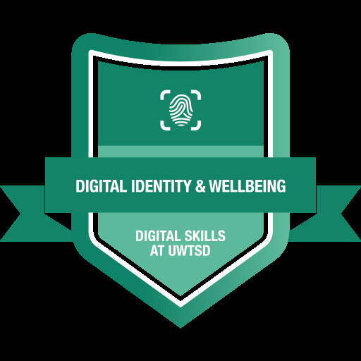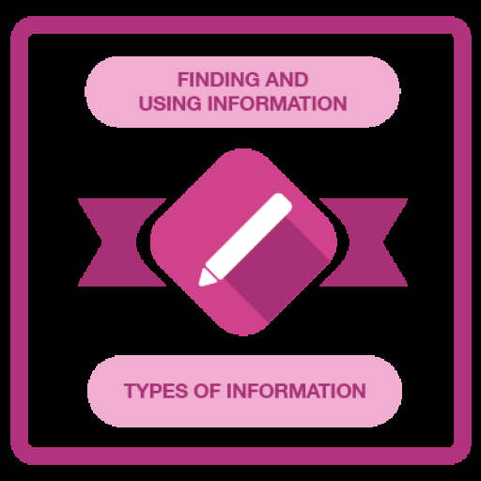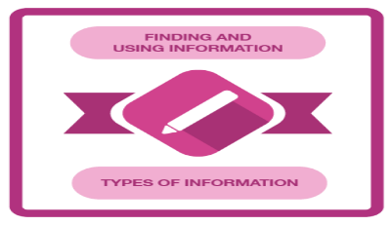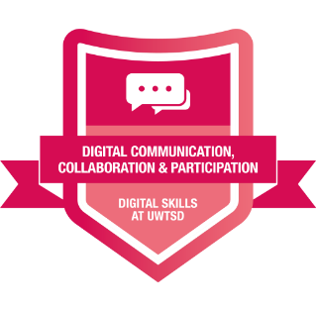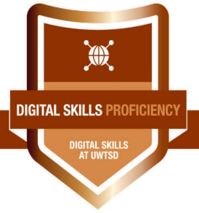
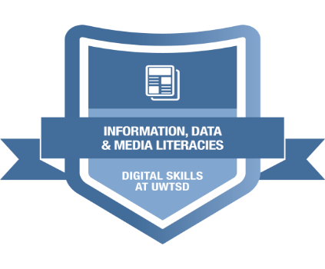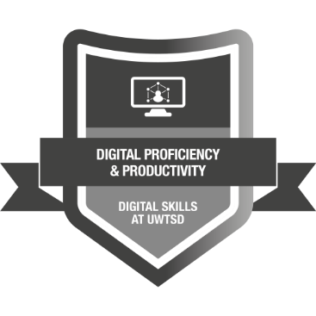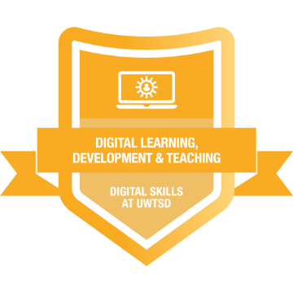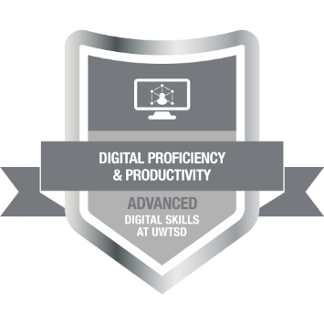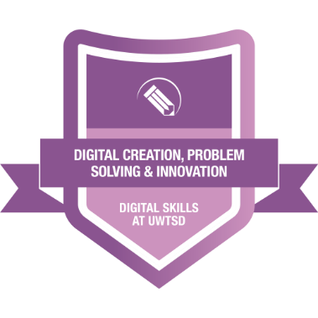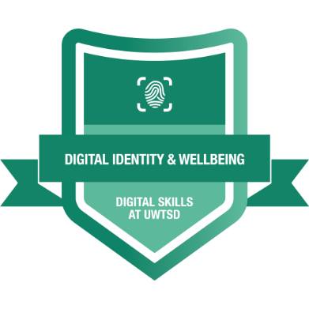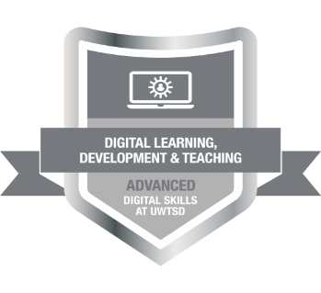

ReferenceTask 2

LinkedIn Learning Certificates for Office365
Add all the certificates from LinkedIn learning here

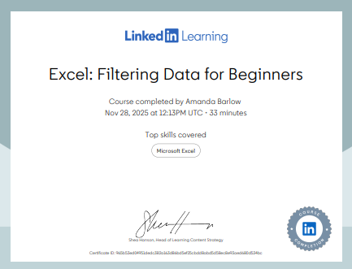

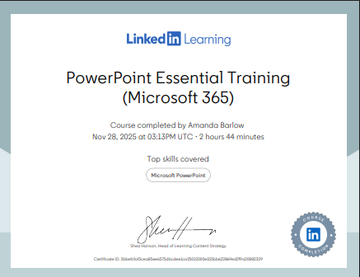

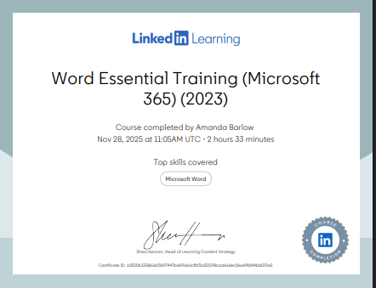

Task 3

Essay on Relevance of Excel in professional and personal life.
Write a 1000 word essay on Relevance of Excel in professional and personal life.

In today's academic and professional environments students need to understand and work with data. Microsoft Excel is used for organising, analysing, and presenting data. Excel is a platform for problem solving and it can make decisions in business, studies, and personal use. (ExcellsFun, 2020) Microsoft Excel has grown from a spread sheet into one of the world’s most popular programme. Excel is a software programme from Microsoft which has spreadsheets that can use formulas and functions, to organize numbers and data. Excel can manage substantial amounts of data to provide information more easily.
Students that develop in Excel will gain digital skills that will enhance efficiency and academic standards. This essay will explore Microsoft Excel, the importance of the skills and ideas, that students are able to acquire through studies. Excel is used for data-analysis, decision making, visualization, and to enhance productivity in businesses small and large. In this digital era Excel is a requirement for students and professionals. Excel usage has increased as the digital era has become driven by data.
The first windows version of Excel was launched in 1985 (Excel 2.0) with better graphics and functions which quickly gained over Lotus 1-2-3. In the early nineties Excel became the dominant spreadsheet application. (Britannica Editors, 2025)
Core features of Data entry in excel is controlled by clicking a cell and typing in the information directly into cells. There is an autofill function to enter numbers, days/months, and formulas. Flash fill recognises patterns and can fill data automatically, Excel can import data from text files, websites, and databases. Students should be careful to enter data correctly as incorrect data will affect outcome. (Microsoft Support, 2023) Data organisation is important for students to work efficiently. learning t label, the columns correctly and avoiding empty rows will provide a clean, well-organised format, to support maximum accountability. Sorting tools and filters help the user identify information or arrange data so that it is meaningful. Students can use the Sum function to add up their income e.g. SUM (B2:B10). Students can use colours in cells to highlight overspending or money that is safe to make budget visually clear,
Formulas and functions in excel include number formatting to change how data looks without changing the values in percentage, fraction date and time. Excel can format cells into assorted colours, borders, font styles and alignments. (McFedries 2020, p.45)
Data visualisation in Excel has may features and tools these include many charts and graphs that can visually present data. The common charts include bar charts, Pie charts and line charts which can be suited to individual tasks. Being able to know the best chart for data is a skill. Creating charts can help students to communicate their findings in a professional way. (Apress, 2022) Students can use Excel for budgeting their own finances. Excel can track income, control spending, build good financial habits, and avoid getting into debt. Budgeting can be interesting to find information on what we are really spending or saving.
Dash boards combine multiple charts slicers and tables. The function of dashboards can make data interactive and supports fast decisions. This is used for timelines etc that can update when data changes. Benefits of dashboards is that it is easy to understand sequences, trends, saves time, is interactive, user friendly and suitable for business reports.
Pivot table is a powerful feature in excel which students can use for organising large data sets, analysing and summarizing data sets with speed. Data can be rotated to view it from a unique perspective without data being changed. Advantages of Pivot table are saves time, quick, manages large data, flexible, suits reports and dashboards. Students in a first year could find Pivot tables difficult to understand but being familiar could be an advantage in an academic future. (Linkedln Learning, 2024)
Excel can be integrated with Microsoft tools to enhance students’ academic studies. Data from power point, word documents and online data can be imported to Excel. Students can use this to create their own analysis, for reports such as budgeting, documents, and presentations. Excel is great for organising group work.
Students can share Excel workbooks through cloud services, SharePoint, OneDrive and google drive. Data permissions can be changed, or set, to allow editing of a view-only access. Students can edit the same workbook simultaneously. for integration with Microsoft teams and SharePoint to link files to class assignments. Collaboration in excel can be used for students for group projects, assignments, and research.

Excel is one of the most used tools for managing and analysing data. Students should be aware of the limitations. Large datasets, complexed tasks and collaborative work can be affected by file crashes, delays, and freezing. Excel has a weakness for loading slowly when multiple access is required, multiple versions of the same files can get mixed causing confusion. Although excel is a versatile and powerful tool it does have its limitations if compared to specialised software that is available. Google Data Studio, Tableau and Power BI are specialised software programs that are customised for larger data sets.
Students can reduce errors or data loss, by using clear and consistent data entry, avoid mixing text/numbers in same column and label columns properly. This reduces mistakes and will help students to improve accuracy. Manuel entry should be correct. (Bakir, Salary and Babb, 2025)
Conclusion
Excel is relevant and is relied upon in most industries. Excel is ls a sort after skill that employers need. Learning Excel develops skills in data organisation, visual presentation, and calculations. By creating budgets students can develop clear insights on their own finances and transform raw information into meaningful charts that help to understand patterns and solve problems effectively. Excel is a tool that empowers students to think critically, manage information confidently and work more efficiently. Microsoft Excel is an essential tool for students in this digital era for business, science, finance, and research.

8 references
Apress (2022) Excel essentials: Entering data accepting data, deleting data and more. Springer Nature Computing video. Available at: HWB Swansea (Accessed: 5 December 2025).
BAKIR, N., SALAZAR, L.R. and BABB, J., 2025. Foundations of Practical Analytic Skills: An Examination of Undergraduate Business Students' Self-Efficacy Using Excel. Journal of Information Systems Education, 36(3), pp. 257-276.
Britannica Editors (2025) Microsoft Excel: Description & History. {online} Encyclopaedia Britannica. Available at: https://www.britannica.com/technology/Microsoft-Excel (Accessed: 15 December 2025)
ExcellsFun (2020) Excel Basics Tutorial. YouTube video,14 May. Available at: https://www.youtube.com/ (Accessed: 4 December 2025).
Linkedln Learning (2024) Build Your Excel Skills {Online course}. Linkedln Learning. Available at: https://www.linkedin.com/learning/build-your-excel-skills-63844 (Accessed:10 December 2025).
McFedries, P. (2023) Teach yourself visually Excel 365. Hoboken, NJ: John Wiley & Sons
Microsoft Support (2023) Overview of formulas in Excel. Available at: https://support.microsoft.com/ (Accessed: 30 November 2025).

Use the following information create an Excel spread sheet, looking at income and expenditure of a typical family of 4 over the course of a year. Use formulars to achieve answers and add headings and highlight the different aspects of the finances, be realistic with the monetary amounts used for each area.
Income | Amount per month £££ | Expenditure | Amount per month £££
Wage 1 |  | Rent/Mortgage
Wage 2 |  | Council tax
Trust Funds |  | Electric
Stocks/Share payouts |  | Gas
Universal credit |  | Water rates
Student Finance |  | Food
Other |  | Car insurance
 |  | Car Tax
 |  | Fuel
 |  | Child Care Costs
 |  | Loans/credit cards
 |  | Other eg Birthdays/savings/holidays

Embed your excel here
￼

Task 4

7 Minute Reflective Presentation
Create a PowerPoint presentation using techniques learned in class, reflecting on the module and what you have learned.
Maximum of 15 slides Minimum 7
You will reference your work where appropriate.
Embed PowerPoint here
Philipas presentation 7 min

Reference

R Wilbert, A. (2024) Microsoft Access Essential Training (Office 2024/LTSC) [Online course]. Available at: https://www.linkedin.com/learning/microsoft-access-essential-training-office-2024-ltsc (Accessed: 28 November 2025).

