Professional and Career Development

Reflective Portfolio

Student name: Ana-Maria Bundea
Student number: 2021299
Module code: BMSW4005_BIRM
Lecturer name: Dr. Vasilios Tavlaridis

University of Wales Trinity Saint David, 2021
Table of Contents
Introduction 3
“Personal Skills and Competencies Audit using analytical tools” 4
“Personal SWOT Analysis” 4
“Personal development Plan” 5
“Analysis of the skills required for being an effective manager in the Gambling Industry” 6
“Introduction to the Gambling Industry” 6
“Assessing the concepts learned” 8
Conclusion 11
References 12

Introduction
Professional development can be referred to as the consistent process of self-development with the major focus on enhanced "career advancement". On the other hand, career development can be defined as the process for focusing on various "learning activities" including professional learning for obtaining high career outcomes. This report will be focusing on my skill audit using SWOT analysis. I will be able to identify the various skills that are essential for becoming an effective manager in any good business organization with high brand value. I will further evaluate my overall learning effects associated with the module. "The System Management Theory” and “Contingency Management Theory” will also be mentioned as the learning theories associated with my learning throughout the module.

“Personal Skills and Competencies Audit using analytical tools”
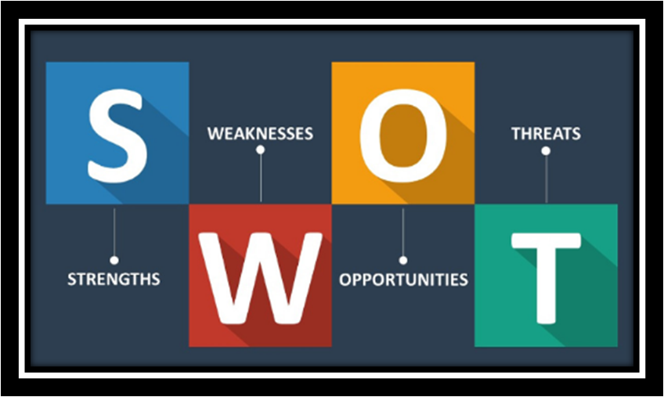
Figure 1 - “SWOT Analytical Model”
(Source - Teoli et al., 2019)

“Personal SWOT Analysis”
To conduct an effective skill audit, I will be using a "personal SWOT analysis". SWOT is the abbreviation of strengths, opportunities, weaknesses, and threats and it is an analytical tool that investigates the professional world and identifies its past, present, and possible future positions (Teoli et al., 2019). Personal SWOT analysis assists in doing the same for an individual pursuing their career objectives. My SWOT analysis is as listed in the Matrix below:
Strengths | Weaknesses
Excellent collaborative skills  Excellent Communication Skills (both written and verbal)  Open-minded, Innovative, Effective, and Motivational.  Providing proficient customer service.  Problem-solving skills, management skills, empathy, competence, enthusiasm, and effective decision-making skills.  Along with these crucial skills I also possess additional strengths of self-competent behavior and a friendly personality. | The tendency of taking on responsibilities more than required.  I have discomfort in taking bigger risks.  I currently lack the practice of working with the odd hours of Casinos.  I also need to develop my activity coordination skills as I have been off this field for some time.  As I have been off this field for some time, I consider it a weakness as I will require practice to balance working in a hectic environment.
Opportunities | Threats
Knowledge of gambling regulations will be assisting me in influencing the management directive positively.  My abilities to organize and manage make me a superior candidate.  During my previous post, I demonstrated my ability to work in a fast-paced environment.  As the gambling industry is growing in Romania with annual revenues of over “9 billion Romanian lei”, my experience will be an asset of opportunity. | My discomfort in taking bigger risks can also be considered a threat because the Casino business I am opting for is developing rapidly, in terms of technology as well as management.  The growing gambling industry also needs more experienced and hires personnel already experienced in this field. This creates a tough competition for me regarding the manager's post I am aiming for.
Table 1 - “Personal SWOT analysis”
(Source - Created by the learner)

Through the analysis, I was able to obtain the outcomes that I have my well-built strengths, and minor weaknesses as well, but these can be worked on over a short period. The opportunities that my previous experience and my learning skills provide me with are significant. The threats that my opted post as a manager faces are high, so I need to work on self-development enormously keeping the company's requirements in view.

“Personal development Plan”
Usually known as "PDP", the personal development plan plays a vital role in assisting the individuals to identify their goals and what they want to achieve in the future. It is a form of the action plan that acts as the "effective framework" assisting in setting specific goals for self-development for the achievement of higher personal as well as organizational goals (O’Reilly et al., 2020) Evaluating and understanding my “strengths, weaknesses, threats and opportunities” through SWOT analysis enabled me to plan my objectives that I must develop and learn. The PDP from my skills, experience, and the areas necessary for my development is provided below: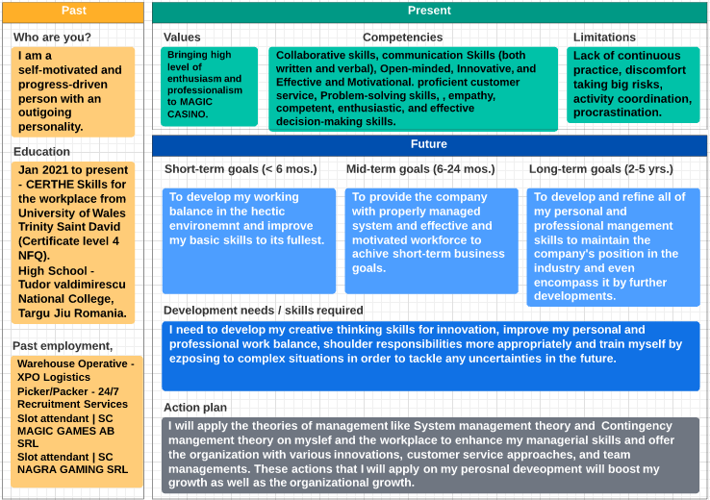
Figure 2 - “Personal Development Plan”
(Source - Created by the learner)

My "Personal Development Plan (PDP)", which Figure 2 provided above, describes how I plan to develop myself while aiming high for the company. MAGIC Casino is a growing company and as the gaming craze is increasing, the scope for online gambling and gaming Casinos increases as well. To properly adhere to and respond to the changes in this environment I plan to develop all of my skills, enhance my personality traits, and learn creative techniques of providing customer satisfaction. These long-, medium- and short-term goals will describe my development progress and how I can benefit the company with the best results possible.

“Analysis of the skills required for being an effective manager in the Gambling Industry”

“Introduction to the Gambling Industry”
Any kind of betting and gambling within the gaming industry forms the "Gambling Industry" and even encompasses it. This industry has been experiencing rapid growth since it was made legal and has been contributing to enormous amounts of "international revenue" creation (Bonello and Griffiths, 2019). This industry is not limited only to regular sports betting, slot machines, card games, and so on. It is carried out to the businesses in "legal Casinos" and recently has been growing through "virtual internet-driven gaming" and the online gaming industries.
I am opting to take on the role of an effective Casino Manager in “MAGIC Games AB SRL, a gambling industry organization based in Bucuresti, Romania”. The company operates with 143 employees generating an annual revenue of approximately £9.86 million and has two “corporate family connections (Mikhaylova et al., 2020).
Understanding, analyzing, and demonstrating a high level of management skills assist an individual to position themselves for successful career options regardless of the level it is starting at. To be an effective manager for MAGIC, I am analyzing the required skills:
“Communication skills”
Communicating effectively with colleagues working together in the workplace and with the subordinates working under them is the most crucial responsibility of an effective manager. They must possess excellent people skills. "Active listening" as already mentioned, is also a crucial part of communicating and interacting in the gambling industry. This includes paying attention to their opinion or issue, giving time and understanding their points, asking questions appropriately, and avoiding inappropriate interruptions (Kononiuka et al., 2020). Practicing these effective communication skills will help me in monitoring, managing, and directing the business operations within the company by directing my subordinates appropriately. Through the assistance of this skill, I can interact correctly with the employees, acknowledge their problems, and provide them with adequate assistance to resolve them. Proper achievement of these factors will develop my skills as an effective manager.
“Customer Service and Personal Service Skills”
Understanding the principles as well as processes of providing personal and customer services is crucial to every industry's management worldwide. To be an effective manager in the gambling industry, the individual needs to understand the value of customer satisfaction and the managers need to enhance their existing skills as much as possible while developing new approaches to provide adequate customer services (Grit et al., 2019). The specific areas that customer service skills target are the assessment of needs and necessities of customers, meeting the "quality" and status-quo of the service provided and evaluating the rate of customer satisfaction. The main, as well as default target audience for the Casinos, is the increasing number of gamers. I can work on my refined skills to apply innovative and creative ideas to provide the customer’s needs with accurate services.

“Innovation”
Innovation can be considered as the "keyword" for almost every organization across the globe as each company these days is indulged in innovating their business internally as well as externally. That includes the organizational structures, management systems, and product/service deliverance, innovative services/products, and so on. Considering the fast-paced environment of the gambling industry, the competitors strive to develop and deliver better services ahead of each other. Businesses that have proper innovative indulgence can tackle the highly competitive environment and stay at the top (Shire et al., 2017). It assists in increasing the customer base with their innovative offerings and satisfying their clients' needs with a spontaneous selection of innovative upgrades. Considering these facts the gambling industry organizations hire candidates possessing the capability of demonstrating different perspectives and creative ideas to the business. I will have to sharpen my creative thinking and innovative skills. Doing so will allow me to be the top preference for the company as I can demonstrate as well as apply my creative perspectives to develop the business.
“Time management skills”
Time management skills refer to the ability to completion of assigned tasks within the specifically stated period. Time management skills and their effectiveness are to ensure that the individual is experienced and concerned about completing the assigned tasks simultaneously. Time management skills in the gambling industry are crucial because the business processes are fast-paced as well as hectic (O’Reilly et al., 2020). The manager overseeing the business operations within the industry has to excel in the demonstration of these skills. Acquiring the proper practice and application of this skill will assist me in providing the company with an excellent management system working towards the achievement of organizational goals.
“Assessing the concepts learned”
Through this module's specifications, I was able to understand what areas I was good at and what skills I needed to develop to be effective in management. The module assisted me in completely understanding my professional and personal skill's negative and positive traits.
Assessment of the concepts is essential in briefing the learner with the knowledge of essential components that are gained throughout the tasks. In the organizational context, the assessment of experiences, gained knowledge, and the impacts of that knowledge within the organization evaluated and understood are the concept. I learned a range of information regarding managerial responsibilities and skills, the gambling industry's requirements, and the approaches to work and develop as an effective manager.

“Setting objectives and goals”
The SMART objective model which is the abbreviation of "Specific, Measurable, Attainable, Relevant, and Time-bound" objectives is one of the concepts I learned during this module. The application of this goal-setting tool has been tremendously helpful throughout time where the organizations, their management, and leadership have shown profound growth. It assists the individuals in determining the specific objectives that complement their overall development and decrease the risk factors by providing assistance to identify the specific time frame for that goal's completion. The concept of this objective is that the goals set by the individual or the organization must be "SMART" (Bjerke and Renger, 2017). This assisted me in setting my goals and objectives mentioned in Figure 2, where I could specify the specifications of my goals as a manager, when and how I would attain them, and during what period. I could determine the specific areas I needed to put my focus on that would complement my smooth development in the short, medium, and long term objectives. The prioritization of respective importance and possibilities of the objectives obtained through the application of this concept was helpful for my overall development planning.

“European Union (EU) Employment Laws”
The legal rules and regulations set by the government play a vital role in organizational management and development. The laws hold organizations responsible for properly ensuring the employees' rights, health and safety, and other related regulations. The managers are particularly in the frontline for making sure that the organization adheres to all the employment laws ( Bulboacă and Jierean, 2020). Therefore, I need to be concerned about the European Laws as it is where MAGIC Casino operates, and I have to have a "high-level awareness" of the concepts of crucial and essential employment laws within the country. The European laws regarding employment include "basic transnational standards" regarding employment and the partnerships within European Countries that directly adhere to the "European Convention on Human Rights”. The "European Labour Laws" provide the employees within the EU context with a sense of safety and security and access to adequate social rights. They have the rights of "Collective Bargaining, Individual Labour rights, and anti-discrimination regulations to name a few. The organizations within the EU follow the principles that are codified in "The Community Charter of Fundamental Social Rights of Workers 1989" (Risak and Dullinger, 2018). These are the basic laws that I need to ensure, are followed and that all these rights are implemented within the working environment.

Learning theories
Learning theories are those models as well as frameworks that help students to gain, process, as well as retain various knowledge. With the help of various learning theories, a student can ensure high personal as well as professional development through the knowledge gained through different processes. The "System Management Theory" and "Contingency Management Theory" were the conceptual theories that assisted me in gaining valuable knowledge on proper management (Vanhorn et al., 2019). These theories provided me with beneficial approaches to handling the employees and improving my management capabilities throughout the module. The main concept behind System management allowed me to learn alternative approaches for planning and managing the organization. The contingency theory provided knowledge on the concepts of suitable management approaches according to the organization's environment.
“Self-awareness methods”
Self-awareness tools or methods are the processes that help in focusing on the factors that create certain challenges or issues (Sutton et al., 2015). These methods have helped me to a great extent in analyzing myself, thereby, identifying the possible weaknesses as well as threats that contribute to the rise of various challenges in my professional development. The Self-awareness traits for improving my level of self-awareness that I learned throughout this module are:
"Self-Concept" - I learned that the self-concept, the perception of an individual about himself/herself comes from their personal experiences, the expectations one has with their future, and what they believe their abilities to be (Dutt et al., 2020). I could understand through this that I need to strengthen and improve my ways of perceiving matters differently that complement my abilities and it made me more competitive and committed to achieving my goals.
"Thoughts" - An individual's thoughts are tied directly to their emotions and when they become aware of that particular emotion they must understand the thoughts as well as the thought processes. I could reflect on my positive and negative thought processes and determine why I acted the way I did (Dutt et al., 2020). Influencing thought processes to generate positive results takes time but eventually, as an outcome; the thought processes are changed to be positive.
“Feelings” - I was able to identify my feelings regarding the job post I wanted, the extent I was ready to train myself and the necessity I felt for working as a manager.
"Body" - Sometimes when the thoughts process, it generates a physical response, and if an individual can identify or justify that reaction, they can effectively change or own the thoughts.
"Emotions" - In Self-awareness, emotions play a crucial factor as to how an individual interacts with other people and people with "higher levels of emotional intelligence" can be recognized as well as accepted or changed, varying according to their emotional states.

Conclusion
In conclusion, it can be said that both careers, as well as professional development, play crucial roles in ensuring the successful prosperity of an individual. The report has been able to focus on my skill audit by using SWOT analysis. I have been able to identify the various skills that are essential for becoming an effective manager in any good business organization with high brand value. I have further evaluated my overall learning effects associated with the module. I was able to gain beneficial information and learn various concepts on my overall self-development.

References
Bjerke, M.B. and Renger, R., 2017. Being smart about writing SMART objectives. Evaluation and program planning, 61, pp.125-127.
Bonello, M. and Griffiths, M.D., 2019. Behavioral tracking, responsible gambling tools, and online voluntary self-exclusion: implications for the gambling industry. Casino and Gaming International, 38, pp.41-45.
Bukharina, A.Y., 2018. Personal development plan (PDP) in practice and technology of introducing mentoring in organizations. Social Psychology and Society, 9(1), pp.162-176.
Bulboacă, Ş. and Jierean, O.M., 2020. THE COST-BENEFIT ANALYSIS OF THE ROMANIAN NATIONAL GAMBLING OFFICE. Bulletin of the Transilvania University of Brasov. Economic Sciences. Series V, 13(2), pp.157-166.
Dutt, N., Regazzoni, C.S., Rinner, B. and Yao, X., 2020. Self-awareness for autonomous systems. Proceedings of the IEEE, 108(7), pp.971-975.
Grit, R., Guit, R. and Van der Sijde, N., 2019. Managing your competencies: personal development plan. Routledge.
Kononiuka, A., Pająkb, A., Gudanowskaa, A.E., Magruka, A., Kozłowskaa, J. and Sacio-Szymańskab, A., 2020. Foresight for career development. Форсайт, 14(2 (eng)), pp.88-104.
Mikhaylova, A.G., Nikitaeva, M.V. and Kokodey, T.A., 2020. Formation of personal qualities by means of acmeological approach in the context of professional becoming. In SHS Web of Conferences (Vol. 87). EDP Sciences.
O’Reilly, V., McMahon, M. and Parker, P., 2020. Career development: Profession or not?. Australian Journal of Career Development, 29(2), pp.79-86.
Risak, M. and Dullinger, T., 2018. The concept of ‘worker’in EU law: Status quo and potential for change. ETUI Research Paper-Report, 140.
Shaheen, S. and Hameed, M., 2020. Personal Development Plan (PDP). World Family Medicine.
Shire, K., Holtgrewe, U. and Kerst, C., 2017. Re-organising customer service work: an introduction. In Re-Organising Service Work (pp. 1-16). Routledge.
Sutton, A., Williams, H.M. and Allinson, C.W., 2015. A longitudinal, mixed method evaluation of self-awareness training in the workplace. European Journal of Training and Development
Teoli, D., Sanvictores, T. and An, J., 2019. SWOT analysis.
Vanhorn, S., Ward, S.M., Weismann, K.M., Crandall, H., Reule, J. and Leonard, R., 2019. Exploring active learning theories, practices, and contexts. Communication research trends, 38(3), pp.5-25.

