Leading and Implementing Workplace Change

(BMSK6003_LON)

Student: Samsul Alom
Student ID: 1605852

Table of Contents
Introduction 1
1. Relationship between organizational change and organizational capability 2
1.1. Recent History of Amazon 2
1.2. Impact of external environment on Amazon 4
2. Nature of change and concepts relating to leadership in relation to change management 7
2.1. Model for change management 7
2.2. Change management and leadership style 11
3. Contemporary Issues and their impact on business management 14
3.1. Issues related to strategic change management 14
4. Relationship between organizational culture and change 18
4.1. Impact of organizational culture on change management 18
Conclusion 20
References 21

List of Figures
Figure 1: Revenue growth of Amazon 3
Figure 2: PESTEL Analysis 4
Figure 3: Lewin's Change management Model 8
Figure 4: Kotter 8 step model 9
Figure 5: Leadership styles 12
Figure 6: Communication in change management 16

Introduction
Change is normal in nature. With the changes in the society and business environment, business organizations also need to change themselves. Activities of a business organization may change with the changes in the environment in which it operates. Different internal and external changes cause changes in the process of business operations (Cameron and Green, 2012). So, change management has become one of the important tasks performed by the modern business organizations. Changes in the business environment may put positive or negative impact on the business organization. Success or failure of an organization largely depends on their efficiency in managing changes (Czichos, 2014). Changes in the environment, changes in customers demand, and changes in the industry environment require changes within business firms. An organization may fail to ensure its sustainability if they fail to cope with the changes that has happened around the business environment. Managers of an organization may find it challenging to manage the changes happening internal or external side of the organization(Gill, 2012). But this is also the stair to take the organization to its desired destination. This assignment has discussed about the changes in the organizations and their impact in the management system. The case study of Amazon has been used to make a better understanding about the impact of changes in the organization and the management system of changes.

1. Relationship between organizational change and organizational capability
Business organizations get influenced by the factors of the environment in which they operate their activities. There are a number of external factors that can shape the culture of an organization (Griffith, 2011). Variety of external factors influences organizational behaviour and performance of the organization. Influence of these external factors may be direct or indirect on the organization. External environment may offer the organizations with a number of opportunities that can facilitate the business organization. It also can hinder the operational activities of a firm by arising threats. Amazon as a popular multinational technology company is also influenced by the external environment of it.

1.1. Recent History of Amazon
Amazon is one of the popular multinational technology based organization which is now considered as one of the big four technology companies along with Google, Apple and Facebook. After its establishment in 1994, the company never slowed down in their journey to success (Amazon, 2019). The company was always in the top of consumer choice with their innovative products and ideas. Technological changes occur more frequently and the company always ensures that the business is also coping with the changed environment. As a technology based organization, they were always aware about consumer needs and demands, and the newer innovations always keeps them in the right track (Ha, 2015). The company is an excellent example of successful change management. Amazon brought a number of changes in the technologies in business field such as, online delivery system, warehouse automation, web server industry, electronic books, streaming video, on-demand media, etc. Innovation considers as the fuel onthe road success. With their innovations and frequent changes has helped Amazon in reaching top to success.
Within the last 10 years, Amazon has brought drastic changes in their organization and brought many positive transformations than a mere online book seller (Amazon, 2019). To reach to a larger number of customers, Amazon started Amazon Web Service (AWS) which is now one of the greatest go-to-cloud server companies in the world. Amazon owned Whole Foods in 2017 and entered into the grocery chain shop business (Amazon, 2019). This has made changes on the organizational structure of the firm. Amazon is popular for their innovative product delivery system. They have started drone delivery system which has opened a new dimension in the product delivery culture of the organization. The company has made great changes in their warehouse management system by making them automated. The company is now using robots in collecting and transporting and collecting products in warehouse which as changed their warehouse management process. The company has now entered into the business of selling and renting videos, movies, TV shows and advertisements. This has brought changes in their organizational structure.
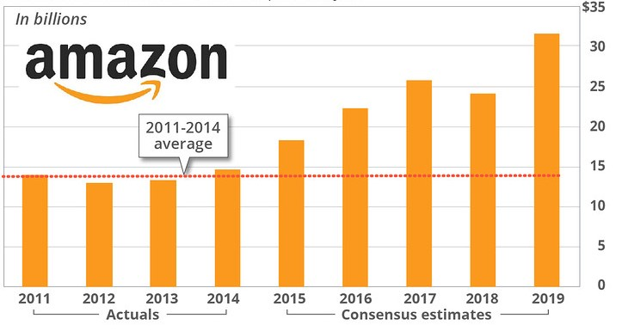
Figure 1: Revenue growth of Amazon
Source:(Amazon, 2019)
Figure 1 shows how successfully Amazon is growing their business with their innovation and changes. The company is also successful in managing their business in the foreign countries. The change managers of Amazon have made the company successfully adapted with the changed environment of different countries. Innovative ideas are being generated to operate business in different business environments (Harrington, Conner and Horney, 2010). Failure in adopting changes in different environment could put negative impacts on international business. Although the company started their business online, now the company has their own retail stores as per demand of the customers. Amazon has brought changes in their marketing system by starting affiliate marketing system. There are almost 900,000 global marketers who are working for promoting the organization. To make an organization moving forward, making changes are obvious (Have et al., 2011). With innovation and changes, the mere online bookstore Amazon has now become a multi-industry giant. The company is the greatest example for successful change management in business.innovation is the precondition of bringing changes. And Amazon has brought these changes to in their business by their innovative ideas. Changes are needed to keep the business moving. Amazon has proved that how a business firm can use changes in taking the business to desired goal.

1.2. Impact of external environment on Amazon
Business organizations are influenced by the external environment in which they operate business. These external environments impact on the policy making and operational activities of the organization. The impact of external environment on an organization can be understood by using different environment analysis models (Karp and Helg, 2018). PESTEL analysis is one of the popular models of examining the impact of external environment on an organization. Impact of external environment on Amazon has been examined in this section by conducting PESTEL analysis. This analysis will provide a great detail about the external environment factors that are putting impact on the business operations by Amazon.
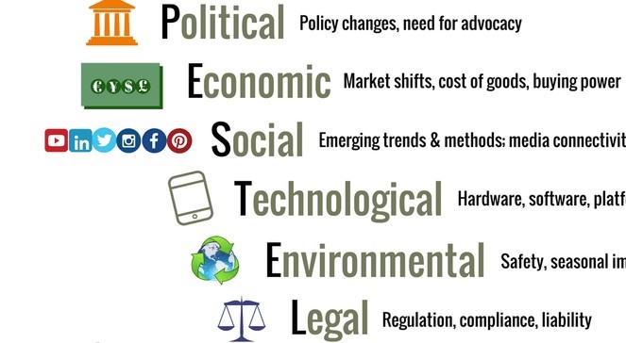
Figure 2: PESTEL Analysis
Source:(Lindberg, 2013)
Political factors
Political condition of a particular country or state keeps impact on the business operations that are operating business in that area. As Amazon is a multinational organization, they have to face different political situations several times. The long term profitability of Amazon in a certain market depends on the political situation of that market. The political factors that impact on the business operations of Amazon are legal framework, trade regulations, tariffs, taxation system, tax rate, employment regulations, wage legislations, risk of military invasion, intellectual property protection, industrial safety, pricing regulation, etc. Different political and system risks are influencing the operations of Amazon in different countries.
Economic factors
There are a number of economic factors that play very crucial role in the business operations of business organizations. Rate of inflation, savings rate, foreign exchange rate are the economic factors that put impact in the business operations of Amazon in different economies. The economic cycle of a specific market determines the amount of investment by Amazon in that market. Amazon considers the economic factors such as growth rate, spending habit of the consumers, inflation rate, while making business decision for a specific market. Labour cost, productivity of the economy, industry cycle, and quality of infrastructure, unemployment rate and many other economic factors influence the business activities of Amazon.
Social factors
Culture of a society shapes the culture of a business organization. While operating business in a specific society, the business organization needs to deal with the employees and customers from that society (Pugh and Mayle, 2019). So, they need to maintain an organizational culture that matches with the culture of the society. Shared beliefs, norms and attitudes influences the way by which Amazon communicate with customers, employees and the other stakeholders. Type of population, level of education, skills and expertise of the population, entrepreneurial spirit of people, psychological orientation, power structure in the society and such other things put impact on the decision making and business activities of Amazon.
Technological factors
Technology is making drastic changes in the activities of business organizations around the world. Most of the business organizations now-a-days are driven by the inventions of modern technology. Technological advancement of an area has impact on the business operations of organizations of that area. Operating business becomes easier with the help of technologies (Whitmore, 2014). Before launching a new technology, Amazon needs to consider the technological demand of customers in the market. Technological development of the competitor firms, customers expectation about technology, impact of technology on product cost, knowledge of the employees about using technology, technological diffusion rate and many such other factors have impact on the operational activities of Amazon in different markets.
Environmental factors
There may have different environmental laws and regulations in different geographical areas. Those laws and regulations have impact on the business operations of an organization. Environmental factors of a specific geographical area put impact on the profitability and growth rate of the organization (Cameron and Green, 2012). Environmental factors that have impact on the business operations of Amazon can be weather of an area, climate change, environmental pollution, waste management system, environmental laws and regulations, sources of renewable energy, attitude of people towards environment, etc. Amazon considers these factors while expanding their business in a new market and when making decisions about existing business.
Legal factors
An organization need to consider the legal factors with great care while operating business in a specific market. Sometimes the existing legal frameworks are not enough for protecting I intellectual property rights of an organization (Czichos, 2014). In those cases, the business organization needs to be careful in protecting their own intellectual assets. As Amazon is a technology based organization, they consider the legal factors carefully while operating business in a market. Anti-trust law, laws regarding copyright, laws regarding patent, data protection law, discrimination law and such other legal factors impact on the activities of Amazon in different countries around the world.

2. Nature of change and concepts relating to leadership in relation to change management
To make a business organization moving forward, change is obvious. It is said that “change is the constant in the universe”. To make keep pace with moving world; organizations need to manage the changes tactfully. Proper change management strategies need to be taken by the organizations. The term change management means to transition an organization from one state to another (Gill, 2012). While making changes in the business organizations, managers need to ensure that the whole transition process is occurring in such a way that meets the changing requirements and objectives of the organization. A change management process needs to be planned and well defined. The change managers need to be well known about the consequences of the changes that has made within the organization. Change management ensures that an organization enters into the planned state of business with the help of structured change management methods and the pre-planned frameworks (Griffith, 2011). Change management allows the business organizations to go ahead to the road of their targeted success and bring structural changes in technology or customers service system. Appropriate change management system makes it possible for the organizations to keep pace with the changing product and service demand of the customers. Change management helps the managers in bringing changes in the organization by using the limited budget.

2.1. Model for change management
While making changes in an organization, it is required to follow an appropriate model for it. Following a random and irrelevant model can make the changing process unsuccessful. So, choosing a suitable method for making changes and implementing it on the changing process is necessary by the change managers of an organization (Ha, 2015). There are a number of change management approaches that are followed by the organizations worldwide. Amazon also follows a suitable change management strategy while making any changes within their organization. This section has discussed about a change management process that can be followed by Amazon in managing changes.
Lewin’s Change Management Model
Lewin’s change management model is one of the popular change management models that are followed by organizations in making changes. This model was developed by Kart Lewin in 1940 to make an understanding about organizational change management.

Figure 3: Lewin's Change management Model
Source:(Harrington, Conner and Horney, 2010).
Unfreeze
According to the Lewin’s change management model, the first stage of change is the stage when the organization makes necessary preparations for making changes (Have et al., 2011). Following this method, Amazon will get the organizational environment ready for the upcoming changes. As people are naturally resistant to changes, it is necessary for Amazon to make the employees and customers ready for the changes that they are going to make. In this stage, Amazon has to make the employees, customers and other stakeholders understand about the necessity of the changes. They can make them mentally prepared by reminding them frequently by notices or advertisements.
Change
In the second stage, the organization needs to make the necessary changes that they have planned. The actual transition takes place in this stage. Employees, customers and other stakeholders embrace the new changes in this stage (Karp and Helg, 2018). A good leadership is the most important thing for amazon in this stage. A doo leader knows how to drive the followers to the planned way. Maintaining a greater communication is necessary for Amazon in this stage of change management.
Refreeze
After making the necessary changes, the firm need to become stable with that new system. In this stage, all the employees, customers and all other stakeholders have been accepted the changes. In this stage, the company make the new changes as a regular thing (Lindberg, 2013). All the employees get themselves used to the new working environment and all the customers get themselves used to with the changed pattern of service. Amazon gets ensured by people in this stage that the changes have been implemented successfully and they are going to continue even after achieving the goals.
Kotter 8 step model
Kotter 8 step model is another popular model for making changes which includes the stages of creating urgency, forming powerful guiding coalitions, developing a vision and strategy, communicating the vision, removing the obstacles, empowering the employees, ensuring short-term wins, consolidating gains and strengthening the changes. Idea of this change management model was developed by John Kotter (1996), in his book ‘Leading Change’.
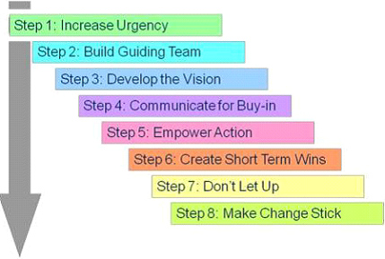
Figure 4: Kotter 8 step model
Source:
Increasing Urgency
At the first step according to this model, Amazon needs to create the urgency of making change among the employees. In this stage, the organization needs to make the stakeholders aware about necessity of change and make request support from the customers, employees and the other stakeholders.
Building guiding team
In the second stage, it is necessary to make a guideline for the changing process. Amazon needs to identify an effective change manager in this stage and involving all the employees, customers and stakeholders in the changing process. A change guiding team will be formed who will operate the changing process.
Developing vision
In the third stage it is necessary to develop a vision for the changing process. The organization will have a vision for the changing process. All the employees and stakeholders of Amazon will be clearly stated about the objectives.
Communicating the vision
Communicating the vision with the change management activities is one of the very crucial things. Operational activities performed by the employees, training, performance review and all these things are needed to be connected with the vision.
Removing obstacles
Amazon may face a number of obstacles while implementing changes within the organization. The organization need to continuously check the barriers that are hindering the change management process. Some people are resistance to change; they also needed to be motivating in the changing process in this stage.
Creating short-term wins
Creating short-term wins can motivate the stakeholders in the changing process by giving them the feel of victory. Short term wins creates the feel among the employees that the changing process is really working and the long term goal is achievable.
Consolidating gains
In this stage, Amazon needs to foster the changing process by analysing the success stories and showing them to the people related to the change. Individual experiences can be improved in this stage.
Anchoring change in the corporate culture
In this last stage of changing process, Amazon needs to ensure that the change has become an integral part of the organizational culture and it is noticeable in organizational aspects. It is also necessary to ensure that all the organizational leaders are supporting the change.

2.2. Change management and leadership style
Leaders of an organization play the most crucial role in the change management process. A leader is the person who drives people toward any targeted goal. While an organization making changes within it, the leaders are responsible for making the people attached to the change. An appropriate leadership style is necessary for making the changing process successful (Pugh and Mayle, 2019). Following an appropriate leadership style will help the managers of Amazon to change the organizational environment, behaviour of the employees and in the organization as a whole. In the changing process, leaders of Amazon need to act as a role driver who influences the people in the organization in the changing process. Success of a change greatly depends on the leadership style that is followed by the managers of Amazon. There are four types of leadership styles followed by the organizations in general. They arelassies faire leadership, transactional leadership and transformational leadership
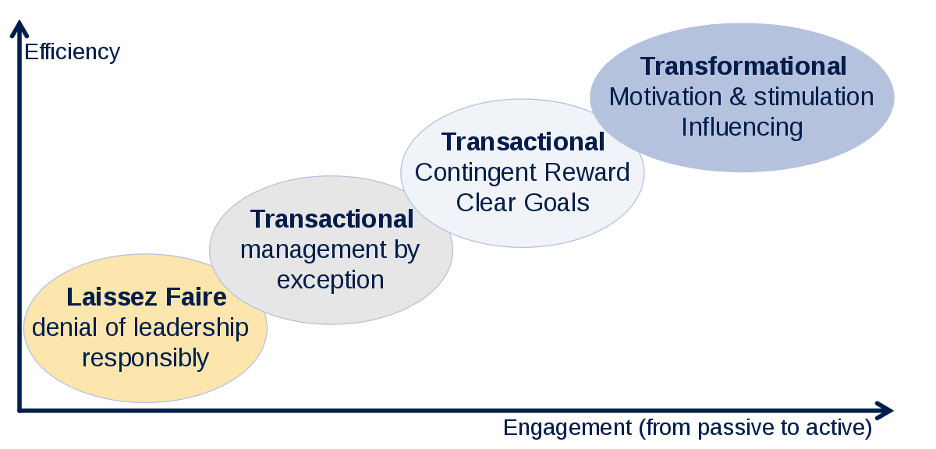
Figure 5: Leadership styles
Source:(Whitmore, 2014)
Laissez-faire leadership
The term “Laisses Faire” has come from a Latin word which means ‘allowing acting’. As per the name, the leaders following the laisses faire leadership allows the followers to act as per their will. Leaders do not interfere on the activities of the followers at all or there may have a little interference. Managers give up all the managerial activities on the subordinates (Cameron and Green, 2012). When there is matter of changing anything in the organization, leaders following the laisses faire leadership strategy tries to avoid the responsibilities of making changes. Rather they give it up on the hands of the employees. Employees make changes as per their capability. Generally there remains a huge communication gap between a laisses faire leader and the subordinates working under that leader (Czichos, 2014). This type of leadership is not suitable for making changes in the organization. Amazon will be failed in making expected changes within their organization of they follow this leadership system.
Transactional leadership
Transactional leadership is another form of leadership in which the leaders are little more attached to the subordinates than they are in the laisses faire leadership. Transactional leadership is sometimes also called as the managerial leadership system (Gill, 2012). According to this leadership style, the leaders focus on the four steps of leadership which are planning supervision and group performance. Transactional leaders generally focus on their behaviour to the employees. They want to meet the behavioural and psychological needs of the employees to get the desired performance from the employees. Transactional leaders believe in the day to day transactions that they are planning to do and make the employees do that as per expectation of the leader (Griffith, 2011). Transactional leaders believe in the reward and punishment system. They think that the employees performing good need to be rewarded for increasing their motivation. On the other hand, the employees performing need to be punished so that they improve their performance level. This leadership style can be good but not the best leadership style for Amazon.
Transformational leadership
Transformational leadership believes in achieving targeted goal by meeting needs of the employees and maintaining a good relationship with the subordinates. This leadership strategy focuses on four things, idealized influence, inspirational motivation, intellectual simulation and individualized consideration (Ha, 2015). While following this leadership system, leaders of Amazon need to empower the followers to drive them toward the change. Empowering the subordinates can be done by increasing their confidence. Following this leadership style, change managers of Amazon need to build trust among the employees and act as a role model to them. Transformational leadership can be a good leadership style for Amazon while implementing changes within the organization.

3. Contemporary Issues and their impact on business management
To make the business organizations keep moving, it is necessary to bring necessary changes in business operational activities. Change in the internal and external environment impact on the change of business organizations. Changes in the business organizations put impact on everything on the business. All the operational activities performed by them get influenced with the changes in organizations. Changes in the organizations influence everyone in that organization whether it is a minor staff or a business manager (Harrington, Conner and Horney, 2010). Business organizations need to make changes for growing it. Changes are obvious for business growth. But people are generally resistant to change easily. Here comes the necessity of change management. Proper change management system makes the transition process smoother and efficient. New changes become acceptable to the employees, customers and other shareholders because of a successful change management system (Have et al., 2011). Made changes put impact on everything within the organization. In that case, some issues may rise while making changes. There may have a number of obstacles on the process of changing within a business organization. This section has discussed about the contemporary issues of changes within an organization so that Amazon can be aware about the issues and manage those while implementing changes on the organization.

3.1. Issues related to strategic change management
People generally take the changes easily. While managing changes within an organization, the change managers can face a number of issues. The issues that Amazon can face while performing strategic change management activities are as followed.
Conflicts
Fear of uncertainty is a common nature of human. That is why people are generally resistant to changes. Changes in the organization systems can arise that fear among the employees, customers and the other stakeholders (Karp and Helg, 2018). So, conflict will be a common issue for Amazon while making changes within the organization. Conflicts among the organizations and the stakeholders may hinder in the success of change management activities if they are not being handled tactfully. The change managers of Amazon need to identify the root of the conflict and need to find the best solution for it while making changes in the organization.
Planning
Proper planning is necessary to make any task successful. Changes within the organization will go in vein if they are not properly planned. A proper planning will shows the way of success of the activities and extract the best result from it. So, planning will be an important issue to be considered for Amazon for making the changes effective (Lindberg, 2013). By making a proper plan of changes, Amazon will be able to reap the targeted benefits from the changing procedure. A planed system will be helpful in making the changing process smoother and acceptable by the employees, customers and the other related parties.
Setbacks
The change managers may face setbacks while implementing changes within the organization. It is another issue that can hinder the changing process within the organization (Pugh and Mayle, 2019). Amazon needs to identify the setbacks that can happen while planning for changes and need to make planning for handling them in the most efficient way. To manage the setbacks, the change managers of Amazon need to prepare the employees and the other related parties mentally prepared for the changes. Fostering a positive mental attitude the changes, implementing the right measures toward the changes and preventive measures of recurrence of the incidents can be the solution for handling the issue of setback.
Lack of communication
Failure to communicate with the employees and others may make the whole changing process failed. A good communication system is necessary for making the subordinates aware about the changing process (Whitmore, 2014). They can take the changes easily when they are well aware about that previously, and that can be possible by proper communication from the side of management.
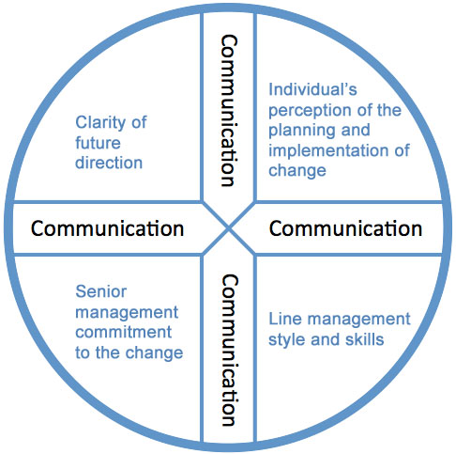
Figure 6: Communication in change management
Source:(Cameron and Green, 2012)
Figure 5 shows how communication plays role in the change management process. While making changes, the managers of Amazon need to make the employees know about the changes that are going to take place within their workplace. This issue can be handled by the managers of Amazon by keeping employees up-to-date about the new reforms.
Resistance
Resistance to changes is the common human nature. Employees feel comfortable with the current system and they fear to face the changes that the organization is trying to do. Organizations need to shift their current situation by making necessary changes (Czichos, 2014). When the organization is too much comfortable with the present system, it becomes impossible for them to move forward. The change managers need to ensure that the employees, customers and other stakeholders are familiar with the new changes. Offering training to the employees about the new system can help the change managers of Amazon in handling this change management issue successfully.
Failed embrace
Even though there are plans before making changes, sometimes the staffs are not fully committed to the plans of changing. Employees may not be ready for the changes at all that the managers are trying to implement (Gill, 2012). Managers of Amazon need to be in consistent throughout for making the necessary changes within the organization. A better communication system can be helpful in this regard. Changes are obvious for making the business growing, but it is challenging for the organization in making the changes well adopted by the employees, customers and all the other stakeholders. Amazon needs to be tactful in making the changes embraced by all.

4. Relationship between organizational culture and change
Organizational culture and organizational change management are interrelated with each other. All the organizational activities are influenced by the organizational culture. Prevailing organizational culture determines how the employees within the organization will act, how the activities will be performed, etc. So, when the managers of an organization plan for making changes within the organization, they need to consider the prevailing organizational culture of the organization (Griffith, 2011). Organizational culture put impact on the change management process followed by an organization. All the organizations have their own culture that they follow within the organization. While adapting new changes, the change managers of Amazon must have to consider the organizational culture. A change management plan should be in such a way that way where organizational culture supports the changes. Likewise, changes also have impact on the organizational culture (Ha, 2015). When there is any change in the activities within the business organizations, it has impact on the organizational culture. The employees act in a new way that they used to follow previously. And after adopting the changes successfully, that becomes that change becomes the culture of the organization. So, it can be said that organizational culture and organization changes are interrelated. Amazon needs to consider their organizational culture while making changes in their organization.

4.1. Impact of organizational culture on change management
All the organizational activities are being influenced by the culture of that organization. To ensure success of an organization, it is necessary to build an appropriate organizational culture within the organization. If the culture is not supporting enough, it becomes easy for a business organization to reach the business objectives. It is said that “culture eats strategy for breakfast” (Harrington, Conner and Horney, 2010). An organization can follow the best strategy for them but it does not matter at all when the culture of that organization does not support that strategy. The best strategies can be doomed if the managers cannot apply that strategy in the workplace. An organization cannot make changes when the organization follows bureaucracy as their organizational culture and fear for taking risk.
When there is a culture of making quick decision without making any necessary researches, the company cannot dream high for going forward in the competitive market. So, it is important to think about the culture prevailing in the organization before making decision for changes. Amazon also has a strong impact of organizational culture on their change management system. Culture describes the set of norms and behaviours followed by the people within the organization while performing their job (Have et al., 2011). Culture shapes the way by which things get done. Organizational culture of Amazon selects the way by which the leaders communicate with the subordinates, how the managers manage the business performances and how the changes can be implemented within the working environment. Culture also has impact on the phycology of the employees. Organizational culture impact the way the employees think about the changes that the managers want to adopt (Karp and Helg, 2018). It is crucial for the leaders of Amazon to understand the culture first.A better understanding on culture will suggest the managers the best effective way of implementing changes. The change management scholars suggest that it is required to disclose all the details of changes and help the employees in coping with change when there is organizational culture of conservative, risk-averse, top down and compliant.
The impact of organizational culture on the changing process can be minimized by maintaining a good communication with the employees, helping them in getting over with the old system and coping with the new changes (Lindberg, 2013). Managers should not rely with the employees thinking that they will adapt themselves with the new changes, Rather they need to make the changes taking the employees with them. Objectives of changes can be achieved by Amazon when the employees are clearly known about the changing details that are going to be made in the organization. The changing process gets more successful when the change process goes along with the existing organizational culture (Pugh and Mayle, 2019). The existing culture need to be dealt with even if Amazon wants to row a new culture for making the necessary changes. Sometimes it is necessary to make multiple changes at a same time. In that case, Amazon need to aware about the capacity of the existing culture. They need to consider whether the existing culture is capable to make room for multiple changes or not.

Conclusion
Everything changes with the passage of time. With the changes in the society and business environment, business organizations also need to change themselves. Business organizations need to change their operational systems with the changes in the environment in which it operates. A number of internal and external changes require changes in the business operational activities. Change management has now become one of the important tasks performed by the modern business organizations. Changes in the business environment can have both positive and negative impact on the business operations. Success or failure of an organization greatly depends on their efficiency in managing changes. Changes in the environment, changes in customers demand, and changes in the industry environment require changes within business firms. An organization may fail to ensure its sustainability if they fail to cope with the changes that has happened around the business environment. Managers of an organization may find it difficult to manage the changes within an organization. But this is also the stair to take the organization to its desired destination. Amazon is the best example of successful change management in this modern time. Amazon has proved that better leadership policies, developed strategic management system, these can make an organization reach to its targeted business goal.

References
Cameron, E. and Green, M. (2012). Making sense of change management.
Czichos, R. (2014). Change Management. Freiburg imBreisgau: Haufe-Lexware.
Gill, R. (2012). Change management--or change leadership?. Journal of Change Management, 3(4), pp.307-318.
Griffith, J. (2011). Why change management fails. Journal of Change Management, 2(4), pp.297-304.
Ha, H. (2015). Change management for sustainability.
Harrington, H., Conner, D. and Horney, N. (2010). Project change management. New York: McGraw Hill.
Have, S., Have, W., Huijsmans, A. and Otto, M. (2011). Reconsidering change management.
Karp, T. and Helg, T. (2018). From Change Management to Change Leadership: Embracing Chaotic Change in Public Service Organizations. Journal of Change Management, 8(1), pp.85-96.
Lindberg, D. (2013). Change Management Tools for Systemic Results. Change Management: An International Journal, 12(3), pp.1-6.
Lindberg, D. (2013). Change Management Tools for Systemic Results. Change Management: An International Journal, 12(3), pp.1-6.
Pugh, D. and Mayle, D. (2019). Change management. London: SAGE.
Whitmore, J. (2014). Something really has to change: ‘change management’ as an imperative rather than a topic. Journal of Change Management, 4(1), pp.5-14.

