Task 2 – Reflective Report 2000
Stephanie Whelan
2029726
Abdi Rahman
BMSW4001_BIRM
Academic and Employability Sills

Contents
Contents 2
1.Introduction 3
2.Reflective Writing 4
2.1 Model of Reflection 4
3. Reflection 6
4. Personal Development Plan 10
5. Conclusion 11
6. Reference List 12

1.Introduction

The purpose of this report is to show how to reflect effectively by using Gibb's reflective cycle. Every week of learning has involved reflection on the previous lesson. After completing the module, we will be able to confidently demonstrate how to reflect and utilise the knowledge in our future studies and by doing so, we will be able to advance in our careers. This reflection is also based on my experience working on the week 8 group activity and drafting an academic report.

During the reflective process, we can understand things more deeply and share our intuitive knowledge. This gives us an opportunity to step back and examine the impact of our work on ourselves and others. According to Gorlewski & Greene (2011) “the use of reflective writing can transform students as they begin to incorporate metacognition, or thinking about thinking, into their writing processes as they simultaneously learn the curriculum”.

Gibbs’ Reflective Cycle was designed to be a continuous cycle of improvement on both repeated and single experiences. Acknowledging the importance of feelings in reflection is a key element for Gibbs.

Gibbs (1998) also asserts that reflecting on your learning experience helps you to improve your performance both in the present and in the future. Therefore, it is difficult to improve your performance next time without evaluating your own learning.

2.Reflective Writing

Writing reflectively requires analysis, elaboration and evaluation of past events and situations. Taking time to evaluate experiences allows you to develop new insights, which in turn allows you to develop new perspectives. Taking the time to examine your responses to past events by writing them down is a beneficial exercise. Bolton (2009) explains that reflective writing enables the discovery of who and what we are in practice and why we act as we do, so essentially it is the process of self-examination.

The different approaches to reflecting are outlined by Bassot (2020) with the models of reflection which are well known in the field of reflective practice. It is important to reflect as a professional to gain a better understanding.

2.1 Model of Reflection

Gibbs’ Reflective Cycle
Gibbs' Reflective Cycle was developed by Graham Gibbs in 1988 to give structure to learning from experiences. Its cyclic nature allows it to be properly adapted to repeated experiences, which allow you to learn from things that went well or that did not go well. There are 6 stages:

- Description of what happened
- Feelings your reactions and feelings
- Evaluation of what was good and bad
- Analysis makes sense of the situation
- Conclusion what you have learnt and what you would do differently
- Action plan how you would deal with similar situations in the future

Gibbs' reflective cycle

The reflective learning cycle shows learners how to link theory and practice by participating in a cyclical sequence of activities: describing, feeling, evaluating, analysing, concluding, and planning. Teacher development programmes and professions related to medicine have been particularly influenced by this model Mulryan-Kyne (2021).

3. Reflection

Task 1 – Academic Report

We began our module with learning about effective notetaking and how it is needed to aid you in your understanding of the topic, theory, or concept. Part of notetaking effectively included highlighting key words and phrases for future use. Your working memory plays a key role in how you take notes as it governs your ability to comprehend what you are hearing and reading.
Mind mapping was also cover in week one as another useful method to aid you as a notetaker. A mind map is a diagram that shows a visual representation of a single concept drawn as an image and your associated ideas will radiate from the centre. Buzan (2018) suggests as we all face new challenges, and a good mind map is an excellent way to note take and improve your work.
Time management is another skill we have learnt is important as it allows you to prioritise and complete tasks before the deadline. There are two strategies in time management:

- The 4D strategy
- The Pomodoro Technique

Before starting Task one the Academic report, learning about these skills were needed to assist in the planning and structure of your work while carrying out your research. My report writing process was challenging at times because of the continuous addition of new information from each week of training and how I had to incorporate it into my report. The transfer of knowledge and their application to my work was an arduous task, even though I understood what I had learned.

The topic for the Academic report was ‘What is the best way to motivate staff?’ As I have previously worked within a team and focused on staff incentives this was a positive factor that I believed would help me towards completing my work. In my overall experience of task one there were several good aspects of learning which included discovering how to manage my time constructively and highlighting keywords during the research process. All the skills I have gained contribute to being able to write academically in all my future assignments.

There were also some things that I struggled with when writing the report for task one. Although we had learnt how to manage our time, implementing that in my own personal environment proved challenging. I gained a greater understanding of the information as we reflected on each week's learning, so it was difficult for me to complete the work as I had to re-evaluate and adjust what I had already completed.

Theoretically, I should have had no problem writing my academic report. This was not the case as I researched into literature and found it hard to separate what was relevant. To help me with this there is an evaluation method called the CRAAP test Lewis (2018). CRAAP is an acronym which stands for:
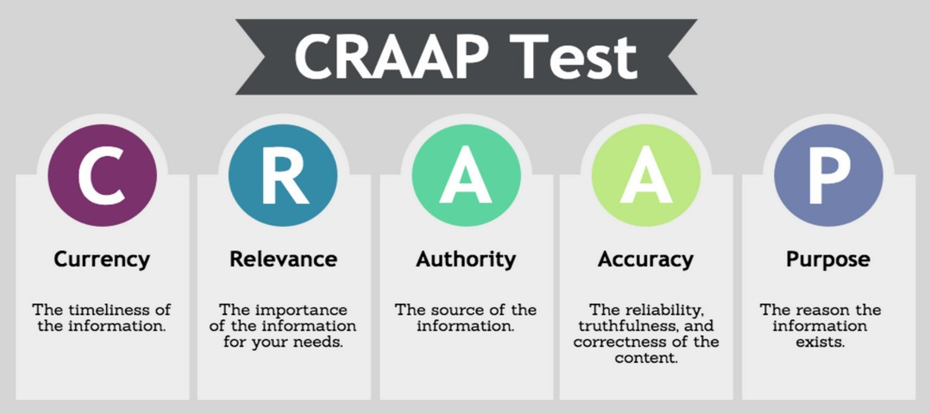
Applying this to my current and future work will help to ensure my information and the source is credible. My understanding of the literature I cited in my report was limited, so I was unclear about the outcome of my research.

I have learnt I need to improve my time management skills as I did not start any work in the first few weeks because of all the new information I was trying to process. I like to focus on one task at a time and did not create specific times to focus on each separate task. By implementing effective note taking and using it to identify key words or phares during research this will contribute towards managing my time and work more efficiently. Most importantly taking time to reflect on each day we learn is vital in helping me to develop critical thinking skills and, improve on future performance by analysing what I have learned and how far I have come.

Task 2 - Group Presentation

In week 7 we were given the task of working in a group to create a presentation on a job advertisement. We got together as a group of four and sat down to discuss what job role would be chosen for the presentation, focusing on the key features of job advertisements, and looking at job websites for inspiration.

In week 8 we then presented our finished job ad to our peers, explaining why we chose the job, where we found the relevant information and how we worked together. Our peers then evaluated the groups advertisement for important feedback. I chose the job role of Cognitive Behavioural Therapist and conducted the initial research because it was a personal interest of mine and as I expand my knowledge and skills this is one of the career paths in health and social care I will explore.

Our group had previously worked together to collaborate on another presentation, so this gave us an advantage as we were already familiar with each other's strengths and weaknesses. As a result of this, I felt more confident about our presentation and our ability to meet the task. Organisation of the job advertisement went well I was happy as everyone agreed on the job role I had proposed to use. We worked quickly and efficiently, we all had a slide each to present, and I was satisfied everyone was clear on what they were going to do.
We spoke in order of the slides we had prepared when it came time to present and when it was my turn to speak in the group I stood at the front. I felt slightly nervous but also confident when talking as I knew other students were feeling a bit tense or anxious about their own presentation and this took the pressure of me. As a result, I felt pleased and relieved.

I personally found it to be a valuable experience, as it gave me more confidence when speaking in public, which is something I can improve on. Additionally, it was good to work in a team because the work was divided evenly so that strengths of individual members could be utilised. Feedback from our peers was also given after the presentation which helped us to identify our strongest skill and which skill requires development. Having worked together previously we had effective communication because we had a keen sense of working together as a team. It was evident that public speaking is an area of improvement in the group, as well as a skill I would like to develop. Practicing Before the presentation, speaking in front of an audience might have enriched the feedback from our peers.

I have learnt that I worked well both in a group and on my own, but I like to be able to discuss my work with others for either. My confidence when speaking publicly has developed which will enhance my presentation skills. In the team I took the role as their leader which the team were happy with but in a future group exercise, I would like to take on a different role to compare experiences to reflect on. When reflecting on my own experiences Driscoll’s ‘What?’ Model is another effective model I like to use as it is simple and easy. Driscoll (2007) outlines three steps to this model which are shown in figure 1:
Figure 1 – Driscoll's ‘What?’ Model.
I can use the simpler models of reflection in future assignments and research to reach a higher level of personal development and continue to evaluate experiences during the process of self-examination.

4. Personal Development Plan

Creating a personal development plan emphasises my self-awareness, reflection, and gives an honest assessment of strengths and weaknesses. The process of writing a PDP should help me define what I want from my studies and how to reach them in realistic terms. I can then review and revise it using it as a tool for future reference.

Personal  Target | How will I achieve this? | How will this help me academically and professionally? | How will I know that I have achieved this? | When will I achieve this by?
Time management skills | Create a daily schedule for studying and personal life. Prioritising important tasks | It will ensure I have enough time available to complete assignments | The quality of my work and decision making will improve and stress will be reduced | Have a schedule ready by the 23rd of May ready for my next modules
Evaluating the quality of  Research | Using the CRAAP method | Sources I select will meet the expectations of the assignment | I will be confident sources are credible | 23rd May
Public Speaking skills | By knowing my audience and material. Study great Public Speakers | Critical thinking skills and  Career advancement as it builds credibility | I will have a boost of confidence and Personal satisfaction from becoming more professional | No end date as it will become part of my CPD plan
Working as a team | Team projects, setting clear goals, and tracking teamwork and progress | It will contribute towards organisations goals and  bring more career opportunities | Clear and efficient communication. Developed planning and organisational skills | No end date as I can continue teamwork throughout my studies and career using a CPD plan

The concept of CPD (continuous professional development) describes a continuous learning process, Whitaker & Megginson (2007) highlight the importance of CPD and the different methods that can be used to analyse development needs and create and implement a CPD plan. The continuous process consists of Reflection, planning, action, and evaluation forming the basis of its four-stage cycle.

A CPD plan can help you identify the essential skills and steps you are going to take to achieve your career goals. Once you have identified the skills, knowledge, and experience you need to develop, the next step is to engage in activities that will help you achieve your goals. In my PDP there are two personal targets that I will put into a CDP plan.

5. Conclusion

Throughout this module I have consistently reflected on the previous lesson allowing me to step back from my experience and develop critical thinking skills. This gave me an opportunity to improve on my future performance by analysing what I have learned and how far I have come. Notetaking, understanding assessments and finding information were the first important things we learnt. We were then shown how to reference using the Harvard referencing style and writing academically. All were part of the planning process for the assignments and to help us to develop our skills for future modules. To enhance my planning and organisational skills and make excellent references to existing literature, I need to develop my time management skills and evaluate the quality of research. I will continue to use such methods as the CRAAP test to assist me in my academic writing. When reflecting I will use different models of reflection depending on my level of understanding and how well the model can be applied to the work I am doing. Finally, to set goals I will refer to the SMART method to guide my personal development.

6. Reference List

Bassot, B. 2020. The Reflective Journal. 3rd Ed. London: red globe press. p30-33.
Bolton, G. 2009. ‘Write to Learn: Reflective Practice Writing’, InnovAiT, 2(12), pp. 752–754. Doi: 10.1093/innovait/inp105.
Buzan, T. 2018. Mind Map Mastery: The Complete Guide to Learning and Using the Most Powerful Thinking Tool in the Universe. United Kingdom: Watkins Media.
Gibbs, G. 1998. Learning by Doing: A Guide to Teaching and Learning Methods. United Kingdom, FEU.
Gorlewski, J, & Greene, K. 2011. Research for the Classroom: The Power of Reflective Writing. The English Journal, 100(4), 90–93.
Lewis, A. 2018. ‘What does bad information look like? Using the craap test for evaluating substandard resources,’ issues in Science and Technology Librarianship. Winter.
Mulryan-Kyne, C. 2021. Supporting reflection and reflective practice in an initial teacher education programme: an exploratory study. European Journal of Teacher Education, 44:4, 502-519, DOI: 10.1080/02619768.2020.1793946
Nicholls, D, Driscoll, J. 2007. Practising Clinical Supervision: A Reflective Approach. United Kingdom: Baillière Tindall Elsevier.
Whitaker, V, Megginson, D. 2007. Continuing Professional Development. United Kingdom: Kogan Page.

