Adding Just Intonation to Equal Temperament
in Voice Pedagogy
An Exploratory Study of Singers’ Tuning Tendencies, Perception and Adaptability in The Third Interval

MA Professional Practice (Voice Pedagogy)
Work-based Learning Project (Extended) – BMPF7329
Aramat Arnheim Sharon
Student Number: 2246292
Word Count: 13036

Acknowledgements
I am deeply grateful to Anat Daskal for her guidance in data visualisation, to my father, Yossi Arnheim, for his guidance in Excel, to Daniel Yehezkeli for developing the tuning-adjustment tool, and to Alon Schab for his teaching and guidance in tuning systems and their mathematical principles. Their generosity, knowledge, and support have been invaluable to my learning.

Contents
Part I - Project Proposal
Part II - Project Report
1. Chapter 1 - Introduction
1.1 Research questions and objectives
2. Chapter 2 - Literature Review
2.1 Review methodology
2.2 Equal temperament, just intonation and the harmonic series
2.3 Historical and cultural naturalization of tuning
2.4 Intonation as a flexible phenomenon
2.5 Tuning behavior in singers and instrumentalists
2.6 The third as a critical interval
2.7 Auditory feedback, perception and learned categories
2.8 Culture, familiarity and tuning expectations
2.9 Voice pedagogy, piano dependence and the research gap
2.10 Conceptual framework and hypotheses
3. Chapter 3 - Methodology and Methods
3.1 Research paradigm and design
3.2 Participants and sampling
3.3 Materials and musical stimuli
3.4 Assessment protocol
3.5 JI intervention
3.6 Quantitative measures
3.6.1 Quantitative data analysis
3.6.2 Qualitative data analysis
3.6.3 Integration of Quantitative and Qualitative data analysis
3.6.4 Temporal Stability
3.6.5 Self-Rated Assessment Measures
3.7 Qualitative Data Collection
3.8 Data analysis plan
3.8.1 Quantitative data analysis
3.8.2 Qualitative data analysis
3.8.3 Integration of Quantitative and Qualitative data analysis
3.9 Ethics and insider-research considerations
3.10 Methodological limitations
4. Chapter 4 - Findings and Analysis
4.1 Participants’ Characteristics and Data Completeness
4.2 Tuning Accuracy at Each Assessment
4.3 ET-JI Tuning Tendency at Each Assessment
4.4 Longitudinal Change and Temporal Stability Across Assessments
4.5 Task-Specific Patterns in Accuracy, Tuning Tendency, and Temporal Stability
4.6 Exploratory Comparison of Intervention and Non-Intervention Trajectories
4.7 Self-Rated Assessment Measures
4.8 Reflective-Writing Themes
4.8.1 Perceived Accuracy and Task-Related Difficulty
4.8.2 Spontaneous Detection of Acoustic Differences in Group B
4.8.3 Listening Strategies Following the Intervention
4.8.4 Confidence, Confusion, and Developing Awareness
4.9 Integration of Quantitative and Qualitative Findings
4.9.1 Task Difficulty and Measured Performance
4.9.2 Intervention-Related Listening Strategies and Acoustic Change
4.9.3 Spontaneous Awareness in the Non-Intervention Group
4.9.4 Perceived and Measured Performance
4.9.5 Integrated Summary
4.10 Unexpected Findings Problems and Limitations
4.10.1 Data Completeness and Technical Problems
4.10.2 Quantitative Limitations
4.10.3 Self-Rating and Qualitative Limitations
4.10.4 Implications for Interpretation
5. Chapter 5 - Conclusion and Critical Reflection
5.1 Overview and Principal Conclusions
5.2 Conclusions in Relation to Objectives and Hypotheses
5.3 Professional and Pedagogical Implications
5.4 Critical Reflection on the Research Process
5.5 Recommendations for Future Research
5.6 Final Conclusion
Part III References
Part IV Appendices

Part I

Project Proposal

Context
This project is part of my ongoing exploration of tuning systems in Western voice training. In Module 5, I critically analyzed the dominance of Equal Temperament (ET) in voice pedagogy and examined the theoretical and practical impacts of incorporating Just Intonation (JI) awareness into the voice studio. This work led to the creation of digital resources and exercises designed to expose singers to JI-based interval relationships.
Western voice lessons usually include piano accompaniment which reinforces ET tuning (Halewood, 2015). However, studies indicate that singers and instrumentalists tend to shift toward JI when performing without fixed pitch instruments (Loosen, 1993; Karrick, 1998; D’Amario et al., 2020). Although this tendency is well documented, private voice teaching usually does not address it.
This proposed study will move from theoretical exploration and artifact development into empirical investigation. I will examine whether singers tend to JI or ET after unknowingly listening to both tunings. It will also examine whether this exposure influences singers’ pitch accuracy and interval tuning over four weeks.
Epistemologically, this research is rooted in pragmatism and a post-positivist perspective. It does not aim to establish which tuning system is “correct,” but instead investigates singers' tendencies and tuning preferences, operating under the hypothesis that singers may prefer JI when given a choice.

Justification for the Project
Extensive research shows that musicians adapt their tuning based on context (Greene, 1937; Hall and Hess, 1984; Leukel and Stoffer, 2004; D’Amario et al., 2020). Thirds and sixths often drift toward JI during ensemble performances, as D’Amario et al. (2020) found that in an a cappella quintet, pitch gradually shifted toward JI. Nonetheless, voice pedagogy still heavily relies on the piano, an ET instrument. Studies in auditory learning (Wright and Zhang, 2009) and multisensory learning (Shams and Seitz, 2008) suggest that perception can be shaped through structured training. Furthermore, neuroplasticity research in vocal learning (Behroozmand, Korzyukov and Larson, 2011; Moss Erickson, 2022) indicates that auditory-motor integration can be refined through targeted feedback.
However, there is currently little pedagogical research investigating whether deliberate exposure to JI can influence singers’ measurable pitch behavior within an ET dominated educational framework.
This project justification therefore rests on four grounds:
- A documented gap between ensemble tuning behavior and studio pedagogy.
- Evidence that pitch perception and production are trainable.
- The need for empirical data evaluating JI informed exposure or intervention.
- It is a timely research project matching a trend of microtonality in music and accessible digital instruments that allow flexibility in tuning

Intended Impact
The intended impact of this project will operate on three levels:
Pedagogical impact:
The study may provide evidence-based justification to re-evaluate the usage of piano in voice lessons, present possible outcomes of incorporating JI awareness into voicing, and demonstrate the usage of a digital piano tuned to JI using a new artifact.
Professional impact:
Findings may contribute to broader discussions in contemporary vocal pedagogy regarding intonation flexibility, ensemble readiness, and harmonic listening.
Personal scholarly impact:
The project will deepen my methodological competence in exploration and intervention design, acoustic measurement, and mixed-methods analysis, preparing me for future research.

Outlined Intention
This study will use a quasi-experimental design with two groups of singers:
- Intervention Group: Will receive structured JI-focused ear training exercises and learn about the focus of the study.
- Control Group: Will continue standard assessments without JI intervention and without knowing that tuning systems regularly change.
Both groups will:
- Complete baseline assessment tasks prior to the intervention.
- Perform the same repeated assessments with interval and pitch accuracy recordings.

Participants
Participants will be singers or voice teachers with previous education in Western ear training. They will answer a questionnaire to provide information regarding their age, previous and current musical education.

Intervention
The intervention group will engage in:
- Listening comparisons between ET and JI thirds and triads.
- Acoustic Beats awareness exercises (Bihari, Páka and Egri, 2025) .
- Sustained interval tuning tasks based on JI tuned piano.

Measurement
Pitch accuracy will be measured acoustically in cents (Edmonds and Howard, 2025) , as this unit allows octave-independent comparison. Specific focus will be placed on:
- Major thirds
- Minor thirds
- Major and minor Chords
- Major thirds within a melody and pentatonic scale
Pre-, mid-, and post-intervention recordings will be analyzed for deviation from ET and deviation from JI ratios.
I will also collect qualitative data through short reflective journals documenting students’ perceptions of tuning awareness and ensemble sensitivity.

Expected Learning Outcomes (Personal)
Through this project, I expect to:
- Develop competence in designing and implementing a controlled pedagogical intervention.
- Gain practical experience in acoustic pitch analysis using cent-based measurement.
- Critically evaluate whether JI informed pedagogy produces measurable outcomes.
- Reflect on the challenges of insider research in my own teaching studio.
- Deepen my theoretical understanding of the JI versus ET tunings.

Ethics and Insider Research Considerations
As this study might involve students I know, insider research considerations will be central.
Participation will be voluntary and require a consent form that provides the project outline:
- The purpose of tuning and pitch accuracy
- The voluntary nature of participation
- The right to withdraw at any time
- Assurance that participation or non-participation will not affect lesson quality
To minimize power imbalance, consent procedures will emphasize autonomy.
Data will be anonymized. Audio recordings will be securely stored and used only for research purposes.
A potential ethical tension arises from differential intervention. To address this, JI exercises will be offered to the control group after the study period if findings suggest benefit.
Reflexivity will be maintained throughout. As both researcher and teacher, I will keep a reflective journal documenting pedagogical decisions and potential bias.

Conclusion
This project will move beyond theoretical advocacy for JI and will empirically investigate whether exposure to JI can influence singers’ measurable pitch accuracy and interval tuning.
Rather than positioning JI as a replacement for ET, the study will explore whether expanding singers’ harmonic awareness may increase tuning flexibility, responsiveness, and pitch sensitivity.
If measurable differences emerge between groups, this may support future larger-scale research. If no significant difference is found, the findings will still contribute valuable insight into the limits of short-term auditory retraining within established tonal frameworks.

Part II

Chapter 1 Introduction
Western singing pedagogy commonly relies on the piano as a stable pitch reference for harmonic and melodic learning. The modern piano is normally tuned in twelve-tone equal temperament (ET), which divides the octave into twelve equal logarithmic semitones. Although this system offers practical advantages for modulation and musical communication, its intervals do not always correspond to the simple frequency ratios found in the harmonic series. By contrast, just intonation (JI) derives intervals from whole-number ratios, producing alternative tuning relationships that singers can potentially access through flexible pitch production.
Research documents context-sensitive tuning among singers and instrumentalists. D’Amario et al. (2020) observed potential patterning within an a cappella quintet but could not confirm consistency across singers. Unlike traditional voice lessons, a cappella offers a distinct pedagogical framework by not relying solely on piano or electronic tuning, facilitating access to pure intervals in just intonation (JI). Leukel and Stoffer (2004) note that professional flutists use flexible JI intonation in specific contexts, indicating its pedagogical relevance, though vocal motor limitations and auditory feedback may require adjustments. Devaney et al. (2011) found that sopranos’ pitch drift varies with musical context, underscoring the complexity and flexibility of the human voice, and suggesting a link to interpretative, unconscious performance styles. This highlights a pedagogical gap and the need for further research on the effects of microtonal exposure, with or without awareness. The increasing availability of digital tuning tools enables exploration of these tuning distinctions in voice training. The project stems from earlier work questioning whether the dominance of ET in Western voice training limits awareness of tuning alternatives (Modules 4 and 5 of the MA). The core pedagogical issue shifted from whether JI should replace ET to whether recognition of multiple tuning targets benefits singers’ control in varied contexts. This reframing draws on auditory-perceptual learning and context-sensitive vocal pitch regulation, recognizing that pitch production is influenced by auditory feedback, learned expectations, accompaniment, harmonic function, and musical context. Intonation is therefore not simply a matter of reproducing one objectively correct frequency. Instead, tuning competence may involve recognizing and responding to different reference targets based on musical circumstances.
This exploratory study examined singers’ tuning behaviour across repeated assessments contrasting ET and JI stimuli. Thirds were selected because they provide measurable and musically meaningful differences between the systems. Recorded tasks included isolated major and minor thirds, chordal contexts, pentatonic scales, and melodies. A subset of participants received targeted JI instruction, while others completed repeated assessments without intervention. Acoustic pitch measurements provided the primary evidence, supplemented by written reflections concerning participants’ awareness and perceived experiences.

1.1 Research Questions and Objectives
The primary research question was: To what extent does targeted exposure to JI influence singers’ production and perception of thirds relative to equal temperament?
A secondary question examined whether observed changes suggested movement toward a single tuning system or greater context-sensitive adaptability between tuning targets. The secondary research question draws on auditory-perceptual learning and context-sensitive vocal pitch regulation, exploring the relationship between changes in vocal pitch production and singers’ reported awareness of alternative tuning targets, without assuming that perceptual recognition and motor adaptation necessarily develop together.
The quantitative analysis distinguished four related dimensions: tuning accuracy, ET versus JI tuning tendency, temporal stability, and task-specific patterns. These were examined through the following objectives:
- Tuning accuracy: Measure signed and absolute deviations from ET and JI reference values.
- Tuning tendency: Characterize the relative position of produced intervals between ET and JI references.
- Temporal stability: Examine changes in tuning performance across consecutive assessments.
- Task-specific patterns: Identify differences across isolated intervals, chords, melodies, and pentatonic tasks.
A secondary exploratory objective was to compare the trajectories of participants receiving JI instruction with those completing repeated assessments without intervention. Given the small and unequal groups, this comparison was descriptive rather than confirmatory.
The intended professional impact was to explore whether explicit tuning awareness and flexible intonation might add value to conventional ET based voice lessons, without assuming either system is superior. As the researcher, I expected to develop competence in intervention design, acoustic measurement, quantitative and qualitative analysis, and critical reflection on insider research and established pedagogical assumptions.
As a practitioner-research project, the study also required reconsidering long-established listening habits and confronting the difficulty of defining accuracy when more than one tuning target may be musically meaningful. The findings are therefore interpreted as exploratory evidence to inform pedagogical reflection and future research, not to establish a universal tuning preference or intervention effect.

Chapter 2 Literature Review

2.1 Review methodology
The literature underpinning this project builds on previous modules that informed the present study. Searches focused on peer-reviewed work concerning equal temperament, just intonation, singing intonation, pitch drift, ensemble tuning, auditory feedback, pitch perception, ear training, microtonality and cultural influences on musical perception. Earlier historical and theoretical sources were retained where they were necessary to explain the development of tuning systems, while recent empirical studies were prioritized for claims concerning perception, singing behavior, and technology. The review was not a systematic review; instead, it served as a focused critical review to establish the conceptual and methodological context for a small practitioner study. It focused on studies that measured pitch in cents, examined musicians in performance or experimental tasks and perception across musical contexts.
The review also evolved in response to the study design. Initial reading was broad and concerned whether JI might offer a ‘more natural’ alternative to ET. As the project progressed, that framing became too simplistic. This shifted focus to the interaction between acoustics, learned musical categories, and context-dependent tuning. This shift is reflected in the organization below: the review begins with tuning systems and their history, then narrows toward empirical evidence on singing and ensemble intonation, before considering auditory learning and the specific pedagogical gap addressed by the study.

2.2 Equal temperament, just intonation and the harmonic series
Musical pitch systems represent different solutions to the problem of organizing frequency relationships into usable scales. ET divides the octave into twelve equal logarithmic parts. This makes every semitone structurally equivalent and allows musicians to transpose or modulate freely without retuning an instrument. The practical value of ET is therefore substantial, particularly for keyboard instruments and modern musical communication (Mason, 1960; Halewood, 2015). Yet this convenience comes at a cost: most ET intervals do not correspond exactly to the simplest ratios of the harmonic series.
JI uses simple whole-number ratios such as 3:2 for a perfect fifth and 5:4 for a major third (Li, Chakraborty and Kanemitsu, 2018). In acoustic terms, these ratios permit partials from simultaneously sounding notes to align more closely. Both systems share the octave, and the fifth differs only slightly, whereas thirds show a much larger contrast. In practical cents measurement, the ET major third is 400 cents while the 5:4 JI major third is approximately 386 cents. The difference is therefore about 14 cents, large enough to be measured reliably and, with training or appropriate harmonic context, often perceived. The minor third also differs between systems, but in that case, instead of JI being a smaller interval than ET, the opposite is true.
The cent measurement, 100 cents per semitone, comes from the ET system, where each semitone is the same. It is easy to get confused about what math in music means; I personally find it helps to remember that it is about interaction. In other words, your root note can be at any frequency, but in a musical context, the note that interacts with the root comes from the harmonic series, the basis of our music. It may be helpful to keep that in mind as we go through the history and logic of tuning.
Simultaneous tones interact through their partials, and near-alignments can generate audible beating. Previous practical work for this project used this phenomenon pedagogically: JI and ET chords could be compared not only as abstract numbers but through the changing periodicity of beats. This was useful because it gave singers an auditory feature to attend to rather than asking them to imagine a difference of only a few cents. Here is a visual example of beating that may appear similar to vibrato; since vibrato is dominant in Western singing, this also raises the question of a possible connection between the natural acoustic phenomenon in ET and its possible effects on Western classical vibrato. This study does not investigate this question but notes it as part of future discussion.
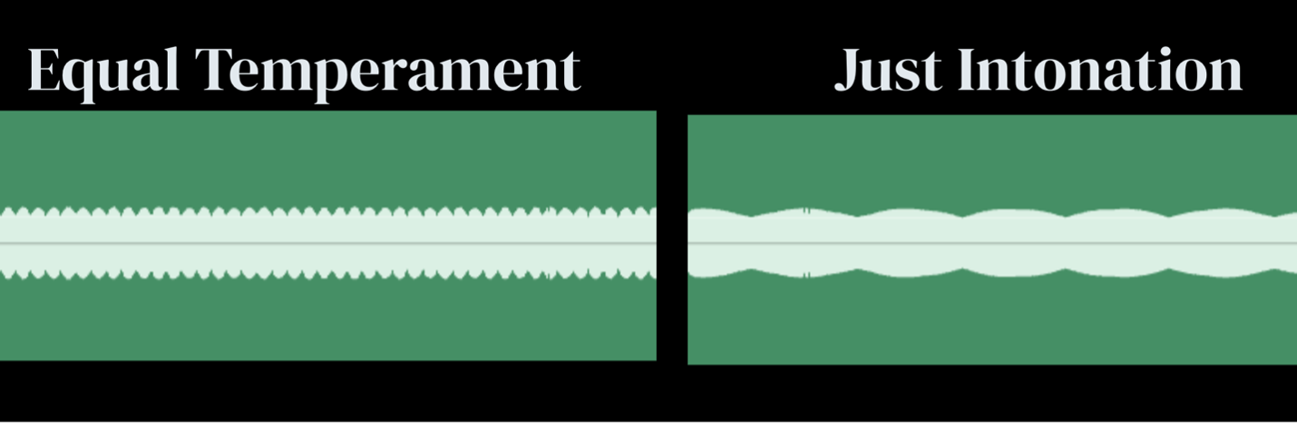
Figure 1. Visual representation of acoustic beat in major chord of JI tuning versus ET

2.3 Historical and cultural naturalization of tuning

The dominance of ET can easily make it seem acoustically inevitable, but it is historically contingent. As Western music and instruments developed, the octave was and still is a simple doubling or halving of frequency, but fractures of notes in the octave for pure interval divisions seemed to always sacrifice the tuning of some notes; this was a mathematical issue (Bartel, 2015). The harmonic series itself presents pure intervals, and when those interact with an impure interval, it may sound disturbing. Earlier tuning systems tried to preserve selected pure intervals and therefore produced unequal keys, commas, and problematic intervals called wolf fifths. The next image visualizes the organization of the circle of fifths in ET versus the natural circle of fifths in which for example the note Db is not equal to the note C#.
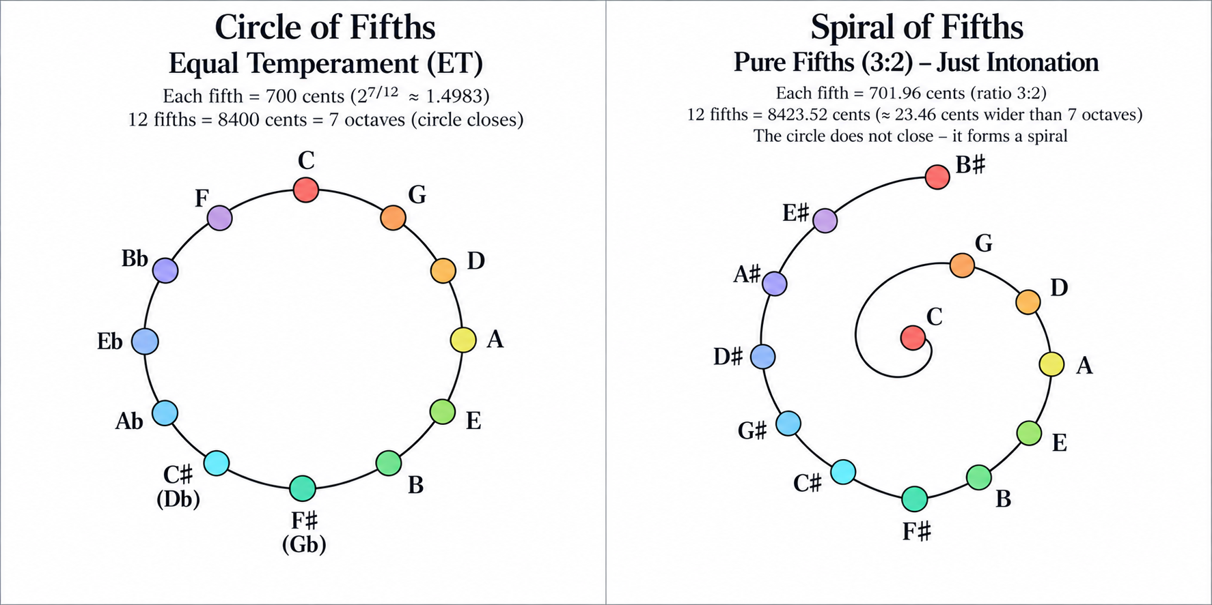
Figure 2. Circles of fifths as visual representation of the tuning differences

The increasing importance of modulation, keyboard standardization, and tonal harmony encouraged systems that distributed ET, ultimately prioritizing flexibility across keys over the purity of every interval. The result was not the discovery of a single correct intonation system but the adoption of a highly useful compromise.
This history matters pedagogically because repeated exposure may shape which tuning conventions listeners perceive as natural or familiar (Jacoby et al., 2019; Armitage et al., 2023). A singer educated almost entirely with piano, fixed-pitch digital keyboards, and pitch-correction software may experience ET as ‘normal’ even though flexible-pitch performers frequently depart from it. Conversely, musicians from different musical traditions may perceive and evaluate pitch relationships differently, reflecting how cultural experience shapes musical perception (Jacoby et al., 2019). The present project therefore uses the term naturalization cautiously: it refers to the process by which repeated cultural and educational exposure makes a tuning pattern feel self-evident, not to claim that ET is biologically unnatural or that JI is universally preferred. The reframing that this article aims for is that today, with digital tools, we have more flexibility and options in our studios which allows us to revisit some of the musical compromises that were made in the past, not as a key to change music but as an additional pedagogical tool that develops singers’ listening and pitch production according to the interaction of the musical setting they are in.

Li, Chakraborty and Kanemitsu (2018) discuss the history of tuning, tracing it from the natural harmonic series to Pythagorean tuning to ET divisions. The only natural tuning system that maintains pure mathematical order is JI, which historically required different instruments for each key. This influences western music in general, according to True (2018), theorists trace the shift from modality to tonality around 550 B.C., moving from melody-driven Western music to the Baroque period, where key and harmony defined a piece's character.
Taking this idea to contemporary music with the preference for harmony, may explain the reduced melodic complexity in charting popular music (Hamilton and Pearce, 2024), or the continuum between speech-like and pitched vocal delivery in rap (Komaniecki, 2021) and the complex relationships between melodic and harmonic tonal centers in contemporary pop (Duinker, 2019) made me hypothesize that a change in the relationship between vocal melody and accompaniment may have occurred. One possible interpretation is that, in some musical contexts, a relatively static or speech-like vocal line may serve as a stable pitch reference, reversing the traditional relationship between a fixed drone and a moving melody. This remains a theoretical analogy rather than an established historical trend, but it raises questions about how singers negotiate tuning targets when harmonic context, rather than melodic movement, provides the principal source of tonal change.
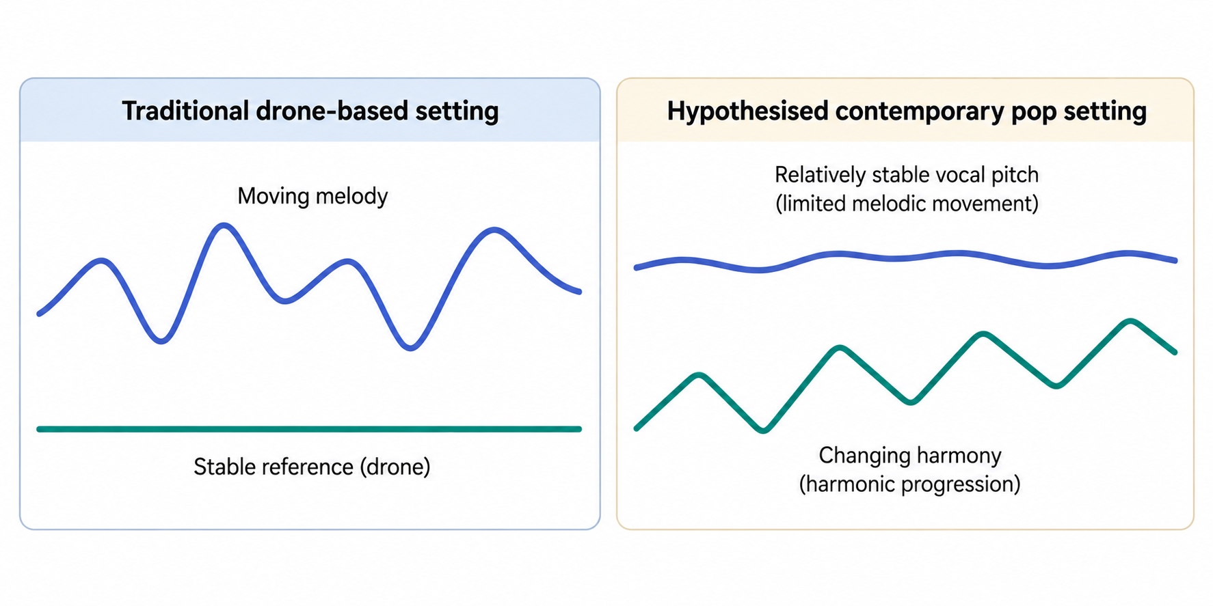
Figure 3. Conceptual comparison of melodic and harmonic roles.
A moving melody over a stable drone is contrasted with a relatively stable vocal line over changing harmony in some contemporary popular music. Note. Author's conceptual illustration; hypothetical, not measured data.

Nevertheless, interval-tuning issues that originally produced dissonance and prompted musicians to move away from JI to gain flexibility in key modulation in ET did not eliminate dissonant intervals from cultures like Turkish music (Benetos and Holzapfel, 2015) or in modern blues with its blue notes (Cutting, 2018), showing that some tolerances for deviation are culturally acceptable and, besides being stylistically desired, they add personal interpretation (Rapoport, 1996; Sundberg, Lã and Himonides, 2013).

2.4 Intonation as a flexible phenomenon
A central difficulty in studying singing intonation is deciding what counts as accurate. Measurements of pitch can be expressed in Hertz, but cents provide a more useful logarithmic scale because the same cent deviation represents the same intervallic distance across registers. Devaney et al. (2011) demonstrated the usefulness of detailed pitch tracking in trained singers, while Larrouy-Maestri, Magis and Morsomme (2014) showed that sung pitch contains normal variability that may remain perceptually acceptable including vibrato, expressive inflection and transitions which complicate any attempt to reduce singing to a single frequency value.
For the present study, this means that deviation from ET cannot automatically be classified as error. If a singer produces a major third approximately 14 cents below ET, that pitch may be less accurate relative to a piano target but more accurate relative to a 5:4 JI target. The analytic problem is therefore relational: the relevant question is not only how far a note is from ET, but where it lies between competing targets and whether the singer can move appropriately when the reference changes.
Taken together, these studies suggest that tuning behaviour cannot be understood solely as adherence to a fixed reference system. However, evidence of context-sensitive intonation in particular musical settings does not necessarily establish that singers can consciously distinguish or transfer between tuning targets following instruction. This distinction directs the present review toward three related questions: how tuning behaviour varies with musical context, how auditory learning may influence the perception and production of intervals, and how reliably such changes can be measured. These questions inform the conceptual framework and hypotheses developed in Section 2.10.

2.5 Tuning behavior in singers and instrumentalists
Empirical ensemble research supports the idea that tuning behavior changes with musical context (Little, Cheng and Wright, 2019). D’Amario et al. (2020) distinguished vertical tuning - the moment-to-moment relationship among simultaneous voices - from horizontal tuning, or pitch stability across the course of a piece in a cappella quintet longitudinally. Their data showed that major thirds tended toward purer, JI-like relationships in some vertical contexts, while minor thirds were more consistent with ET in others, and generally the outcome was affected by fatigue, attention and ensemble negotiation. While these studies help understand choir singing, they do not discuss singing pedagogy or conscious tuning decisions.
The same tendency for major thirds was shown among flutists by Leukel and Stoffer (2004), and earlier ensemble studies likewise documented tuning strategies that depart from fixed-pitch standards (Greene, 1937; Hall and Hess, 1984; Loosen, 1993; Karrick, 1998). Taken together, though limited by not being directly relevant to singers and pedagogy, these studies challenge a simple model in which trained musicians merely aim at ET frequencies.

2.6 The third as a critical interval
The major third became the central construct in this study for both theoretical and practical reasons. First, it is commonly used and it contains one of the clear differences between commonly used ET and JI targets. Second, it has a familiar harmonic function for Western-trained singers, making tasks relatively easy to perform. Third, existing ensemble research already suggests that third tuning is sensitive to harmonic context. These properties make the interval suitable for an exploratory intervention: a change of approximately 14 cents is small enough to test fine-grained perception but large enough to distinguish the systems acoustically.
The minor third was retained as a comparison because the literature does not predict the same simple behavior. Uniform interval shifts following JI intervention may indicate response bias rather than tuning-system learning, whereas divergent responses to major and minor thirds would suggest sensitivity to harmonic function rather than generalized pitch adjustment.

2.7 Auditory feedback, perception and learned categories
According to Behroozmand, Korzyukov and Larson (2011) our brains literally work harder while processing a complex natural voice with all its natural harmonics versus a pure tone. This merely shows the complexity of learning and adapting to improve intonation, but it does not provide pedagogical answers. Musical perception is trainable; (Parlitz and Bangert, 1999) discuss how learning creates categorical distinctions, and (Shams and Seitz, 2008; Yashaswini and Maruthy, 2020) suggest that repeated contrasts can sharpen distinctions previously treated as belonging to one category. Pedagogically, this project examines the categorical process by using two reference categories, hypothesizing that, with intervention and practice, singers might learn to distinguish between ET third and JI third. However, this remains exploratory owing to the study's short duration and small sample size.

2.8 Culture, familiarity and tuning expectations
Cross-cultural research shows that pitch perception reflects cultural experience, as Jacoby et al. (2019) examined Western participants and members of the Tsimane’ society, identifying cultural differences in octave pitch-processing characteristics. Armitage et al. (2023) further demonstrated that cultural familiarity influenced conscious evaluations of acoustic roughness, but not automatic responses. Although these studies examined different perceptual processes rather than ET versus JI tuning, they support the idea that musical experience may shape singers’ tuning expectations and behavior.
Wong et al. (2012) found that Cantonese speakers have enhanced musical pitch perception due to the tonal nature of the language. This connects to absolute pitch in singers, which may have genetic links, but is mostly related to early-age development of pitch memory and therefore to tonal language cultures and early musical education (Takeuchi and Hulse, 1993; Baharloo et al., 1998).
If Western-trained singers have spent years hearing ET, a brief JI intervention should not be expected to erase that learning. However, repeated contrastive exposure may increase awareness or expand to a JI category. The most plausible pedagogical outcome is therefore expanded discrimination and context-sensitive adaptability.

2.9 Voice pedagogy, piano dependence and the research gap
Intonation is central to singing pedagogy (Watts et al., 2003), and keyboards are valued tools in voice studios (Gerhard and Rosow, 2016). However, piano-based pitch references reinforce ET expectations, potentially differing from the flexible tuning observed in unaccompanied singing (Howard, 2007a). Research on ensemble singing and intonation education has explored alternative tuning references, including drones (Howard and Overy, 2020; Lu et al., 2025). Yet, how explicitly these distinctions are addressed in individual Western voice pedagogy remains insufficiently documented. Furthermore, contemporary microtonal composition introduces additional intonation demands for singers, challenging conventional Western pitch expectations (Groß, 2025).
The gap is therefore pedagogical rather than purely acoustical. Less clear is whether a small, practical intervention within voice training can make singers more aware of ET or JI distinctions and whether that awareness is measurable in their vocal production. This study was designed as an exploratory, work-based contribution to that question.

2.10 Conceptual framework and hypotheses
The conceptual framework links four constructs: (1) tuning-system exposure, particularly experience of ET and targeted exposure to JI; (2) auditory-perceptual discrimination, meaning the ability to notice or categorize differences between tuning targets; (3) vocal tuning production, operationalized as the cent deviation of sung pitches relative to ET and JI targets; and (4) musical context, including whether the third is isolated, embedded in a chord, supported by a drone, or placed within a short melodic structure. These constructs are expected to interact. Exposure may alter perception; perception may support intentional production; and musical context may strengthen or weaken the relevance of a particular tuning target.
The study followed the following working hypotheses. H1: at baseline, singers would not produce all thirds exactly at the ET target; some major thirds would show spontaneous displacement toward JI, particularly in harmonically supportive contexts. H2: singers receiving targeted JI exposure would show a greater post-intervention shift toward JI when reproducing JI stimuli than singers completing repeated assessment without that exposure. H3: intervention would not simply create a uniform downward pitch shift; instead, improved performance would appear as greater separation between ET-target and JI-target responses, indicating tuning-system-specific adaptability. H4: changes would be larger or more consistent for major thirds than for minor thirds because the major-third contrast is both acoustically clearer and more consistently reported in the literature. H5: participants receiving intervention would be more likely to report conscious awareness of tuning differences or changed listening strategies in reflective writing.
These hypotheses position the primary outcome as tuning adaptability rather than a claim that JI is universally superior. The study therefore asks whether singers can become more responsive to multiple tuning targets and whether such responsiveness has implications for ear training and voice pedagogy.

Chapter 3 Methodology and Methods

3.1 Research paradigm and design
This study used a quantitatively dominant mixed-methods design within a post-positivist framework with pragmatic features (Putnam, 1995; Kivinen and Ristela¨, 2003; Maksimović and Evtimov, 2023). Acoustic pitch measurements provided the primary evidence of changes in tuning performance, while written reflections contextualized participants’ awareness, listening strategies, and experiences. This approach supported systematic measurement while recognizing the practice-based and interpretive dimensions of vocal tuning.

3.2 Participants and sampling
Eleven adult singers with previous musical training and familiarity with Western ear-training practices were recruited through voice and music-education networks. Participation was voluntary, with written informed consent and no payment. The small, non-random sample was appropriate to the exploratory repeated-measures design, which examined individual tuning behavior across tasks and time points rather than seeking population-level inference. Group A received the JI intervention, while Group B completed the assessments without intervention and served as a descriptive, non-randomized comparison group. Participants with usable acoustic data from at least one assessment were included in the quantitative analysis; participant characteristics and data completeness are reported in Section 4.1.

3.3 Materials and musical stimuli
Stimuli contrasted ET and JI. Tasks progressed from isolated intervals and chordal contexts to pentatonic and melodic material with drones, allowing examination of tuning behavior across increasingly contextual musical tasks. Appendices provide the full stimulus frequencies and assessment materials, as well as details on the software used for interventions and for assessments (artifact created for this project called “JUST”).

3.4 Assessment protocol
Participants completed repeated self-recorded assessments in which they heard a stimulus and then reproduced it vocally. ET and JI were not identified, and tuning order varied to reduce expectancy effects. Participants repeated the same task families across assessments to enable within-participant comparison over time. Participants also provided brief written reflections following each assessment.

3.5 JI intervention
Group A received two 15-minute interventions focused on distinguishing ET and JI through listening, identifying acoustic beating, and singing against JI references. The first intervention occurred after Assessment 1 and before Assessment 2. The appendix provides the full intervention protocol.

3.6 Quantitative measures

3.6.1 Analysis dataset and measurement unit
The quantitative dataset comprised usable task-level acoustic measurements from 11 participants, with each sung target treated as a separate observation. Missing or unusable measurements were excluded without imputation.
Acoustic analysis was conducted in Praat version 6.4.63 (Boersma Paul, 2001; Mohammed and Nagy, 2023) using raw cross-correlation, a 75–600 Hz pitch range, and the standard time step. For each target note, the sung segment was manually selected from onset to offset and mean fundamental frequency (F0) was extracted. A fixed-duration analysis window was not used, allowing measurement of the complete produced note despite differences in note duration.
The tonic, ET reference, JI reference, and produced frequencies were converted from Hertz to cents relative to the tonic using C = 1,200 × log₂(f/f_tonic), where C is the interval size in cents, f is the target or produced frequency, and f_tonic is the tonic frequency. Conversion to cents permits comparison across tasks and voice ranges (Devaney et al., 2011).

3.6.2 Tuning accuracy
Consistent with previous acoustic studies of singing accuracy (Devaney et al., 2011; Larrouy-Maestri, Magis and Morsomme, 2014; D’Amario et al., 2020), signed deviations from the ET and JI references were calculated in cents for each observation: d_ET = C_produced − C_ET and d_JI = C_produced − C_JI. Positive values indicated intervals wider than the reference and negative values narrower intervals. Absolute deviations, |d_ET| and |d_JI|, represented the magnitude of deviation irrespective of direction.
ET and JI deviations were retained separately because movement toward either tuning system was not assumed to represent improvement. Furthermore, because participants produced one response after hearing both reference versions, the intended reference could not be determined.
As a supplementary study-specific measure, nearest-reference deviation was calculated as min(|d_ET|, |d_JI|), and each production was classified as closer to ET, closer to JI, or equidistant using unrounded values. This measure described proximity to the nearest theoretical reference without implying intended target or preference and was not treated as a validated outcome measure. Rounding was applied only for presentation.

3.6.3 ET–JI tuning tendency
Relative position between the two tuning references was calculated using an ET–JI tuning-tendency score: T = [2C_produced − (C_ET + C_JI)]/(C_JI − C_ET). The score equals −1 at the ET reference, 0 at the midpoint, and +1 at the JI reference; values outside this range indicate productions beyond the two reference points. Normalization accounted for differences in the distance and direction between ET and JI references across tasks. This study-specific continuous measure represented relative tuning position rather than accuracy and was not assigned a clinical or pedagogical cut-off.

3.6.4 Temporal stability
As each task was performed only once per assessment, within-assessment repeatability could not be estimated. Temporal stability was therefore defined as the absolute change in the produced interval for the same participant and task between consecutive assessments: successive change = |C_t+1 − C_t|, where C_t and C_t+1 represent consecutive assessments. Smaller values indicated greater consistency over time, but not necessarily greater accuracy. Changes in nearest-reference deviation and ET–JI tuning tendency were also examined to distinguish temporal stability from changes in accuracy or tuning orientation. These study-specific indices were not treated as standardized reliability measures.

3.6.5 Self-rated assessment measures
Following each assessment, participants rated their perceived intonation during the assessment and during the corresponding week on five-point ordinal scales, with higher scores indicating more favorable perceived intonation. Self-ratings were analyzed separately from the acoustic data. They were treated as additional measures of perceived performance rather than objective measures of tuning accuracy.

3.7 Qualitative Data Collection
Written reflections provided a secondary qualitative dataset, contextualized and compared to the acoustic findings rather than a standalone phenomenological account (Stilwell and Harman, 2021). Reflections explored participants’ perceived accuracy, task difficulty, listening strategies, bodily or acoustic sensations, confidence, confusion, and awareness of tuning differences; Section 3.8.2 describes the analytical procedure.

3.8 Data analysis plan

3.8.1 Quantitative data analysis
Quantitative analysis was descriptive and exploratory because of the small, unequal groups and variable assessment completion. Results were examined by participant, assessment, and task to preserve individual and task-specific patterns. Continuous outcomes were summarized primarily using the median and interquartile range (IQR), which were preferred because of the small number of observations and heterogeneous values that could disproportionately influence mean-based summaries. Participant characteristics and data completeness were summarized descriptively using appropriate measures of central tendency, range, counts, and percentages.
Longitudinal analyses used available consecutive assessment pairs (1–2, 2–3, and 3–4), with missing data handled by complete-pair analysis and no imputation. For Group A, Assessment 1 represented baseline and Assessment 2 the first post-intervention assessment. Task-specific analyses retained the predefined task categories, combining the two melody components for category-level summaries while keeping them as separate task-level observations. We paid particular attention to the major-third task because the intervention directly targeted it.

Group comparisons were descriptive; no inferential tests of intervention effect were conducted due to the small sample size of Group A and unequal group sizes. Self-ratings, analyzed as ordinal data using medians, IQRs, ranges, and individual trajectories, also did not involve inferential testing.

3.8.2 Qualitative data analysis
Written reflections were analyzed manually using a descriptive thematic approach informed by(Braun and Clarke (2006). Responses were repeatedly reviewed and coded in Excel according to recurring topics, including bodily sensations, emotions, perceived pitch changes, and self-evaluation. Related codes were grouped into themes, and their frequencies were descriptively compared across participants, groups, and assessments. Within the study’s pragmatic framework, these interpretive findings contextualized the post-positivist acoustic measurements, allowing perceived experiences and measured tuning behaviour to be compared without treating either as validation of the other.

3.8.3 Integration of quantitative and qualitative findings
Integration occurred during interpretation by comparing participants’ acoustic measures, numerical self-ratings, and reflective accounts. Convergence, complementarity, and divergence between measured performance and perceived experience were examined to contextualize quantitative patterns. Integration was interpretive and was not treated as an additional test of intervention efficacy.

3.9 Ethics and insider-research considerations
Ethical approval was obtained before data collection. Participation was voluntary, with informed consent and the right to withdraw. Audio recordings, questionnaires, and reflections were treated confidentially and reported without identifying participants, consistent with established principles concerning informed consent, confidentiality, and protection from harm (Sanjari et al., 2014). Potential risks included frustration, embarrassment, or reduced confidence during intonation tasks, and temporary confusion from exposure to unfamiliar tuning framework. These were mitigated by framing the study as an exploration of tuning behavior rather than musical ability, presenting JI as an additional tuning option rather than a correction, and allowing participation to stop at any time.
As a practicing voice pedagogue who designed and delivered the intervention, and a researcher’s professional interest in JI presented a potential risk of confirmation bias. Reflexivity is particularly important where researchers’ professional experience and prior assumptions may influence the research process and interpretation (Berger, 2015). Safeguards included retaining raw and derived acoustic data, reporting contradictory findings, separating acoustic measures from reflective interpretation, and explicitly acknowledging the researcher’s dual role.

3.10 Methodological limitations
The small, non-random and unequal sample, including only two Group A participants with usable acoustic data, precluded confirmatory evaluation of an intervention effect. Variable assessment completion also produced an unbalanced longitudinal dataset, limiting analysis of complete trajectories.
Self-recording reduced control over conditions and procedural adherence. Each task was performed only once per assessment, preventing estimation of within-assessment repeatability. Analysis manual note selection introduced potential measurement variability, while mean F0 enabled consistent comparisons across performances but did not capture within-note pitch fluctuations. Repeated assessment may also have produced practice or familiarisation effects; Group B therefore provided a descriptive comparison rather than a randomised control.
The assessment design limited interpretation since participants heard both ET and JI references before responding, preventing the determination of tuning preference. Recorded reproduction tasks cannot replicate real-time ensemble tuning feedback, and JI references are context-dependent. Therefore, findings should be regarded as exploratory evidence of short-term tuning within the specific tasks, rather than indicating a general JI preference or causal effect.

Chapter 4 Findings and Analysis
Combined quantitative, qualitative, and integrated findings concerning tuning accuracy, ET–JI tuning tendency, temporal stability, self-rated performance, and reflective writing.

4.1 Participant Characteristics and Data Completeness
Eleven participants contributed usable acoustic data: two in Group A and nine in Group B. Participants were aged 22–56 years (M = 35.5); six identified as female and five as male. Mean reported musical experience was 19.2 years and singing experience 13.4 years. All reported previous music-theory and unaccompanied-singing experience; eight reported formal ear training and eight previous exposures to microtonal music. Participants represented varied musical backgrounds and singing styles.
Across the sample, 32 assessments yielded 252 usable task-level observations. Six participants completed all four assessments, three completed two, and two completed one. Group A completed all eight possible assessments (2 participants × 4 assessments), yielding 64 observations; Group B completed 24 of 36 possible assessments, yielding 188 observations. Subsequent analyses therefore used available observations or complete consecutive pairs, as appropriate.
Table 1. Participant characteristics and assessment completion by study group
Characteristic | Group A (n = 2) | Group B (n = 9) | Total (N = 11)
Age, years, mean (SD) | 32.0 (2.8) | 36.2 (12.6) | 35.5 (11.4)
Age, median (range) | 32.0 (30–34) | 36.0 (22–56) | 34.0 (22–56)
Years playing music, mean (SD) | 10.0 (8.5) | 21.3 (13.2) | 19.2 (12.9)
Years playing music, median (range) | 10.0 (4–16) | 20.0 (4.5–50) | 20.0 (4–50)
Years singing or receiving voice training, mean (SD) | 9.0 (9.9) | 14.3 (11.2) | 13.4 (10.7)
Years singing or receiving voice training, median (range) | 9.0 (2–16) | 10.0 (3–40) | 10.0 (2–40)
Female voice, n (%) | 2 (100.0) | 4 (44.4) | 6 (54.5)
Male voice, n (%) | 0 (0.0) | 5 (55.6) | 5 (45.5)
Formal ear-training experience, n (%) | 1 (50.0) | 7 (77.8) | 8 (72.7)
Previous exposure to microtonal music, n (%) | 2 (100.0) | 6 (66.7) | 8 (72.7)
Completed all four assessments, n (%) | 2 (100.0) | 4 (44.4) | 6 (54.5)
Completed two assessments, n (%) | 0 (0.0) | 3 (33.3) | 3 (27.3)
Completed one assessment, n (%) | 0 (0.0) | 2 (22.2) | 2 (18.2)
Complete assessments available, n/N (%) | 8/8 (100.0) | 24/36 (66.7) | 32/44 (72.7)
Valid task-level observations, n | 64 | 188 | 252
Note. Percentages for participant characteristics and completion categories are based on participants within each group; assessment-completion percentages are based on planned assessments within each group.

4.2 Tuning Accuracy at Each Assessment
Tuning accuracy was calculated for all 252 valid task-level observations. Signed and absolute deviations from ET and JI were summarized by participant and assessment using medians and interquartile ranges (IQRs), as described in Section 3.8.1. Table 2 presents the six participants who completed all four assessments; Appendix G provides complete participant-by-assessment-by-task results.
Substantial between- and within-participant variability was observed. Across the 24 assessment combinations shown in Table 2, median absolute deviations ranged from 3.47 to 42.81 cents for ET and from 9.44 to 34.12 cents for JI, with several assessments also showing wide within-assessment IQRs.
The two Group A participants showed different accuracy profiles. A2 maintained comparatively small deviations across assessments (ET medians 3.47–12.78 cents; JI medians 9.44–14.61 cents), with ET nearer in Assessments 1, 2, and 4 and JI slightly nearer in Assessment 3. A3 showed larger deviations and consistently positive signed medians, indicating production above both references; ET was nearer in Assessments 1 and 2 and JI in Assessments 3 and 4.
Group B trajectories were similarly heterogeneous. B3 showed the largest deviations and remained nearer JI across assessments; B5 and B7 varied in which reference was nearer; and B11 consistently produced below both references while showing reduced ET deviation by Assessment 4. Thus, accuracy patterns varied across participants and assessments rather than showing a uniform progression. Longitudinal change is examined separately in Section 4.4.
Table 2. Median and interquartile range of signed and absolute tuning deviations among participants who completed four assessments
Participant | Group | Assessment | Tasks | Signed ET Median (IQR) | Absolute ET Median (IQR) | Signed JI Median (IQR) | Absolute JI Median (IQR)
A2 | A | 1 | 8 | 2.94 (0.06 to 6.61) | 3.47 (3.07 to 17.11) | 12.72 (−0.42 to 16.23) | 13.37 (9.33 to 16.23)
A2 | A | 2 | 8 | −5.13 (−10.87 to 2.57) | 9.22 (5.43 to 16.61) | 1.89 (−14.53 to 11.88) | 14.61 (7.27 to 20.25)
A2 | A | 3 | 8 | −12.04 (−13.83 to −7.81) | 12.78 (11.32 to 17.94) | −0.81 (−15.43 to 3.83) | 11.88 (1.53 to 25.46)
A2 | A | 4 | 8 | −7.31 (−14.56 to −2.53) | 7.31 (3.18 to 14.56) | −1.80 (−10.44 to 7.41) | 9.44 (5.75 to 16.00)
A3 | A | 1 | 8 | 19.47 (9.81 to 27.85) | 19.47 (12.54 to 27.85) | 27.95 (13.44 to 32.55) | 27.95 (13.44 to 32.55)
A3 | A | 2 | 8 | 17.49 (3.46 to 28.55) | 17.49 (9.20 to 28.55) | 18.58 (4.81 to 41.96) | 18.78 (7.79 to 41.96)
A3 | A | 3 | 8 | 25.26 (1.87 to 38.26) | 25.26 (9.93 to 38.26) | 21.93 (5.61 to 46.37) | 21.93 (5.61 to 46.37)
A3 | A | 4 | 8 | 21.80 (5.35 to 29.45) | 26.36 (13.47 to 29.45) | 21.64 (1.97 to 43.36) | 21.64 (8.97 to 43.36)
B3 | B | 1 | 8 | −0.62 (−25.54 to 12.20) | 26.44 (4.85 to 35.30) | 4.90 (−21.00 to 18.10) | 18.79 (17.30 to 27.79)
B3 | B | 2 | 8 | −32.62 (−47.93 to 27.63) | 40.42 (36.26 to 57.66) | −19.20 (−34.28 to 15.58) | 32.75 (22.84 to 54.14)
B3 | B | 3 | 8 | −42.81 (−74.10 to −27.16) | 42.81 (27.16 to 74.10) | −34.12 (−59.99 to −25.31) | 34.12 (25.31 to 59.99)
B3 | B | 4 | 8 | −28.58 (−39.81 to −15.86) | 30.80 (26.80 to 39.81) | −15.16 (−25.70 to −9.60) | 16.38 (13.39 to 25.70)
B5 | B | 1 | 8 | −13.17 (−37.20 to 16.44) | 34.58 (18.29 to 40.57) | −6.31 (−30.30 to 18.22) | 34.11 (7.94 to 54.49)
B5 | B | 2 | 8 | 9.59 (−10.19 to 35.42) | 25.50 (13.45 to 40.08) | 11.54 (−6.16 to 48.83) | 29.06 (14.36 to 48.83)
B5 | B | 3 | 8 | −10.08 (−20.74 to 2.18) | 15.58 (7.03 to 23.55) | −2.16 (−24.45 to 15.84) | 21.82 (11.55 to 32.15)
B5 | B | 4 | 8 | −9.66 (−30.50 to 16.98) | 31.86 (13.34 to 39.57) | −3.70 (−23.23 to 31.09) | 27.24 (19.79 to 53.49)
B7 | B | 1 | 8 | 21.61 (4.75 to 33.84) | 31.62 (23.55 to 42.80) | 30.13 (15.39 to 33.08) | 30.80 (29.04 to 39.20)
B7 | B | 2 | 8 | 9.03 (−4.06 to 28.83) | 15.56 (4.69 to 28.83) | 11.65 (7.83 to 22.87) | 11.65 (7.83 to 22.87)
B7 | B | 3 | 8 | 10.66 (−12.05 to 18.57) | 22.47 (11.98 to 45.97) | 16.63 (−7.68 to 29.62) | 27.88 (19.03 to 39.66)
B7 | B | 4 | 8 | 19.32 (6.01 to 31.83) | 27.17 (11.60 to 38.21) | 22.97 (16.20 to 30.67) | 24.19 (20.12 to 30.67)
B11 | B | 1 | 8 | −33.98 (−55.62 to −17.71) | 33.98 (17.71 to 55.62) | −22.36 (−41.51 to −16.77) | 22.36 (16.77 to 41.51)
B11 | B | 2 | 8 | −29.13 (−71.50 to −4.55) | 29.13 (11.32 to 71.50) | −15.71 (−57.85 to −9.97) | 15.71 (10.90 to 57.85)
B11 | B | 3 | 6 | −26.57 (−33.49 to −12.16) | 29.69 (21.21 to 33.49) | −21.26 (−24.29 to −20.06) | 23.68 (20.66 to 32.54)
B11 | B | 4 | 6 | −17.25 (−33.52 to −6.24) | 17.25 (8.89 to 33.52) | −21.31 (−25.14 to −12.74) | 22.06 (20.53 to 25.14)
Note. ET = equal temperament; JI = just intonation; IQR = interquartile range. Values are median (IQR), in cents. Positive and negative signed values indicate production above and below the reference, respectively; absolute values indicate deviation magnitude. Results are descriptive and do not demonstrate longitudinal change or an intervention effect.

4.3 ET–JI Tuning Tendency at Each Assessment
Relative tuning tendency was calculated for all 252 valid task-level observations. Across the complete dataset, 121 performances were closer to ET and 131 to JI, with none located exactly at the midpoint. These aggregate counts combine participants, assessments, and tasks and therefore describe the overall distribution rather than individual tuning preference.
Table 3 presents ET–JI tendency scores and task classifications for the six participants who completed all four assessments; Appendix G provides complete task-level results. The two Group A participants were predominantly ET-oriented in the first two assessments. By Assessments 3 and 4, both showed an equal division of ET- and JI-oriented tasks; however, A2’s median tendency briefly moved to the JI side of the midpoint in Assessment 3, whereas A3’s remained on the ET side throughout.
Group B showed contrasting trajectories: B3 became strongly JI-oriented, B5 increasingly ET-oriented, B7 remained mixed, and B11 moved from a predominantly JI-oriented pattern toward the midpoint. Overall, tuning tendency varied substantially by participant and assessment, with no uniform progression toward either ET or JI. Sections 4.4 and 4.6 examine longitudinal changes in tuning tendency further.
Table 3. Median and interquartile range of relative ET–JI tuning tendency among participants who completed four assessments
Participant | Group | Assessment | Median T | IQR (Q1 to Q3) | Closer to ET (n) | Closer to JI (n) | Equidistant (n)
A2 | A | 1 | −0.88 | −1.42 to −0.09 | 6 | 2 | 0
A2 | A | 2 | −0.56 | −1.75 to 0.62 | 5 | 3 | 0
A2 | A | 3 | 0.10 | −2.31 to 1.06 | 4 | 4 | 0
A2 | A | 4 | −0.21 | −1.17 to 1.13 | 4 | 4 | 0
A3 | A | 1 | −1.94 | −3.77 to 1.06 | 5 | 3 | 0
A3 | A | 2 | −1.63 | −5.26 to −0.01 | 6 | 2 | 0
A3 | A | 3 | −0.79 | −5.59 to 0.85 | 4 | 4 | 0
A3 | A | 4 | −1.42 | −5.05 to 0.90 | 4 | 4 | 0
B3 | B | 1 | 0.24 | −1.53 to 3.72 | 4 | 4 | 0
B3 | B | 2 | 5.00 | 2.59 to 6.71 | 1 | 7 | 0
B3 | B | 3 | 4.13 | −0.29 to 6.29 | 2 | 6 | 0
B3 | B | 4 | 3.28 | 3.00 to 4.66 | 0 | 8 | 0
B5 | B | 1 | 0.07 | −6.37 to 2.53 | 4 | 4 | 0
B5 | B | 2 | −2.48 | −6.26 to 0.34 | 5 | 3 | 0
B5 | B | 3 | −1.48 | −2.55 to 1.16 | 5 | 3 | 0
B5 | B | 4 | −2.68 | −6.65 to 0.65 | 6 | 2 | 0
B7 | B | 1 | 0.13 | −3.93 to 4.60 | 4 | 4 | 0
B7 | B | 2 | −0.37 | −1.96 to 0.99 | 5 | 3 | 0
B7 | B | 3 | 0.08 | −2.39 to 5.28 | 4 | 4 | 0
B7 | B | 4 | −1.81 | −3.57 to 2.80 | 5 | 3 | 0
B11 | B | 1 | 4.06 | 1.47 to 6.90 | 2 | 6 | 0
B11 | B | 2 | 3.34 | 0.50 to 9.34 | 1 | 7 | 0
B11 | B | 3 | 0.86 | −3.23 to 3.99 | 3 | 3 | 0
B11 | B | 4 | 0.46 | −2.08 to 3.73 | 3 | 3 | 0
Note. T = normalized ET–JI tendency score; IQR = interquartile range; ET = equal temperament; JI = just intonation. Negative and positive scores indicate positions on the ET and JI sides of the midpoint, respectively; −1 and +1 represent the exact ET and JI references. Values beyond ±1 indicate production beyond the corresponding reference. Equidistant indicates the exact ET–JI midpoint.

4.4 Longitudinal Change and Temporal Stability Across Assessments
Temporal stability could be evaluated for nine participants. Six completed all four assessments and contributed to all three consecutive transitions, while three contributed only to the Assessment 1–2 comparison. Participants completing only one assessment were excluded from this analysis.
Figure 3 presents median absolute change in the produced interval across consecutive assessments for the six participants who completed all four assessments; lower values indicate greater temporal consistency. For Group A, Assessment 1–2 followed the first intervention, Assessment 2–3 followed the second, and Assessment 3–4 represented subsequent follow-up. Appendix G provides complete numerical results, including participants who completed only two assessments.
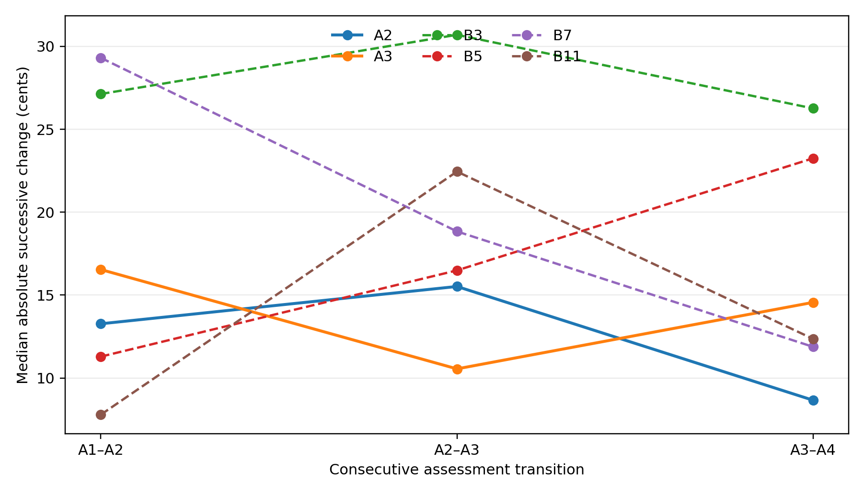
Figure 4. Median absolute interval change across consecutive assessments.
Note. Each line represents one participant who completed all four assessments. Solid lines represent Group A and dashed lines Group B. Lower values indicate greater temporal consistency. Results are descriptive and should not be interpreted as evidence of an intervention effect.
The two Group A participants showed different stability trajectories. A2’s median successive change was 13.27 cents after the first intervention, increased to 15.52 at the next transition, and decreased to 8.66 at follow-up. A3 showed 16.54, 10.55, and 14.56 cents, respectively. Thus, neither participant showed their greatest temporal consistency immediately following the first intervention.
Group B trajectories were heterogeneous: some participants became more consistent across assessments, while others became less consistent or fluctuated between transitions. No common longitudinal stability pattern was observed across participants or within Group B. These descriptive trajectories do not support a causal interpretation of intervention-related change.

4.5 Task-Specific Patterns in Accuracy, Tuning Tendency, and Temporal Stability
Task-specific patterns were examined across seven categories: major third, minor third, major chord, minor chord, melody, ascending pentatonic, and descending pentatonic. The two melody components were combined into a single category. Figure 4 presents median tuning accuracy, ET–JI tendency, and temporal stability across all available observations; Appendix G provides complete numerical results.
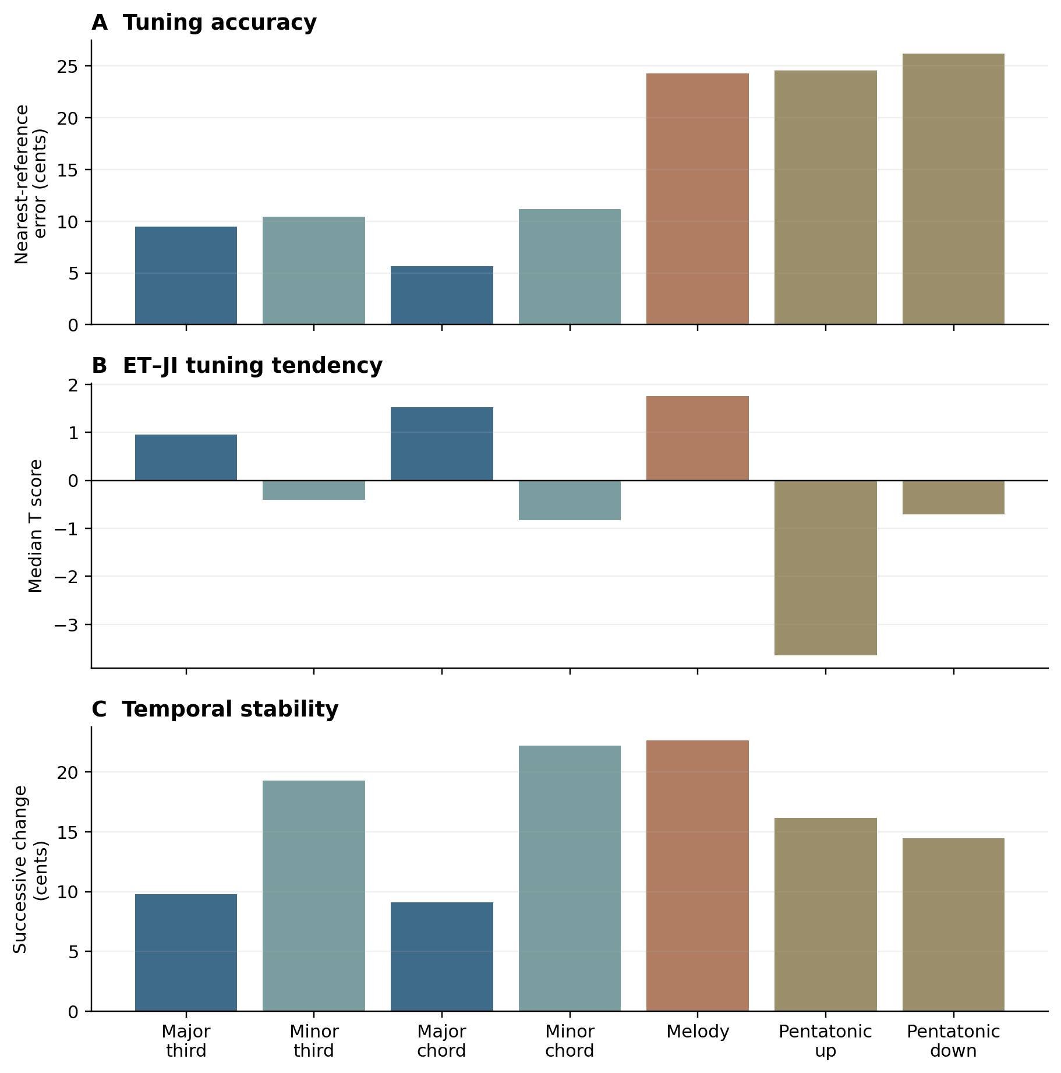
Figure 5. Task-specific tuning accuracy, relative ET–JI tendency, and temporal stability.
Note. Panel A presents median absolute deviation from the nearer ET or JI reference. Panel B presents median normalized ET–JI tendency, with negative and positive values indicating the ET and JI sides of the midpoint, respectively. Panel C presents median absolute successive change. Lower values in Panels A and C indicate greater accuracy and temporal stability, respectively. The melody category combines two melody components.
Tuning accuracy differed across tasks. The smallest median nearest-reference errors occurred for major chord (5.65 cents), major third (9.46), minor third (10.44), and minor chord (11.16), whereas melody (24.28), ascending pentatonic (24.57), and descending pentatonic (26.19) showed substantially larger errors.
ET–JI tendency was also task-specific. Median scores fell on the JI side of the midpoint for melody (1.75), major chord (1.52), and major third (0.96), and on the ET side for minor third (−0.41), minor chord (−0.83), ascending pentatonic (−3.64), and descending pentatonic (−0.71).
Temporal stability showed a partly different pattern. Major chord (9.10 cents) and major third (9.79) had the smallest median successive changes, while melody had the largest (22.64). The pentatonic tasks, despite their relatively large tuning errors, showed intermediate successive changes (14.46–16.15 cents). Thus, accuracy and temporal stability did not necessarily vary together across tasks. The divergence between accuracy and temporal stability suggests that these dimensions capture distinct aspects of vocal pitch regulation. A stable production may remain consistently displaced from the target, while a less stable production may approximate it more closely. Consequently, improvements in pitch steadiness should not be interpreted as equivalent to improvements in tuning accuracy, highlighting the importance of assessing both dimensions separately.

4.6 Exploratory Comparison of Intervention and Non-Intervention Trajectories
The exploratory comparison focused on change from Assessment 1 to Assessment 2, the common interval available for the two Group A participants and seven Group B participants with repeated acoustic measurements. For Group A, this represented change from baseline to the first post-intervention assessment; for Group B, it represented repeated assessment without intervention. Overall accuracy and ET–JI tendency were examined using participant-level medians, with the major-third task examined separately because of its direct relevance to the intervention.
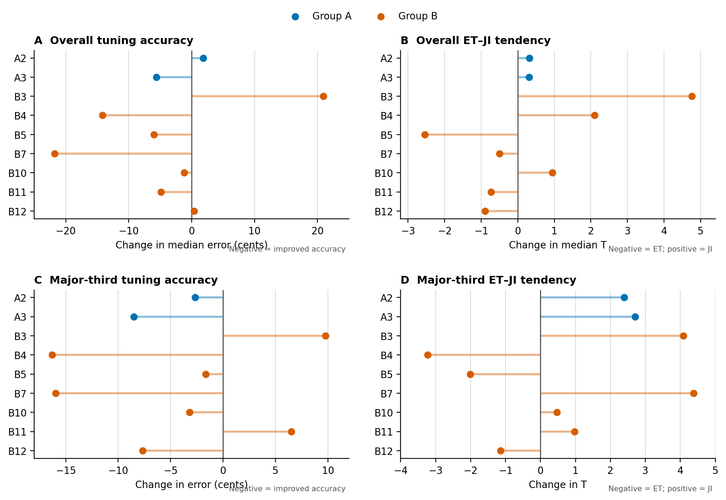
Figure 6. Participant-level changes from Assessment 1 to Assessment 2 in Groups A and B.
Note. Each point represents one participant’s change from Assessment 1 to Assessment 2; horizontal segments connect each change score to zero. Panels A and B show participant-level medians across all tasks; Panels C and D show the major-third task. Negative accuracy-change values indicate reduced error and therefore improved accuracy. Positive and negative tendency-change values indicate movement in the JI and ET directions, respectively. For Group A, this interval represents baseline to first post-intervention assessment; for Group B, repeated assessment without intervention. No inferential between-group comparison was performed.
Across all tasks, accuracy changed in mixed directions in both groups. A2’s median nearest-reference error increased by 1.84 cents, whereas A3’s decreased by 5.62 cents. Group B also showed substantial variation, with five of seven participants showing reduced error and individual changes ranging from a 21.75-cent reduction to a 20.93-cent increase. Overall ET–JI tendency moved in the JI direction for both Group A participants (+0.32 for A2 and +0.31 for A3), while Group B was mixed, with three participants moving in the JI direction and four in the ET direction.
A clearer common pattern appeared in the major-third task. A2’s nearest-reference error decreased from 3.21 to 0.54 cents and A3’s from 13.32 to 4.82 cents. Their tendency scores moved from −1.48 to 0.92 and from −2.98 to −0.28, respectively, indicating a shift toward JI. A2 moved from closer to ET to closer to JI, while A3 remained closer to ET but moved toward the midpoint.
However, major-third changes in Group B were also heterogeneous: five of seven participants showed reduced error, four moved toward JI, and three moved toward ET. Thus, both Group A participants showed improved major-third accuracy and movement in the JI direction immediately following the first intervention, but similar changes also occurred among some non-intervention participants. Given the two-participant Group A sample and descriptive design, these findings do not establish an intervention effect. Appendix G provides complete participant-level results.

4.7 Self-Rated Assessment Measures
Numerical self-ratings were available for 14 participants across 35 assessments: three from Group A and 11 from Group B. This dataset included A1, B1, and B2, who were not included in the final acoustic dataset. Self-ratings were therefore analyzed separately from the acoustic measures. After each assessment, participants rated their perceived intonation during the assessment and during the corresponding week on five-point scales.
Table 4. Self-rated intonation by assessment
Assessment | n | Assessment rating median | IQR | Range | Weekly rating median | IQR | Range
1 | 14 | 4 | 4–4 | 2–5 | 4 | 4–4.75 | 3–5
2 | 10 | 4 | 4–4 | 4–4 | 4 | 4–4.75 | 3–5
3 | 7 | 4 | 3–4 | 2–5 | 4 | 3.5–4.5 | 3–5
4 | 4 | 3.5 | 3–4.25 | 3–5 | 4.5 | 4–5 | 4–5
Note. IQR = interquartile range. The number of available ratings declined across assessments because participants completed different numbers of assessments. Ratings are ordinal and summarized descriptively.
Assessment-specific ratings remained relatively high at the group level, with a median of 4 at Assessments 1–3 and 3.5 at Assessment 4. Among the 10 participants with repeated ratings, first-to-last assessment ratings decreased for five participants, remained unchanged for three, and increased for two. Notably, all three Group A participants reported lower first-to-last assessment-specific ratings.
Weekly ratings were more stable: the median was 4 at Assessments 1–3 and 4.5 at Assessment 4. Among participants with repeated ratings, eight reported no first-to-last change in their weekly rating, while one increased and one decreased. Individual trajectories are shown in Figure 4. Thus, participants’ perceptions of individual assessment performance varied more than their broader perceptions of weekly intonation.

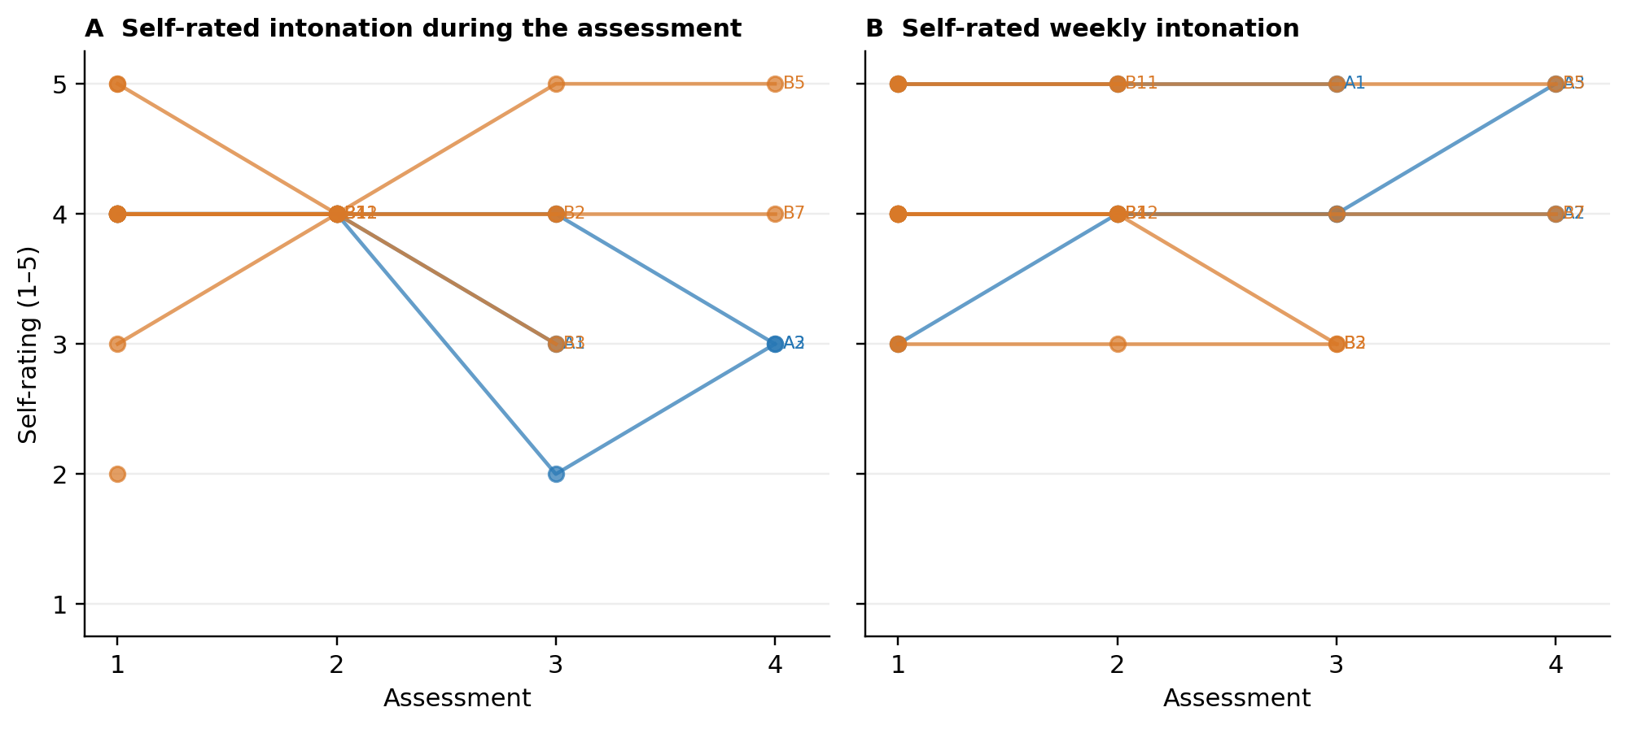
Figure 7. Individual trajectories in self-rated intonation.
Note. Each line shows all available ratings for one participant; participants with only one rating are shown as single points. Group A and Group B are distinguished by color. The figure includes all participants who provided numerical self-ratings, including those without usable acoustic data.

4.8 Reflective-Writing Themes
The thematic analysis of participants’ written reflections identified recurring patterns relating to perceived accuracy and task difficulty, awareness of acoustic differences, listening strategies, and confidence or uncertainty. This section reports the reflective findings independently; Section 4.9 examines their relationship with the quantitative findings.
4.8.1 Perceived Accuracy and Task-Related Difficulty
Across both groups, participants commented on whether they felt in tune and identified tasks they experienced as more or less difficult. Headphone use, reference timbre, vocal stability, concentration, and familiarity with the repeated tasks also affected perceived performance.
Melody-based exercises were repeatedly described as challenging, although several participants reported that they became more familiar or easier across repeated assessments. Participants’ experiences therefore reflected both the tuning demands and the assessment's technical and attentional demands.
4.8.2 Spontaneous Detection of Acoustic Differences in Group B
Several Group B participants reported noticing acoustic differences despite receiving no intervention and not being informed that different tuning systems were being contrasted. B3 described the reference pitch as appearing to “go flat” and later referred to hearing beats while singing a major third. B12 reported “microtonal changes” between repeated versions of the exercises, while B13 described some exercises as sounding “off” and referred to a “collision of waves.”
These accounts indicate spontaneous awareness of pitch or acoustic differences in some non-intervention participants, although this was not a uniform pattern across Group B.
4.8.3 Listening Strategies Following the Intervention
Following the intervention, Group A participants increasingly described deliberate attention to the perceptual cues introduced during the instructional sessions. A2 reported listening for the “wowowowowo” or beating discussed during the intervention, later describing an attempt to locate the “wobbly thing” and stating that their “ear was more focused.” A3 similarly described vibrations and interactions between simultaneously heard and produced pitches.
These reflections indicated a shift from general evaluation of accuracy toward deliberate attention to beating, vibration, and interactions between pitches. Participants also reported that these cues were easier to identify while listening than while singing, suggesting continued difficulty applying the listening strategy during vocal production.
4.8.4 Confidence, Confusion, and Developing Awareness
Increased attention to tuning differences was not consistently accompanied by greater confidence. Group A reflections included both interest in the new approach and uncertainty about applying it. A2 described the new information as having “shattered” their previous understanding of thirds, while other comments noted increased monitoring and pitch adjustment when distinguishing between interval versions. A2’s description suggests that introducing alternative tuning references may initially disrupt established perceptual expectations rather than immediately improve production accuracy. Although based on a single reflection, this raises the possibility that perceptual reorientation and measurable tuning adaptation develop at different rates. Overall, the reflections showed a distinction between spontaneous detection of acoustic differences in some Group B participants and deliberate use of intervention-related listening cues in Group A. These patterns describe participants’ reported experiences and do not establish that the intervention caused a specific perceptual change.

4.9 Integration of Quantitative and Qualitative Findings
The quantitative findings, self-ratings, and written reflections were compared to identify convergence, complementarity, and divergence between measured performance and perceived experience. Integration focused on patterns within participants and tasks rather than formal statistical associations.

4.9.1 Task Difficulty and Measured Performance
The clearest convergence concerned task difficulty. Participants repeatedly described melody tasks as challenging, and quantitatively melody showed both relatively large tuning error (Md = 24.28 cents) and the largest successive change (Md = 22.64 cents). By contrast, the major-chord and major-third tasks showed smaller tuning errors and greater temporal stability, broadly corresponding with reflections that acoustic differences or beating could be easier to identify in intervals and chords than in extended musical material.
The pentatonic tasks demonstrated a different relationship: despite relatively large tuning errors, their temporal stability was intermediate. Thus, perceived difficulty, tuning accuracy, and temporal stability were related in some tasks but did not represent the same dimension of performance.
The persistent difficulty observed in the melodic tasks may warrant consideration beyond the immediate effects of the intervention. Across assessments, melodic tuning remained comparatively challenging, converging with participants’ qualitative reflections in which melodic exercises were frequently perceived as more difficult. This agreement between measured performance and subjective experience suggests that tuning a moving melodic line against a stable reference may present different demands from tuning isolated intervals or pitches within a more explicitly defined harmonic context.
These findings can be considered within the changing musical environments through which singers develop pitch expectations. As discussed previously, Western music shifted from modal systems organised substantially through melodic relationships towards tonal systems in which key and functional harmony increasingly organised musical structure and melodic possibilities (True, 2018) . Contemporary popular music, however, does not simply reproduce common-practice functional harmony. (Spicer, 2017) describes fragile, emergent and absent tonics in pop and rock, while (Duinker, 2019) identifies recurring “plateau loops” and hybrid tonics, including contexts in which melodic and harmonic information contribute differently to the perception of tonal centre. Together, these accounts demonstrate that perceived pitch relationships may emerge from interacting melodic and harmonic cues rather than a single stable functional hierarchy.
Contemporary empirical work further supports this interdependence. (Dai, Zhang and Dannenberg, 2024) found interactions between musical structure, harmony, melody and rhythm in a large popular-music dataset, supporting the view that melodic pitch behaviour cannot necessarily be understood independently of its musical context. Corpus studies also indicate that popular melody itself has changed over time. (Clark and Arthur, 2023) identified differences between melodies of the 1960s and contemporary repertoire, while Hamilton and Pearce (2024), examining U.S. chart melodies from 1950 to 2023, found substantial historical changes in melodic organisation and an overall decline in several measures of melodic complexity.
These studies do not demonstrate that historical changes in popular music caused the melodic tuning behaviour observed here. Rather, they provide a basis for considering intonation within a learned musical ecology in which pitch expectations develop through repeated exposure to particular melodic, harmonic and tuning environments. A sustained drone presents a markedly different context from changing ET-based harmonic accompaniment: a single acoustic reference against which the singer must continually negotiate the intervallic relationships of a moving melody. The comparatively greater difficulty of the melodic tasks may therefore reflect not only the production of successive target frequencies, but the continuing determination of where those targets lie.
This interpretation may be particularly relevant when comparing ET and JI, where learned expectations and acoustic relationships can provide competing definitions of an appropriate interval. Rather than treating all movement from a reference frequency simply as error, future research could therefore examine both the direction of drift and the contextual information available to the singer. The question may be not only whether singers drift, but what they drift towards: a learned ET target, an acoustically reinforced relationship, a harmonically implied pitch, or another contextually constructed point of stability.

4.9.2 Intervention-Related Listening Strategies and Acoustic Change
Following the intervention, A2 and A3 increasingly described deliberate attention to beating, vibration, and interactions between pitches. This change in listening strategy coincided with improved major-third accuracy and movement in the JI direction between Assessments 1 and 2 for both participants.
However, the relationship did not generalize across tasks: A2’s overall accuracy decreased slightly, while A3’s improved, and some Group B participants showed comparable major-third changes without intervention. The qualitative and acoustic findings therefore converged for the immediate major-third response but did not demonstrate a unique or generalized intervention effect.

4.9.3 Spontaneous Awareness in the Non-Intervention Group
Group B reflections provided an important contrast. Participants reported pitch changes, beating, microtonal differences, and acoustic interaction without explicit JI instruction, alongside variable movement between the ET and JI sides of the midpoint.
Thus, sensitivity to acoustic differences was not confined to Group A. The qualitative distinction was primarily in how the cues were described and used: Group B participants reported spontaneous detection, whereas Group A participants increasingly described deliberate attention to intervention-related cues. This distinction was clearer in the reflective data than in the acoustic trajectories.

4.9.4 Perceived and Measured Performance
Self-ratings and acoustic outcomes did not show a simple parallel relationship. Assessment-specific ratings decreased from first to last assessment for all three Group A participants, although A2 and A3 showed improved major-third accuracy immediately following the first intervention; A1 had no usable acoustic data. A2’s reflections also combined increased uncertainty with a more focused listening strategy.
Weekly ratings were more stable than assessment-specific ratings and acoustic performance. Together, these findings indicate that increased perceptual attention or task-specific acoustic improvement did not necessarily correspond to greater perceived performance.

4.9.5 Integrated Summary
Across the three data sources, the strongest convergence concerned task difficulty and the immediate major-third response following intervention. However, similar acoustic changes and spontaneous awareness occurred in Group B, overall trajectories remained heterogeneous, and perceived performance did not consistently follow measured performance.
Together, these findings indicate that tuning accuracy, tuning tendency, temporal stability, perceived performance, and listening awareness represent related but distinct aspects of participants’ tuning behavior.

4.10 Unexpected Findings Problems and Limitations
Several findings differed from the anticipated pattern. Although both Group A participants with usable acoustic data improved their major-third accuracy and moved in the JI direction immediately following the first intervention, this pattern did not generalize across tasks or subsequent assessments. Comparable changes and spontaneous awareness of acoustic differences also occurred among some Group B participants, preventing attribution of these changes specifically to the intervention.
Perceived and measured performance also diverged. Assessment-specific self-ratings decreased for all three Group A participants between their first and last available ratings, despite the immediate major-third improvements observed for A2 and A3. Similarly, task-specific findings showed that accuracy and temporal stability were distinct: the pentatonic tasks showed relatively large tuning errors while remaining more temporally consistent than melody.
4.10.1 Data Completeness and Technical Problems
The longitudinal dataset was unbalanced because assessment completion varied across participants, and one Group A recording was technically unusable. Self-recording also introduced uncontrolled variation in recording and playback conditions. These factors reduced comparability across participants and assessment points.
4.10.2 Quantitative Limitations
The small, non-random and unequal sample, including only two Group A participants with usable acoustic data, precluded confirmatory evaluation of an intervention effect. Single performances per task prevented estimation of within-assessment repeatability, while mean F0 from manually selected segments did not capture within-note movement or correction.
Because participants heard both ET and JI references before producing a single response, proximity to either reference could not establish intended target or tuning preference. These constraints are detailed further in Section 3.10.
4.10.3 Self-Rating and Qualitative Limitations
The self-rating dataset included participants without usable acoustic data, restricting direct comparison to cases for which both measures were available. Self-ratings were subjective ordinal measures and could reflect factors other than tuning accuracy.
Written reflections varied in detail and were collected through broad open-ended questions rather than structured interviews. As the researcher also delivered the intervention and analysed the reflections, the qualitative findings are interpreted as contextual patterns rather than evidence of prevalence or causation.
4.10.4 Implications for Interpretation
The findings therefore describe variation in tuning accuracy, tendency, stability, perceived performance, and listening awareness within this sample, but do not establish a causal intervention effect or generalizability beyond it.

Chapter 5 Conclusion and Critical Reflection

5.1 Overview and Principal Conclusions
This study examined patterns of change, temporal stability, and tuning tendency in singers' intonation across repeated assessments, together with an exploratory comparison between participants who received explicit training in JI (Group A) and participants who completed the assessments without intervention (Group B). Acoustic measurements, self-ratings, and written reflections were used to examine related but distinct aspects of intonation and experience.
The key finding is that tuning behavior varied significantly across participants, tasks, and assessments. Although all participants struggled with singing melodies compared to sustained notes, no consistent pattern emerged, and neither repeated testing nor explicit JI instructions resulted in a uniform shift toward a specific tuning system. Accuracy, ET or JI tendencies, and temporal stability functioned as independent dimensions; a participant could perform consistently while remaining distant from theoretical references or improve accuracy while altering tuning direction. These results deliberately did not consider progression toward JI as overall improvement.
The clearest intervention-compatible pattern occurred in the major-third task immediately after the first intervention. Both Group A participants with usable acoustic data improved their nearest-reference accuracy and moved in the JI direction between Assessments 1 and 2. Their reflections also increasingly referred to beating, vibration, and interactions between pitches. However, the wider results did not show a consistent shift toward JI across tasks or later assessments. Comparable changes and spontaneous awareness of acoustic differences were also observed among some Group B participants. Therefore, the findings do not establish an intervention effect and offer a potential pattern for further investigation.

5.2 Conclusions in Relation to the Objectives and Hypotheses
The first objective was to describe tuning accuracy at each assessment. Signed and absolute deviations from ET and JI showed substantial variations both within and between participants. The results did not support interpreting either reference as a universally preferred or more accurate target. The second objective was to quantify temporal stability through successive changes in the produced interval. Stability differed across tasks and participants and did not necessarily accompany greater accuracy. The repeated assessments therefore revealed variability over time rather than a simple progression from less stable to more stable performance.
The third objective was to examine longitudinal change in accuracy, stability, and ET-JI tuning tendency. Changes were often nonlinear, and their direction and magnitude differed across tasks. The hypothesis that repeated exposure could be accompanied by changes in these measures was consistent with the observation that performance changed across assessments. Nevertheless, the design could not determine whether these changes reflected familiarization, practice, ordinary within-person variability, shifting attention, or another cause. The heterogeneous results may relate to singing technique; in other words, a tendency to sing slightly high or low could relate to coordination of muscles involved in voice production, or, as mentioned in previous studies, environment and recording conditions also affect tuning changes, and therefore causality is hard to detect. The findings therefore did not demonstrate systematic improvement resulting from repeated exposure alone.
The secondary exploratory objective concerned whether Group A showed different or more pronounced patterns of change than Group B, particularly in the major-third task. The immediate post-intervention findings for the major-third task offered limited descriptive support for the intervention hypothesis. That support remained task-specific and provisional. With only two Group A participants contributing usable acoustic data, unequal group sizes, no random allocation, and similar changes in some Group B participants, the study could not attribute the observed changes causally to the intervention.
5.3 Professional and Pedagogical Implications
The findings do not justify replacing ET-based teaching with JI nor endorsing a single system as the definitive model for vocal intonation. They reveal that tuning behavior varies by participant, task, and context. Pedagogically, this supports exploring approaches that expose singers to multiple tuning references, rather than treating intonation as mere reproduction of a fixed ET target.
Guided listening to beating, harmonic interactions, drones, and small differences between reference intervals may enhance perceptual cues. Participants incorporated some of these cues into their reflections, but acoustic data did not show a general tuning improvement, this may indicate that a longer duration and more frequent training is needed to improve microtonal intonation. Moreover, performance on isolated intervals does not necessarily translate to more contextualized material; melody and pentatonic tasks showed different accuracy and stability patterns than isolated intervals and chords, and they converged with reflection results. Pedagogical assessment could benefit from combining controlled interval exercises with more music-like tasks.
Self-perception should be distinguished from acoustic performance, as self-ratings often do not align with acoustic changes and can increase uncertainty. A lower self-rating does not necessarily indicate deterioration, nor does a positive subjective impression confirm acoustic improvement. These findings imply that intonation training should separately target perceptual awareness, tuning accuracy, and stability. A2’s disruption of pitch expectations shows how alternative tuning references challenge familiar understanding without immediate measurable gains and serves as a reminder that accuracy and stability may not vary together; stability measured between assessments using mean F0 may obscure real-time pitch adjustments. Future research should examine within-note F0 trajectories to better understand how singers’ approach and adjust tuning in real time.
The task-specific nature of these findings is also consistent with auditory perceptual-learning research, in which pitch-discrimination training can improve performance while transfer to untrained stimuli remains incomplete or stimulus-specific (Micheyl et al., 2006; Carcagno and Plack, 2011). From a pedagogical perspective, this suggests that developing sensitivity to fine-tuning differences may require practice across varied musical contexts rather than assuming that learning within an isolated interval will automatically generalize to melody or ensemble performance.

5.4 Critical Reflection on the Research Process
As a voice pedagogue, I explored whether awareness of JI could improve singers' listening and vocal production, guiding the development of musically relevant tasks and interventions. Auditory-learning research shows that training can enhance pitch and interval discrimination, depending on practice structure (Amitay, Irwin and Moore, 2006; Micheyl et al., 2006). Exposure to JI should thus be seen as perceptual training to broaden listening categories and strategies, not as instruction in a new tuning system. Variations in accuracy and stability across intervals, chords, and melodies align with findings that pitch accuracy depends on task demands and feedback (Mürbe et al., 2002, 2004). Therefore, intonation is not a single, stable skill measurable by one task. The analysis also distinguished measured accuracy, tuning tendency, stability, self-ratings, and reflection to avoid bias toward intervention-favorable cases over contradictory or neutral results. The study also demonstrated the practical consequences of an ambitious repeated-assessment design. Participant attrition, incomplete assessments, one technically unusable Group A recording, and variation in self-recording conditions reduced the comparability of the data. The use of one performance per task limited the ability to distinguish a stable tuning pattern from an isolated production. These difficulties indicate that feasibility, participant burden, recording quality, and repeated trials should be treated as central design issues rather than procedural details.
The mixed-methods component added useful context but also required restraint. The reflections showed how participants described difficulty, confidence, beating, vibration, and emerging awareness, yet these accounts could not validate the acoustic measures or establish why a measured change occurred. Treating convergence and divergence as findings produced a more credible interpretation than using the reflections only to support the original hypothesis.

5.5 Recommendations for Future Research
Future studies should recruit a larger and more balanced sample and, where feasible, allocate participants randomly to intervention and comparison conditions. A prospective sample-size justification and strategies to reduce participant burden would improve both interpretability and retention. Recording equipment, playback level, headphones, room conditions, and instructions should be standardized as far as possible.
Each task should include repeated trials so that within-assessment repeatability can be estimated. Separate sung responses following ET and JI references would allow direct examination of intended-target accuracy. Acoustic analysis could also retain information about within-note movement, vibrato, and correction rather than relying solely on the mean fundamental frequency of a manually selected segment. Independent or blinded checking of segment selection, acoustic calculations, and qualitative coding would further reduce researcher expectancy effects.
Longer follow-up is needed to determine whether any change in listening or production persists beyond immediate exposure. Future interventions should document their duration, content, delivery, and pedagogical sequence in sufficient detail to permit replication. Research should also move beyond isolated responses to include singing with drones and possibly harmonized tasks.
Self-ratings would be more informative if collected with clearly defined, consistently worded items that distinguish perceived accuracy, confidence, task difficulty, and listening awareness. These additions would allow future studies to examine not only whether acoustic performance changes, but also how singers perceive and apply new listening strategies.

5.6 Final Conclusion
This exploratory study revealed that vocal tuning is neither uniform nor necessarily predictable across musical contexts. Accuracy, ET or JI tuning tendency, temporal stability, perceived performance, and listening awareness varied across participants, tasks, and assessments. Notably, melodic and pentatonic tasks showed greater tuning deviations than isolated intervals and chords, converging with participants’ reflections on their increased difficulty. The immediate improvements in the major third and the developing acoustic vocabulary observed in Group A suggest potential benefits of directed listening, although comparable changes and spontaneous awareness in Group B prevent causal attribution. While the findings establish neither a general preference for ET or JI nor a consistent intervention effect, they highlight the importance of musical context and the distinction between measurable tuning performance and developing perceptual awareness.
These findings invite a reconsideration of stability in vocal intonation, and correlate with literature on major third tendency to JI. Unlike a piano key, the human voice is an adaptive biological instrument that continuously produces and regulates pitch. Singers might therefore be understood as “forever drifters”, not because they are perpetually out of tune, but because vocal stability emerges through continual calibration towards a musical target (Howard, 2007). As in homeostatic regulation, relative stability may depend on ongoing adjustment rather than immobility. Yet if singers are inevitably “forever drifters”, the more important question becomes what they drift towards, and how their musical environments shape the targets they learn to recognise.
Historically, vocal tuning has involved negotiating pitch according to harmonic and melodic context rather than reproducing one fixed frequency for each written note. Contemporary approaches to Renaissance JI similarly encourage recognition of pure intervals and conscious microtonal adjustment (Duffin, 2006, 2017). Other musical traditions demonstrate alternative learned pitch organizations, including Turkish Makam, which has been explored through vocal ear-training using both its original temperament and ET (Altun and Egermann, 2021). Such examples reinforce the importance of understanding intonation through pitch relationships, rather than isolated frequencies.
Returning to the acoustic relationships at the center of this study, the harmonic series provides a foundation for exploring how sung pitches interact, producing beating, and alternative interval relationships. Voice pedagogy could therefore complement ET piano accompaniment with a cappella singing, sustained drones, and digital tools such as “JUST”, developed for this research (appendix H), that allow teachers and singers to compare ET and JI harmonic contexts. Guided exploration of these differences may help singers attend to acoustic interactions that are difficult to distinguish while simultaneously producing sound. Although this study cannot establish the effectiveness of such approaches, Group A’s developing attention to beating and harmonic interaction provides a rationale for investigating them. The pedagogical implication is not to abandon ET, but to make room for JI as an additional reference through which singers can learn to listen, calibrate, and adapt.

Part III

References
Altun, F. and Egermann, H. (2021) “Temperament systems influence emotion induction but not makam recognition performance in Turkish makam music,” Psychology of Music, 49(5), pp. 1088–1101. Available at: https://doi.org/10.1177/0305735620922892.
Amitay, S., Irwin, A. and Moore, D.R. (2006) “Discrimination learning induced by training with identical stimuli,” Nature Neuroscience, 9(11), pp. 1446–1448. Available at: https://doi.org/10.1038/nn1787.
Armitage, J. et al. (2023) “Culture influences conscious appraisal of, but not automatic aversion to, acoustically rough musical intervals,” PLOS ONE, 18(12), p. e0294645. Available at: https://doi.org/10.1371/journal.pone.0294645.
Baharloo, S. et al. (1998) “Absolute Pitch: An Approach for Identification of Genetic and Nongenetic Components,” The American Journal of Human Genetics, 62(2), pp. 224–231. Available at: https://doi.org/10.1086/301704.
Bartel, D. (2015) “Andreas Werckmeister’s final tuning: the path to equal temperament: 1,” Early Music, 43(3), pp. 503–512. Available at: https://doi.org/10.1093/em/cav047.
Behroozmand, R., Korzyukov, O. and Larson, C.R. (2011) “Effects of voice harmonic complexity on ERP responses to pitch-shifted auditory feedback,” Clinical Neurophysiology, 122(12), pp. 2408–2417. Available at: https://doi.org/10.1016/j.clinph.2011.04.019.
Benetos, E. and Holzapfel, A. (2015) “Automatic transcription of Turkish microtonal music,” The Journal of the Acoustical Society of America, 138(4), pp. 2118–2130. Available at: https://doi.org/10.1121/1.4930187.
Berger, R. (2015) “Now I see it, now I don’t: researcher’s position and reflexivity in qualitative research,” Qualitative Research, 15(2), pp. 219–234. Available at: https://doi.org/10.1177/1468794112468475.
Bihari, G., Páka, G. and Egri, S. (2025) “Demonstrating the shift of acoustic beat frequency with tuning forks and smartphones and its application for measuring the speed,” Physics Education, 60(5), p. 055030. Available at: https://doi.org/10.1088/1361-6552/adfac6.
Boersma Paul, W.D. (2001) “PRAAT, a system for doing phonetics by computer,” Glot international, 5, pp. 341–345.
Braun, V. and Clarke, V. (2006) “Using thematic analysis in psychology,” Qualitative Research in Psychology, 3(2), pp. 77–101. Available at: https://doi.org/10.1191/1478088706qp063oa.
Carcagno, S. and Plack, C.J. (2011) “Subcortical Plasticity Following Perceptual Learning in a Pitch Discrimination Task,” Journal of the Association for Research in Otolaryngology, 12(1), pp. 89–100. Available at: https://doi.org/10.1007/s10162-010-0236-1.
Clark, B. and Arthur, C. (2023) “Is Melody ‘Dead?’: A Large-scale Analysis of Pop Music Melodies from 1960 through 2019,” Empirical Musicology Review, 17(2), pp. 120–149. Available at: https://doi.org/10.18061/emr.v17i2.8746.
Dai, S., Zhang, H. and Dannenberg, R.B. (2024) “The Interconnections of Music Structure, Harmony, Melody, Rhythm, and Predictivity,” Music & Science, 7. Available at: https://doi.org/10.1177/20592043241234758.
D’Amario, S. et al. (2020) “A Longitudinal Study of Intonation in an a cappella Singing Quintet,” Journal of Voice, 34(1), pp. 159.e13-159.e27. Available at: https://doi.org/10.1016/j.jvoice.2018.07.015.
Devaney, J. et al. (2011) “Automatically extracting performance data from recordings of trained singers.,” Psychomusicology: Music, Mind and Brain, 21(1–2), pp. 108–136. Available at: https://doi.org/10.1037/h0094008.
Duffin, R.W. (2006) “Just Intonation in Renaissance Theory and Practice,” Music Theory Online, 12(3). Available at: https://doi.org/10.30535/mto.12.3.1.
Duffin, R.W. (2017) “Cipriano de Rore, Giovanni Battista Benedetti, and the Just Tuning Conundrum,” Journal of the Alamire Foundation, 9(2), pp. 239–266. Available at: https://doi.org/10.1484/J.JAF.5.115544.
Duinker, B. (2019) “Plateau Loops and Hybrid Tonics in Recent Pop Music,” Music Theory Online, 25(4). Available at: https://doi.org/10.30535/mto.25.4.3.
Edmonds, T.J. and Howard, D.M. (2025) “An Investigation in the Measurable Differences between Pitch Perception in the Voice and Pitch Perception of External Sound Sources,” Journal of Voice, 39(3), pp. 656–663. Available at: https://doi.org/10.1016/j.jvoice.2022.11.026.
Gerhard, J. and Rosow, D.E. (2016) “A Survey of Equipment in the Singing Voice Studio and Its Perceived Effectiveness by Vocologists and Student Singers,” Journal of Voice, 30(3), pp. 334–339. Available at: https://doi.org/10.1016/j.jvoice.2015.03.012.
Greene, P.C. (1937) “Violin Intonation,” The Journal of the Acoustical Society of America, 9(1), pp. 43–44. Available at: https://doi.org/10.1121/1.1915909.
Groß, C. (2025) “Singen, was geschrieben steht – schreiben, was gesungen wird?. Wechselbeziehungen zwischen Komposition und Interpretation mikrotonaler Musik für Vokalensembles,” GMTH Proceedings, pp. 235–253. Available at: https://doi.org/10.31751/p.330.
Halewood, M. (2015) “On equal temperament,” History of the Human Sciences, 28(3), pp. 3–21. Available at: https://doi.org/10.1177/0952695114567480.
Hall, D.E. and Hess, J.T. (1984) “Perception of Musical Interval Tuning,” Music Perception, 2(2), pp. 166–195. Available at: https://doi.org/10.2307/40285290.
Hamilton, M. and Pearce, M. (2024) “Trajectories and revolutions in popular melody based on U.S. charts from 1950 to 2023,” Scientific Reports, 14(1), p. 14749. Available at: https://doi.org/10.1038/s41598-024-64571-x.
Howard, D. and Overy, S. (2020) “Influences on pitching variation in a cappella choral singing,” ABCD Choral Research Journal, 1, pp. 94–101.
Howard, D.M. (2007a) “Intonation Drift in A Capella Soprano, Alto, Tenor, Bass Quartet Singing With Key Modulation,” Journal of Voice, 21(3), pp. 300–315. Available at: https://doi.org/10.1016/j.jvoice.2005.12.005.
Howard, D.M. (2007b) “Intonation Drift in A Capella Soprano, Alto, Tenor, Bass Quartet Singing With Key Modulation,” Journal of Voice, 21(3), pp. 300–315. Available at: https://doi.org/10.1016/j.jvoice.2005.12.005.
Jacoby, N. et al. (2019) “Universal and Non-universal Features of Musical Pitch Perception Revealed by Singing,” Current Biology, 29(19), pp. 3229-3243.e12. Available at: https://doi.org/10.1016/j.cub.2019.08.020.
Karrick, B. (1998) “An Examination of the Intonation Tendencies of Wind Instrumentalists Based on Their Performance of Selected Harmonic Musical Intervals,” Journal of Research in Music Education, 46(1), pp. 112–127. Available at: https://doi.org/10.2307/3345764.
Kivinen, O. and Ristela¨, P. (2003) “From Constructivism to a Pragmatist Conception of Learning,” Oxford Review of Education, 29(3), pp. 363–375. Available at: https://doi.org/10.1080/03054980307442.
Komaniecki, R. (2021) “Vocal Pitch in Rap Flow,” Intégral, 34, pp. 25–45.
Larrouy-Maestri, P., Magis, D. and Morsomme, D. (2014) “The Evaluation of Vocal Pitch Accuracy,” Music Perception, 32(1), pp. 1–10. Available at: https://doi.org/10.1525/mp.2014.32.1.1.
Leukel, W. and Stoffer, T. (2004) “The Influence of Harmoniccontext on the Tuning of Thirds Played by Professional Flautists,” Psychology of Music, 32(1), pp. 75–88. Available at: https://doi.org/10.1177/0305735604039283.
Li, H., Chakraborty, K. and Kanemitsu, S. (2018) “Music as Mathematics of Senses,” Advances in Pure Mathematics, 08(12), pp. 845–862. Available at: https://doi.org/10.4236/apm.2018.812052.
Little, D.F., Cheng, H.H. and Wright, B.A. (2019) “Inducing musical-interval learning by combining task practice with periods of stimulus exposure alone,” Attention, Perception, & Psychophysics, 81(1), pp. 344–357. Available at: https://doi.org/10.3758/s13414-018-1584-x.
Loosen, F. (1993) “Intonation of solo violin performance with reference to equally tempered, Pythagorean, and just intonations,” The Journal of the Acoustical Society of America, 93(1), pp. 525–539. Available at: https://doi.org/10.1121/1.405632.
Lu, H. et al. (2025) “Unlocking sound: New trends and innovations in intonation education over the past decade,” International Journal of Music Education, 43(4), pp. 691–703. Available at: https://doi.org/10.1177/02557614241237528.
Maksimović, J. and Evtimov, J. (2023) “Positivism and post-positivism as the basis of quantitative research in pedagogy,” Research in Pedagogy, 13(1), pp. 208–218. Available at: https://doi.org/10.5937/IstrPed2301208M.
Mason, J.A. (1960) “Comparison of Solo and Ensemble Performances with Reference to Pythagorean, Just, and Equi-Tempered Intonations,” Journal of Research in Music Education, 8(1), pp. 31–38. Available at: https://doi.org/10.2307/3344235.
Micheyl, C. et al. (2006) “Influence of musical and psychoacoustical training on pitch discrimination,” Hearing Research, 219(1–2), pp. 36–47. Available at: https://doi.org/10.1016/j.heares.2006.05.004.
Mohammed, A.A. and Nagy, A. (2023) “Fundamental Frequency and Jitter Percent in MDVP and PRAAT,” Journal of Voice, 37(4), pp. 496–503. Available at: https://doi.org/10.1016/j.jvoice.2021.03.008.
Moss Erickson, H. (2022) “Vocal Learning and Songbirds: An Evolutionary Tale of Singing,” Journal of Singing, 79(1), pp. 87–94. Available at: https://doi.org/10.53830/XHJI5745.
Mürbe, D. et al. (2002) “Significance of Auditory and Kinesthetic Feedback to Singers’ Pitch Control,” Journal of Voice, 16(1), pp. 44–51. Available at: https://doi.org/10.1016/S0892-1997(02)00071-1.
Mürbe, D. et al. (2004) “Effects of a professional solo singer education on auditory and kinesthetic feedback—a longitudinal study of singers’ pitch control,” Journal of Voice, 18(2), pp. 236–241. Available at: https://doi.org/10.1016/j.jvoice.2003.05.001.
Parlitz, D. and Bangert, M. (1999) “Short and medium motor responses to auditory pitch shift: Latency measurements of the professional musician’s audio-motor loop for intonation,” The Journal of the Acoustical Society of America, 105(2_Supplement), pp. 1298–1298. Available at: https://doi.org/10.1121/1.426186.
Putnam, H. (1995) “Pragmatism,” Proceedings of the Aristotelian Society, 95, pp. 291–306.
Rapoport, E. (1996) “Emotional expression code in opera and lied singing,” Journal of New Music Research, 25(2), pp. 109–149. Available at: https://doi.org/10.1080/09298219608570700.
Sanjari, M. et al. (2014) “Ethical challenges of researchers in qualitative studies: the necessity to develop a specific guideline.,” Journal of medical ethics and history of medicine, 7, p. 14.
Shams, L. and Seitz, A.R. (2008) “Benefits of multisensory learning,” Trends in Cognitive Sciences, 12(11), pp. 411–417. Available at: https://doi.org/10.1016/j.tics.2008.07.006.
Spicer, M. (2017) “Fragile, Emergent, and Absent Tonics in Pop and Rock Songs,” Music Theory Online, 23(2). Available at: https://doi.org/10.30535/mto.23.2.2.
Stilwell, P. and Harman, K. (2021) “Phenomenological Research Needs to be Renewed: Time to Integrate Enactivism as a Flexible Resource,” International Journal of Qualitative Methods, 20, p. 160940692199529. Available at: https://doi.org/10.1177/1609406921995299.
Sundberg, J., Lã, F.M.B. and Himonides, E. (2013) “Intonation and Expressivity: A Single Case Study of Classical Western Singing,” Journal of Voice, 27(3), pp. 391.e1-391.e8. Available at: https://doi.org/10.1016/j.jvoice.2012.11.009.
Takeuchi, A.H. and Hulse, S.H. (1993) “Absolute pitch.,” Psychological Bulletin, 113(2), pp. 345–361. Available at: https://doi.org/10.1037/0033-2909.113.2.345.
True, T. (2018) “The Battle Between Impeccable Intonation and Maximized Modulation,” Musical Offerings, 9(2), pp. 61–74. Available at: https://doi.org/10.15385/jmo.2018.9.2.2.
Watts, C. et al. (2003) “Potential factors related to untrained singing talent: a survey of singing pedagogues,” Journal of Voice, 17(3), pp. 298–307. Available at: https://doi.org/10.1067/S0892-1997(03)00068-7.
Wong, P.C.M. et al. (2012) “Effects of Culture on Musical Pitch Perception,” PLoS ONE, 7(4), p. e33424. Available at: https://doi.org/10.1371/journal.pone.0033424.
Wright, B.A. and Zhang, Y. (2009) “A review of the generalization of auditory learning,” Philosophical Transactions of the Royal Society B: Biological Sciences, 364(1515), pp. 301–311. Available at: https://doi.org/10.1098/rstb.2008.0262.
Yashaswini, L. and Maruthy, S. (2020) “Effect of Music Training on Categorical Perception of Speech and Music,” Journal of Audiology and Otology, 24(3), pp. 140–148. Available at: https://doi.org/10.7874/jao.2019.00500.

Part IV

Research Study Appendices
Participant-facing forms and assessment materials
Appendix A Consent Form
Appendix B Background Form
Appendix C Assessment and Reflection Form
Appendix D Intervention Protocol
Appendix E Signed ethical approval form
Appendix F Reflective author Journal
Appendix G Reflective-writing, Coding and full data set Analysis Charts
Appendix H Software Data – by Daniel Yehezkeli

Appendix A — Consent Form
Participant information
This study is designed for adult singers and/or voice teachers who are willing to record their voices in short online assessments.
Participants are encouraged to use the same device, headphones, microphone, and recording setup throughout the study to support consistency across assessments. The study website is used to complete assessments and forms.
Participation is entirely voluntary. There is no financial compensation, although participants may find value in the learning experience and increased awareness of listening and intonation processes.
All collected data, recordings, and questionnaire responses remain confidential and are securely stored. Data are used only for research purposes and are anonymized in publications and presentations. Participants’ names and identifying information do not appear in study outputs.
Participants may withdraw from the study at any time without penalty and without providing a reason.
This study is approved by the Wales Trinity University Ethics Committee.
Researcher: Aramat Arnheim Sharon | intonation2026study@gmail.com

Consent statements
Please read each statement and check the box to confirm. All boxes must be checked.
- I understand the purpose of the study.
- I understand that participation is voluntary.
- I understand that I may withdraw from the study at any time.
- I understand that my recordings and questionnaire answers will be used only for research purposes.
- I understand that my data will be anonymized in any written report or publication.
- I understand that participation or non-participation will not affect my lessons, grades, or relationship with my institution.
- I am willing to answer questions in writing during the process of this study regarding my personal journey.
- I agree to participate in this study.

Participant details
Full name

Email address

Phone / WhatsApp number

Date

Digital signature (type your full name)

The online form required the digital signature to match the participant’s full name. Account-password fields are omitted from this research appendix because they were used only for secure website access.

Following are 25 consent forms. Some participants completed the consent form but did not continue in the study. 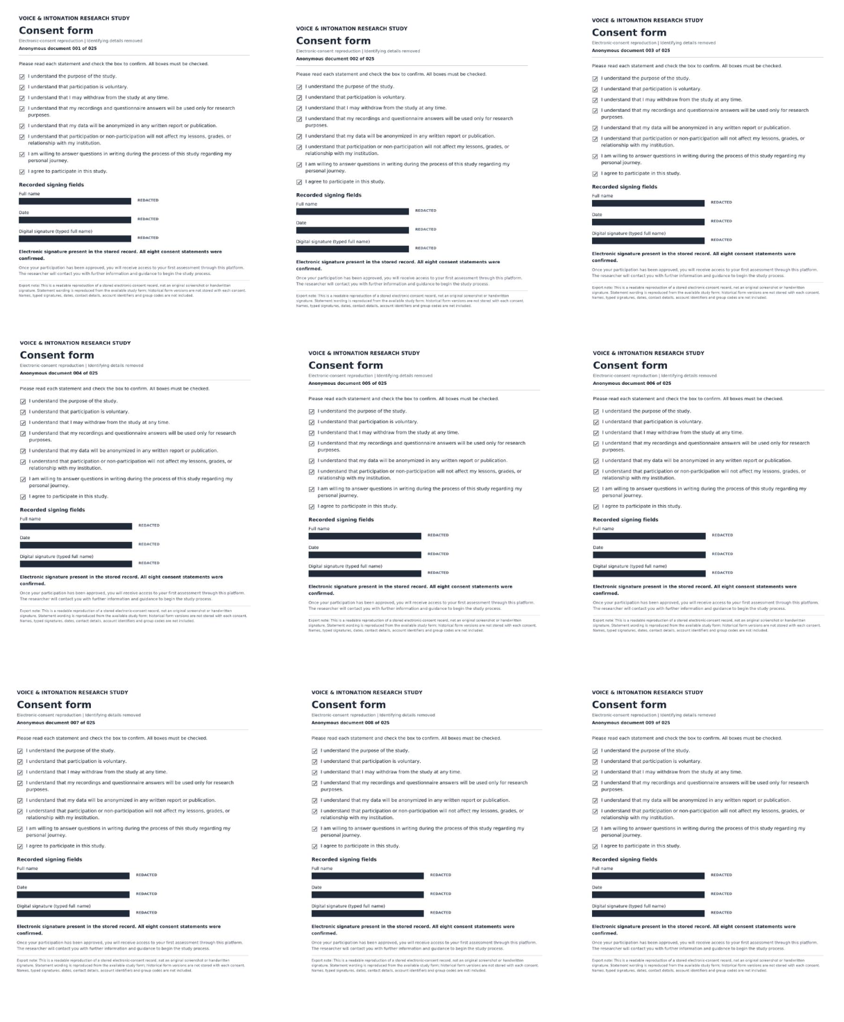

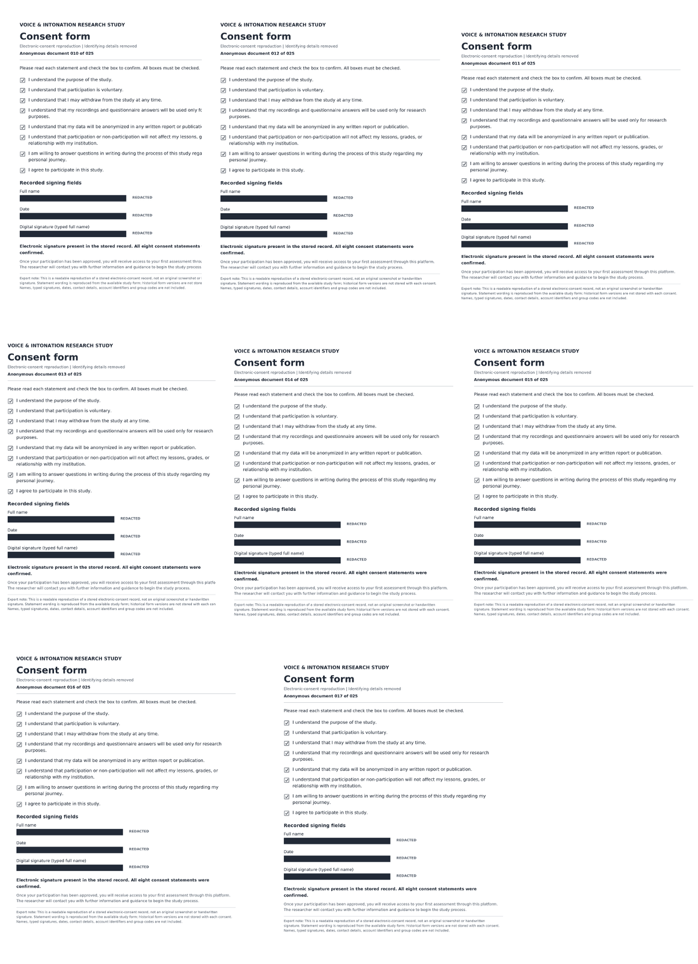

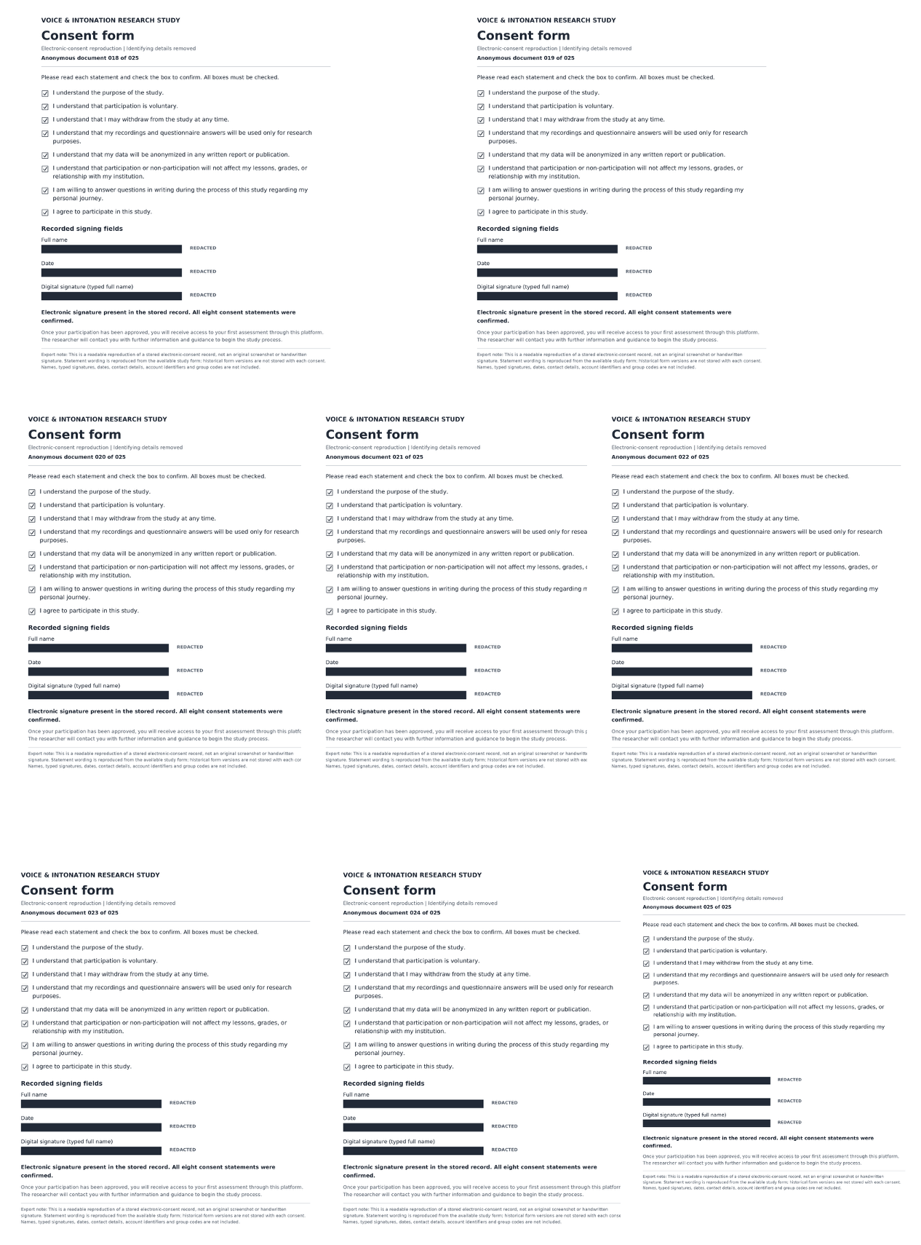

Appendix B — Background Form
Participant instruction: Please answer as completely as you can. You can return to update this later.

Personal / study background
1. Age

2. Institutions or Type of Degree / Program where you studied or currently study music and singing

3. Years of study in each program

4. Did you study ear training? If yes for how long and to what level?

5. Main vocal style / genre

6. How would you describe your intonation and ability to sing accurately?

7. How many years of voice training?

8. How many years have you studied music overall?

Musical background
9. Do you play an instrument? If yes, which instrument(s)?

10. How many years have you played each instrument?

11. Do you sing in an a cappella group, vocal ensemble, or choir?

12. Do you have experience singing without piano accompaniment?

13. Have you studied harmony / theory?
Yes ☐ No ☐
14. Have you been exposed to microtonal music or non-Western music (Middle Eastern, Indian, non-Western scales, or microtonality)?

15. Have you used tuning apps, drones, or other intonation-training tools before?

Technology setup
16. What device will you use for recordings?

17. What microphone will you use?

18. What headphones or earphones will you use?

19. Will you be able to use the same setup for all assessments?
Yes ☐ No ☐
20. Describe the room where you will usually record.

21. Can you record in a quiet room with minimal background noise?
Yes ☐ No ☐

Appendix C — Assessment and Reflection Form
The same assessment format and six audio samples were used at four data-collection points: Baseline Assessment, Assessment 2, Assessment 3, and Assessment 4.

Assessment instructions shown to participants
- Complete the assessment in a quiet room.
- Use the same device, microphone, headphones, and recording setup whenever possible.
- Wear headphones so the sample audio does not bleed into the recording.
- Record your response while listening to each sample.
- Do not repeat the task many times to perfect it. Complete it once and re-record only if there is a technical issue; record your natural response.
Stage instruction: Listen to each sample carefully, then record your response.

Recorded exercises
No. | Exercise | Instruction | Frequencies Participants heard
1 | Major Third | Listen and sing along — sustain the third.
2 | Minor Third | Listen and sing along — sustain the third.
3 | Major Chord | Listen and sing along — sustain the third.
4 | Minor Chord | Listen and sing along — sustain the third.
5 | Melody | Listen and sing along with the melody, then sing it by yourself above the tonic.
6 | Pentatonic Scale | Listen and sing along with the scale, then sing it by yourself above the tonic.
Recording procedure
For each exercise, the sample began playing when the participant started recording. Recording continued while the participant listened and sang, then stopped automatically when the sample ended. Participants could review the take, save it, or discard and re-record it if there was a technical issue. At least one saved take was required for each exercise.

Final reflection completed after each assessment
1. What did you notice about your listening, tuning, pitch adjustment, or vocal experience during this assessment?

2. How would you rate your intonation during this assessment?

1 — Very unstable 2 — Mostly unstable 3 — Neutral / mixed 4 — Mostly stable 5 — Very stable and accurate
3. How would you rate your intonation in general this week?

1 — Very unstable 2 — Mostly unstable 3 — Neutral / mixed 4 — Mostly stable 5 — Very stable and accurate
Participants completed all three reflection questions before submitting. Submission locked the assessment and prevented later editing or re-recording unless the researcher reopened it.

Appendix D — Intervention Protocol

Intervention protocol

Overview and pedagogical stance

The software used for listening to and creating samples for recording is an artifact created for this project. It is called “JUST,” and details are in Appendix H.

The intervention group participated in two practical sessions designed to explore the perceptual and vocal experience of equal temperament (ET) and just intonation (JI). Both sessions included active listening and singing. The first session contained a greater theoretical component and focused primarily on recognizing acoustic beating in differently tuned chords. The second session revisited the chord comparisons before applying the tuning framework to a melodic exercise sung over a drone.

The sessions were deliberately exploratory and non-directive. Participants were not told that they should prefer one tuning system, experience JI as more consonant, or feel a particular physical or auditory sensation. The researcher explicitly acknowledged uncertainty regarding whether the tuning differences would necessarily produce a perceptible sensation, including stating that she was not always certain that she experienced the difference herself. Participants were therefore invited only to observe and explore any auditory, vocal or bodily sensations that arose within the logic and framework of each tuning system.

Intervention Session 1: Harmonic structure and acoustic beating

The first intervention combined theoretical explanation with practical listening and singing exercises. Participants were introduced to the principle that intervals and chords can be constructed according to different tuning systems, with particular attention given to the distinction between ET and JI.

Harmonic relationships were demonstrated visually using VoceVista. This allowed participants to observe the harmonic components of the sounds while listening to their acoustic interaction. The principal perceptual focus was the presence, absence or changing periodicity of beats produced when pitches were sounded simultaneously.

Participants listened to direct comparisons of chords tuned according to ET and JI. They were encouraged to attend to any beating or interaction between the pitches without being told what they should hear or which version should sound preferable. They then sang with the differently tuned chords, exploring whether the contrasting harmonic contexts affected their listening, vocal adjustment or physical sensation.

The sequence of the first session was therefore:

1. Introduction to ET and JI as two different tuning frameworks.
2. Visual demonstration of harmonics using VoceVista.
3. Explanation and demonstration of acoustic beating between simultaneously sounding pitches.
4. Listening comparisons between chords tuned in ET and JI.
5. Practical singing with the differently tuned chords.
6. Open reflection on any auditory, vocal or bodily sensations noticed during the exercises.

Intervention Session 2: Melodic application over a drone

The second intervention returned briefly to the comparison of chords and thirds in ET and JI, reinforcing the listening explored during the first session. The primary focus then shifted from identifying acoustic beating within simultaneously sounded intervals and chords to experiencing the tuning frameworks within a melodic context.

Participants listened repeatedly to thirds presented according to the two tuning systems. They subsequently sang a pentatonic melodic line over a sustained drone. The melodic pattern used was:

1–2–3–4–5–6–5–3–2–1

Within this pattern, the third scale degree was lengthened while the tonic drone continued underneath it. Sustaining the third created additional time for participants to listen to and experience its relationship with the tonic. The purpose was not to direct the singers towards a predetermined adjustment or sensation, but to allow them to explore whether the ET and JI tuning contexts produced any perceptible differences when embedded within a melodic line.

The sequence of the second session was therefore:

1. Review of ET- and JI-tuned chords and thirds.
2. Repeated listening to thirds presented within both tuning systems.
3. Singing a pentatonic melodic line over a sustained tonic drone.
4. Lengthening the third scale degree within the melodic pattern.
5. Attending to the relationship between the sustained third and the tonic drone.
6. Open reflection on any auditory, vocal or bodily sensations, without suggesting an expected response or preferred tuning.

Measures taken to minimise expectancy and researcher-led response

Throughout both intervention sessions, the researcher avoided language suggesting that one tuning system was superior, more correct, more resonant or more likely to produce a particular sensation. Participants were not expected to identify a preferred tuning or to report that they could hear or feel a difference.

The researcher framed the exercises as a shared exploration and openly communicated that she was not certain whether she always perceived a difference herself. This stance was intended to reduce demand characteristics and minimise pressure on participants to confirm the premise of the intervention. Any reported perceptions—including hearing a difference, feeling a physical or vocal change, preferring one version, or noticing no difference—were treated as equally valid observations.

Appendix E — Signed Ethical Approval
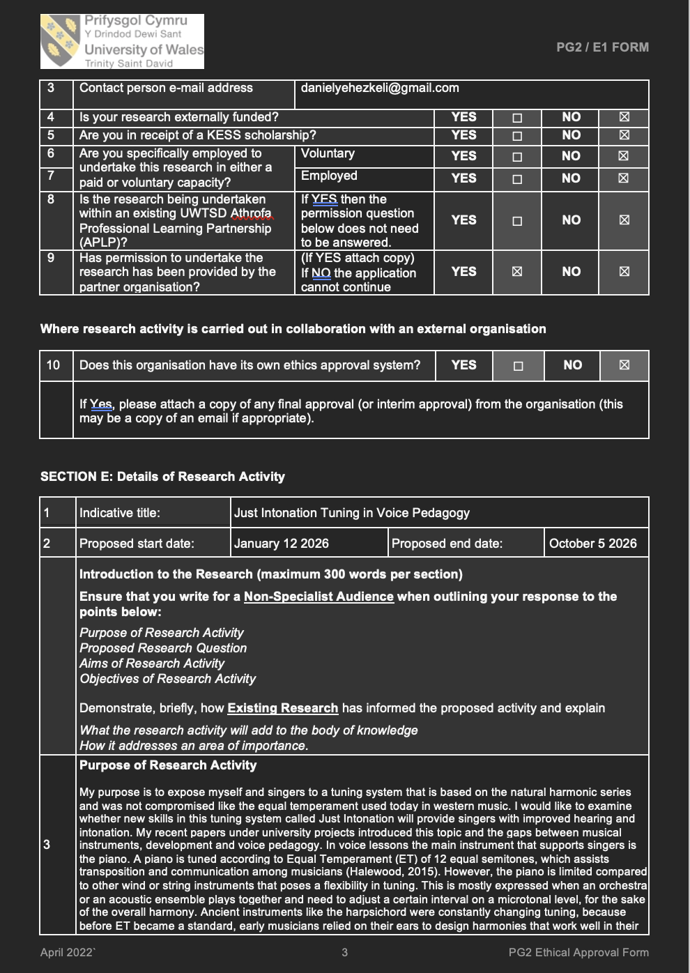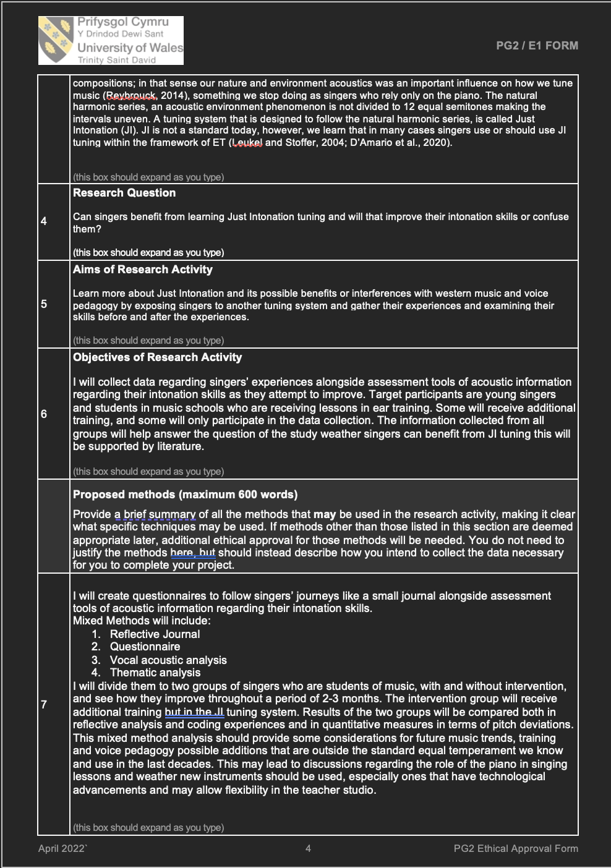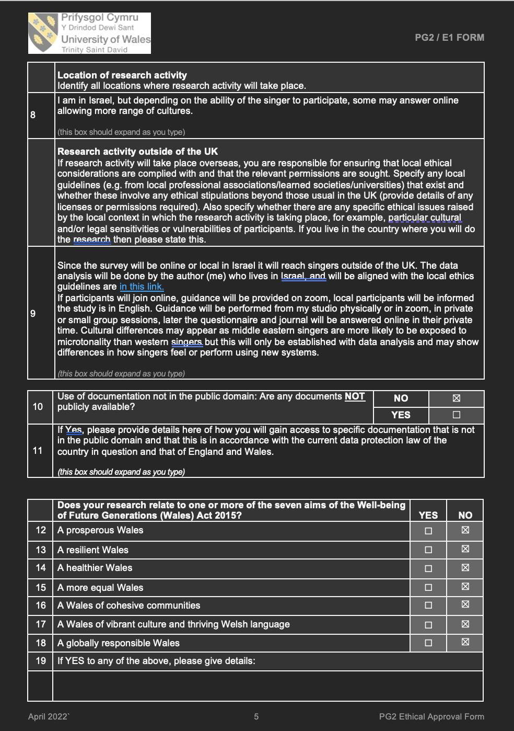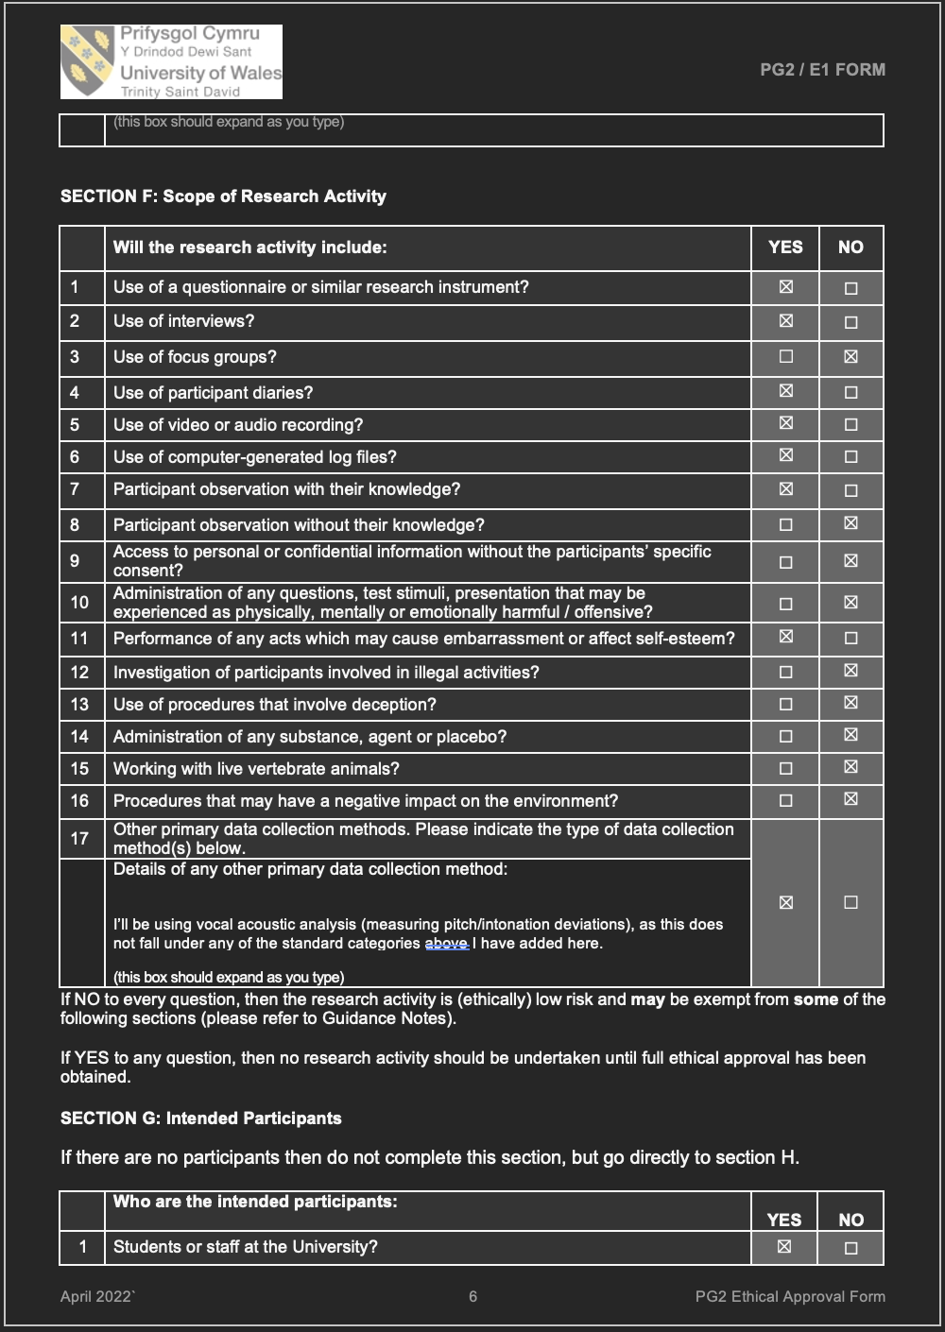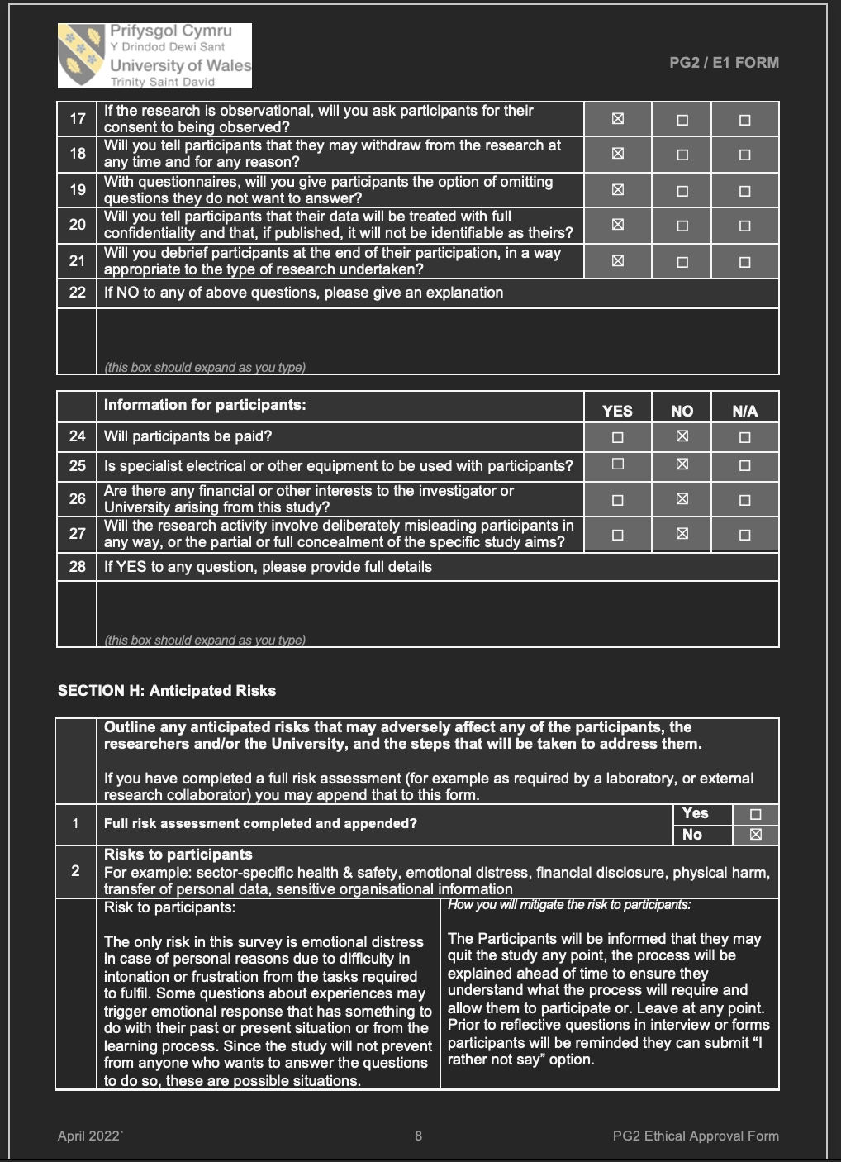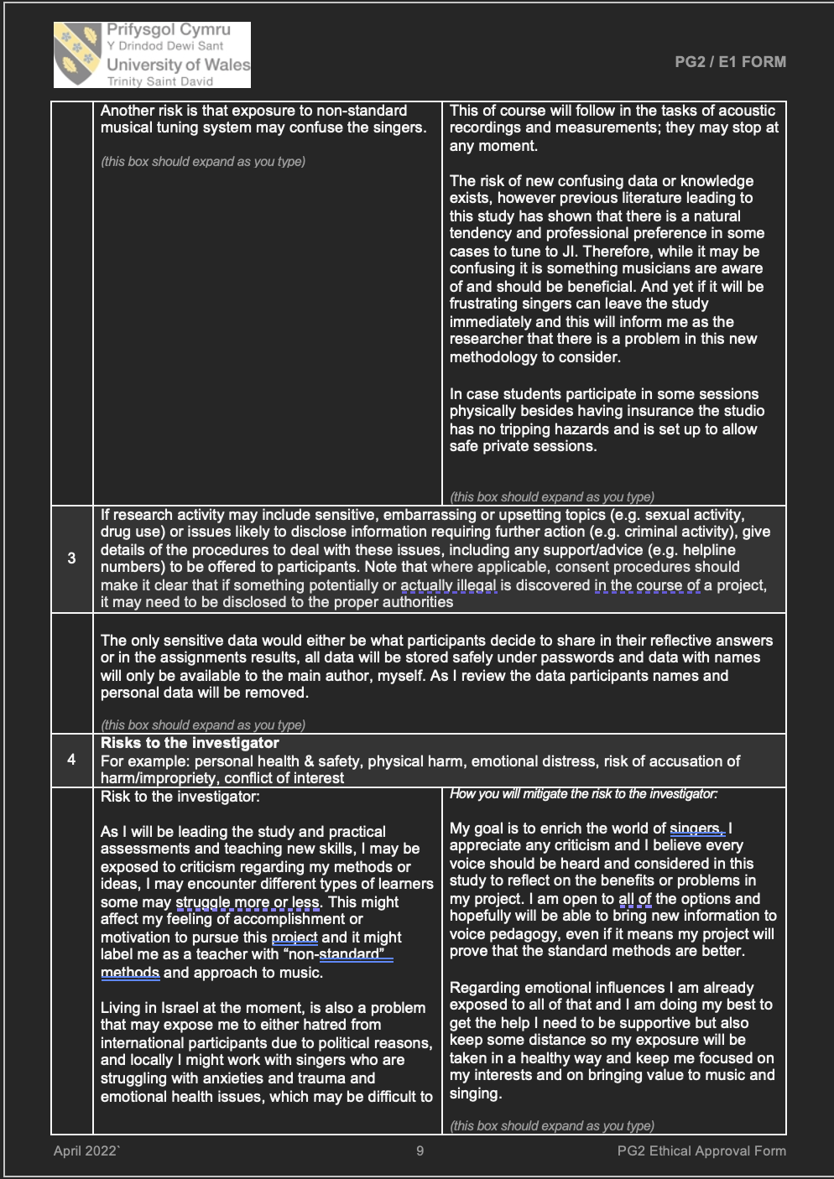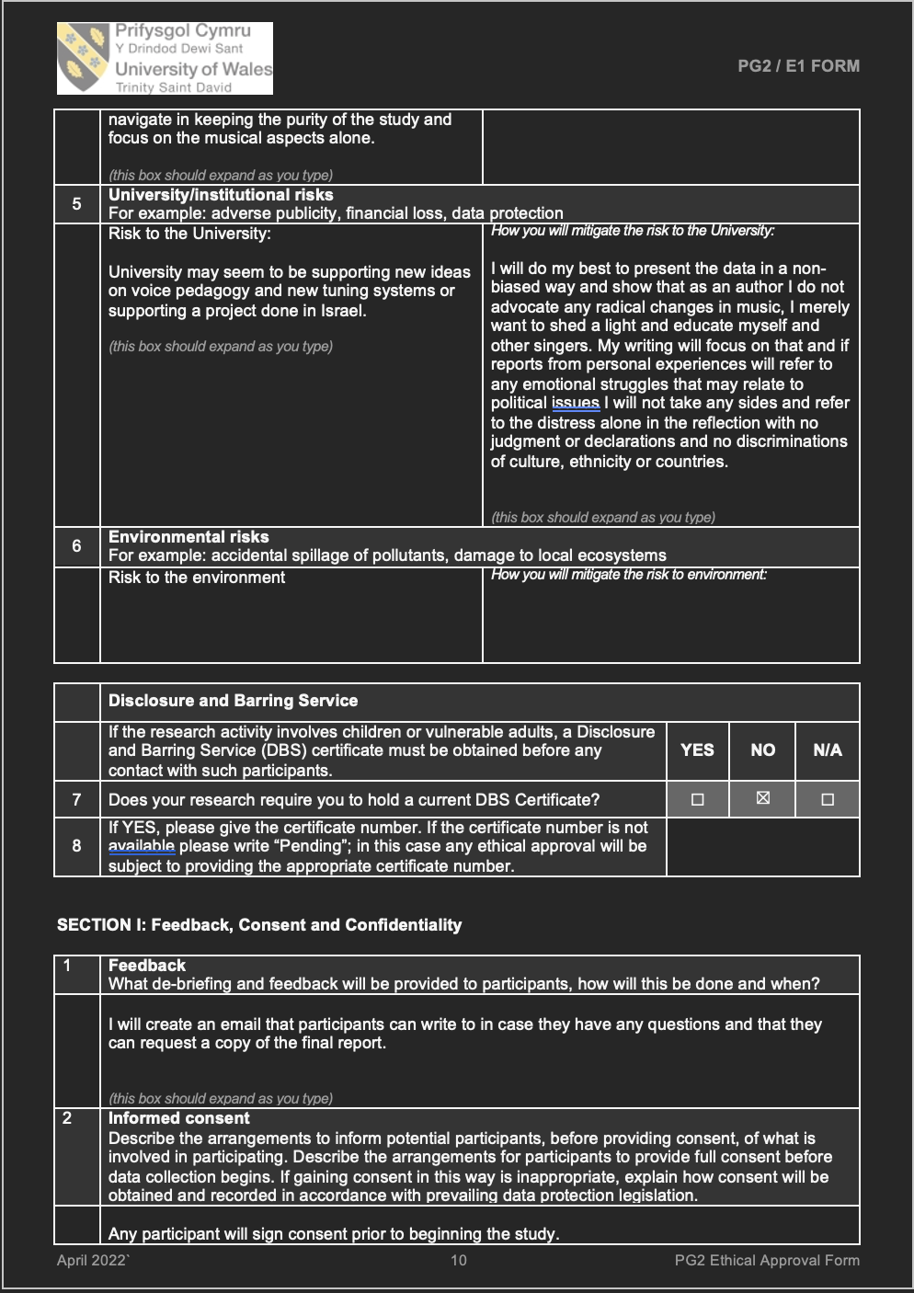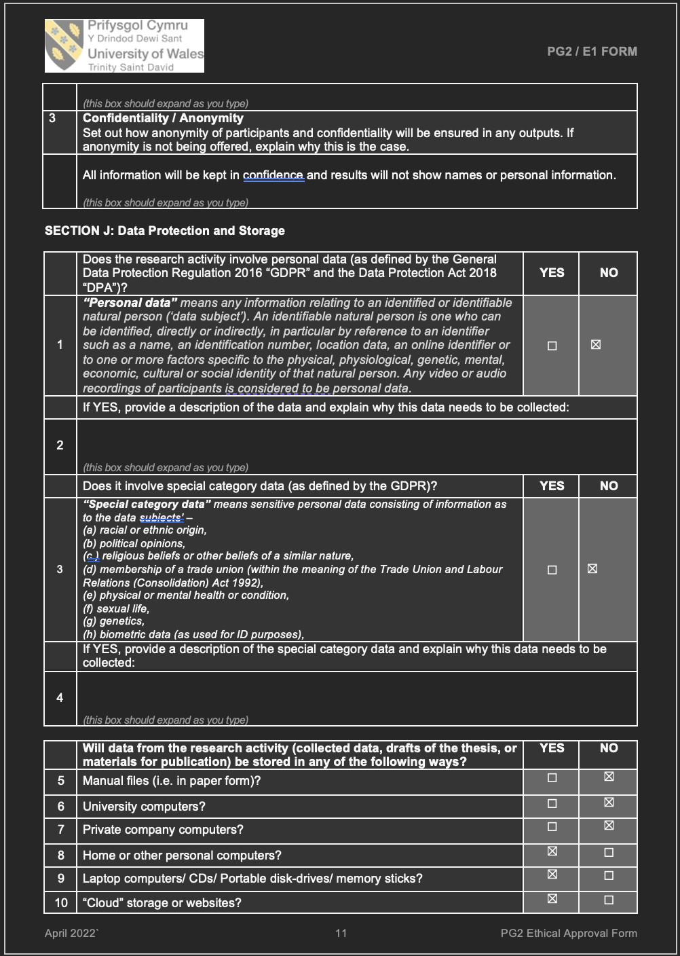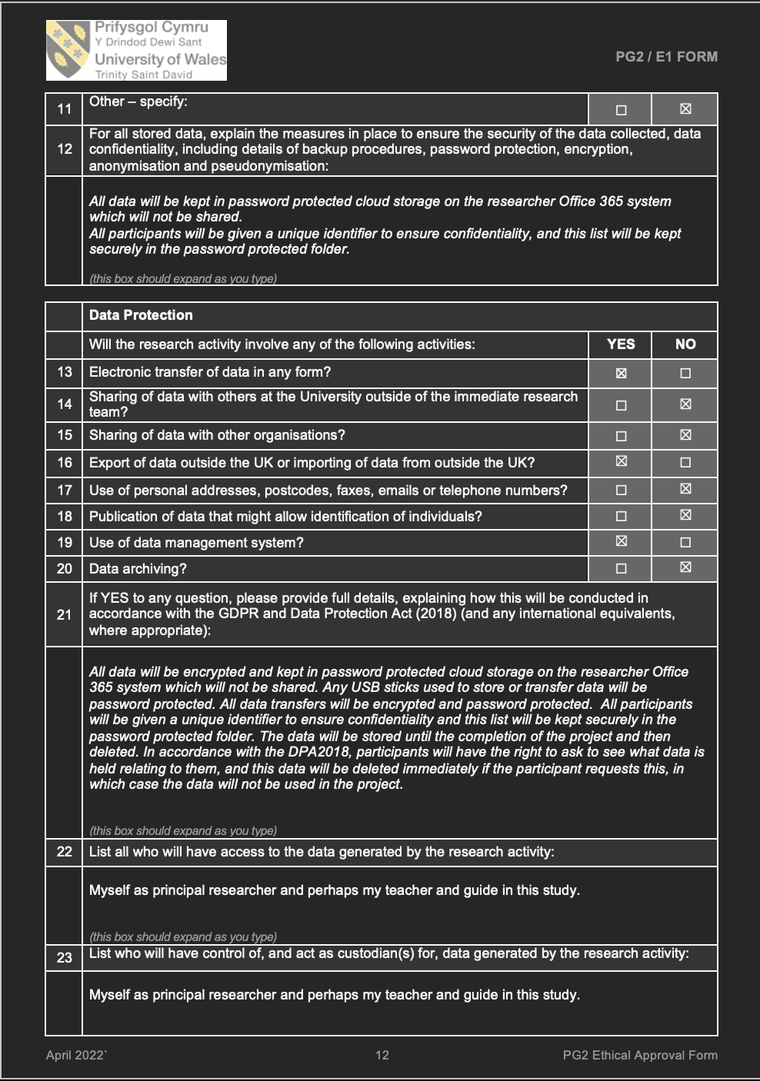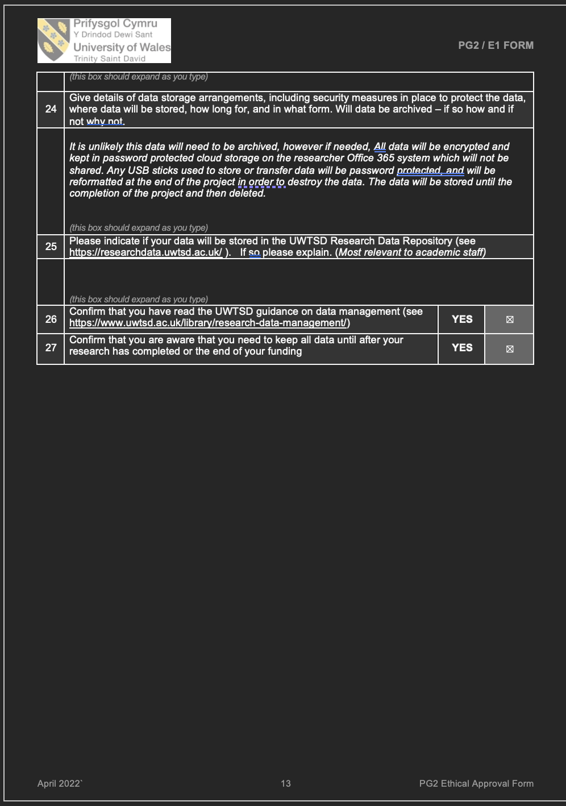

Appendix F — Reflection Author Journal

APPENDIX Journal significant moments:

REFLECTIVE TIMELINE OF SIGNIFICANT MOMENTS IN THE RESEARCH JOURNEY

This timeline records significant practical, conceptual and personal moments in the development of the project. It is intended as a reflective journal outline rather than a comprehensive record of every activity undertaken. It traces how my understanding of tuning developed gradually through study, listening, experimentation, pedagogical application, technological challenges and the research process itself.

1. EARLY 2025 ONWARDS: GRADUAL DEVELOPMENT OF MY UNDERSTANDING

Throughout the period beginning in early 2025, I gradually developed my understanding of the measurements and acoustic relationships associated with equal temperament (ET) and just intonation (JI).

This was not a single moment of discovery, but a cumulative process in which theoretical knowledge, auditory perception and practical experimentation began to inform one another. I increasingly recognised that understanding tuning intellectually did not necessarily mean that I could immediately identify or experience its effects consistently through listening or singing.

2. MARCH 2025: FIRST MEETING WITH ALON

I met with Alon to develop my understanding of the circle of fifths and the discrepancies that arise in comparison with equal temperament.

This meeting helped me begin to understand tuning as a system of interconnected relationships rather than as a collection of isolated intervals. It also highlighted the compromises involved in equal temperament and the complexity behind pitch relationships that can initially appear fixed or self-evident.

3. JUNE 2025: HARPSICHORD-TUNING CHALLENGE

In a further meeting with Alon, we undertook the practical challenge of tuning a harpsichord.

For the first time, I listened closely not only to individual pitches but also to the acoustic interaction between simultaneously sounding tones. This was a significant experience in the development of the way I listen to intervals.

My attention began to shift from asking whether each individual note was “correct” to noticing what occurred between the notes, including beating, alignment and changes in the combined sound. This became an important conceptual and perceptual foundation for the subsequent research.

4. OCTOBER 2025: PRESENTING THE PROJECT AT PAVA

I presented the developing project at PAVA. Preparing for the conference required me to articulate the distinction between ET and JI harmony clearly enough for others to understand.

Together with Daniel Yehezkeli, I attempted to demonstrate the audible difference between an ET chord and a JI chord.

The preparation process revealed the difficulty of translating an acoustically complex phenomenon into an accessible explanation and demonstration. It also reinforced the importance of creating practical ways for singers and voice teachers to hear, explore and discuss tuning rather than encountering it only through numerical descriptions.

5. APRIL 2026: APPLYING THE IDEAS IN FUNNY GIRL

While working with the choir in a production of Funny Girl, I began applying ideas related to harmonic interaction within a professional pedagogical setting.

I used familiar vocal techniques, acoustic software and overtone singing to help the singers attend to shared components in the upper frequencies of their voices. I asked the pianist to stop playing temporarily so that the singers could focus more closely on the relationships among their own pitches rather than relying on the piano as the primary tuning reference.

The musical director was pleased with the resulting blend. This experience suggested that focusing the singers’ attention on the interaction among their voices could have practical musical value, even without presenting the work explicitly as ET or JI training.

It also contributed to my growing questions about the extent to which vocal pedagogy relies on the piano and what singers may perceive when that reference is removed.

6. JUNE 2026: MIDI APPLICATION AND INCREASED AWARENESS OF BEATING

Daniel developed a MIDI application that enabled me to move between different piano tunings. I used the application to explore the tuning systems and to try to perceive their differences more clearly myself.

Through this experimentation, I developed greater awareness of acoustic beats and beating. The process reinforced the importance of remaining open about the limits and variability of my own perception. My growing theoretical understanding did not mean that every distinction was always immediately or consistently audible or physically perceptible to me.

This uncertainty later informed the non-directive approach used during the intervention sessions.

7. JUNE 2026: DEVELOPING THE RESEARCH APPLICATION

I developed an application intended to make participation and recording as accessible as possible for the study participants.

I experimented with recording different intervals and constructing tasks that participants could complete independently. I encountered technological difficulties, particularly in relation to using MIDI within the recording process.

I conducted repeated tests and made adjustments to ensure that the participants’ recordings would be captured under the best possible conditions. Further technical problems emerged during the data-collection process.

These difficulties became part of the research journey and demonstrated the gap that can arise between the conceptual design of an assessment and its real-world implementation.

8. JULY 2026: RECRUITMENT DIFFICULTIES AND ADAPTATION

At first, no participants joined the study. I considered whether the difficulty arose from the application, the level of commitment required, exclusion criteria, the study design or a combination of these factors.

In consultation with my supervisor, Joshua, I revised and adapted aspects of the process. This stage required me to reconsider what was practically feasible while retaining the central purpose of the research.

It also reminded me that participant accessibility and the usability of research tools are integral parts of research design rather than merely administrative considerations.

9. LATE JULY 2026: BEGINNING DATA COLLECTION

By the end of July, several participants had begun entering the study. I randomly selected three participants to receive the intervention.

This marked a transition from designing and testing the research process to observing how participants engaged with it in practice.

10. AUGUST 2026: DESIGNING AND DELIVERING TWO INTERVENTION SESSIONS

During data collection, I developed two practical intervention protocols. Both interventions involved active listening and singing, although the first included a greater theoretical component.

11. AUGUST 2026: RECORDING PROBLEMS AND MATHEMATICAL COMPLEXITY

During data collection and analysis, I identified additional recording problems and difficulties in the mathematical treatment of the data.

Although frustrating, these problems helped clarify how the findings would need to be presented. They also demonstrated the complexity of reducing vocal tuning behaviour to a single numerical measurement.

The difficulties encouraged me to consider questions of variability, context, measurement limitations and the distinction between a theoretically defined tuning target and an actual sung response.

12. AUGUST 2026: RECONSIDERING THE SIGNIFICANCE OF THE PARTICIPANT DATA

As the project developed, I began to recognise that the participants’ numerical results might be less important at this exploratory stage than I had initially assumed.

The process itself brought the broader importance and complexity of tuning into clearer focus. I began to see value in presenting the topic, explaining why tuning is pedagogically complex and considering how it might be made accessible to singers and voice teachers.

This led to a broader pedagogical question: Is vocal pedagogy justified in relying so extensively—and often almost exclusively—on the piano as its tuning framework and reference?

The study therefore became not only an investigation of participants’ tuning tendencies, but also a means of examining assumptions embedded within current teaching practices.

13. EMERGING FUTURE DIRECTIONS

The project prompted me to consider possible directions for future doctoral research.

One possibility is a more focused investigation of tuning and its place within vocal pedagogy. Another is a broader book or doctoral project concerned with reimagining vocal pedagogy.

Such a project could examine tuning as one element within a wider collection of changes already occurring in the field, including developments in voice science, acoustics, neuroscience, somatic practice and performance pedagogy.

The present study has therefore functioned both as an individual research project and as a starting point for a larger inquiry into how established assumptions in vocal pedagogy might be reconsidered.

Appendix G — Reflective data and full Data set analysis Charts

Table G1a. Acoustic reference values used in the assessment tasks
Note. Reference values are presented once because they were repeated across participant assessments. "Lower-octave reference" indicates reference material presented one octave below the original reference. Interval values in cents are unchanged by octave.
Task | Reference | Tonic  (Hz) | ET ref.  (Hz) | JI ref.  (Hz) | ET interval  (cents) | JI interval  (cents)
Major Third | Original reference | 256.90 | 323.60 | 321.10 | 399.61 | 386.18
Major Third | Lower-octave reference | 128.45 | 161.80 | 160.55 | 399.61 | 386.18
Minor Third | Original reference | 256.90 | 305.50 | 308.20 | 299.96 | 315.19
Minor Third | Lower-octave reference | 128.45 | 152.75 | 154.10 | 299.96 | 315.19
Major Chord | Original reference | 256.90 | 323.60 | 321.10 | 399.61 | 386.18
Major Chord | Lower-octave reference | 128.45 | 161.80 | 160.55 | 399.61 | 386.18
Minor Chord | Original reference | 216.00 | 256.90 | 259.20 | 300.21 | 315.64
Minor Chord | Lower-octave reference | 108.00 | 128.45 | 129.60 | 300.21 | 315.64
Melody part 1 | Original reference | 192.40 | 242.50 | 240.50 | 400.65 | 386.31
Melody part 1 | Lower-octave reference | 96.20 | 121.25 | 120.25 | 400.65 | 386.31
Melody part 2 | Original reference | 192.40 | 242.50 | 240.50 | 400.65 | 386.31
Melody part 2 | Lower-octave reference | 96.20 | 121.25 | 120.25 | 400.65 | 386.31
Pentatonic Up | Original reference | 216.00 | 272.10 | 270.00 | 399.73 | 386.31
Pentatonic Up | Lower-octave reference | 108.00 | 136.05 | 135.00 | 399.73 | 386.31
Pentatonic Down | Original reference | 216.00 | 272.10 | 270.00 | 399.73 | 386.31
Pentatonic Down | Lower-octave reference | 108.00 | 136.05 | 135.00 | 399.73 | 386.31

Table G1b. Complete participant task-level acoustic results
Note. Reference frequencies and theoretical interval values are reported in Table G1a. Participant codes identify study group (A = intervention; B = non-intervention comparison). B11 Assessments 3 and 4 contain six valid task observations each.
Participant | Assessment | Task | Produced F0  (Hz) | Produced interval  (cents) | ET deviation  (cents) | JI deviation  (cents) | Nearest-reference  error (cents) | ET-JI  tendency | Nearest  reference
A2 | 1 | Major Third | 324.20 | 402.81 | 3.21 | 16.63 | 3.21 | -1.48 | ET
A2 | 1 | Minor Third | 308.40 | 316.32 | 16.36 | 1.12 | 1.12 | 1.15 | JI
A2 | 1 | Major Chord | 324.10 | 402.28 | 2.67 | 16.10 | 2.67 | -1.40 | ET
A2 | 1 | Minor Chord | 257.40 | 303.58 | 3.37 | -12.06 | 3.37 | -0.56 | ET
A2 | 1 | Melody part 1 | 239.80 | 381.27 | -19.38 | -5.05 | 5.05 | 1.70 | JI
A2 | 1 | Melody part 2 | 242.00 | 397.08 | -3.57 | 10.76 | 3.57 | -0.50 | ET
A2 | 1 | Pentatonic Up | 272.30 | 401.00 | 1.27 | 14.69 | 1.27 | -1.19 | ET
A2 | 1 | Pentatonic Down | 277.50 | 433.75 | 34.02 | 47.43 | 34.02 | -6.07 | ET
A2 | 2 | Major Third | 321.20 | 386.72 | -12.89 | 0.54 | 0.54 | 0.92 | JI
A2 | 2 | Minor Third | 304.70 | 295.42 | -4.54 | -19.77 | 4.54 | -1.60 | ET
A2 | 2 | Major Chord | 321.70 | 389.41 | -10.19 | 3.23 | 3.23 | 0.52 | JI
A2 | 2 | Minor Chord | 257.00 | 300.88 | 0.67 | -14.76 | 0.67 | -0.91 | ET
A2 | 2 | Melody part 1 | 241.70 | 394.93 | -5.72 | 8.62 | 5.72 | -0.20 | ET
A2 | 2 | Melody part 2 | 238.50 | 371.86 | -28.79 | -14.46 | 14.46 | 3.02 | JI
A2 | 2 | Pentatonic Up | 273.40 | 407.98 | 8.25 | 21.66 | 8.25 | -2.23 | ET
A2 | 2 | Pentatonic Down | 276.50 | 427.50 | 27.77 | 41.18 | 27.77 | -5.14 | ET
A2 | 3 | Major Third | 321.10 | 386.18 | -13.43 | 0.00 | 0.00 | 1.00 | JI
A2 | 3 | Minor Third | 303.40 | 288.02 | -11.94 | -27.17 | 11.94 | -2.57 | ET
A2 | 3 | Major Chord | 320.80 | 384.56 | -15.04 | -1.62 | 1.62 | 1.24 | JI
A2 | 3 | Minor Chord | 255.50 | 290.75 | -9.46 | -24.89 | 9.46 | -2.23 | ET
A2 | 3 | Melody part 1 | 238.80 | 374.03 | -26.62 | -12.28 | 12.28 | 2.71 | JI
A2 | 3 | Melody part 2 | 242.10 | 397.79 | -2.86 | 11.48 | 2.86 | -0.60 | ET
A2 | 3 | Pentatonic Up | 277.70 | 435.00 | 35.27 | 48.68 | 35.27 | -6.26 | ET
A2 | 3 | Pentatonic Down | 270.20 | 387.60 | -12.13 | 1.28 | 1.28 | 0.81 | JI
A2 | 4 | Major Third | 319.50 | 377.53 | -22.07 | -8.65 | 8.65 | 2.29 | JI
A2 | 4 | Minor Third | 305.40 | 299.39 | -0.57 | -15.80 | 0.57 | -1.07 | ET
A2 | 4 | Major Chord | 321.10 | 386.18 | -13.43 | 0.00 | 0.00 | 1.00 | JI
A2 | 4 | Minor Chord | 255.90 | 293.46 | -6.75 | -22.18 | 6.75 | -1.88 | ET
A2 | 4 | Melody part 1 | 240.00 | 382.71 | -17.94 | -3.60 | 3.60 | 1.50 | JI
A2 | 4 | Melody part 2 | 241.40 | 392.78 | -7.87 | 6.47 | 6.47 | 0.10 | JI
A2 | 4 | Pentatonic Up | 271.60 | 396.54 | -3.18 | 10.23 | 3.18 | -0.53 | ET
A2 | 4 | Pentatonic Down | 272.60 | 402.91 | 3.18 | 16.59 | 3.18 | -1.47 | ET
A3 | 1 | Major Third | 326.10 | 412.93 | 13.32 | 26.75 | 13.32 | -2.98 | ET
A3 | 1 | Minor Third | 310.50 | 328.06 | 28.11 | 12.87 | 12.87 | 2.69 | JI
A3 | 1 | Major Chord | 321.70 | 389.41 | -10.19 | 3.23 | 3.23 | 0.52 | JI
A3 | 1 | Minor Chord | 263.60 | 344.78 | 44.57 | 29.14 | 29.14 | 4.78 | JI
A3 | 1 | Melody part 1 | 242.40 | 399.94 | -0.71 | 13.62 | 0.71 | -0.90 | ET
A3 | 1 | Melody part 2 | 245.40 | 421.23 | 20.58 | 34.92 | 20.58 | -3.87 | ET
A3 | 1 | Pentatonic Up | 276.50 | 427.50 | 27.77 | 41.18 | 27.77 | -5.14 | ET
A3 | 1 | Pentatonic Down | 275.00 | 418.08 | 18.35 | 31.77 | 18.35 | -3.74 | ET
A3 | 2 | Major Third | 322.70 | 394.78 | -4.82 | 8.61 | 4.82 | -0.28 | ET
A3 | 2 | Minor Third | 306.60 | 306.18 | 6.22 | -9.01 | 6.22 | -0.18 | ET
A3 | 2 | Major Chord | 321.70 | 389.41 | -10.19 | 3.23 | 3.23 | 0.52 | JI
A3 | 2 | Minor Chord | 260.00 | 320.98 | 20.77 | 5.34 | 5.34 | 1.69 | JI
A3 | 2 | Melody part 1 | 244.50 | 414.87 | 14.22 | 28.56 | 14.22 | -2.98 | ET
A3 | 2 | Melody part 2 | 248.70 | 444.36 | 43.71 | 58.04 | 43.71 | -7.10 | ET
A3 | 2 | Pentatonic Up | 277.90 | 436.24 | 36.51 | 49.93 | 36.51 | -6.44 | ET
A3 | 2 | Pentatonic Down | 276.20 | 425.62 | 25.89 | 39.30 | 25.89 | -4.86 | ET
A3 | 3 | Major Third | 322.20 | 392.10 | -7.51 | 5.92 | 5.92 | 0.12 | JI
A3 | 3 | Minor Third | 312.60 | 339.73 | 39.77 | 24.54 | 24.54 | 4.22 | JI
A3 | 3 | Major Chord | 321.60 | 388.87 | -10.73 | 2.69 | 2.69 | 0.60 | JI
A3 | 3 | Minor Chord | 259.90 | 320.31 | 20.10 | 4.67 | 4.67 | 1.61 | JI
A3 | 3 | Melody part 1 | 243.20 | 405.64 | 4.99 | 19.33 | 4.99 | -1.70 | ET
A3 | 3 | Melody part 2 | 246.80 | 431.08 | 30.43 | 44.77 | 30.43 | -5.24 | ET
A3 | 3 | Pentatonic Up | 280.00 | 449.27 | 49.55 | 62.96 | 49.55 | -8.39 | ET
A3 | 3 | Pentatonic Down | 278.10 | 437.49 | 37.76 | 51.17 | 37.76 | -6.63 | ET
A3 | 4 | Major Third | 321.90 | 390.49 | -9.12 | 4.31 | 4.31 | 0.36 | JI
A3 | 4 | Minor Third | 307.30 | 310.13 | 10.17 | -5.06 | 5.06 | 0.34 | JI
A3 | 4 | Major Chord | 319.20 | 375.90 | -23.70 | -10.27 | 10.27 | 2.53 | JI
A3 | 4 | Minor Chord | 261.50 | 330.94 | 30.72 | 15.29 | 15.29 | 2.98 | JI
A3 | 4 | Melody part 1 | 246.60 | 429.68 | 29.03 | 43.36 | 29.03 | -5.05 | ET
A3 | 4 | Melody part 2 | 246.60 | 429.68 | 29.03 | 43.36 | 29.03 | -5.05 | ET
A3 | 4 | Pentatonic Up | 277.40 | 433.12 | 33.40 | 46.81 | 33.40 | -5.98 | ET
A3 | 4 | Pentatonic Down | 274.40 | 414.30 | 14.57 | 27.99 | 14.57 | -3.17 | ET
B3 | 1 | Major Third | 324.00 | 401.74 | 2.14 | 15.57 | 2.14 | -1.32 | ET
B3 | 1 | Minor Third | 311.40 | 333.07 | 33.12 | 17.88 | 17.88 | 3.35 | JI
B3 | 1 | Major Chord | 324.60 | 404.95 | 5.34 | 18.77 | 5.34 | -1.80 | ET
B3 | 1 | Minor Chord | 256.40 | 296.84 | -3.37 | -18.80 | 3.37 | -1.44 | ET
B3 | 1 | Melody part 1 | 236.70 | 358.74 | -41.91 | -27.57 | 27.57 | 4.85 | JI
B3 | 1 | Melody part 2 | 239.70 | 380.55 | -20.11 | -5.77 | 5.77 | 1.80 | JI
B3 | 1 | Pentatonic Up | 277.30 | 432.50 | 32.77 | 46.19 | 32.77 | -5.89 | ET
B3 | 1 | Pentatonic Down | 265.60 | 357.87 | -41.86 | -28.45 | 28.45 | 5.24 | JI
B3 | 2 | Major Third | 318.90 | 374.28 | -25.33 | -11.90 | 11.90 | 2.77 | JI
B3 | 2 | Minor Third | 315.10 | 353.52 | 53.56 | 38.33 | 38.33 | 6.03 | JI
B3 | 2 | Major Chord | 316.10 | 359.01 | -40.60 | -27.17 | 27.17 | 5.05 | JI
B3 | 2 | Minor Chord | 260.40 | 323.64 | 23.43 | 8.00 | 8.00 | 2.04 | JI
B3 | 2 | Melody part 1 | 232.90 | 330.72 | -69.93 | -55.59 | 55.59 | 8.75 | JI
B3 | 2 | Melody part 2 | 230.60 | 313.54 | -87.11 | -72.77 | 72.77 | 11.15 | JI
B3 | 2 | Pentatonic Up | 278.50 | 439.98 | 40.25 | 53.66 | 40.25 | -7.00 | ET
B3 | 2 | Pentatonic Down | 265.90 | 359.82 | -39.90 | -26.49 | 26.49 | 4.95 | JI
B3 | 3 | Major Third | 315.80 | 357.37 | -42.24 | -28.81 | 28.81 | 5.29 | JI
B3 | 3 | Minor Third | 301.30 | 275.99 | -23.97 | -39.20 | 23.97 | -4.15 | ET
B3 | 3 | Major Chord | 309.80 | 324.16 | -75.45 | -62.02 | 62.02 | 10.24 | JI
B3 | 3 | Minor Chord | 190.00 | -222.04 | -522.25 | -537.68 | 522.25 | -68.69 | ET
B3 | 3 | Melody part 1 | 236.50 | 357.28 | -43.37 | -29.04 | 29.04 | 5.05 | JI
B3 | 3 | Melody part 2 | 232.40 | 327.00 | -73.65 | -59.31 | 59.31 | 9.27 | JI
B3 | 3 | Pentatonic Up | 267.70 | 371.50 | -28.22 | -14.81 | 14.81 | 3.21 | JI
B3 | 3 | Pentatonic Down | 270.00 | 386.31 | -13.41 | 0.00 | 0.00 | 1.00 | JI
B3 | 4 | Major Third | 318.70 | 373.19 | -26.42 | -12.99 | 12.99 | 2.93 | JI
B3 | 4 | Minor Third | 308.30 | 315.75 | 15.80 | 0.56 | 0.56 | 1.07 | JI
B3 | 4 | Major Chord | 318.00 | 369.38 | -30.22 | -16.80 | 16.80 | 3.50 | JI
B3 | 4 | Minor Chord | 261.60 | 331.60 | 31.39 | 15.96 | 15.96 | 3.07 | JI
B3 | 4 | Melody part 1 | 237.20 | 362.39 | -38.26 | -23.92 | 23.92 | 4.34 | JI
B3 | 4 | Melody part 2 | 235.30 | 348.47 | -52.18 | -37.84 | 37.84 | 6.28 | JI
B3 | 4 | Pentatonic Up | 267.90 | 372.80 | -26.93 | -13.52 | 13.52 | 3.02 | JI
B3 | 4 | Pentatonic Down | 265.20 | 355.26 | -44.47 | -31.05 | 31.05 | 5.63 | JI
B4 | 1 | Major Third | 158.80 | 367.20 | -32.40 | -18.97 | 18.97 | 3.83 | JI
B4 | 1 | Minor Third | 149.90 | 267.35 | -32.61 | -47.84 | 32.61 | -5.28 | ET
B4 | 1 | Major Chord | 160.30 | 383.48 | -16.12 | -2.70 | 2.70 | 1.40 | JI
B4 | 1 | Minor Chord | 126.80 | 277.83 | -22.38 | -37.81 | 22.38 | -3.90 | ET
B4 | 1 | Melody part 1 | 249.90 | 452.69 | 52.04 | 66.38 | 52.04 | -8.26 | ET
B4 | 1 | Melody part 2 | 252.50 | 470.61 | 69.96 | 84.30 | 69.96 | -10.76 | ET
B4 | 1 | Pentatonic Up | 276.60 | 428.12 | 28.40 | 41.81 | 28.40 | -5.23 | ET
B4 | 1 | Pentatonic Down | 271.00 | 392.71 | -7.01 | 6.40 | 6.40 | 0.05 | JI
B4 | 2 | Major Third | 160.80 | 388.87 | -10.73 | 2.69 | 2.69 | 0.60 | JI
B4 | 2 | Minor Third | 151.90 | 290.30 | -9.66 | -24.89 | 9.66 | -2.27 | ET
B4 | 2 | Major Chord | 160.00 | 380.24 | -19.37 | -5.94 | 5.94 | 1.88 | JI
B4 | 2 | Minor Chord | 127.50 | 287.36 | -12.85 | -28.28 | 12.85 | -2.67 | ET
B4 | 2 | Melody part 1 | 251.30 | 462.36 | 61.71 | 76.05 | 61.71 | -9.61 | ET
B4 | 2 | Melody part 2 | 251.50 | 463.74 | 63.09 | 77.43 | 63.09 | -9.80 | ET
B4 | 2 | Pentatonic Up | 274.60 | 415.56 | 15.83 | 29.25 | 15.83 | -3.36 | ET
B4 | 2 | Pentatonic Down | 270.50 | 389.52 | -10.21 | 3.20 | 3.20 | 0.52 | JI
B5 | 1 | Major Third | 319.70 | 378.61 | -20.99 | -7.56 | 7.56 | 2.13 | JI
B5 | 1 | Minor Third | 307.30 | 310.13 | 10.17 | -5.06 | 5.06 | 0.34 | JI
B5 | 1 | Major Chord | 322.60 | 394.25 | -5.36 | 8.07 | 5.36 | -0.20 | ET
B5 | 1 | Minor Chord | 250.00 | 253.08 | -47.13 | -62.57 | 47.13 | -7.11 | ET
B5 | 1 | Melody part 1 | 237.80 | 366.77 | -33.88 | -19.55 | 19.55 | 3.73 | JI
B5 | 1 | Melody part 2 | 231.80 | 322.53 | -78.13 | -63.79 | 63.79 | 9.90 | JI
B5 | 1 | Pentatonic Up | 278.20 | 438.11 | 38.38 | 51.80 | 38.38 | -6.72 | ET
B5 | 1 | Pentatonic Down | 277.70 | 435.00 | 35.27 | 48.68 | 35.27 | -6.26 | ET
B5 | 2 | Major Third | 322.20 | 392.10 | -7.51 | 5.92 | 5.92 | 0.12 | JI
B5 | 2 | Minor Third | 302.30 | 281.73 | -18.23 | -33.46 | 18.23 | -3.39 | ET
B5 | 2 | Major Chord | 324.30 | 403.35 | 3.74 | 17.17 | 3.74 | -1.56 | ET
B5 | 2 | Minor Chord | 259.20 | 315.64 | 15.43 | 0.00 | 0.00 | 1.00 | JI
B5 | 2 | Melody part 1 | 237.10 | 361.66 | -38.99 | -24.65 | 24.65 | 4.44 | JI
B5 | 2 | Melody part 2 | 249.00 | 446.44 | 45.79 | 60.13 | 45.79 | -7.39 | ET
B5 | 2 | Pentatonic Up | 279.00 | 443.08 | 43.35 | 56.77 | 43.35 | -7.46 | ET
B5 | 2 | Pentatonic Down | 277.30 | 432.50 | 32.77 | 46.19 | 32.77 | -5.89 | ET
B5 | 3 | Major Third | 323.70 | 400.14 | 0.53 | 13.96 | 0.53 | -1.08 | ET
B5 | 3 | Minor Third | 300.30 | 270.24 | -29.72 | -44.95 | 29.72 | -4.90 | ET
B5 | 3 | Major Chord | 320.30 | 381.86 | -17.75 | -4.32 | 4.32 | 1.64 | JI
B5 | 3 | Minor Chord | 255.90 | 293.46 | -6.75 | -22.18 | 6.75 | -1.88 | ET
B5 | 3 | Melody part 1 | 236.20 | 355.08 | -45.57 | -31.23 | 31.23 | 5.36 | JI
B5 | 3 | Melody part 2 | 243.50 | 407.78 | 7.12 | 21.46 | 7.12 | -1.99 | ET
B5 | 3 | Pentatonic Up | 270.00 | 386.31 | -13.41 | 0.00 | 0.00 | 1.00 | JI
B5 | 3 | Pentatonic Down | 275.50 | 421.23 | 21.50 | 34.91 | 21.50 | -4.21 | ET
B5 | 4 | Major Third | 318.20 | 370.47 | -29.13 | -15.71 | 15.71 | 3.34 | JI
B5 | 4 | Minor Third | 303.00 | 285.73 | -14.23 | -29.46 | 14.23 | -2.87 | ET
B5 | 4 | Major Chord | 317.20 | 365.02 | -34.58 | -21.16 | 21.16 | 4.15 | JI
B5 | 4 | Minor Chord | 249.50 | 249.61 | -50.60 | -66.03 | 50.60 | -7.56 | ET
B5 | 4 | Melody part 1 | 244.00 | 411.33 | 10.68 | 25.01 | 10.68 | -2.49 | ET
B5 | 4 | Melody part 2 | 250.50 | 456.84 | 56.19 | 70.53 | 56.19 | -8.84 | ET
B5 | 4 | Pentatonic Up | 271.30 | 394.63 | -5.10 | 8.32 | 5.10 | -0.24 | ET
B5 | 4 | Pentatonic Down | 277.80 | 435.62 | 35.89 | 49.30 | 35.89 | -6.35 | ET
B7 | 1 | Major Third | 326.80 | 416.64 | 17.04 | 30.46 | 17.04 | -3.54 | ET
B7 | 1 | Minor Third | 313.00 | 341.95 | 41.99 | 26.75 | 26.75 | 4.51 | JI
B7 | 1 | Major Chord | 328.40 | 425.10 | 25.49 | 38.92 | 25.49 | -4.80 | ET
B7 | 1 | Minor Chord | 263.70 | 345.44 | 45.23 | 29.80 | 29.80 | 4.86 | JI
B7 | 1 | Melody part 1 | 246.90 | 431.78 | 31.13 | 45.47 | 31.13 | -5.34 | ET
B7 | 1 | Melody part 2 | 235.00 | 346.26 | -54.39 | -40.05 | 40.05 | 6.59 | JI
B7 | 1 | Pentatonic Up | 274.90 | 417.45 | 17.72 | 31.14 | 17.72 | -3.64 | ET
B7 | 1 | Pentatonic Down | 267.10 | 367.62 | -32.11 | -18.70 | 18.70 | 3.79 | JI
B7 | 2 | Major Third | 321.30 | 387.26 | -12.35 | 1.08 | 1.08 | 0.84 | JI
B7 | 2 | Minor Third | 311.20 | 331.96 | 32.00 | 16.77 | 16.77 | 3.20 | JI
B7 | 2 | Major Chord | 322.90 | 395.86 | -3.75 | 9.68 | 3.75 | -0.44 | ET
B7 | 2 | Minor Chord | 259.70 | 318.98 | 18.77 | 3.34 | 3.34 | 1.43 | JI
B7 | 2 | Melody part 1 | 242.40 | 399.94 | -0.71 | 13.62 | 0.71 | -0.90 | ET
B7 | 2 | Melody part 2 | 241.80 | 395.65 | -5.00 | 9.33 | 5.00 | -0.30 | ET
B7 | 2 | Pentatonic Up | 279.10 | 443.70 | 43.97 | 57.39 | 43.97 | -7.56 | ET
B7 | 2 | Pentatonic Down | 276.50 | 427.50 | 27.77 | 41.18 | 27.77 | -5.14 | ET
B7 | 3 | Major Third | 325.10 | 407.61 | 8.01 | 21.43 | 8.01 | -2.19 | ET
B7 | 3 | Minor Third | 308.10 | 314.63 | 14.67 | -0.56 | 0.56 | 0.93 | JI
B7 | 3 | Major Chord | 323.30 | 398.00 | -1.61 | 11.82 | 1.61 | -0.76 | ET
B7 | 3 | Minor Chord | 265.00 | 353.95 | 53.74 | 38.31 | 38.31 | 5.97 | JI
B7 | 3 | Melody part 1 | 236.50 | 357.28 | -43.37 | -29.04 | 29.04 | 5.05 | JI
B7 | 3 | Melody part 2 | 231.90 | 323.27 | -77.38 | -63.04 | 63.04 | 9.79 | JI
B7 | 3 | Pentatonic Up | 276.90 | 430.00 | 30.27 | 43.69 | 30.27 | -5.51 | ET
B7 | 3 | Pentatonic Down | 274.20 | 413.04 | 13.31 | 26.72 | 13.31 | -2.98 | ET
B7 | 4 | Major Third | 326.10 | 412.93 | 13.32 | 26.75 | 13.32 | -2.98 | ET
B7 | 4 | Minor Third | 310.00 | 325.27 | 25.32 | 10.08 | 10.08 | 2.32 | JI
B7 | 4 | Major Chord | 324.50 | 404.41 | 4.81 | 18.23 | 4.81 | -1.72 | ET
B7 | 4 | Minor Chord | 263.00 | 340.84 | 40.63 | 25.20 | 25.20 | 4.27 | JI
B7 | 4 | Melody part 1 | 243.40 | 407.06 | 6.41 | 20.75 | 6.41 | -1.89 | ET
B7 | 4 | Melody part 2 | 237.30 | 363.12 | -37.53 | -23.19 | 23.19 | 4.23 | JI
B7 | 4 | Pentatonic Up | 276.70 | 428.75 | 29.02 | 42.44 | 29.02 | -5.33 | ET
B7 | 4 | Pentatonic Down | 278.50 | 439.98 | 40.25 | 53.66 | 40.25 | -7.00 | ET
B9 | 1 | Major Third | 319.80 | 379.16 | -20.45 | -7.02 | 7.02 | 2.05 | JI
B9 | 1 | Minor Third | 309.30 | 321.36 | 21.40 | 6.17 | 6.17 | 1.81 | JI
B9 | 1 | Major Chord | 317.10 | 364.48 | -35.13 | -21.70 | 21.70 | 4.23 | JI
B9 | 1 | Minor Chord | 257.90 | 306.94 | 6.73 | -8.70 | 6.73 | -0.13 | ET
B9 | 1 | Melody part 1 | 241.90 | 396.36 | -4.29 | 10.05 | 4.29 | -0.40 | ET
B9 | 1 | Melody part 2 | 239.30 | 377.65 | -23.00 | -8.66 | 8.66 | 2.21 | JI
B9 | 1 | Pentatonic Up | 268.30 | 375.38 | -24.35 | -10.93 | 10.93 | 2.63 | JI
B9 | 1 | Pentatonic Down | 260.60 | 324.97 | -74.76 | -61.35 | 61.35 | 10.15 | JI
B10 | 1 | Major Third | 326.40 | 414.52 | 14.92 | 28.34 | 14.92 | -3.22 | ET
B10 | 1 | Minor Third | 306.80 | 307.31 | 7.35 | -7.88 | 7.35 | -0.03 | ET
B10 | 1 | Major Chord | 319.00 | 374.82 | -24.79 | -11.36 | 11.36 | 2.69 | JI
B10 | 1 | Minor Chord | 252.80 | 272.36 | -27.85 | -43.28 | 27.85 | -4.61 | ET
B10 | 1 | Melody part 1 | 237.50 | 364.58 | -36.07 | -21.73 | 21.73 | 4.03 | JI
B10 | 1 | Melody part 2 | 234.30 | 341.10 | -59.55 | -45.22 | 45.22 | 7.31 | JI
B10 | 1 | Pentatonic Up | 274.10 | 412.41 | 12.68 | 26.09 | 12.68 | -2.89 | ET
B10 | 1 | Pentatonic Down | 265.70 | 358.52 | -41.21 | -27.79 | 27.79 | 5.14 | JI
B10 | 2 | Major Third | 325.80 | 411.34 | 11.73 | 25.16 | 11.73 | -2.75 | ET
B10 | 2 | Minor Third | 303.40 | 288.02 | -11.94 | -27.17 | 11.94 | -2.57 | ET
B10 | 2 | Major Chord | 319.60 | 378.07 | -21.53 | -8.11 | 8.11 | 2.21 | JI
B10 | 2 | Minor Chord | 253.60 | 277.83 | -22.38 | -37.81 | 22.38 | -3.90 | ET
B10 | 2 | Melody part 1 | 234.90 | 345.53 | -55.13 | -40.79 | 40.79 | 6.69 | JI
B10 | 2 | Melody part 2 | 234.30 | 341.10 | -59.55 | -45.22 | 45.22 | 7.31 | JI
B10 | 2 | Pentatonic Up | 262.40 | 336.88 | -62.84 | -49.43 | 49.43 | 8.37 | JI
B10 | 2 | Pentatonic Down | 268.60 | 377.31 | -22.41 | -9.00 | 9.00 | 2.34 | JI
B11 | 1 | Major Third | 159.80 | 378.07 | -21.53 | -8.11 | 8.11 | 2.21 | JI
B11 | 1 | Minor Third | 152.20 | 293.71 | -6.24 | -21.48 | 6.24 | -1.82 | ET
B11 | 1 | Major Chord | 158.90 | 368.29 | -31.31 | -17.88 | 17.88 | 3.66 | JI
B11 | 1 | Minor Chord | 128.60 | 302.23 | 2.02 | -13.41 | 2.02 | -0.74 | ET
B11 | 1 | Melody part 1 | 116.30 | 328.49 | -72.16 | -57.82 | 57.82 | 9.07 | JI
B11 | 1 | Melody part 2 | 117.70 | 349.21 | -51.44 | -37.11 | 37.11 | 6.18 | JI
B11 | 1 | Pentatonic Up | 133.20 | 363.08 | -36.65 | -23.24 | 23.24 | 4.47 | JI
B11 | 1 | Pentatonic Down | 130.80 | 331.60 | -68.13 | -54.72 | 54.72 | 9.16 | JI
B11 | 2 | Major Third | 159.20 | 371.56 | -28.05 | -14.62 | 14.62 | 3.18 | JI
B11 | 2 | Minor Third | 153.00 | 302.79 | 2.83 | -12.40 | 2.83 | -0.63 | ET
B11 | 2 | Major Chord | 159.00 | 369.38 | -30.22 | -16.80 | 16.80 | 3.50 | JI
B11 | 2 | Minor Chord | 129.40 | 312.97 | 12.76 | -2.67 | 2.67 | 0.65 | JI
B11 | 2 | Melody part 1 | 116.20 | 327.00 | -73.65 | -59.31 | 59.31 | 9.27 | JI
B11 | 2 | Melody part 2 | 114.40 | 299.97 | -100.68 | -86.34 | 86.34 | 13.04 | JI
B11 | 2 | Pentatonic Up | 135.50 | 392.71 | -7.01 | 6.40 | 6.40 | 0.05 | JI
B11 | 2 | Pentatonic Down | 130.60 | 328.95 | -70.78 | -57.37 | 57.37 | 9.55 | JI
B11 | 3 | Major Third | 158.70 | 366.11 | -33.49 | -20.06 | 20.06 | 3.99 | JI
B11 | 3 | Minor Third | 151.90 | 290.30 | -9.66 | -24.89 | 9.66 | -2.27 | ET
B11 | 3 | Major Chord | 158.70 | 366.11 | -33.49 | -20.06 | 20.06 | 3.99 | JI
B11 | 3 | Minor Chord | 127.00 | 280.56 | -19.65 | -35.08 | 19.65 | -3.55 | ET
B11 | 3 | Melody part 1 | 118.70 | 363.85 | -36.80 | -22.46 | 22.46 | 4.13 | JI
B11 | 3 | Pentatonic Up | 138.10 | 425.62 | 25.89 | 39.30 | 25.89 | -4.86 | ET
B11 | 4 | Major Third | 159.60 | 375.90 | -23.70 | -10.27 | 10.27 | 2.53 | JI
B11 | 4 | Minor Third | 151.80 | 289.16 | -10.80 | -26.03 | 10.80 | -2.42 | ET
B11 | 4 | Major Chord | 156.80 | 345.26 | -54.34 | -40.92 | 40.92 | 7.09 | JI
B11 | 4 | Minor Chord | 128.10 | 295.49 | -4.72 | -20.15 | 4.72 | -1.61 | ET
B11 | 4 | Melody part 1 | 118.70 | 363.85 | -36.80 | -22.46 | 22.46 | 4.13 | JI
B11 | 4 | Pentatonic Up | 136.70 | 407.98 | 8.25 | 21.66 | 8.25 | -2.23 | ET
B12 | 1 | Major Third | 315.80 | 357.37 | -42.24 | -28.81 | 28.81 | 5.29 | JI
B12 | 1 | Minor Third | 300.90 | 273.69 | -26.27 | -41.50 | 26.27 | -4.45 | ET
B12 | 1 | Major Chord | 313.90 | 346.92 | -52.69 | -39.26 | 39.26 | 6.85 | JI
B12 | 1 | Minor Chord | 258.40 | 310.29 | 10.08 | -5.35 | 5.35 | 0.31 | JI
B12 | 1 | Melody part 1 | 243.70 | 409.20 | 8.55 | 22.88 | 8.55 | -2.19 | ET
B12 | 1 | Melody part 2 | 242.10 | 397.79 | -2.86 | 11.48 | 2.86 | -0.60 | ET
B12 | 1 | Pentatonic Up | 279.80 | 448.04 | 48.31 | 61.72 | 48.31 | -8.20 | ET
B12 | 1 | Pentatonic Down | 269.30 | 381.82 | -17.91 | -4.49 | 4.49 | 1.67 | JI
B12 | 2 | Major Third | 317.20 | 365.02 | -34.58 | -21.16 | 21.16 | 4.15 | JI
B12 | 2 | Minor Third | 307.70 | 312.38 | 12.42 | -2.81 | 2.81 | 0.63 | JI
B12 | 2 | Major Chord | 317.80 | 368.29 | -31.31 | -17.88 | 17.88 | 3.66 | JI
B12 | 2 | Minor Chord | 253.90 | 279.87 | -20.34 | -35.77 | 20.34 | -3.64 | ET
B12 | 2 | Melody part 1 | 240.60 | 387.03 | -13.62 | 0.72 | 0.72 | 0.90 | JI
B12 | 2 | Melody part 2 | 245.80 | 424.05 | 23.40 | 37.74 | 23.40 | -4.26 | ET
B12 | 2 | Pentatonic Up | 274.90 | 417.45 | 17.72 | 31.14 | 17.72 | -3.64 | ET
B12 | 2 | Pentatonic Down | 273.90 | 411.14 | 11.41 | 24.83 | 11.41 | -2.70 | ET
B13 | 1 | Major Third | 318.00 | 369.38 | -30.22 | -16.80 | 16.80 | 3.50 | JI
B13 | 1 | Minor Third | 300.00 | 268.51 | -31.45 | -46.69 | 31.45 | -5.13 | ET
B13 | 1 | Major Chord | 320.70 | 384.02 | -15.58 | -2.16 | 2.16 | 1.32 | JI
B13 | 1 | Minor Chord | 252.30 | 268.93 | -31.28 | -46.71 | 31.28 | -5.05 | ET
B13 | 1 | Melody part 1 | 238.70 | 373.31 | -27.34 | -13.01 | 13.01 | 2.81 | JI
B13 | 1 | Melody part 2 | 235.10 | 347.00 | -53.65 | -39.31 | 39.31 | 6.48 | JI
B13 | 1 | Pentatonic Up | 267.90 | 372.80 | -26.93 | -13.52 | 13.52 | 3.02 | JI
B13 | 1 | Pentatonic Down | 269.40 | 382.46 | -17.26 | -3.85 | 3.85 | 1.57 | JI

Table G2. Complete longitudinal successive-change data
Note. Each row represents a valid consecutive assessment pair for the same participant and task. Participant codes identify study group. Lower values indicate greater temporal consistency.
Participant | Task | Assessment transition | Absolute successive change (cents)
A2 | Major Chord | 1–2 | 12.87
A2 | Major Chord | 2–3 | 4.85
A2 | Major Chord | 3–4 | 1.62
A2 | Major Third | 1–2 | 16.09
A2 | Major Third | 2–3 | 0.54
A2 | Major Third | 3–4 | 8.65
A2 | Melody part 1 | 1–2 | 13.66
A2 | Melody part 1 | 2–3 | 20.90
A2 | Melody part 1 | 3–4 | 8.68
A2 | Melody part 2 | 1–2 | 25.22
A2 | Melody part 2 | 2–3 | 25.94
A2 | Melody part 2 | 3–4 | 5.01
A2 | Minor Chord | 1–2 | 2.69
A2 | Minor Chord | 2–3 | 10.13
A2 | Minor Chord | 3–4 | 2.71
A2 | Minor Third | 1–2 | 20.90
A2 | Minor Third | 2–3 | 7.40
A2 | Minor Third | 3–4 | 11.37
A2 | Pentatonic Down | 1–2 | 6.25
A2 | Pentatonic Down | 2–3 | 39.90
A2 | Pentatonic Down | 3–4 | 15.31
A2 | Pentatonic Up | 1–2 | 6.98
A2 | Pentatonic Up | 2–3 | 27.02
A2 | Pentatonic Up | 3–4 | 38.45
A3 | Major Chord | 1–2 | 0.00
A3 | Major Chord | 2–3 | 0.54
A3 | Major Chord | 3–4 | 12.97
A3 | Major Third | 1–2 | 18.15
A3 | Major Third | 2–3 | 2.68
A3 | Major Third | 3–4 | 1.61
A3 | Melody part 1 | 1–2 | 14.93
A3 | Melody part 1 | 2–3 | 9.23
A3 | Melody part 1 | 3–4 | 24.04
A3 | Melody part 2 | 1–2 | 23.13
A3 | Melody part 2 | 2–3 | 13.28
A3 | Melody part 2 | 3–4 | 1.40
A3 | Minor Chord | 1–2 | 23.81
A3 | Minor Chord | 2–3 | 0.67
A3 | Minor Chord | 3–4 | 10.63
A3 | Minor Third | 1–2 | 21.88
A3 | Minor Third | 2–3 | 33.55
A3 | Minor Third | 3–4 | 29.60
A3 | Pentatonic Down | 1–2 | 7.54
A3 | Pentatonic Down | 2–3 | 11.87
A3 | Pentatonic Down | 3–4 | 23.19
A3 | Pentatonic Up | 1–2 | 8.74
A3 | Pentatonic Up | 2–3 | 13.03
A3 | Pentatonic Up | 3–4 | 16.15
B10 | Major Chord | 1–2 | 3.25
B10 | Major Third | 1–2 | 3.19
B10 | Melody part 1 | 1–2 | 19.06
B10 | Melody part 2 | 1–2 | 0.00
B10 | Minor Chord | 1–2 | 5.47
B10 | Minor Third | 1–2 | 19.29
B10 | Pentatonic Down | 1–2 | 18.79
B10 | Pentatonic Up | 1–2 | 75.52
B11 | Major Chord | 1–2 | 1.09
B11 | Major Chord | 2–3 | 3.27
B11 | Major Chord | 3–4 | 20.85
B11 | Major Third | 1–2 | 6.51
B11 | Major Third | 2–3 | 5.45
B11 | Major Third | 3–4 | 9.79
B11 | Melody part 1 | 1–2 | 1.49
B11 | Melody part 1 | 2–3 | 36.85
B11 | Melody part 1 | 3–4 | 0.00
B11 | Melody part 2 | 1–2 | 49.23
B11 | Minor Chord | 1–2 | 10.74
B11 | Minor Chord | 2–3 | 32.41
B11 | Minor Chord | 3–4 | 14.93
B11 | Minor Third | 1–2 | 9.08
B11 | Minor Third | 2–3 | 12.49
B11 | Minor Third | 3–4 | 1.14
B11 | Pentatonic Down | 1–2 | 2.65
B11 | Pentatonic Up | 1–2 | 29.64
B11 | Pentatonic Up | 2–3 | 32.90
B11 | Pentatonic Up | 3–4 | 17.64
B12 | Major Chord | 1–2 | 21.38
B12 | Major Third | 1–2 | 7.66
B12 | Melody part 1 | 1–2 | 22.16
B12 | Melody part 2 | 1–2 | 26.26
B12 | Minor Chord | 1–2 | 30.41
B12 | Minor Third | 1–2 | 38.69
B12 | Pentatonic Down | 1–2 | 29.32
B12 | Pentatonic Up | 1–2 | 30.59
B3 | Major Chord | 1–2 | 45.94
B3 | Major Chord | 2–3 | 34.85
B3 | Major Chord | 3–4 | 45.23
B3 | Major Third | 1–2 | 27.47
B3 | Major Third | 2–3 | 16.91
B3 | Major Third | 3–4 | 15.83
B3 | Melody part 1 | 1–2 | 28.02
B3 | Melody part 1 | 2–3 | 26.56
B3 | Melody part 1 | 3–4 | 5.12
B3 | Melody part 2 | 1–2 | 67.00
B3 | Melody part 2 | 2–3 | 13.46
B3 | Melody part 2 | 3–4 | 21.47
B3 | Minor Chord | 1–2 | 26.80
B3 | Minor Chord | 2–3 | 545.68
B3 | Minor Chord | 3–4 | 553.64
B3 | Minor Third | 1–2 | 20.45
B3 | Minor Third | 2–3 | 77.53
B3 | Minor Third | 3–4 | 39.76
B3 | Pentatonic Down | 1–2 | 1.95
B3 | Pentatonic Down | 2–3 | 26.49
B3 | Pentatonic Down | 3–4 | 31.05
B3 | Pentatonic Up | 1–2 | 7.48
B3 | Pentatonic Up | 2–3 | 68.47
B3 | Pentatonic Up | 3–4 | 1.29
B4 | Major Chord | 1–2 | 3.24
B4 | Major Third | 1–2 | 21.67
B4 | Melody part 1 | 1–2 | 9.67
B4 | Melody part 2 | 1–2 | 6.87
B4 | Minor Chord | 1–2 | 9.53
B4 | Minor Third | 1–2 | 22.95
B4 | Pentatonic Down | 1–2 | 3.20
B4 | Pentatonic Up | 1–2 | 12.56
B5 | Major Chord | 1–2 | 9.10
B5 | Major Chord | 2–3 | 21.49
B5 | Major Chord | 3–4 | 16.84
B5 | Major Third | 1–2 | 13.49
B5 | Major Third | 2–3 | 8.04
B5 | Major Third | 3–4 | 29.67
B5 | Melody part 1 | 1–2 | 5.10
B5 | Melody part 1 | 2–3 | 6.58
B5 | Melody part 1 | 3–4 | 56.25
B5 | Melody part 2 | 1–2 | 123.92
B5 | Melody part 2 | 2–3 | 38.67
B5 | Melody part 2 | 3–4 | 49.07
B5 | Minor Chord | 1–2 | 62.57
B5 | Minor Chord | 2–3 | 22.18
B5 | Minor Chord | 3–4 | 43.85
B5 | Minor Third | 1–2 | 28.40
B5 | Minor Third | 2–3 | 11.49
B5 | Minor Third | 3–4 | 15.50
B5 | Pentatonic Down | 1–2 | 2.50
B5 | Pentatonic Down | 2–3 | 11.27
B5 | Pentatonic Down | 3–4 | 14.39
B5 | Pentatonic Up | 1–2 | 4.97
B5 | Pentatonic Up | 2–3 | 56.77
B5 | Pentatonic Up | 3–4 | 8.32
B7 | Major Chord | 1–2 | 29.24
B7 | Major Chord | 2–3 | 2.14
B7 | Major Chord | 3–4 | 6.41
B7 | Major Third | 1–2 | 29.38
B7 | Major Third | 2–3 | 20.36
B7 | Major Third | 3–4 | 5.32
B7 | Melody part 1 | 1–2 | 31.84
B7 | Melody part 1 | 2–3 | 42.66
B7 | Melody part 1 | 3–4 | 49.79
B7 | Melody part 2 | 1–2 | 49.38
B7 | Melody part 2 | 2–3 | 72.37
B7 | Melody part 2 | 3–4 | 39.85
B7 | Minor Chord | 1–2 | 26.46
B7 | Minor Chord | 2–3 | 34.98
B7 | Minor Chord | 3–4 | 13.12
B7 | Minor Third | 1–2 | 9.98
B7 | Minor Third | 2–3 | 17.33
B7 | Minor Third | 3–4 | 10.64
B7 | Pentatonic Down | 1–2 | 59.88
B7 | Pentatonic Down | 2–3 | 14.46
B7 | Pentatonic Down | 3–4 | 26.94
B7 | Pentatonic Up | 1–2 | 26.25
B7 | Pentatonic Up | 2–3 | 13.70
B7 | Pentatonic Up | 3–4 | 1.25

Table G3. Complete numerical self-rating data
Note. The table contains 35 assessment records from 14 participants. Participant codes identify study group. Self-ratings were analysed separately from the acoustic dataset.
Participant | Assessment | Assessment self-rating (1-5) | Weekly self-rating (1-5)
A1 | 1 | 4 | 5
A1 | 2 | 4 | 5
A1 | 3 | 3 | 5
A2 | 1 | 4 | 4
A2 | 2 | 4 | 4
A2 | 3 | 2 | 4
A2 | 4 | 3 | 4
A3 | 1 | 4 | 3
A3 | 2 | 4 | 4
A3 | 3 | 4 | 4
A3 | 4 | 3 | 5
B1 | 1 | 5 | 5
B2 | 1 | 4 | 4
B2 | 2 | 4 | 4
B2 | 3 | 4 | 3
B3 | 1 | 4 | 3
B3 | 2 | 4 | 3
B3 | 3 | 3 | 3
B4 | 1 | 4 | 4
B4 | 2 | 4 | 4
B5 | 1 | 4 | 5
B5 | 2 | 4 | 5
B5 | 3 | 5 | 5
B5 | 4 | 5 | 5
B7 | 1 | 4 | 4
B7 | 2 | 4 | 4
B7 | 3 | 4 | 4
B7 | 4 | 4 | 4
B9 | 1 | 4 | 4
B10 | 1 | 4 | 4
B11 | 1 | 5 | 5
B11 | 2 | 4 | 5
B12 | 1 | 3 | 4
B12 | 2 | 4 | 4
B13 | 1 | 2 | 3

Table G4. Written reflections and thematic coding
Note. Written responses are presented alongside the thematic coding fields used in the qualitative analysis. Participant codes identify study group. Original participant wording is retained.
Participant | Assessment | Written reflection | Technical  difficulties | Pitch  accuracy | Tuning knowledge /  awareness | Mind /  emotions | Singing  technique | Intervention /  listening strategy
A1 | 1 | In the exercises where in needed to sing the third and the pentatonic I felt like I was pretty accurate sing the beginning and didn’t need much correction. In the melody part the first round wasn’t good but the second was better but still there was one note I had a hard time correcting.
A1 | 2 | I noticed that my tuning was pretty good the first time but after I was a bit more free and flexible, the melody part was harder for me and the difference between the first part of the melody and the second one was kind of confusing so I was having a hard time correcting my tuning there.
A1 | 3 | I noticed that my listening got a bit worse cause I was trying to feel the difference between the natural way the third is played and the tuned way, it made me do a lot of pitch adjustments. In the melody part it was better for some reason.
A2 | 1 | please let me know if it is audible, otherwise I can record again. I was not able to play the recordings back so I don't know if it worked or not. I think I lost focus many times when you were giving the instructions. My pitch was not very well sustained like an "always" 100% accurate pitch and it was worse when you took away the guiding note. But I think it was accurate enough to recognise the notes, though. I made a mistake during the Melody part, the first times. Then you played it again and I corrected. *** Notes for Takes # 2: I am not so sure about it but I think I used an ee vowel for Takes #1. This time I went with oo. I think I was accurate for the most part; not perfectly pitch, probably oscillating with a bit too many cents or not enough cents throughout the recordings, but I would say it is acceptable as "accurate". I would say I was further from the pitch on the minor third exercise, maybe because it was lower than the previous ones. My first notes were probably less accurate than the rest, especially for the "Melody" and "pentatonic" exercises were I got a bit confused with my rhythm. | was not able to play back | acceptable as accurate, less acurate in melodies | cents | lost focus | vowel changes
A2 | 2 | I have the impression that I was more accurate than last week on most takes. Last week, I made sure to have one of my earphones placed differently on my ear so I can hear myself better, but this week I did not do that because I realised I felt more accurate. This may not be the case but that's what I experienced. Like last week, I think that the first notes of the melody and pentatonic scale were less accurate than the other notes. | earphones | was more accurate, again less in melodies
A2 | 3 | We had our chat this morning, so I tried to pay attention to when I would hear a little wowowowowowo during the recordings, but I don't think I heard anything. If I really had to guess, I would say I may have heard something in the Major chord recording, but honestly, I couldn't really hear. Since I had to sing right after, it was also hard to focus on listening. I don't think I was able to pay attention to this specific JI (is it?) concept while singing, I was too distracted by my voice to listen properly. I think I was less in tune than the previous weeks because the new information shattered how I understand thirds, hehe. |  | distracted by my voice | tried to focus on the beats "wowowo" couldn't hear it |  |  | felt in session together but not alone "I don't know what accurate means anymore! Hehe"
A2 | 4 | I don't know what was what, but I was trying to find the wobbly thing we talked about when listening, so I think my ear was more focused this time than the 1st two times, perhaps even than the 3rd time. I would say my pitch was accurate than the first two times, but thanks to you, I don't know what accurate means anymore! Hehe. When we had our 2nd meeting, it was easier for me to notice if something felt off. During this assessment, I could not really notice if a note I held or a melody felt more off than the previous or next one. |  | my ear was more focused this time than the 1st two times, perhaps even than the 3rd time. I could not really notice if a note I held or a melody felt more off than the previous or next one.
A3 | 1 | I felt like my throat is shrinking because I wasn't sure if I'm doing the right note. and also when I felt like I'm on the right note then the echoing of my voice became stronger |  | not sure if im doing the right note |  |  | throat was shrinking
A3 | 2 | for one time I felt like my voice is vibrating tp my ears with the note i hear. and another recording it felt like the note i hear is vibrating to my ears while I sing the other note |  |  |  |  | vibration source feels different each time - from the note or from the voice
A3 | 3 | parts of the exercises it felt like while singing, listening to the notes has a sort of conflict between them, as if more frequent vibrations , noticed especially in the melody and the pentatonic. felt like it vibrates more to my ears for parts of it. |  |  |  |  | more to my ear | noticing vibrations between repeats motly in melody
A3 | 4 | I noticed while singing with the major chord the vibrations between the takes while singing and I think maybe the second one was more vibrating and then at the minor chord it felt less vibrating to my ears but did too. I also felt it at the melodic part, especially at the last long note, more vibrating the second time |  |  |  |  |  | attention to vibrations
B1 | 1 | I was very concentrated on staying on the note it was kinda fun and I love exercising ear training although I don’t do it enough |  |  |  | concentrated
B2 | 1 | I have to say I struggled due to volume coming from my earbuds being really quiet, even though the volume was turned all the way up. I found it difficult to hear the instructions and found it even more difficult to hear the sounds at such a low volume while also having to sing along. I don't know why this problem happened, but that has made it difficult for me to do the assessment, let alone have a precise understanding of how it went. But I'd say it was mostly fine and I found it easy (only struggled with the melody, but that's because I really couldn't hear properly whilst singing at the same time). | volume | difficulty in percision, especially melody
B2 | 2 | Still struggled with hearing, I wonder if it's my internet connection here. However, I didn't notice anything in particular, I found the assessment straighforward and easy. | volume |  |  | easy
B2 | 3 | I think sometimes in longer notes I had slight pitch variations, that I was very slightly out of tune sometimes and then would go back to the right pitch. Melody was easier because I've heard it a few times. When there's only the bass note I can't really hear it, but I did my best to hear it in my head and sing everything else accurately on top of that. | When there's only the bass note I can't really hear it, but I did my best | slight pitch variations |  |  | to hear in my hand
B3 | 1 | I had to laugh at how I couldn't remember a simple melody. :-) It was more difficult to tune the lower tones. |  | couldnt remember |  | had to laugh | dificcult low
B3 | 2 | During the first two exercises in particular, while I was singing the third, it sounded like the pitch in my headphones was changing and going flat. I tried to hold the pitch that was originally given not tune to the slightly lowered sound. It was weird. |  |  | it sounded like the pitch in my headphones was changing and going flat | weird
B3 | 3 | I definitely wanted to go slower than the prompt, but I think I am just tired. Otherwise, I thought it was ok. The major third in the first exercise I could hear the beats so I know my pitch was not exactly matching. |  |  |  | tired
B4 | 1 | The held notes were completely easy, but the melody, since it used what sounded like mixolydian was a bit more challenging. Fun challenge! |  | melody challanging | mixolydian
B4 | 2 | It seems to be the same as last time!
B5 | 1 | There was no instruction as to whether to sing a vowel or solfege so I used both The sine/synth timbre is difficult to hear through my headphones whilst singing so I’m not sure my intonation was just. This timbre is also unlike what a singer would usually pitch with: piano, strings, guitar, something more acoustic seems easier to sing with just as it’s more practised from previous experience . My intonation seemed to fluctuate. | lack of vowel instructions, sine/synth timbre is difficult
B5 | 2 | Similar to last time- the timbre is a bit off putting but feel my intonation was ok. The melody exercise- the melody changes the first phrase slightly between the first playing and the second round so was a bit confused. But easy enough! | timbre |  | melody changes from first to second time | offputting, confusing
B5 | 3 | It’s different whether you have one or both ear phones on for sure! | earphones
B5 | 4 | I tried taking one ear phone out to see if it made intonation adjustment easier but didn’t find it did so kept both earphones in (as I had with the other assessments previously) | earphones
B7 | 1 | Major thirds were the easiest as that is what I am most used to. I found the melody the most challenging exercise, I know I did not get it completely right even the second time around. I also feel like the timbre of the template music influenced my accuracy. | timbre | major third easiest, melodies challanging
B7 | 2 | Melody was again the hardest, I felt like the thirds were a bit easier than last week. |  | same but improved thirds | a bit easier
B7 | 3 | The melody and pentatonic scale felt easier than the last two weeks |  | improve | better
B7 | 4 | The melody got much easier over the weeks of repeating the same exercise. This time, the major chord was a bit more complicated for me, as I got very used to the minor thirds and was not paying as much attention with doing the same exercise for the 4th time, so I had a harder time switching back from minor to major. |  | switching minor to major was harder
B9 | 1 | זה היה קצת גבוה לשיר על הבוקר אבל תרגילים פשוטים סך הכל |  |  |  |  | morning hard sing
B10 | 1 | third was tricky on the melody |  | third on the melody hard
B11 | 1 | It felt like it builds up the pentatonic scale and being able to skip the minor thirds it contaond. |  |  | build up to pentatonic thirds
B11 | 2 | Much more easier |  |  |  | easier
B12 | 1 | I think I may have noticed microtonal changes in the reference pitches. My voice felt very shaky and I did worse than I thought. |  |  | noticed microtonal changes in the reference pitches | worse than I thought. | very shaky
B12 | 2 | I felt like my voice was less shaky than last week. Like last week, I also noticed microtonal changes between the first and second time each exercise repeat itself. |  |  | I also noticed microtonal changes between the first and second time each exercise repeat itself. |  | less shaky
B13 | 1 | I felt like the major chord wasn't actually a major chord, some of the exercises felt"off" like the title wasn't really the actual notes It felt weird in my brain to try and repeat some of the exercises in pitch, it was harder because Im the person in the a cappella groups that feels us drift in pitch, or can pick up a song in the actual key, so the whole experience felt off to me, can't really point out what Also in the first two exercises I could feel the collision of waves (lacking a better term for it) while performing the exercise |  |  | harder because Im the person in the a cappella groups that feels us drift in pitch, or can pick up a song in the actual key, | some of the exercises felt"off" , feel the collision of waves (

Appendix H — Artifact

Appendix H: The JUST Software

Purpose
JUST is a desktop application, developed by Daniel Yehezkeli (Music and Sound Services) for this research, that lets a vocal teacher play drill material in just intonation from the digital piano they already use. The teacher plays their own keyboard as usual; JUST receives the notes over MIDI and sounds them through a built-in synthesizer, tuned in just intonation rather than the equal temperament of a standard piano. No DAW, sample library or additional instrument is required.

Tuning
JUST uses 5-limit just intonation: each of the twelve pitch classes is tuned as a whole-number frequency ratio above a chosen root note. The ratios, and their distance from equal temperament, are:
Interval above root | Ratio | Cents | Difference from equal temperament (cents)
Unison | 1/1 | 0 | 0
Minor 2nd | 16/15 | 111.7 | +11.7
Major 2nd | 9/8 | 203.9 | +3.9
Minor 3rd | 6/5 | 315.6 | +15.6
Major 3rd | 5/4 | 386.3 | -13.7
Perfect 4th | 4/3 | 498.0 | -2.0
Tritone | 45/32 | 590.2 | -9.8
Perfect 5th | 3/2 | 702.0 | +2.0
Minor 6th | 8/5 | 813.7 | +13.7
Major 6th | 5/3 | 884.4 | -15.6
Minor 7th | 9/5 | 1017.6 | +17.6
Major 7th | 15/8 | 1088.3 | -11.7
The same ratios repeat in every octave. The root itself is pitched as in equal temperament with A4 = 440 Hz (adjustable), so the tonal centre matches a standard piano and only the other scale degrees move.

Changing key during a lesson
The root can be moved to any of the twelve keys without leaving the keyboard: holding the sustain pedal and pressing a key makes that key the new root, and the whole tuning is recalculated around it. Notes played without the pedal simply sound. A key range on a pad controller can also be assigned to this function ("MIDI Learn"). A switch toggles between just intonation and equal temperament, so the same drill can be heard both ways for comparison.

Sound
The synthesizer is sine-based, chosen to give a soft, clear tone in which tuning differences are easy to hear. It offers four presets (Soft Sine, Warm Pad, Pure Tone, Bright Bell), a volume and a brightness control, and up to 12 simultaneous notes.

Technical details
- Platforms: Windows and macOS, installed as a standard desktop application.
- Built with Tauri 2; the tuning, MIDI and audio engine are written in Rust (MIDI input via midir, audio output via cpal).
- Runs entirely on the teacher's computer. It has no network access and does not record, store or transmit audio or any personal data. Only its own settings (tuning mode, root, preset, levels) are saved locally.
- Version used in this study: 1.0.4 (May 2026).

Limitations
- The tuning is fixed relative to one root at a time. Intervals measured from the root are pure, but some intervals between other scale degrees are not: for example, with C as root, the fifth D to A is 40/27 (680.4 cents), about 22 cents narrower than a pure fifth. Moving the root with the pedal is the intended way to keep the reference intervals of a drill pure.
- The tuning does not adapt to the harmony as it is played; it follows the root the teacher sets.
- The instrument is a synthesized tone, not a sampled piano, so its timbre differs from the teacher's usual instrument.

